Supplementary information

Synthesis and characterization of N-doped porous carbon from chicken feathers for 3D printed electrode applications.
Zaheeruddin Mohammed¹, Shaik Jeelani¹, Naga S. Korivi², Vijaya Rangari^{1*}
^{1.} Department of Materials Science & Engineering, Chappie James Hall, Tuskegee University 1200 West Montgomery Road, Tuskegee, AL 36088, USA
^{2.} Department of Electrical & Computer Engineering, Luther Foster Hall, Tuskegee University 1200 West Montgomery Road, Tuskegee, AL 36088, USA

*Telephone: 334-724-4875; Email: vrangari@tuskegee.edu

S1. Supercapacitor device fabrication

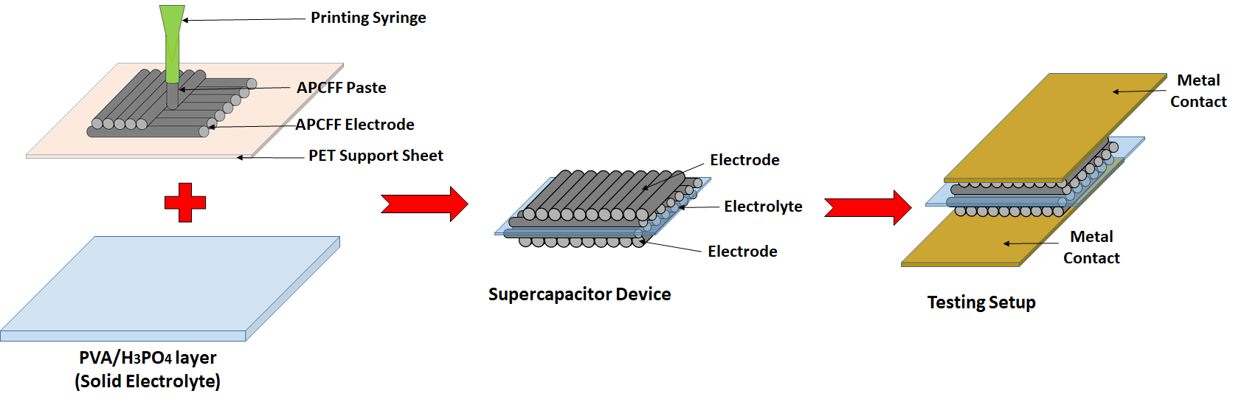
Figure S1. Schematic representation of the supercapacitor fabrication process.

S2. Mechanical testing
Hardness and elastic modulus are the mechanical characteristics that are evaluated by the nanoindentation using equations 1,2 and 3.
The indentation hardness is given by
$$H=\frac{P_{max}}{A}$$ | (1)
where, Pmax is maximum load and A is projected contact area at the maximum load.
The reduced modulus can be calculated from the contact stiffness (S)
$$S={2β\sqrt{\frac{A}{π}}E}_{r}$$ | (2)
$$\frac{1}{E_{r}}=\frac{1-v^{2}}{E_{s}}+\frac{1-v_{i}^{2}}{E_{i}}$$ | (3)

where, Er is the reduced modulus of indentation contact, Ei= 1140 Gpa and υi= 0.07 are elastic modulus and Poisson’s ratio of the indenter tip, β =1.034 for berkovich tip, and υ=0.3 is the poisons ratio (assumed) of the test sample.

S3. Supercapacitor characterization
The total device capacitance (C) was calculated using the following equation:
$$C=\frac{ IΔt}{ΔV}$$
Where I is the discharge current, ΔV is the discharge voltage, and Δt is discharge time.
The specific capacitance of the device (C_{s}) was calculated using the following equation.
$$Cs=\frac{C}{m}$$
Where m is the mass of active material in both electrodes.

