Inventory of Supporting Information
Triterpenoids in aerenchymatous phellem contribute to internal root aeration and waterlogging adaptability in soybean
Hirokazu Takahashi^{1*}, Chisato Abo¹, Hayato Suzuki², Jutapat Romsuk², Takao Oi¹, Asako Yanagawa¹, Tomoka Gorai¹, Yukari Tomisaki², Mana Jitsui¹, Satoshi Shimamura³, Hitoshi Mori¹, Akito Kaga⁴, Hikaru Seki², Toshiya Muranaka², Mikio Nakazono^{1, 5}
¹Graduate School of Bioagricultural Sciences, Nagoya University, Furo-Cho, Chikusa, Nagoya 464-8601, Japan
²Department of Biotechnology, Graduate School of Engineering, Osaka University, 2-1 Yamadaoka, Suita, Osaka 565-0871, Japan
³Tohoku Agricultural Research Center, National Agriculture and Food Research Organization, Kariwano, Daisen, Akita 019-2112, Japan
⁴Institute of Crop Science, National Agriculture and Food Research Organization, 2-1-2 Kannondai, Tsukuba, Ibaraki 305-8602, Japan
⁵School of Plant Biology, The University of Western Australia, 35 Stirling Highway, Crawley, WA 6009, Australia

*Corresponding author.

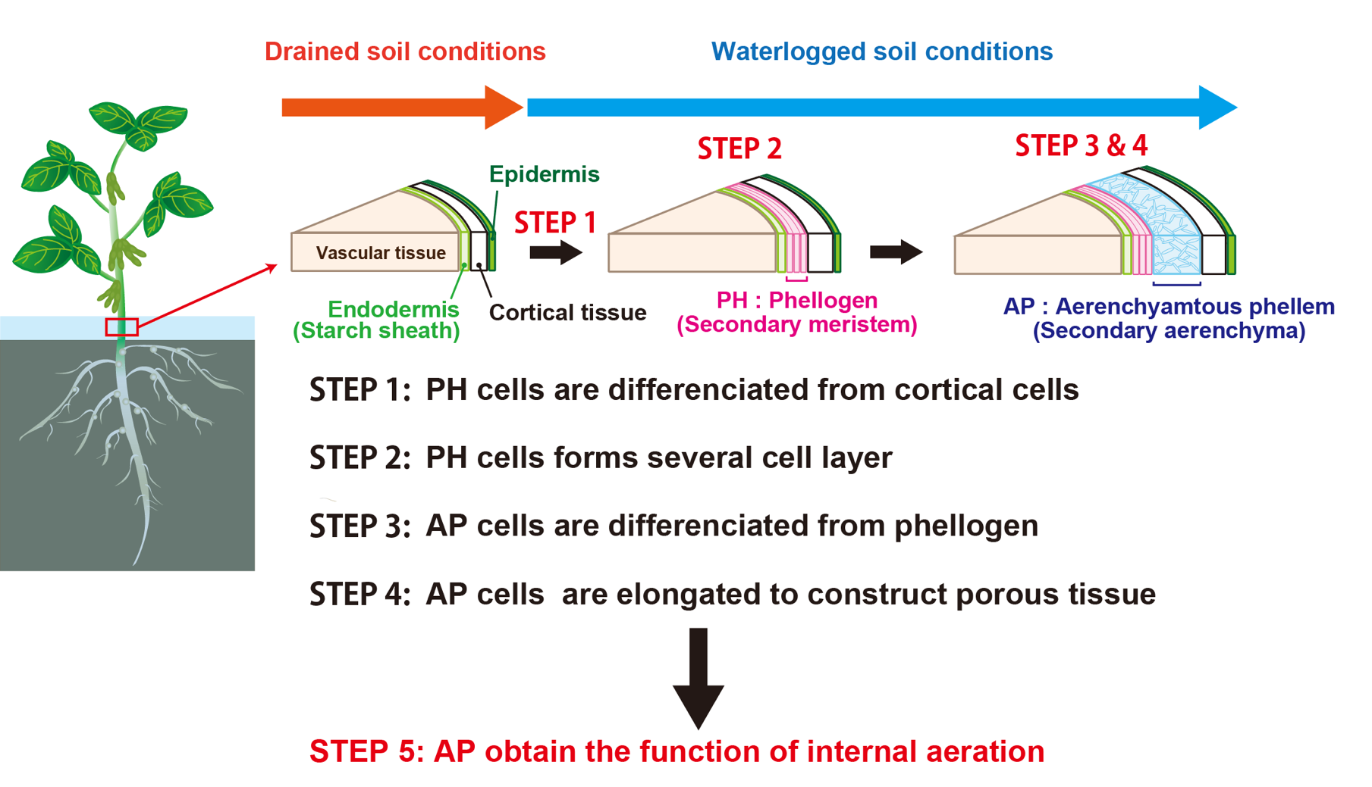
Extended Data Fig. 1. Important phases in the development of phellogen and aerenchymatous phellem (AP) in response to the waterlogging stress in soybean. Soybean does not develop phellogen and AP in well-drained soil. The formation of AP can be broadly divided into four stages. When soybean is subject to waterlogged soil conditions, cortical cells are differentiated into phellogen cells (STEP 1). Phellogen cells undergo consecutive cell divisions and organize themselves into cell layers (STEP 2). The phellogen's outermost cell develops into an AP cell (STEP 3). AP cells are elongated to enlarge the intercellular space between AP cells for the construction of porous tissue (STEP 4).

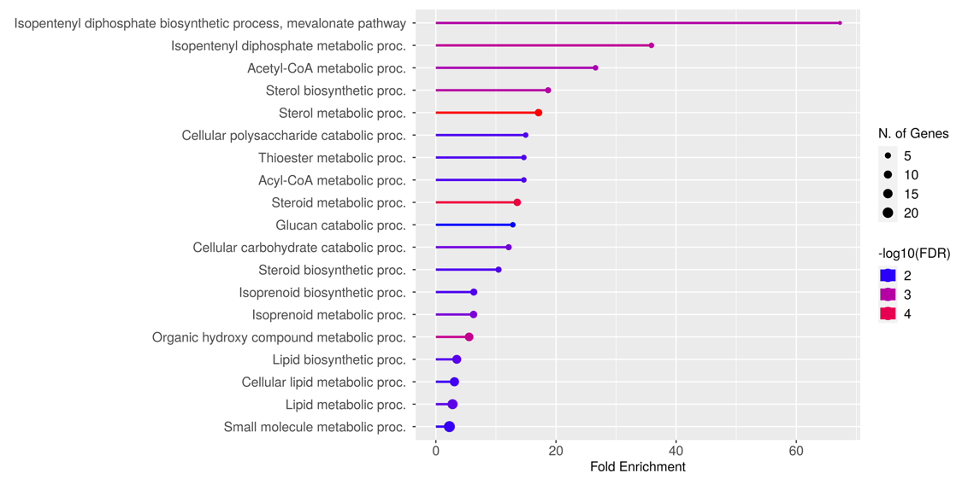
Extended Data Fig. 2. Induction of triterpenoid biosynthesis pathway in aerenchymatous phellem. Gene Ontology enrichment analysis was performed for 207 genes specifically upregulated in AP using ShinyGo 0.76 (http://bioinformatics.sdstate.edu/go/). Nineteen GO terms showing FDR < 0.01 were identified.

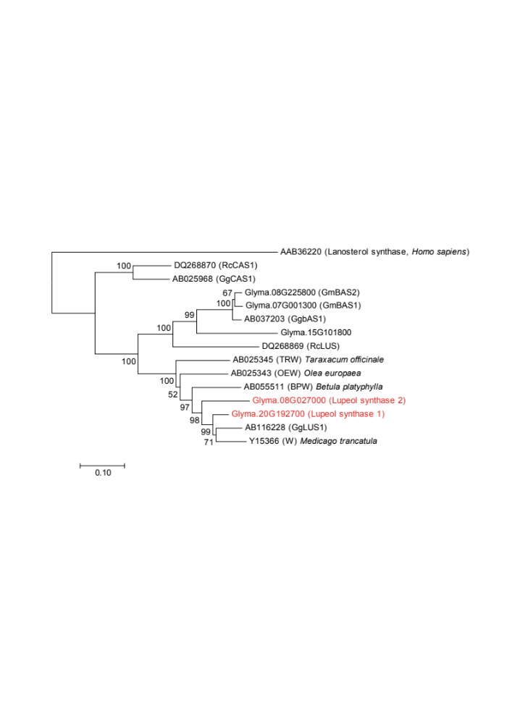

Extended Data Fig. 3. Phylogenic tree of lupeol synthase in plants. Its evolutionary history was inferred using the Neighbor-Joining method¹. The optimal tree with the sum of branch length = 2.38426883 is shown. The percentage of replicate trees in which the associated taxa clustered together in the bootstrap test (1,000 replicates) are shown next to the branches². The tree is drawn to scale, with branch lengths in the same units as the evolutionary distances used to infer the phylogenetic tree. The evolutionary distances were computed using the Poisson correction method³ and are in the units of the number of amino acid substitutions per site. The analysis involved 15 amino acid sequences. All positions containing gaps and missing data were eliminated. There were a total of 454 jobs in the final dataset. Evolutionary analyses were conducted using MEGA7⁴.

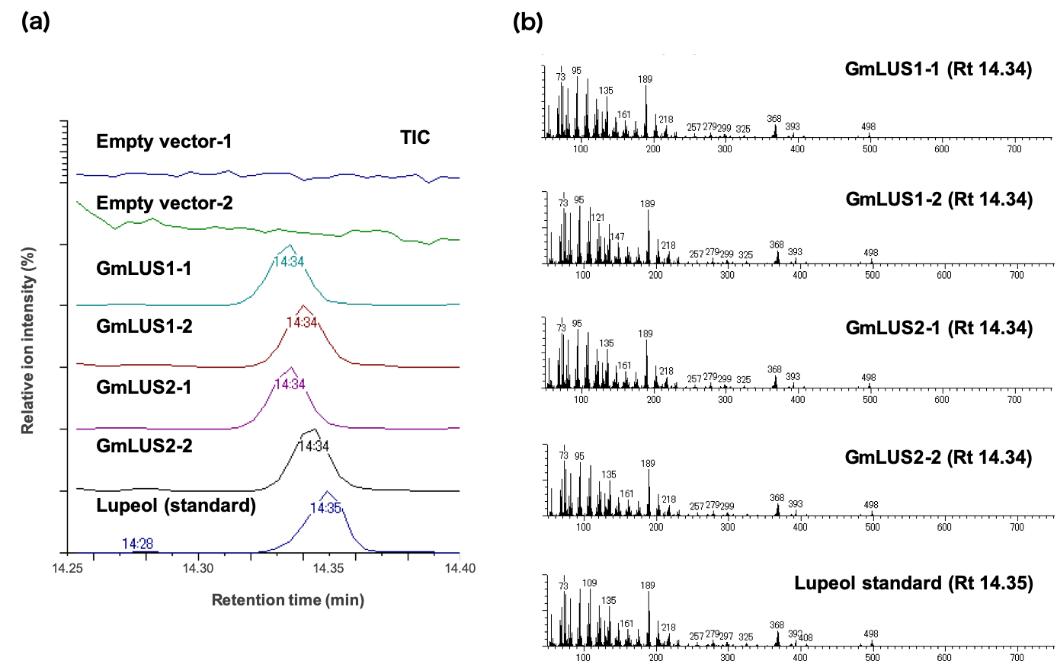

Extended Data Fig. 4. Enzymatic activities of lupeol synthases GmLUS1 and GmLUS2 in yeast cells. Lupeol was extracted from yeast-transformed with empty vectors GmLUS1and GmLUS2, respectively, and determined by GC-MS analysis. Empty vector-1 and Empty vector-2, GmLUS1-1 and GmLUS1-2, GmLUS2-1 and GmLUS2-2 originated from different colonies. Total ion chromatograms were shown in (a) Mass spectra of each peak in (a) are shown in (b).

(a)
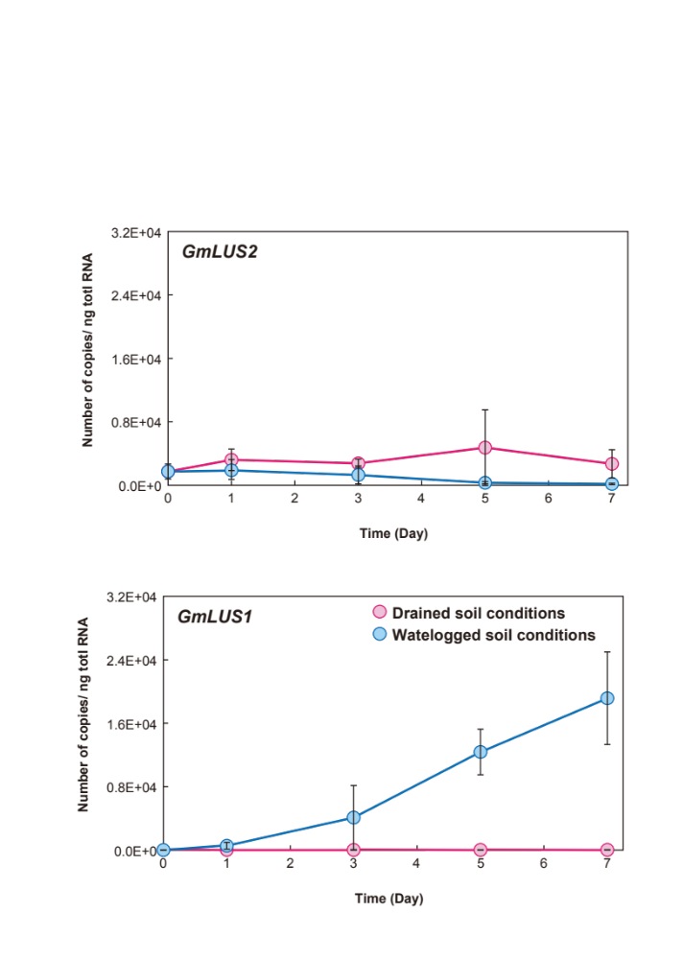
(b)
Extended Data Fig. 5. Time-dependent gene expression of GmLUS1 and GmLUS2 in hypocotyl under drained and waterlogged soil conditions.
After the unifoliate leaves were fully expanded, seedlings were grown under drained or waterlogged soil conditions for 0 d, 1 d, 3 d, 5 d, and 7 d. Total RNA was extracted from each hypocotyl, and amounts of the transcript were determined by qRT-PCR using specific primers in Table S1. Values indicate mean ± SD (n = 3).

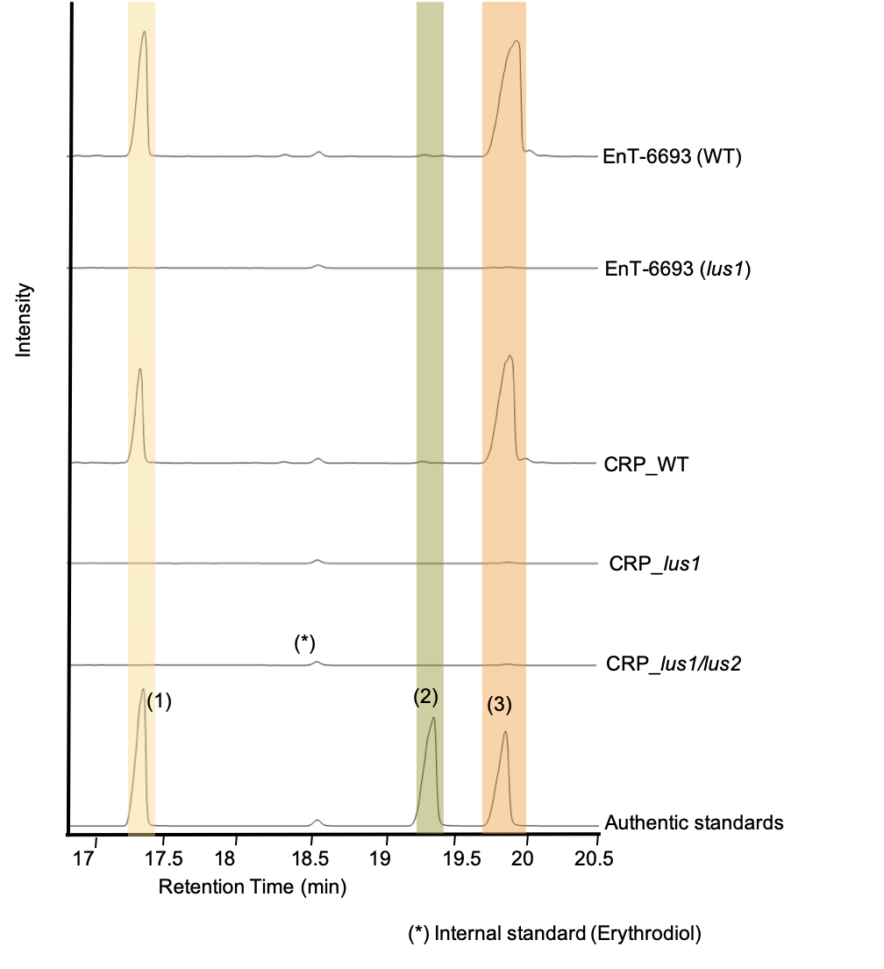
Extended Data Fig. 6. TIC of GC-MS analysis in the hypocotyls of EnT-6693(WT), EnT-6693(lus1), CRP_WT, CRP_lus1, and CRP_lus1/lus2 grown under waterlogged conditions for 2 weeks. The peak of (1) showed lupeol, (2) betulin, and (3) betulinic acid.

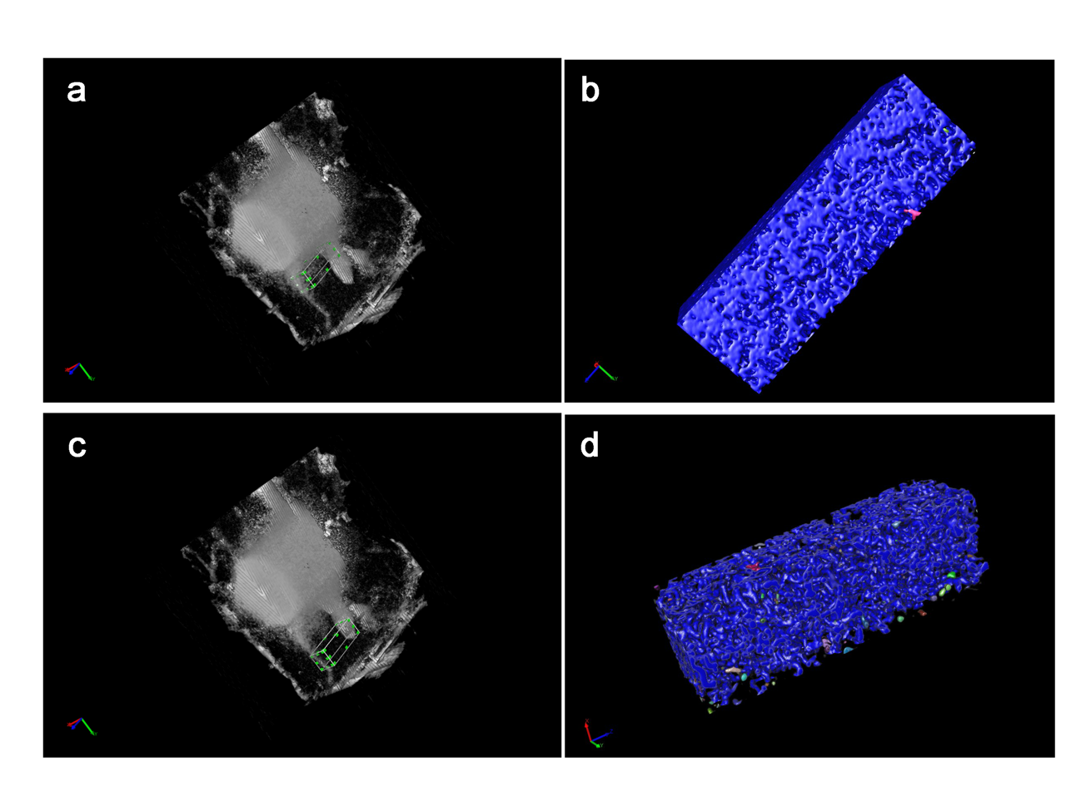
Extended Data Fig. 7. Constructed images of soybean hypocotyls by micro-X-ray CT scanning and “Inside” and “Outside” areas of AP; 3D images were constructed by Image-Pro (ver.10, Media Cybernetics). As an “Inside” area of AP, the 96 × 96 × 296 pixel region, which is indicated by green dots and white lines, was extracted from 3D images (a and b). The “Outside” area is shown in panels c and d.

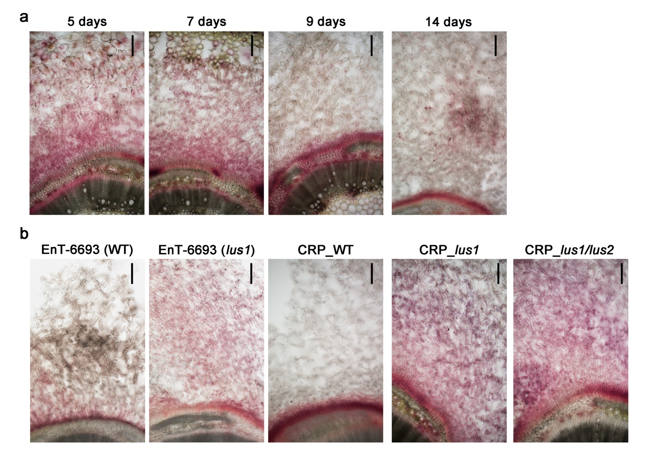
Extended Data Fig. 8. Cross-section after 2,3,5-triphenyl tetrazolium chloride (TTC) staining in hypocotyl during aerenchymatous phellem formation and EnT-6693(WT), EnT-6693(lus1), CRP_WT, CRP_lus1 and CRP_lus1/lus2. After the unifoliate leaves were fully expanded, seedlings were grown under waterlogged soil conditions for 5 d, 7 d, 9 d, and 14 d. EnT-6693 (WT), EnT-6693 (lus1), CRP_WT, CRP_lus1 and CRP_lus1/lus2 were grown until the unifoliate leaves were fully expanded. Then, seedlings were grown under waterlogged soil conditions for 2 weeks. After TTC staining, the cross-section of each hypocotyl was prepared at 200 µm thickness (a). Scale bar: 200 µm.

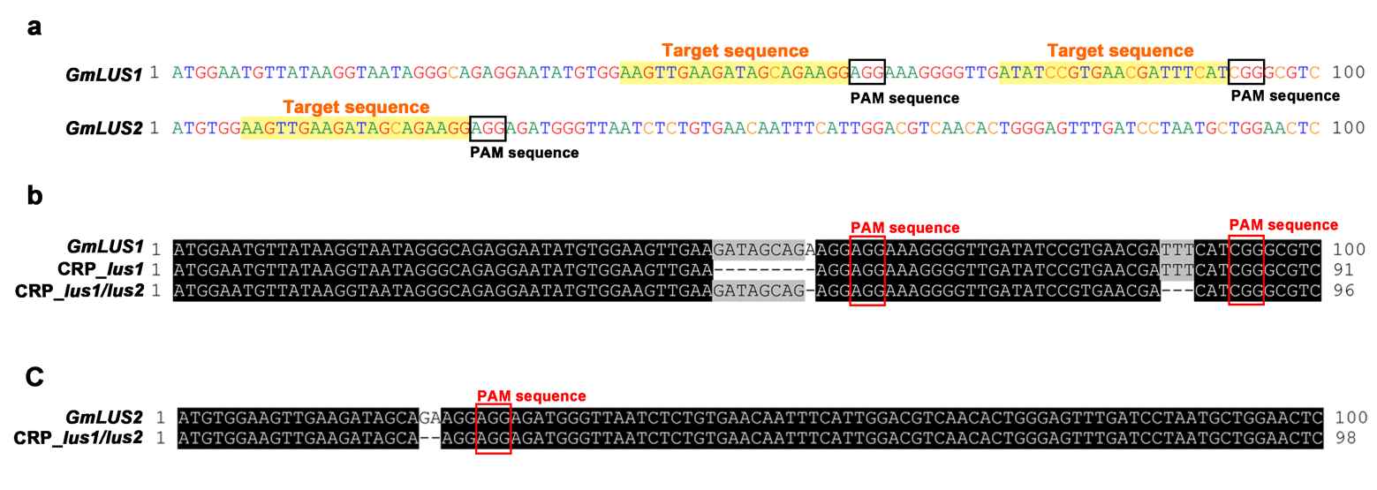

Extended Data Fig. 9. Target sequences of GmLUS1 and GmLUS2 for CRISPR/CAS9, and mutation in CRP_lus1 and CRP_lus1/lus2. The target sequence is highlighted in yellow, and the PAM sequence is shown in a black square (a) and a red square (b, c). CRP_lus1 had 9-bp deletion in GmLUS1 (b). CRP_ lus1/lus2 possessed 1-bp and 3-bp deletion in GmLUS1 and 2-bp deletion in GmLUS
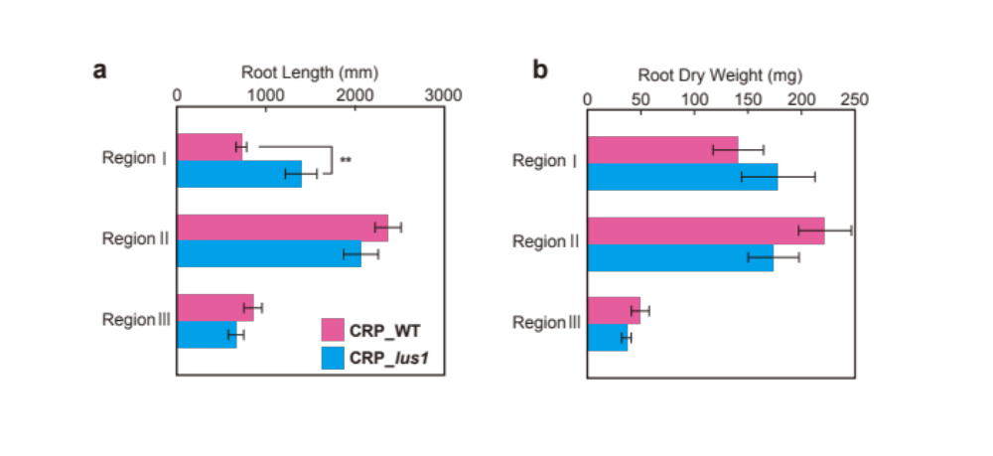
Extended Data Fig. 10. Total root length and root dry weight at different soil depths in CRP_lus1. Seedlings were grown under drained soil conditions for 2 weeks and waterlogged soil conditions for 3 weeks in a root box. Roots were separated into three regions (Region I: between water level and soil surface, Region II: between the soil surface and 40 mm below the soil surface, Region III: below the 40 mm from the soil surface) and collected for the measurement of total root length (a) and root dry weight (b). Values indicate mean ± SD (n = 3).

Table S6. Shoot and root growth in root box experiments

 | CRP_WT | CRP_lus1
Plant height (cm) | 79.9 ± 12.7 | 81.1 ± 16.7
No. of Node | 5.4 ± 1.0 | 5.1 ± 0.8
Shoot DW (g) | 1.5 ± 0.2 | 1.5 ± 0.3
Root DW (g) | 0.41± 0.11 | 0.39 ± 0.12
Total root length (mm) | 3942 ± 561 | 3541 ± 828
Shoot/Root ratio | 3.8 ± 0.8 | 4.0 ± 0.8
Values indicate mean ± SD (n = 3).

Table S7. Primer list

Experiments | Primer Name | Sequence (5'→3')
Genotyping for EnT-6693 | LUS-Gln729stop-053_F | AGGCTGAGATAGATCCGACACCCATAC
Genotyping for EnT-6693 | LUS-Gln729stop-053_R | ACCTTAACCACACAAGACTCGGCAAC
Genotyping for CRISPR mutant | GmLUS1_W82_F | TGATCATCTGTTTGCTTTAACCTTA
Genotyping for CRISPR mutant | GmLUS1_W82_R | TTTCTACCTCAGCGCGTTCTT
Genotyping for CRISPR mutant | GmLUS2_W82_F | GGACGCAAACTCGAGGAATG
Genotyping for CRISPR mutant | GmLUS2_W82_R | CTGCATTCTCATGAGTAGGTCACC
qRT-PCR | LUS1_F | GGCTTTGTTGTCCCTTATTGATG
qRT-PCR | LUS1_R | CTCCTGTGATTTCCTGTTGTTG
CDS cloning for LUS activity assay | GmLUS1_UTR_F | GCGTATCCATCTCTCGATTC
CDS cloning for LUS activity assay | GmLUS1_UTR_R | CAACCAAACCAAACACTTGC
CDS cloning for LUS activity assay | GmLUS1_CDS_F | CACCATGTGGAAGTTGAAGATAGC
CDS cloning for LUS activity assay | GmLUS1_CDS_R | TTAACCACACAAGACTCGGC
CDS cloning for LUS activity assay | GmLUS2_UTR_F | AATCAACACGTTGGACGAG
CDS cloning for LUS activity assay | GmLUS2_UTR_R | AATAATGGGTGCATTGAGGC
CDS cloning for LUS activity assay | GmLUS2_CDS_F | CACCATGTGGAAGTTGAAGATAGC
CDS cloning for LUS activity assay | GmLUS2_CDS_R | TTAGGTGGAGCTAAGTATTTG
In situ probe | GmLUS1-insitu_F | ATGTGGAAGTTGAAGATAGC
In situ probe | GmLUS1-insitu_R | TTAACCACACAAGACTCGGC

Supplementary References

1. Saitou, N. & Nei, M. The neighbor-joining method: A new method for reconstructing phylogenetic trees. Mol. Biol. Evol. 4,406-425 (1987).
2. Felsenstein, J. Confidence limits on phylogenies: An approach using the bootstrap. Evolution 39, 783-791 (1985).
3. Zuckerkandl, E. & Pauling, L. Evolutionary divergence and convergence in proteins. In: Evolving Genes and Proteins (Ed. Bryson, V. & Vogel, H. J.). pp. 97-166 (Academic Press, New York, 1965).
4. Kumar, S., Stecher, G. & Tamura, K. MEGA7: Molecular Evolutionary Genetics Analysis Version 7.0 for Bigger Datasets. Mol. Biol. Evol. 33, 1870-1874 (2016).

