Appendix A
SenseMaker® cross-sectional survey
Prompting Questions:
- Describe the best or worst experience of a particular woman or girl in your community who has interacted with foreign UN or MINUSTAH personnel. What happened?
- Describe how living in a community with a UN or MINUSTAH presence has provided either a particular opportunity or a danger to a particular woman or girl in the community. What happened?
- Describe the negative or positive experience of a particular women or girl who requested support or assistance after interacting with foreign UN or MINUSTAH personnel. What happened?

Triad Questions:
To answer the question, use your finger to drag the ball in each triangle to a position that best describes the experience shared in the story. The closer the ball to any one corner, the stronger that quality is in the context of the experience. If a triangle topic does not relate to your experience or you prefer to not answer the question, check the Not Applicable box by pressing on it with your finger.
- This story is about: 1. Financial/material security, 2. Social status, 3. Emotional needs
- In this story, the foreign UN or MINUSTAH personnel was: 1. In a position of authority, 2. Able to offer protection, 3. Wealthy and able to provide support
- Was the interaction in the story: 1. Friendly, 2. Business, 3. Relationship
- In the story, what would a fair response look like? 1. Acceptance of responsibility, 2. Justice, 3. Reparation
- In the story, it would have helped the woman or girl most to have had support from: 1. The UN or MINUSTAH, 2. NGOs or civil society organizations, 3. Haitian authorities
- In the story, barriers to the woman or girl getting a fair response were: 1. Lack of information in the community about assistance, 2. Lack of response from Haitian authorities, 3. Lack of response from the UN or MINUSTAH
- In the story, what would have helped most to make the experience more positive: 1. Material/financial support, 2. Emotional support, 3. Legal support
- Based on the events in the story, the presence of the UN or MINUSTAH led to: 1. Disrespect of Haitian values and laws, 2. Negative financial impact, 3. Anger and resentment

Dyad Questions:
Position the ball on each scale where it best describes the experiences in the story you shared. If a question is not applicable to your experience, check the non-applicable box.
- The interaction and relations you shared in the story were: Entirely initiated by the foreign UN or MINUSTAH personnel ↔ entirely initiated by the woman or girl
- In the story you shared, who had power and control: Foreign UN or MINUSTAH personnel ↔ the woman or girl
- In relation to the woman or the girl in the story you shared, those in power: Did absolutely nothing to assist or support her ↔ Provided her with too much assistance and support
- Events in the story led the community to have an: Overwhelming desire to engage with the UN or MINUSTAH ↔ Absolute rejection of the UN or MINUSTAH

Multiple Choice Questions Pertaining to the Narrative:

M1) Who is the story about?

- About me
- About someone in my household
- About someone in my family who doesn’t live in my household
- About a friend
- Community
- Something I heard or read about
- Prefer not to say
M2) How often does the situation in this story occur?

- Very rarely
- Occasionally
- Regularly
- Very frequently
- All the time
- Not sure

M3) How important is it for others to hear and learn from your story
- Must hear this story and take action
- Should definitely hear this story and pay attention
- Can learn some
M4) Who would most benefit from hearing the story shared? (choose up to three)

- Family
- Friends
- Neighbours
- Haitian politicians
- The UN or MINUSTAH
- NGOs
- The military of the foreigner
- Churches
- Community leaders
- Business people
- Girls in my community
- Women in my community
- Men in my community
- Not sure

M5) What is the emotional tone of this story?

- Strongly positive
- Positive
- Neutral
- Negative
- very negative
- Not sure

M6) How does your story make you feel (choose up to 3):

- Angry
- Disappointed
- Embarrassed
- Encouraged
- Frustrated
- Good
- Happy
- Hopeful
- Indifferent
- Relieved
- Sad
- Satisfied
- Worried
- Not sure

M7) What country was the foreigner in the story from?

- Uruguay
- Sri Lanka
- Pakistan
- Nepal
- Argentina
- Bolivia
- Brazil
- Chile
- Peru
- Indonesia
- Jordan
- Nigeria
- Pakistan
- Indonesia
- Senegal
- United States
- France
- Canada
- Japan
- China
- Other
- Don’t know

M8) What was the role of the foreigner with the UN or MINUSTAH?

- Soldier (UNPOL, MINUSTAH, or Multinational Forces)
- Civilian who works with the UN (doesn’t wear a uniform)
- Police
- Worked for an NGO rather than the UN or MINUSTAH
- Other
- Don’t know

Multiple Choice Questions Pertaining to the Participant:

D1) What is your gender?

- Female
- Male
- Prefer not to say
D2) How old are you:

- 11– 17 years old
- 18– 24 years old
- 25 – 34 years old
- 35 – 44 years old
- 45 – 54 years old
- ≥ 55 years old
D3) What is your marital status?

- Married or living together as if married
- Divorced/Separated from spouse
- Widowed
- Single, never married
- Prefer not to say

D4) What is your highest educational qualification?

- No formal education
- Some primary school
- Completed primary school
- Some secondary school
- Completed secondary school
- Some post-secondary school
- Completed post-secondary school

D5) I'll read you a list of 5 items that some people have at home. Please tell me which of these you or your household owns. Your household consists of people who sleep under the same roof and eat the same meals. Chose as many as your family has:

- radio
- mobile phone
- refrigerator or freezer
- vehicle such as a truck, a car or a motorcycle
- generator, inverter or a sun panel that provides electricity to your home.
- None of the above

D6) Here are some questions about your life

- 7 Strongly agree
- 6 Agree
- 5 Slightly agree
- 4 Neither agree nor disagree
- 3 Slightly disagree
- 2 Disagree
- 1 Strongly disagree

____ In most ways my life is close to my ideal.
____ The conditions of my life are excellent.
____ I am satisfied with my life.
____ So far I have gotten the important things I want in life.
____ If I could live my life over, I would change almost nothing

Multiple Choice Questions for the Research Assistant
I1) Which category /group does this narrator belong to?
- Child fathered by foreign UN or MINUSTAH personnel
- Woman or girl who had interacted with foreign UN or MINUSTAH personnel
- Family member of a woman or girl who had interacted with foreign UN or MINUSTAH personnel
- Friend of a woman or girl who had interacted with foreign UN or MINUSTAH personnel
- Community member where foreign UN or MINUSTAH personnel are hosted
- Community leader where foreign UN or MINUSTAH personnel are hosted
- Foreign UN or MINUSTAH personnel
- Haitian UN or MINUSTAH personnel
- Politician
- NGO staff
- Other

I2) In what location was the interview conducted?

- Citè Soleil
- Charlie Log Base / Tabarre
- Gonaives
- St. Marc
- Hinche
- Leogane
- Port Salut
- Miragoane
- Port-au-Paix
- Morne Casse / Fort Liberté
- Cap Haitien

I3) Do you think the participant was comfortable taking part in this survey? (choose up to three)

- No – because of the survey
- No – because of the topic
- No – because of the iPad
- No – because of the voice recording
- No – because of the SenseMaker questions
- No – because of concerns about motivations or identity of the researchers
- No – because of Voodoo related fears or concerns
- No – other
- Yes
- Not sure

I4) Was this story about a peace baby?
- About peace baby
- Mentioned a peace baby
- About sexual abuse or exploitation by UN or MINUSTAH but not a peace baby
- No
- Not sure

I5) Was this story about cholera?
- About cholera
- Mentioned cholera
- About wrongdoings committed by foreign UN or MINUSTAH personnel but not about cholera
- No
- Not sure

I6) Would you flag this story for translation and further analysis based on richness or interest?
- Yes
- No
- Not sure

I7) Which story number is this for this participant?
- 1st,
- 2nd,
- 3rd,
- 4th

I8) Research assistant number?
- 1, 2, 3, 4, 5, 6, 7, 8, 9, 10, 11, 12, 13, 14, 15, 16, 17, 18

If the participant is a women / girl who experienced sexual abuse or exploitation by foreign UN or MINUSTAH personnel, is she willing to be contacted for a more in-depth interview in the future? Complete the separate QuickTap survey with contact information if she agrees to participate.
- Yes
- No

Appendix B
Sample Triad and Dyad Questions
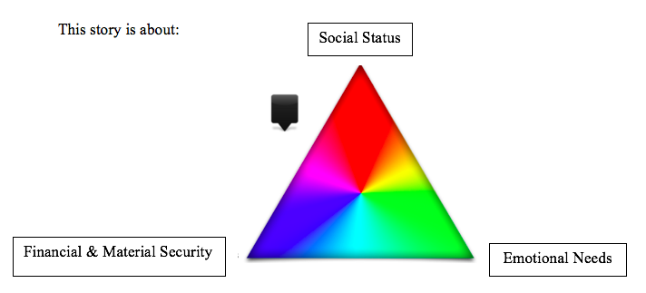

Figure 1: Example triad question

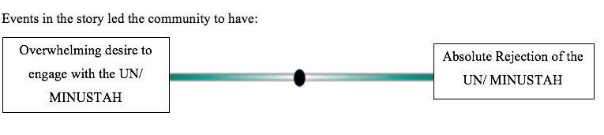

Figure 2: Example dyad question

Appendix C
Dyad Distribution

Figure 1: Distribution of dyad responses for the outcome variable in model 2

