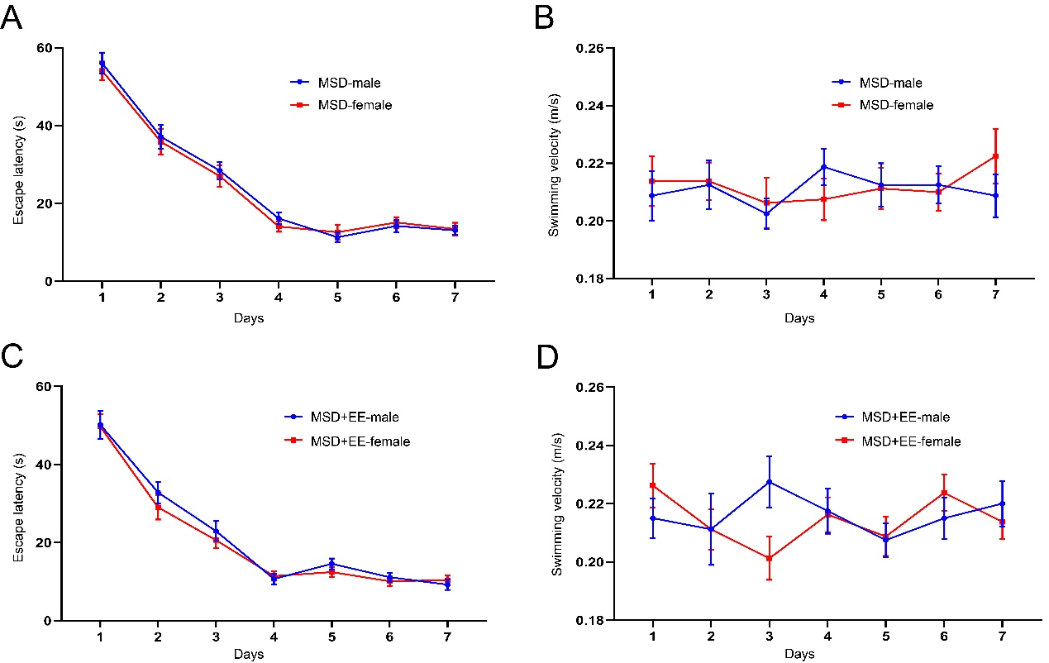
Supplemental Fig 1. The escape latency and swimming velocity of the Morris water maze test for mice subjected to the different treatments (except for the Control group). In the learning phase, the escape latency (A, C) and swimming velocity (B, D) for each of the seven training days are shown.

