APPENDIX A: The Application of the Ps splitting analysis
(a) | 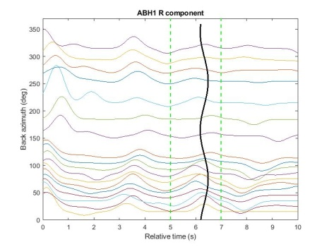 | (c) | 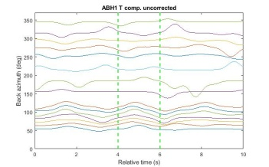
(b) | 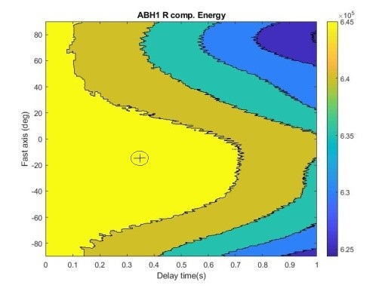 | (d) | 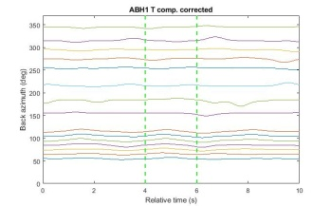
(e) | 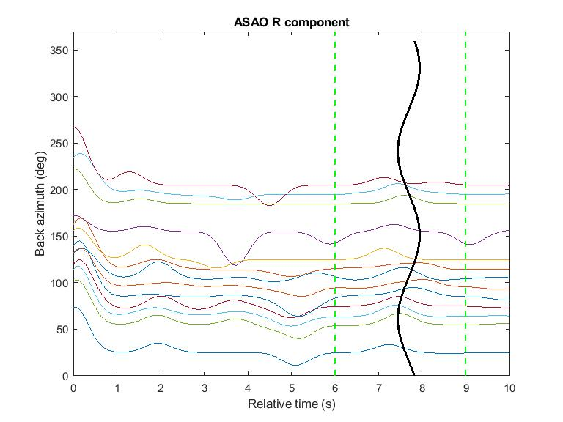 | (g) | 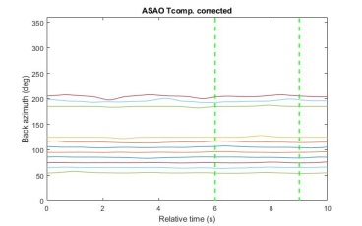
(f) | 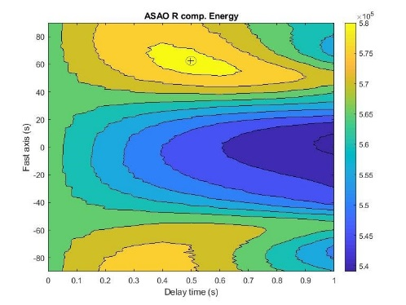 | (h) | 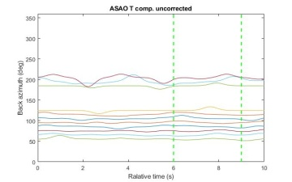
Figure A1. Application of the Ps splitting analysis from ABH1and ASAO stations. a) and e) Azimuthally gather of the radial receiver functions and fitting the best curve (equation 2). b) and f) Radial component energy diagrams obtained from grid search over splitting parameters at corresponding stations. We obtained φ=-15°, 61°, and δt= 0.31, 0.5 s at ABH1 and ASAO stations, respectively. The best fitting pair of splitting parameters is marked and surrounded by a black ellipse that indicates the uncertainty of the splitting parameters. c) and g) Azimuthal gather of transverse receiver functions before, d) and h) after application of inverse splitting based on the parameters derived from the splitting analysis.
(a) | 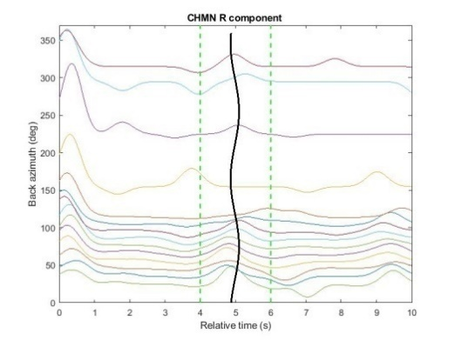 | (c) | 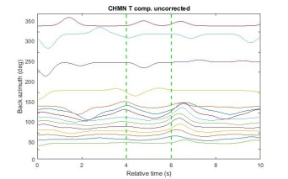
(b) | 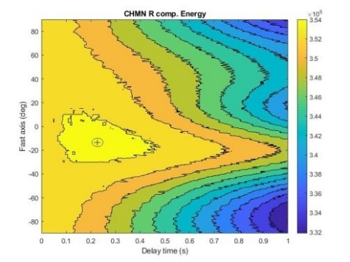 | (d) | 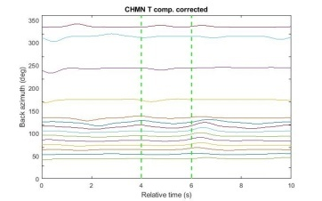
(e) | 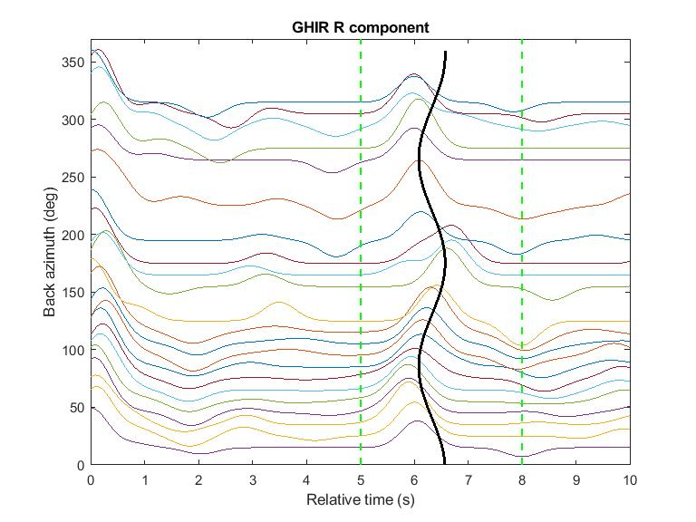 | (g) | 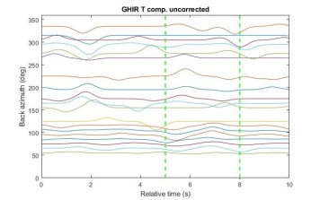
(f) | 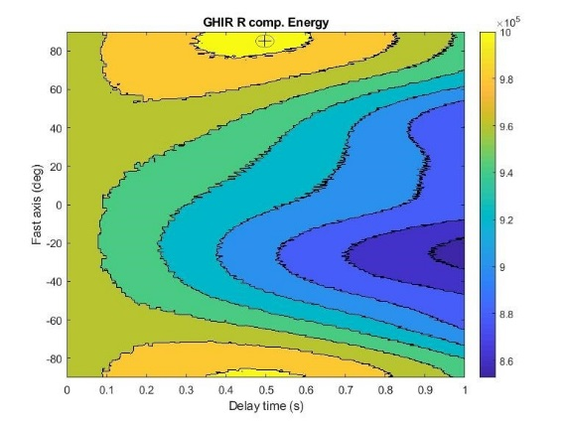 | (h) | 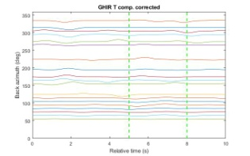
Figure A2. Application of the Ps splitting analysis data from CHMN and GHIR stations. a) and e) Azimuthally gather of the radial receiver functions and fitting the best curve (equation 2). b) and f) Radial component energy diagrams obtained from grid search over splitting parameters at corresponding stations. We obtained φ=-15°, 85°and δt= 0.25, 0.49 s at CHMN and GHIR stations, respectively. The best fitting pair of splitting parameters is marked and surrounded by a black ellipse that indicates the uncertainty of the splitting parameters. c) and g) Azimuthal gather of transverse receiver functions before, d) and h) after application of inverse splitting based on the parameters derived from the splitting analysis.
(a) | 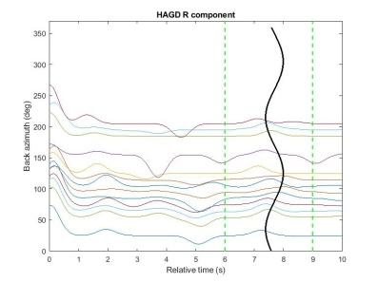 | (c) | 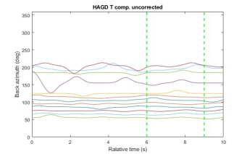
(b) | 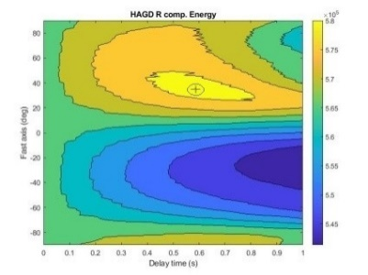 | (d) | 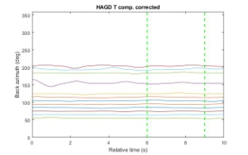
(e) | 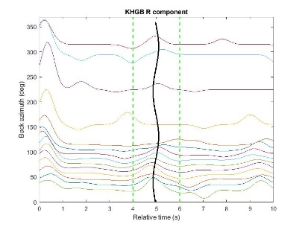 | (g) | 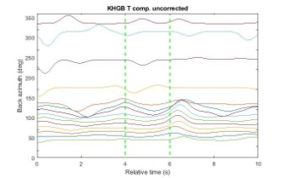
(f) | 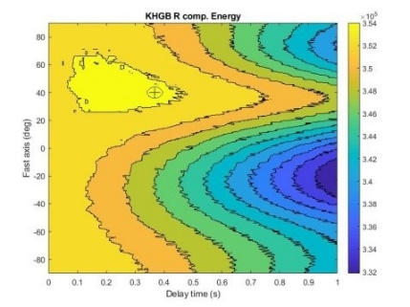 | (h) | 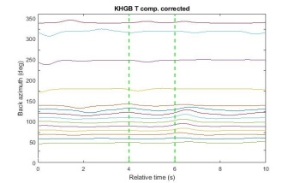
Figure A3. Application of the Ps splitting analysis data from HAGD and KHGB stations. a) and e) Azimuthally gather of the radial receiver functions and fitting the best curve as (equation 2). b) and f) Radial component energy diagrams obtained from grid search over splitting parameters at corresponding stations. We obtained φ=35°, 41° and δt= 0.57, 0.37s at HAGD and KHGB stations, respectively. The best fitting pair of splitting parameters is marked and surrounded by a black ellipse that indicates the uncertainty of the splitting parameters. c) and g) Azimuthal gather of transverse receiver functions before, d) and h) after application of inverse splitting based on the parameters derived from the splitting analysis.

(a) | 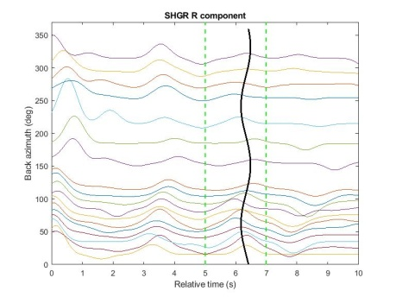 | (c) | 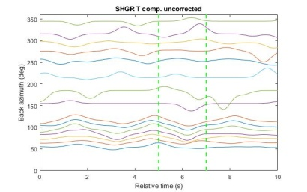
(b) | 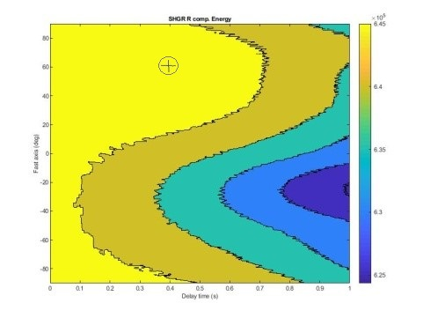 | (d) | 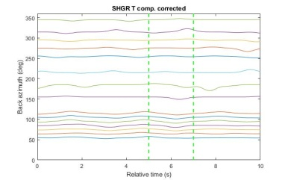
(e) | 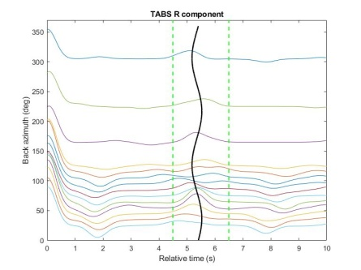 | (g) | 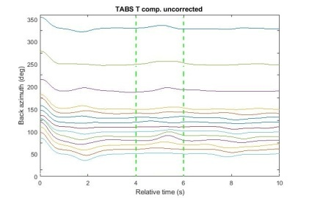
(f) | 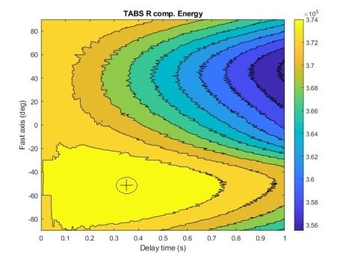 | (h) | 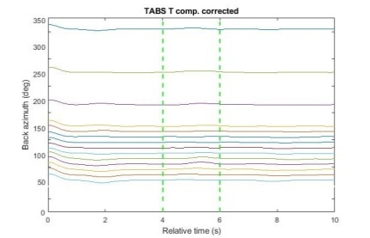
Figure A4. Application of the Ps splitting analysis data from SHGR and TABS stations. a) and e) Azimuthally gather of the radial receiver functions and fitting the best curve as (equation 2). b) and f) Radial component energy diagrams obtained from grid search over splitting parameters at corresponding stations. We obtained φ=61, -53° and δt= 0.40, 0.35 s at SHGR and TABS stations, respectively. The best fitting pair of splitting parameters is marked and surrounded by a black ellipse that indicates the uncertainty of the splitting parameters. c) and g) Azimuthal gather of transverse receiver functions before, d) and h) after application of inverse splitting based on the parameters derived from the splitting analysis.

