Modular Assembly of Metal Nanoparticles/Mesoporous Carbon Two-Dimensional Nanosheets
Pengpeng Qiu^{1,2}, Xingmiao Zhang, Yan Ai, Wei Luo^{2,}*, Wei Li,^{1,}* Dongyuan Zhao¹
¹Department of Chemistry, Laboratory of Advanced Materials, Shanghai Key Laboratory of Molecular Catalysis and Innovative Materials, iChEM and State Key Laboratory of Molecular Engineering of Polymers, Fudan University, Shanghai 200433, China.
²State Key Laboratory for Modification of Chemical Fibers and Polymer Materials, College of Materials Science and Engineering, Donghua University, Shanghai 201620, P. R. China.
E-mail: wluo@dhu.edu.cn, weilichem@fudan.edu.cn

Experimental section
Chemicals and Materials.
PEO-5000 was purchased from Sigma-Aldrich. 2-bromoisobutyryl bromide m N, N, N’, N’, N’-Pentamethyldiethylenetriamine (PMDETA) was purchased from Acros. Styrene, tetrahydrofuran (THF) (>99%), pyridine (>99%), cuprous bromide (CuBr), ammonium hydroxide (NH₄OH, 28−30 wt%), dopamine hydrochloride, iron nitrate, cobalt nitrate, nickel nitrate, copper nitrate, vanadium nitrate, palladium chloride and ethanol were purchased from Shanghai Chemical Corp. All chemicals were of analytical grade and used without furtherpurification. Deionized water was used for all experiments.

Characterization.
TEM was carried out (JEOL 2011, Japan) at200 kV. FESEM images were obtained usingfield emission scanningmicroscopy (Hitachi model S-4800, Japan). XRD patterns were collected (Bruker D4, Germany) with Ni-filtered Cu KR radiation (40 kV, 40 mA). The N2sorption isotherms were measured at 77 K (Micromeritcs Tristar 3020, USA). Before measurement, the samples were degassed in a vacuum at 180°C for at least 8 h. The surface areas were calculated by the BET method using the adsorption data in a relative pressure (P/P₀) ranging from 0.005 to 0.25. By using the BJH method, the pore size distribution and pore volume were calculated from the adsorption branches of isotherms, and the total pore volume (Vt) was estimated from the adsorbed amount at the relative pressure (P/P0) of 0.995. XPS was collected with a monochrome Al source (AXIS ULTRA DLD XPS Shimadzu Corp.). All of the binding energies were modified using the C 1s standard peak at 284.6 eV.
Synthesis of PEO-b-PS template
The PEO-b-PS diblock copolymers were prepared by an atom transfer radical polymerization (ATRP) method. First, the micro-initiator PEO-Br was prepared through the acyl bromide reaction. 20.0 g of PEO-5000 was dissolved in 120 mL of THF. Then, 20mL of pyridine was added to form a homogeneous solution at 30 ℃, which was followed reducing the temperature to 0 ℃ by using an ice-water bath. Next, 6.00 g of 2-bromoisobutyryl bromide was added dropwise, and the mixed solution was stirred at 30°C for 24 h. After adding 200 mL of cold ether, the white precipitation of PEO-Br was collected by centrifugation, washed with cold ether, and dried in vacuum at 30 ℃ overnight. In the second step, 5.00 g of the above made PEO-Br, 0.15 g of CuBr, 0.50 g of PMDETA and 35 mL of styrene were added to an ampoule bottle and degassed with three freeze-pump-thaw cycles. The mixture was subsequently immersed in an oil bath at 115°C under stirring. After reacting for 2h, the ampoule bottle was cooled down in liquid nitrogen. The gel-like product was dissolved in 100 mL of THF and filtered through Al₂O₃ column to remove Cu complex. After that, 200 mL of petroleum ether was poured into the solution to precipitate PEO-b-PS block copolymer. The copolymer was then dried in vacuum at 40 ℃.

Synthesis of metal nanoparticles/mesoporous carbon two-dimensional nanosheets
In a typical synthesis, 60 mg of PEO-b-PS was dissolved in 8 mL of THF to obtain a transparent solution. Then, a mixture of water/ethanol solution (24/12 mL) was quickly added to the solution to obtain a light-blue micelle colloid solution, which presents clear Tyndall effect. After stirring for 5 min, 80 mg of dopamine (DA) and certain amount of metal salts were added. Owing to the slight oxidative ability of metal ions, the solution gradually become gray with string for 5 min. Then, 0.5 mL of GO solution (5 mg/mL) prepared by a modiﬁed Hummers method was injected into the solution above. After sonicating the solution for 10 min, the reaction was initiated by adjusting the pH to 8 using a certain amount of ammonia hydroxide. After reacting for 8 h, the as-made sample were obtained by centrifuging at 8000 rpm for 5 min and washed repeatedly for three time by using water and ethanol, respectively. Finally, the obtained black precipitates were freeze dried and then carbonized at a certain temperature in N₂ atmosphere. For controlling the pore size, the template with different PS blocks were added.
Evaluation of electrocatalytic performance of resultant materials as ORR catalysts.
The performance of G@mC-Co as ORR catalysts was evaluated on a CHI 760E workstation (CH Instruments) in a conventional three-electrode cell. Ag/AgCl and Pt wires were used as reference and counter electrodes, respectively. 2 mg G@mC-Co catalyst was dispersed in 200 μL Nafion ethanol solution (0.25 wt %), and then was sonicated for 30 min to obtain a homogeneous ink. Then, 10 μL of the catalyst ink was pipetted onto a glassy carbon electrode and dried at room temperature for 30 min. The ORR performance of the catalysts was evaluated by CV and LSV. CV curves were measured in an N₂- or O₂-saturated 0.1 M KOH solution from 1.1 to 0 V with a scan rate of 50 mV s−1. LSVs were measured in an O₂-saturated 0.1 M KOH solution from 1.1 to 0 V at a scan rate of 5 mV s⁻¹ with different disk rotation rates of 400–2025 rpm. The electron transfer number (n) per oxygen molecule in an ORR process was calculated by the K–L equations. Chronoamperometric responses of G@mC-Co and Pt/C were measured at 0.40 V with a rotation rate of 1600 rpm for 600 s in O₂-saturated 0.1 M KOH solution with the introduction of 10% (v/v) methanol at 200 s.

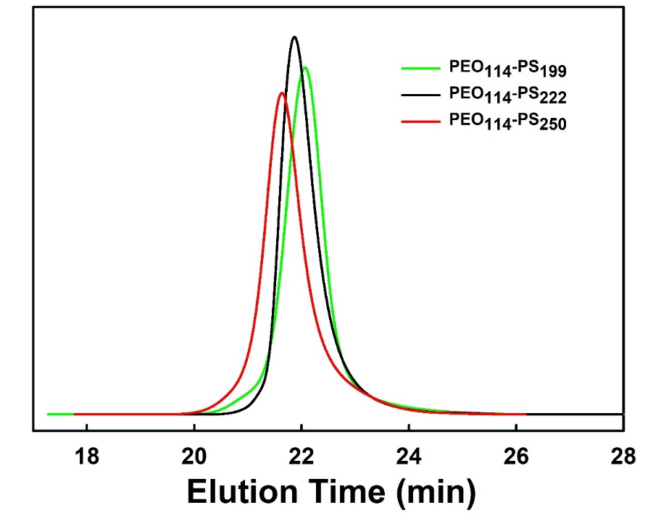
Figure S1. Gel permeation chromatography (GPC) traces of PEO₁₁₄-PS₁₉₉, PEO₁₁₄-PS₂₂₂ and PEO₁₁₄-PS₂₅₀.

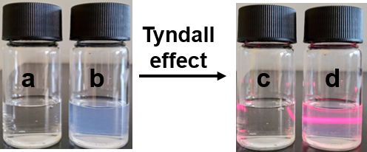
Figure S2. Digital photograph of PEO-b-PS/THF solution (a and c) and PEO-b-PS micelle solution after the addition of a mixture of water/ethanol with the irradiation of a laser (b and d).

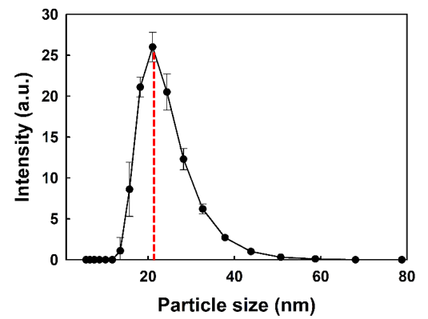
Figure S3. The hydrodynamic diameters of the PS₂₂₂-b-PEO₁₁₄ micelles.

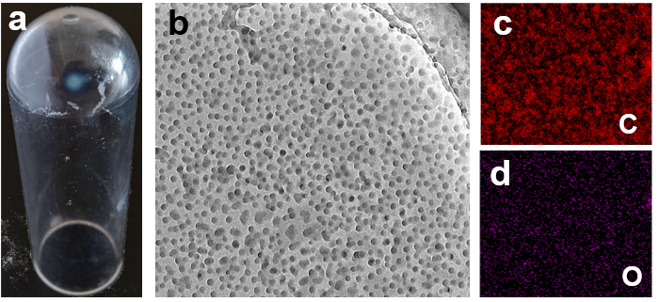
Figure S4. Digital photograph of the MC monomicelles after the ultracentrifugation (a), TEM image of the MC monomicelles after ultracentrifugation (c), and STEM images of C and O.

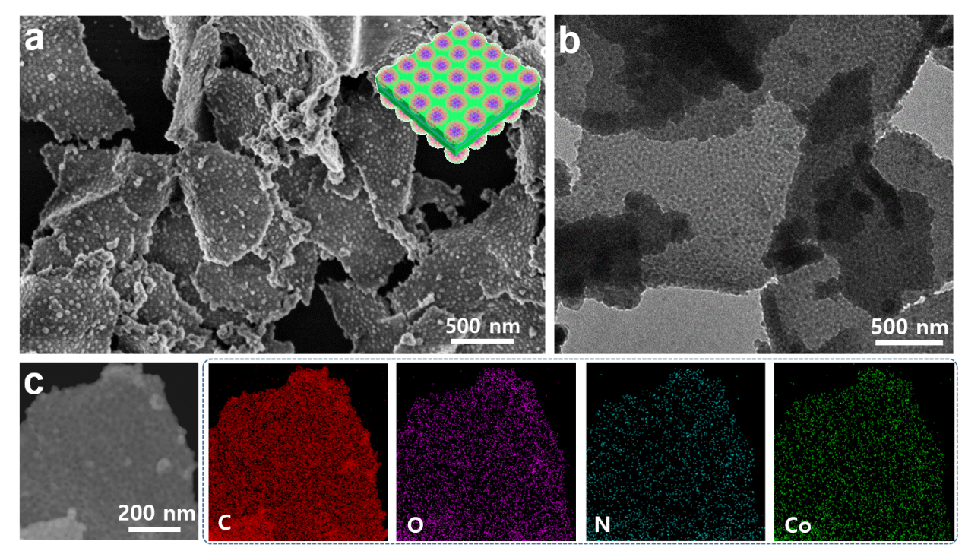
Figure S5. SEM (a), TEM (b) and STEM (c) images of as-made 2D mesoporous structure and their corresponding EDX elemental maps. Insert in a is the model structure for as-made organic-inorganic superstructures.

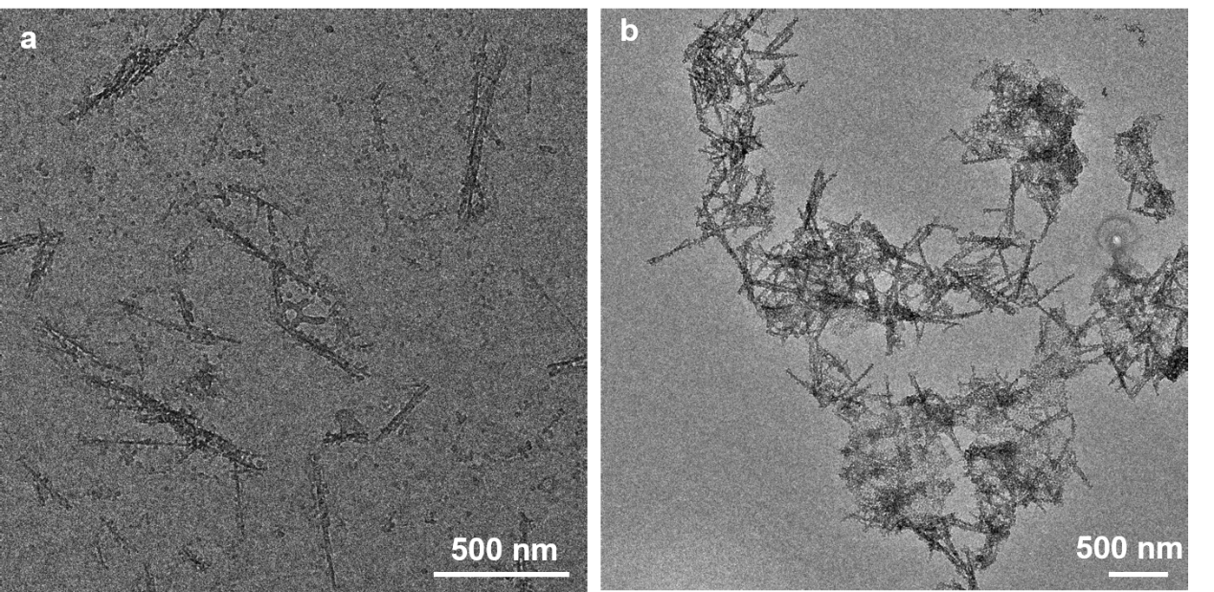
Figure S6. TEM images of the solution sample after the addition of GO dispersion (b) and reaction for 8 (c) without ultrasonic treatment.

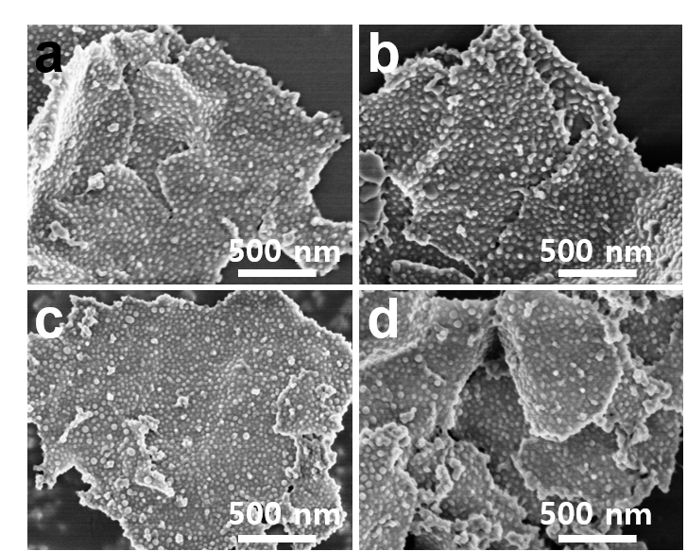
Figure S7. (a) SEM images of the sample withdrawn at different reaction time: 0 min (a), 60 min (b), 180 min (c) and 360 min (d).

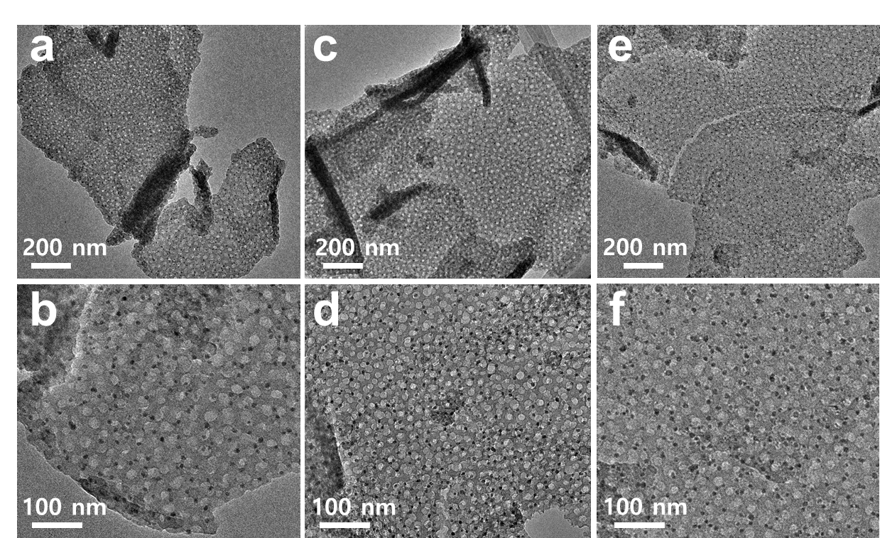
Figure S8. TEM images of 2D functional carbon nanosheets with different loading amount of CoO nanoparticles by changing the metal to DA ratio: 1:5 (a, b), 1:3 (c, d) and 1:2 (e, f).

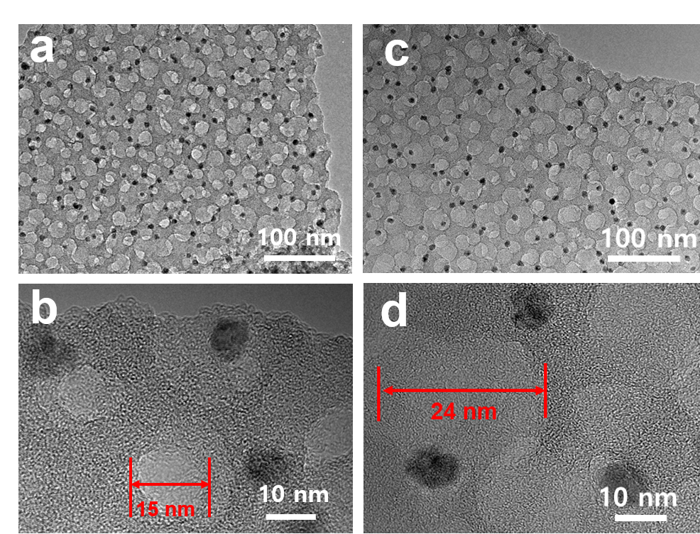
Figure S9. TEM images of 2D GO@mC-Co-550 prepared with different templates: PS₁₉₉-b-PEO₁₁₄ (a, b) and PS₂₅₀-b-PEO₁₁₄ (c, d).

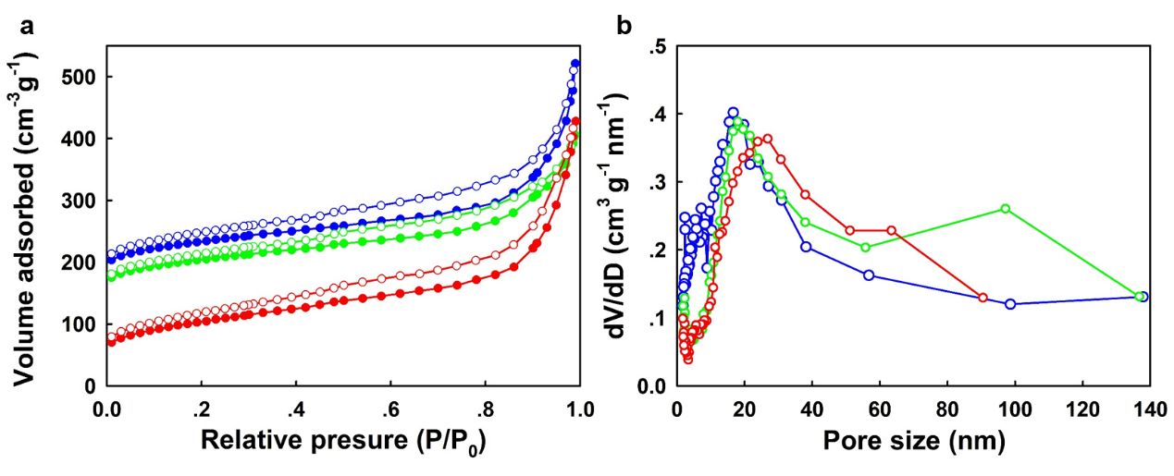
Figure S10. N₂ sorption isothermals (a) and pore size distribution (b) of GO@mC-Co-550 prepared by using PS₁₉₉-b-PEO₁₁₄ (blue), PS₂₂₂-b-PEO₁₁₄ (Green) and PS₂₅₀-b-PEO₁₁₄ (red) as the template, respectively;

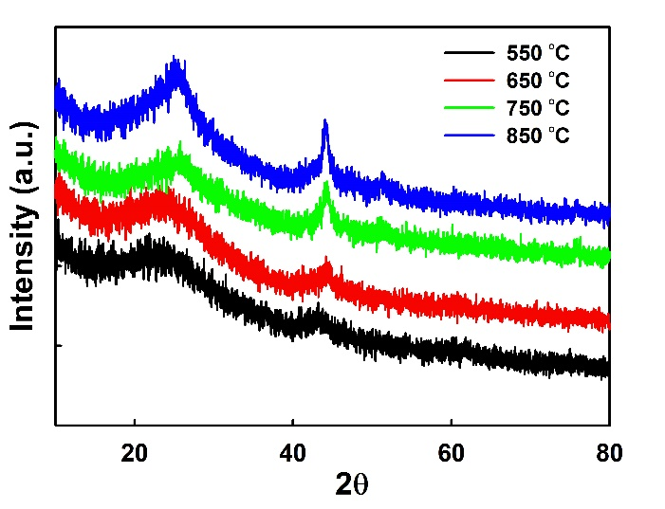
Figure S11. XRD patterns of the GO@mC-Co samples carbonized at 550 (black), 650 (red), 750 (green) and 850 (blue) ℃, respectively

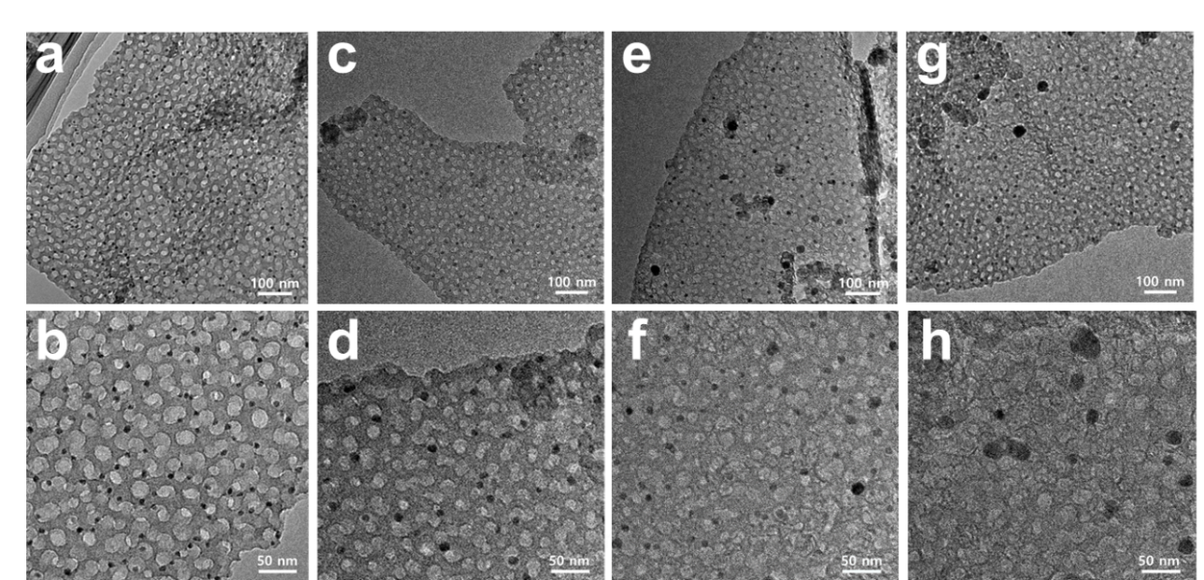
Figure S12. TEM images of 2D mesoporous G@mC-Co composites with different annealing temperature: 550 (a, b), 650 (c, d), 750 (e, f) and 850 (g, h) ℃.

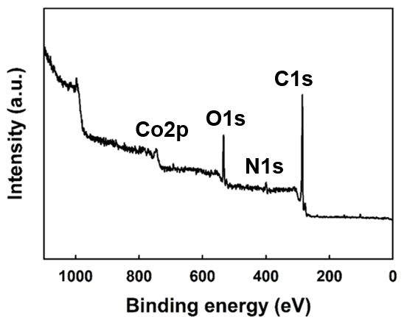

Figure S13. Total XPS survey spectra of GO@mC-Co-550 prepared by using PS₂₂₂-b-PEO₁₁₄ as the template.

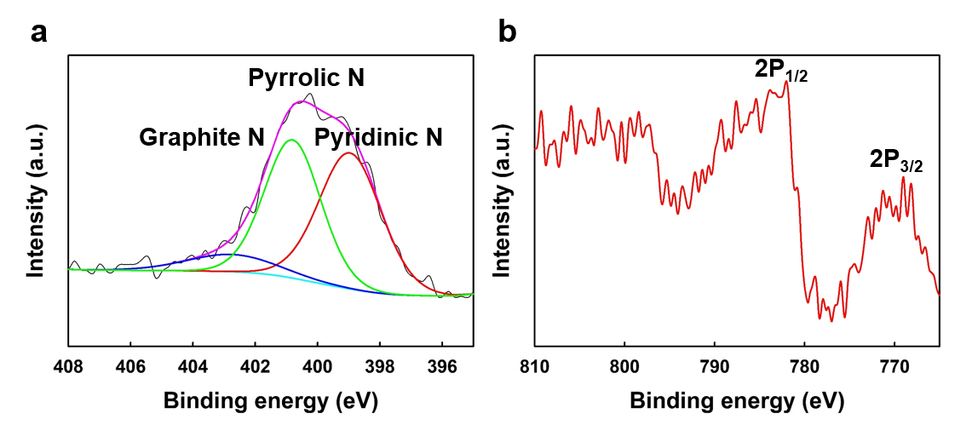

Figure S14. High resolution N 1s (e) and Co 2P (f) spectra of GO@mC-Co-550 prepared by using PS₂₂₂-b-PEO₁₁₄ as the template.

