Super-strong and flexible wood through cell wall swelling-assisted spontaneously fibers aggregation
Tao Zhang,^{a,b,c} Weimin Chen,^{a,b,c} Daotong Zhang,^{a,b,c} Yan Chen,^{d} Kai Yang,^{a,b,c} Pei Yang,^{a,b,c} Nana Pan,^{a,b,c} Qi Quan,^{a,b,c} Zhao Li,^{a,b,c} Ke Zhou,∗,^{d,e} Minzhi Chen,∗,^{a,b,c} Xiaoyan Zhou∗,^{a,b,c}

ª Co-Innovation Center of Efficient Processing and Utilization of Forest Resources, Nanjing Forestry University, Nanjing 210037, China
^{b} International Innovation Center for Forest Chemicals and Materials, Nanjing 210037, China
^{c} Jiangsu Engineering Research Center of Fast-growing Trees and Agri-fiber Materials, Nanjing 210037, China
^{d} Laboratory for Multiscale Mechanics and Medical Science, State Key Laboratory for Strength and Vibration of Mechanical Structures, School of Aerospace, Xi’an Jiaotong University, Xi’an 710049, China
^{e} College of Energy, Soochow Institute for Energy and Materials InnovationS (SIEMIS), Jiangsu Provincial Key Laboratory for Advanced Carbon Materials and Wearable Energy Technologies, Soochow University, Suzhou 215006, China

The orientation factor ($f$) of the oriented SSWF film was determined by the following empirical equation:
Seq. (1) $f=\frac{(180°-FWDTH)}{180°}$
where FWDTH is the half-height width of the azimuthal intensity distribution.

Fig. S1 Compositional changes of the wood before and after NaOH/Na₂SO₃/anthraquinone treatment. (a) FT-IR of the natural wood and SSWF film. The SSWF film features a decrease in the peak intensities at 1735 cm⁻¹ and 1245 cm⁻¹, which correspond to the carboxyl groups of hemicellulose and the ester linkage of the carboxyl groups of hemicellulose, indicating successful removal of hemicellulose. (b) Partially enlarged FT-IR spectra of the natural wood and SSWF film. The peaks at 1506 cm⁻¹ correspond to the phenyl ring stretching vibration, which is attributed to the aromatic skeleton vibrations of lignin. The absorption peaks at 1460 and 1425 cm⁻¹ correspond to the C-H deformations in lignin and carbohydrates. The characteristic peaks almost disappeared after the NaOH/Na₂SO₃/anthraquinone treatment, indicating that the lignin is successfully removed.
Fig. S2 Variation in cellulose, hemicellulose and lignin content from natural wood to SSWF film. The results showed that NaOH/Na₂SO₃/anthraquinone treatment removed most of the lignin and hemicellulose.

The effective distance of capillarity force on solid deformation could be evaluated by the following empirical equation:
Seq. (2) $l_{s}=\frac{γ}{G}$
Where $l_{s}$ is the effective distance, $γ$ is the surface tension, $G$ is the elastic modulus of the solid.
The surface tension of anisotropic surface between cellulose and pure water was 72 mN m^{−1[1]}. As shown in Figure S3, the average elastic modulus of the wood after delignification and DMSO swelling was 1.18 ± 0.46 KPa. It can be seen that the effective distance of elastic capillary tension in delignified wood was about 61.02 μm, which satisfied the requirements of wood cell wall shrinkage.
Fig. S3 Morphological and structural features of natural wood, delignified wood and fully swollen wood, respectively.

Fig. S4 XRD patterns of delignified wood and fully swollen wood.

Fig. S5 Elastic modulus of natural balsa wood and delignified balsa wood, respectively.

Fig. S6 Schematic diagram of force analysis of wood cell wall during moisture evaporation process.

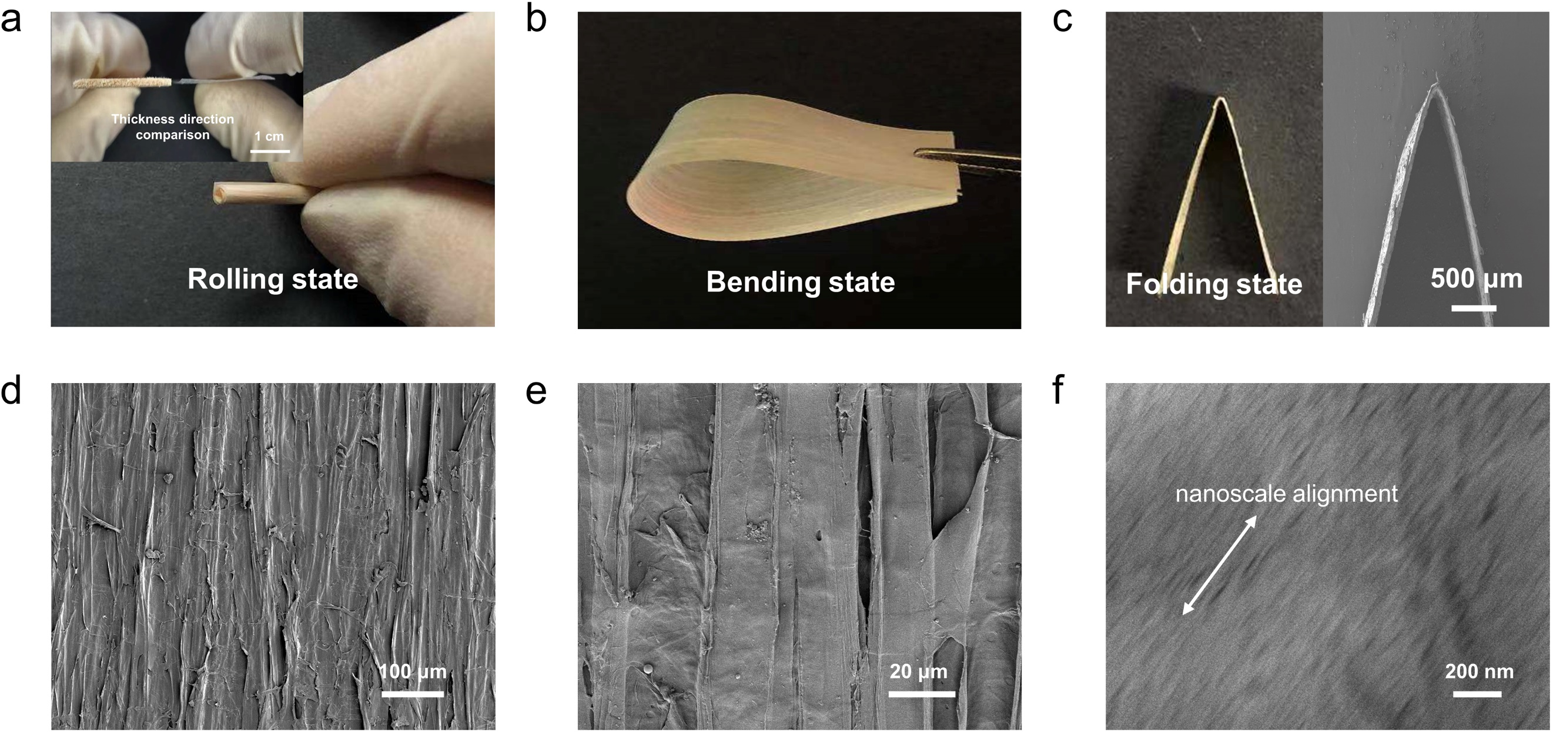
Fig. S7 Microstructures of SSWF film. a The comparison of the thickness changes of natural wood and SSWF film, respectively; Photograph shows that delignified wood samples can be directly converted into SSTW film after air-assisted drying process via our “top-down” method; b The SSTW film is completely bent parallel to the fiber direction and along the fiber direction, indicating better flexibility and durability. c A top-view SEM image of the SSTW film, which is subjected to fully folded in the direction of the wood fibers; d The surface SEM image of SSWF film, showing the aligned microfibers. e Enlarged SEM image of wood fiber. f SEM image of the SSWF film, showing the aligned nanofibers.

Fig. S8 Optical transmittance of the SSWF film.

Fig. S9 Polarized light microscopy images of the SSWF film exhibited bright birefringence primarily.

Fig. S10 Interlayer shear loading in MD simulation.

Fig. S11 DTS model for SSWF film. a Representative volume unit of DTS model. b n-layer stacked cellulose block in SSWF film. c Atomic configuration of SSWF film with regularly distributed breaks. d Homogenization and continuity from discrete atomic configuration to the continuum model where n-layer stacked cellulose blocks are considered as hard layers and interlayer H-bond networks are simplified as soft layers.

Fig. S12 a Stress-strain curves and b corresponding in-plane stiffness of n-layer stacked cellulose block. In b the lines are the fitting curves and the symbols are MD results.

Fig. S13 a Relationship between lignin content and cellulose DP with different cooking time; b Tensile strength and lignin content of cellulose as a function of cooking time.

Fig. S14 Comparison of the storage modulus of the SSWF film with petroleum-based plastics.

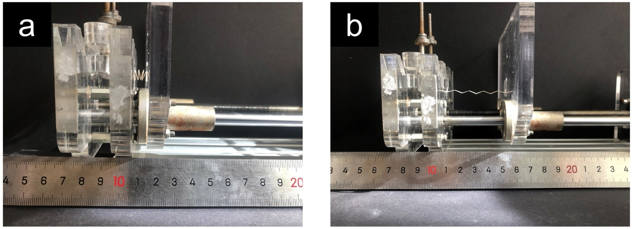
Fig. S15 The bending cycle stability test.

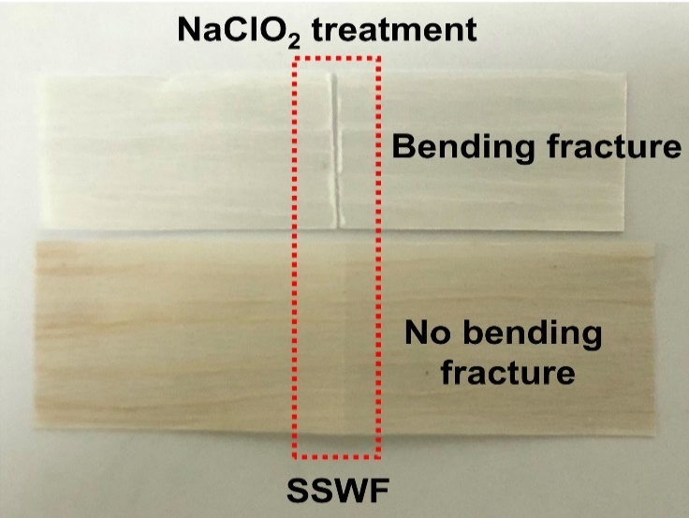
Fig. S16 When the lignin is almost removed (1.3%), the transparent wood film is broken after being subjected to bending stress.

Fig. S17 a Pencil-drawn 2D logos (NJFU) on SSWF film as interconnects integrated with blue LEDs. b The relationship between sheet resistance and writing cycles. c Joule heating performance of conductive SSWF film with input voltages ranging from 3 to 12 V. d The changes of temperature distribution in the conductive SSWF film under 5 V, 10 V, 15 V, respectively (recorded by an infrared camera).
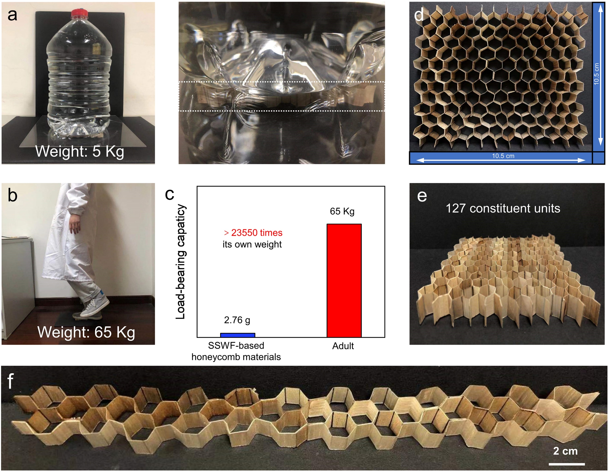
Fig. S18 The bearing capacity of woody honeycomb panel under the weight of a 5 kg and b 65 kg, respectively. c Woody honeycomb panel with a weight of only 2.76 g easily supported an adult of ≈65 kg, which was over 23550 times its own weight. d The appearance of 3D woody honeycomb panel with an area of 10.5 × 10.5 × 1 cm³ and a weight of 2.76g. e The density of woody honeycomb panel is 0.025 g/cm³, and the load-bearing direction is the direction of wood fibers. f Photograph of a 3D woody honeycomb panel, 33 cm in length.

Reference
1. Miller, A. F. & Donald, A. M. Langmuir, 18, 10155-10162 (2002).

∗ Corresponding author. E-mail address: zhouke@xjtu.edu.cn
∗ Corresponding author. E-mail address: chenminzhi@njfu.edu.cn. ∗ Corresponding author. E-mail address: zhouxiaoyan@njfu.edu.cn.

