Supplementary materials for Archives of Microbiology

Halocynthiibacte halioticoli sp. nov., isolated from abalone Haliotis discus hanai
Dan-Dan Zhang^{1,} †, Yu-Yan Yue^{1,} †, Meng-Di Zhang² and Zong-Jun Du^{1, 3, *}
¹Marine College, Shandong University, Weihai, Shandong, 264209, PR China
²Joint Science College, Shandong University, Weihai, Shandong, 264209, PR China
³Weihai Research Institute of Industrial Technology of Shandong University, 264209, PR China

*Correspondence:
Corresponding author at: Marine College, Shandong University, Weihai, 264209, China.
Zong- Jun Du, Email: duzongjun@sdu.edu.cn
Telephone and fax number: +86-631-5688303

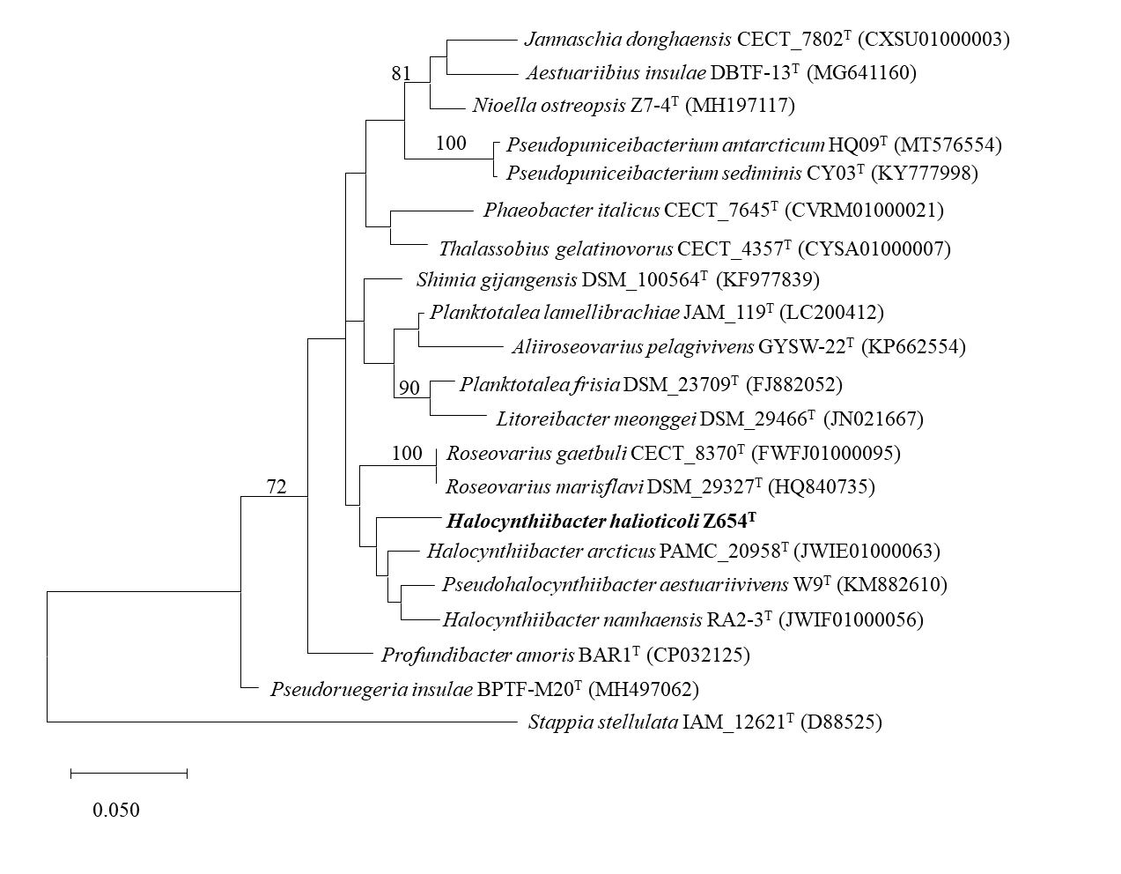
Supplementary Fig. S1 Maximum-likelihood phylogeny reconstructed from 16S rRNA gene sequences of strain Halocynthiibacter halioticoli Z654^{T} and its closest relatives. Only bootstrap values of >70% are shown at branching points. GenBank accession numbers of 16S rRNA gene sequences are presented in parentheses. Stappia stellulata IAM_12621^{T} was used as an out group. The scale bar indicated 0.0500 substitutions per nucleotide position.

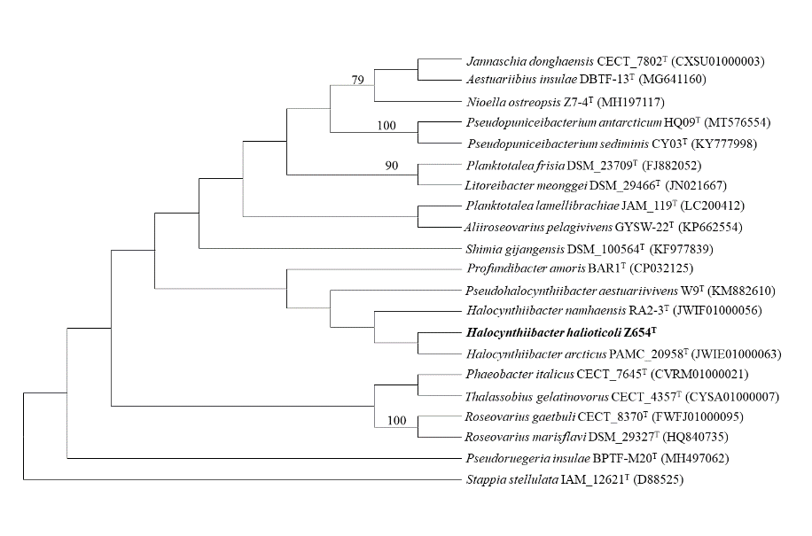
Supplementary Fig. S2 Maximum-parsimony phylogeny reconstructed from 16S rRNA gene sequences of strain Halocynthiibacter halioticoli Z654^{T} and closest relatives. Only bootstrap values of > 70% are shown at branching points. GenBank accession numbers of 16S rRNA gene sequences are presented in parentheses. Stappia stellulata IAM_12621^{T} was used as an out group.

Supplementary Fig. S3 Histogram of predicted carbohydrate-active enzymes (CAZYmes) in strains Z654^{T}. Number of each enzyme detected in the genome were shown in the map.
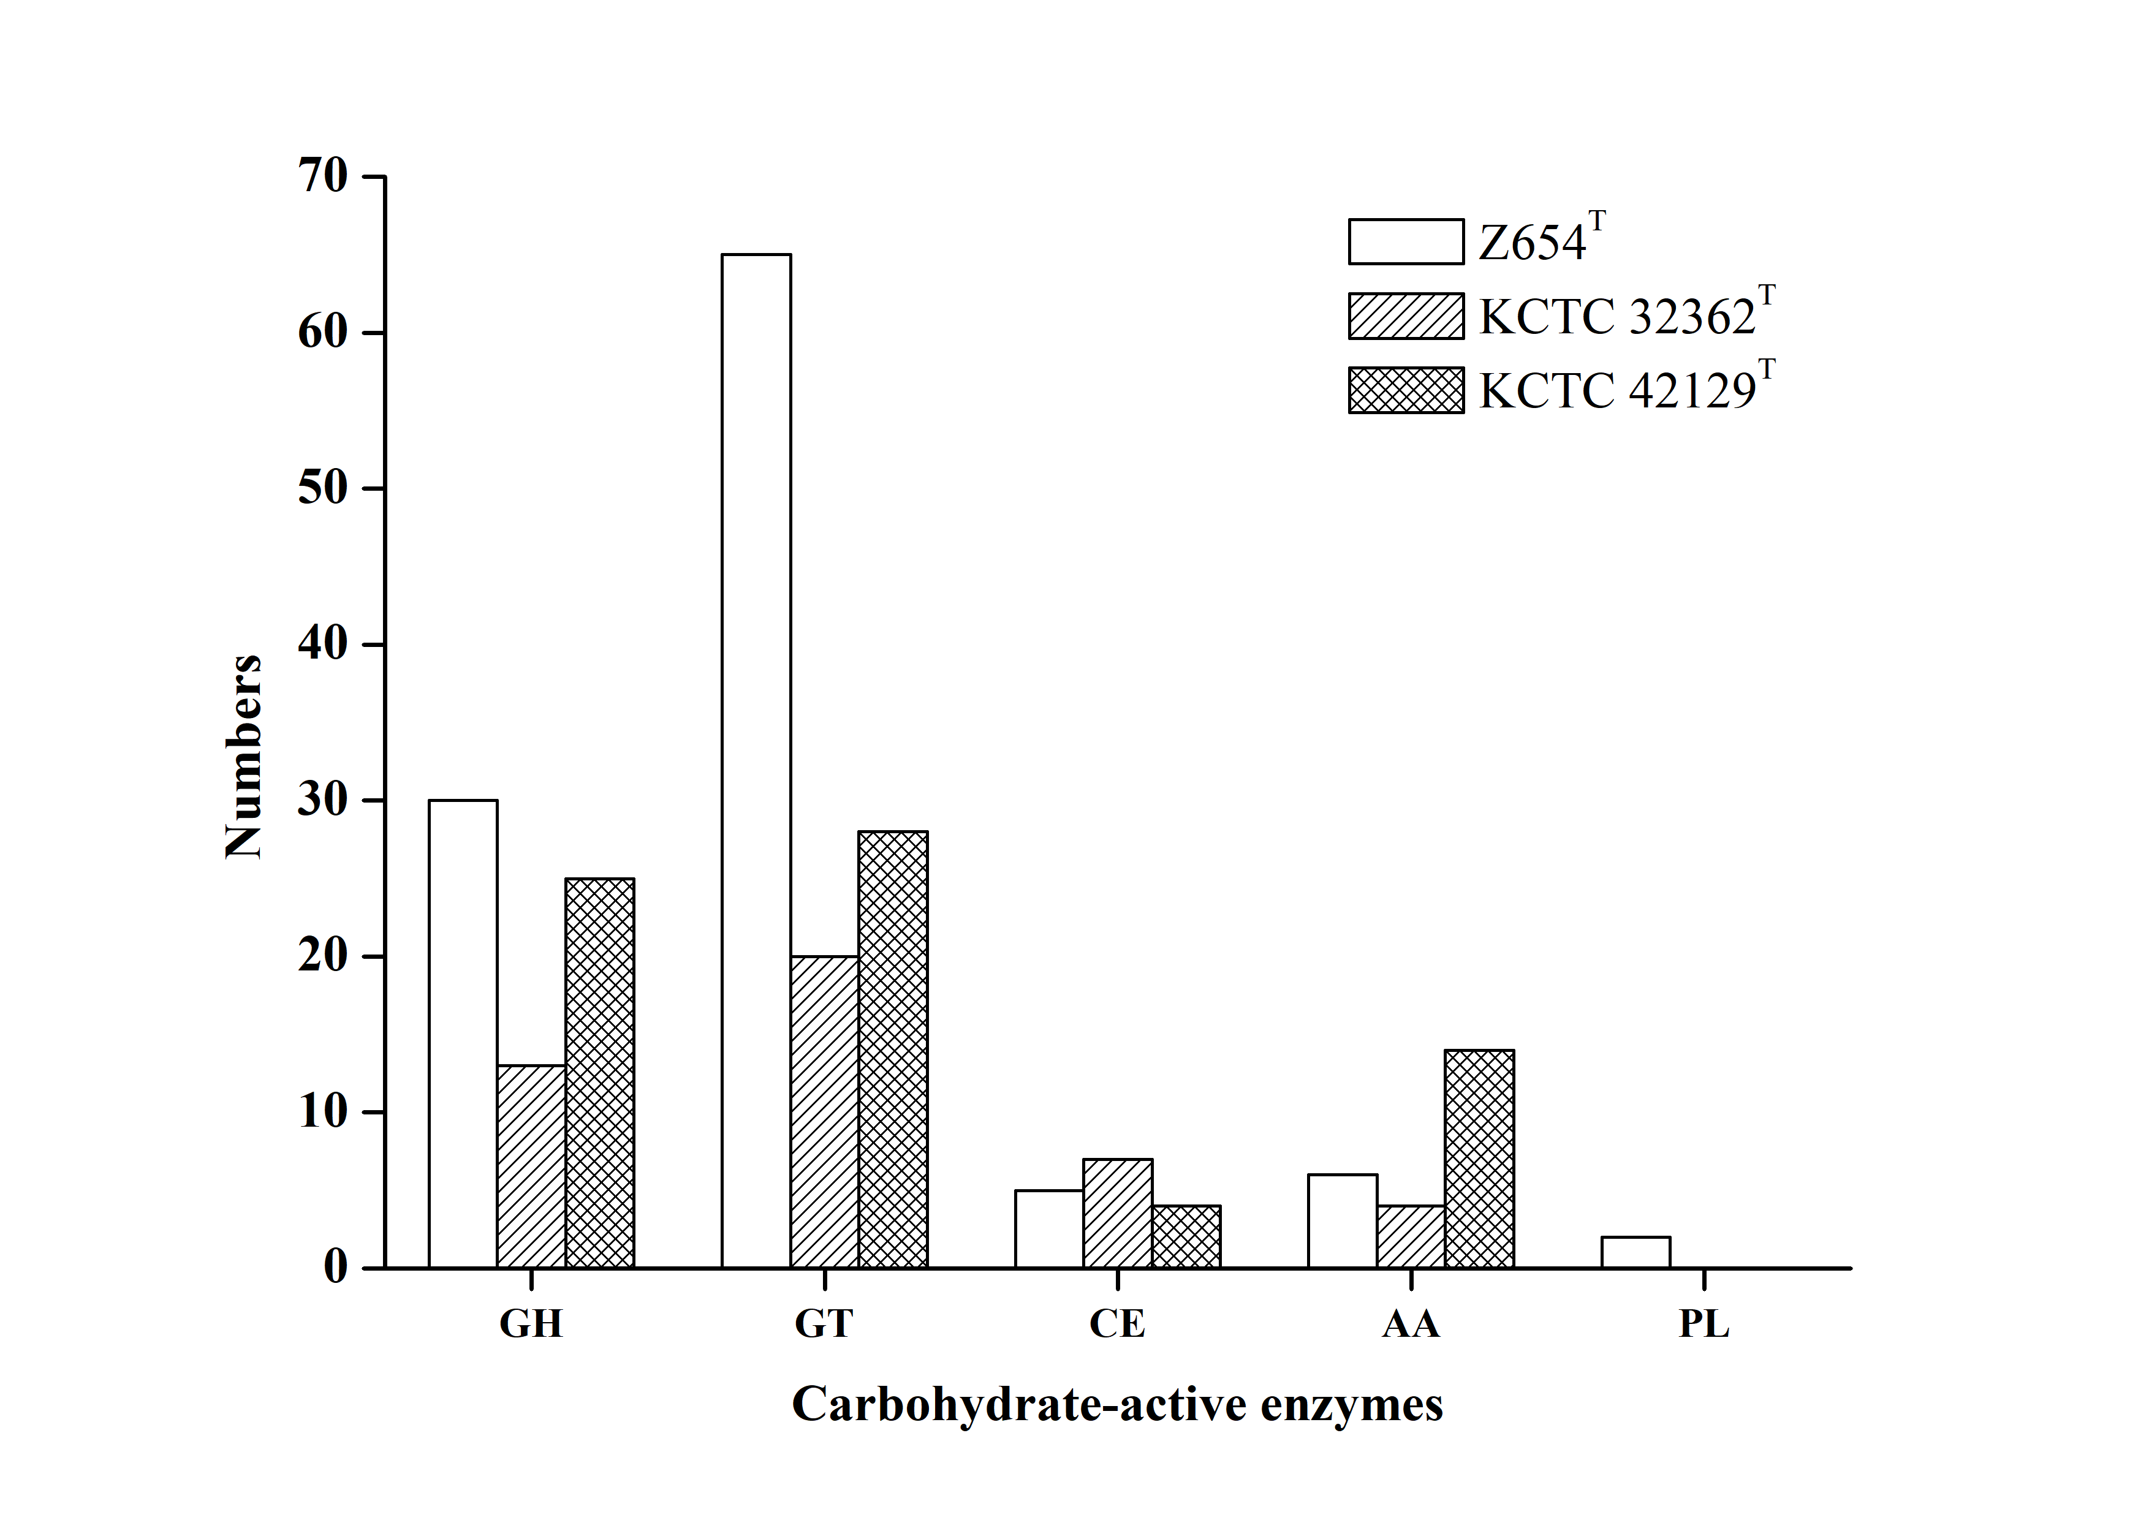

Supplementary Fig. S4 Scanning electron microscopy image of cells of strain SDUMZ654^{T}. Scale bars, 5 μm.

Supplementary Fig. S5 Two-dimensional thin-layer chromatograms of polar lipids of strain H. arcticus KCTC 42129^{T} (a), H. namhaensis KCTC 32362^{T} (b), SDUMZ654^{T} (c). APL, aminophospholipid; PC, phosphatidylcholine; PG, phosphatidylglycerol; AL, unknown aminolipids; PL, unidentified phospholipid; L, unknown lipids.
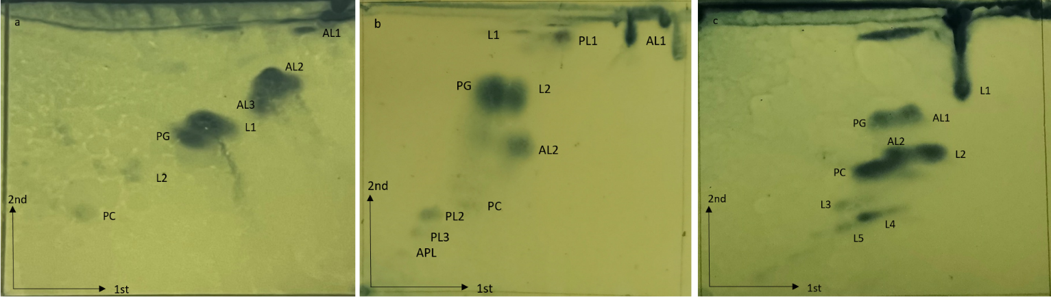

Supplementary Table S1 List of phenotypic response to API 20E, API ZYM, API 50CHB identification systems (bioMérieux) and Biolog GEN III MicroPlates. Strains: 1, SDUMZ654^{T}; 2, H. arcticus KCTC 42129^{T}; 3, H. namhaensis KCTC 32362^{T}. All data are from this study. +, Positive; –, negative.
Strain |  | 1 | 2 | 3
API ZYM
2 | alkaline phosphatase | + | - | -
3 | esterase (C4) | + | + | +
4 | esterase lipase (C8) | + | - | -
5 | lipase (C14) | + | - | -
6 | leucine arylamidase | + | + | -
7 | valine arylamidase | + | - | -
8 | cystine arylamidase | + | - | -
9 | trypsin | - | - | -
10 | a-chymotrypsin | + | - | -
11 | acid phosphatase | + | - | +
12 | naphthol-AS-BI-phosphohydrolase | + | + | +
13 | α-galactosidase | - | - | -
14 | β-galactosidase | + | - | -
15 | β-glucuronidase | - | - | -
16 | α-glucosidase | + | - | -
17 | β-glucosidase | + | - | -
18 | N-acetyl-β-glucosaminidase | + | - | -
19 | α-mannosidase | - | - | -
20 | β-fucosidase | + | - | -
API 20E
ONPG | o-nitrophenyl-β-d-galactopyranoside | + | - | -
ADH | arginine dihydrolase | - | - | -
LDC | lysine decarboxylase | - | - | -
ODC | ornithine decarboxylase | - | - | -
CIT | citrate utilization | - | - | -
H2S | H₂S production | - | - | -
URE | Urease | - | - | -
TDA | tryptophan deaminase | - | - | -
IND | indole production | - | - | -
VP | Voges–Proskauer reaction | + | - | -
GEL | gelatinase | - | - | -
GLU | glucose | - | - | -
MAN | mannitol | - | - | -
INO | nositol | - | - | -
SOR | sorbitol | - | - | -
RHA | rhamnol | - | - | -
SAC | sucrose | - | - | -
MEL | melibiose | - | - | -
AMY | amygdalin | - | - | -
ARA | arabinose | - | - | -
API 50CHB
1 | glycerol | - | - | -
2 | erythritol | - | - | -
3 | d-arabinose | + | - | -
4 | l-arabinose | + | - | -
5 | d-ribose | - | + | +
6 | d-xylose | + | - | -
7 | l-xylose | - | - | -
8 | d-αDonitol | - | - | -
9 | methyl-β-d-xylopyranosiDe | - | - | -
10 | d-galactose | - | - | -
11 | D-glucose | - | - | -
12 | d-fructose | - | - | -
13 | d-mannose | - | - | -
14 | l-sorbose | - | - | -
15 | l-rhamnose | - | - | -
16 | dulcitol | - | - | -
17 | inositol | - | - | -
18 | d-mannitol | - | - | -
19 | d-sorbitol | - | - | -
20 | methyl-α-d-mannopyranoside | - | - | -
21 | methyl-α-D-glucopyranoside | - | - | -
22 | N-acetylglucosamine | - | - | -
23 | amygdaline | - | - | +
24 | arbulin | - | - | -
25 | aesculin ferric citrate | - | + | +
26 | salicin | - | - | -
27 | d-cellobiose | - | - | -
28 | d-maltose | - | - | -
29 | d-lactose | - | - | -
30 | d-melibiose | - | - | -
31 | d-saccharose | - | - | -
32 | d-trehalose | - | - | -
33 | inulin | - | - | -
34 | d-melezitose | - | - | -
35 | d-raffinose | - | - | -
36 | starch | - | - | -
37 | glycogen | - | - | -
38 | xylitol | - | - | -
39 | gentiobiose | - | - | -
40 | d-turanose | - | - | -
41 | d-lyxose | - | - | -
42 | d-tagatose | - | + | +
43 | d-fucose | - | - | -
44 | l-fucose | - | + | -
45 | d-arabitol | - | + | -
46 | l-arabitol | - | + | -
47 | potassium gluconate | - | + | -
48 | potassium 2-keto-gluconate | - | - | -
49 | potassium 5-keto-gluconate | + | + | +
Biolog GEN III MicroPlate
1A | negative-control | - | - | -
2A | dextrin | + | - | -
3A | d-maltose | + | - | -
4A | d-trehalose | + | - | -
5A | d-cellobiose | + | - | -
6A | gentiobiose | + | - | -
7A | sucrose | + | - | -
8A | d-turanose | + | - | -
9A | stachyose | - | - | -
1B | d-raffinose | - | - | -
2B | α- d-lactose | + | - | -
3B | d-melibiose | + | - | -
4B | β-methyl- d-glucoside | + | - | -
5B | d-salicin | + | - | -
6B | N-acetyl- d-glucosamine | + | - | -
7B | N-acetyl-β- d-mannosamine | - | - | -
8B | N-acetyl- d-galactosamine | - | - | -
9B | N-acetyl neuraminic acid | - | - | -
1C | α- d-glucose | + | - | -
2C | d-mannose | + | - | -
3C | d-fructose | + | - | -
4C | d-galactose | + | + | -
5C | 3-methyl glucose | + | - | -
6C | d-fucose | + | - | -
7C | l-fucose | + | - | -
8C | l-rhamnose | + | - | -
9C | inosine | - | - | -
1D | d-sorbitol | + | - | -
2D | d-mannitol | + | - | -
3D | d-arabitol | + | - | -
4D | myo-inositol | + | - | -
5D | glycerol | + | - | -
6D | d-glucose-6-PO₄ | + | - | +
7D | d-fructose-6-PO₄ | - | - | +
8D | d-aspartic acid | + | + | -
9D | d-serine | - | - | -
1E | gelatin | + | - | -
2E | glycyl-l-proline | + | - | -
3E | l-alanine | + | - | -
4E | l-arginine | + | - | -
5E | l-aspartic acid | + | - | -
6E | l-glutamic acid | + | - | -
7E | l-histidine | + | - | -
8E | l-pyroglutamic acid | + | - | -
9E | l-serine | + | - | -
1F | pectin | + | - | -
2F | d-galacturonic acid | + | + | +
3F | l-galactonic acid lactone | + | - | +
4F | d-gluconic acid | + | - | -
5F | d-glucuronic acid | + | + | +
6F | glucuronamide | + | + | +
7F | mucic acid | + | - | -
8F | quinic acid | + | - | -
9F | d-saccharic acid | + | - | -
1G | ρ-hydroxy-phenylacectic acid | - | - | -
2G | methyl pyruvate | + | - | -
3G | d-lactic acid methyl ester | + | - | -
4G | l-lactic acid | + | - | -
5G | citric acid | + | - | -
6G | α-keto-glutaric acid | + | - | -
7G | d-malic acid | + | - | -
8G | l-malic acid | + | - | -
9G | bromo-succinic acid | - | - | -
1H | Tween-40 | + | - | -
2H | γ-amino-butyric acid | + | - | -
3H | α-hydroxy-butyric acid | + | - | -
4H | β-hydroxy-d, l-butyric acid | + | - | -
5H | α-keto-butyric acid | + | - | -
6H | acetoacetic acid | + | - | -
7H | propionic acid | + | - | -
8H | acetic acid | + | - | -
9H | formic acid | - | - | -

