Supplementary Information

Out-of-plane electrokinetics via pumping potential achieved by 100 nm-thin polyethylene nanomembranes

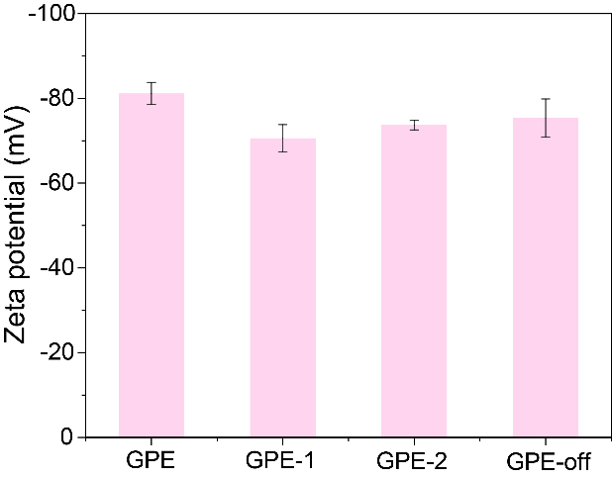
Supplementary Figure 1 | Zeta potential of the various PE nanomembrane.

The various PE nanomembrane all exhibited negative zeta potential and changed with thickness and pore structure slightly (GPE: -81.2 mV; GPE-1: -70.6 mV; GPE-2: -73.7 mV; GPE-off: -75.4 mV). This was a prerequisite for DEG based on the electrokinetic effect, which ensured the preferential adsorption and accumulation of cations. The thickness of GPE, GPE-1, GPE-2, and GPE-off were 109 nm, 504 nm, 1028 nm, and 198 nm, respectively (Supplementary Fig. 10), which was inversely proportional to the draw ratio (GPE: 604; GPE-1: 357; GPE-2: 81). By annealing the GPE-1 at 140ºC for 10 min, the GPE-off was fabricated and the pore channels were shut down.

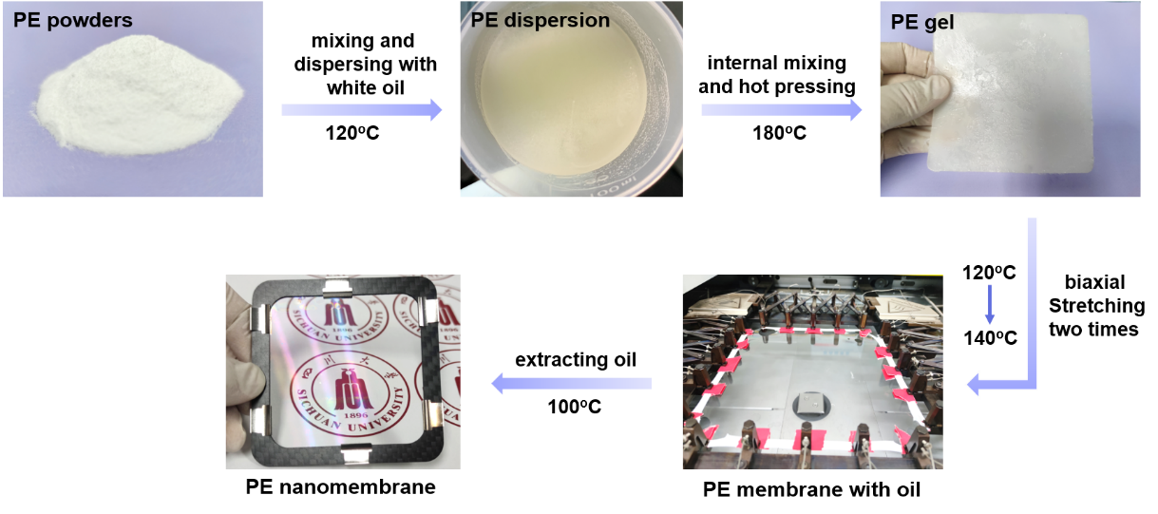
Supplementary Figure 2 | The fabrication of PE nanomembrane.

The PE powders and white oil were mixed and dispersed at 120ºC for 3 min to prepare the PE dispersions, which ensured the evenly dispersed PE resin particles without melting. The PE gel was prepared by internal mixing and hot pressing of PE dispersions at 180ºC, aiming to melt and shape and following by crystallizing at room temperature. The PE gel was anisotropic and stress concentration-free, containing randomly distributed PE molecular chains. The PE membrane was fabricated by stretching gel biaxially near the melting point by facilitating the activity of PE molecular chains. Extracting oil by n-hexane at 90ºC, the PE nanomembrane was fabricated and the nanopores formed in this process.

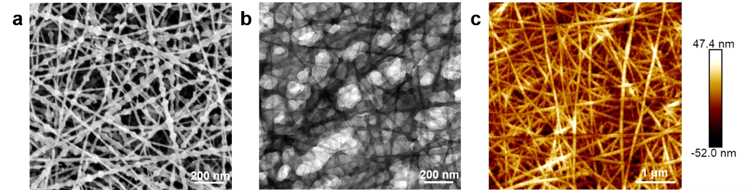
Supplementary Figure 3 | SEM (a), TEM (b), and AFM (c) micrograph of PE nanomembrane.

All three characterizations indicated that the PE nanomembrane consists of a network of isotropic fibrous bundles, which was a typical shish-kebab¹ structure of the PE membrane. The multilayer network of fiber bundles formed the polygonal porous structure of the membrane. It was directly observed by TEM due to the thickness of the PE nanomembrane approaching 100 nm. From the statistics of AFM, the roughness of the membrane was 11.1 nm.

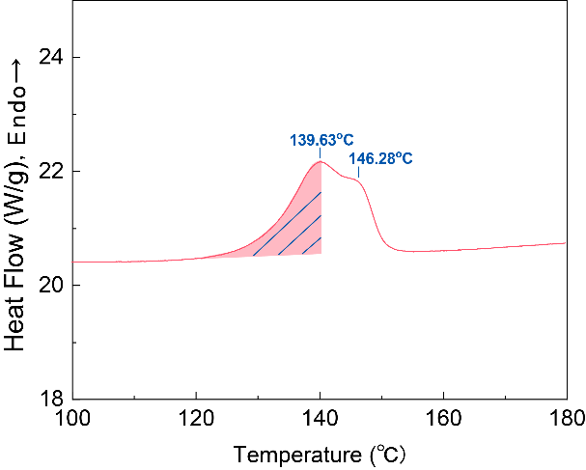
Supplementary Figure 4 | DSC 1st heating curve of PE nanomembrane.

PE nanomembrane had two melting peaks because it contained two kinds of crystals, extended chain crystal (ECC) and folded chain crystal (FCC)², and the melting point was 139.63ºC and 146.28ºC. The thermal stability of ECC was worse than that of FCC, and molecular chains were vulnerable to folding and growing further at high temperatures (such as at 140ºC, the shadow of the figure represented the melting of ECC).

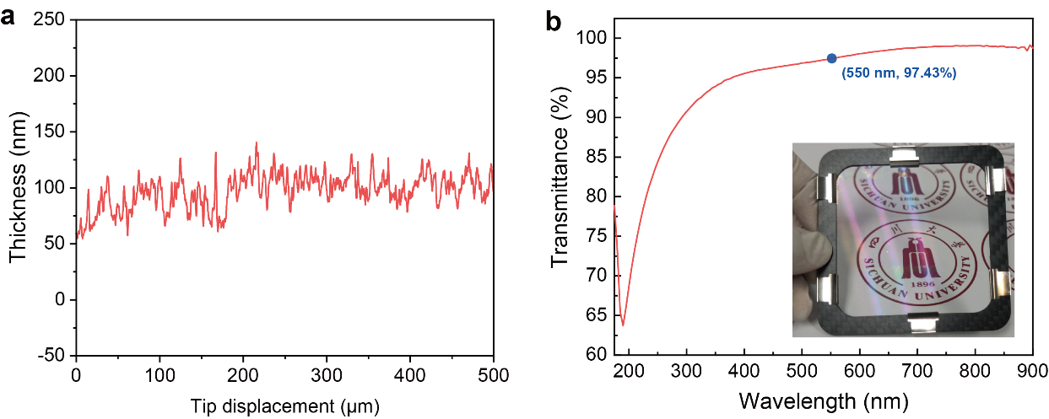
Supplementary Figure 5 | The thickness scanning (a) and transmittance (b) of PE nanomembrane. Inset: the photograph of PE nanomembrane.

Compared with the milky white and opaque traditional UHMWPE battery separator, the PE nanomembrane was transparent (inset), and most of the light passed through it due to its thickness (approximately 100 nm) of lower than the visible wavelength (390 nm - 780 nm).

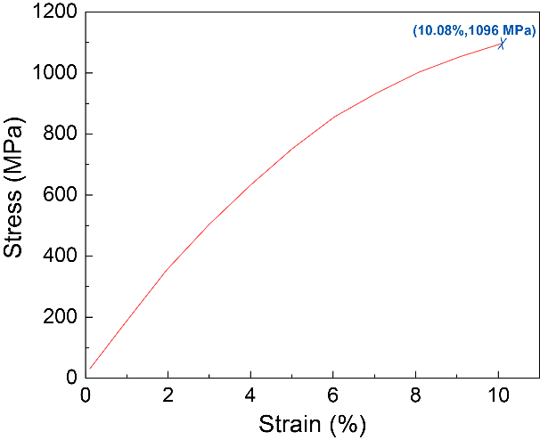
Supplementary Figure 6 | The mechanical property of PE nanomembrane.

The Young’s modulus of the PE nanomembrane was 18.8 GPa, with a breaking elongation of 10.08% and a breaking strength of 1096 MPa. The well mechanical properties of PE nanomembrane ensured a high success rate in the process of transferring graphene.

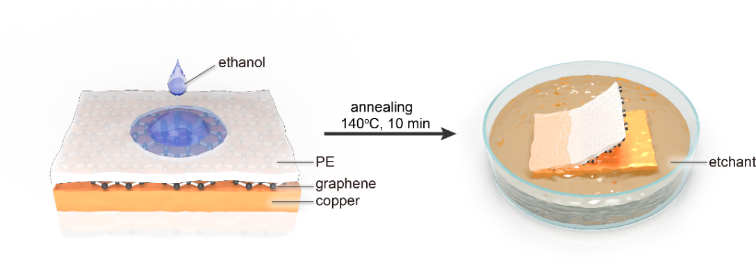
Supplementary Figure 7 | The transfer of graphene on PE nanomembrane.

The copper foil with graphene was flattened by two glass sheets and attached to the PE nanomembrane. A certain amount of ethanol was dripped on the backside of the membrane, which was fully covered. After the ethanol evaporated, the PE/graphene/copper membrane was annealed at 140ºC for 10 min. In this process, a strong bonding appeared between the PE nanomembrane and graphene as a result of the partial melting of the PE membrane and recrystallization³. The PE/graphene/copper membrane was floating on the etchant for 3 h to etch away the copper foil. After several washes with deionized water, the PE/graphene composite nanomembrane was fabricated.

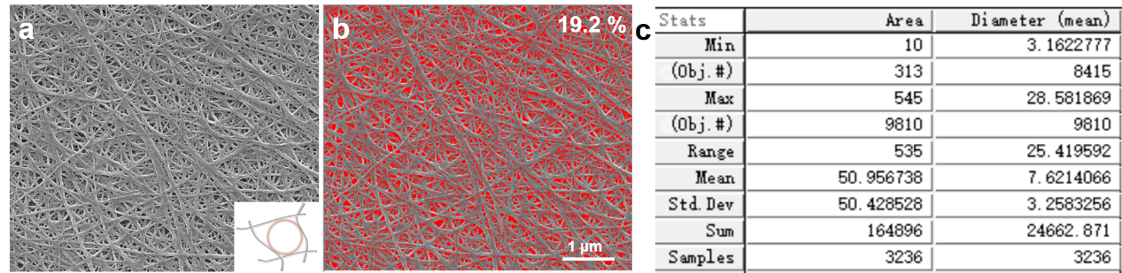
Supplementary Figure 8 | Surface porosity and pore diameter of the PE side of GPE nanomembrane. The SEM image (a) and software processing SEM image with the pores filled with the red area (b). c, The statistics of pore diameter. Inset: the schematic of a circular equivalent to the polygonal pore. c, the statistics of pore diameter.

Through the software of Image Pro Plus 6.0, we calculated that the surface porosity of the PE nanomembrane was 19.2 % (Supplementary Figure 8b) and the maximum pore diameter was 28.6 nm (Supplementary Figure 8c). This porous structure provided a semi-freestanding state of graphene. The spanning cover length of graphene was illustrated in the inset, which was the diameter of a circular pore equivalent to the polygonal pore lapped between fiber bundles.

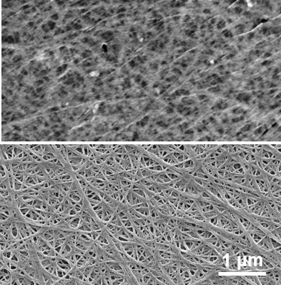
Supplementary Figure 9 | Surface morphology of graphene side (upper) and PE side (bottom) of GPE nanomembrane.

GPE nanomembrane had two sides: one was graphene, which was intact with some wrinkles on a micron scale, and the other was a porous PE nanomembrane with a fibrous network. From the upper figure, the fiber network structure of the PE nanomembrane under the graphene can be seen. This was because the graphene itself acted as a conductive material, which allowed electrons to pass through the graphene to the PE membrane. Using the GB (gental beam) mode in the SEM, the wrinkles on the graphene surface and the state of graphene on the porous substrate were more clearly observed.

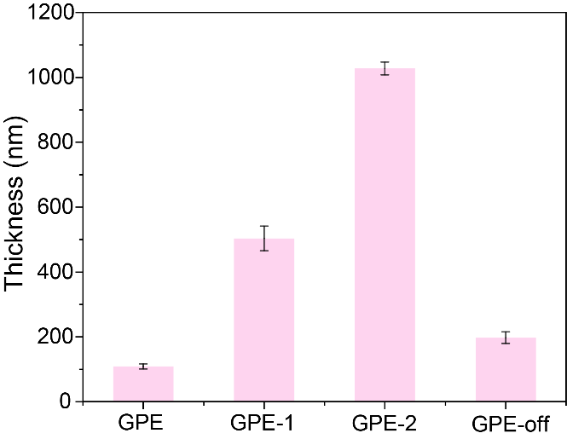
Supplementary Figure 10 | Thickness of the various GPE nanomembrane.

The thickness of various membranes was 109 nm, 504 nm, 1028 nm, and 198 nm, respectively. We prepared PE membranes of different thicknesses by regulating the draw ratio during biaxial stretching. The draw ratio of GPE, GPE-1 and GPE-2 was 604, 357, and 81, respectively, which was inversely proportional to thickness. The GPE-off was prepared by annealing the GPE-1 at 140ºC for 10 min.

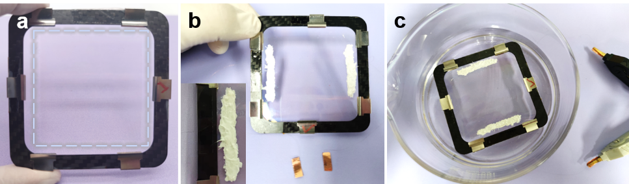
Supplementary Figure 11 | The photograph of GPE nanomembrane (a), GPE device (b), and experimental device (c). Inset: Close-up of the protected electrode.

In Supplementary Fig. 11a, the square inside the dotted line was graphene of size 5×5 cm²; Supplementary Fig. 11b illustrated a GPE device with silver electrodes fabricated at both ends, and before being embedded in a silicone elastomer (inset), copper wires were connected with the silver electrodes for testing; The GPE device floated on the NaCl solution and the electrodes were clamped by the tester for signal measuring (Supplementary Fig. 11c).

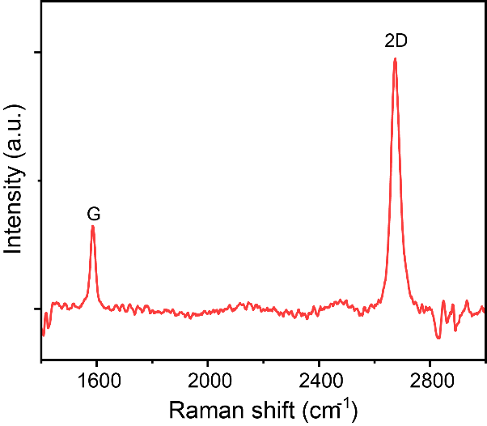
Supplementary Figure 12 | Raman spectra of GPE nanomembrane.

The position of the G peak and 2D peak were 1586 cm⁻¹ and 2675 cm⁻¹ and the D peak (1350 cm⁻¹) and D' peak (1620 cm⁻¹) were absent, which suggested the direct transfer of graphene by annealing could guarantee the high quality of graphene⁴. The intensity ratio of the 2D to G peak was 2.84, indicating that the monolayer graphene⁵ was transferred to the PE nanomembrane.

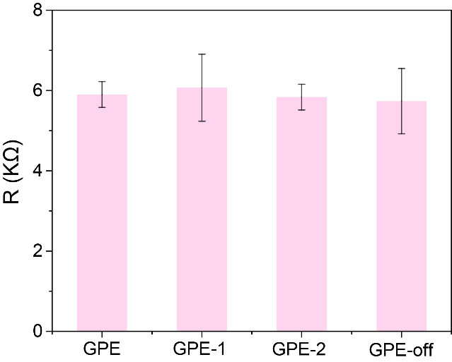
Supplementary Figure 13 | Resistance of the various GPE nanomembrane.

The resistance of various membranes was about 6 kΩ, which indicated the successful transfer of graphene and the stability of the transfer method.

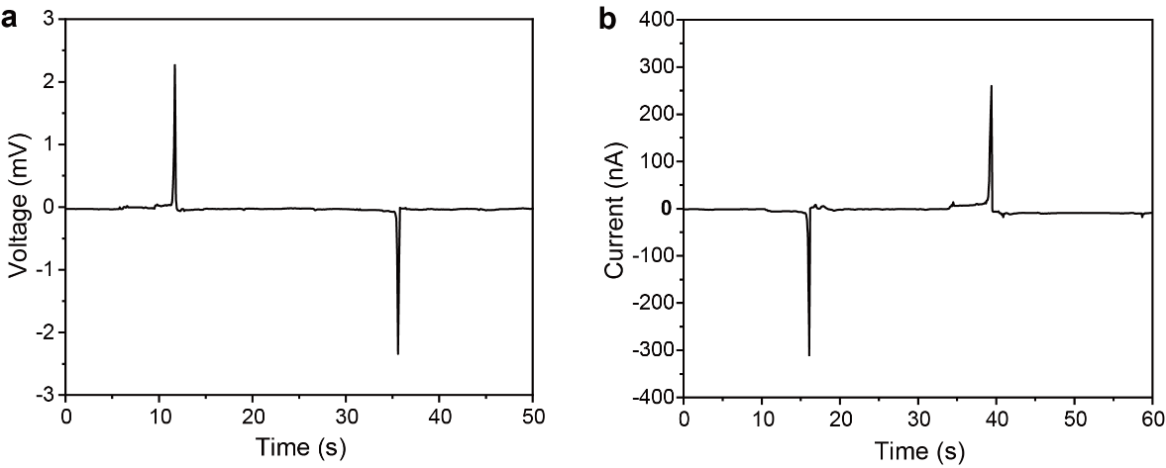
Supplementary Figure 14 | The in-plane electricity generation.The voltage (a) and current (b) induced by a NaCl droplet (with a volume of 150 μL) flowing forward and backward on the GPE nanomembrane.

The peak voltage (2.31mV) and current (285 nA) were generated by flowing a NaCl droplet on the GPE surface. As the droplet moved in the opposite direction, the voltage and current were in opposite signs and the magnitude was almost unchanged. It illustrated that the GPE nanomembrane could generate droplet-induced electricity like other graphene/negatively charged membranes⁶. However, the electricity was relatively weak due to the low surface charge density of the PE nanomembrane caused by the porous structure (the surface porosity can be seen in Supplementary Figure 8).

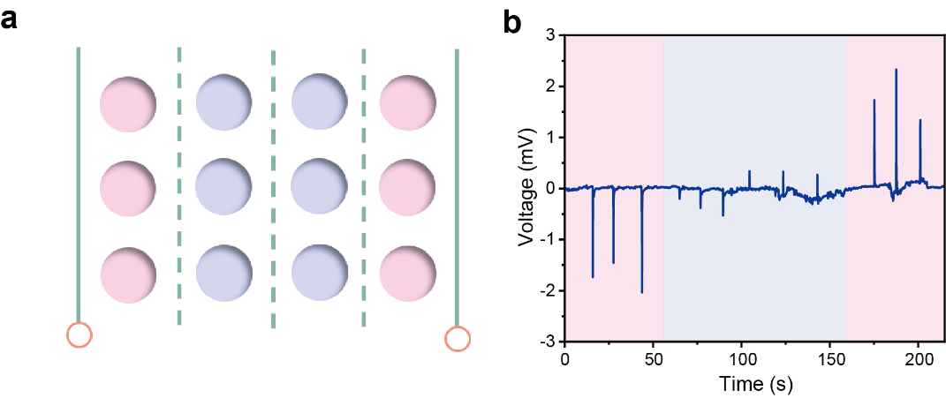
Supplementary Figure 15 | a, The GPE nanomembrane divided into four areas. b, The intensified pumping potential via dripping three droplets of 15 μL primer to each area from left to right end sequentially.

Taking the middle of the GPE nanomembrane as the dividing line, the voltage first decreased, then the sign reversed, and the magnitude increased. The voltage with the same magnitude was induced by the primer dripping at the same distance from the electrode. When the primer dripped on the middle of the membrane, the electrons of the left and right parts of graphene migrated to this site, and the voltage decreased due to the counteracting effect.

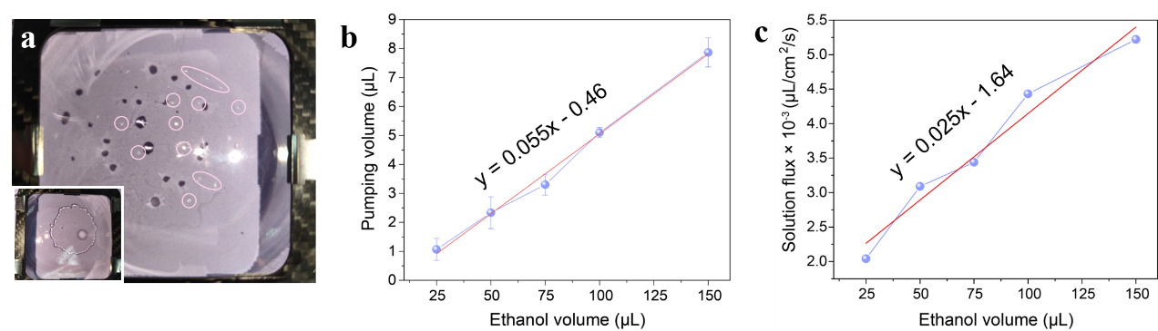
Supplementary Figure 16 | Determination of pumping volume and flux. a, The photograph of the pumping NaCl solution (inside the circle) by dripping a primer (Inset). The volume (b) and flux (c) of solution pumped by primers with various volumes.

The primer with various volumes was dripped on the middle of the PE nanomembrane floating on the NaCl solution (Supplementary Figure 16a). After 2 min, the primer was volatilized, and the pumping solution was adsorbed by tissue to measure the weight. As a result, the volume of the pumping solution elevated from 1.1 μL to 7.9 μL when the volume of the primer increased from 25 μL to 150 μL (Supplementary Fig. 16b). The solution flux was proportional to the primer volume, and the linear equation was shown in the Supplementary Figure 16c. This was consistent with the pumping potential proportional to the primer volume.

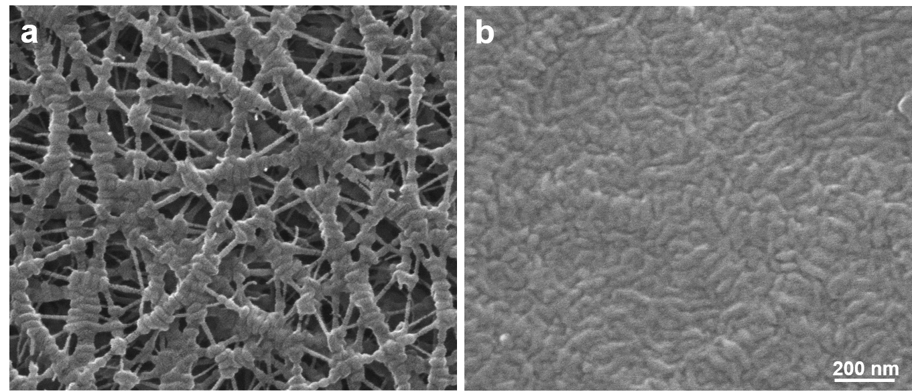
Supplementary Figure 17 | Surface morphology of PE side of GPE-1 (on) (a) and GPE-off (b) membrane.

The Crystalline of the PE nanomembrane was composed of ECC and FCC, wherein the melting point of the FCC was generally lower than 140 ºC. Thus, by annealing at 140 ºC for 10 min, we can partially melt the PE nanomembrane and the pore channels of the membrane were shut down by recrystallization mesoscopically. The PE nanomembrane transformed from a porous shish-kebab structure (Supplementary Figure 17a) to a closely packed lamellar structure (Supplementary Figure 17b) after annealing.

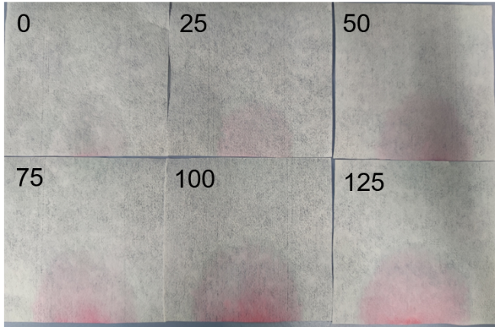
Supplementary Figure 18 | Verify the primer-induced intensified micro-pumping of ionic solution of PE nanomembrane. The photograph of tissue paper absorbing the mixture of primer (with different volumes as marked in the upper left of the picture) and water (50 μL).

The red color on the tissue became more and more apparent as the volume of primer increased (the tissue absorbed the red ink pumped by primer). It illustrated the intensified micro-pumping of NaCl solution of PE nanomembrane was induced by primer and the pumping volume was proportional to the amount of primer.

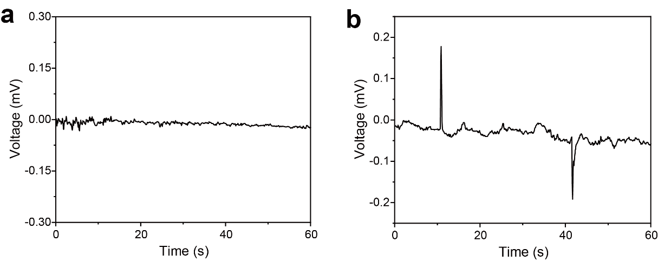
Supplementary Figure 19 | The intensified pumping potential by replacing the NaCl solution with air (a) and DI water (b).

It can not generate voltage by dripping a droplet of 50 μL primer on the membrane when not floating on the NaCl solution. The voltage of 0.19 mV was induced by pumping the DI water due to the existence of H₃O⁺. Therefore, as long as the solution contains cations, they will preferentially accumulate during the pumping of the solution, causing electron migration in the graphene.

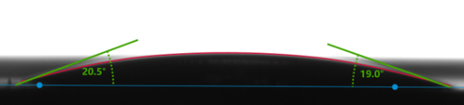
Supplementary Figure 20 | Ethanol Contact Angle of GPE nanomembrane.

It can be seen that the ethanol droplet diffused on the surface of the GPE nanomembrane with the Ethanol Contact Angle of about 20º.

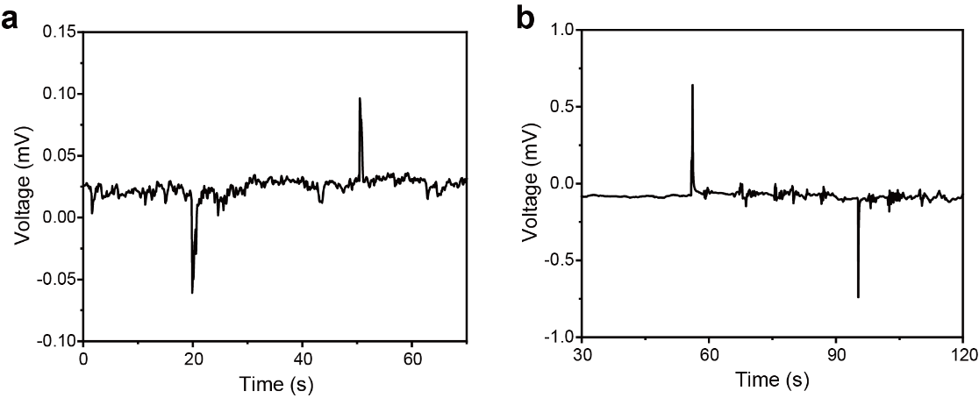
Supplementary Figure 21 | The intensified pumping potential generated as droplets of 50 μL deionized (DI) water (a) and acetone (b) dripping on the far left and right of the GPE nanomembrane.

For DI water, a voltage close to 0.1 mV was induced by pumping the NaCl solution as the result of the gravity of the droplet. Other polar solutions, such as acetone, can also generate pumping potentials. However, the voltage induced by acetone (0.69 mV) was less than ethanol due to the weaker interaction with water compared to ethanol. It suggested that any droplet may generate an intensified pumping potential on the graphene surface, but the magnitude depended on the mutual solubility of the droplet and solution.

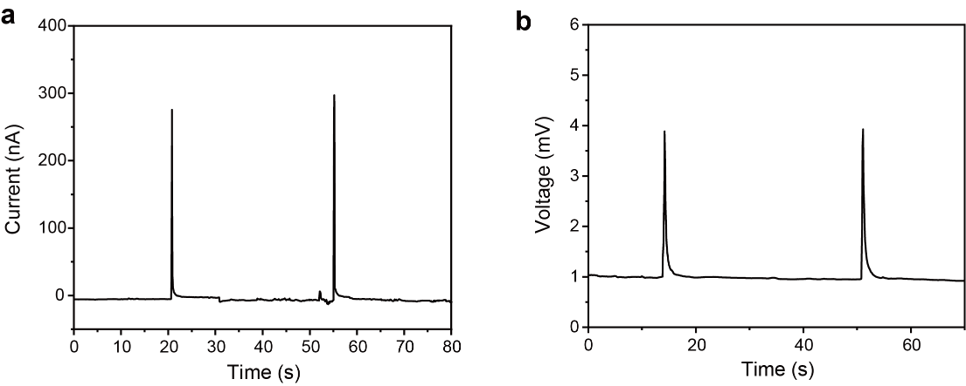
Supplementary Figure 22 | The intensified pumping current and potential induced by two drops of primer dripping parallel (a) and perpendicular (b) to electron movements.

The series-parallel model showed that each droplet acted as an independent power generation unit, which could be scaled up easily.

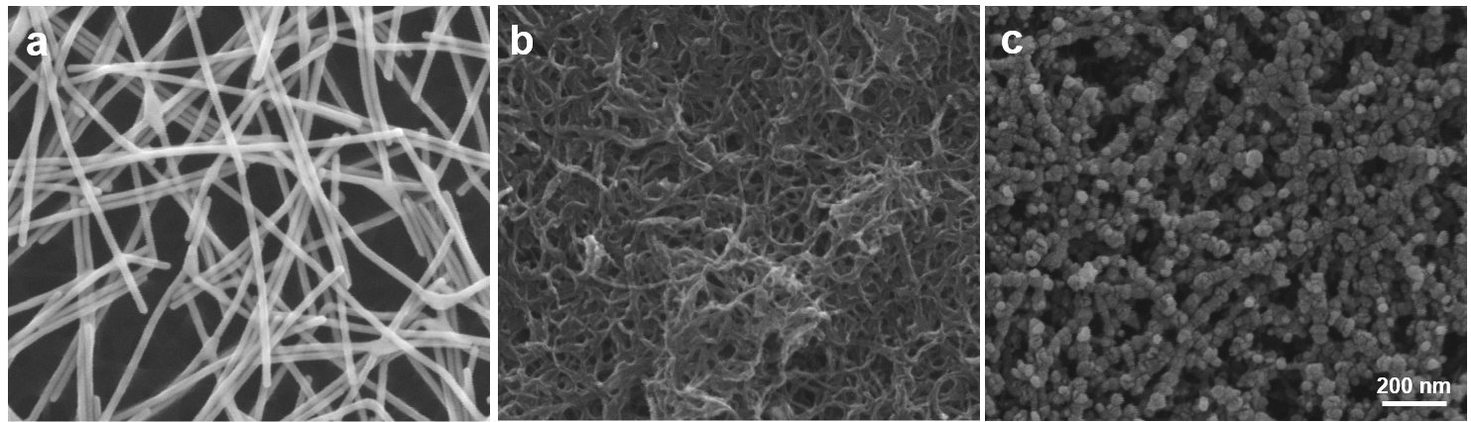Supplementary Figure 23 | The morphology of Ag nanowires (a), carbon nanotubes (b), and platinum (c) on PE nanomembrane.

Three coating materials were isotropically and uniformly distributed on the PE nanomembrane. The loose structure ensured the rapid pumping of the solution and the rapid movement of the liquid-solid-gas three-phase line.

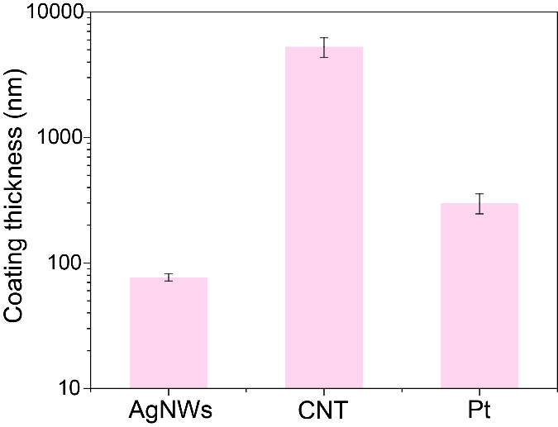
Supplementary Figure 24 | The thickness of three coating materials on PE nanomembrane.

The thickness of various coating materials was 77 nm, 5286 nm, and 301 nm, respectively. The coating thickness was obtained by subtracting the thickness of the PE nanomembrane from the overall thickness of the composite membrane.

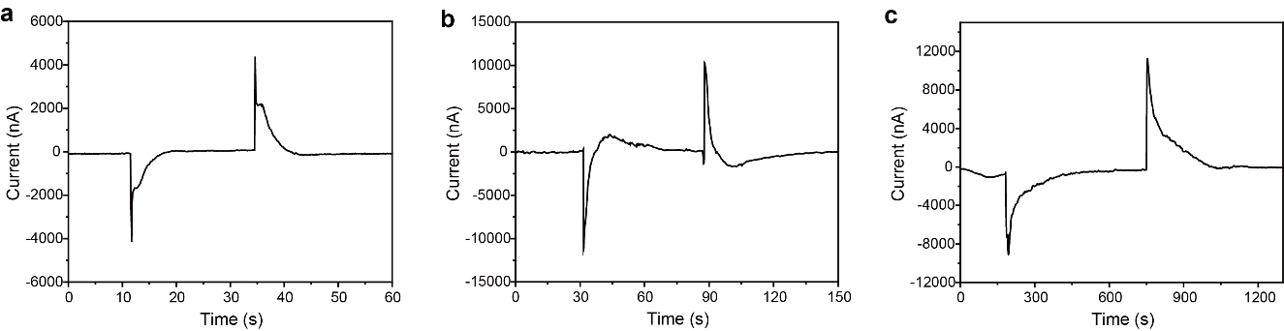
Supplementary Figure 25 | The pumping current generated by Ag nanowires (a), carbon nanotubes (b), and platinum (c) on the PE nanomembrane.

The Pt nanomembrane device possessed the highest current and excellent persistence among the three types of conductive materials (the pumping current: Ag: 4262 nA, CNTs: 10738 nA, Pt: 10142 nA).

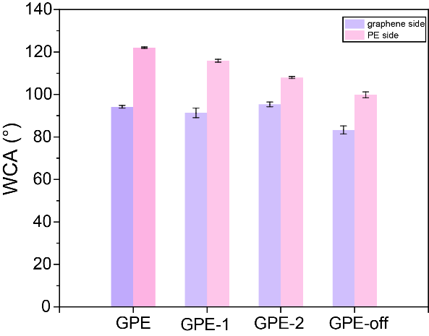
Supplementary Figure 26 | Water Contact Angle (WCA) of the various GPE nanomembrane.

GPE nanomembranes exhibited asymmetric wettability, in which one side was hydrophilic and the other was hydrophobic.

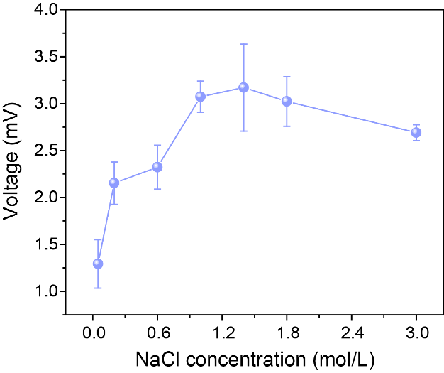
Supplementary Figure 27 | The influence of NaCl concentration on the intensified pumping potential.

The NaCl concentration corresponding to the maximum voltage was 1.4 mol/L. The adsorbed Na⁺ increased with the NaCl concentration, which would draw electrons in graphene more. When the concentration of NaCl reached a certain extent, the net adsorbed Na⁺ decreased due to the increasing adsorption of Cl⁻ and the voltage reduced correspondingly. A high saturation concentration indicated that the PE nanomembrane had a strong ability to resist the shielding effect of Cl⁻.

References
1. Kimata, S. et al. Molecular basis of the shish-kebab morphology in polymer crystallization. Science 316, 1014–1017 (2007).
2. Hikosaka, M. Unified theory of nucleation of folded-chain crystals and extended-chain crystals of linear-chain polymers. Polymer 28, 1257–1264 (1987).
3. Li, R. et al. Etching- and intermediate-free graphene dry transfer onto polymeric thin films with high piezoresistive gauge factors. J. Mater. Chem. C 7, 13032–13039 (2019).
4. Ferrari, A. C. & Basko, D. M. Raman spectroscopy as a versatile tool for studying the properties of graphene. Nat. Nanotechnol 8, 235–246 (2013).
5. Ferrari, A. C. et al. Raman spectrum of graphene and graphene layers. Phys. Rev. Lett 97, 187401 (2006).
6. Yin, J. et al. Generating electricity by moving a droplet of ionic liquid along graphene. Nat. Nanotechnol 9, 378–383 (2014).

