SUPPLEMENENTARY INFORMATION

Supplementary Fig. 1. Study flowchart and data sources.

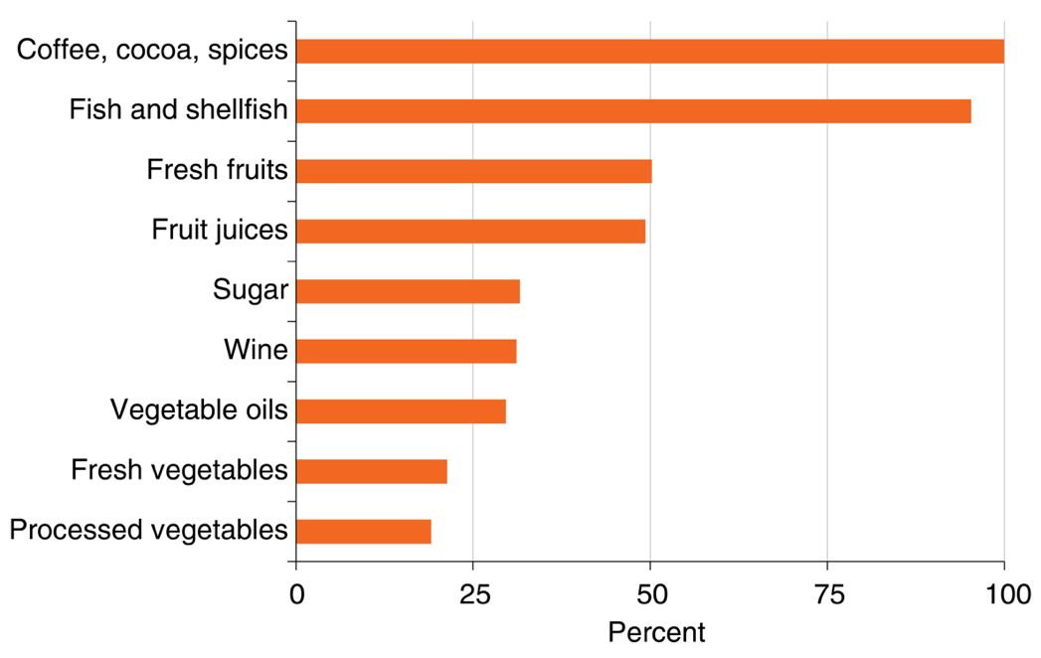

Supplementary Fig. 2 Import share of U.S. food consumption, 2011-2013. Source: (USDA n.d.)

Biomass loss in aquaculture

Growth rate and biomass loss for salmon, catfish, pangasius, and tilapia
Fish weight at a given time t is estimated using a von Bertalanffy growth function. In its general form this is given as:
$$W_{t}=W_{asa}{\left(1-e^{\left(-k\left(t-t_{0}\right)\right)}\right)}^{}$$
where $W_{t}$ is the expected weight at a given time t, $W_{asa}$ is the asymptotic average weight, t₀ is the starting point of the production process, k is the growth coefficient of the curve, is the slope of the weight/length relationship. To represent different species, species specific parameters have been set. These are given in Supplementary Table 1.
Following previous methods (Thyholdt 2014; Hernández-Llamas, Ruiz-Velazco, and Gomez-Muñoz 2013; Hernandez-Llamas and Ratkowsky 2004; Yu and Leung 2006; Bjørndal 1988), the impact of mortality can be found by determining the number of survivors as:
$$n_{t}=n_{0}{.(1-M}_{t}(X_{t}))$$
where $n_{t}$ is the number of survivors at time t, $n_{0}$ is the juveniles stocked at time t₀, (initial population) and Mt(Xt) is the mortality rate of species X at time t. This equation is presented in exponential form:
$$n_{t}≅n_{0}.e^{-M_{t}\left(X_{t}\right).t}$$
Specific mortality occurrences can be added with additional terms in the general function. For instance, release mortality of 5% can be added as
$n_{t}≅n_{0}.e^{-M_{t}\left(X_{t}\right).t}-0.05n_{0}$
The total biomass stock of fish in a pen/pond at time t is then given as
B_{t}=n_{t}W_{t}
The biomass loss in each period is estimated by the following equation:
Loss_{t}=n_{t1}W_{t}-n_{t}W_{t}
Mortality rate, stocking density, average cycle length, and harvested weight of salmon, catfish, pangasius, and shrimp are presented in Table 1.

Growth rate and biomass loss for shrimp
For shrimp we used the growth function of (Hernández-Llamas, Ruiz-Velazco, and Gomez-Muñoz 2013). This is given as:
$$w_{t}=w_{i}+(w_{f}{-w_{i})[(1-k^{n})/(1-k^{h})]}^{3}$$
Where $w_{t}$ is the shrimp weight after t time periods, $w_{i}$is the initial weight, $w_{f}$ is the final weight, and k is the growth coefficient equal to 0.8 in this model, h is the time periods that have passed until harvesting time.
The number of survivors, total biomass, and biomass loss for shrimp are estimated using the same equations as for the other species.

Supplementary Table 1. Parameters used to estimate growth and biomass loss at the grow-out stage.
Indicators ª | Salmon | Catfish | Pangasius | Shrimp | Tilapia
Average mortality rate/cycle (%) | 14 | 22 | 35 | 31 | 10
Stocking density (PLs) | 100,000/pen | 8,000/acre | 200,000/acre | 200/m² | 16,500/ha
Average cycle length (week) | 66 | 30 | 32 | 21 | 22
Harvested weight (g/count) | 4,938 | 663 | 857 | 30 | 625
ª Parameters for species were obtained from study participants.

Supplementary Table 2. Biomass loss ratios for five species under three scenarios.

Species, Country | Time to minimum harvestable size (weeks) | Time at harvest (weeks) | Biomass loss ratio ª
Species, Country | Time to minimum harvestable size (weeks) | Time at harvest (weeks) | scenario 1 | scenario 2 | scenario 3
Catfish, United States | 10 | 30 | 0.12 | 0.16 | 0.21
Pangasius, Vietnam | 9 | 33 | 0.22 | 0.24 | 0.26
Atlantic salmon, Norway | 16 | 81 | 0.06 | 0.08 | 0.11
Shrimp, Vietnam | 6 | 21 | 0.12 | 0.17 | 0.22
Tilapia, China | 7 | 22 | 0.06 | 0.09 | 0.14
ª The biomass loss ratio was calculated as the total biomass at harvest divided by the sum of biomass lost weekly from the time that animals were of minimal harvestable size until the final harvest date.
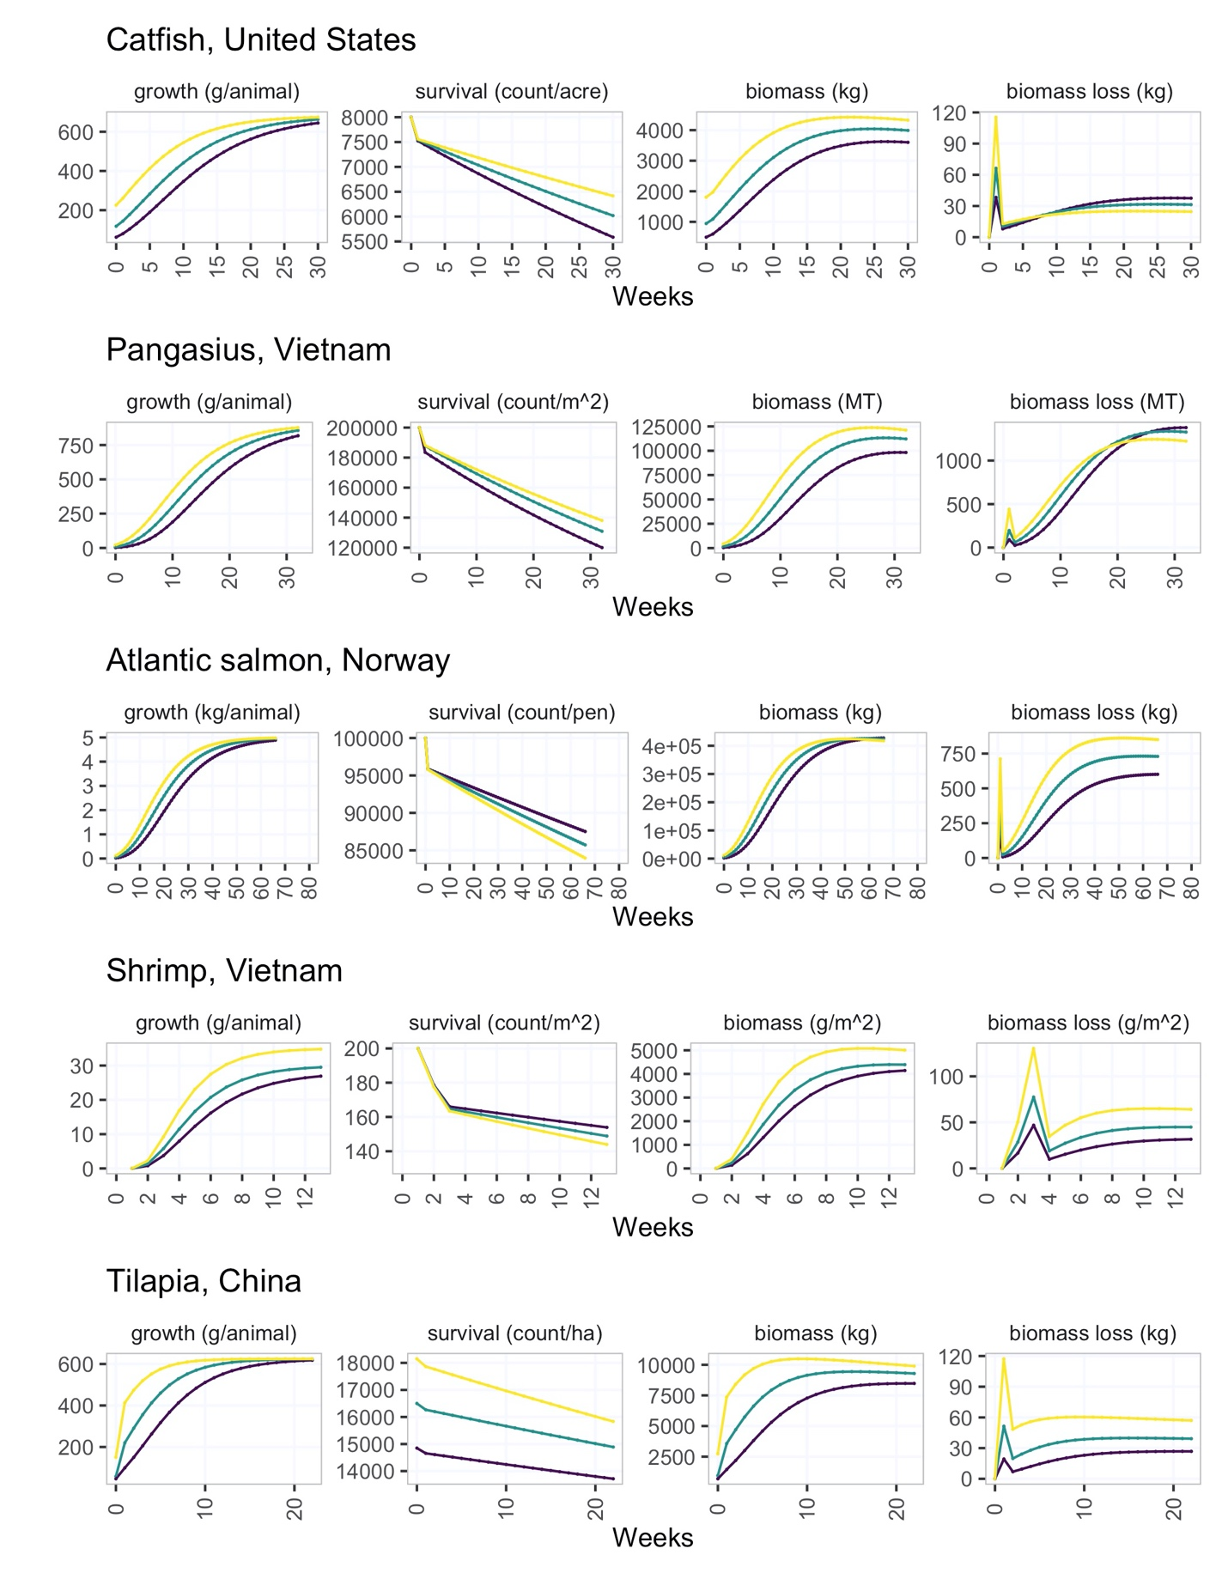

Supplementary Fig. 3 Growth, survival, biomass, and biomass loss modeled for five aquaculture species under three scenarios.

Supplementary Table 3. Production loss in the United States aquatic food supply.

Stage | Description | Physical loss |  |  |  | Quality loss |  |  | Data source
Stage | Description | rate | weighted avg | % of total | rate |  | weighted avg | % of total
Production
 | US supply |  | 7.3% |  |  |  | 3.4%
Fisheries
Canned tuna | Pacific fisheries | 2.7% | 0.4% | 5.2% | 2.6% |  | 0.4% | 10.6% | (Gilman et al. 2020)
Sockeye salmon | Alaska, US | 0.0% | 0.0% | 0.0% | 0.0% |  | 0.0% | 0.0% | Industry representatives Alaska US;
Alaska pollock | Alaska, US | 0.3% | 0.0% | 0.2% | 0.0% |  | 0.0% | 0.0% | (NOAA 2022; Fissel et al. 2019) Industry and government representatives, Alaska, US
Shrimp | global avg | 15.5% | 0.6% | 8.4% | 8.6% |  | 0.3% | 10.1% | (Gilman et al. 2020; Rashid and Sarkar 2020)
Tilapia | global avg | 5.4% | 0.0% | 0.4% | 2.6% |  | 0.0% | 0.4% | Gilman 2020; Yared 2007; Yared 2014; (Teklu 2015; Akande and Diei-Ouadi 2010)
Catfish | global avg | 7.8% | 0.0% | 0.1% | 4.0% |  | 0.0% | 0.1% | (Adelaja, Kamaruddin, and Chiat 2018; Nowsad et al. 2015)
Pangasius | global avg | 7.8% | 0.0% | 0.0% | 4.0% |  | 0.0% | 0.0% | (Adelaja, Kamaruddin, and Chiat 2018; Nowsad et al. 2015)
Crab | global avg | 15.5% | 0.5% | 6.4% | 2.5% |  | 0.1% | 2.2% | (Lahiri et al. 2021)
Cod | global avg | 6.6% | 0.3% | 3.7% | 2.6% |  | 0.1% | 3.2% | (Gilman et al. 2020)
Clams | global avg | 4.0% | 0.1% | 0.9% | 0.0% |  | 0.0% | 0.0% | Industry representative, US clams
Other wild seafood | global avg | 5.4% | 0.4% | 5.3% | 2.6% |  | 0.2% | 5.4% | (Gilman et al. 2020)
Aquaculture
Shrimp (Penaeus monodon, Litopenaeus vannamei) | Vietnam | 9.7% | 2.3% | 30.8% | 8.3% |  | 1.9% | 57.5% | producer survey, n=5, Vietnam
Atlantic salmon | Norway | 7.0% | 1.1% | 14.3% | 0.0% |  | 0.0% | 0.0% | producer survey, n=3, Norway; (“Atlantic Salmon and Rainbow Trout” n.d.)
Channel and hybrid catfish | Southern US | 8.3% | 0.3% | 3.7% | 0.0% |  | 0.0% | 0.0% | producer survey, n=9, US
Pangasius | Vietnam | 18.5% | 0.9% | 12.0% | 1.0% |  | 0.0% | 1.4% | producer survey, n=7, Vietnam
Tilapia | China | 3.9% | 0.3% | 4.0% | 2.6% |  | 0.2% | 5.7% | (Teklu 2015; Yared Tigabu 2012), China tilapia expert
Crab | global avg | 6.7% | 0.0% | 0.4% | 2.5% |  | 0.0% | 0.3% | (Lahiri et al. 2021)
Clams | global avg | 5.8% | 0.0% | 0.4% | 0.0% |  | 0.0% | 0.0% | Industry representative, US clams
Other farmed seafood | global avg | 7.5% | 0.3% | 3.9% | 2.6% |  | 0.1% | 2.9%

Supplementary Table 4. Processing loss in the United States aquatic food supply.

Stage | Description | Physical loss |  |  | Quality loss |  |  | Data source
Stage | Description | rate | weighted avg | % of total | rate | weighted avg | % of total
Processing
 | US supply |  | 1.8% |  |  | 3.2%
Fisheries
Canned tuna | Pacific fisheries | 0.1% | 0.0% | 0.5% | 4.0% | 0.6% | 17.9% | processor survey, n=1, Pacific region
Sockeye salmon | Alaska, US | 0.3% | 0.0% | 0.2% | 10.1% | 0.1% | 3.4% | processor survey, n=5, Alaska, US; BBRSDA 2019
Alaska pollock | Alaska, US | 0.1% | 0.0% | 0.2% | 1.8% | 0.1% | 3.2% | NOAA SAFE report 2019; this study (industry and government representatives, US, personal communication)
Shrimp | global avg | 3.8% | 0.2% | 8.4% | 8.6% | 0.3% | 10.9% | (Adelaja, Kamaruddin, and Chiat 2018; Rashid and Sarkar 2020)
Tilapia | global avg | 4.6% | 0.0% | 1.4% | 2.6% | 0.0% | 0.4% | (Yared Tigabu 2012; Y. Tigabu, Degebase, and Mohammed 2007; Teklu 2015; Akande and Diei-Ouadi 2010)
Catfish | global avg | 2.9% | 0.0% | 0.2% | 4.0% | 0.0% | 0.2% | (Adelaja, Kamaruddin, and Chiat 2018; Nowsad et al. 2015)
Pangasius | global avg | 2.9% | 0.0% | 0.0% | 4.0% | 0.0% | 0.0% | (Adelaja, Kamaruddin, and Chiat 2018; Nowsad et al. 2015)
Crab | global avg | 2.9% | 0.1% | 5.0% | 2.5% | 0.1% | 2.4% | (Lahiri et al. 2021)
Cod | global avg | 2.9% | 0.1% | 6.8% | 4.0% | 0.2% | 5.3% | na
Clams | global avg | 4.0% | 0.1% | 3.5% | 0.0% | 0.0% | 0.0% | Industry representative, US clams
Other wild seafood | global avg | 2.9% | 0.2% | 11.7% | 4.0% | 0.3% | 9.1%
Aquaculture
Shrimp (Penaeus monodon, Litopenaeus vannamei) | Vietnam | 2.1% | 0.5% | 27.0% | 0.4% | 0.1% | 3.1% | processor survey, n=5, Vietnam; industry trade group; (FDA 2022; Nirmal et al. 2020; Ngoan et al. 2000; Trung and Phuong 2020)
Atlantic salmon | Norway | 0.7% | 0.1% | 5.5% | 0.0% | 0.0% | 0.1% | processor survey, n=3, Norway; (FDA 2022)
Channel and hybrid catfish | Southern US | 0.1% | 0.0% | 0.1% | 2.0% | 0.1% | 2.1% | processor survey, n=3, US; (USDA 2022)
Pangasius | Vietnam | 0.0% | 0.0% | 0.0% | 7.1% | 0.3% | 10.7% | processor survey, n=3, Vietnam; (USDA 2022)
Tilapia | China | 4.5% | 0.3% | 18.7% | 11.0% | 0.8% | 26.1% | (Teklu 2015; Nowsad et al. 2015; Y. Tigabu, Degebase, and Mohammed 2007)
Crab | global avg | 10.0% | 0.0% | 2.2% | 2.5% | 0.0% | 0.3% | (Lahiri et al. 2021)
Clams | global avg | 8.0% | 0.0% | 2.5% | 0.0% | 0.0% | 0.0% | Industry representative, US clams
Other farmed seafood | global avg | 2.9% | 0.1% | 6.2% | 4.0% | 0.2% | 4.9% | global average

Supplementary Table 5. Weighting factors for production and processing loss.

Species | % of supply ª | % fisheries ^{b} | % aquaculture ^{b} | % imported, fisheries ^{b} | % imported, aquaculture ^{b}
Shrimp | 27% | 15% | 85% | 28% | 100%
Canned tuna | 14% | 100% | 0% | 56% | 0%
Salmon | 16% | 7% | 93% | 9% | 99%
Alaska pollock | 6% | 100% | 0% | 0% | 0%
Tilapia | 8% | 7% | 93% | 100% | 93%
Catfish | 3% | 4% | 96% | 0% | 0%
Pangasius | 5% | 0% | 100% | 100% | 100%
Crab | 3% | 89% | 11% | 67% | 100%
Cod | 4% | 100% | 0% | 25% | 100%
Clams | 2% | 74% | 26% | 24% | 48%
Other | 11% | 65% | 35% | 66% | 84%
ª NFI/NOAA average, 2014-2018
^{b} based on US production, imports and exports for 2018. Methods described in the supplement.

Supplementary Table 6. Distribution loss in the United States aquatic food supply.

Stage | Description | Physical loss (%) | Quality loss (%) | Data source
Distribution
 | unweighted avg | 1.2% | 2.0% | wholesale survey, n=5 selling a total of 33M kg/yr); FDA food recalls (1.4 million kg/yr) (FDA 2016)

Supplementary Table 7. Retail loss and waste in the United States aquatic food supply.

Stage | Description | Physical loss (%) | Quality loss (%) | Data source
Retail
 | weighted avg | 2.9% | na | Survey, n=90 retail businesses (FMI 2015, 2017, 2019)
 | fresh aquatic food | 6.7% | na | “
 | all frozen food (not aquatic food specific) | 0.7% | na | “
 | shelf-stable food (not aquatic food specific) | 1.0% | na | “

Supplementary Table 8. Weighting factors for retail loss.

Stage | Value | Data source
Retail | (share of US retail aquatic food sales)
fresh seafood | 35.4% | (Love et al. 2022)
frozen seafood | 42.0% | (Love et al. 2022)
shelf-stable seafood | 22.6% | (Love et al. 2022)
total | 100%

Supplementary Table 9. Food service loss and waste in the United States aquatic food supply.
Stage | Description | Physical loss (%) | Quality loss (%) | Data source
Food service
 | all kitchen waste (not aquatic food specific) | 9.9% | na | (Betz et al. 2015; Papargyropoulou et al. 2019; Collison and Colwill 1986; Engström and Carlsson-Kanyama 2004; Silvennoinen et al. 2015; Eriksson et al. 2017)

Supplementary Table 10. Consumer loss and waste in the United States aquatic food supply.

Stage | Description | Physical loss (%) | Quality loss (%) | Data source
Consumer
 | at home (aquatic food specific) | 8.5% | na | food diary survey, n=70
 | away from home / plate waste (not aquatic food specific) | 9.4% | na | (Betz et al. 2015; Papargyropoulou et al. 2019; Collison and Colwill 1986; Engström and Carlsson-Kanyama 2004; Silvennoinen et al. 2015; Eriksson et al. 2017; von Massow and McAdams 2015; Cohen et al. 2013; Roe et al. 2018; Fogler-Levitt et al. 1995; Pinto et al. 2018; Ferreira, Margarida, and Rocha 2013; Smith and Cunningham-Sabo 2014)

Supplementary Table 11. Weighting factors for consumer food waste.

Stage | Value | Data source
Food source | (share of US aquatic foods consumed)
At home seafood | 65.7% | (Love et al. 2020)
Away from home seafood | 34.3% | (Love et al. 2020)
total | 100%

Supplementary Table 12. Loss in production and processing used to represent the US aquatic food supply.
Country | Region | Species | Production method | Type | % Loss  (by volume) ª
na | Oceania | canned tuna | wild capture | Physical loss | 3.97
USA | North America | sockeye salmon | wild capture | Physical loss | 0.35
USA | North America | Alaska pollock | wild capture | Physical loss | 0.35
Bangladesh | Asia | shrimp | wild capture | Physical loss | 21.68
Kenya, Ethiopia, Uganda | Africa | tilapia | wild capture | Physical loss | 9.09
Nigeria | Africa | catfish | wild capture | Physical loss | 10.70
Nigeria | Africa | pangasius | wild capture | Physical loss | 10.70
Madagascar | Africa | crab | wild capture | Physical loss | 16.75
Iceland, Norway | Europe | cod | wild capture | Physical loss | 9.33
USA | North America | clam | wild capture | Physical loss | 8.00
Vietnam | Asia | shrimp | aquaculture | Physical loss | 11.74
Norway | Europe | Atlantic salmon | aquaculture | Physical loss | 7.71
USA | North America | channel catfish | aquaculture | Physical loss | 8.42
Vietnam | Asia | pangasius | aquaculture | Physical loss | 18.47
China | Asia | tilapia | aquaculture | Physical loss | 8.40
Bangladesh | Asia | crab | aquaculture | Physical loss | 16.66
USA | North America | clam | aquaculture | Physical loss | 13.76
na | Oceania | canned tuna | wild capture | Quality loss | 6.6
USA | North America | sockeye salmon | wild capture | Quality loss | 10.1
USA | North America | Alaska pollock | wild capture | Quality loss | 1.8
Bangladesh | Asia | shrimp | wild capture | Quality loss | 17.2
Kenya, Ethiopia, Uganda | Africa | tilapia | wild capture | Quality loss | 5.2
Bangladesh | Asia | catfish | wild capture | Quality loss | 7.9
Bangladesh | Asia | pangasius | wild capture | Quality loss | 7.9
Bangladesh | Asia | crab | wild capture | Quality loss | 5.0
Iceland, Norway | Europe | cod | wild capture | Quality loss | 6.6
USA | North America | clam | wild capture | Quality loss | 0.0
Vietnam | Asia | shrimp | aquaculture | Quality loss | 8.8
Norway | Europe | Atlantic salmon | aquaculture | Quality loss | 0.0
USA | North America | channel catfish | aquaculture | Quality loss | 2.0
Vietnam | Asia | pangasius | aquaculture | Quality loss | 8.1
Bangladesh | Asia | tilapia | aquaculture | Quality loss | 13.6
Bangladesh | Asia | crab | aquaculture | Quality loss | 2.03
USA | North America | clam | aquaculture | Quality loss | 0.0

ª data sources reported in Supplementary Tables 3-4
Supplementary Table 13. Literature values for loss in production and processing.
Country | Region | Species | Production method | % Physical loss  (by volume) | % Quality loss (by volume) | Reference
Ghana | Africa | fish | wild capture | 10.0 | 37.5 | (Akande and Diei-Ouadi 2010)
Ghana | Africa | sardinella | wild capture | 18.0 | 30.7 | “
Mali | Africa | fish | wild capture | 2.5 | 17.0 | “
Mali | Africa | catfish | wild capture | 2.0 | 8.5 | “
Tanzania | Africa | dagaa | wild capture | 30.0 | 20.0 | “
Uganda | Africa | dagaa | wild capture | 33.0 | 3.50 | “
Uganda | Africa | tilapia | wild capture |  | 3.85 | “
Uganda | Africa | nile perch | wild capture |  | 5.0 | “
Malawi | Africa | fish | wild capture | 4.90 |  | (Torell et al. 2020)
Ghana | Africa | fish | wild capture | 2.31 | 3.86 | (Gyan et al. 2020)
Burkina Faso | Africa | fish | wild capture | 3.60 | 8.4 | (Diei-Ouadi et al. 2015)
Ghana | Africa | fish | wild capture | 4.00 | 5 | “
Cote d' Ivoire | Africa | fish | wild capture |  | 0.33 | “
Mali | Africa | fish | wild capture | 1.28 | 10.87 | “
Togo | Africa | fish | wild capture | 1.64 | 3.65 | “
Ethiopia | Africa | tilapia | wild capture | 2.53 | 4.37 | (Teklu 2015)
Ethiopia | Africa | carp | wild capture | 1.42 | 9.88 | “
Ethiopia | Africa | tilapia | wild capture | 4.37 | 10.8 | (Y. Tigabu, Degebase, and Mohammed 2007)
Ethiopia | Africa | carp | wild capture | 3.40 | 0.99 | “
Ethiopia | Africa | tilapia | wild capture | 6.76 | 1.58 | (Yared Tigabu 2012)
Ethiopia | Africa | carp | wild capture | 9.39 | 6.01 | “
Ethiopia | Africa | fish | wild capture | 3.63 |  | (Tesfay and Teferi 2017)
Zambia | Africa | fish | wild capture | 13.40 | 43.5 | (Kaminski et al. 2020)
Zambia | Africa | fish | wild capture | 5.70 | 21.9 | “
Tanzania | Africa | multi-species, inland | wild capture | 5.00 |  | (A. Ward 1996)
Tanzania | Africa | nile perch | wild capture | 6.15 |  | “
 | Africa | multi-species, inland | wild capture | 9.45 |  | (Kefi et al. 2017)
Zambia | Africa | multi-species, inland | wild capture | 12.32 |  | “
Zambia | Africa | multi-species, inland | wild capture | 6.00 |  | Kaminski 2017
Indonesia | Asia | fish | wild capture | 8.20 | 22 | (Wibowo et al., n.d.)
Indonesia | Asia | lobster | wild capture | 26.67 | 10 | “
Indonesia | Asia | small pelagics | wild capture |  | 32 | “
Indonesia | Asia | squid | wild capture | 0.00 | 5 | “
Nigeria | Africa | multi-species, inland | wild capture | 24.60 |  | (Eyo and Mdaihli 2001)
Tanzania | Africa | dagaa | wild capture | 5.00 | 11 | (Mgawe 2008)
Bangladesh | Asia | ilisha | wild capture |  | 7.00 | (Nowsad et al. 2015)
Bangladesh | Asia | rohu | aquaculture |  | 6 | “
Bangladesh | Asia | tilapia | aquaculture |  | 11 | “
Bangladesh | Asia | catfish | aquaculture |  | 4 | “
India | Asia | fish | wild capture | 10.43 | 39.25 | (A. R. Ward 2000)
Bangladesh | Asia | mud crab | aquaculture | 10.00 | 5 | (Lahiri et al. 2021)
Bangladesh | Asia | multi-species, inland | wild capture | 0.42 | 0.29 | (Prodhan et al. 2022)
Bangladesh | Asia | multi-species, inland | aquaculture | 0.13 | 0.567 | “
Bangladesh | Asia | multi-species, inland | wild capture | 2.18 | 14.7 | (Rashid and Sarkar 2020)
Bangladesh | Asia | multi-species, inland | aquaculture | 1.51 | 17.93 | “
Bangladesh | Asia | multi-species, marine | wild capture | 4.12 | 17.74 | “
Bangladesh | Asia | shrimp | aquaculture | 1.27 | 9.3 | “
Bangladesh | Asia | shrimp | wild capture | 1.84 | 16.72 | “
Bangladesh | Asia | shrimp | wild capture | 4.02 | 18.28 | “

References
Adelaja, Olusumbo Adeolu, Roslina Binti Kamaruddin, and Lee Wen Chiat. 2018. “Assessment of Post-Harvest Fish Losses Croaker Pseudotolithus Elongatus, (Bowdich, 1825), Catfish Arius Heudeloti, (Valenciennes, 1840) and Shrimp Nematopalaemon Hastatus (Aurivillius, 1898) in Ondo State, Nigeria.” Aquaculture and Fisheries 3 (5): 209–16.
Akande, Gg, and Y. Diei-Ouadi. 2010. Post-Harvest Losses in Small-Scale Fisheries: Case Studies in Five Sub-Saharan African Countries. Rome, Italy: FAO.
“Atlantic Salmon and Rainbow Trout.” n.d. Norway Directorate of Fisheries. Accessed October 21, 2022. https://www.fiskeridir.no/English/Aquaculture/Statistics/Atlantic-salmon-and-rainbow-trout.
Betz, Alexandra, Jürg Buchli, Christine Göbel, and Claudia Müller. 2015. “Food Waste in the Swiss Food Service Industry – Magnitude and Potential for Reduction.” Waste Management 35 (January): 218–26.
Bjørndal, Trond. 1988. “Optimal Harvesting of Farmed Fish.” Marine Resource Economics 5 (2): 139–59.
Cohen, Juliana F. W., Scott Richardson, S. Bryn Austin, Christina D. Economos, and Eric B. Rimm. 2013. “School Lunch Waste Among Middle School Students: Nutrients Consumed and Costs.” American Journal of Preventive Medicine 44 (2): 114–21.
Collison, Roger, and Janet S. Colwill. 1986. “The Analysis of Food Waste Results and Related Attributes of Restaurants and Public Houses.” Journal of Foodservice 4 (1): 17–30.
Diei-Ouadi, Y., B. K. Sodoke, F. Oduro, Y. Ouedraogo, K. Bokobosso, and I. Rosenthal. 2015. “Strengthening the Performance of Post-Harvest Systems and Regional Trade in Small-Scale Fisheries: Case Study of Post-Harvest Loss Reduction in the Volta Basin Riparian Countries.” https://www.fao.org/documents/card/en/c/d9491544-87ea-47e3-a0fd-32d829b3b460/.
Engström, Rebecka, and Annika Carlsson-Kanyama. 2004. “Food Losses in Food Service Institutions Examples from Sweden.” Food Policy 29 (3): 203–13.
Eriksson, Mattias, Christine Persson Osowski, Christopher Malefors, Jesper Björkman, and Emelie Eriksson. 2017. “Quantification of Food Waste in Public Catering Services – A Case Study from a Swedish Municipality.” Waste Management 61 (March): 415–22.
Eyo, A. A., and M. Mdaihli. 2001. Assessment of Post-Harvest Losses in Nigeria Fishery: The Kainji Lake Model. Expert Consultation on Fish Technology in Africa. FAO.
FDA. 2016. “Recalls, Market Withdrawals, & Safety Alerts.” Published Raw Data 2019. https://www.fda.gov/safety/recalls-market-withdrawals-safety-alerts.
———. 2022. “FDA Dashboards - Import Refusals.” 2022. https://datadashboard.fda.gov/ora/cd/imprefusals.htm.
Ferreira, Manuela, Liz Martins Margarida, and Ada Rocha. 2013. “Food Waste as an Index of Foodservice Quality.” British Food Journal 115 (11): 1628–37.
Fissel, B., M. Dalton, B. Garber-Yonts, A. Haynie, S. Kasperski, J. Lee, D. Lew, et al. 2019. 2017 Stock Assessment and Fishery Evaluation Report for the Groundfish Resource of the Bering Sea/Aleutian Islands Area: Economic Status of the Groundfish Fisheries off Alasksa, 2017. NOAA.
FMI. 2015. The Food Retailing Industry Speaks 2015. Food Marketing Institute.
———. 2017. The Food Retailing Industry Speaks 2017. Food Marketing Institute.
———. 2019. The Food Retailing Industry Speaks 2019. Food Marketing Institute.
Fogler-Levitt, E., D. Lau, A. Csima, M. Krondl, and P. Coleman. 1995. “Utilization of Home-Delivered Meals by Recipients 75 Years of Age or Older.” Journal of the American Dietetic Association 95 (5): 552–57.
Gilman, E., A. Perez Roda, T. Huntington, S. J. Kennelly, P. Suuronen, M. Chaloupka, and P. A. H. Medley. 2020. “Benchmarking Global Fisheries Discards.” Scientific Reports 10 (1): 14017.
Gyan, Watson Ray, Elliot Haruna Alhassan, Amos Asase, Daniel Nsoh Akongyuure, and Yang Qi-Hui. 2020. “Assessment of Postharvest Fish Losses: The Case Study of Albert Bosomtwi-Sam Fishing Harbour, Western Region, Ghana.” Marine Policy 120 (October): 104120.
Hernandez-Llamas, A., and D. A. Ratkowsky. 2004. “Growth of Fishes, Crustaceans and Molluscs: -Estimation of the von Bertalanffy, Logistic, Gompertz and Richards Curves and a New Growth Model.” Marine Ecology Progress Series 282: 237–44.
Hernández-Llamas, Alfredo, Javier M. J. Ruiz-Velazco, and Victor M. Gomez-Muñoz. 2013. “Economic Risk Associated with White Spot Disease and Stochastic Variability in Economic, Zootechnical and Water Quality Parameters for Intensive Production OfLitopenaeus Vannamei.” Reviews in Aquaculture 5 (2): 121–31.
Kaminski, Alexander Michael, Steven Michael Cole, Robin Elizabeth Al Haddad, Alexander Shula Kefi, Alex Dennis Chilala, Gethings Chisule, Kelvin Ntaswila Mukuka, Catherine Longley, Shwu Jiau Teoh, and Ansen Ronald Ward. 2020. “Fish Losses for Whom? A Gendered Assessment of Post-Harvest Losses in the Barotse Floodplain Fishery, Zambia.” Sustainability: Science Practice and Policy 12 (23): 10091.
Kefi, A. S., S. M. Cole, A. M. Kaminski, Ward A., and N. L. Mkandawire. 2017. “Physical Losses of Fish along the Value Chain in Zambia: A Case Study of Barotse Floodplain.” International Journal of Fisheries and Aquaculture 9 (10): 98–107.
Lahiri, Taushik, K. M. Shahriar Nazrul, Muhammad Arifur Rahman, Debasish Saha, Hillary Egna, Md Abdul Wahab, and Abdullah‐al Mamun. 2021. “Boom and Bust: Soft‐shell Mud Crab Farming in South‐east Coastal Bangladesh.” Aquaculture Research. https://doi.org/10.1111/are.15377.
Love, David C., Frank Asche, Zach Conrad, Ruth Young, Jamie Harding, Elizabeth M. Nussbaumer, Andrew L. Thorne-Lyman, and Roni Neff. 2020. “Food Sources and Expenditures for Seafood in the United States.” Nutrients 12 (6). https://doi.org/10.3390/nu12061810.
Love, David C., Frank Asche, Ruth Young, Elizabeth M. Nussbaumer, James L. Anderson, Robert Botta, Zach Conrad, et al. 2022. “An Overview of Retail Sales of Seafood in the USA, 2017–2019.” Reviews in Fisheries Science & Aquaculture 30 (2): 259–70.
Massow, Mike von, and Bruce McAdams. 2015. “Table Scraps: An Evaluation of Plate Waste in Restaurants.” Journal of Foodservice Business Research 18 (5): 437–53.
Mgawe, L. Y. 2008. “Postharvest Fish Loss Assessment on Lake Victoria Sardine Fishery in Tanzania-Rastrineobola Argentea.” Fisheries and Aquaculture Report #904. FAO.
Ngoan, L. D., J. E. Lindberg, B. Ogle, and S. Thomke. 2000. “Anatomical Proportions and Chemical and Amino Acid Composition of Common Shrimp Species in Central Vietnam.” Asian-Australasian Journal of Animal Sciences 13 (10): 1422–28.
Nirmal, Nilesh Prakash, Chalat Santivarangkna, Mithun Singh Rajput, and Soottawat Benjakul. 2020. “Trends in Shrimp Processing Waste Utilization: An Industrial Prospective.” Trends in Food Science & Technology 103 (September): 20–35.
NOAA. 2022. “Fisheries Catch and Landings Reports in Alaska.” NOAA. September 30, 2022. https://www.fisheries.noaa.gov/alaska/commercial-fishing/fisheries-catch-and-landings-reports-alaska.
Nowsad, Aakm, M. M. Hossain, M. N. Hassan, S. M. Sayem, and J. F. Polanco. 2015. “Assessment of Post Harvest Loss of Wet Fish: A Novel Approach Based on Sensory Indicator Assessment.” SAARC Journal of Agriculture 13 (1): 75–89.
Papargyropoulou, Effie, Julia K. Steinberger, Nigel Wright, Rodrigo Lozano, Rory Padfield, and Zaini Ujang. 2019. “Patterns and Causes of Food Waste in the Hospitality and Food Service Sector: Food Waste Prevention Insights from Malaysia.” Sustainability: Science Practice and Policy 11 (21): 6016.
Pinto, Renata Soares, Renata Machado Dos Santos Pinto, Felipe Fochat Silva Melo, Suzana Santos Campos, and Cláudia Marques-Dos-Santos Cordovil. 2018. “A Simple Awareness Campaign to Promote Food Waste Reduction in a University Canteen.” Waste Management 76 (June): 28–38.
Prodhan, Md Masudul Haque, Md Akhtaruzzaman Khan, Md Salauddin Palash, and Md Takibur Rahman. 2022. “Nature, Extent, and Causes of Post-Harvest Losses at Fisher and Farmer Level: An in-Depth Study.” Aquaculture 550 (March): 737856.
Rashid, Md Mamun Or, and Md Sujahangir Kabir Sarkar. 2020. “Post-Harvest Losses of Culture, Capture and Marine Fisheries of Bangladesh.” International Journal of Business and Economy 2 (2): 11–20.
Roe, Brian E., John W. Apolzan, Danyi Qi, H. Raymond Allen, and Corby K. Martin. 2018. “Plate Waste of Adults in the United States Measured in Free-Living Conditions.” PloS One 13 (2): e0191813.
Silvennoinen, Kirsi, Lotta Heikkilä, Juha-Matti Katajajuuri, and Anu Reinikainen. 2015. “Food Waste Volume and Origin: Case Studies in the Finnish Food Service Sector.” Waste Management 46 (December): 140–45.
Smith, Stephanie L., and Leslie Cunningham-Sabo. 2014. “Food Choice, Plate Waste and Nutrient Intake of Elementary- and Middle-School Students Participating in the US National School Lunch Program.” Public Health Nutrition 17 (6): 1255–63.
Teklu, Demeke. 2015. “Determinant Factors For Wasted Fish During Harvesting At Amerti And Fichawa Reservoirs Oromia/Ethiopia.” Journal of Fisheries Sciences 9 (4): 12–15.
Tesfay, Solomon, and Mekonen Teferi. 2017. “Assessment of Fish Post-Harvest Losses in Tekeze Dam and Lake Hashenge Fishery Associations: Northern Ethiopia.” Agriculture & Food Security 6 (1): 1–12.
Thyholdt, Sverre Braathen. 2014. “The Importance of Temperature in Farmed Salmon Growth: Regional Growth Functions for Norwegian Farmed Salmon.” Aquaculture Economics & Management 18 (2): 189–204.
Tigabu, Y., A. Degebase, and A. Mohammed. 2007. “Kinds and Levels of Post- Harvest Losses and the Possible Ways to Reduce the Losses in Lake Ziway.” ESAPproc. Ethiopian Society of Animal Production, 141–48.
Tigabu, Yared. 2012. “Fish Post Harvest Losses and Intervention Measure to Reduce Losses in Lake Hashengie.” Journal of Agricultural Development 2 (2).
Torell, Elin C., Daniel M. Jamu, Geoffrey Z. Kanyerere, Levison Chiwaula, Joseph Nagoli, Patrick Kambewa, Alan Brooks, and Peter Freeman. 2020. “Assessing the Economic Impacts of Post-Harvest Fisheries Losses in Malawi.” World Development Perspectives 19 (September): 100224.
Trung, T. S., and P. T. D. Phuong. 2020. “Bioactive Compounds from By-Products of Shrimp Processing Industry in Vietnam.” Journal of Food and Drug Analysis 20 (1). https://doi.org/10.38212/2224-6614.2130.
USDA. 2022. “Recalls & Public Health Alerts.” 2022. https://www.fsis.usda.gov/recalls.
———. n.d. “American Diet Includes Many High-Value Imported Products.” Accessed October 21, 2022. https://www.ers.usda.gov/data-products/chart-gallery/gallery/chart-detail/?chartId=58398.
Ward, A. 1996. Quantitative Data on Post-Harvest Fish Losses in Tanzania. The Fisheries of Lake Victoria and Mafia Island. February - 1996. Chatham, UK: Natural Resources Institute.
Ward, A. R. 2000. Monsoon Season Post Harvest Losses in Traditional Fish Processing in India. Chatham, UK: Natural Resources Institute.
Wibowo, S., B. S. B. Utomo, A. R. Ward, Y. Diei-Ouadi, S. Susana, and P. Suuronen. n.d. Case Studies on Fish Loss Assessment of Small-Scale Fisheries in Indonesia. Rome, Italy: FAO Fisheries and Aquaculture Circular No.1129.
Yu, Run, and Pingsun Leung. 2006. “Optimal Partial Harvesting Schedule for Aquaculture Operations.” Marine Resource Economics 21 (3): 301–15.

