Supplementary Information

Split-type flexible magnetic tactile sensor with three-dimensional force decoupling
Huangzhe Dai^{1,2}, Chengqian Zhang^{3 *}, Hao Hu^{1,2}, Haonan Sun^{1,2}, Chenxin Lyu^{1,2}, Daofan Tang ^{1,2}, Jianzhong Fu^{1,2} & Peng Zhao^{1,2 *}

(¹ The State Key Laboratory of Fluid Power and Mechatronic Systems, College of Mechanical Engineering, Zhejiang University, Hangzhou 310027, China
² The Key Laboratory of 3D Printing Process and Equipment of Zhejiang Province, College of Mechanical Engineering, Zhejiang University, Hangzhou 310027, China
³ Center for X-Mechanics, Department of Engineering Mechanics, Zhejiang University, 310027, Hangzhou, China
* Corresponding Author Email: zhangcq@zju.edu.cn; pengzhao@zju.edu.cn)

This file includes:
Supplementary Methods
Supplementary Figures 1-4
References
Supplementary Methods
Magnetic material preparation and magnetic film magnetization
This particular magnetic material used in this paper consisted of the following components: 11.71 wt% SE 1700 base (DOWSIL), 1.17 wt% SE 1700 catalyst (DOWSIL), 21.78 wt% Ecoflex 00-30 Part B (Shanghai Zhixin Corp), 2.72 wt% fumed silica nanoparticles (Aladdin Biochemistry Technology Corp) and 62.62 wt% NdFeB microparticles (Jianghuai Ciye Corp).¹ By mixing the two silicon-based materials SE 1700 and Ecoflex 00-30 Part B in a 1:2 volume ratio, we obtained a high-strength and high-flexible elastomer matrix, which was used to fabricate magnetic films with excellent mechanical properties. The fumed silica nanoparticles were added to adjust the rheological properties of the mixed materials under extrusion. Sufficient NdFeB microparticles are added to ensure that the magnetic film could maintain the required strength of the magnetic field after magnetization. The components were mixed at 2000 rpm for 3 min, followed by defoaming at 2000 rpm for 2 min. The thoroughly mixed magnetic paste was placed between two release plates, which were squeezed to a distance of 1mm. Then, them were put together in an oven at 120 ℃ for 1.5 h to fully cure the magnetic materials, which would be cut to get the desired magnetic film (20mm×20mm). After the magnetic film was folded into the shape shown in Supplementary Figure 1, it was magnetized in a high-intensity magnetic field (about 4.0 T) generated by a high-current electromagnetic coil to obtain centripetal magnetization.
Magnetic field distribution model of the magnetic film
As shown in Supplementary Figure 2, the magnetic field in the magnetic film was equivalent to the annular currents on the upper and lower surfaces of the magnetic film, and the external magnetic field distributions generated by them could be superimposed to obtain the magnetic field distribution around the magnetic film. The magnetic field distributions of the annular currents can be calculated by Bio-Savart's law (Eq. (2)). Taking the current segment AB as an example, the position of the current element on AB is 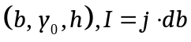, so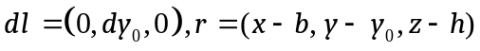.Finally the magnetic field distribution of AB can be expressed as:
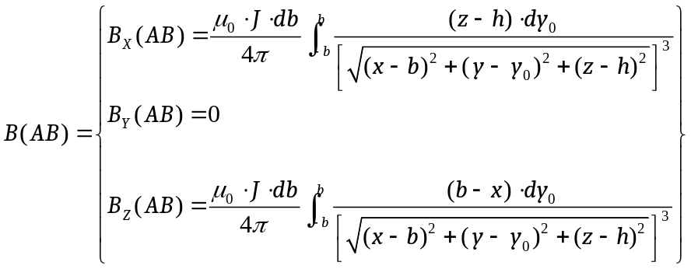 | S1
Similarly, the magnetic field distributions of BC, CD, DA, A'B', B'C', C'D' and D'A' can be obtained. The magnetic field generated by the currents on the surface of the magnetic film at a distance of b from the center can be expressed as:
S2
Consequently, the magnetic field produced by all equivalent currents can be calculated by:
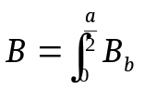 | S3
In this way, combined with experimental corrections, we can accurately calculate the magnetic field generated by the centripetal magnetized magnetic film at any position, and in theory, we can use this to realize the decoupling of the magnetic field in triaxial displacement. However, this expression is too complicated to solve inversely. Finally, inspired by the work of Yan et al.² and Mallinson et al.³, meanwhile, benefiting from the symmetry of x and y of centripetal magnetization, we tried to find the decoupling expression by adding the appropriate coefficients and finally established three fitting parameters S, Rx, Ry that were approximately decoupled from each other within the working range of x: -3~3mm, y: -3~3mm, z: 0~3mm, as shown in Eq. (1), which were proven reliable through our established magnetic field distribution models.
Magnetic film’s characterization measurement
In order to accurately model the magnetic field of the magnetic film, correctly decoupling the magnetic field change caused by the three-dimensional displacements of the magnetic film, and realizing the sensor’s decoupling perception of the three-dimensional forces, we measured the hysteresis curve of the magnetized magnetic film by the superconducting quantum interference device (SQUID, Quantum Design). The test specimens (1mm×1mm×1mm) were prepared by cutting from the magnetic film. The magnetic moments of the test specimens were measured under a varying external magnetic field from -4.0 T to 4.0 T. According to the hysteresis curve shown in Supplementary Figure 3, the remanent magnetization of the magnetic film corresponding to the magnetic moment can be obtained when the external magnetic field is 0. The remanent magnetization can be calculated according to the magnetic moment without external magnetic field (0.1085 emu) divided by the volume of the test specimens (1 mm³). Consequently, we can get the equivalent current density J of the remanent magnetization as 1.085×10⁵ A/m. However, due to the interference of the different magnetization directions of the folds of the film and the measurement error of the volume of specimens, the magnetic field distribution obtained by modeling and calculation using this value has a certain deviation from the experimental measurement. Considering the possible error, we corrected the equivalent current density J to 1.76×10⁵ A/m, so that the magnetic field distribution calculated by our model is consistent with the experimental measurement, as shown in Fig. 2b.
Force-displacement relationship of different flexible layers
Our magnetic-based flexible tactile sensor is actually a "displacement sensor", which senses the magnitude of the force indirectly by sensing the deformation of the flexible layer through the displacement of the magnetic film. As shown in Fig. 2d, we had achieved the displacement sensing calibration of the sensor. Therefore, we needed to calibrate the force-displacement relationship of the sensor to finally realize the sensor's perception of force.
We used a three-dimensional platform to drive the dynamometer to apply shear displacement and normal displacement to the sensor respectively and recorded the dynamometer readings at the same time. Multiple experiments were performed on the sensors with different "Buffer layers" and the measured values were averaged. Finally, the force-displacement curves as shown in Supplementary Figure 4 were obtained.
Supplementray Figures
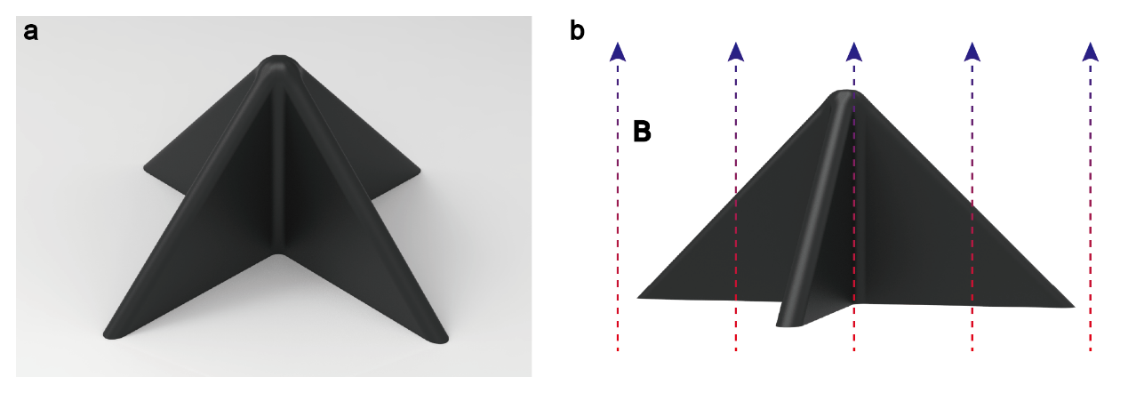
Supplementary Figure 1 Centripetal magnetization of the magnetic film. a) The folded magnetic film. b) Illustration of the folded magnetic film being magnetized in a high-intensity magnetic field (about 4.0 T), where the arrows B indicate the direction of the magnetic field.
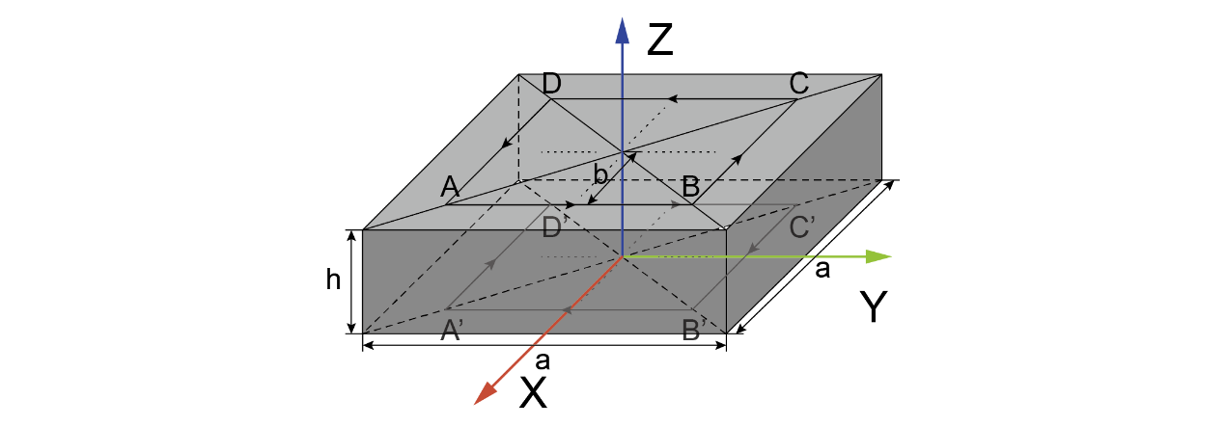
Supplementary Figure 2 Schematic diagram of the equivalent current on the surface of the magnetic film with centripetal magnetization.
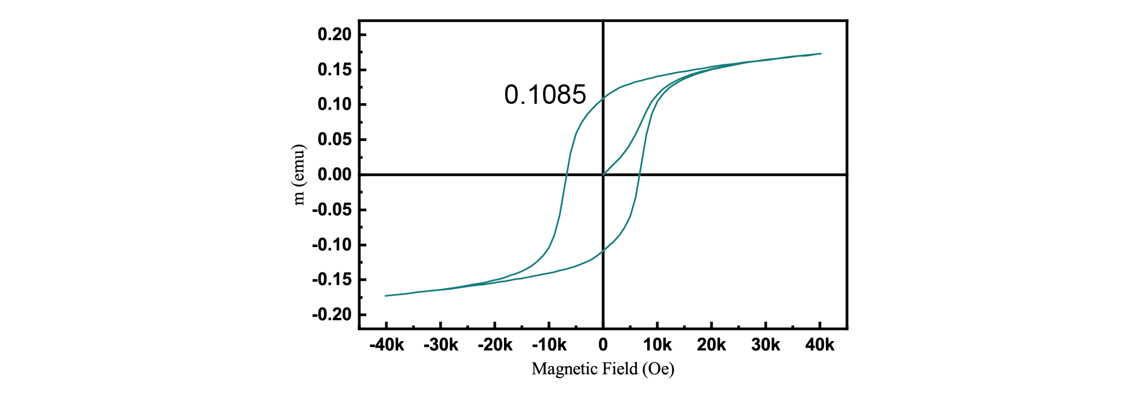
Supplementary Figure 3 Hysteresis curve of the magnetic film’s material.
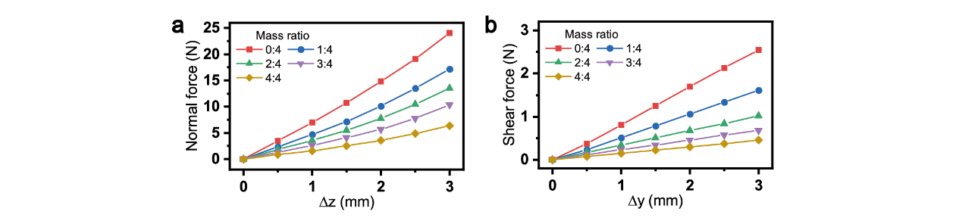
Supplementary Figure 4 Force-displacement calibration of the sensors. (a) The relationship between normal force and normal displacement for the sensors with different flexible layers. (b) The relationship between shear force and shear displacement for the sensors with different flexible layers.
References
1. Kim Y, Yuk H, Zhao R, et al. Printing ferromagnetic domains for untethered fast-transforming soft materials[J]. Nature, 2018, 558(7709): 274-279.
2. Yan Y, Hu Z, Yang Z, et al. Soft magnetic skin for super-resolution tactile sensing with force self-decoupling[J]. Science Robotics, 2021, 6(51): eabc8801.
3. Mallinson J. One-sided fluxes--A magnetic curiosity?[J]. IEEE Transactions on magnetics, 1973, 9(4): 678-682.

