Supplementary Information
Additional file 1 of Ionospheric electron enhancement immediately before the 2022 January 15 eruption of the Hunga-Tonga Hunga-Ha’apai submarine volcano: A fake precursor caused by space weather

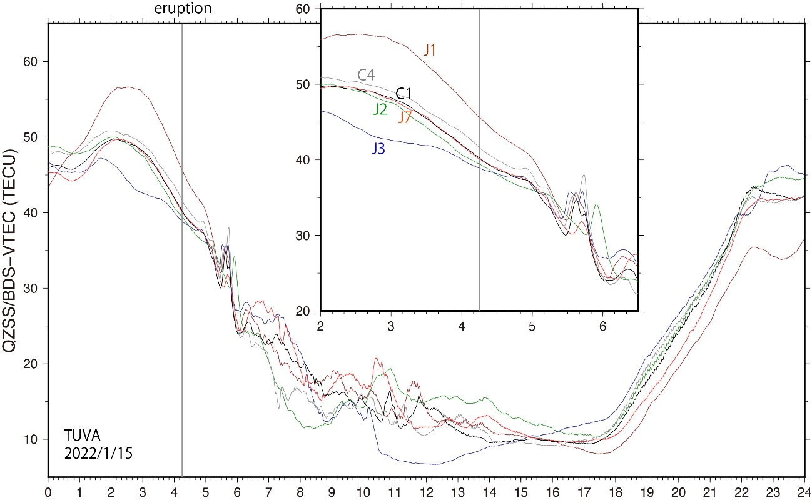
Figure S1. VTEC on 2022 January 15 at the TUVA station, located ~1500 km NW of HTHH. Data from different satellites are distinguished by colors. The inset shows the close-up view of the period 2-6 UT. The eruption (4:15) is indicated by vertical grey lines. We recognize disturbances by acoustic waves and internal gravity waves, harmonic oscillations reflecting atmospheric modes, but do not recognize temporary departure of TEC from smooth curves before the eruption as seen in TONG (Figure 2).

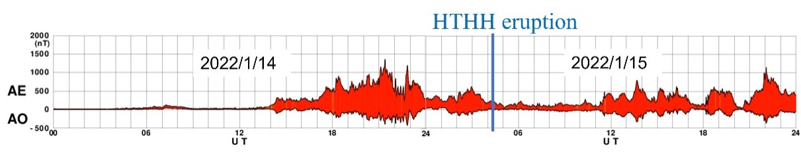
Figure S2. AE index over the period 2022 January 14-15 after World Data Center for Geomagnetism, Kyoto (Nose et al., 2015).

