Supporting Information
for “Feasibility of nanoscale zero-valent iron loaded sediment-based biochar (nZVI-SBC) for simultaneous removal of nitrate and phosphate: high selectivity towards dinitrogen and synergistic mechanism”

Xiaohui Liu, Jia Wei *, Liangang Hou, Yuhan Zhu, Yaodong Wu, Luyi Xing, Yifei Zhang, Jun Li

College of Architecture Engineering, Beijing University of Technology, 100 Pingleyuan, Chaoyang district, Beijing 100124, China.

Corresponding author: weij@bjut.edu.cn (Jia Wei)

Details of materials and methods
1. Materials
The sediment was sampled from the esturary of the Tonghui River (39°54′20″N; 116°33′11″E), which is a polluted river connecting the Gaobeidian sewage treatment plant (Beijing, China). A core sampler (Ø80 mm × L500 mm) was used and the sediment was transported into a laboratory with airtight polyethylene self-sealing bags within 4 h. Sediment was prepared as the precursor of SBC, and was dried, smashed and passed through a 0.15 mm sieve.
Sodium borohydride (NaBH₄, ≥97.0%), potassium dihydrogen phosphate (KH₂PO₄, ≥99.0%), potassium nitrate (KNO₃, ≥99.0%), sodium nitrite (NaNO₂, ≥99.0%) and ammonium chloride (NH₄Cl, ≥99.8%) were purchased from Tianjin Guangfu Development Company Limited, China. Ferrous sulfate heptahydrate (FeSO₄·7H₂O, 99.0-101.0%) was purchased from Sheng Ao Chemical Reagent (Tianjin, China). Anhydrous ethanol (CH₃CH₂OH, ≥99.7%) was purchased from Fuyu Chemical Co., Ltd (Tianjin, China). All chemicals were used as purchased without further purification, and all solutions were prepared with high purity deionized water (EC =2.0 μs·cm ⁻¹).
2. Preparation of nZVI-SBC
SBC was produced through pyrolysis of 20 g dry sediment at 400 °C for 4 h in an anaerobic muffle furnace (KABML-602A, Coal, China). The product was then smashed and passed through a 0.15 mm sieve and kept under oxygen-limited condition.
In order to prepare nZVI-SBC, a certain concentration of FeSO₄·7H₂O and SBC were mixed in the ultrasonic cleaning machine (Model B12, Yamato, Japan) for 1h to disperse it evenly. N₂ was purged into the solution for 30 min to exclude the dissolved O₂. Then excessive NaBH₄ was dissolved in 20 mL of deionized water and added drop-wise to the above solution. The mixture was stirred at 120 rpm for another 30 min to complete the reaction. After settled and washed 3 times with deionized water and anhydrous ethanol respectively, the solution was finally dried by purging N₂ and vacuum pump alternately.
3. Characteration
The morphology of samples was examined by scanning electron microscopy (SEM) (Vega-3XMU, Tescan, Czech). Transmission electron microscopy (TEM) images were taken by Tecnai G2 F20 S-TWIN (FEI, USA) at 200 kV to characterize the size and dispersion of nZVI on the surface of nZVI-SBC. Brunauer-Emmett-Teller (BET) specific surface areas and the pore size distribution were measured by Micromeritics ASAP 2460 (Micromeritics, USA) at 77 K. X-ray diffraction (XRD) was carried out scanning from 10° to 90° 2θ (BRUKER, Germany) and counting time of 2 s·step ⁻¹ to determine the composition. Fourier transformation infrared spectroscopy (FTIR) (Thermo, USA) was used to evaluate the functional groups over the spectra range of 400-4000 cm⁻¹. Zeta potentials were measured by Zetasizer Nano zeta potential analyzer (Malvern Instruments, UK) at varying solution pH from 3.0 to 11.0 and the isoelectric point were determined. X-ray photoelectron spectrometer (XPS) (ESCLAB 250Xi, Thermo Fischer, USA) was used to characterize the surface composition and combination state of element with a monochromatic Al-Ka source.
4. Analytical methods
All nitrogen-containing compounds (NO₃⁻, 220 nm and 275 nm; NO₂⁻, 540 nm; NH₄⁺, 420 nm) and phosphate (700 nm) were measured by a 765 UV–vis spectrophotometer (Shanghai, China). Values of DO and pH were monitored by a portable DO meter (HQ30d, Hach, USA) and a pH meter (MP220, Mettler Toledo, Switzerland) respectively. The nitrate removal efficiency and byproducts were calculated using the following equations:
$R_{{NO}_{3}^{-}}（\%）=\frac{{[{NO}_{3}^{-}]}_{i}-{[{NO}_{3}^{-}]}_{f}}{{[{NO}_{3}^{-}]}_{i}}×100$ (1) $B_{{NH}_{4}^{+}}（\%）=\frac{{[{NH}_{4}^{+}]}_{f}}{{[{NO}_{3}^{-}]}_{i}-{[{NO}_{3}^{-}]}_{f}}×100$ (2) $B_{{NO}_{2}^{-}}（\%）=\frac{{[{NO}_{2}^{-}]}_{f}}{{[{NO}_{3}^{-}]}_{i}-{[{NO}_{3}^{-}]}_{f}}×100$ (3) $B_{N_{2}}（\%）=\frac{{[{NO}_{3}^{-}]}_{i}-{\left[{NO}_{3}^{-}\right]}_{f}-{\left[{NH}_{4}^{+}\right]}_{f}-{[{NO}_{2}^{-}]}_{f}}{{[{NO}_{3}^{-}]}_{i}-{[{NO}_{3}^{-}]}_{f}}×100$ (4)
where [NO₃⁻], [NH₄⁺] and [NO₂⁻] represent the concentration (mg·L⁻¹) of nitrate, ammonium and nitrite, respectively. The subscripts i and f are the initial and final sampls, respectively.

Supplementary Figures
Fig. S1. Effect of dosage on removal capacity (20 NO₃–-N mg·L⁻¹, 5 PO₄³-P mg·L⁻¹, pH = 7, DO = 3 mg·L⁻¹).
Fig. S2. Effects of initial solution pH on nitrate and ammonium production (20 NO₃–-N mg·L⁻¹, 5 PO₄³-P mg·L⁻¹, dosage = 2g·L⁻¹, DO = 3 mg·L⁻¹).
Fig. S3. Effect of DO on nitrate and ammonium production (20 NO₃–-N mg·L⁻¹, 5 PO₄³-P mg·L⁻¹, dosage = 2 g·L⁻¹, pH = 7).
Fig. S4. X-ray diffraction patterns of nVZI-SBC after reaction.

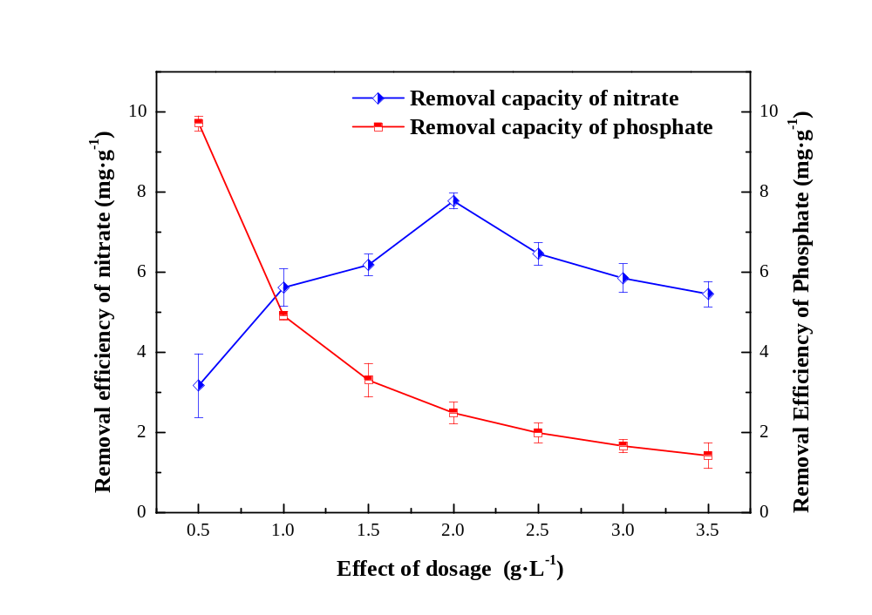
Fig. S1. Effect of dosage on removal capacity (20 NO₃–-N mg·L⁻¹, 5 PO₄³-P mg·L⁻¹, pH = 7, DO = 3 mg·L⁻¹).

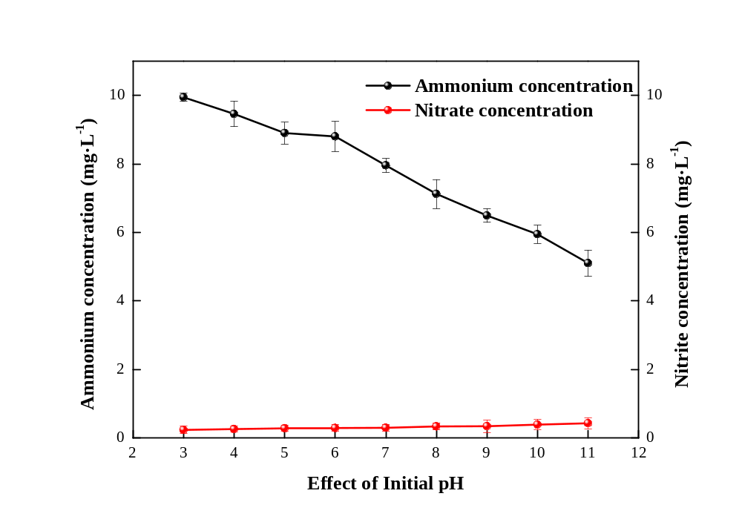
Fig. S2. Effects of initial solution pH on nitrate and ammonium production (20 NO₃–-N mg·L⁻¹, 5 PO₄³-P mg·L⁻¹, dosage = 2g·L⁻¹, DO = 3 mg·L⁻¹).

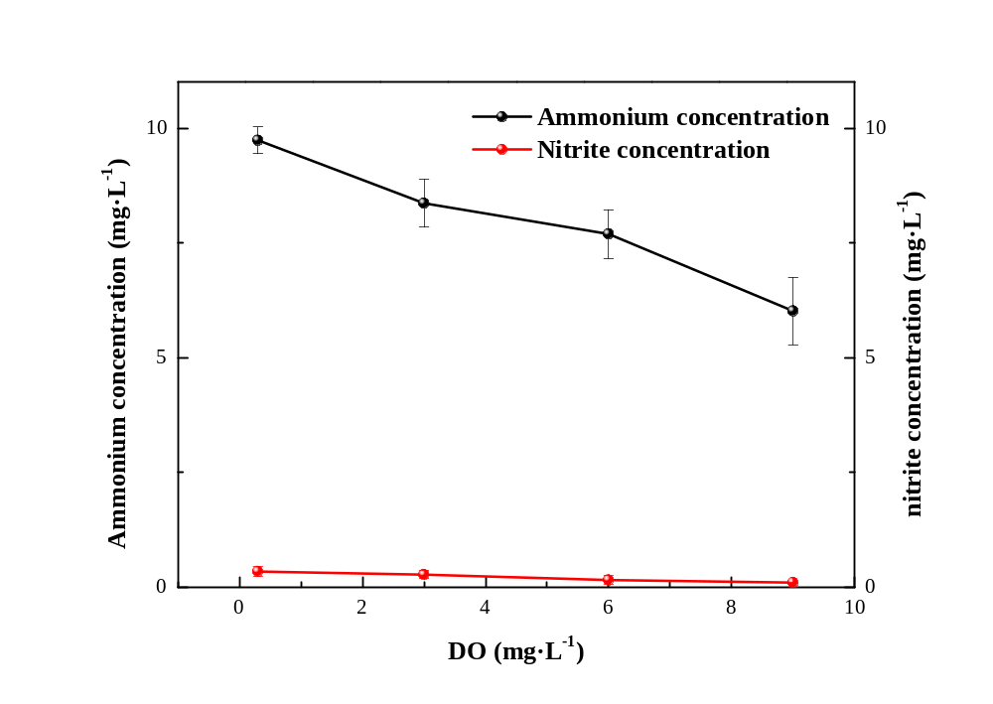
Fig. S3. Effect of Do on nitrate and ammonium production (20 NO₃–-N mg·L⁻¹, 5 PO₄³-P mg·L⁻¹, dosage = 2 g·L⁻¹, pH = 7).

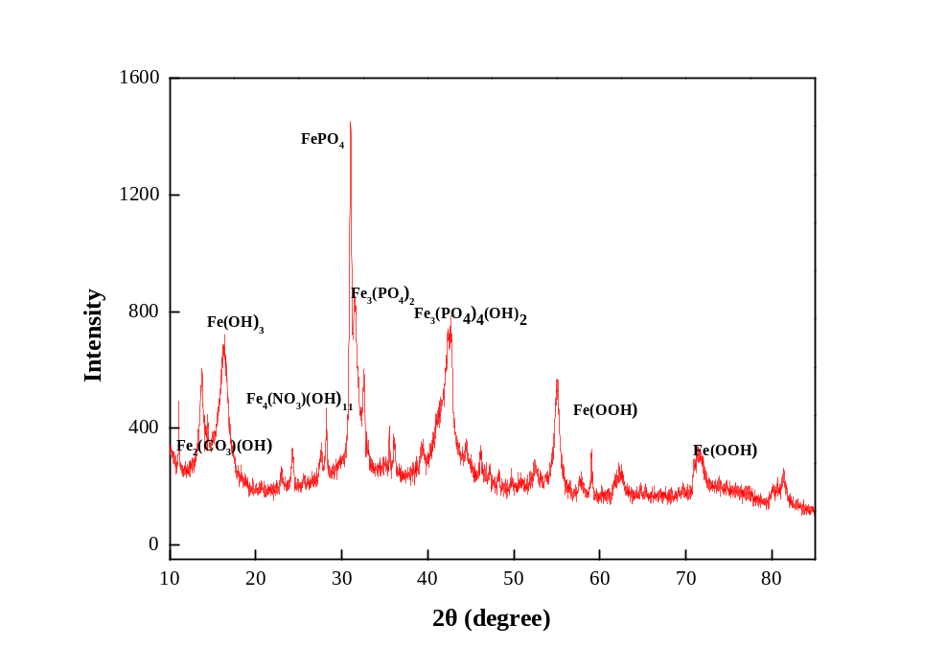
Fig. S4. X-ray diffraction patterns of nVZI-SBC after reaction.

