Appendix

List of Appendices

Appendix No. | Appendix | Page No.
I | Ethics Committee Approval Letter. | 23-25
II | Administrative Approval Letter | 26
III | Informed Consent form English | 27-29
IV | Informed Consent Form Arabic | 30-32
V | Research Questionnaire English | 33-36
VI | PSS Stress scale | 37-38
VII | Good Clinical Practice Certificate for all team members | 39-45

- Ministry of Health and Prevention Ethical Committee approval letter.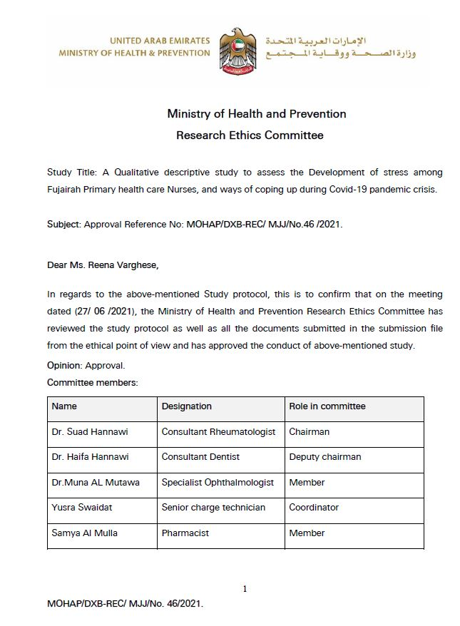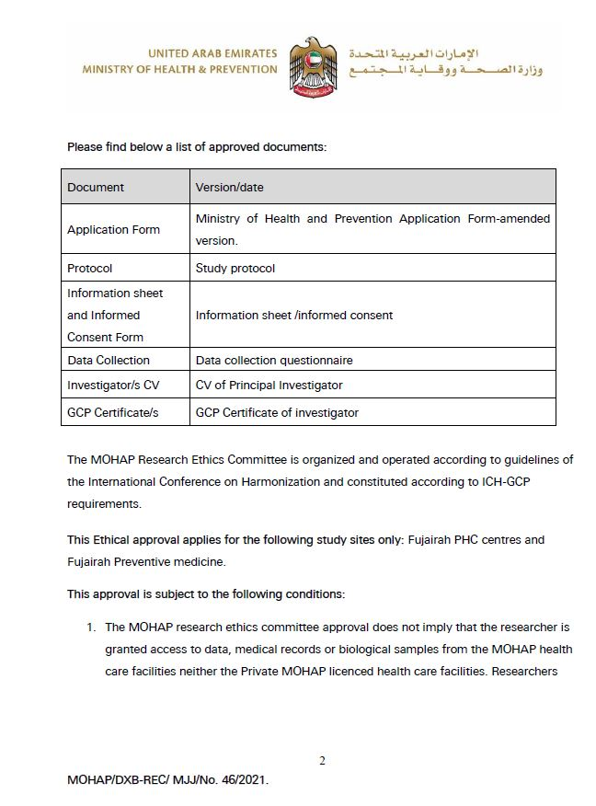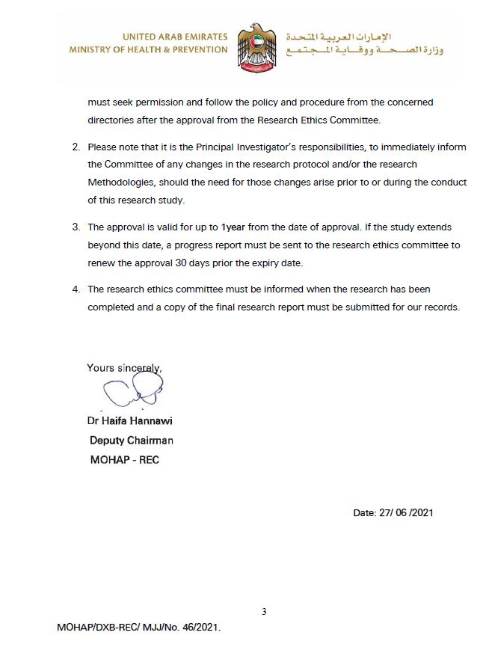

II. Administrative Approval letter.
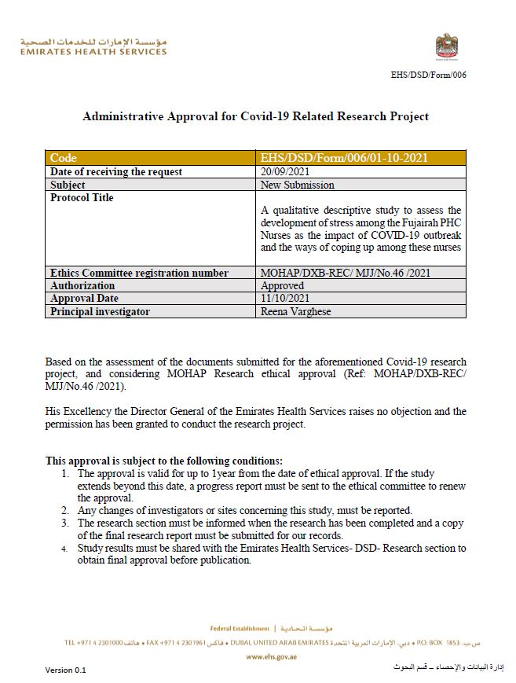
III. Informed Consent Form-English Version.
INFORMED CONSENT FORM
Informed Consent form for nurses, both males and females who served in Primary health centers in Ministry of health and prevention, Fujairah zone, and who we are inviting to participate in research on, “A qualitative descriptive study to assess the development of stress among the Fujairah PHC Nurses as the impact of COVID-19 outbreak and the ways of coping up among these nurses”.
Name of Principal Investigator: Reena Varghese
Name of Organization : Primary health centers, Fujairah
Name of Sponsor : Ministry of Health
Name of Proposal : A qualitative descriptive cross-sectional study to assess the development of stress among the Fujairah PHC Nurses as the impact of COVID-19 outbreak and the ways of coping up among these nurses.
PART I: Information Sheet
Introduction
I am Reena Varghese, working for Ministry of Health and prevention, Fujairah zone. Investigators are doing research on Development of stress among Fujairah Primary health care Nurses, and ways of coping up during Covid -19 pandemic crisis.
Purpose of the research
Psychological stress is one of the most common problems among healthcare providers during COVID-19 pandemic. The purpose of this study is to provide a deeper understanding of the impact of stress among you and ways of coping stress during this pandemic. This would in turn enable leaders and decision makers to promote a healthier work environment for their nurses. The investigators are doing this research through a questionnaire.
Type of Research
This is a qualitative descriptive cross-sectional study; in which it will involve answering a questionnaire once.
Participant selection: - Investigators are inviting all nurses, both males and females’ working at primary health centers under ministry of health and prevention, Fujairah. Participation in this study is voluntary and participants have the right to withdraw from the study at any time, without giving an explanation.
The participants responsibilities are answering the questionnaire in a proper way within the allotted time period and should be: - clear -accurate - complete.
If you agree: -
- All information obtained will be completely anonymous.
- The information will be used for research purposes only.
- There are questionnaires in the survey.
Risk /benefits/ expenses: All nurses working in Fujairah PHC will be included in the study without any cost/ payment/ additional benefits. There is no maleficence/ intended clinical benefits, but just assessment of nurses in current situation. There is no anticipated expense, assessment by general online questionnaire, which is not intended to do any harm to the subjects of this study.
The subject’s participation is voluntary and may refuse to participate or withdraw at any time, without penalty or loss of benefits.
The inconveniences to participate in this survey, we are expecting is the lack of interest to share, work load and tiredness. To overcome, we are giving the questionnaire through e-mail and time period to finish even at home.
Confidentiality: The ethical committee and concerned authority will be granted direct access to the original records for verification of data, without violating the confidentiality of the subject, to the extent permitted by the applicable laws and regulations and that, by signing a written consent form.
Safety: The records, identifying the subject will be kept confidential and to the extent permitted by the applicable law and / or regulations, will not be made publicly available. The data will not be shared or use for any other study or purposes. If the results of the study are published, the subject’s identity will remain confidential.
For further information/ if you have any questions you may ask to research team members/ Nursing administration in Murshid, now or later, even after the study has started.
The foreseeable circumstances and / or reasons under which the participation may be terminated are:
- Incomplete data
- Unclear data
- Postdated data
- Inaccurate data
The expected duration of the subject’s participation is 2-3 weeks.
Estimated participants are 150-180 out of which 100-120 exact data will be considered into account.

PART 2: CONSENT CERTIFICATE
TOPIC: A qualitative descriptive study to assess the development of stress among the Fujairah PHC Nurses as the impact of COVID-19 outbreak and the ways of coping up among these nurses.
Principal investigator: Reena Varghese
Other members: Eric, Gils Jacob, Amal, Alma, Jindya Cris, Tiji Mathai

Participant name:

We invite you to take part in a research study at Fujairah zone. Taking part in this study is entirely voluntary. We urge you to discuss any questions about this study with our staff members. Talk to your family and friends about it and take your own time to make your decision. If you decide to participate, you must sign this form to show that you want to take part. If you have questions/ complaints/concerns, contact principal investigator at (055-6193357)/ contact any research team members.

I have read the information. I have had the opportunity to ask questions about it and any questions I have been asked have been answered to my satisfaction. I consent voluntarily to be a participant in this study.
Name of participant: Signature:
Date:

I confirmed that the individual has not been coerced into giving consent and the consent has been given freely and voluntarily.
Name of the research member/ person taking the consent:
Signature:
Date:

III. Informed Consent Form-Arabic Version.
إستمارة الموافقة المسبقة
استمارة الموافقة للممرضات والممرضين الذين خدموا في مراكز الصحة الأولية بوزارة الصحة ووقاية المجتمع بالفجيرة، حيث ندعوهم للمشاركة في بحث حول "دراسة وصفية نوعية لتقييم تطور الإجهاد بين ممرضات وممرضي الرعاية الصحية الاولية، وطرق التعامل مع أزمة جائحة كوفيد -19.

اسم الباحث الرئيسي: رينا فارغيز
اسم الجهة: المراكز الصحية الأولية، الفجيرة
اسم الكفيل: وزارة الصحة
اسم الاقتراح: تطور التوتر بين ممرضات الرعاية الصحية الأولية في الفجيرة، وطرق التعامل مع أزمة جائحة كوفيد -19.

الجزء الأول: المعلومات
مقدمة
أنا رينا فارغيز، أعمل في وزارة الصحة والوقاية، منطقة الفجيرة. يقوم الباحثون بإجراء بحث حول دراسة وصفية نوعية لتقييم تطور الإجهاد بين ممرضات وممرضين الرعاية الصحية الأولية في الفجيرة، وطرق التعامل مع أزمة جائحة كوفيد -19.
الغرض من البحث:
يُعد الإجهاد النفسي أحد أكثر المشاكل شيوعًا بين مقدمي الرعاية الصحية خلال جائحة كوفيد -19
الغرض من هذه الدراسة هو توفير فهم أعمق لتأثير التوتر والاجهاد النفسي وطرق التعامل بها خلال هذه الجائحة ,وهذا بدوره سيمكن القادة وصناع القرار من تعزيز بيئة عمل صحية لممرضاتهم.
يقوم الباحثون باستخدام طريقة الاستبيان في التقصي عن المعلومات المرادة تجميعها

نوع البحث
هذه دراسة وصفية كمية, والتي ستشمل الإجابة على استبيان لمرة واحدة.

اختيار المشاركين: -
يقوم المحققون بدعوة جميع الممرضات والممرضين العاملين في المراكز الصحية الأولية التابعة لوزارة الصحة ووقاية المجتمع بالفجيرة.
المشاركة في هذه الدراسة تطوعية ويحق للمشاركين الانسحاب من الدراسة في أي وقت دون إبداء أسباب.

في حال الموافقة: -
- ستكون جميع المعلومات التي تم الحصول عليها مجهولة المصدر تمامًا.
- سيتم استخدام المعلومات لأغراض البحث فقط.
- توجد استبيانات في المسح.
- لن يكون هناك مخاطر ومزايا مباشرة / غير مباشرة

ملحوظة: - إذا كان لديك أي أسئلة يمكنك طرحها على أعضاء فريق البحث / إدارة التمريض في مريشد، الآن أو لاحقًا، حتى بعد بدء الدراسة.

الجزء الثاني: شهادة الموافقة
الموضوع: دراسة وصفية نوعية لتقييم تطور الإجهاد بين ممرضات وممرضين الرعاية الصحية الأولية في الفجيرة، وطرق التعامل مع أزمة جائحة كوفيد -19.
الباحث الرئيسي: رينا فارغيز
الأعضاء الآخرون: إريك توريس، جيلز جاكوب، أمل علي، ألما دي جوزمان، جينديا كريس، تيجي ماثاي

اسم المشارك: .........................................................................................

ندعوكم للمشاركة في دراسة بحثية في منطقة الفجيرة ,المشاركة في هذه الدراسة تطوعية بالكامل , نحثك على مناقشة أي أسئلة حول هذه الدراسة مع موظفينا, تحدث إلى عائلتك وأصدقائك حول هذا الموضوع وخذ وقتك الخاص لاتخاذ قرارك, إذا قررت المشاركة، يجب عليك التوقيع على هذا النموذج لإظهار رغبتك في المشاركة, إذا كانت لديك أسئلة / شكاوى / مخاوف، فاتصل بالباحث الرئيسي على الرقم (055-6193357) / اتصل بأي من أعضاء فريق البحث.

لقد قرأت جميع المعلومات ,ولقد أتيحت لي الفرصة لطرح الأسئلة حول هذا الموضوع وتم الرد عليها.
أوافق طواعية على أن أكون مشاركًا في هذه الدراسة.
اسم المشارك: التوقيع:
تاريخ:
أؤكد إن المشارك لم يُجبر على إعطاء الموافقة وأن الموافقة تم منحها بحرية وطوعية.
اسم عضو البحث: الشخص الذي أخذ الموافقة:
التوقيع:
تاريخ:

IV. Questionnaire Used for Survey
Questionnaire to assess nurse’s demographic and professional information in relation to the development of stress on Fujairah PHC nurses working during Covid-19 pandemic.
PART A : Demographic Data
- Sex:
- M
- F
- Age:
- 18-25
- 26 -30
- 31- 40
- >40

- Marital status:
- Married
- Unmarried

- Having children:
- Yes
- No

- Educational level:
- Diploma
- Bachelor in nursing
- Master’s in nursing
- Other’s( Specify)………….

PART B : Socio-economic, physical and psychosocial Data

- Job title:
- ………………………..

- Working position with Covid patients
- Front line
- Second line

- Working area
- Isolation
- General

- Clinical experience
- 1-5
- 6-10
- 11-15
- > 15

- Average working hours
- 7 to 8
- 10 to 12

- Have you received infection control training?
- Yes
- No

- Do you have any prior experience of caring patients with infectious diseases?
- Yes
- No

- Are you confident in caring Covid-19 patient?
- Lack of confident
- General confident
- Quite confident

- Do you feel safe while caring Covid-19 patient?
- Safe
- Unsafe

- Are afraid of being infected by Covid-19?
- Yes
- No

- Please select what do you feel about your control over the work that is assigned to you.
- Well controlled
- Partially controlled
- Slightly controlled
- Uncontrolled

- Do you feel you have work -life balance?
- Yes
- No

- Do you have fear of infecting your family members?
- Yes
- No

- Do you have strong familial support?
- Yes
- No

- Are you afraid of being isolated in the society?
- Yes
- No

- Do you receive strong organizational support to combat Covid-19 pandemic?
- Yes
- No

- Are you informed about the recent updated of Covid-19 pandemic?
- Yes
- No

- Do you get affected with any of the following psychological problems?
- Yes
- No

- If Yes, select any of the listed below: -
- Anxiety
- Sleep disturbances
- Loss of appetite
- Over stress
- Fear

- Are you satisfied as a nurse during Covid-19 pandemic?
- Yes
- No

- What is your professional attitude towards Covid-19 pandemic?
- Negative
- General
- Positive
- Strongly positive

- Do you have any support either emotionally/psychologically in case you got infected by Covid19? 
- Are you either anxious/excited regarding your job or situation being affected by Covid19 pandemic due to global crisis?

- Are you holding up knowing that you have limited/restricted time to be with your family at home or in your own country?

V. Perceived stress scale (PSS) used for stress association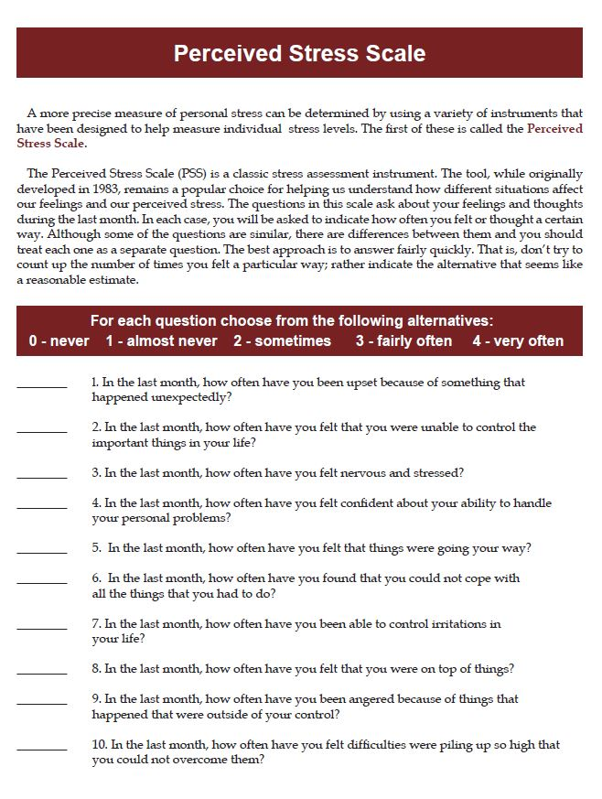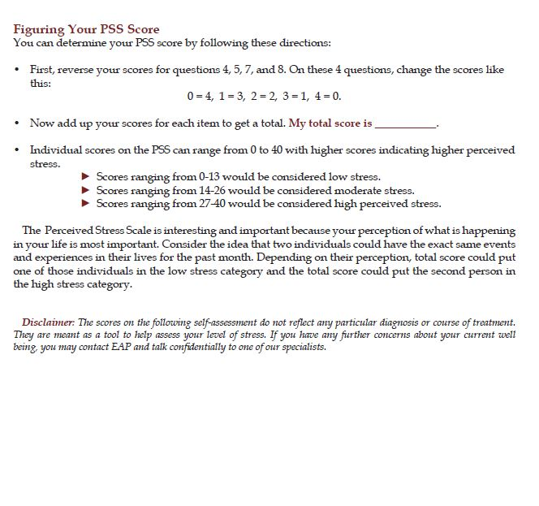

VI. Good Clinical Practice(GCP) certification for all team members
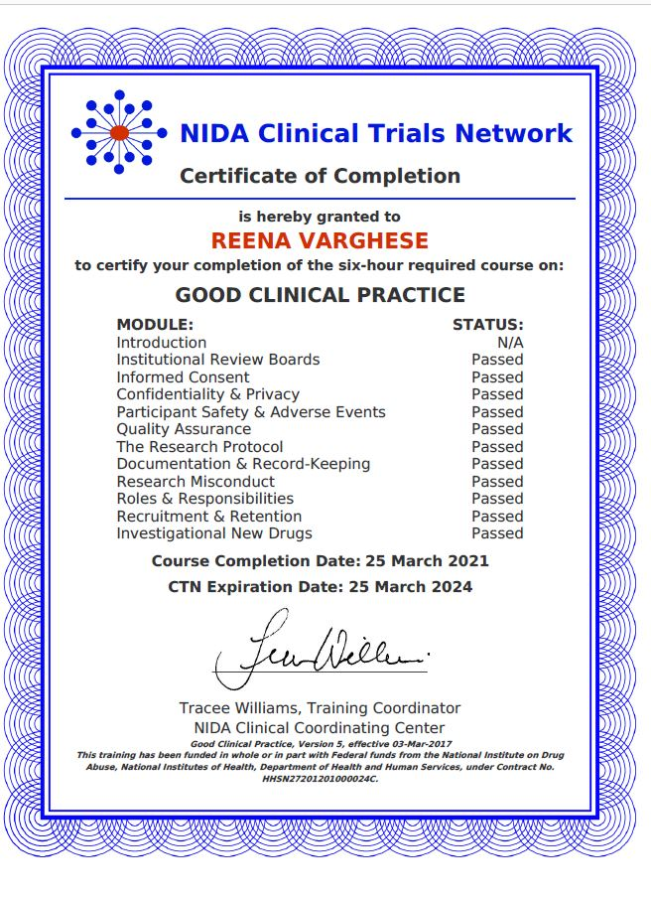

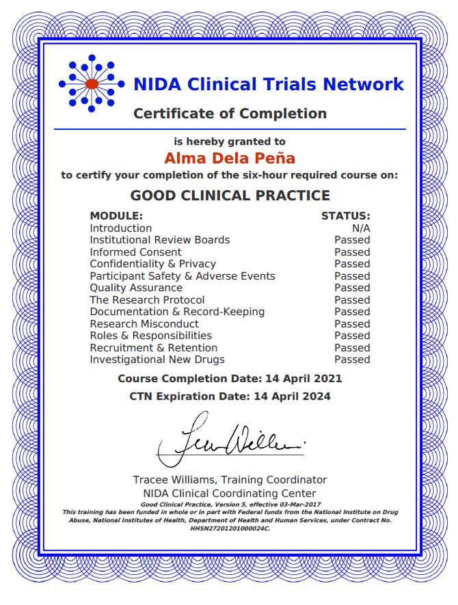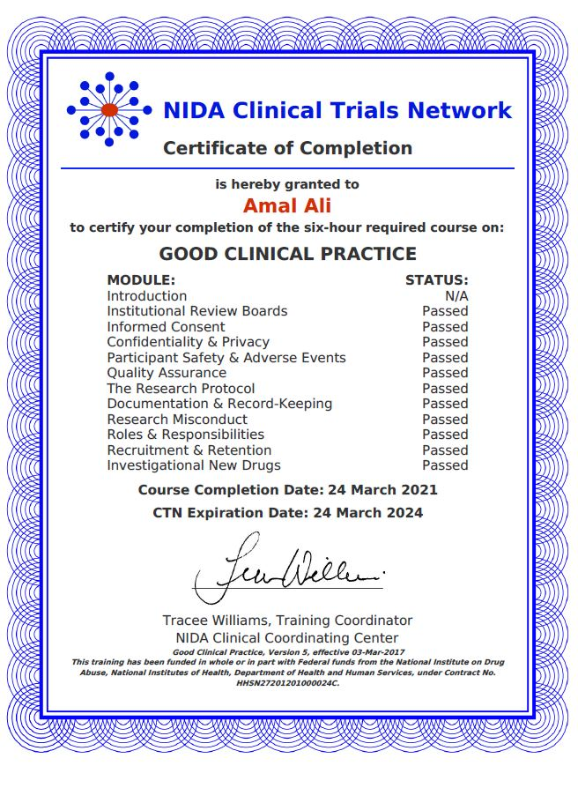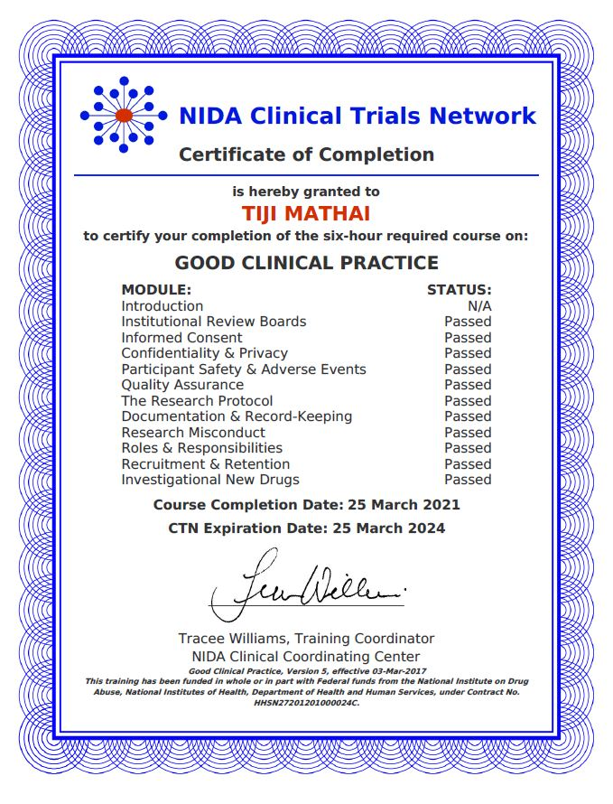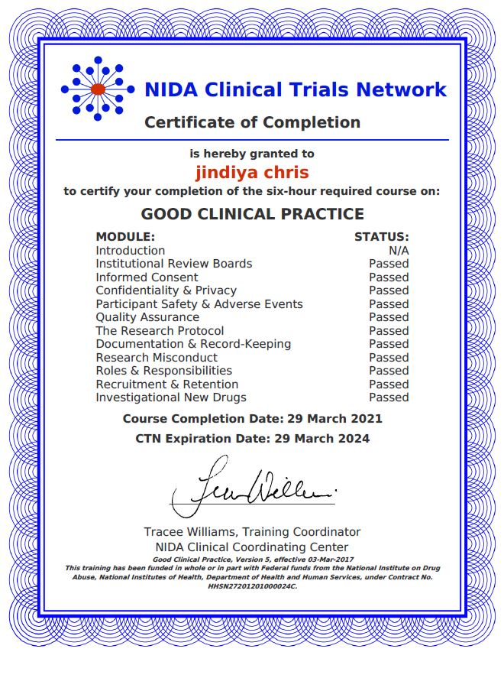

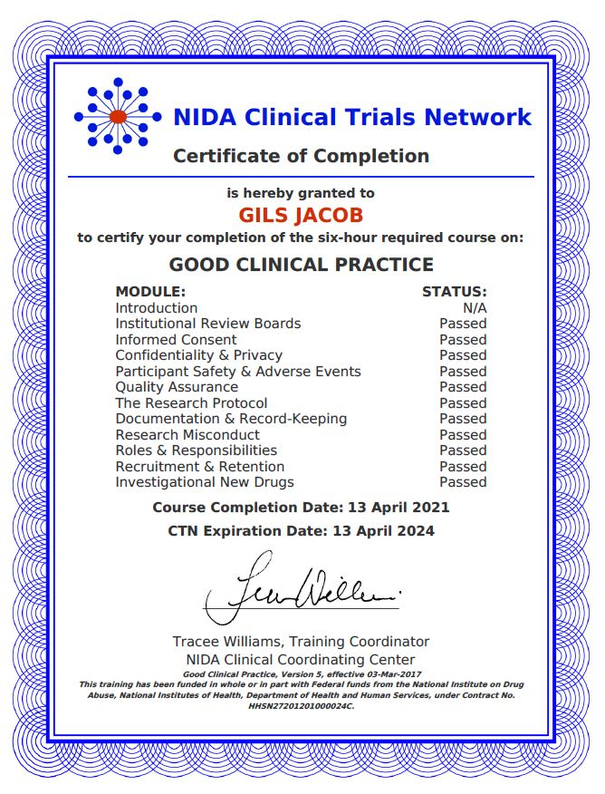
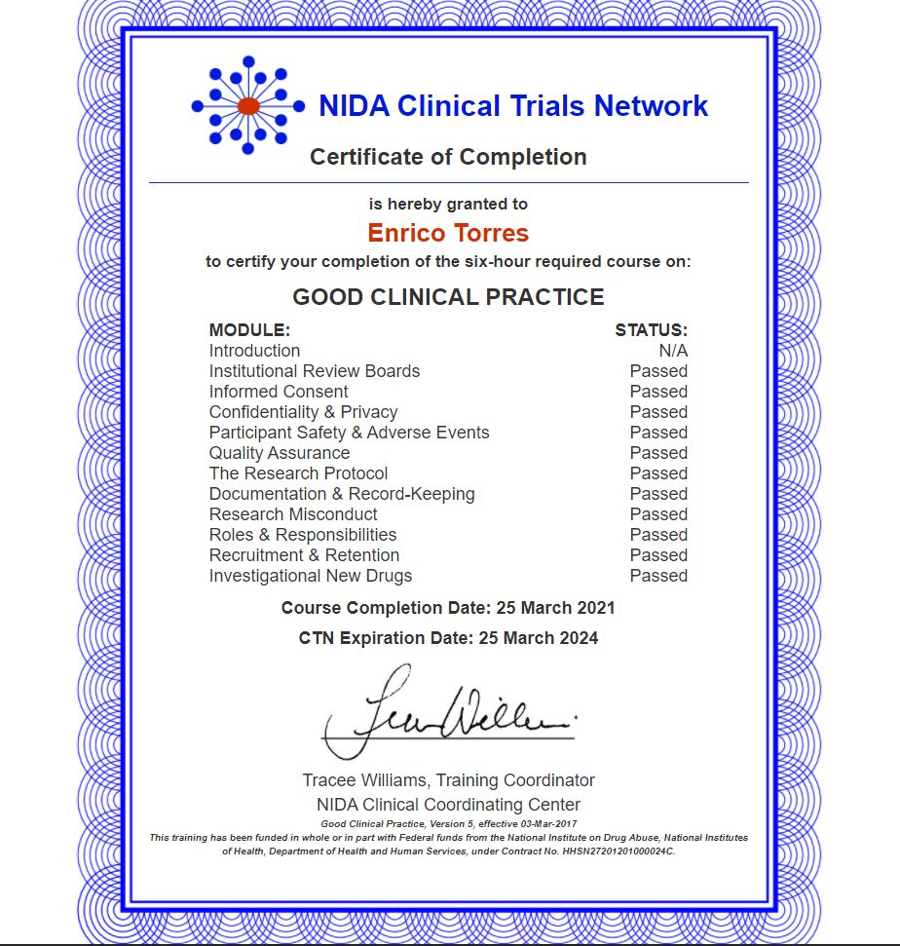

……………………………. THANK YOU……………………….…….

