Promoting stable step-flow growth of metal deposits for deeply cyclable multivalent batteries

The PDF file includes:
Materials and Methods
Figs. S1 to S30
Tables S1 to S3
References

Materials and Methods
Materials
2,5-Dimethylpyrrole (DMP, 98%), dipyrromethane (DPM, 98%), tetraphenylporphyrin (TPP, 99%), anhydrous AlCl₃ (99.99%), 1-ethyl-3-methylimidazolium chloride (EMImCl, 98%) tetraphenylporphinesulfonate (TPP-SO₃⁻, 95%), polyaniline (PANI, 98%) were purchased from Shanghai Macklin Biochemical Co., Ltd. ZnSO₄·7H₂O and phenyl magnesium chloride (PhMgCl) solution were purchased from Shanghai Aladdin Biochemical Technology Co., Ltd. Tetrahydrofuran (THF) was purchased from DodoChem Co., Ltd. Aluminum foil, zinc foil, magnesium foil, titanium foil and tantalum foil were bought from Runde Metal Products Co., Ltd. All metal foils were polished by fine-grained sandpaper, and the thickness of metal foils were controlled by a roller press (MTI Corporation). The flake graphite powder (99.9%) was purchased from Energy Chemical Co., Ltd. The aqueous CNT suspension and PTFE binder for high mass loading cathodes was purchased from Canrd New Energy Technology Co., Ltd.

Preparation of electrolytes
Preparation of [EMIm]Cl/AlCl₃ electrolyte: anhydrous AlCl₃ was slowly added into [EMIm]Cl slowly with continuous stirring. The molar ratio [EMIm]Cl: AlCl₃ = 1:2. The ionic liquid was treated with Al foil at 90 °C for 6 h to remove hydrochloric acid in the electrolyte.
Preparation of (PhMgCl)₂/AlCl₃ electrolyte: AlCl₃ powder was slowly added into PhMgCl THF solution in an Ar atmosphere, and its concentration was 0.25 M.
Preparation of 2 M ZnSO₄/CuSO₄ electrolyte: ZnSO₄·7H₂O or CuSO₄·5H₂O was dissolved in deionized water to prepare 2 M electrolyte. Deionized water was obtained from Milli-Q water purification system (18.2 MΩ cm⁻¹).

Material characterizations
Field-emission SEM measurements were conducted on Hitachi SU8000 equipped with an EDX detector. Pole figures were obtained at room temperature on a D8 ADVANCE Da Vinci with CuKα radiation. TEM sample was prepared by a dual-beam focused ion beam (FIB)-SEM (FEI Quanta 3D FEG) with a nanomanipulator using a standard lift-out procedure. Platinum was deposited for surface protection from the Ga ion beam. The initial lamella was milled, cleaned, lifted out and mounted on a TEM grid. Thinning was first conducted with a beam current of 500 pA, and then final polishing with a beam current of tens of pA to remove amorphization and Ga implantation. TEM measurements were performed on JEOL 2100F with Gatan double tilt analytical holder to identify the crystallography of electrodeposits.

AFM-IR spectroscopy measurements
The local nanoscale IR spectra and absorption mappings were carried out on a NanoIR2-fs instrument (Anasys Instruments Inc.) under contact/tapping mode. These AFM-IR measurements are based on the photothermal-induced resonance of the AFM probe (PR-EX-Nir2-10). The resonant amplitudes of the AFM cantilever are positively correlated with the absorbed IR radiation on samples. The AFM-IR spectra and 3D intensity mappings were analyzed using Analysis Studio software for the NanoIR2 system. The equipped AFM tip for KPFM measurements was Pt/Ir coated (25 nm thick) with ~60 kHz resonance frequency (PR-EX-KPFM-5). Surface potential images were acquired at a scan rate of 0.8 Hz and tip lift height was 20 nm under tapping mode.

Preparation of high mass loading cathodes
High mass loading graphite cathodes were fabricated by a tape-casting method. The aqueous mixture of CNT suspension and flake graphite powder (2:8 by weight) was sonicated for 1 h. The slurry was then cast onto polyethylene terephthalate (PET) foil using a doctor blade, then slowly dried at 40 °C for 8 h, followed by vacuum drying at 100 °C for 8 h. and then vacuum infiltrated. The freestanding cathodes were dried at 80 °C for 12 h. The freestanding cathodes can be peeled off form the PET substrate after drying. High mass loading PANI cathodes were fabricated by a dry electrode method. The mixture of PANI, Ketjenblack and PTFE (8.5:1:0.5 by weight) was grinded, placed between two PET substrates and rolled out. The freestanding cathodes were dried at 100 °C for 8 h.

Electrochemical measurements
All Al metal batteries (symmetric Al batteries, Al/Ti batteries and Ti/C full batteries) were assembled in an argon-filled glovebox with H₂O and O₂ content below 0.3 ppm using pouch-type batteries. Glass fiber membrane (934-AH, Whatman) was used as separator. LAND battery cycler and VMP3 potentiostat/galvanostat (Bio-Logic) were used for the electrochemical measurements. Coulombic efficiency was measured in multivalent metal/Ti cells. A fixed amount multivalent metal (e.g., Zn. Mg Al) was plated on Ti electrode and then stripped back under different current densities until the cutoff voltage increased to 1 V. The symmetrical cells using 20 μm Al anode were cycled at current densities of 1 mA cm⁻² under fixed charge/discharge capacities of 3 mAh cm⁻². Long-term cycling lifespan tests of Ti/C full cells were cycled at 2 mA cm⁻² within a voltage range of 0.4 V-2.4 V versus Al³⁺/Al. Long-term cycle lifespan tests of Zn/PANI full cells were charged/discharged at 3 mA cm⁻² within a voltage range of 0.5 V-1.5 V versus Zn²⁺/Zn. Tafel plots were obtained from the symmetric cells between −0.15 V and 0.15 V at a scan rate of 0.1mV s⁻¹.

Theoretical calculations
DFT calculations were performed with the Gaussian 16 software package. Geometry optimizations of all the minima and transition states were carried out at the B3LYP level of theory with additional Grimme’s D3 dispersion correction (Becke-Johnson damping)⁴ with the def2-SVP basis set. Vibrational frequencies were computed at the same level to evaluate its zero-point vibrational energy (ZPVE) and thermal corrections at 298 K, and to check whether the optimized structures are real intermediates. Single point calculations were carried out at the same level of theory with a larger basis set def2-TZVPP. The ESP surfaces were drawn with isovalue of 0.0004 a.u. based on the single point calculation at B3LYP-D3(BJ)/def2-TZVPP with VMD.
Spin-polarized density functional theory (DFT) calculations were performed using the DMol3 code. The electron exchange-correlation potential was conducted by the Perdew-Burke-Ernzerhof (PBE) functional of generalized gradient approximation (GGA). In all calculations, a global orbital cutoff with the value of 4.4 Å was used for the numerical atomic orbital basis, and the convergence tolerances were set to be 1 × 10⁻⁵ Ha for energy, 5 × 10⁻³ Å for maximum displacement,0.02 Ha/Å for maximum force, and 1.0 × 10⁻⁶ eV/atom for SCF tolerance. The Al (200) surface is modeled by a three-layers surface supercell (75 Al atoms per layer) with only considering the γ point for saving the computational resources. The long-range dispersion correction for the van der Waals interaction was implemented through the DFT-D method in all calculations.

Supplementary Text

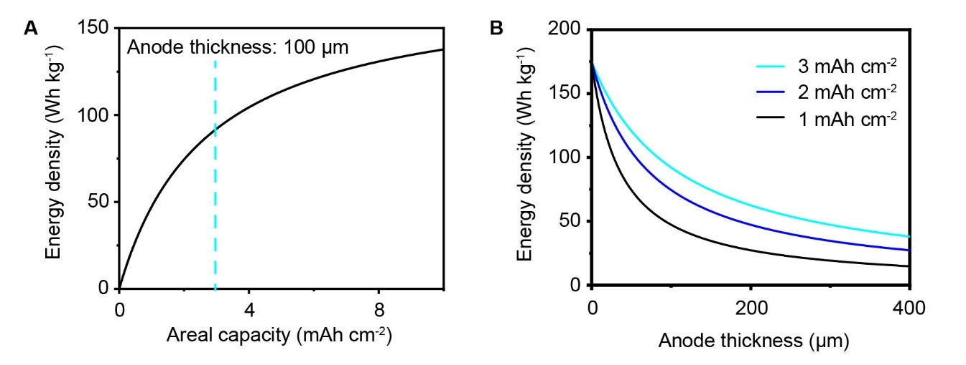
Fig. S1. Calculated cell energy density. (A) Dependence of gravimetric energy density on the areal capacity. The anode thickness is fixed at 100 µm for calculation. (B) Dependence of gravimetric energy density on anode thickness and areal capacity.

We first provide a quantitative understanding on the relationship between areal capacity utilization of anodes and practical energy density of Al-metal batteries (fig. S1 and table S1). If the cycling areal capacity is fixed at a commonly reported literature value (< 1 mAh cm⁻²), the practically achievable energy density of the full cells using 100 μm Al-metal anodes is less than 50 Wh kg⁻¹, far below the expectations for energy-dense MMBs. Optimizing the electrode parameters by increasing the cycling areal capacity (e.g., > 3 mAh cm⁻²) or decreasing the Al-metal excess (e.g., anode free) can effectively enhance the cell-level energy to 175 Wh kg⁻¹, which follows a similar design principle for practical Li-ion or Li-metal batteries.

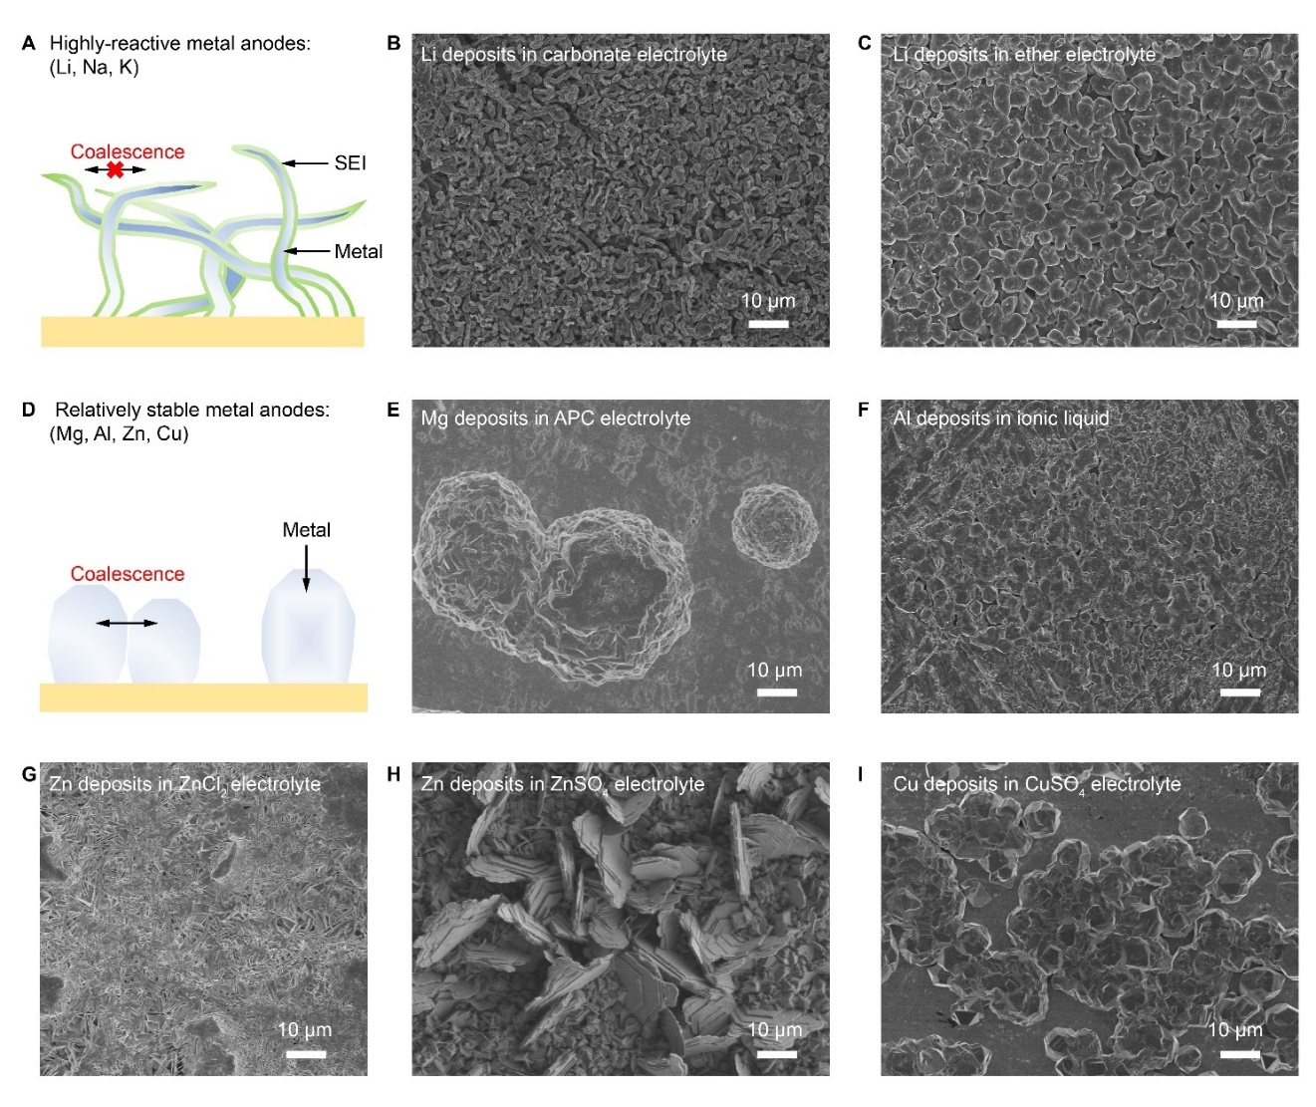
Fig. S2. Coalescence behavior in multivalent metal anodes. (A) Li-metal are physically confined in an electron-insulating/ion conducting interphases. (B and C) The morphology of Li-metal deposits in carbonate electrolyte (1 M LiPF₆ ethylene carbonate/diethyl carbonate with 10 wt% fluoroethylene carbonate) (b) and ether electrolyte (1 M LiTFSI dioxolane/dimethoxyethane with 1 wt% LiNO₃) (C). (D) Coalescence behavior governs the high areal growth stage in multivalent metal anodes. (E-I) The morphology of Mg-metal deposits in APC electrolyte (E) Al-metal deposits in [EMIm]Cl /AlCl₃ electrolyte (F), Zn-metal deposits in ZnCl₂ electrolyte (G), Zn-metal deposits in ZnSO₄ electrolyte (H), Cu-metal deposits in CuSO₄ electrolyte (I). Areal capacity: 3 mAh cm⁻².
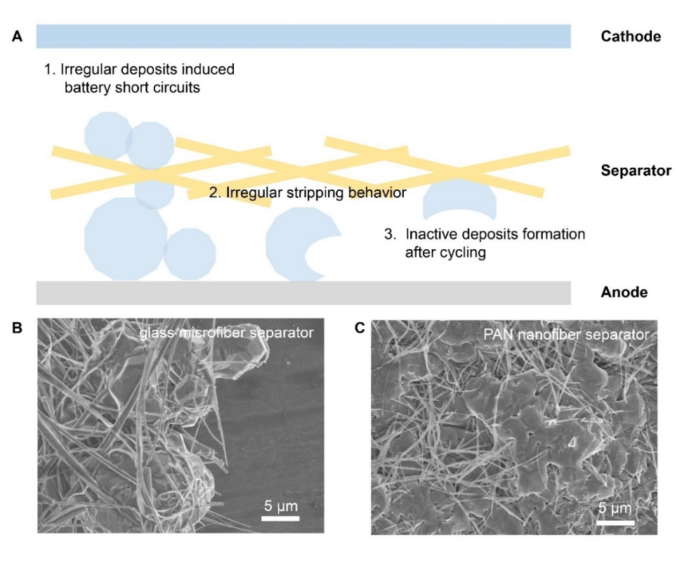
Fig. S3. The failure mechanism of Al-metal anodes during cycling. (A) Schematic diagram showing the failure mechanism at Al-metal anode sides. (B) The uncontrolled proliferation of disordered Al deposit into to the glass microfiber separator after 10 plating/stripping cycles. (C) The disordered Al deposit can penetrate into the dense PAN nanofiber separator after 10 plating/stripping cycles.

Different from the well-established nucleation/growth theories in Li-metal anode studies, the coalescence behavior governs the high-areal-capacity growth stage in multivalent metal anodes (e.g., Al, Mg, Zn, Cu) due to the electro-conductive interface between the crystal clusters. The growth of Li-metal is physically confined in an electron-insulating/ion conducting interphases induced by interfacial chemical/electrochemical reactions, and thus grain coalescence of the Li-metal deposits is strictly forbidden. The anisotropic grains coalesce in a disorderly manner and induce formation of tens to hundreds of microns multivalent metal deposits during the later period of high areal electrodeposition. This is the main cause for the uncontrolled proliferation of deposits into separators and cell internal short circuits during deep cycling conditions (fig. S2). It worth noting that reducing the pore sizes in separators cannot solve the irregular island-like deposit growth/coalescence, and disordered coalescence of Al-metal deposits can still occur in the electrospun nanofibrous separators (fig. S3).
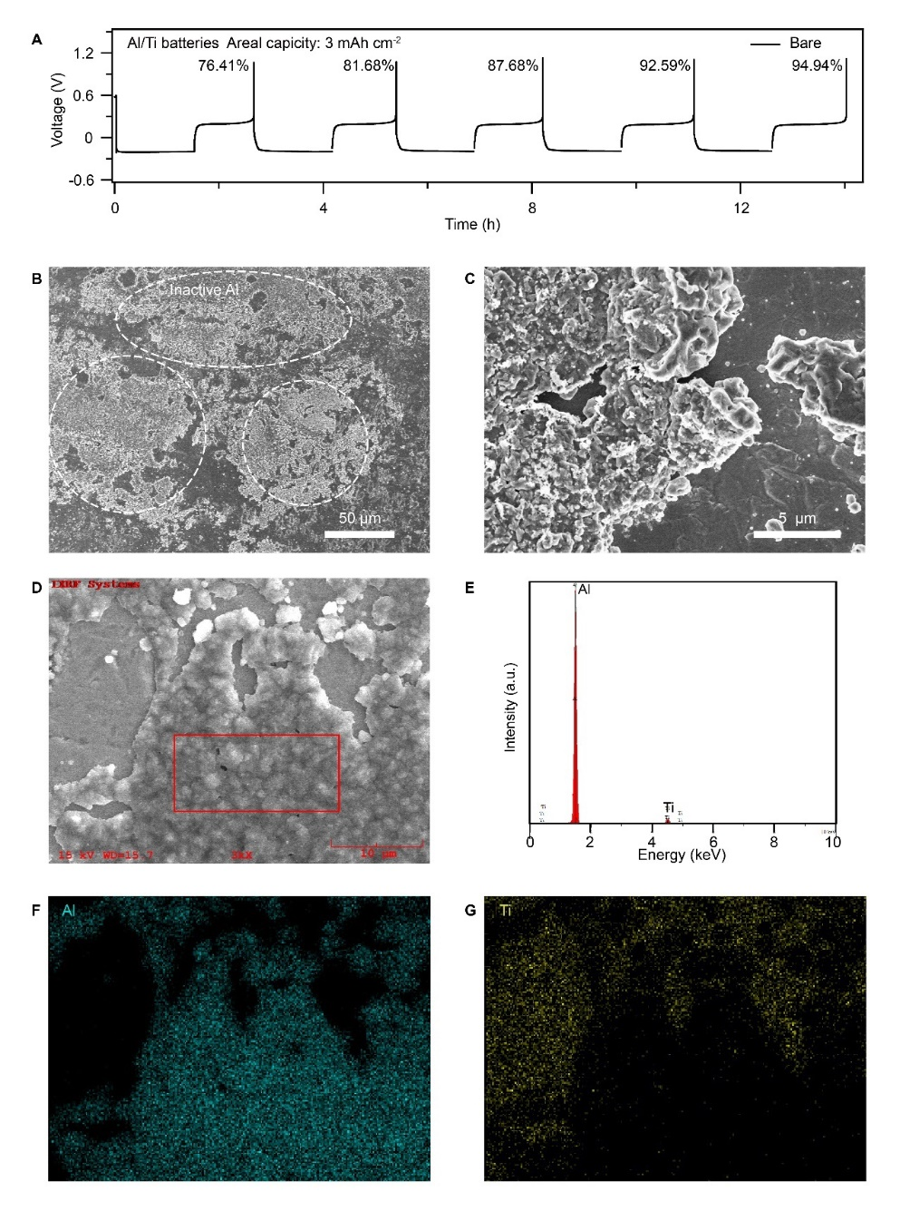
Fig. S4. Inactive Al accumulation during cycling in bare electrolyte. (A) Voltage profiles of Al/Ti batteries during first cycles in the bare electrolyte. (B and C) Microstructures of inactive Al generated in the bare electrolyte after 5 cycles. (D-G) EDX spectra (D-E) and elemental maps (F-G) of inactive Al left on the Ti current collector after 5 cycles.

These disordered Al-metal deposits have strong tendency to become electrochemically inactive because of the random dissolution sites and poor electro-conductive connections insides the bulk deposits during the high areal capacity stripping process. The average plating/stripping Coulombic efficiency (CE) of Al-metal is 86.66% in bare [EMIm]Cl/AlCl₃ electrolyte under deep cycling condition of 3 mAh cm⁻², and large areas of inactive Al (>50 µm wide) are left on the planar Ti current collector under 1.0 V cut-off voltage after 5 cycles (fig. S4).
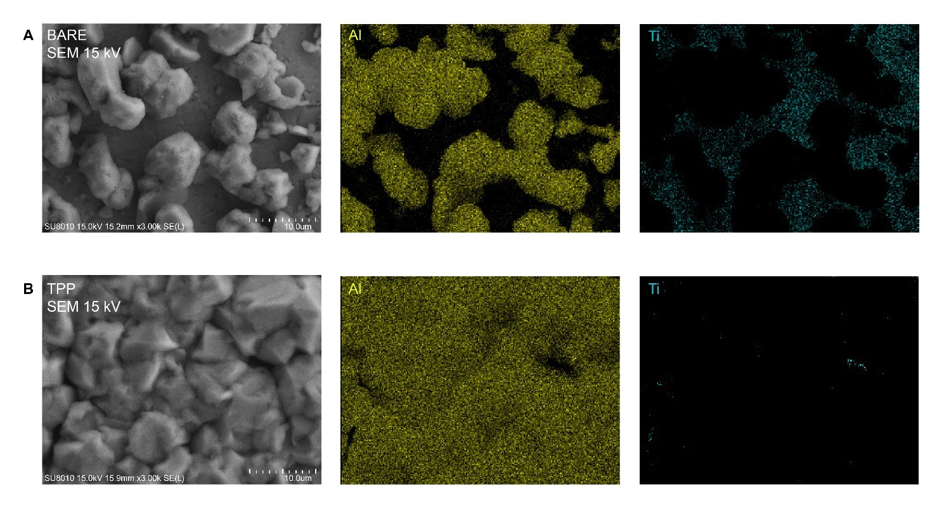
Fig. S5. SEM and corresponding elemental maps of Al deposits in bare electrolyte (A) and TPP mediated electrolyte (B). Current density: 1 mA cm⁻². Areal capacity: 3 mAh cm⁻².
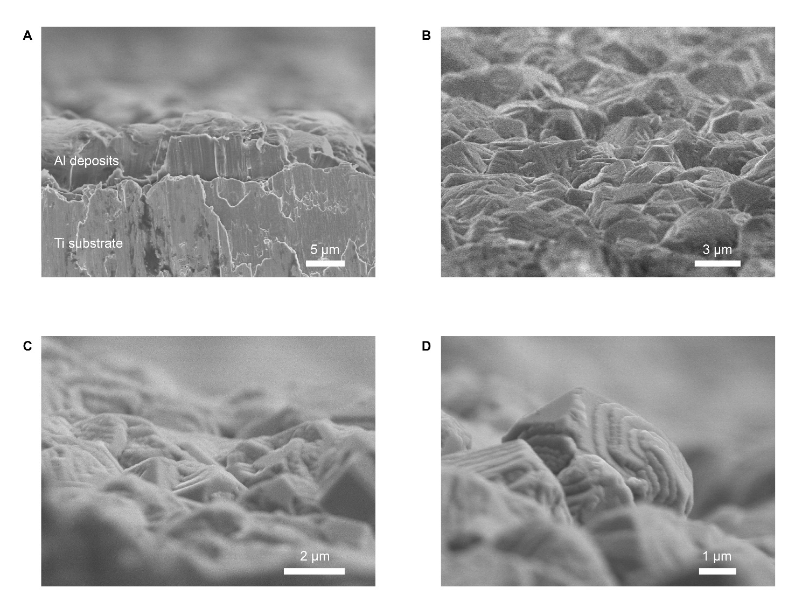
Fig. S6. Side view SEM images of Al deposits under the mediation of TPP. Areal capacity: 3 mAh cm⁻².

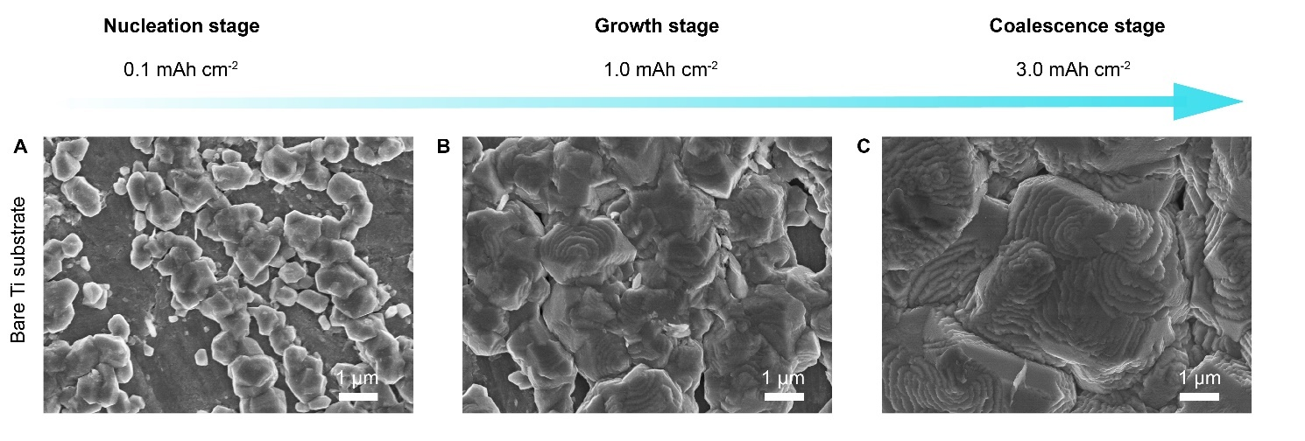
Fig. S7. The high-areal Al electrodeposition using TPP-mediated electrolyte. (A-C) Nucleation (A), growth (B) and coalescence (C) of Al-metal deposits on a bare Ti current collector.

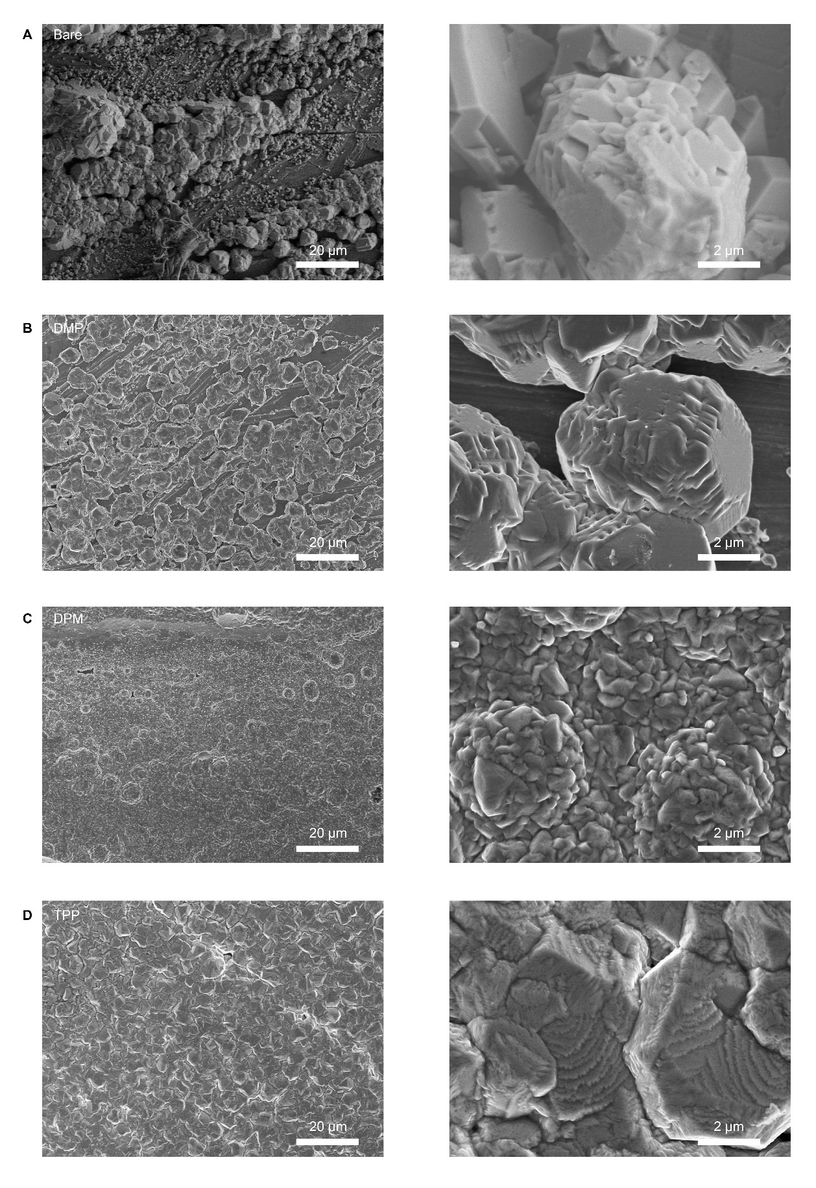
Fig. S8. Comparison of the deposition morphology under the mediation of different ligands. (A-D) SEM images of Al deposits in bare electrolyte (A), DMP mediated electrolyte (B), DPM mediated electrolyte (C) and TPP mediated electrolyte (D).

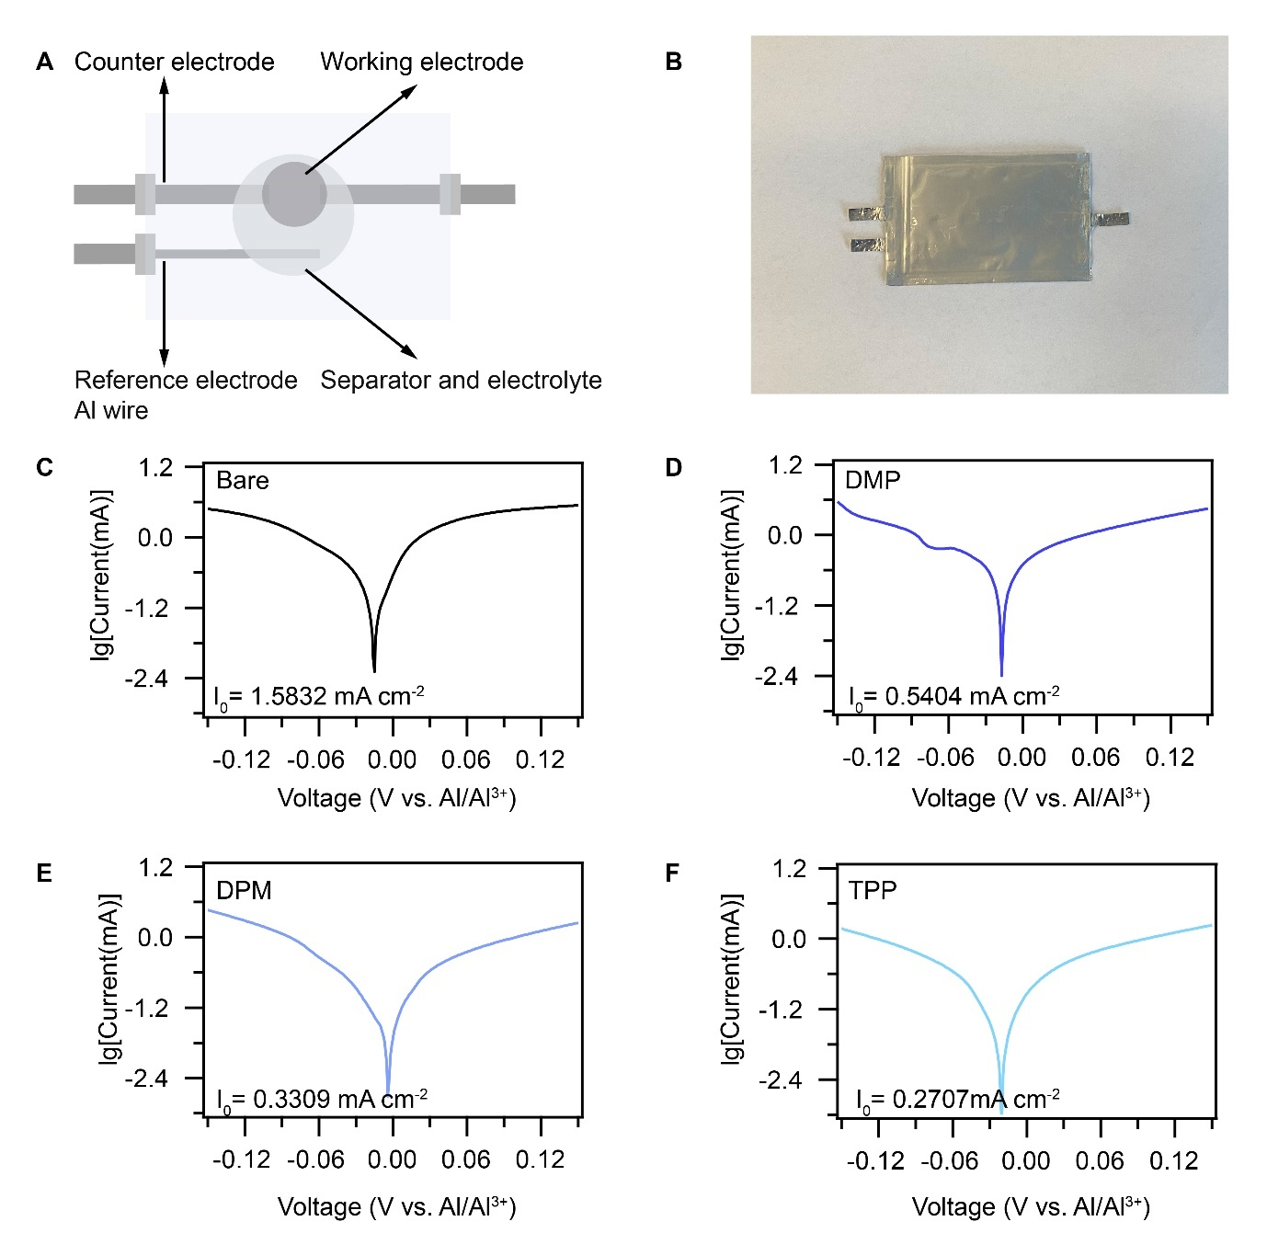
Fig. S9. Comparison of exchange current densities (I₀). (A) Tafel plots measured in customized 3-electrode pouch cells. (B) Optical image of the 3-electrode pouch cell. (C-F) Tafel plots of bare electrolyte (C), DMP mediated electrolyte (D), DPM mediated electrolyte (E) and TPP mediated electrolyte (F).

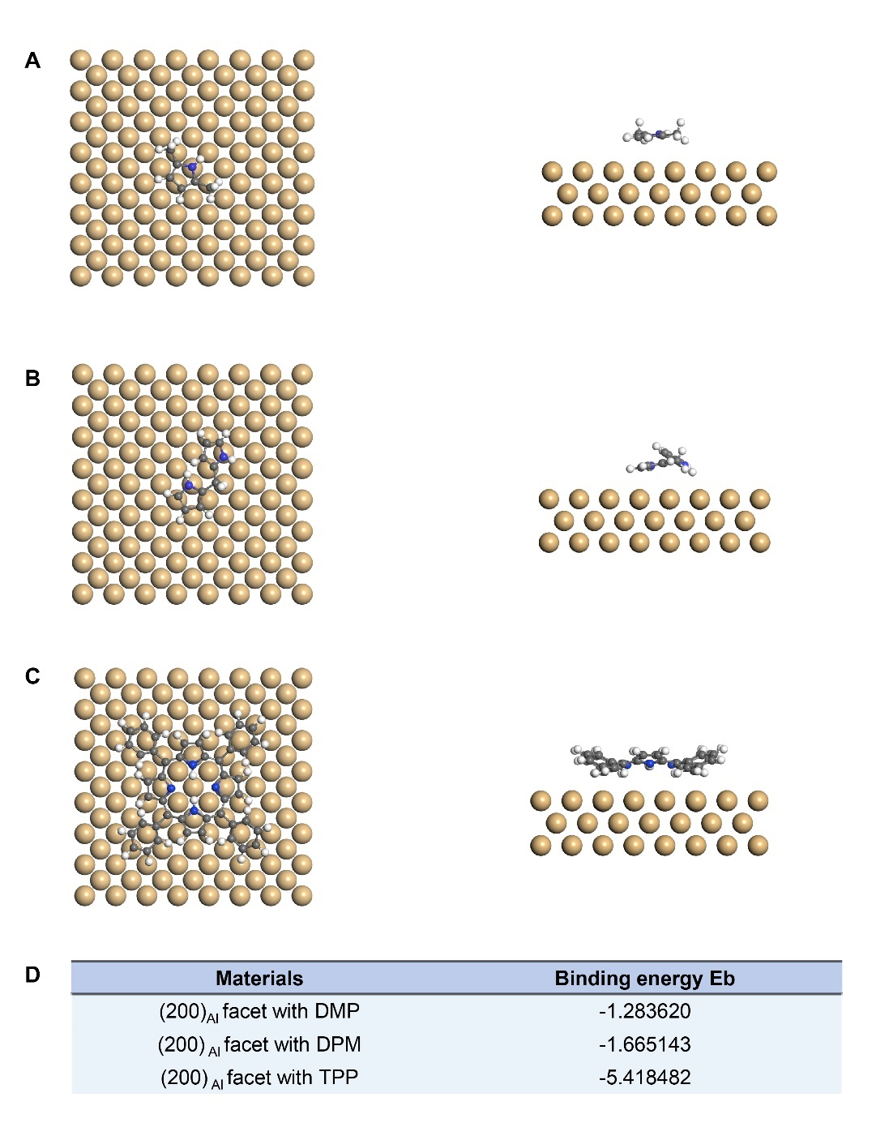
Fig. S10. Adsorption of different ligands at (200)_{Al} facet. (A-C) Adsorption configurations of DMP ligand (a), DPM ligand (b) and TPP ligand (c) at (200)_{Al} facet. (D) Binding energies between ligands and (200)_{Al} facet.

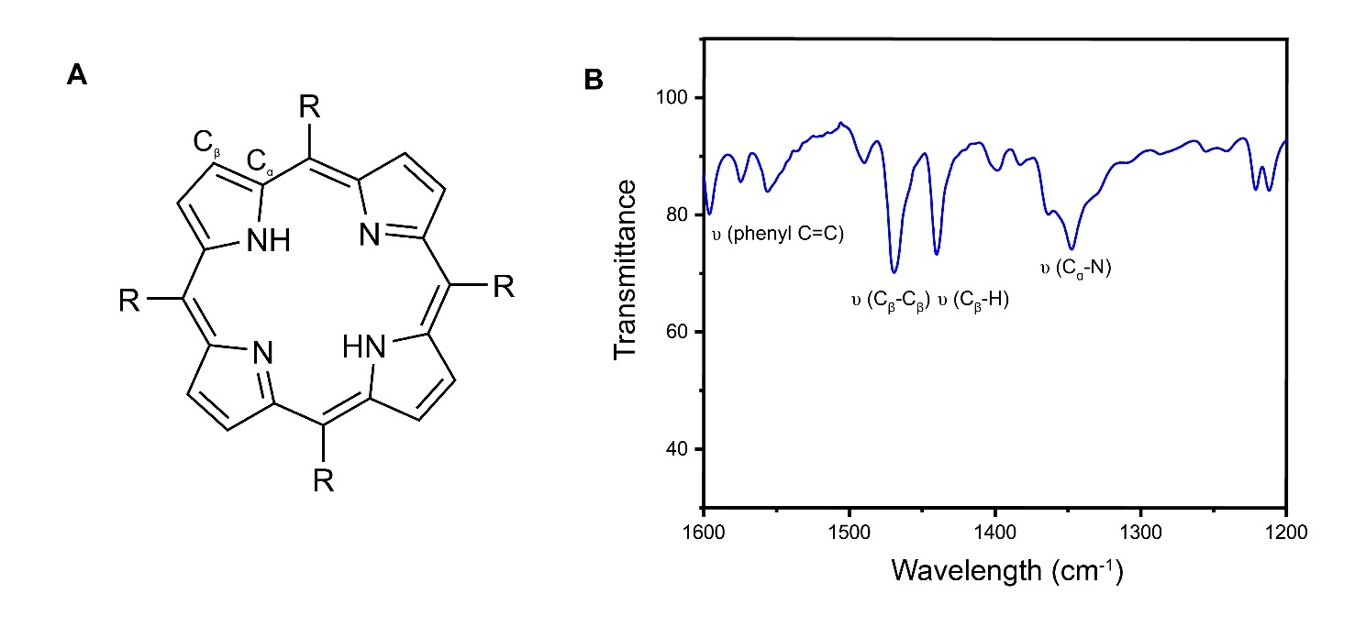
Fig. S11. Molecular structure and FTIR spectra of the TPP ligand. (A) Chemical structure of TPP ligand. (B) Conventional FTIR spectra of the TPP powder.

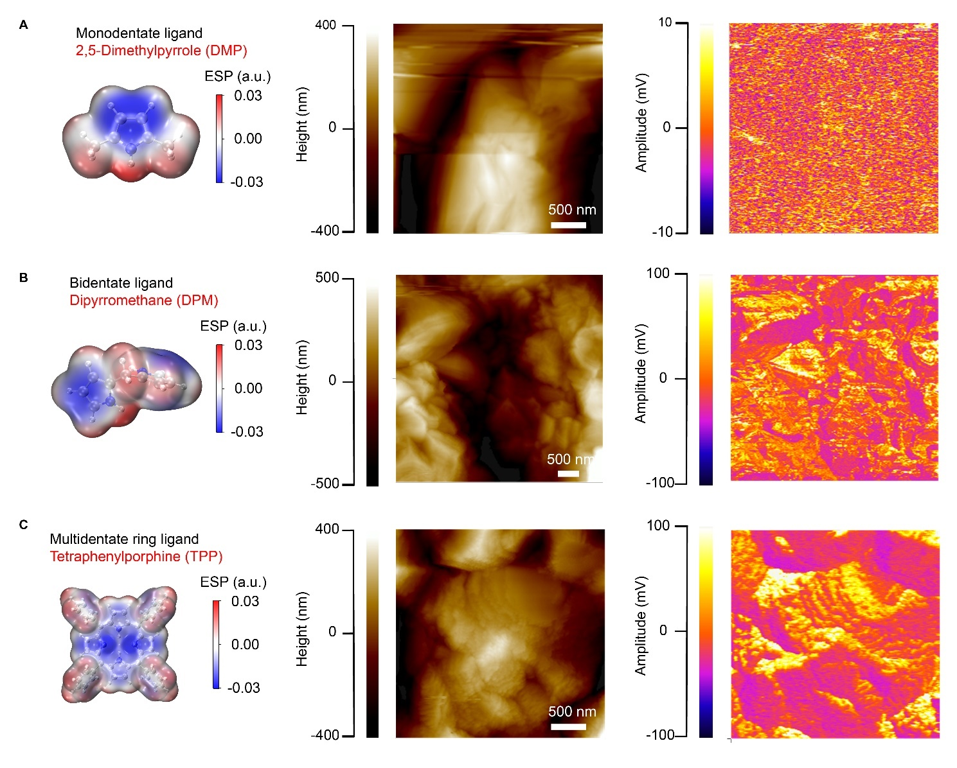
Fig. S12. AFM-IR characterizations on Al deposits formed in different electrolytes. (A-C) AFM topography map and the corresponding IR absorption mapping of C-N bond stretching on the Al deposits under the mediation of DMP (A), DPM (B) and TPP (C).

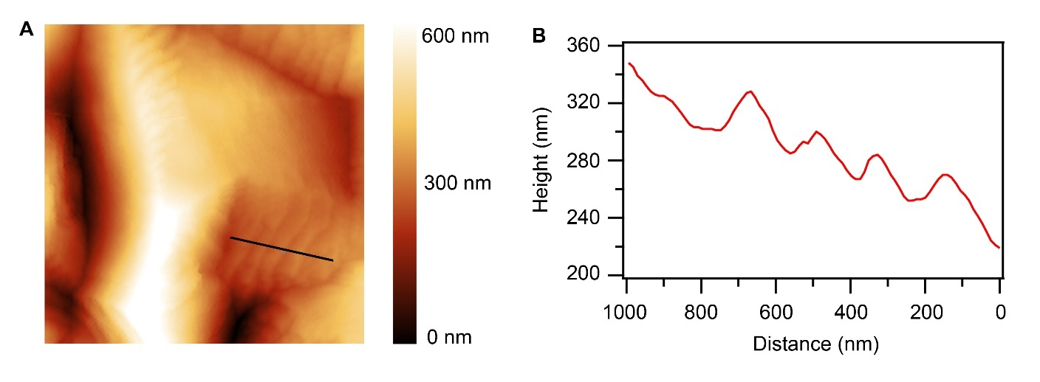
Fig. S13. Topographical image of Al deposits under the step-flow growth pattern. (A and B) AFM image (A) and the height profile (B) of the Al deposits along the black line marked in (A).

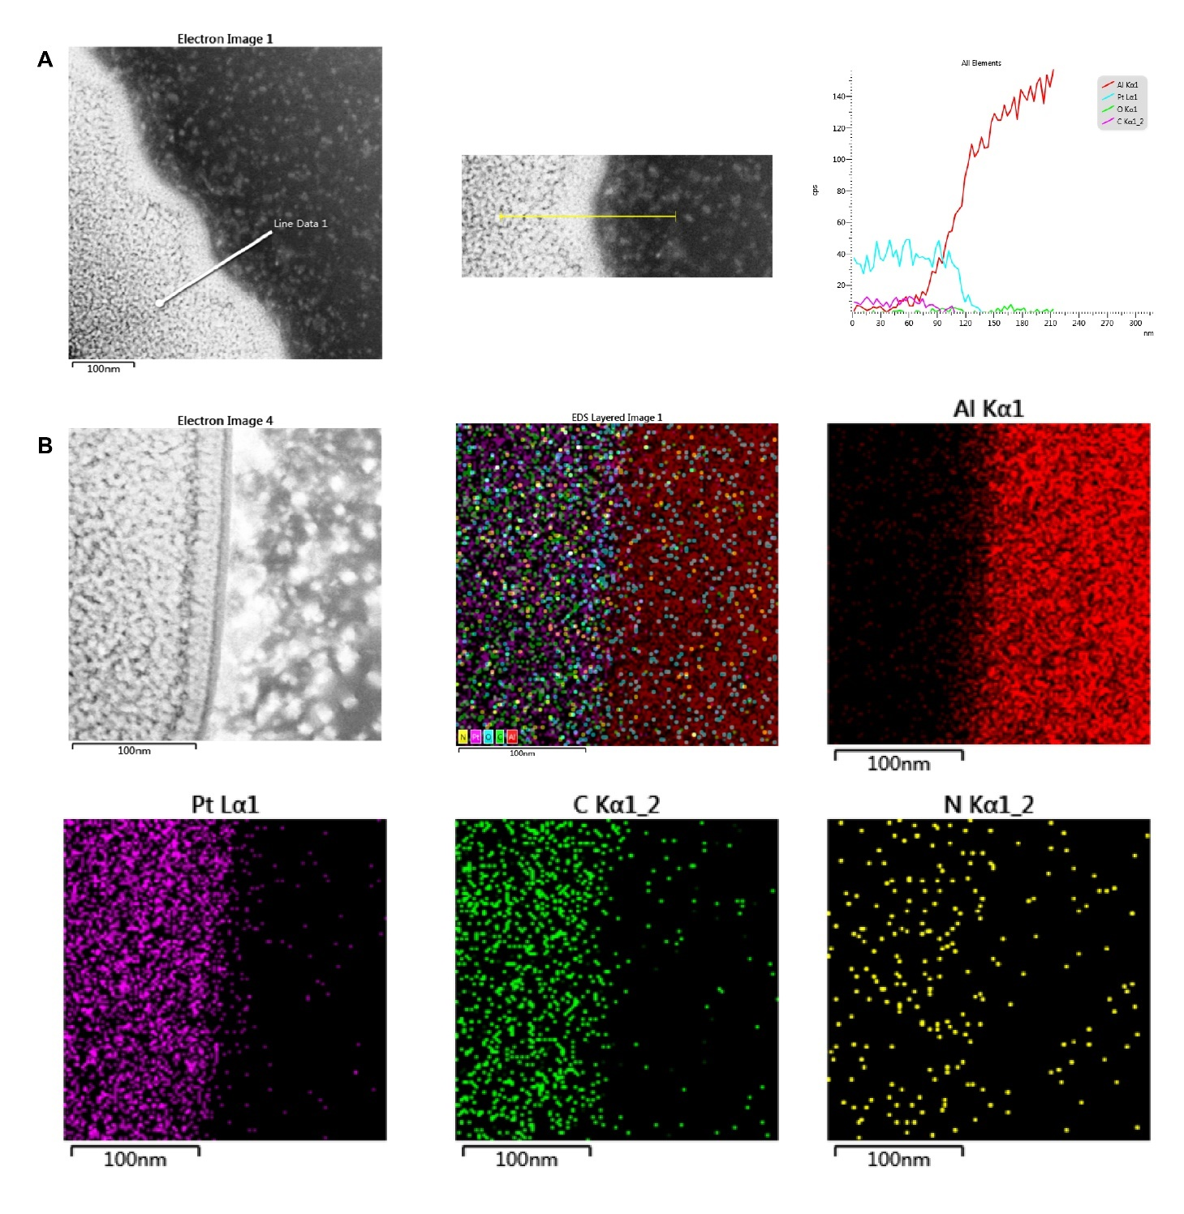
Fig. S14. Morphology and compositional mapping of the TPP induced interphase. (A) EDS line scan of Al deposits in TPP-mediated electrolyte. (B) EDS mapping of the Al anode interface with terrace/edge microstructures.

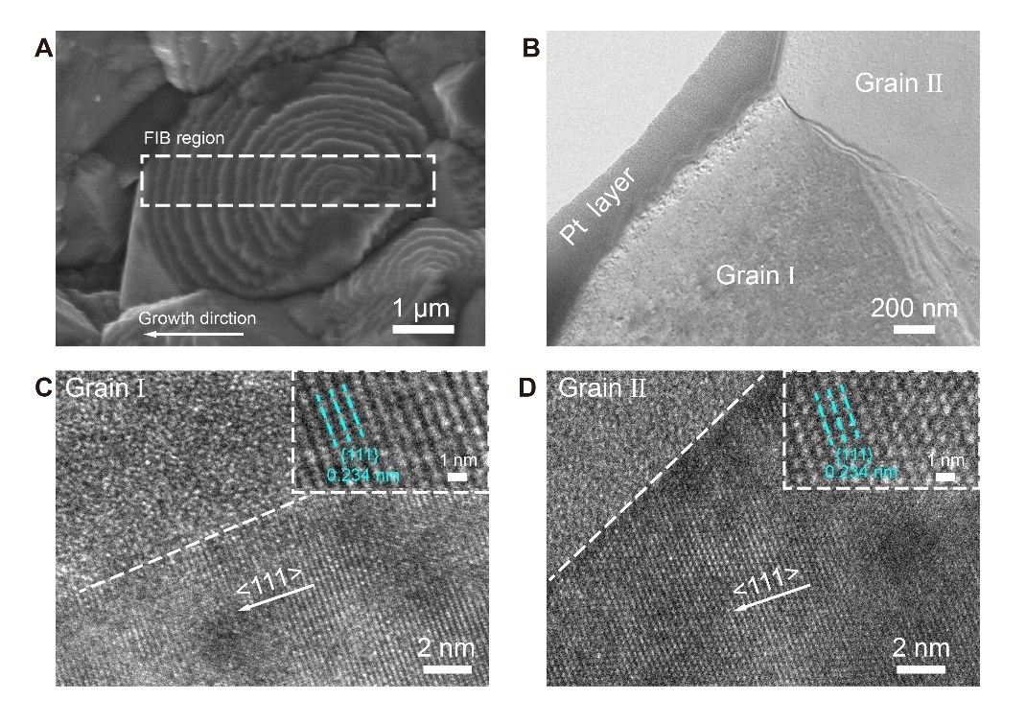
Fig. S15. Magnified TEM images of Al deposits composed of several grains at high resolution.

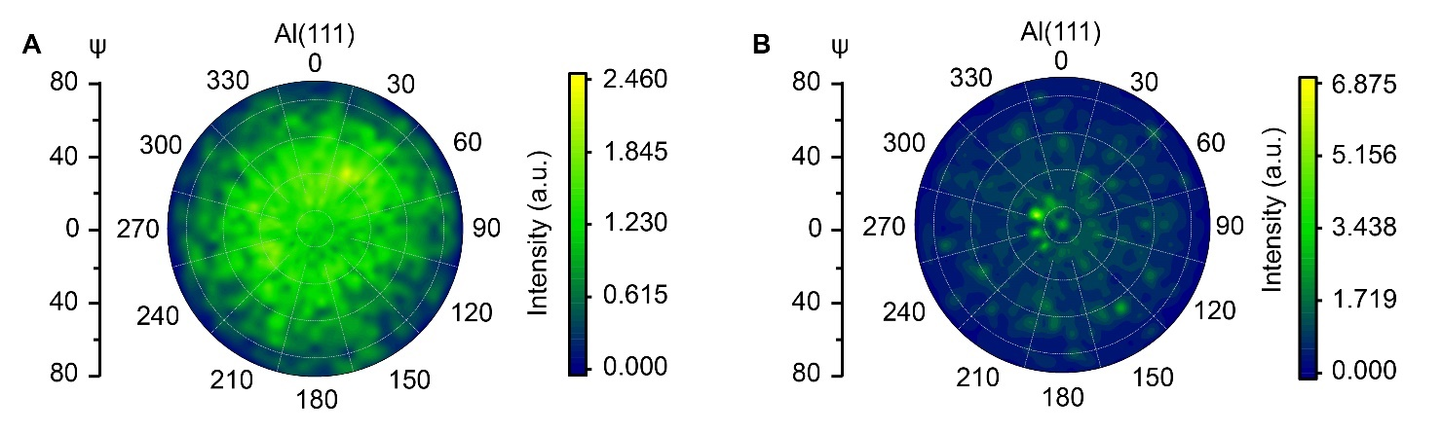
Fig. S16. Pole figures of the Al deposits in different electrolyte. (A and B) (111) plane pole figures of the Al deposits in bare electrolyte (A) and in TTP-mediated electrolyte (B).

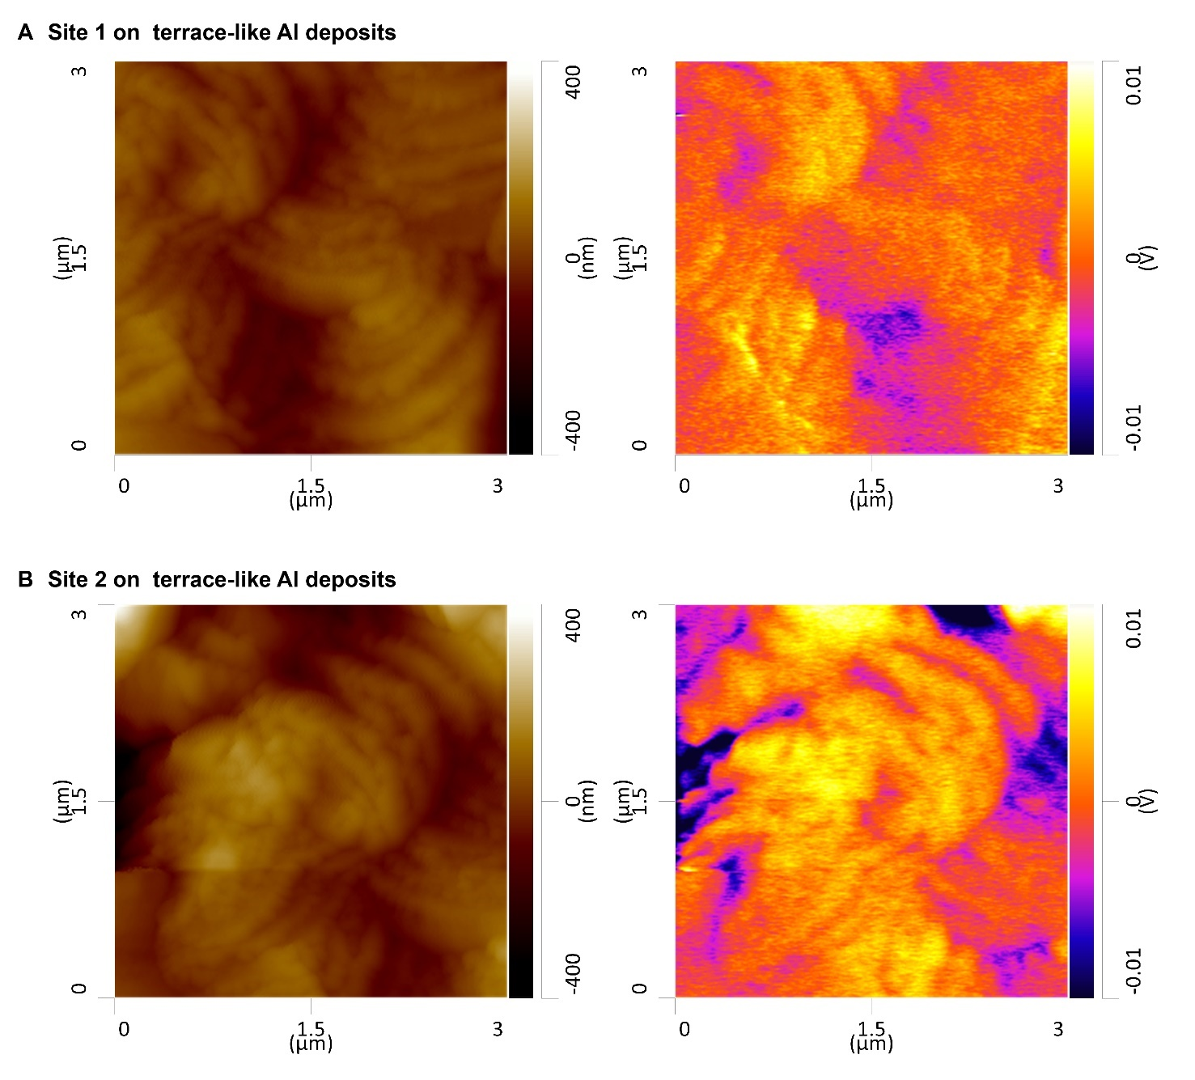
Fig. S17. (A and B) AFM topography (left) and CPD maps (right) of terrace-like Al deposits at site 1 (A) and site 2 (B).
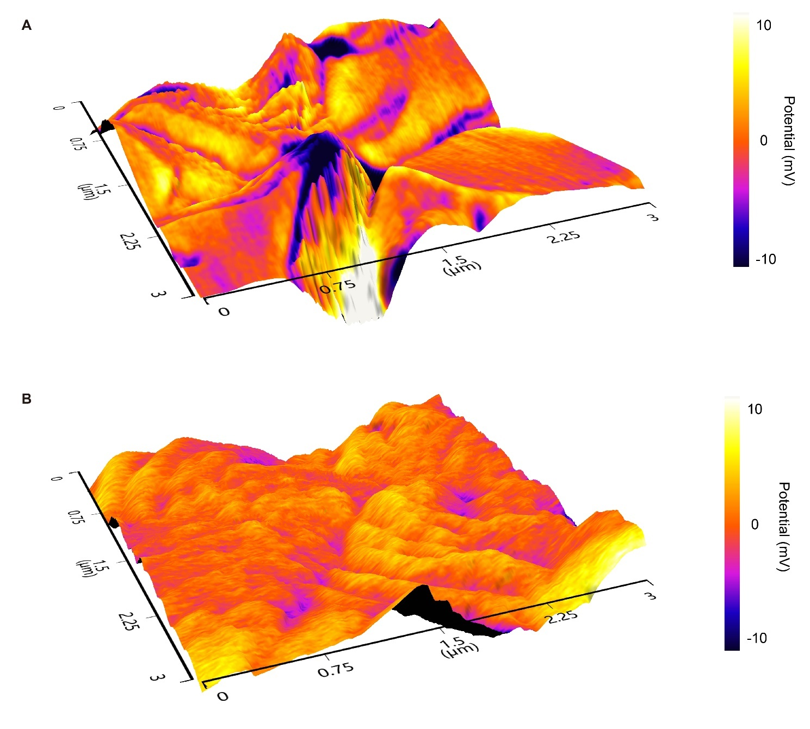
Fig. S18. (A and B) 3D height-contact potential difference mapping of Al deposits in bare electrolyte (A) and in TTP-mediated electrolyte (B).

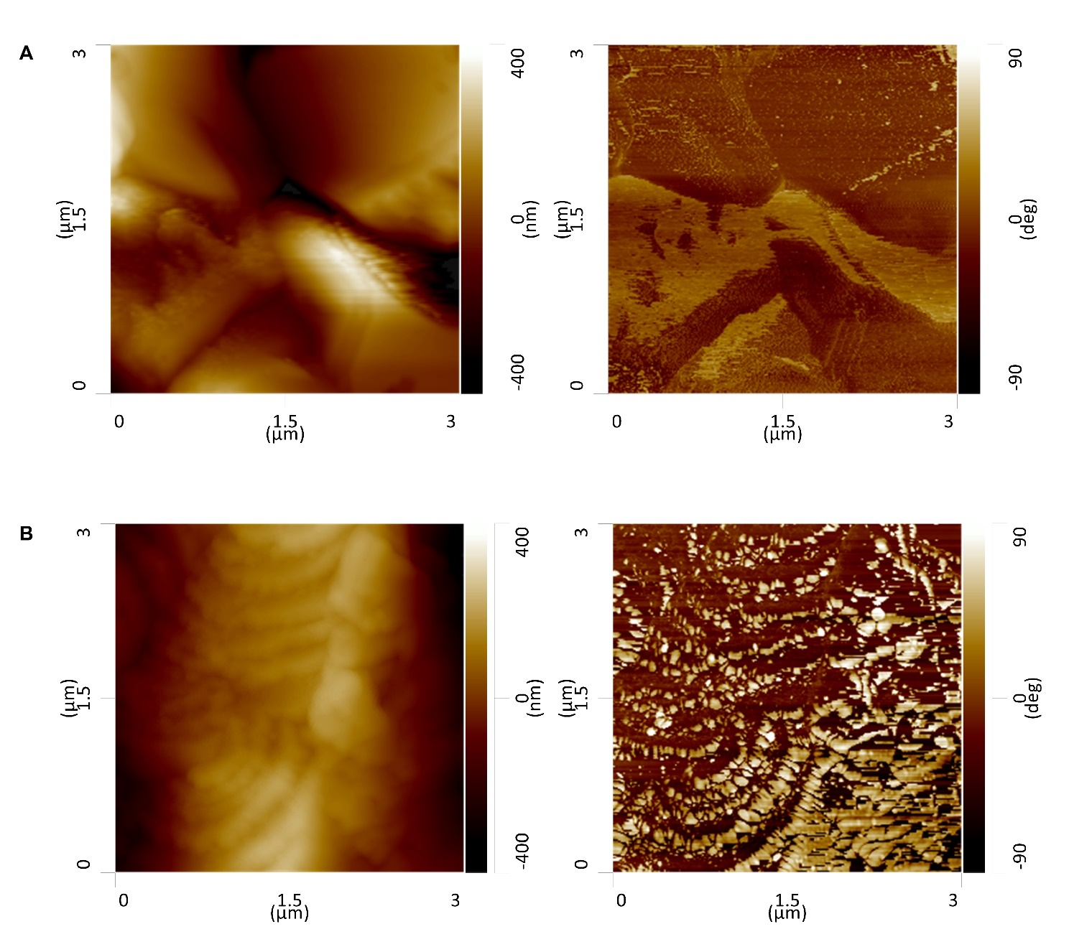
Fig. S19. (A and B) Height and phase images of Al deposits in bare electrolyte (A) and in TTP-mediated electrolyte (B).

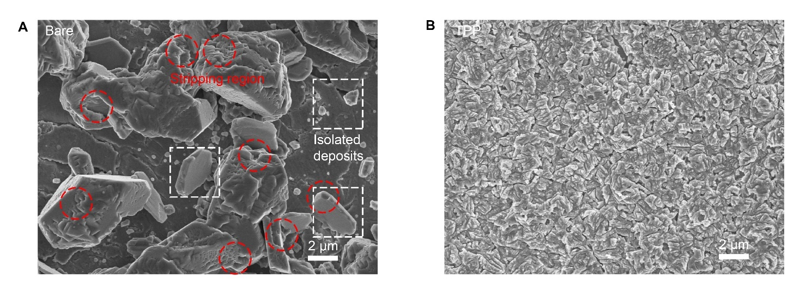Fig. S20. The morphology of deposits after shallow stripping process. (A and B) 3 mAh cm⁻² Al-metal was pre-deposited on the Ti current collector, and then 1 mAh cm⁻² Al-metal was stripped. (A) in bare electrolyte; (B) in TPP mediated electrolyte.

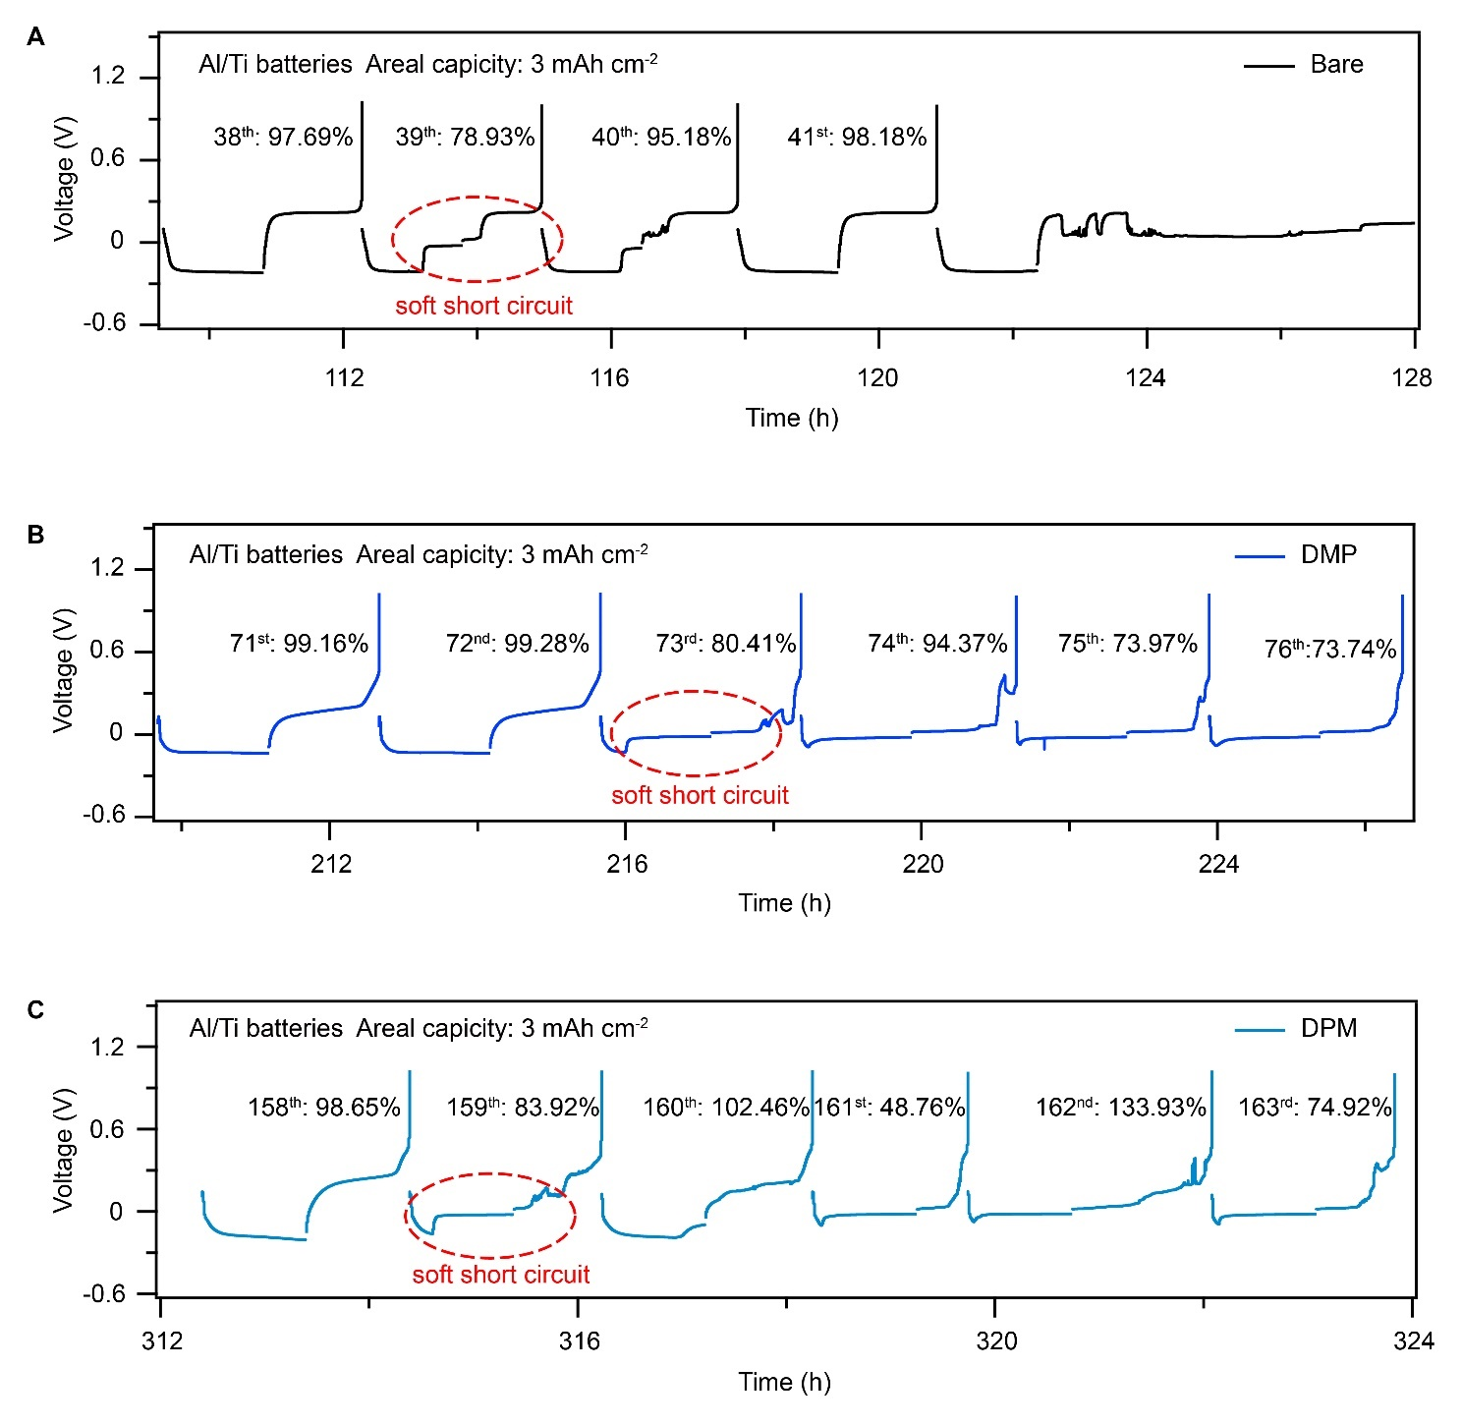
Fig. S21. The failure process of Al/Ti batteries using different electrolytes. (A-C) Voltage profiles measured during Al depositing/stripping at a high areal capacity of 3 mAh cm⁻². Soft short circuits occurred before the final failures in these bare (A), DMP-mediated (B) and DPM-mediated (C) electrolytes.

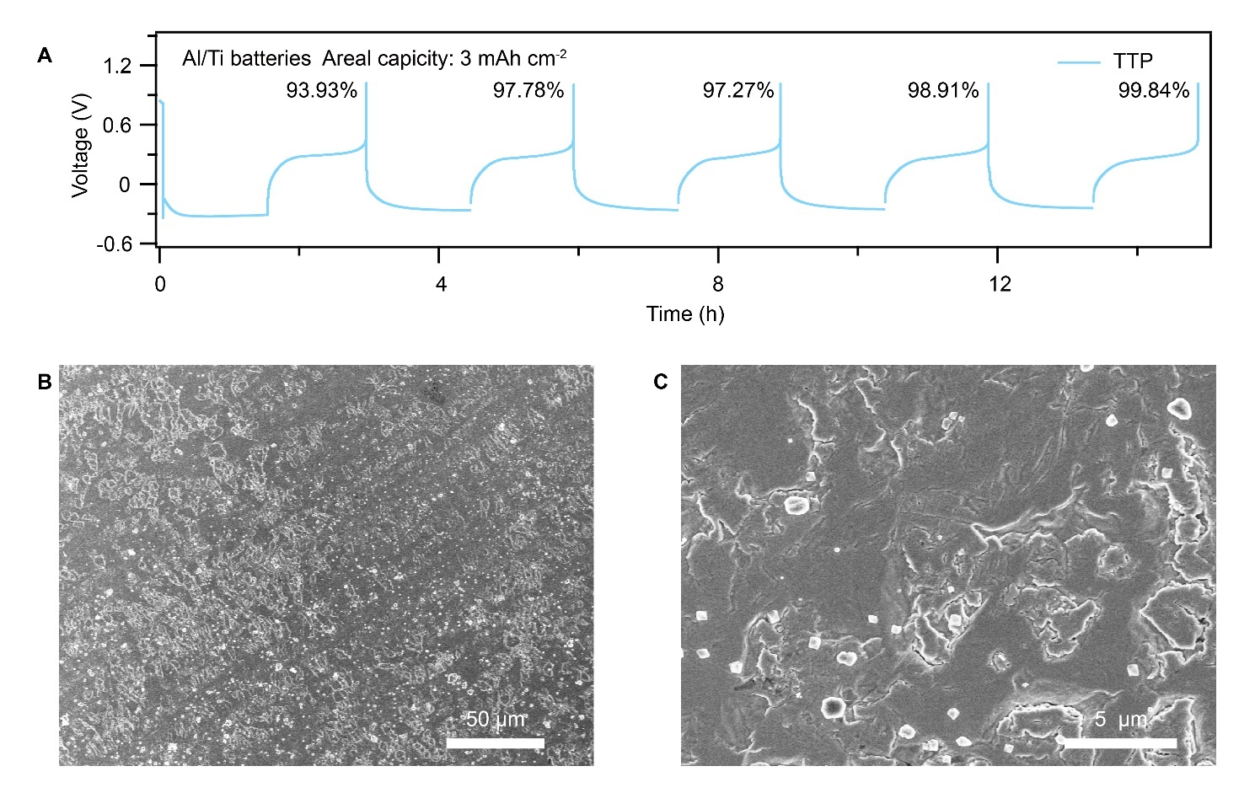
Fig. S22. High efficiency Al metal plating/stripping under step-flow growth pattern. (A) Voltage profiles of Al/Ti batteries during first cycles in the TPP mediated electrolyte. (B and C) Almost no inactive Al left on the Ti current collector after 5 cycles.
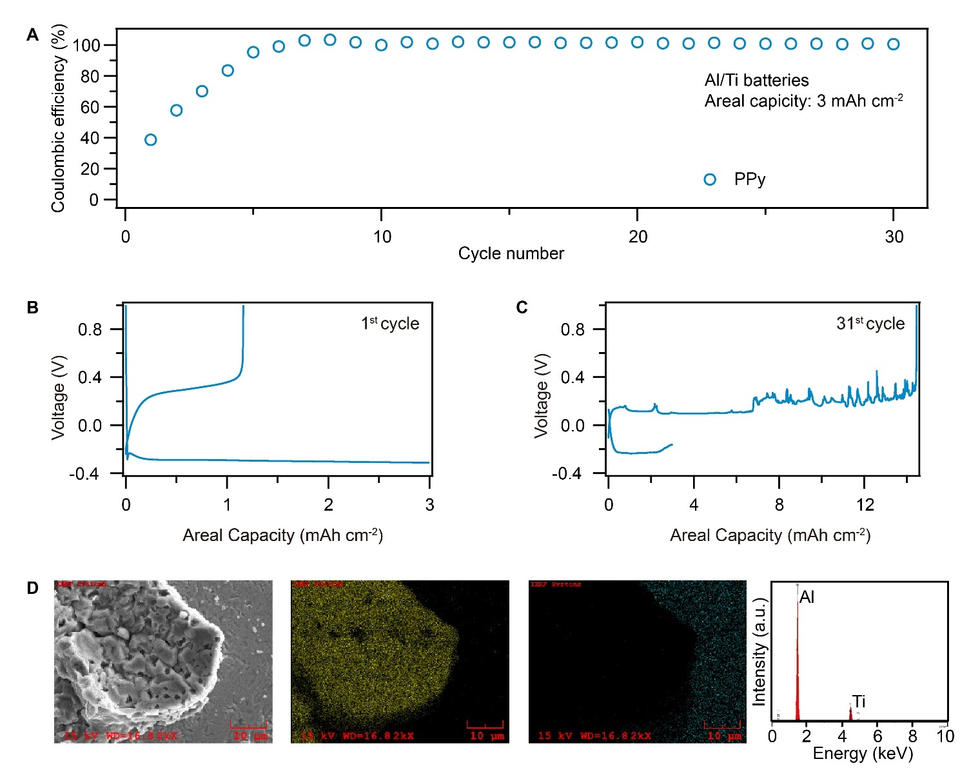
Fig. S23. Al metal plating/stripping in polypyrrole mediated electrolyte. (A) CE of Al plating/stripping in polypyrrole mediated electrolyte. Current density: 2 mA cm⁻². Areal capacity: 3 mAh cm⁻². (B and C) Voltage profiles of Al/Ti batteries at 1st (B) and 31st (C) cycle in the polypyrrole mediated electrolyte. (D) Inactive Al formation on the Ti current collector after only 1 cycle. Elemental maps and EDX spectra confirm the inactive residue on the Ti current collector is metallic Al.

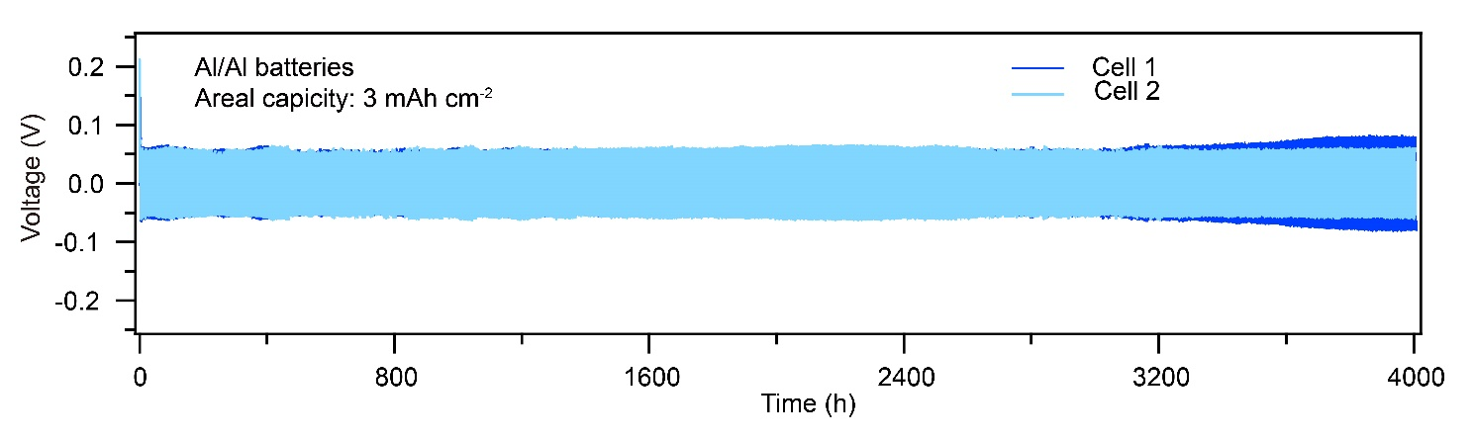
Fig. S24. Cycling performance of Al symmetric cell using 20 µm Al anodes. 1 mA cm⁻². Areal capacity: 3 mAh cm⁻². Two parallel Al symmetric cells can further confirm the excellent performance repeatability under step-flow growth/stripping pattern.

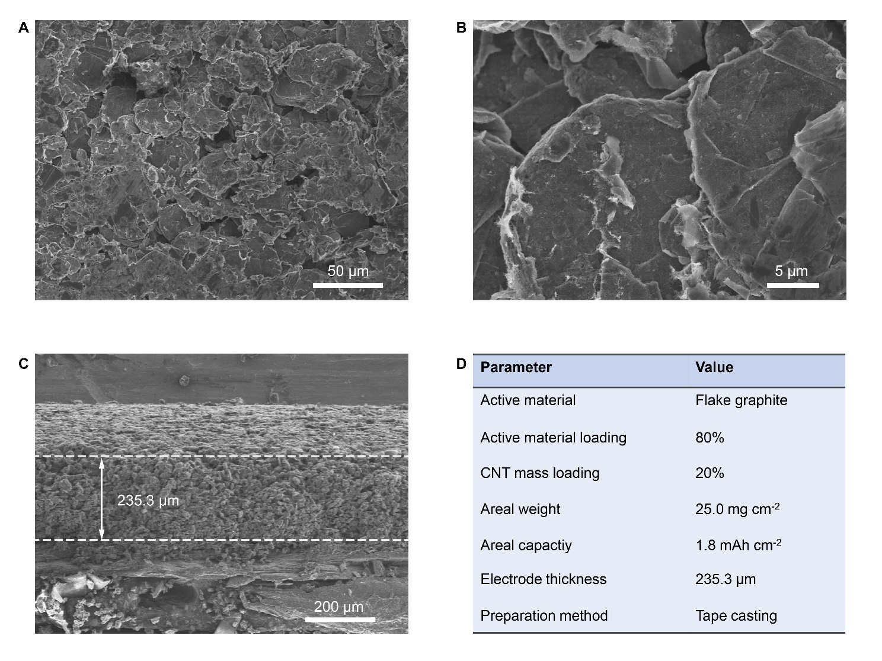
Fig. S25. High mass loading graphite cathode. (A-C) Top view SEM images (A and B) and side view SEM images (C) of the binder-free graphite cathode. (D) Parameters of the high mass loading graphite cathode.

Carbon nanotube can effectively provide the physical links and electrical pathways between graphite flakes, and avoid the use of polymeric binders incompatible with AlCl₃ based ionic liquids
Fig. S26. High mass loading PANI cathode. (A-C) Top view SEM images (A and B) and side view SEM images (C) of the freestanding PANI cathode. (D) Parameters of the high mass loading PANI cathode.

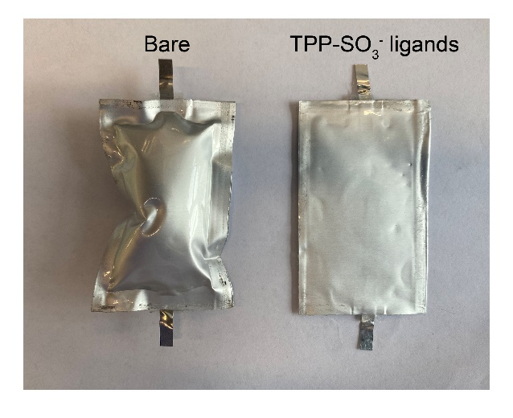
Fig. S27. Optical images of Zn/PANI full batteries using different electrolytes after cycling.

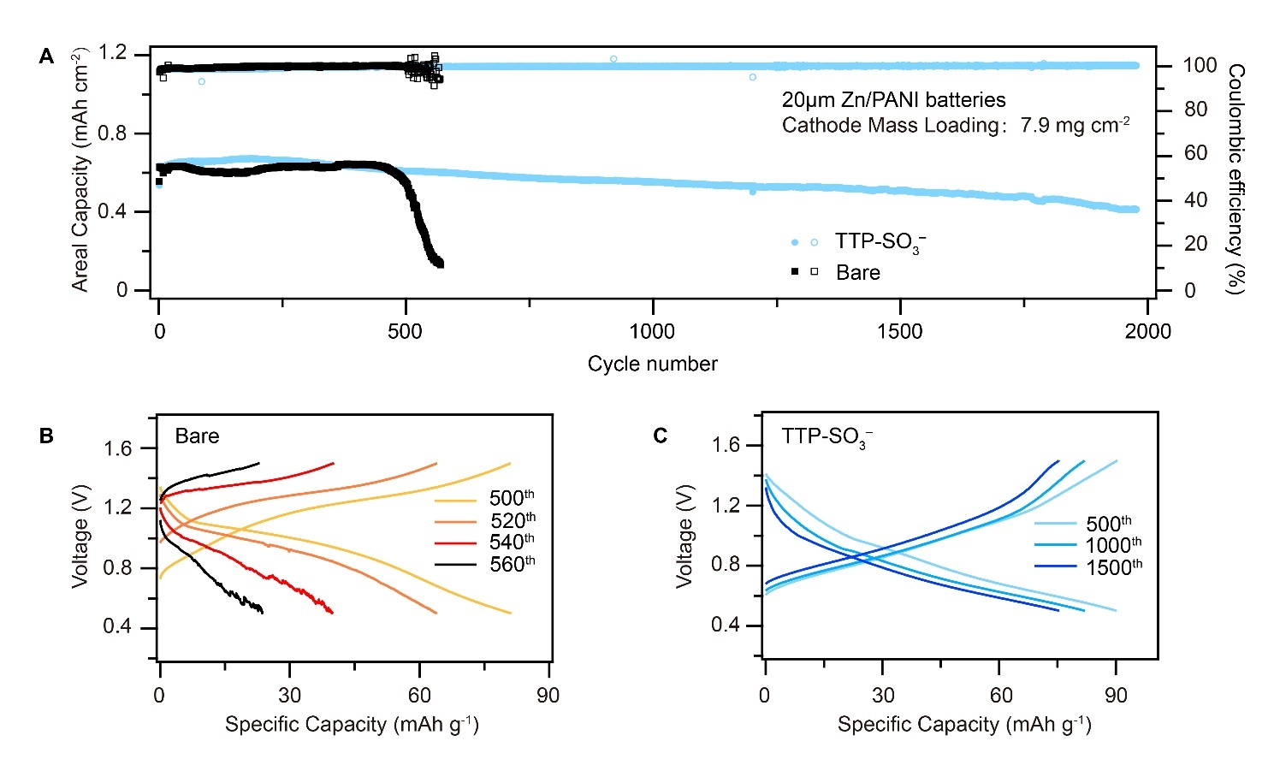
Fig. S28. Zn/PANI full cells under moderate areal capacity. (A) Long-term cycling performance of full cells using 20 µm Zn anodes and PANI cathodes (0.6 mAh cm⁻²). (B and C) The corresponding charge/discharge curves of Zn/PANI using bare electrolyte (B) or TTP-SO₃⁻ mediated electrolyte (C) at different cycles.

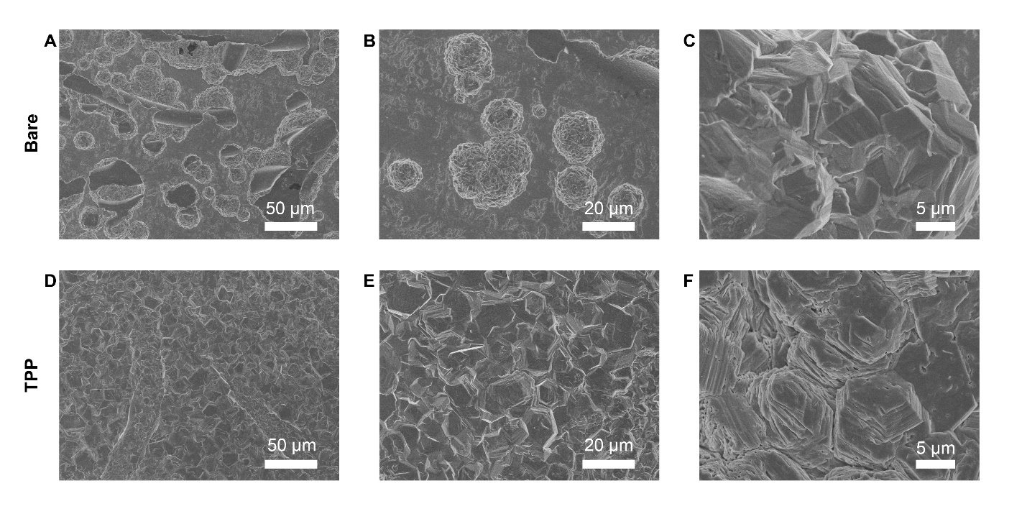
Fig. S29. Morphology of Mg deposits under the mediation of different ligands. (A-C) SEM images of Mg deposits in bare electrolyte. (D-F) SEM images of Mg deposits in TPP mediated electrolyte Current density: 1 mA cm⁻². Areal capacity: 3 mAh cm⁻².

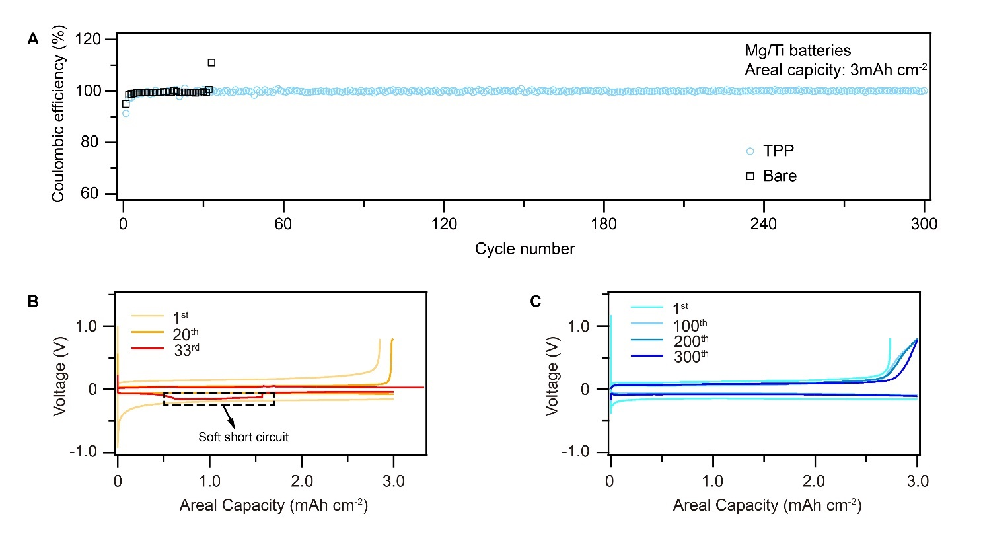
Fig. S30. Mg plating/stripping behavior in different electrolytes. (A) CE of Mg plating/stripping in different electrolytes. Current density: 2 mA cm⁻². Areal capacity: 3 mAh cm⁻². (B and C) Voltage profiles of Mg/Ti batteries using bare electrolyte (B) or TPP-SO₃⁻ mediated electrolyte (C) at different cycles.

Table S1. Estimated energy density of Al/C full cells.

 | Parameter | Value
Anode | Density | 2.7 g cm⁻³
Anode | Thick | 100 µm
Anode | Mass loading | 27 mg cm⁻²
Cathode | Specific capacity | 100 mAh g⁻¹
Cathode | Mass loading | 10 mg mAh⁻¹
Full cell | Average voltage | 1.75 V
The calculation of energy density is based on
$$E_{m}=\frac{VC}{\sum{M_{i}}}=\frac{V×\frac{C}{A}}{\frac{M_{cathode}}{A}+\frac{M_{anode}}{A}}$$
where $V$ is the average output voltage, C is the areal capacity, A is the electrode area, $M_{i}$ are the mass of cell components including the cathodes and anodes.

Table S2. Comparison of Al CE after electrolyte/anode modifications
 | Modification | Al CE | Test condition | Ref.
Step-flow growth | rigid conjugated ligands | 99.72% (650 cycles) | 2 mA cm^{–2}  3 mAh cm^{–2} | This work
Electrolyte designs | AlCl₃/EMIMCl | 91% (550 cycles) | 0.5 mA cm^{–2}  0.01 mAh cm^{–2} | ¹
Electrolyte designs | AlCl₃/Et₃NHCl | 95% (550 cycles) | 0.5 mA cm^{–2}  0.01 mAh cm^{–2} | ¹
Electrolyte designs | AlCl₃/[BMIM]Cl | 98.7% (50 cycles) | 0.4 mA cm^{–2}  0.4 mAh cm^{–2} | ²
Anode interface designs | 3D carbon paper | 88% (7 cycles) | 0.5 mA cm^{–2}  0.25 mAh cm^{–2} | ³
Anode interface designs | Cu current collector | ~ 96 % (100 cycles) | 0.4 mA cm^{–2}  0.4 mAh cm^{–2} | ⁴
Anode interface designs | Al-Cu composite anode | * ~ 100% (500 cycles)  * pre-deposit 4mAh cm^{–2} Al metal | 0.4 mA cm^{–2}  0.4 mAh cm^{–2} | ⁴
Anode interface designs | Carbon cloth host | 99.6% (900 cycles) | 3.2 mAh cm^{–2} | ⁵
Anode interface designs | Au nanosheets | 98.8% (80 cycles) | 0.5 mAh cm^{–2} | ⁶
Anode interface designs | Carbon cloth anode | 99.7 % (35 cycles) | 0.5 mA cm^{–2}  1.0 mAh cm^{–2} | ⁷

Table S3. Electrochemical performances of “state-of-the-art” Al-metal batteries
Modification |  | Anode | Cathode | Cathode  Areal capacity | Cycling performance | Ref.
Step-flow growth | rigid conjugated ligands | Anode free | Graphite  25.0 mg cm^{–2} | 1.82 mAh cm^{–2} | 95.11% capacity retention after 600 cycles | This work
Electrolyte designs | zirconium-based MOF | Al foil  50 μm | Graphite  9 mg cm^{–2} | * 0.63 mAh cm^{–2} | 2000 cycles | ⁸
Electrolyte designs | hydrated eutectic electrolyte | Al foil  100 μm | SO₃H doped PANI  1.4 mg cm^{–2} | * 0.26 mAh cm^{–2} | 300 cycles | ⁹
Electrolyte designs | AlCl₃/Et₃NHCl | Al foil | graphene  0.8 mg cm^{–2} | * 0.09 mAh cm^{–2} | 30000 cycles | ¹
Electrolyte designs | AlCl3/urea | Al foil  16 μm | Graphite  5 mg cm^{–2} | * 0.36 mAh cm^{–2} | 200 cycles | ¹⁰
Electrolyte designs | AlCl3/[BMIM]Cl | Al foil | V₂O₅ | - | 30 cycles | ²
Anode interface designs | PAN  separator | Al foil | pyrolytic graphite  4.71 mg cm⁻² | * 0.31 mAh cm^{–2} | 300 cycles | ¹¹
Anode interface designs | Oxide Film | Al foil  20 μm | graphene  ~1 mg cm⁻² | * 0.05 mAh cm^{–2} | 45000 cycles | ¹²
Anode interface designs | substrate bonding | Carbon cloth | graphene | *0.4-0.5 mAh cm^{–2} | 1000 cycles | ⁵
Anode interface designs | Au nanosheets | Anode free | Graphene  3-5 mg cm⁻² | *0.13-0.22 mAh cm^{–2} | 2000 cycles | ⁶
Anode interface designs | porous Al anode | Al foil  100 μm | Graphite  2 mg cm^{–2} | * 0.06 mAh cm^{–2} | 18000 cycles | ¹³
Anode interface designs | graphite current collector | graphite paper  50 μm | Graphite  6.5 mg cm^{–2} | * 0.35 mAh cm^{–2} | 1000 cycles | ¹⁴
Full cell design | graphitic foam cathode | Al foil  250 μm | graphitic foam  4 mg cm^{–2} | * 0.24 mAh cm^{–2} | 7500 cycles | ¹⁵
Full cell design | graphene film cathode | Al foil  20 μm | graphene film  1.2-1.5 mg cm^{–2} | 0.14-0.18 mAh cm^{–2} | 25000 cycles | ¹⁶
Full cell design | graphite flakes | Al foil  20 μm | natural graphite flakes  4 mg cm^{–2} | * 0.4 mAh cm^{–2} | 1100 cycles | ¹⁷
Full cell design | Organic cathode | Al foil | Phenanthrenequinone(PQ)0.5 mg cm^{–2} | * 0.045 mAh cm^{–2} | 5000 cycles | ¹⁸
Full cell design | Organic cathode | Al foil | PQ + graphite  2 mg cm^{–2} | * 0.25 mAh cm^{–2} | 100 cycles | ¹⁸
Full cell design | Organic cathode | Al foil | PQ + graphite  9 mg cm^{–2} | * 0.90 mAh cm^{–2} | 100 cycles | ¹⁸
Full cell design | ITO Current Collectors | Al foil  50 μm | Graphite  3 mg cm^{–2} | * 0.18 mAh cm^{–2} | 1500 cycles | ¹⁹
Full cell design | a-TiS₄ cathode | Al foil  100 μm | a-TiS₄  5.6 mg cm^{–2} | * 1.12 mAh cm^{–2} | 1000 cycles | ²⁰
* estimated areal capacity based on specific discharge capacity and mass loading of cathode materials

1. Xu, H. et al. Low-cost AlCl3/Et3NHCl electrolyte for high-performance aluminum-ion battery. Energy Storage Materials 17, 38-45 (2019).
2. Wu, F., Zhu, N., Bai, Y., Gao, Y. & Wu, C. An interface-reconstruction effect for rechargeable aluminum battery in ionic liquid electrolyte to enhance cycling performances. Green Energy & Environment 3, 71-77 (2018).
3. Muñoz-Torrero, D. et al. Investigation of different anode materials for aluminium rechargeable batteries. Journal of Power Sources 374, 77-83 (2018).
4. Jiao, H. et al. Cu-Al Composite as the Negative Electrode for Long-life Al-Ion Batteries. Journal of The Electrochemical Society 166, A3539-A3545 (2019).
5. Zheng, J. et al. Regulating electrodeposition morphology in high-capacity aluminium and zinc battery anodes using interfacial metal–substrate bonding. Nature Energy 6, 398-406 (2021).
6. Zhao, Q., Zheng, J., Deng, Y. & Archer, L. Regulating the growth of aluminum electrodeposits: towards anode-free Al batteries. Journal of Materials Chemistry A 8, 23231-23238 (2020).
7. Li, J. et al. Electrodeposition of a dendrite-free 3D Al anode for improving cycling of an aluminum–graphite battery. Carbon Energy 4, 155-169 (2022).
8. Huang, Z. et al. Stable Quasi-Solid-State Aluminum Batteries. Advanced Materials 34, 2104557 (2022).
9. Meng, P. et al. A Low-Cost and Air-Stable Rechargeable Aluminum-Ion Battery. Advanced Materials 34, 2106511 (2022).
10. Angell, M. et al. High Coulombic efficiency aluminum-ion battery using an AlCl3-urea ionic liquid analog electrolyte. Proceedings of the National Academy of Sciences 114, 834-839 (2017).
11. Elia, G.A. et al. Polyacrylonitrile Separator for High-Performance Aluminum Batteries with Improved Interface Stability. ACS Applied Materials & Interfaces 9, 38381-38389 (2017).
12. Chen, H. et al. Oxide Film Efficiently Suppresses Dendrite Growth in Aluminum-Ion Battery. ACS Applied Materials & Interfaces 9, 22628-22634 (2017).
13. Long, Y. et al. Suppressing Al dendrite growth towards a long-life Al-metal battery. Energy Storage Materials 34, 194-202 (2021).
14. Wang, L. et al. Initial-anode-free aluminum ion batteries: In-depth monitoring and mechanism studies. Energy Storage Materials 44, 461-468 (2022).
15. Lin, M.-C. et al. An ultrafast rechargeable aluminium-ion battery. Nature 520, 324-328 (2015).
16. Chen, H. et al. Ultrafast all-climate aluminum-graphene battery with quarter-million cycle life. Science Advances 3, eaao7233 (2017).
17. Wang, D.-Y. et al. Advanced rechargeable aluminium ion battery with a high-quality natural graphite cathode. Nature Communications 8, 14283 (2017).
18. Kim, D.J. et al. Rechargeable aluminium organic batteries. Nature Energy 4, 51-59 (2019).
19. Chen, L.-L. et al. Nonmetal Current Collectors: The Key Component for High-Energy-Density Aluminum Batteries. Advanced Materials 32, 2001212 (2020).
20. Lin, Z. et al. Amorphous anion-rich titanium polysulfides for aluminum-ion batteries. Science Advances 7, eabg6314 (2021).
References and Notes

