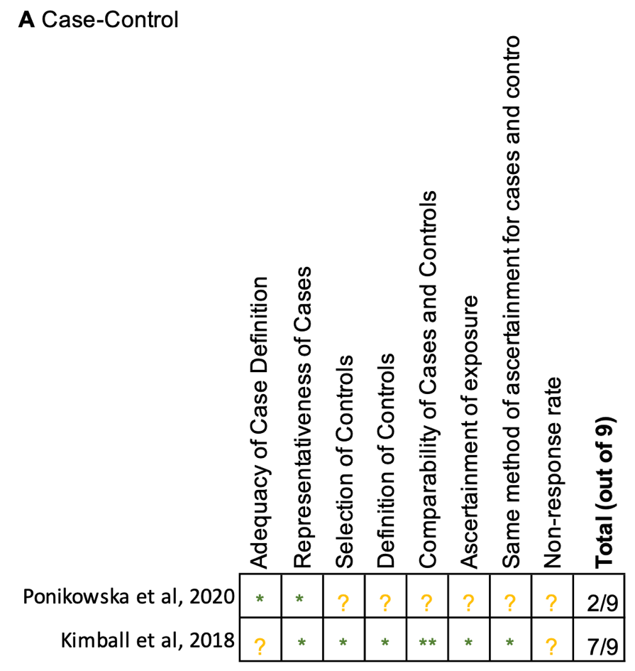
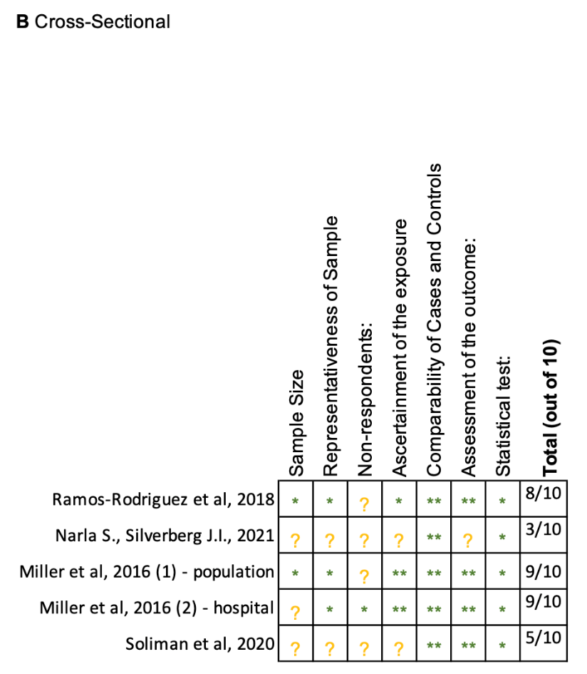
Risk of bias was assessed using the Newcastle-Ottawa Scale. Green stars indicate low risk; yellow question marks indicate unclear risk. Number of green stars were counted to determine NOS score for each study. A high NOS score indicates low risk of bias.
Figure 3. Risk of Bias Among Included Studies

