Supplementary files

Methods

Experimental Protocol
During the sedation and experimental protocol, a number of parameters were monitored to ensure the animal physiological parameters were with the normal ranges. Hartmann’s solution was infused intravenously at 5 ml/kg throughout anaesthesia to maintain adequate hydration status. Vital signs (pulse oximetry, invasive blood pressure, heart rate, electrocardiogram, end tidal carbon dioxide, and oesophageal temperature) were continuously monitored throughout the procedure (IntelliVue Mx800 system, Philips Healthcare, Australia). Following securement of vascular access, heparin was administered at 100 – 300 iu/kg intravenously as required to maintain an activated clotting time of greater than 250 seconds for the remainder of the procedure.

Electrode placement
Abdominal only configuration of the electrodes: In this configuration, the umbilicus centre stimulates the dermatomes around the umbilicus. The last 4 thoracic spinal nerves and upper lumbar (L1-L2) dermatomes contribute to periumblical dermatomal innervation in pigs. Additionally, it has been demonstrated that up to 3 spinal nerves can contribute to one dermatomal segment in pigs. In the context of the above-mentioned literature, T10 to L2 can be considered as the dermatomes of abdomen-only configuration but it’s worth noting that it is not an absolute map.
The Abdominal and Hind Limb combined configuration of the electrodes: This is the same electrode configuration for the 2 electrodes that are placed lower to umbilicus in the abdominal only stimulation and this corresponds with the lower dermatomes(T16-L2) of the abdomen only configuration) and 3 cm lateral to midline while the other 2 electrodes were placed on the hind limb (3cm lateral and inferior to the knee, on the L6 dermatome with contributions from L5 and S1- to stimulate the common peroneal nerve.
Intracranial and extracranial blood flow Analysis with DSA-Syngo iflow
In pigs, the rete mirabile caroticum (paper Figure 3) blocks the arterial passage at the distal end of the ascending pharyngeal artery so the catheters cannot reach the internal carotid artery. Hence, flow catheters are not an option to monitor blood flow changes in the internal carotid artery.

Results
Average peak velocity Distal pressure Arterial pressure
Figure 1: LAD-Anterior Interventricular Artery (Left Coronary Artery) average peak velocity, distal and aortic pressure derived modulation with stimulation frequency and orientation A: Stimulation with the ABDOMEN configuration of TENS electrodes, B = Stimulation with the ABDOMEN-HINDLIMB configuration of TENS electrodes
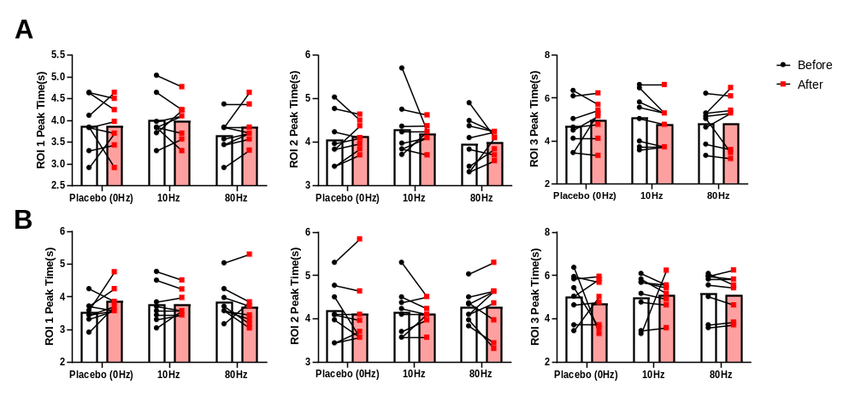
Figure 2: Carotid artery ROI peak times taken from iFlow A: Stimulation with the ABDOMEN configuration of TENS electrodes, B = Stimulation with the ABDOMEN-HINDLIMB configuration of TENS electrodes. ROI 1-3 are defined and demonstrated in the Figure 3 of the main manuscript.

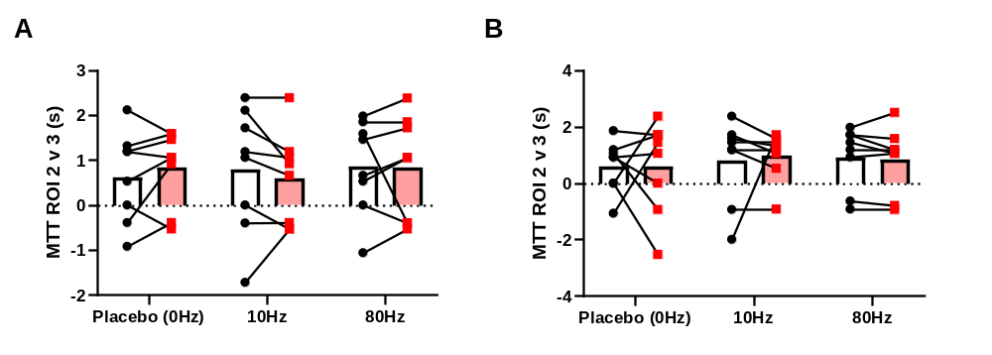
Figure 3: Cerebral Arterial Circulation Mean Transit Time. A: Stimulation with the ABDOMEN configuration of TENS electrodes, B = Stimulation with the ABDOMEN-HINDLIMB configuration of TENS electrodes. ROI 2-3 are defined and demonstrated in the Figure 3 of the main manuscript.

