Supplementary data

First Mesomorphic and DFT Characterizations for supramolecular assemblies of 3 (or 4)-n-alkanoyloxy benzoic acids and their optical applications

Mohamed A. El-Atawy^{1,2}, Mohd Taukeer Khan³, Saheed A. Popoola⁴, Muna S. Khushaim^{5,6}, Mariusz Jaremko⁷, Abdul-Hamid Emwas ⁸, Fowzia S. Alamro ⁹ and Hoda A. Ahmed ^{10,}*
- Chemistry Department, Faculty of Science, Alexandria University, P.O. Box 426, Ibrahemia, Alexandria 21321, Egypt; mohamed.elatawi@alexu.edu.eg
- Chemistry Department, College of Sciences, Taibah University, Yanbu 30799, Saudi Arabia
- Department of Physics, Faculty of Science, Islamic University of Madinah,
Al-Madinah Al-Munawwarah 42351, Saudi Arabia; khanmtk@iu.edu.sa
- Chemistry Department, Faculty of Science, Islamic University of Madinah, Madinah Saudi Arabia; abiodun@iu.edu.sa
- Department of Physics, Faculty of Science, Taibah University, P.O. Box 30002,
Al-Madina 41447, Saudi Arabia; mkhushaim@taibahu.edu.sa
- Nanotechonolgy Center, Taibah University, P.O. Box 30002, Al-Madina 41447, Saudi Arabia
- Biological and Environmental Sciences & Engineering Division (BESE), King Abdullah University of Science and Technology (KAUST), Thuwal, 23955-6900, Saudi Arabia ; Mariusz.jaremko@kaust.edu.sa
- Core Labs., King Abdullah University of Science and Technology, Thuwal 23955-6900, Saudi Arabia; abdelhamid.emwas@kaust.edu.sa
- Department of Chemistry, College of Science, Princess Nourah bint Abdulrahman University, P.O. Box 84428, Riyadh 11671, Saudi Arabia; fsalamro@pnu.edu.sa
- Department of Chemistry, Faculty of Science, Cairo University, Giza 12613, Egypt; ahoda@sci.cu.edu.eg

* Correspondence: ahoda@sci.cu.edu.eg (H.A.A.)

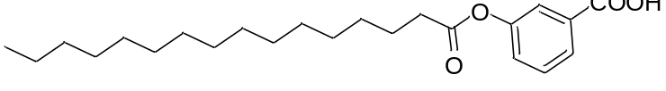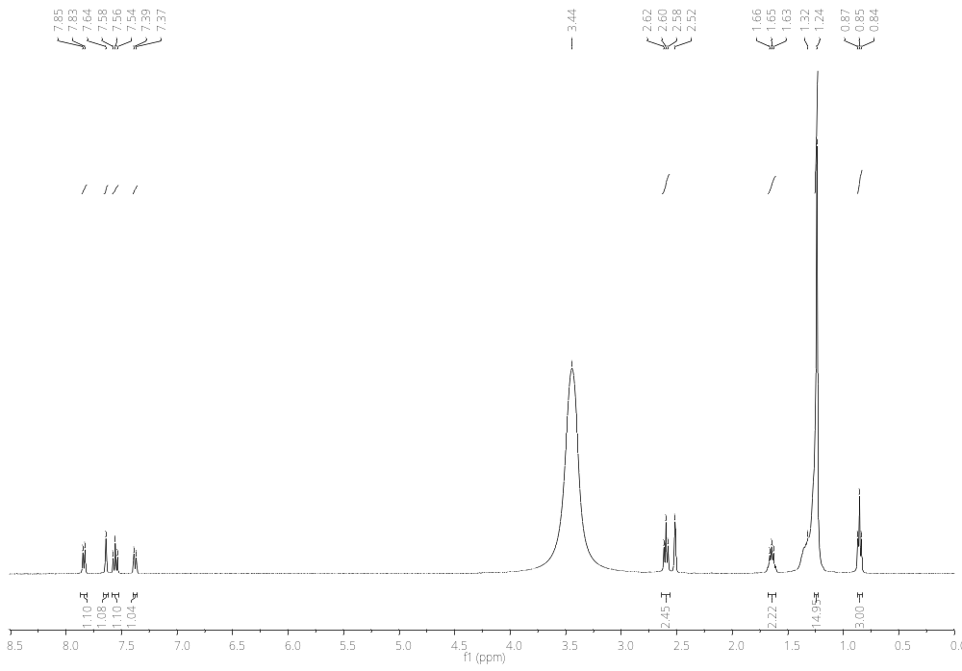
Figure S1.¹H-NMR of 3-(palmitoyloxy)benzoic acid
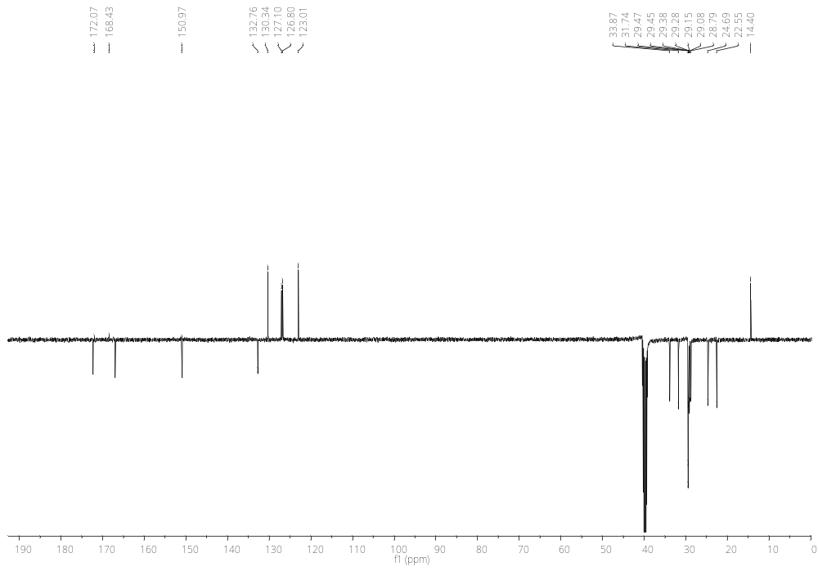
Figure S2.¹³C-NMR of 3-(palmitoyloxy)benzoic acid

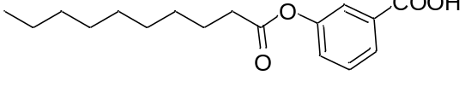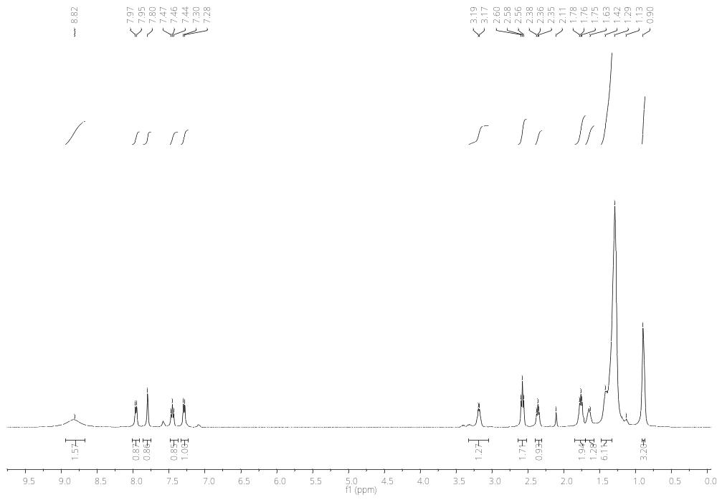
Figure S3.¹HNMR of 3-(decanoyloxy)benzoic acid

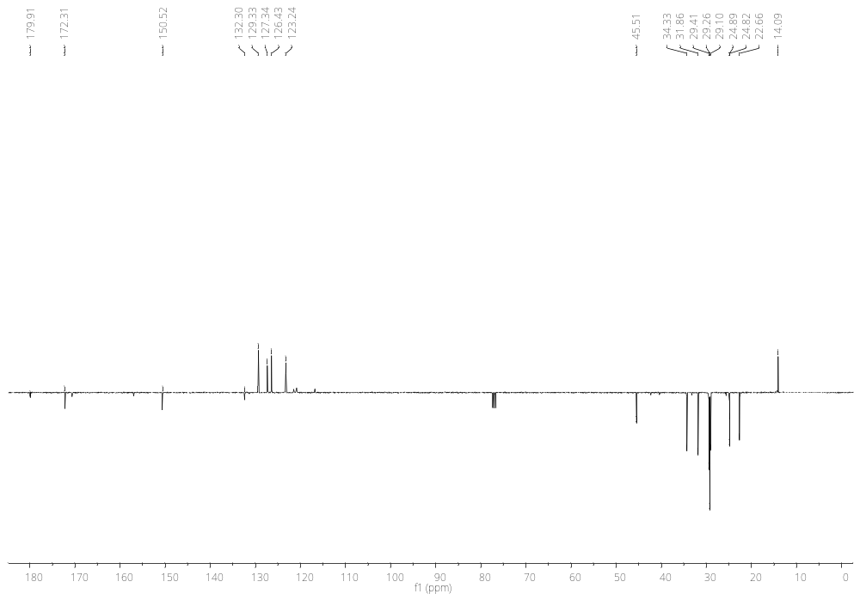
Figure S4.¹³C-NMR of 3-(decanoyloxy)benzoic acid

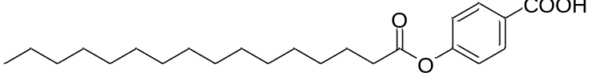

Figure S5.¹H-NMR of 4-(palmitoyloxy)benzoic acid

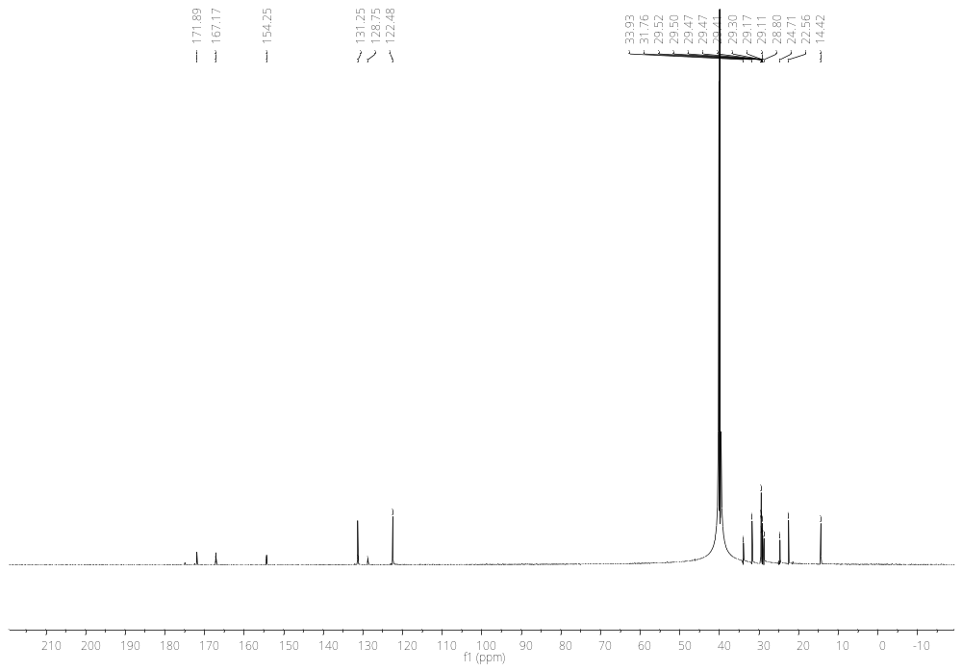
Figure S6.¹³C-NMR of 4-(palmitoyloxy)benzoic acid

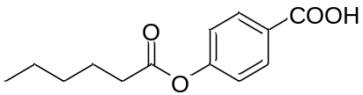
Figure S7.¹H-NMR of 4-(hexanoyloxy)benzoic acid

Figure S8.¹³C-NMR of 4-(hexanoyloxy)benzoic acid

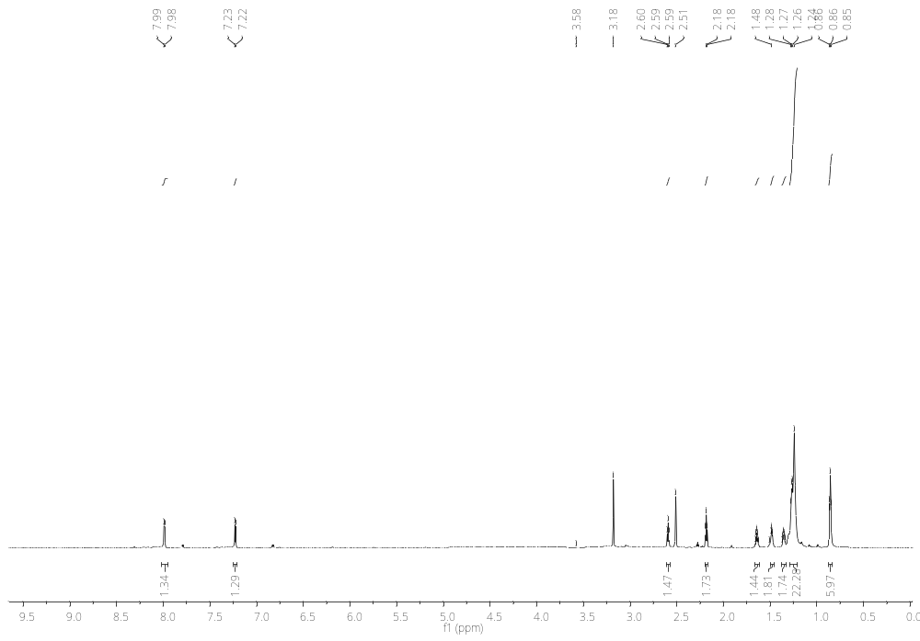

Figure S9.1H-NMR of decanoic 4-(decanoyloxy)benzoic anhydride

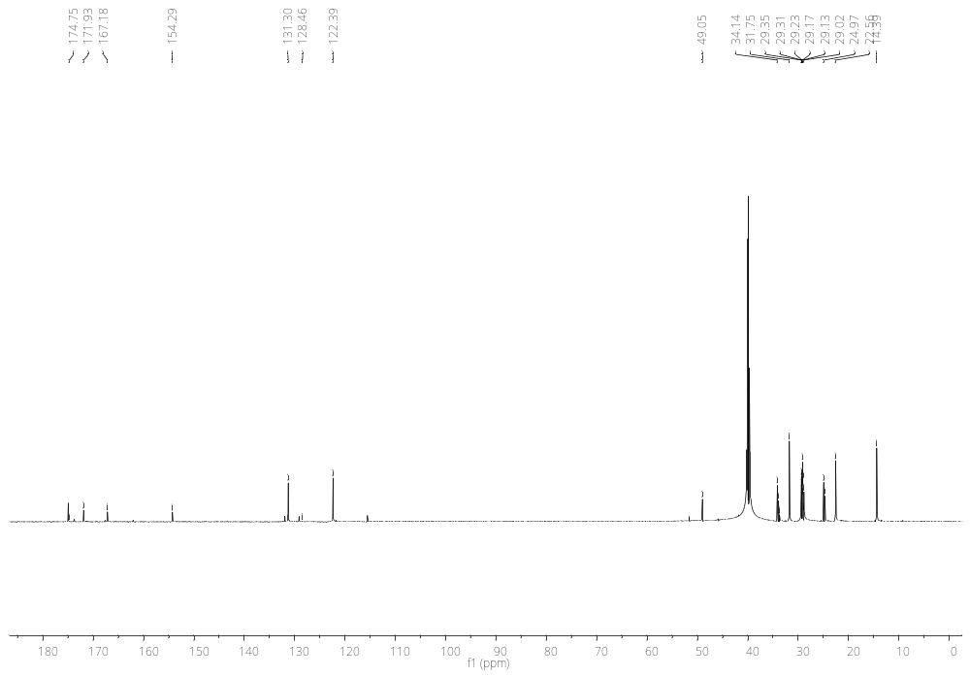

Figure S10.¹³C-NMR of decanoic 4-(decanoyloxy)benzoic anhydride

