Supplementary Information
Biochemical response of human endothelial and fibroblast cells to silver nanoparticles

Cristofher Victor Vivas Palomares¹, Jennifer Adriane dos Santos¹, Yan Borges Barreto¹, Sergio Hiroshi Toma³, Jonnatan Julival dos Santos³, Marco Antonio Stephano², Cristiano Luis Pinto de Oliveira¹, Koiti Araki³, Adriano Mesquita Alencar¹, Antonio Carlos Bloise Junior^{1*}

¹Universidade de São Paulo, Instituto de Física, Rua do Matão 1371 São Paulo, 05508-090, Brazil
²Universidade de São Paulo, Faculdade de Ciências Farmacêuticas, Av. Prof. Lineu Prestes 580 São Paulo, 05508-000, Brazil
³Universidade de São Paulo, Instituto de Química, Av. Prof. Lineu Prestes 748 São Paulo, 05508-900, Brazil
*Corresponding author: acbloise@if.usp.br, +55 11 3091-6651, ORCID 0000-0002-8529-157

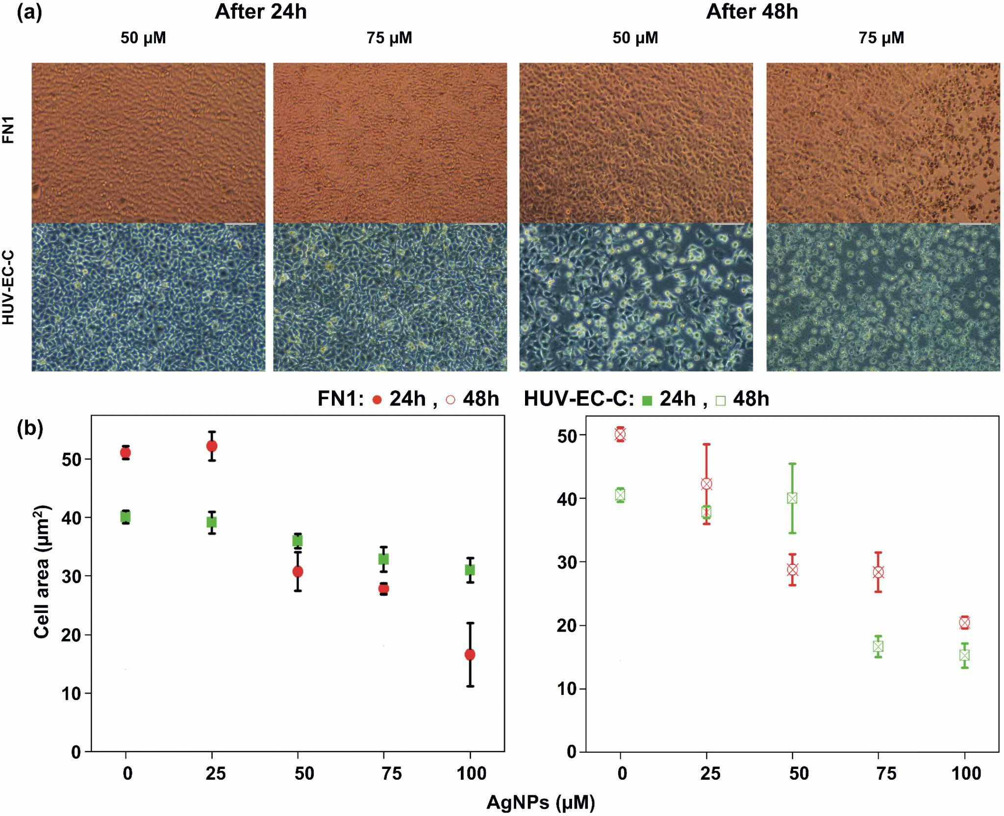
Supplementary figure 1. (a) Photomicroscopies showing the morphological aspects of FN1 and HUV-EC-C cells treated with 50 µM and 75 µM of AgNP incubated for 24 and 48 hours. The microscopies were obtained in an inverted microscope Leica MC170HD with ×10 magnification. (b) Cell area average values are plotted as a function of molar concentrations and incubation times.

Dynamic Light Scattering (DLS) and Zeta-potential (ZP). Size distribution data of nanoparticles from DLS were obtained using a Malvern Zetasizer Nano−ZS90 (Worcestershire, UK) equipment. Measurements were performed at least in a triplicates scheme, each with 20 sub-runs, a fixed angle of 90º, and a quartz cuvette with 10.0 mm of the optical path. As proposed in this work, the sample volume used in the measurements was 1 mL for the AgNP stock dispersion and the dispersion of nanoparticles in DMEM culture media as a function of concentrations. The temperature was controlled at 37ºC to simulate the cellular environment.
Surface charge data of nanoparticles from ZP were obtained using the same Malvern Zetasizer Nano−ZS90 equipment used in DLS measurements, which were also performed in a triplicates scheme and 20 sub-runs at 37ºC, using a 633 nm laser, fixed angle of 17º, and plastic cuvettes with 10 mm optical path, but using 600 μL with the same samples of AgNP dispersions used in the DLS measurements.

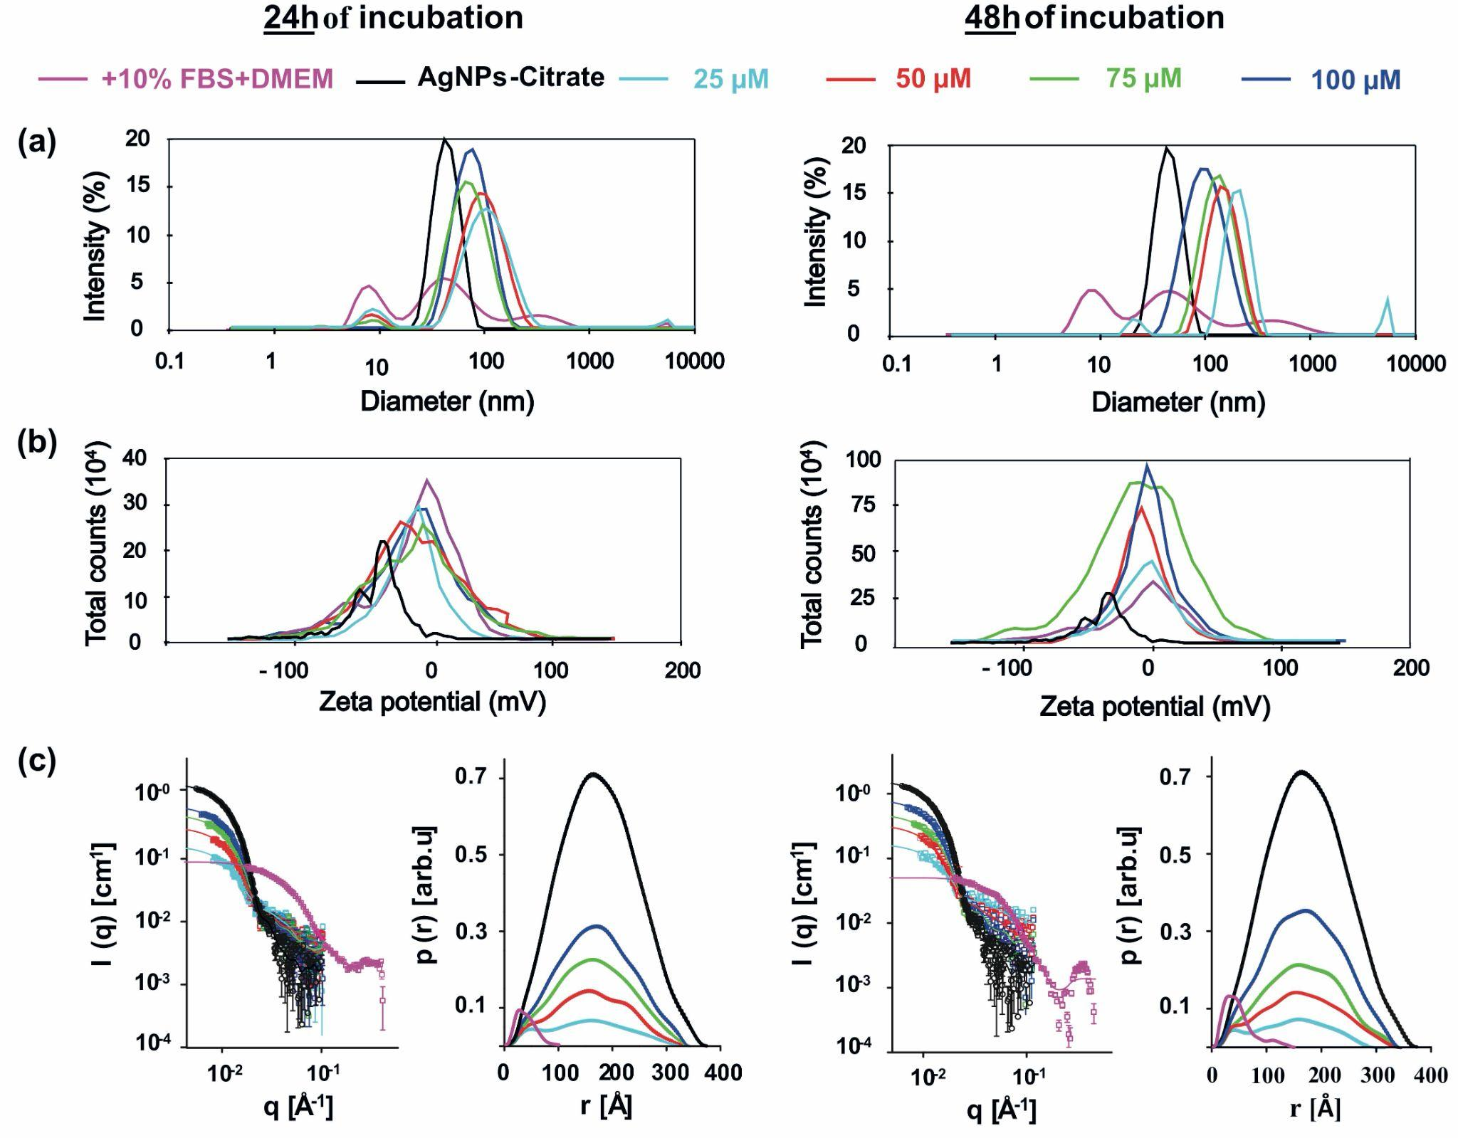
Supplementary figure 2. (a) Diameters’ distribution results obtained from DLS measurements to the stock nanoparticles, i.e., AgNP diluted in sodium citrate; the supplemented DMEM culture media, i.e., the fresh DMEM diluted in 10% (v/v) with fetal bovine serum FBS; and AgNP diluted in supplemented DMEM at molar concentrations of 25, 50, 75, and 100 µM, incubated in two distinct times: 24 hours (left panels) and 48 hours (right panels). (b) and (c) are, respectively, zeta surface potential results obtained from ZP measurements and SAXS curves as a function of scattering angle and incident wavelength (left plots) and radius of gyration (right plots) for samples incubated at same experimental conditions.

Stock nanoparticles (Supplementary figures 2a, black lines) presented a well-defined diameter of 41.7 ± 0.8 nm besides low dispersion with a polydispersity index value, PDI, estimated at 0.14 ± 0.01, suggesting monodisperse of the silver nanoparticles. The zeta surface potential informed by the data (Supplementary figures 2b, black lines) demonstrates that the stock presented aggregates of silver atoms of high stability with a liquid charge of -33.6 ± 0.7 mV, which can be attributed to the stabilizing agent, the sodium citrate. For supplemented DMEM free of nanoparticles, the data do not seem to exhibit a single size distribution showing a more complex line shape with two peaks at approximately 8 and 60 nm with higher intensity and two others at 300 and 1300 nm, but with lower intensity (Supplementary figures 2a, purple lines). The broadening of line width values associated with the peaks and the high value calculated, PDI of 0.90 ± 0.02, suggests a polydispersity arrangement of molecules with different sizes as expected for this kind of sample composed, for instance, by a bunch of amino acids, proteins, and organic salts. For the zeta potential (Supplementary figures 2b, purple lines), the data reveals that the electrical arrangement of charges in the culture media also presents a negative value, estimated at -6.4 ± 2.8, indicating that their components are slightly negatively charged.
Stock nanoparticles incubated with supplemented DMEM at different molar concentrations and incubation times are depicted in Supplementary figure 1a colored in cyan (25 µM), red (50 µM), green (75 µM), and dark blue (25 µM) lines. As can be seen in the Supplementary figure 2a, after 24 hours of incubation with AgNP, the average diameters tend to increase in comparison to stock nanoparticles, reaching peaks of maximum intensity at 90.8 ± 11.0 nm and 88.5 ± 10.9 nm for the concentrations, respectively, 25 and 50 µM. The remaining concentrations, 75 and 100 µM had their average diameters (and standard deviation) reduced but greater than AgNP in sodium citrate. This tendency of increasing the sizes of nanoparticles when diluted in supplemented DMEM is followed by an intense increase in Zeta-potential values of all mixtures that seem to achieve a plateau near -5.4 ± 2.8 mV, as shown in the Supplementary figures 2b. It is quite interesting to note that this value is very similar to those obtained for supplemented DMEM free of nanoparticles which could suggest a not contemptible electrical influence of the components of culture media that induces a slight destabilization of AgNP mixtures prepared in this work. For 48 hours of incubation, it can be observed that there is a clear tendency to decrease the size of nanoparticles occurring linearly, starting with the lower concentration, 190.6 ± 5.9 nm for 25 µM, until the higher, 78.0 ± 1.7 nm for 100 µM as shown in the Supplementary figures 2a, upper-right panel. Supplementary Table 1 tabulated the numeric data from the analysis addressing the average values, PDI, surface Zeta-potential, and the corresponding standard deviations of stock nanoparticles incubated with supplemented DMEM. The Zeta-potential for this time is also similar to the supplemented DMEM and does not change significantly with the concentration.

Supplementary Table 1. Summary of main results obtained from DLS and Zeta-potential of AgNP diluted in supplemented DMEM at four different molar concentrations, incubated at two different times. PDI < 0.1 generally indicates monodispersity, while PDI values in the 0.1 – 0.4 range or > 0.4 reflect moderate or broad polydisperse size distributions, respectively ¹.
[AgNPs] (µM) | incubation times
[AgNPs] (µM) | 24 hours |  |  | 48 hours
[AgNPs] (µM) | DLS (nm) | PDI | 𝜁 (mV) | DLS (nm) | PDI | 𝜁 (mV)
25 | 90.82 ± 11.05 | 0.34 ± 0.08 | -6.70 ± 1.26 | 190.60 ± 5.86 | 0.48 ± 0.02 | -1.83 ± 0.33
50 | 88.52 ± 19.93 | 0.26 ± 0.02 | -7.30 ± 1.48 | 141.43 ± 2.00 | 0.25 ± 0.01 | -3.37 ± 0.34
75 | 57.29 ± 1.25 | 0.28 ± 0.01 | -5.98 ± 1.27 | 97.56 ± 1.58 | 0.16 ± 0.01 | -4.68 ± 1.40
100 | 61.41 ± 1.20 | 0.24 ± 0.01 | -6.26 ± 1.23 | 78.04 ± 1.74 | 0.12 ± 0.02 | -3.44 ± 0.30

Small-angle X-ray scattering (SAXS). Silver Nanoparticles diluted on cell culture media were provided for Small-angle X-ray Scattering (SAXS) experiments. The data were collected at the EMUSAXS Multiuser SAXS Center at the Institute of Physics, University of São Paulo. From the SAXS data, it was possible to obtain overall shapes, average sizes, indications of particle concentrations, and interactions. Analyses were performed using the Indirect Fourier Transformation method.
Since the culture media is rich in proteins, lipids, and other macromolecules, it was essential to investigate the SAXS profiles to compare them with the contribution from AgNP. The treated SAXS curves for the cell culture media are shown in Supplementary figures 2c colored in cyan (25 µM), red (50 µM), green (75 µM), and dark blue (25 µM) lines. We have a signal from the molecules in the system, with a radius of gyration of ≈29 Å and maximum size of ≈100 Å for the system at 24 hours and a radius of gyration of ≈39 Å and maximum size of ≈150 Å for the system at 48 hours. Therefore, one indicates the growth of complexes inside of the system. The SAXS curves for the silver nanoparticles in 24 hours of cell culture are shown that p(r) function’s peak and the maximum size are similar to the AgNP in the stock dispersion. Interestingly, there is a shoulder around 50 Å, which probably came from the macromolecules in the cell culture, as shown in the figure (plots in the left panel). As the AgNP concentration increases, the shoulder becomes less apparent, as expected, due to the much higher electron density of the AgNP. The SAXS curves for the silver nanoparticles in 48 hours of cell culture are shown, again, that peak of the p(r) function and its maximum size are similar to the AgNP in the stock dispersion. Similar to the 24 hours case, there is a shoulder around 50 Å, which probably came from the macromolecules in the cell culture, as shown in the figure (plots in the right panel). As the AgNP concentration increases, the shoulder becomes less pronounced, as expected, due to the much higher electron density of AgNP.
From the IFT fitting, the radius of gyration and forward scattering were obtained and is shown in Supplementary Table 2. The radius of gyration is the square averaged radius of the system, similar to the inertia radius but weighted by the electron density contrast. The forward scattering is related to the concentration of the samples, volume, and electron density contrast ².

Supplementary Table 2. The radius of gyration and forward scattering for the SAXS curves for the analyzed samples. The values were obtained from the IFT method.
sample label | Rg [Å] | I(0) [cm⁻¹]
M24h | 29.1(1) | 0.048(2)
M48h | 38.9(5) | 0.092(9)
NP-STK | 134.7(2) | 1.68(1)
C25-24h | 121.1(8) | 0.161(2)
C50-24h | 124.8(5) | 0.326(3)
C75-24h | 128.2(3) | 0.522(2)
C100-24h | 130.0(3) | 0.716(3)
C25-48h | 114.0(1) | 0.161(3)
C50-48h | 126.6(4) | 0.337(3)
C75-48h | 127.8(4) | 0.501(3)
C100-48h | 130.3(3) | 0.843(3)

SAXS investigations of AgNP in solution were shown. Form-free model fitting indicated that AgNP has a spherical shape. For the cell culture, an average radius of gyration of 30 - 40 Å was obtained and is related to the macromolecules in the system. AgNP has an average radius of 170 - 180 Å and seems stable (without aggregation) either in water or in the cell culture. Comparing SAXS and DLS results reveals an exciting behavior of NPs in the system. As shown from the SAXS data, AgNP remains monodisperse in the system after 48 hours of incubation.
On the other hand, the average size of the macromolecules inside the culture medium grows during the incubation time from ≈100 Å to 150 Å. However, the DLS data of AgNP in the culture medium indicates a size of ≈40 nm for the stock solution (similar to the SAXS results) but consistent growth of the hydrodynamic sizes after incubation. The differences in sizes observed from SAXS and DLS, principally after incubation time, do not disagree with the results but reveal the evolution mechanism of particle growth. The scattering of X-rays is related to electron density contrast between the AgNP and the culture medium. Therefore, since the contrast is much higher for silver than for the proteins in the culture medium, SAXS mainly detects AgNP. The SAXS data demonstrate no aggregation of the NPs in the system. The increase in the hydrodynamic sizes seen in DLS indicates an accumulation of the biological material “around” the NPS, causing an increase in their sizes. Since DLS quantifies the average diffusion coefficient of the particles, the larger the particle, the slower its diffusion. By comparing DLS and SAXS, one can estimate the thickness of the shell around the NPS since AgNP has the same average size during all the processes.

References
1. Carrola, J. et al. Metabolomics of silver nanoparticles toxicity in HaCaT cells: structure-activity relationships and role of ionic silver and oxidative stress. Nanotoxicology 10, 1105–1117 (2016).
2. Pinto Oliveira, C. L. Investigating Macromolecular Complexes in Solution by Small Angle X-Ray Scattering. in Current Trends in X-Ray Crystallography (ed. Chandrasekaran, A.) (InTech, 2011). doi:10.5772/30730.

