Supplementary Information for

Fabrication and Evaluation of Biodegradable Alginate Bead Controlled Release Fertilizer for the Controlled Release on Nitrogen

Dong Ki Hwang^{1,‡}, Ha Young Cho^{2,3,‡}, Truong Vu Thanh^{2,3}, Hyeri Kim², Hyo Jeong Kim², Hyeonyeol Jeon², Dongyeop X. Oh^{2,3,*}, Jeyoung Park^{4,*}, and Jun Mo Koo^{5,*}

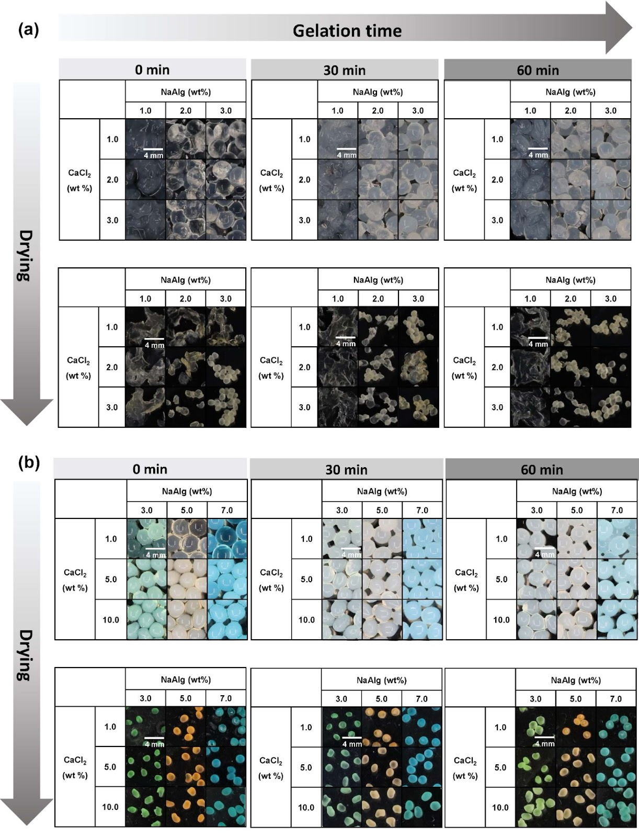
Figure S1. Optical images of different CRF beads. (a) Optical images of synthesized alginate beads in the condition of relatively lower concentration of sodium alginate (NaAlg) and calcium chloride (CaCl₂) with different additional gelation time, and drying, (b) Optical images of beads synthesized with different ratios of sodium alginate (NaAlg) and calcium chloride (CaCl₂), and drying.Three colors (green, orange, and blue) of pigments (0.5 wt%) were added to the NaAlg suspensions to give contrast between the samples for clear images.

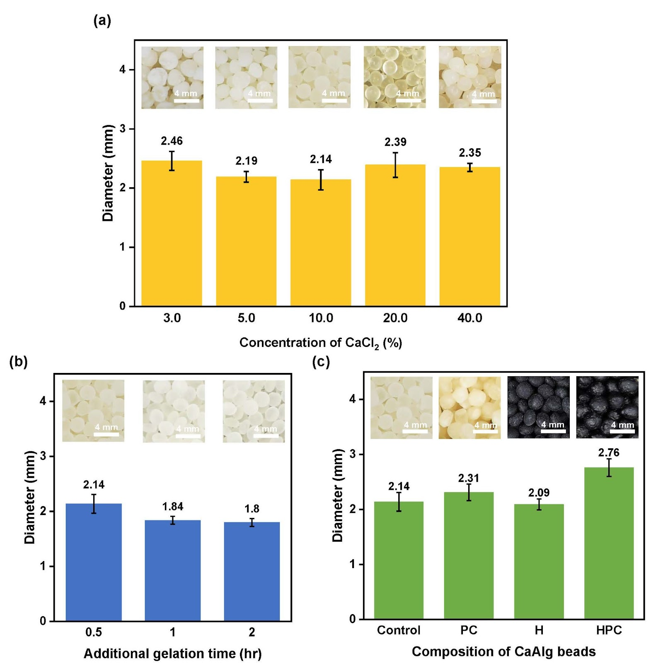
Figure S2. Diameter of CaAlg CRF beads based on (a) the concentration of CaCl₂, (b) gelation time, and (c) composition of CaAlg beads
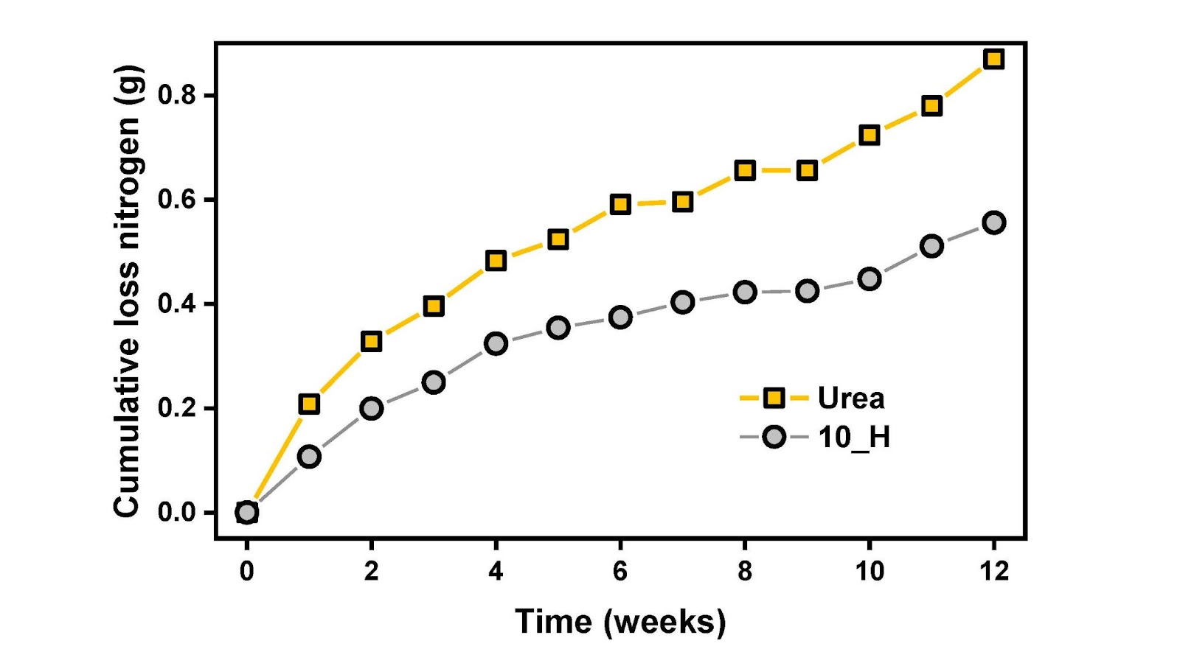
Figure S3. The nitrogen content of leachates after irrigation.

