Appendix
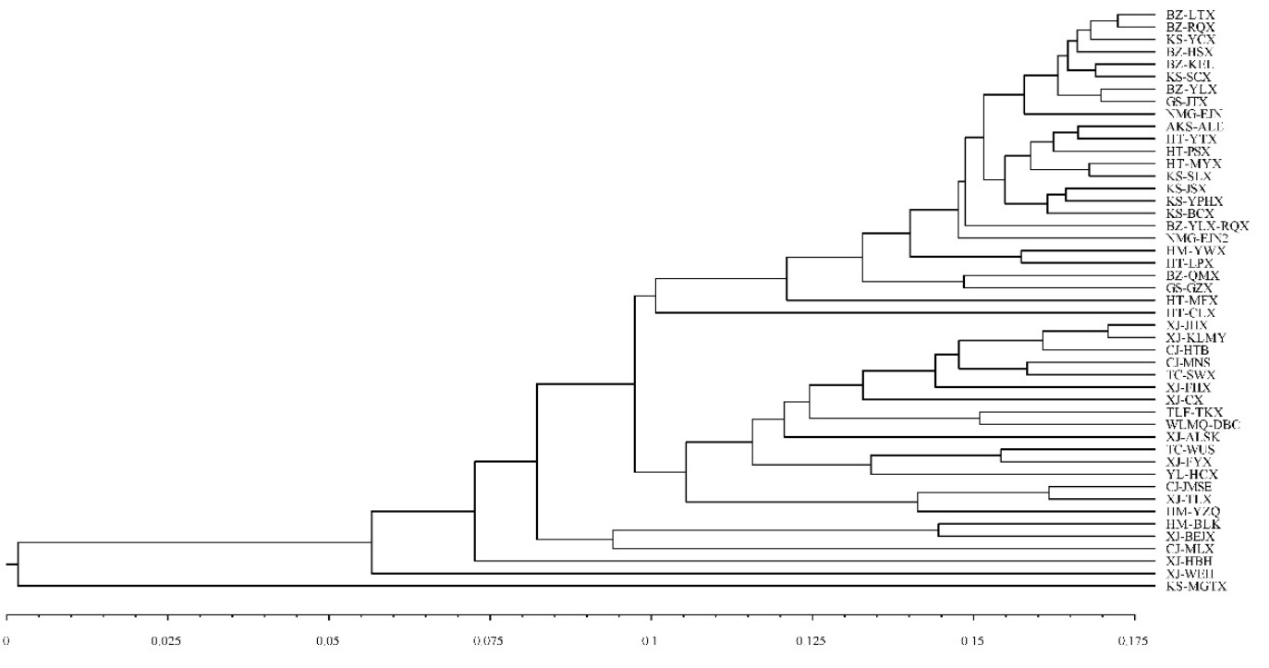
Fig. S1 Cluster analysis of 47 natural Populus euphratica populations
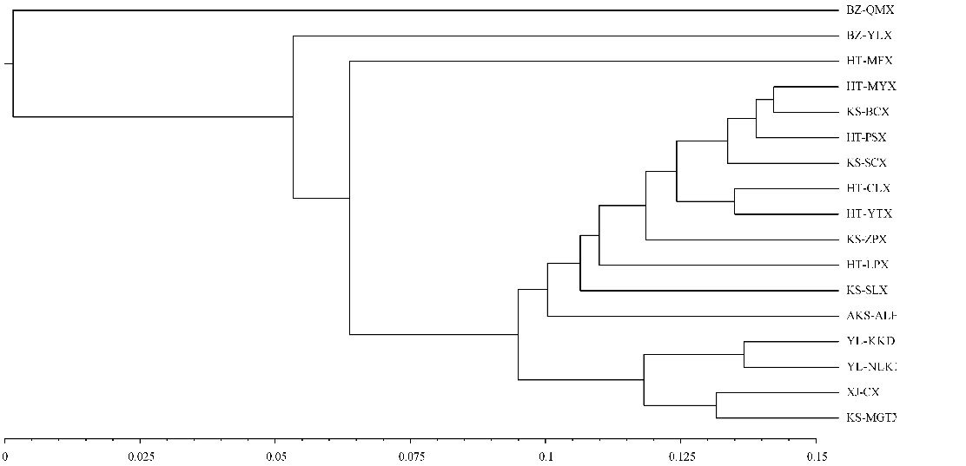
Fig. S2 Cluster analysis of 17 natural Populus pruinosa populations
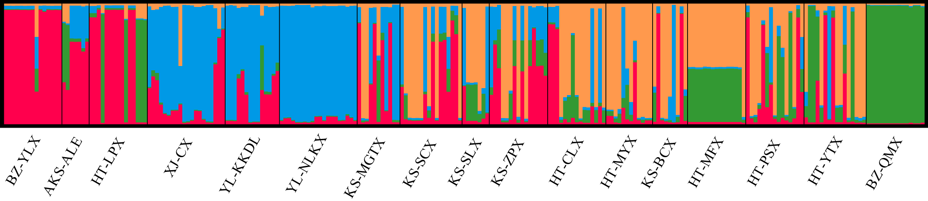
Fig. S3 Analysis of population structure of 17 natural Populus pruinosa populations
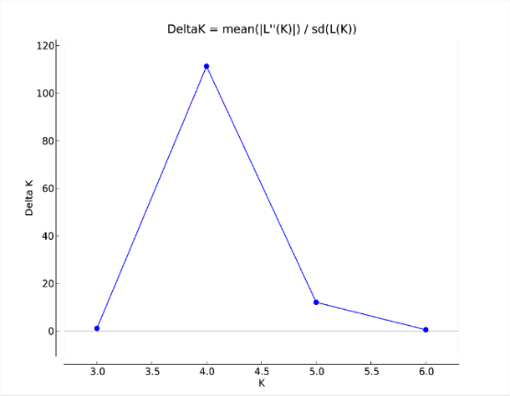
Fig. S4 Optimal K value of natural Populus euphratica populations
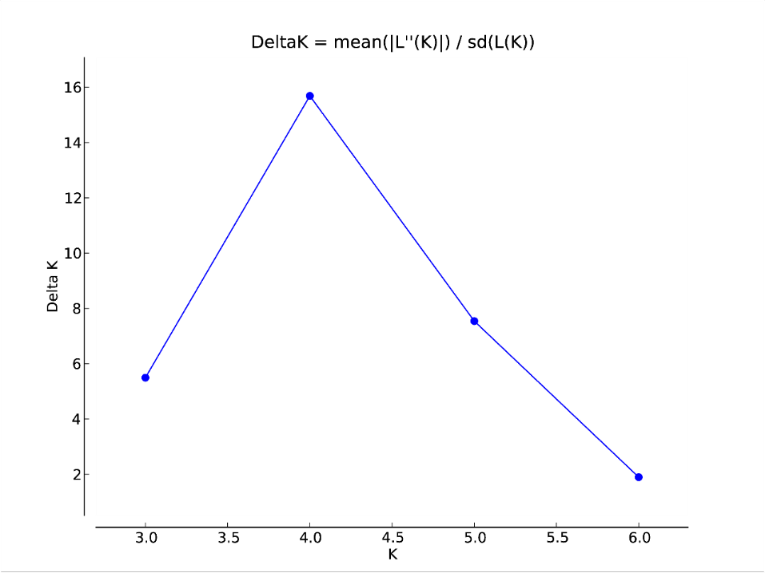
Fig. S5 Optimal K value of natural Populus pruinosa populations

Fig. S6 Principal coordinates analysis of 47 natural Populus euphratica populations

Fig. S7 Principal coordinates analysis of 17 natural Populus pruinosa populations

Tab. S1 PCR reaction system
Reagents | Volume
2×Taq PCR Master Mix | 12.5μL
forward primer | 1μL
reverse primer | 1μL
DNA template | 1μL
ddH2O | 9.5μL
total | 25μL

Tab. S2 Core primer sequences
编号  Code | 引物名称  Primer name | 引物序列（5'-3'）  Primer sequence | 预期片段bp  Expected fragment
1 | EST-SSR24 | F： CCAAGCAGTGGTGCTCTGTA | 109
1 | EST-SSR24 | R： CGTGGCCATGAACACACTAT | 121
2 | EST-SSR44 | F： TCTCATTCCGTATTTGGCATT | 100
2 | EST-SSR44 | R： TAGCGCAAACATGTCCAATC | 112
3 | EST-SSR48 | F： ACCTTTTCCTTTCCTTCCGA | 223
3 | EST-SSR48 | R： TGATGTTGATGCTGGGAGAG | 233
4 | EST-SSR57 | F： CATCCTTTGCGTAGGGTGAG | 127
4 | EST-SSR57 | R： AGGAAAAATCGGGAAAAGGA | 145
5 | EST-SSR81 | F： TAATACGCTGGTGGGTCACA | 118
5 | EST-SSR81 | R： CATGAAATTTGAGGATGGCA | 130
6 | EST-SSR82 | F： CCAGCTCCAGTGATGAGTGA | 118
6 | EST-SSR82 | R： TCTCCGAGATGAGTCCAACA | 133
7 | EST-SSR85 | F： TCGCTTCTTGGAGTCTGGTT | 120
7 | EST-SSR85 | R： GAAAGTGCTGTGGACGACAA | 135
8 | EST-SSR97 | F： ATTTCAGTTCGCTTAACGGG | 129
8 | EST-SSR97 | R： CACGCACTTCCACTCAGAAA | 139
9 | EST-SSR113 | F：AAACCCCCTTAAAGTTGGAAA | 145
9 | EST-SSR113 | R： CCCAGGGGCTTACATTCATA | 160
10 | EST-SSR117 | F： TGTGCTTGCCTTTTGTTTTTC | 151
10 | EST-SSR117 | R： TGTCGGTTGTTCCAAATTCA | 167

Tab. S3 Genetic diversity parameters of different Populus euphratica populations
Population | Na | Ne | I | Ho | He | uHe | F
ALE | 1.900 | 1.662 | 0.514 | 0.358 | 0.343 | 0.357 | -0.071
HSX | 1.700 | 1.446 | 0.360 | 0.275 | 0.234 | 0.243 | -0.163
KEL | 1.700 | 1.393 | 0.333 | 0.187 | 0.207 | 0.214 | 0.022
LTX | 1.800 | 1.497 | 0.421 | 0.251 | 0.275 | 0.285 | 0.078
QMX | 1.700 | 1.298 | 0.273 | 0.193 | 0.168 | 0.174 | 0.056
RQX | 1.800 | 1.422 | 0.372 | 0.265 | 0.245 | 0.252 | -0.065
YLX | 1.800 | 1.307 | 0.307 | 0.153 | 0.188 | 0.194 | 0.082
YL-RQ | 1.700 | 1.343 | 0.305 | 0.238 | 0.187 | 0.197 | -0.217
CLX | 1.300 | 1.188 | 0.136 | 0.120 | 0.080 | 0.083 | -0.356
LPX | 2.100 | 1.324 | 0.389 | 0.233 | 0.226 | 0.234 | -0.056
MFX | 1.700 | 1.409 | 0.315 | 0.300 | 0.200 | 0.207 | -0.126
MYX | 2.000 | 1.470 | 0.428 | 0.253 | 0.272 | 0.284 | 0.002
PSX | 2.100 | 1.754 | 0.598 | 0.411 | 0.393 | 0.416 | -0.085
YTX | 2.000 | 1.613 | 0.486 | 0.290 | 0.308 | 0.319 | -0.006
BCX | 1.900 | 1.652 | 0.515 | 0.387 | 0.341 | 0.353 | -0.169
JSX | 2.200 | 1.571 | 0.527 | 0.360 | 0.326 | 0.337 | -0.134
MGT | 2.100 | 1.522 | 0.468 | 0.317 | 0.290 | 0.304 | 0.145
SCX | 1.900 | 1.487 | 0.412 | 0.226 | 0.261 | 0.270 | 0.105
SLX | 1.900 | 1.518 | 0.423 | 0.247 | 0.274 | 0.284 | 0.028
YCX | 1.800 | 1.454 | 0.399 | 0.240 | 0.257 | 0.266 | 0.054
YPH | 1.900 | 1.412 | 0.371 | 0.187 | 0.236 | 0.244 | 0.083
HTB | 1.700 | 1.455 | 0.331 | 0.221 | 0.215 | 0.223 | 0.032
JMSE | 1.800 | 1.537 | 0.39 | 0.271 | 0.237 | 0.246 | -0.159
MLX | 1.000 | 1.000 | 0.000 | 0.000 | 0.000 | 0.000 | 0.000
MNS | 1.900 | 1.569 | 0.441 | 0.248 | 0.275 | 0.285 | 0.025
BLK | 1.300 | 1.214 | 0.163 | 0.200 | 0.112 | 0.116 | -0.333
YWX | 1.700 | 1.366 | 0.305 | 0.168 | 0.193 | 0.199 | 0.203
YZQ | 1.500 | 1.383 | 0.260 | 0.300 | 0.167 | 0.173 | -0.807
SWX | 1.800 | 1.414 | 0.357 | 0.227 | 0.219 | 0.227 | -0.067
WSS | 1.900 | 1.351 | 0.316 | 0.217 | 0.187 | 0.193 | 0.039
TKX | 1.700 | 1.345 | 0.294 | 0.293 | 0.192 | 0.199 | -0.330
DBC | 1.600 | 1.460 | 0.335 | 0.302 | 0.218 | 0.226 | -0.383
ALSK | 1.900 | 1.658 | 0.492 | 0.456 | 0.326 | 0.338 | -0.194
BEJ | 1.900 | 1.309 | 0.315 | 0.240 | 0.192 | 0.199 | -0.115
CX | 1.800 | 1.324 | 0.295 | 0.185 | 0.186 | 0.193 | 0.037
FHX | 1.800 | 1.655 | 0.443 | 0.239 | 0.286 | 0.297 | 0.138
FYX | 1.700 | 1.320 | 0.324 | 0.226 | 0.205 | 0.213 | -0.047
HBH | 1.100 | 1.100 | 0.069 | 0.100 | 0.050 | 0.052 | -1.000
JHX | 1.900 | 1.386 | 0.331 | 0.181 | 0.199 | 0.206 | 0.075
KLMY | 1.700 | 1.317 | 0.304 | 0.207 | 0.186 | 0.193 | -0.120
TLX | 1.800 | 1.324 | 0.264 | 0.235 | 0.151 | 0.157 | -0.264
WEH | 1.100 | 1.032 | 0.041 | 0.000 | 0.024 | 0.025 | 1.000
HCX | 1.200 | 1.140 | 0.095 | 0.100 | 0.058 | 0.061 | -0.712
GZX | 1.700 | 1.332 | 0.288 | 0.134 | 0.180 | 0.186 | 0.129
JTX | 1.700 | 1.446 | 0.366 | 0.232 | 0.237 | 0.245 | -0.018
EJN1 | 2.000 | 1.477 | 0.401 | 0.298 | 0.239 | 0.247 | -0.183
EJN2 | 1.700 | 1.467 | 0.404 | 0.425 | 0.273 | 0.285 | -0.495
Mean (SX) | 1.857 | 1.464 | 0.398 | 0.261 | 0.253 | 0.263 | -0.038
Mean (NX) | 1.627 | 1.348 | 0.280 | 0.210 | 0.176 | 0.183 | -0.136
Mean (OA) | 1.775 | 1.431 | 0.365 | 0.272 | 0.232 | 0.241 | -0.142
Mean | 1.743 | 1.407 | 0.340 | 0.238 | 0.215 | 0.223 | -0.066
SD | 0.031 | 0.023 | 0.015 | 0.013 | 0.010 | 0.010 | 0.020

Tab. S4 Genetic diversity parameters of different Populus pruinosa populations
Population | Na | Ne | I | Ho | He | uHe | F
ALE | 1.900 | 1.529 | 0.465 | 0.371 | 0.304 | 0.327 | -0.180
QMX | 1.400 | 1.399 | 0.277 | 0.393 | 0.200 | 0.207 | -0.969
YLX | 1.200 | 1.107 | 0.085 | 0.107 | 0.057 | 0.059 | -0.519
CLX | 1.900 | 1.322 | 0.315 | 0.195 | 0.192 | 0.199 | -0.050
LPX | 1.500 | 1.380 | 0.311 | 0.183 | 0.215 | 0.225 | 0.133
MFX | 1.300 | 1.212 | 0.151 | 0.193 | 0.103 | 0.106 | -0.879
MYX | 1.900 | 1.379 | 0.355 | 0.167 | 0.212 | 0.221 | 0.097
PSX | 2.100 | 1.494 | 0.440 | 0.206 | 0.265 | 0.275 | 0.076
YTX | 2.100 | 1.593 | 0.500 | 0.258 | 0.311 | 0.321 | 0.121
BCX | 1.700 | 1.414 | 0.346 | 0.113 | 0.223 | 0.236 | 0.376
MGTX | 1.900 | 1.411 | 0.390 | 0.159 | 0.241 | 0.253 | 0.251
SCX | 1.900 | 1.469 | 0.379 | 0.196 | 0.225 | 0.233 | 0.073
SLX | 1.400 | 1.219 | 0.199 | 0.043 | 0.131 | 0.141 | 0.585
ZPX | 2.000 | 1.525 | 0.418 | 0.243 | 0.275 | 0.285 | 0.174
CX | 1.700 | 1.299 | 0.294 | 0.137 | 0.187 | 0.193 | 0.195
KKDL | 1.700 | 1.448 | 0.320 | 0.267 | 0.192 | 0.200 | -0.326
NLKX | 1.500 | 1.295 | 0.227 | 0.243 | 0.145 | 0.149 | -0.485
Mean（SX） | 1.729 | 1.390 | 0.331 | 0.202 | 0.211 | 0.221 | -0.051
Mean（NX） | 1.633 | 1.347 | 0.280 | 0.216 | 0.175 | 0.181 | -0.205
Mean | 1.712 | 1.382 | 0.322 | 0.204 | 0.205 | 0.214 | 0.009
SD | 0.051 | 0.037 | 0.025 | 0.022 | 0.017 | 0.017 | 0.041

Tab. S5 Molecular variance analysis of Populus pruinosa populations
Source | Degree of freedom (df) | Sum of square (SS) | Mean square (MS) | Variance component | Proportion (%)
Among populations | 16 | 216.083 | 13.505 | 0.423 | 24%
Among individuals | 220 | 389.235 | 1.769 | 0.395 | 22%
Within individual | 237 | 232.000 | 0.979 | 0.979 | 54%
Total | 473 | 837.319 | - | 1.797 | 100%

Tab. S6 Fingerprinting of 47 natural Populus euphratica populations constructed with 10 pairs of SSR primers
Population | Fingerprinting | m24 | m44 | m48 | m57 | m81 | m82 | m85 | m97 | m113 | m117
AKS-ALE | 01001101001010011011010 | 010 | 01 | 10 | 100 | 10 | 10 | 01 | 10 | 11 | 010
AKS-ALE | 01011101001010011101101 | 010 | 11 | 10 | 100 | 10 | 10 | 01 | 11 | 01 | 101
AKS-ALE | 10001101101010111110100 | 100 | 01 | 10 | 110 | 10 | 10 | 11 | 11 | 10 | 100
AKS-ALE | 10001991101099111199100 | 100 | 01 | 99 | 110 | 10 | 99 | 11 | 11 | 99 | 100
AKS-ALE | 10010101001110111111011 | 100 | 10 | 10 | 100 | 11 | 10 | 11 | 11 | 11 | 011
AKS-ALE | 11001101001010011111011 | 110 | 01 | 10 | 100 | 10 | 10 | 01 | 11 | 11 | 011
AKS-ALE | 11001101101110111110010 | 110 | 01 | 10 | 110 | 11 | 10 | 11 | 11 | 10 | 010
AKS-ALE | 11011101001010011101010 | 110 | 11 | 10 | 100 | 10 | 10 | 01 | 11 | 01 | 010
BZ-HSX | 01001101001010011111010 | 010 | 01 | 10 | 100 | 10 | 10 | 01 | 11 | 11 | 010
BZ-HSX | 01011101001010011001011 | 010 | 11 | 10 | 100 | 10 | 10 | 01 | 10 | 01 | 011
BZ-HSX | 11001111001010011101011 | 110 | 01 | 11 | 100 | 10 | 10 | 01 | 11 | 01 | 011
BZ-HSX | 11011101001010011011011 | 110 | 11 | 10 | 100 | 10 | 10 | 01 | 10 | 11 | 011
BZ-HSX | 11099101009910019910011 | 110 | 99 | 10 | 100 | 99 | 10 | 01 | 99 | 10 | 011
BZ-HSX | 11099111009910011010011 | 110 | 99 | 11 | 100 | 99 | 10 | 01 | 10 | 10 | 011
BZ-KEL | 01001101001010991001100 | 010 | 01 | 10 | 100 | 10 | 10 | 99 | 10 | 01 | 100
BZ-KEL | 01001111001010011111010 | 010 | 01 | 11 | 100 | 10 | 10 | 01 | 11 | 11 | 010
BZ-KEL | 01011101001010011011100 | 010 | 11 | 10 | 100 | 10 | 10 | 01 | 10 | 11 | 100
BZ-KEL | 01011101001010011111011 | 010 | 11 | 10 | 100 | 10 | 10 | 01 | 11 | 11 | 011
BZ-KEL | 10001101001010011010100 | 100 | 01 | 10 | 100 | 10 | 10 | 01 | 10 | 10 | 100
BZ-KEL | 11001111001010011110011 | 110 | 01 | 11 | 100 | 10 | 10 | 01 | 11 | 10 | 011
BZ-LTX | 01001101001010011111101 | 010 | 01 | 10 | 100 | 10 | 10 | 01 | 11 | 11 | 101
BZ-LTX | 01001991001010011111011 | 010 | 01 | 99 | 100 | 10 | 10 | 01 | 11 | 11 | 011
BZ-LTX | 01011109991010011011999 | 010 | 11 | 10 | 999 | 10 | 10 | 01 | 10 | 11 | 999
BZ-LTX | 01011111001010011011010 | 010 | 11 | 11 | 100 | 10 | 10 | 01 | 10 | 11 | 010
BZ-LTX | 01011111001010011011100 | 010 | 11 | 11 | 100 | 10 | 10 | 01 | 10 | 11 | 100
BZ-LTX | 10010111011010011001011 | 100 | 10 | 11 | 101 | 10 | 10 | 01 | 10 | 01 | 011
BZ-LTX | 10099111011010019901011 | 100 | 99 | 11 | 101 | 10 | 10 | 01 | 99 | 01 | 011
BZ-LTX | 11001111001010011010010 | 110 | 01 | 11 | 100 | 10 | 10 | 01 | 10 | 10 | 010
BZ-LTX | 11011101001010010110010 | 110 | 11 | 10 | 100 | 10 | 10 | 01 | 01 | 10 | 010
BZ-QMX | 01010101001010011001011 | 010 | 10 | 10 | 100 | 10 | 10 | 01 | 10 | 01 | 011
BZ-QMX | 01010111001010011011011 | 010 | 10 | 11 | 100 | 10 | 10 | 01 | 10 | 11 | 011
BZ-QMX | 11010101001010011001101 | 110 | 10 | 10 | 100 | 10 | 10 | 01 | 10 | 01 | 101
BZ-QMX | 11010111001010011010011 | 110 | 10 | 11 | 100 | 10 | 10 | 01 | 10 | 10 | 011
BZ-QMX | 11099990009999999999999 | 110 | 99 | 99 | 000 | 99 | 99 | 99 | 99 | 99 | 999
BZ-QMX | 99910101001010011001011 | 999 | 10 | 10 | 100 | 10 | 10 | 01 | 10 | 01 | 011
BZ-RQX | 01010111001010011101010 | 010 | 10 | 11 | 100 | 10 | 10 | 01 | 11 | 01 | 010
BZ-RQX | 01010111001010011111010 | 010 | 10 | 11 | 100 | 10 | 10 | 01 | 11 | 11 | 010
BZ-RQX | 10001101101010011011011 | 100 | 01 | 10 | 110 | 10 | 10 | 01 | 10 | 11 | 011
BZ-RQX | 11001101001010011011101 | 110 | 01 | 10 | 100 | 10 | 10 | 01 | 10 | 11 | 101
BZ-RQX | 11001101001010011110010 | 110 | 01 | 10 | 100 | 10 | 10 | 01 | 11 | 10 | 010
BZ-YLX | 01001101001110011011101 | 010 | 01 | 10 | 100 | 11 | 10 | 01 | 10 | 11 | 101
BZ-YLX | 01011101001010011110010 | 010 | 11 | 10 | 100 | 10 | 10 | 01 | 11 | 10 | 010
BZ-YLX | 10001101001010011001010 | 100 | 01 | 10 | 100 | 10 | 10 | 01 | 10 | 01 | 010
BZ-YLX | 10001101001010011010011 | 100 | 01 | 10 | 100 | 10 | 10 | 01 | 10 | 10 | 011
BZ-YLX | 11001111001010011001100 | 110 | 01 | 11 | 100 | 10 | 10 | 01 | 10 | 01 | 100
BZ-YLX-RQX | 10011101001010011001011 | 100 | 11 | 10 | 100 | 10 | 10 | 01 | 10 | 01 | 011
BZ-YLX-RQX | 11001101001010011101100 | 110 | 01 | 10 | 100 | 10 | 10 | 01 | 11 | 01 | 100
BZ-YLX-RQX | 11001101001110011011010 | 110 | 01 | 10 | 100 | 11 | 10 | 01 | 10 | 11 | 010
BZ-YLX-RQX | 99911101001010011101011 | 999 | 11 | 10 | 100 | 10 | 10 | 01 | 11 | 01 | 011
CJ-HTB | 01001100101010011101100 | 010 | 01 | 10 | 010 | 10 | 10 | 01 | 11 | 01 | 100
CJ-HTB | 01001100111010011110100 | 010 | 01 | 10 | 011 | 10 | 10 | 01 | 11 | 10 | 100
CJ-HTB | 01001110111010011110100 | 010 | 01 | 11 | 011 | 10 | 10 | 01 | 11 | 10 | 100
CJ-HTB | 10101111001010010101100 | 101 | 01 | 11 | 100 | 10 | 10 | 01 | 01 | 01 | 100
CJ-JMSE | 01001100119910011011011 | 010 | 01 | 10 | 011 | 99 | 10 | 01 | 10 | 11 | 011
CJ-JMSE | 01001110111010011111011 | 010 | 01 | 11 | 011 | 10 | 10 | 01 | 11 | 11 | 011
CJ-JMSE | 01101101001010011011100 | 011 | 01 | 10 | 100 | 10 | 10 | 01 | 10 | 11 | 100
CJ-JMSE | 01101119999910011001100 | 011 | 01 | 11 | 999 | 99 | 10 | 01 | 10 | 01 | 100
CJ-MLX | 99901101001010011001100 | 999 | 01 | 10 | 100 | 10 | 10 | 01 | 10 | 01 | 100
CJ-MNS | 01001101001010019911100 | 010 | 01 | 10 | 100 | 10 | 10 | 01 | 99 | 11 | 100
CJ-MNS | 01001110111010011101011 | 010 | 01 | 11 | 011 | 10 | 10 | 01 | 11 | 01 | 011
CJ-MNS | 01001110111010011199011 | 010 | 01 | 11 | 011 | 10 | 10 | 01 | 11 | 99 | 011
CJ-MNS | 01011101001010011010011 | 010 | 11 | 10 | 100 | 10 | 10 | 01 | 10 | 10 | 011
CJ-MNS | 01011991001010011010011 | 010 | 11 | 99 | 100 | 10 | 10 | 01 | 10 | 10 | 011
CJ-MNS | 01099101001010011010011 | 010 | 99 | 10 | 100 | 10 | 10 | 01 | 10 | 10 | 011
CJ-MNS | 11001110101010011010100 | 110 | 01 | 11 | 010 | 10 | 10 | 01 | 10 | 10 | 100
CJ-MNS | 11001111001010011099999 | 110 | 01 | 11 | 100 | 10 | 10 | 01 | 10 | 99 | 999
GS-GZX | 01011101001010011010101 | 010 | 11 | 10 | 100 | 10 | 10 | 01 | 10 | 10 | 101
GS-GZX | 99901101011010011001011 | 999 | 01 | 10 | 101 | 10 | 10 | 01 | 10 | 01 | 011
GS-JTX | 10001101001010011001100 | 100 | 01 | 10 | 100 | 10 | 10 | 01 | 10 | 01 | 100
GS-JTX | 10001101001010011011010 | 100 | 01 | 10 | 100 | 10 | 10 | 01 | 10 | 11 | 010
GS-JTX | 10001101001010991001011 | 100 | 01 | 10 | 100 | 10 | 10 | 99 | 10 | 01 | 011
GS-JTX | 10011101001010011011010 | 100 | 11 | 10 | 100 | 10 | 10 | 01 | 10 | 11 | 010
GS-JTX | 11001101001010011011100 | 110 | 01 | 10 | 100 | 10 | 10 | 01 | 10 | 11 | 100
GS-JTX | 11011101001010011110010 | 110 | 11 | 10 | 100 | 10 | 10 | 01 | 11 | 10 | 010
GS-JTX | 11011101001010011110011 | 110 | 11 | 10 | 100 | 10 | 10 | 01 | 11 | 10 | 011
GS-JTX | 11011101001010011111100 | 110 | 11 | 10 | 100 | 10 | 10 | 01 | 11 | 11 | 100
GS-JTX | 99999119999999019999999 | 999 | 99 | 11 | 999 | 99 | 99 | 01 | 99 | 99 | 999
HM-BLK | 01101111001010011001010 | 011 | 01 | 11 | 100 | 10 | 10 | 01 | 10 | 01 | 010
HM-YWX | 01001111001010011010011 | 010 | 01 | 11 | 100 | 10 | 10 | 01 | 10 | 10 | 011
HM-YWX | 01001111001010011010101 | 010 | 01 | 11 | 100 | 10 | 10 | 01 | 10 | 10 | 101
HM-YWX | 01010101001010011001010 | 010 | 10 | 10 | 100 | 10 | 10 | 01 | 10 | 01 | 010
HM-YWX | 01099101001010011011010 | 010 | 99 | 10 | 100 | 10 | 10 | 01 | 10 | 11 | 010
HM-YWX | 10101101001010011001100 | 101 | 01 | 10 | 100 | 10 | 10 | 01 | 10 | 01 | 100
HM-YZQ | 01001100111010011101011 | 010 | 01 | 10 | 011 | 10 | 10 | 01 | 11 | 01 | 011
HM-YZQ | 01001100111010011101101 | 010 | 01 | 10 | 011 | 10 | 10 | 01 | 11 | 01 | 101
HM-YZQ | 01001100111010991101011 | 010 | 01 | 10 | 011 | 10 | 10 | 99 | 11 | 01 | 011
HM-YZQ | 01001101011010011101101 | 010 | 01 | 10 | 101 | 10 | 10 | 01 | 11 | 01 | 101
HM-YZQ | 01001109991010011101011 | 010 | 01 | 10 | 999 | 10 | 10 | 01 | 11 | 01 | 011
HM-YZQ | 01001109999910991101999 | 010 | 01 | 10 | 999 | 99 | 10 | 99 | 11 | 01 | 999
HM-YZQ | 99999991101099019999011 | 999 | 99 | 99 | 110 | 10 | 99 | 01 | 99 | 99 | 011
HT-CLX | 01001101001010011010011 | 010 | 01 | 10 | 100 | 10 | 10 | 01 | 10 | 10 | 011
HT-CLX | 01001101001010011010101 | 010 | 01 | 10 | 100 | 10 | 10 | 01 | 10 | 10 | 101
HT-CLX | 01001991009910999910101 | 010 | 01 | 99 | 100 | 99 | 10 | 99 | 99 | 10 | 101
HT-LPX | 01001111001010011011010 | 010 | 01 | 11 | 100 | 10 | 10 | 01 | 10 | 11 | 010
HT-LPX | 10001111101010111110011 | 100 | 01 | 11 | 110 | 10 | 10 | 11 | 11 | 10 | 011
HT-LPX | 11011101011110111110011 | 110 | 11 | 10 | 101 | 11 | 10 | 11 | 11 | 10 | 011
HT-LPX | 11011111001010011010010 | 110 | 11 | 11 | 100 | 10 | 10 | 01 | 10 | 10 | 010
HT-MFX | 10001101001010011001101 | 100 | 01 | 10 | 100 | 10 | 10 | 01 | 10 | 01 | 101
HT-MFX | 11001101001010011110011 | 110 | 01 | 10 | 100 | 10 | 10 | 01 | 11 | 10 | 011
HT-MFX | 11001101001010011110101 | 110 | 01 | 10 | 100 | 10 | 10 | 01 | 11 | 10 | 101
HT-MFX | 11010101001010011199101 | 110 | 10 | 10 | 100 | 10 | 10 | 01 | 11 | 99 | 101
HT-MYX | 10001101101110111110100 | 100 | 01 | 10 | 110 | 11 | 10 | 11 | 11 | 10 | 100
HT-MYX | 11010111001010011001010 | 110 | 10 | 11 | 100 | 10 | 10 | 01 | 10 | 01 | 010
HT-MYX | 11011101101010011010100 | 110 | 11 | 10 | 110 | 10 | 10 | 01 | 10 | 10 | 100
HT-MYX | 99999991009999999999999 | 999 | 99 | 99 | 100 | 99 | 99 | 99 | 99 | 99 | 999
HT-MYX | 99999999991099999999999 | 999 | 99 | 99 | 999 | 10 | 99 | 99 | 99 | 99 | 999
HT-PSX | 01010111001010011010101 | 010 | 10 | 11 | 100 | 10 | 10 | 01 | 10 | 10 | 101
HT-PSX | 01011111001010010101011 | 010 | 11 | 11 | 100 | 10 | 10 | 01 | 01 | 01 | 011
HT-PSX | 11001101101110011110011 | 110 | 01 | 10 | 110 | 11 | 10 | 01 | 11 | 10 | 011
HT-PSX | 11010101101111111110100 | 110 | 10 | 10 | 110 | 11 | 11 | 11 | 11 | 10 | 100
HT-PSX | 11011101001010011011101 | 110 | 11 | 10 | 100 | 10 | 10 | 01 | 10 | 11 | 101
HT-PSX | 11011111101110011111010 | 110 | 11 | 11 | 110 | 11 | 10 | 01 | 11 | 11 | 010
HT-YTX | 01011101001010011001101 | 010 | 11 | 10 | 100 | 10 | 10 | 01 | 10 | 01 | 101
HT-YTX | 01099109991099011099999 | 010 | 99 | 10 | 999 | 10 | 99 | 01 | 10 | 99 | 999
HT-YTX | 10001101001010011110101 | 100 | 01 | 10 | 100 | 10 | 10 | 01 | 11 | 10 | 101
HT-YTX | 10001101101110111111100 | 100 | 01 | 10 | 110 | 11 | 10 | 11 | 11 | 11 | 100
HT-YTX | 10110101001010011111010 | 101 | 10 | 10 | 100 | 10 | 10 | 01 | 11 | 11 | 010
KS-BCX | 01001101101010011011010 | 010 | 01 | 10 | 110 | 10 | 10 | 01 | 10 | 11 | 010
KS-BCX | 10001101101010111111011 | 100 | 01 | 10 | 110 | 10 | 10 | 11 | 11 | 11 | 011
KS-BCX | 10001101101010111111101 | 100 | 01 | 10 | 110 | 10 | 10 | 11 | 11 | 11 | 101
KS-BCX | 11001101001010010101010 | 110 | 01 | 10 | 100 | 10 | 10 | 01 | 01 | 01 | 010
KS-BCX | 11001111001010010111010 | 110 | 01 | 11 | 100 | 10 | 10 | 01 | 01 | 11 | 010
KS-BCX | 11011111001010011001011 | 110 | 11 | 11 | 100 | 10 | 10 | 01 | 10 | 01 | 011
KS-BCX | 11011111001010011001100 | 110 | 11 | 11 | 100 | 10 | 10 | 01 | 10 | 01 | 100
KS-BCX | 11011111001010111111100 | 110 | 11 | 11 | 100 | 10 | 10 | 11 | 11 | 11 | 100
KS-JSX | 01011101001010011011101 | 010 | 11 | 10 | 100 | 10 | 10 | 01 | 10 | 11 | 101
KS-JSX | 01101101001010011011010 | 011 | 01 | 10 | 100 | 10 | 10 | 01 | 10 | 11 | 010
KS-JSX | 10001101001010111111011 | 100 | 01 | 10 | 100 | 10 | 10 | 11 | 11 | 11 | 011
KS-JSX | 10001101011110111111101 | 100 | 01 | 10 | 101 | 11 | 10 | 11 | 11 | 11 | 101
KS-JSX | 10001111011010011010010 | 100 | 01 | 11 | 101 | 10 | 10 | 01 | 10 | 10 | 010
KS-JSX | 11001101101110111101100 | 110 | 01 | 10 | 110 | 11 | 10 | 11 | 11 | 01 | 100
KS-JSX | 11001101101110111111010 | 110 | 01 | 10 | 110 | 11 | 10 | 11 | 11 | 11 | 010
KS-JSX | 11011111001010011011100 | 110 | 11 | 11 | 100 | 10 | 10 | 01 | 10 | 11 | 100
KS-MGTX | 10010100101110100110100 | 100 | 10 | 10 | 010 | 11 | 10 | 10 | 01 | 10 | 100
KS-MGTX | 11001100110111100110100 | 110 | 01 | 10 | 011 | 01 | 11 | 10 | 01 | 10 | 100
KS-MGTX | 11001101100111100110100 | 110 | 01 | 10 | 110 | 01 | 11 | 10 | 01 | 10 | 100
KS-MGTX | 11001110110111100110100 | 110 | 01 | 11 | 011 | 01 | 11 | 10 | 01 | 10 | 100
KS-MGTX | 11001111001010011011101 | 110 | 01 | 11 | 100 | 10 | 10 | 01 | 10 | 11 | 101
KS-MGTX | 11001111100111100110100 | 110 | 01 | 11 | 110 | 01 | 11 | 10 | 01 | 10 | 100
KS-MGTX | 99910999999999999999100 | 999 | 10 | 99 | 999 | 99 | 99 | 99 | 99 | 99 | 100
KS-SCX | 01001101001010011011100 | 010 | 01 | 10 | 100 | 10 | 10 | 01 | 10 | 11 | 100
KS-SCX | 01001111001010011011100 | 010 | 01 | 11 | 100 | 10 | 10 | 01 | 10 | 11 | 100
KS-SCX | 01001991009910991001011 | 010 | 01 | 99 | 100 | 99 | 10 | 99 | 10 | 01 | 011
KS-SCX | 01011101001010011101010 | 010 | 11 | 10 | 100 | 10 | 10 | 01 | 11 | 01 | 010
KS-SCX | 01011101001010011111100 | 010 | 11 | 10 | 100 | 10 | 10 | 01 | 11 | 11 | 100
KS-SCX | 01011101101010011011011 | 010 | 11 | 10 | 110 | 10 | 10 | 01 | 10 | 11 | 011
KS-SCX | 10010101001010011001100 | 100 | 10 | 10 | 100 | 10 | 10 | 01 | 10 | 01 | 100
KS-SCX | 11001101001110011011100 | 110 | 01 | 10 | 100 | 11 | 10 | 01 | 10 | 11 | 100
KS-SCX | 11001109991010011011999 | 110 | 01 | 10 | 999 | 10 | 10 | 01 | 10 | 11 | 999
KS-SCX | 11001111001010011001011 | 110 | 01 | 11 | 100 | 10 | 10 | 01 | 10 | 01 | 011
KS-SCX | 11010111001010011001011 | 110 | 10 | 11 | 100 | 10 | 10 | 01 | 10 | 01 | 011
KS-SCX | 11011100101010011011100 | 110 | 11 | 10 | 010 | 10 | 10 | 01 | 10 | 11 | 100
KS-SLX | 01001111001110011010010 | 010 | 01 | 11 | 100 | 11 | 10 | 01 | 10 | 10 | 010
KS-SLX | 01011101001010011010010 | 010 | 11 | 10 | 100 | 10 | 10 | 01 | 10 | 10 | 010
KS-SLX | 10011101001010011011011 | 100 | 11 | 10 | 100 | 10 | 10 | 01 | 10 | 11 | 011
KS-SLX | 11010101101010011001100 | 110 | 10 | 10 | 110 | 10 | 10 | 01 | 10 | 01 | 100
KS-SLX | 11010111101010011010999 | 110 | 10 | 11 | 110 | 10 | 10 | 01 | 10 | 10 | 999
KS-SLX | 11011111001110011111001 | 110 | 11 | 11 | 100 | 11 | 10 | 01 | 11 | 11 | 001
KS-SLX | 11099109991099011099999 | 110 | 99 | 10 | 999 | 10 | 99 | 01 | 10 | 99 | 999
KS-YCX | 01011111001010011101010 | 010 | 11 | 11 | 100 | 10 | 10 | 01 | 11 | 01 | 010
KS-YCX | 10001111001010011101010 | 100 | 01 | 11 | 100 | 10 | 10 | 01 | 11 | 01 | 010
KS-YCX | 10001111001010991101010 | 100 | 01 | 11 | 100 | 10 | 10 | 99 | 11 | 01 | 010
KS-YCX | 11001101001010011001101 | 110 | 01 | 10 | 100 | 10 | 10 | 01 | 10 | 01 | 101
KS-YCX | 11010101101010011001101 | 110 | 10 | 10 | 110 | 10 | 10 | 01 | 10 | 01 | 101
KS-YCX | 11010111001010011010010 | 110 | 10 | 11 | 100 | 10 | 10 | 01 | 10 | 10 | 010
KS-YCX | 11099999999999999999999 | 110 | 99 | 99 | 999 | 99 | 99 | 99 | 99 | 99 | 999
KS-YPHX | 10001101001010011111100 | 100 | 01 | 10 | 100 | 10 | 10 | 01 | 11 | 11 | 100
KS-YPHX | 10001101001010011111101 | 100 | 01 | 10 | 100 | 10 | 10 | 01 | 11 | 11 | 101
KS-YPHX | 10001101001010111110010 | 100 | 01 | 10 | 100 | 10 | 10 | 11 | 11 | 10 | 010
KS-YPHX | 11001101101010011001010 | 110 | 01 | 10 | 110 | 10 | 10 | 01 | 10 | 01 | 010
NMG-EJN1 | 01001101001110011011011 | 010 | 01 | 10 | 100 | 11 | 10 | 01 | 10 | 11 | 011
NMG-EJN1 | 01001101101010011001011 | 010 | 01 | 10 | 110 | 10 | 10 | 01 | 10 | 01 | 011
NMG-EJN1 | 01011111101010011111010 | 010 | 11 | 11 | 110 | 10 | 10 | 01 | 11 | 11 | 010
NMG-EJN1 | 01101111001010011011011 | 011 | 01 | 11 | 100 | 10 | 10 | 01 | 10 | 11 | 011
NMG-EJN1 | 01111111001010011001010 | 011 | 11 | 11 | 100 | 10 | 10 | 01 | 10 | 01 | 010
NMG-EJN1 | 10101101001010011101101 | 101 | 01 | 10 | 100 | 10 | 10 | 01 | 11 | 01 | 101
NMG-EJN1 | 11001101001010011101101 | 110 | 01 | 10 | 100 | 10 | 10 | 01 | 11 | 01 | 101
NMG-EJN1 | 11001111001010011101100 | 110 | 01 | 11 | 100 | 10 | 10 | 01 | 11 | 01 | 100
NMG-EJN2 | 11011101001110011111011 | 110 | 11 | 10 | 100 | 11 | 10 | 01 | 11 | 11 | 011
NMG-EJN2 | 11011111001010011001010 | 110 | 11 | 11 | 100 | 10 | 10 | 01 | 10 | 01 | 010
TC-SWX | 01001101001010011110011 | 010 | 01 | 10 | 100 | 10 | 10 | 01 | 11 | 10 | 011
TC-SWX | 01001101001010011111011 | 010 | 01 | 10 | 100 | 10 | 10 | 01 | 11 | 11 | 011
TC-SWX | 01001110111010011010100 | 010 | 01 | 11 | 011 | 10 | 10 | 01 | 10 | 10 | 100
TC-SWX | 01101100111010011011100 | 011 | 01 | 10 | 011 | 10 | 10 | 01 | 10 | 11 | 100
TC-SWX | 01101100119910011011010 | 011 | 01 | 10 | 011 | 99 | 10 | 01 | 10 | 11 | 010
TC-WUS | 01001110111010011110011 | 010 | 01 | 11 | 011 | 10 | 10 | 01 | 11 | 10 | 011
TC-WUS | 01101110111010011110100 | 011 | 01 | 11 | 011 | 10 | 10 | 01 | 11 | 10 | 100
TC-WUS | 11001100111010011001100 | 110 | 01 | 10 | 011 | 10 | 10 | 01 | 10 | 01 | 100
TC-WUS | 99901100111010011001100 | 999 | 01 | 10 | 011 | 10 | 10 | 01 | 10 | 01 | 100
TC-WUS | 99901111001010011001100 | 999 | 01 | 11 | 100 | 10 | 10 | 01 | 10 | 01 | 100
TLF-TKX | 01001101101010011011100 | 010 | 01 | 10 | 110 | 10 | 10 | 01 | 10 | 11 | 100
TLF-TKX | 11001101101010011011100 | 110 | 01 | 10 | 110 | 10 | 10 | 01 | 10 | 11 | 100
TLF-TKX | 11001101101010111011100 | 110 | 01 | 10 | 110 | 10 | 10 | 11 | 10 | 11 | 100
TLF-TKX | 11001109991010011010100 | 110 | 01 | 10 | 999 | 10 | 10 | 01 | 10 | 10 | 100
TLF-TKX | 11001111001010011001101 | 110 | 01 | 11 | 100 | 10 | 10 | 01 | 10 | 01 | 101
TLF-TKX | 11001111001010011010011 | 110 | 01 | 11 | 100 | 10 | 10 | 01 | 10 | 10 | 011
TLF-TKX | 11001111101010011010999 | 110 | 01 | 11 | 110 | 10 | 10 | 01 | 10 | 10 | 999
TLF-TKX | 99901101101010011011100 | 999 | 01 | 10 | 110 | 10 | 10 | 01 | 10 | 11 | 100
WLMQ-DBC | 11001110111010011010100 | 110 | 01 | 11 | 011 | 10 | 10 | 01 | 10 | 10 | 100
WLMQ-DBC | 11001110111010011010999 | 110 | 01 | 11 | 011 | 10 | 10 | 01 | 10 | 10 | 999
WLMQ-DBC | 11001110111010019999100 | 110 | 01 | 11 | 011 | 10 | 10 | 01 | 99 | 99 | 100
WLMQ-DBC | 11001110119910011010100 | 110 | 01 | 11 | 011 | 99 | 10 | 01 | 10 | 10 | 100
WLMQ-DBC | 99901110111010011010100 | 999 | 01 | 11 | 011 | 10 | 10 | 01 | 10 | 10 | 100
WLMQ-DBC | 99911101001010011011100 | 999 | 11 | 10 | 100 | 10 | 10 | 01 | 10 | 11 | 100
XJ-ALSK | 01011110101110011110010 | 010 | 11 | 11 | 010 | 11 | 10 | 01 | 11 | 10 | 010
XJ-ALSK | 01011110111110011110100 | 010 | 11 | 11 | 011 | 11 | 10 | 01 | 11 | 10 | 100
XJ-ALSK | 01011111011110011110100 | 010 | 11 | 11 | 101 | 11 | 10 | 01 | 11 | 10 | 100
XJ-ALSK | 01011111101110011110100 | 010 | 11 | 11 | 110 | 11 | 10 | 01 | 11 | 10 | 100
XJ-ALSK | 01099991011199999999999 | 010 | 99 | 99 | 101 | 11 | 99 | 99 | 99 | 99 | 999
XJ-ALSK | 01101109999910011101999 | 011 | 01 | 10 | 999 | 99 | 10 | 01 | 11 | 01 | 999
XJ-ALSK | 01101110111010011001100 | 011 | 01 | 11 | 011 | 10 | 10 | 01 | 10 | 01 | 100
XJ-ALSK | 01101111011010011001100 | 011 | 01 | 11 | 101 | 10 | 10 | 01 | 10 | 01 | 100
XJ-BEJX | 01001101011010011001100 | 010 | 01 | 10 | 101 | 10 | 10 | 01 | 10 | 01 | 100
XJ-BEJX | 01011101001010011101100 | 010 | 11 | 10 | 100 | 10 | 10 | 01 | 11 | 01 | 100
XJ-BEJX | 01101111001010011101100 | 011 | 01 | 11 | 100 | 10 | 10 | 01 | 11 | 01 | 100
XJ-BEJX | 01111101001010011111100 | 011 | 11 | 10 | 100 | 10 | 10 | 01 | 11 | 11 | 100
XJ-CX | 01001100101110011011100 | 010 | 01 | 10 | 010 | 11 | 10 | 01 | 10 | 11 | 100
XJ-CX | 01001101001110011011100 | 010 | 01 | 10 | 100 | 11 | 10 | 01 | 10 | 11 | 100
XJ-CX | 01099999991199019999999 | 010 | 99 | 99 | 999 | 11 | 99 | 01 | 99 | 99 | 999
XJ-CX | 01101100119910011001011 | 011 | 01 | 10 | 011 | 99 | 10 | 01 | 10 | 01 | 011
XJ-FHX | 01001100111010011010011 | 010 | 01 | 10 | 011 | 10 | 10 | 01 | 10 | 10 | 011
XJ-FHX | 01001110111010010101011 | 010 | 01 | 11 | 011 | 10 | 10 | 01 | 01 | 01 | 011
XJ-FHX | 01001110111010010110011 | 010 | 01 | 11 | 011 | 10 | 10 | 01 | 01 | 10 | 011
XJ-FHX | 01001111001010019901100 | 010 | 01 | 11 | 100 | 10 | 10 | 01 | 99 | 01 | 100
XJ-FHX | 01099990111099999999999 | 010 | 99 | 99 | 011 | 10 | 99 | 99 | 99 | 99 | 999
XJ-FHX | 11001010101010011111011 | 110 | 01 | 01 | 010 | 10 | 10 | 01 | 11 | 11 | 011
XJ-FHX | 11001100101010011111011 | 110 | 01 | 10 | 010 | 10 | 10 | 01 | 11 | 11 | 011
XJ-FYX | 01001100101010011001100 | 010 | 01 | 10 | 010 | 10 | 10 | 01 | 10 | 01 | 100
XJ-FYX | 01001109991010011001010 | 010 | 01 | 10 | 999 | 10 | 10 | 01 | 10 | 01 | 010
XJ-FYX | 01001109991010011001100 | 010 | 01 | 10 | 999 | 10 | 10 | 01 | 10 | 01 | 100
XJ-FYX | 01101110111110011011010 | 011 | 01 | 11 | 011 | 11 | 10 | 01 | 10 | 11 | 010
XJ-FYX | 01101110111110011011100 | 011 | 01 | 11 | 011 | 11 | 10 | 01 | 10 | 11 | 100
XJ-FYX | 01101111011110011011100 | 011 | 01 | 11 | 101 | 11 | 10 | 01 | 10 | 11 | 100
XJ-HBH | 01001101001010011001011 | 010 | 01 | 10 | 100 | 10 | 10 | 01 | 10 | 01 | 011
XJ-HBH | 01001109999910011001011 | 010 | 01 | 10 | 999 | 99 | 10 | 01 | 10 | 01 | 011
XJ-JHX | 01001100101010011110100 | 010 | 01 | 10 | 010 | 10 | 10 | 01 | 11 | 10 | 100
XJ-JHX | 01001101001010991010100 | 010 | 01 | 10 | 100 | 10 | 10 | 99 | 10 | 10 | 100
XJ-JHX | 01001110111010011101100 | 010 | 01 | 11 | 011 | 10 | 10 | 01 | 11 | 01 | 100
XJ-JHX | 01001110111110011111011 | 010 | 01 | 11 | 011 | 11 | 10 | 01 | 11 | 11 | 011
XJ-JHX | 99901101101010011110100 | 999 | 01 | 10 | 110 | 10 | 10 | 01 | 11 | 10 | 100
XJ-KLMY | 01001100111010011011100 | 010 | 01 | 10 | 011 | 10 | 10 | 01 | 10 | 11 | 100
XJ-KLMY | 01001111011010011110100 | 010 | 01 | 11 | 101 | 10 | 10 | 01 | 11 | 10 | 100
XJ-KLMY | 01011111011010011011100 | 010 | 11 | 11 | 101 | 10 | 10 | 01 | 10 | 11 | 100
XJ-KLMY | 01101101011010011001100 | 011 | 01 | 10 | 101 | 10 | 10 | 01 | 10 | 01 | 100
XJ-KLMY | 01101101011010011101100 | 011 | 01 | 10 | 101 | 10 | 10 | 01 | 11 | 01 | 100
XJ-TLX | 01001100011010011001011 | 010 | 01 | 10 | 001 | 10 | 10 | 01 | 10 | 01 | 011
XJ-TLX | 01001100111010011001101 | 010 | 01 | 10 | 011 | 10 | 10 | 01 | 10 | 01 | 101
XJ-TLX | 01001101011010011001011 | 010 | 01 | 10 | 101 | 10 | 10 | 01 | 10 | 01 | 011
XJ-TLX | 01101101011010011001011 | 011 | 01 | 10 | 101 | 10 | 10 | 01 | 10 | 01 | 011
XJ-TLX | 99901100011010011001011 | 999 | 01 | 10 | 001 | 10 | 10 | 01 | 10 | 01 | 011
XJ-TLX | 99901110111010011111101 | 999 | 01 | 11 | 011 | 10 | 10 | 01 | 11 | 11 | 101
XJ-WEH | 01001101001010019910100 | 010 | 01 | 10 | 100 | 10 | 10 | 01 | 99 | 10 | 100
XJ-WEH | 01001101001010019999100 | 010 | 01 | 10 | 100 | 10 | 10 | 01 | 99 | 99 | 100
XJ-WEH | 01099101001010011010100 | 010 | 99 | 10 | 100 | 10 | 10 | 01 | 10 | 10 | 100
YL-HCX | 01001100111010011001100 | 010 | 01 | 10 | 011 | 10 | 10 | 01 | 10 | 01 | 100
YL-HCX | 01001100011010011001100 | 010 | 01 | 10 | 001 | 10 | 10 | 01 | 10 | 01 | 100

Tab. S7 Fingerprinting of 17 natural Populus pruinosa populations constructed with 10 pairs of SSR primers
Population | Fingerprinting | m24 | m44 | m48 | m57 | m81 | m82 | m85 | m97 | m113 | m117
AKS-ALE | 10001101100110100111100 | 100 | 01 | 10 | 110 | 01 | 10 | 10 | 01 | 11 | 100
AKS-ALE | 10010101001110111111011 | 100 | 10 | 10 | 100 | 11 | 10 | 11 | 11 | 11 | 011
AKS-ALE | 10010111101110111111011 | 100 | 10 | 11 | 110 | 11 | 10 | 11 | 11 | 11 | 011
BZ-QMX | 11001101101010011110010 | 110 | 01 | 10 | 110 | 10 | 10 | 01 | 11 | 10 | 010
BZ-YLX | 10010111100110100110100 | 100 | 10 | 11 | 110 | 01 | 10 | 10 | 01 | 10 | 100
HT-CLX | 10011100100110100110010 | 100 | 11 | 10 | 010 | 01 | 10 | 10 | 01 | 10 | 010
HT-CLX | 10011100111110100110100 | 100 | 11 | 10 | 011 | 11 | 10 | 10 | 01 | 10 | 100
HT-CLX | 10011101100110100111100 | 100 | 11 | 10 | 110 | 01 | 10 | 10 | 01 | 11 | 100
HT-CLX | 11001100100110100110011 | 110 | 01 | 10 | 010 | 01 | 10 | 10 | 01 | 10 | 011
HT-LPX | 10001101000110010110010 | 100 | 01 | 10 | 100 | 01 | 10 | 01 | 01 | 10 | 010
HT-MFX | 10001101100110110110010 | 100 | 01 | 10 | 110 | 01 | 10 | 11 | 01 | 10 | 010
HT-MYX | 10001100000110110110010 | 100 | 01 | 10 | 000 | 01 | 10 | 11 | 01 | 10 | 010
HT-MYX | 10001100100110100110101 | 100 | 01 | 10 | 010 | 01 | 10 | 10 | 01 | 10 | 101
HT-MYX | 10001100100111111110011 | 100 | 01 | 10 | 010 | 01 | 11 | 11 | 11 | 10 | 011
HT-MYX | 10011100100111110110010 | 100 | 11 | 10 | 010 | 01 | 11 | 11 | 01 | 10 | 010
HT-MYX | 10011100110110110110010 | 100 | 11 | 10 | 011 | 01 | 10 | 11 | 01 | 10 | 010
HT-MYX | 11001100110110110110100 | 110 | 01 | 10 | 011 | 01 | 10 | 11 | 01 | 10 | 100
HT-PSX | 10001100011110111110010 | 100 | 01 | 10 | 001 | 11 | 10 | 11 | 11 | 10 | 010
HT-PSX | 10001101000110111110010 | 100 | 01 | 10 | 100 | 01 | 10 | 11 | 11 | 10 | 010
HT-PSX | 10010100100110100110011 | 100 | 10 | 10 | 010 | 01 | 10 | 10 | 01 | 10 | 011
HT-PSX | 10010100100110100110101 | 100 | 10 | 10 | 010 | 01 | 10 | 10 | 01 | 10 | 101
HT-PSX | 10010101100110100110010 | 100 | 10 | 10 | 110 | 01 | 10 | 10 | 01 | 10 | 010
HT-PSX | 10010110100110100110010 | 100 | 10 | 11 | 010 | 01 | 10 | 10 | 01 | 10 | 010
HT-PSX | 10011100011110111110010 | 100 | 11 | 10 | 001 | 11 | 10 | 11 | 11 | 10 | 010
HT-PSX | 10011101000110100110010 | 100 | 11 | 10 | 100 | 01 | 10 | 10 | 01 | 10 | 010
HT-PSX | 10011101100110100110010 | 100 | 11 | 10 | 110 | 01 | 10 | 10 | 01 | 10 | 010
HT-PSX | 11011100101110100110100 | 110 | 11 | 10 | 010 | 11 | 10 | 10 | 01 | 10 | 100
HT-PSX | 11011100110110100110100 | 110 | 11 | 10 | 011 | 01 | 10 | 10 | 01 | 10 | 100
HT-PSX | 11011101001110100110100 | 110 | 11 | 10 | 100 | 11 | 10 | 10 | 01 | 10 | 100
HT-YTX | 10001100010110100110100 | 100 | 01 | 10 | 001 | 01 | 10 | 10 | 01 | 10 | 100
HT-YTX | 10001100110110100110011 | 100 | 01 | 10 | 011 | 01 | 10 | 10 | 01 | 10 | 011
HT-YTX | 10001101000111100110011 | 100 | 01 | 10 | 100 | 01 | 11 | 10 | 01 | 10 | 011
HT-YTX | 10001101001110110111100 | 100 | 01 | 10 | 100 | 11 | 10 | 11 | 01 | 11 | 100
HT-YTX | 10001111011110111101010 | 100 | 01 | 11 | 101 | 11 | 10 | 11 | 11 | 01 | 010
HT-YTX | 10011101101110100110101 | 100 | 11 | 10 | 110 | 11 | 10 | 10 | 01 | 10 | 101
HT-YTX | 10011101101110110110100 | 100 | 11 | 10 | 110 | 11 | 10 | 11 | 01 | 10 | 100
KS-BCX | 10001100010110111110011 | 100 | 01 | 10 | 001 | 01 | 10 | 11 | 11 | 10 | 011
KS-BCX | 10001100110111100110011 | 100 | 01 | 10 | 011 | 01 | 11 | 10 | 01 | 10 | 011
KS-BCX | 10011100010110111110010 | 100 | 11 | 10 | 001 | 01 | 10 | 11 | 11 | 10 | 010
KS-MGTX | 10001100110110111110010 | 100 | 01 | 10 | 011 | 01 | 10 | 11 | 11 | 10 | 010
KS-MGTX | 10010101010110100110100 | 100 | 10 | 10 | 101 | 01 | 10 | 10 | 01 | 10 | 100
KS-MGTX | 10011100010110100110100 | 100 | 11 | 10 | 001 | 01 | 10 | 10 | 01 | 10 | 100
KS-SCX | 10010101000110111110100 | 100 | 10 | 10 | 100 | 01 | 10 | 11 | 11 | 10 | 100
KS-SCX | 11010100110110100110010 | 110 | 10 | 10 | 011 | 01 | 10 | 10 | 01 | 10 | 010
KS-SLX | 10001101010110100110010 | 100 | 01 | 10 | 101 | 01 | 10 | 10 | 01 | 10 | 010
KS-SLX | 10001111010110100110010 | 100 | 01 | 11 | 101 | 01 | 10 | 10 | 01 | 10 | 010
KS-SLX | 10010100010110100110100 | 100 | 10 | 10 | 001 | 01 | 10 | 10 | 01 | 10 | 100
KS-ZPX | 10001100010110111110100 | 100 | 01 | 10 | 001 | 01 | 10 | 11 | 11 | 10 | 100
KS-ZPX | 10011100110110100110010 | 100 | 11 | 10 | 011 | 01 | 10 | 10 | 01 | 10 | 010
XJ-CX | 10001110010110100110100 | 100 | 01 | 11 | 001 | 01 | 10 | 10 | 01 | 10 | 100
XJ-CX | 10011100010110100111100 | 100 | 11 | 10 | 001 | 01 | 10 | 10 | 01 | 11 | 100
XJ-CX | 10011100100110100110100 | 100 | 11 | 10 | 010 | 01 | 10 | 10 | 01 | 10 | 100
XJ-CX | 10011100110110010110100 | 100 | 11 | 10 | 011 | 01 | 10 | 01 | 01 | 10 | 100
XJ-CX | 10011100110110100111100 | 100 | 11 | 10 | 011 | 01 | 10 | 10 | 01 | 11 | 100
YL-KKDL | 10001100110111100111100 | 100 | 01 | 10 | 011 | 01 | 11 | 10 | 01 | 11 | 100
YL-KKDL | 10001101100111100111100 | 100 | 01 | 10 | 110 | 01 | 11 | 10 | 01 | 11 | 100
YL-KKDL | 10011101000111110111100 | 100 | 11 | 10 | 100 | 01 | 11 | 11 | 01 | 11 | 100
YL-NLKX | 10011100110111110110100 | 100 | 11 | 10 | 011 | 01 | 11 | 11 | 01 | 10 | 100

