Supplementary Material

Ultrafine ZnSe/CoSe Nanodots Encapsulated in Core-shell MOFs-Derived Hierarchically Porous N-doped Carbon Nanotubes for Superior Lithium/Sodium Storage

Chuan-Ling Zhang,^{a,*} Qiang Zhang,ª Meng-Li Chen,ª Xi-Xi Zhu,ª Chen-Fan Zhao,ª Fu-Hu Cao,ª Hao Li,^{b} and Huai-Ping Congª

* Corresponding author. E-mail address: zhangcl@hfut.edu.cn (C.-L. Zhang).

This PDF file includes:

Figures S1 to S14
Table 1 S1-S4

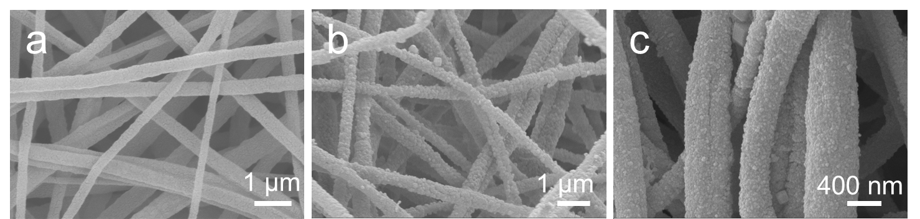
Fig. S1 SEM images of (a) ES-Zn(CH₃COO)₂, (b) PAN@ZIF-8, and (c) PAN@ZIF-8@ZIF-67, respectively.

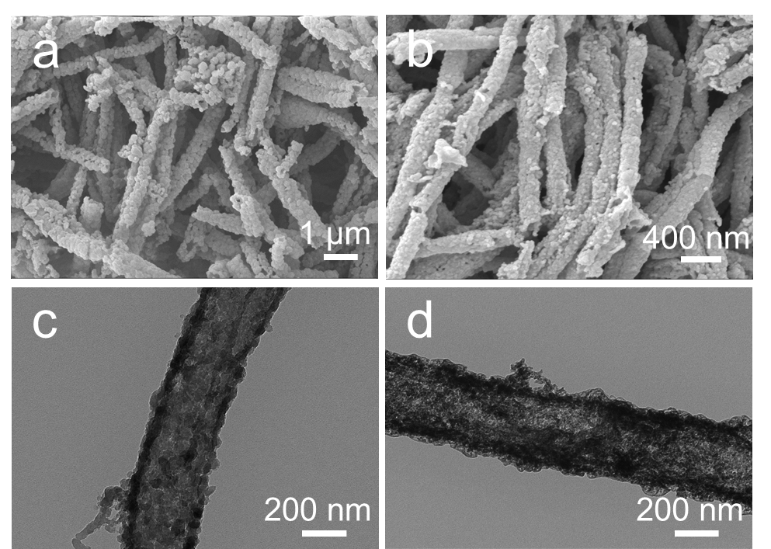
Fig. S2 SEM and TEM images of (a, c) ZIF-8@ZIF-67 and (b, d) ZnSe@CoSe.

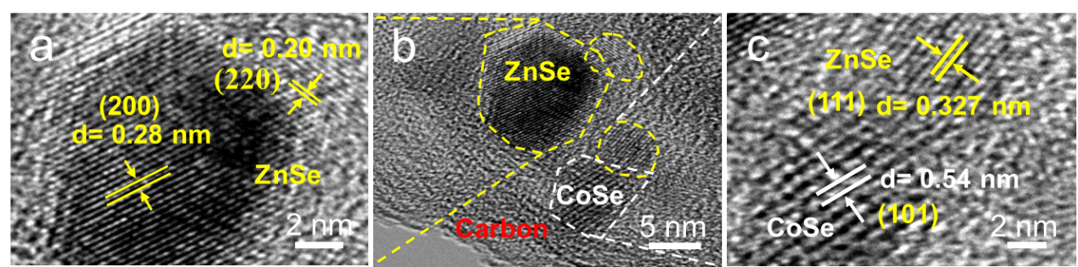
Fig. S3 HRTEM images of ZnSe@CoSe@CN.

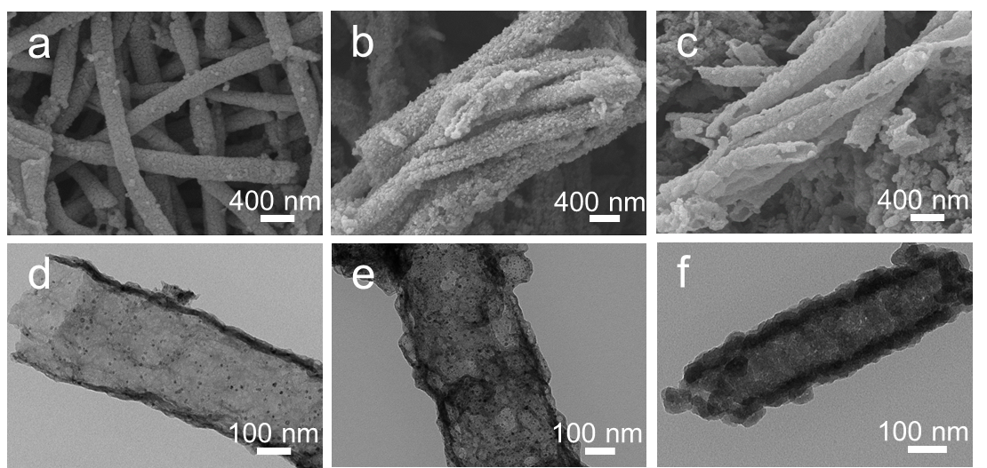
Fig. S4 SEM and TEM images of (a, d) ZnSe@CN, (b, e) CoSe@CN, and (c, f) Zn@Co@CN, respectively.

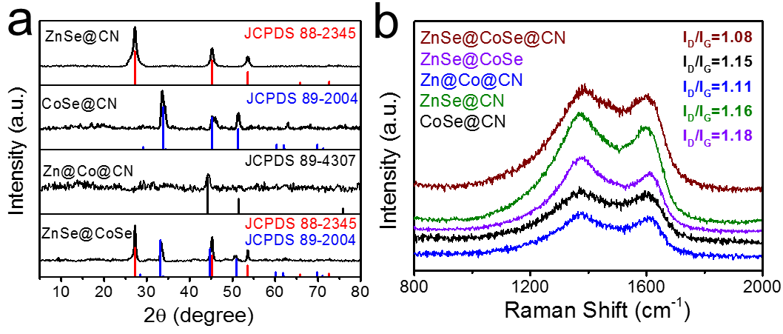
Fig. S5 (a) Powder XRD patterns and (b) Raman spectra of the samples.

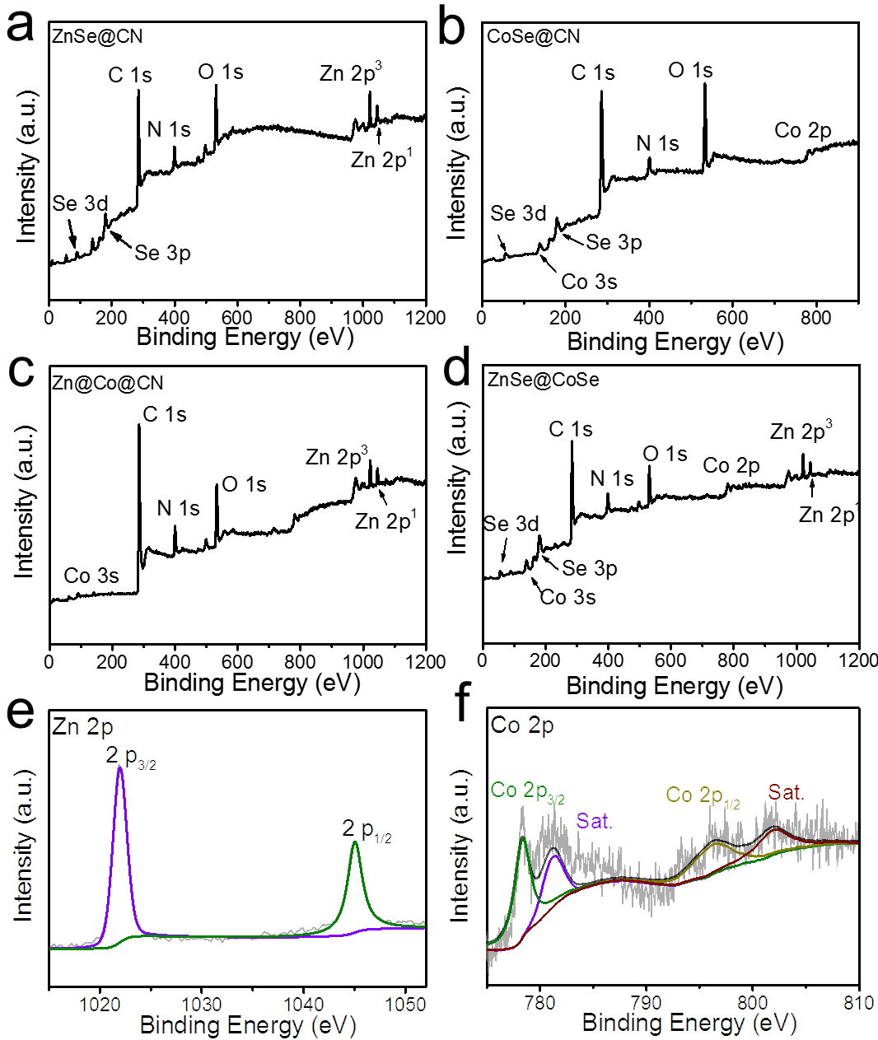
Fig. S6 XPS survey spectra of (a) ZnSe@CN, (b) CoSe@CN, (c) Zn@Co@CN, and (d) ZnSe@CoSe, respectively. High-resolution XPS spectra of (e) Zn 2p of ZnSe@CN and (f) Co 2p of CoSe@CN.
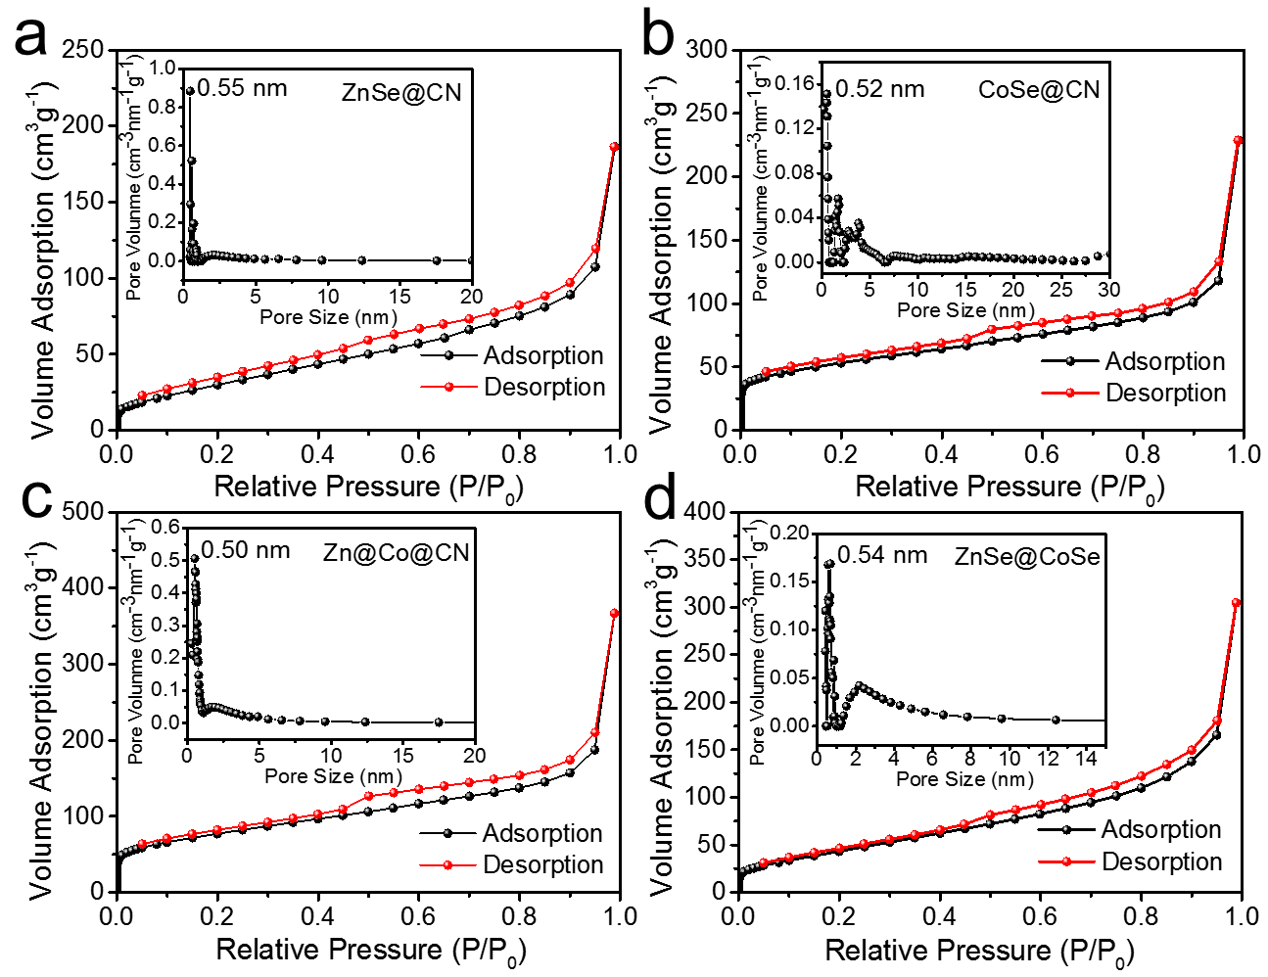
Fig. S7 N₂ sorption isotherms of (a)ZnSe@CN, (b) CoSe@CN, (c) Zn@Co@CN, and (d) ZnSe@CoSe, respectively. Inset is the corresponding pore size distribution.

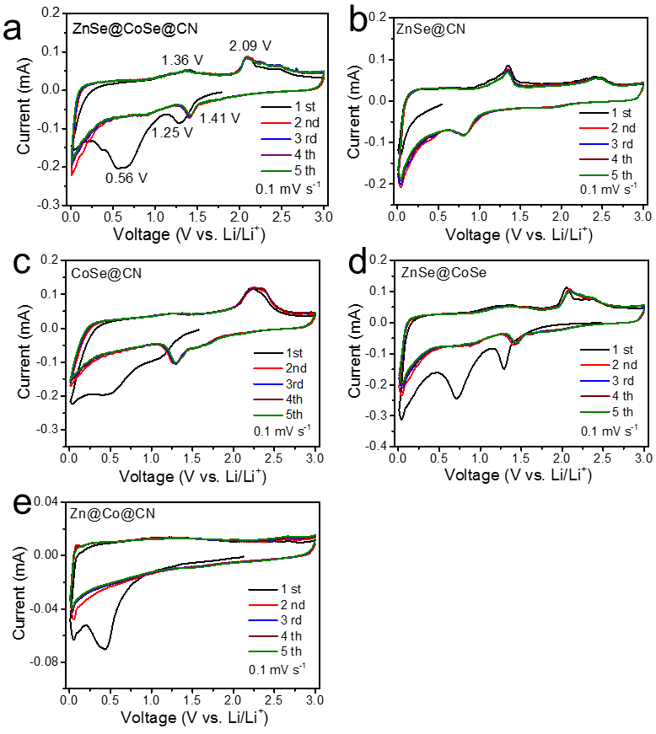
Fig. S8 CV profiles of the anodes with a scanning rate of 0.1 mV s⁻¹ for lithium-ion storage.

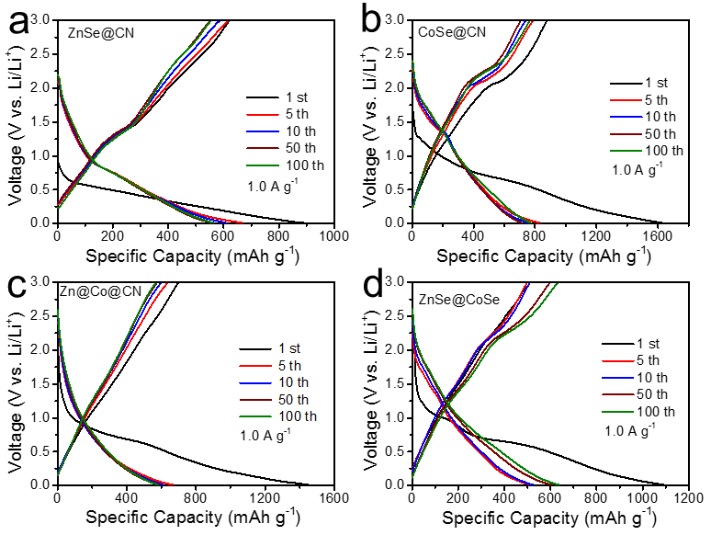
Fig. S9 GDC profiles of the contrast anodes at 1.0 A g⁻¹ for lithium-ion storage.

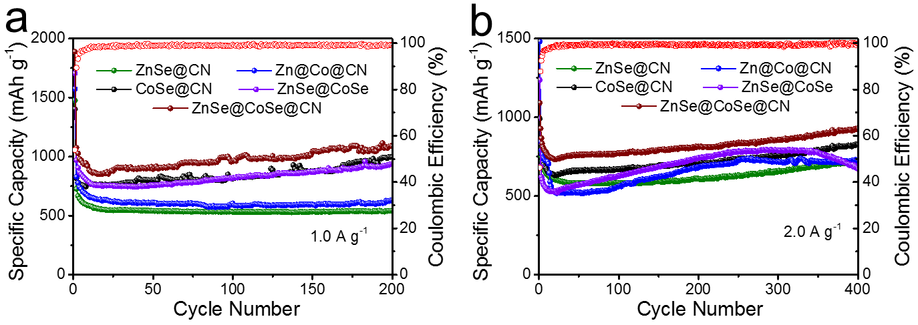
Fig. S10 Cycling performance of the anodes at (a) 1.0 A g⁻¹ and (b) 2.0 A g⁻¹ for lithium-ion storage.

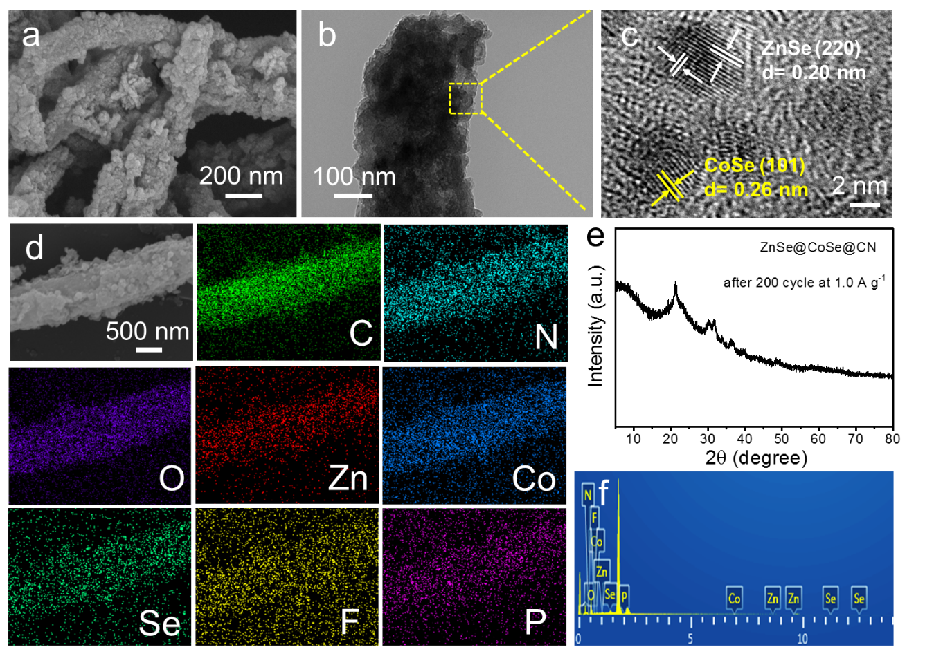
Fig. S11 (a) SEM, (b) TEM, (c) HRTEM, (d) elemental mapping images, (e) XRD pattern, and (f) EDS pattern of the ZnSe@CoSe@CN anode after 200 cycles at 1.0 A g⁻¹, respectively.

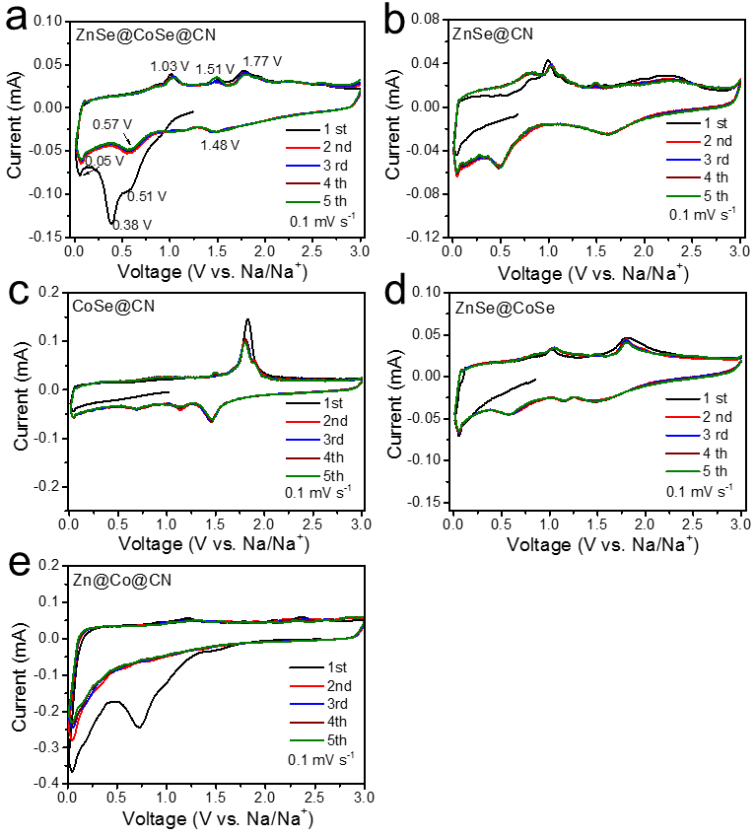
Fig. S12 CV profiles of the anodes with a scanning rate of 0.1 mV s⁻¹ for sodium-ion storage.

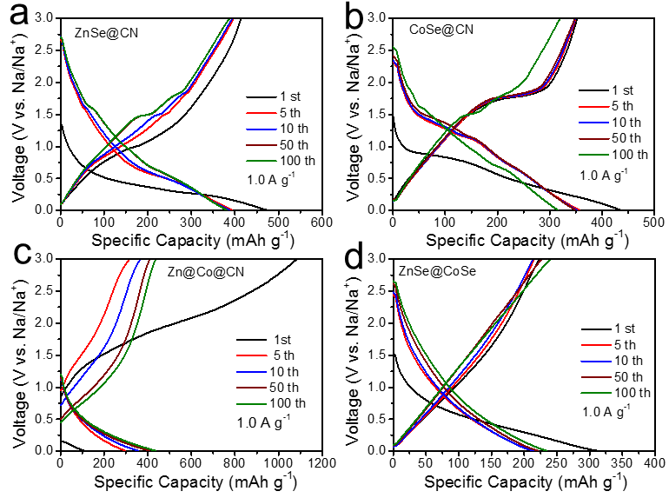
Fig. S13 GDC profiles of (a) ZnSe@CN, (b) CoSe@CN, (c) Zn@Co@CN, and (d) ZnSe@CoSe for sodium-ion storage, respectively.

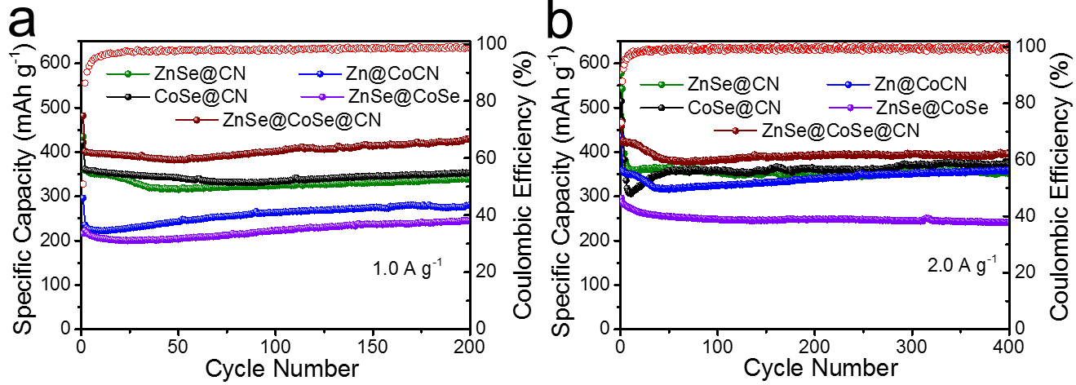
Fig. S14 Cycling performance of the anodes at (a) 1.0 A g⁻¹ and (b) 2.0 A g⁻¹ for sodium-ion storage.

Table S1 XPS measured element contents of the samples.
Samples | C[atomic%] | N[atomic%] | O[atomic%] | Co[atomic%] | Zn[atomic%] | Se[atomic%]
ZnSe@CN | 68.98 | 9.64 | 16.46 | — | 2.26 | 2.74
CoSe@CN | 68.47 | 8.05 | 19.31 | 1.69 | — | 2.47
Zn@Co@CN | 75.82 | 9.4 | 12.57 | 1.06 | 1.11 | —
ZnSe@CoSe | 68.99 | 11.06 | 13.06 | 1.8 | 1.68 | 3.41
ZnSe@CoSe@CN | 72 | 10.55 | 11.87 | 1.14 | 1.15 | 3.29

Table S2 The specific surface area and total pore volume of the samples.
Samples | Surface area  (m²·g⁻¹) | Total pore volume  (cm³·g⁻¹)
ZnSe@CN | 120.61 | 2.892
CoSe@CN | 143.89 | 3.555
Zn@Co@CN | 275.49 | 5.693
ZnSe@CoSe | 191.267 | 4.724
ZnSe@CoSe@CN | 168.81 | 4.454

Table S3 Electrochemical performances of the anode materials for lithium-ion storage.
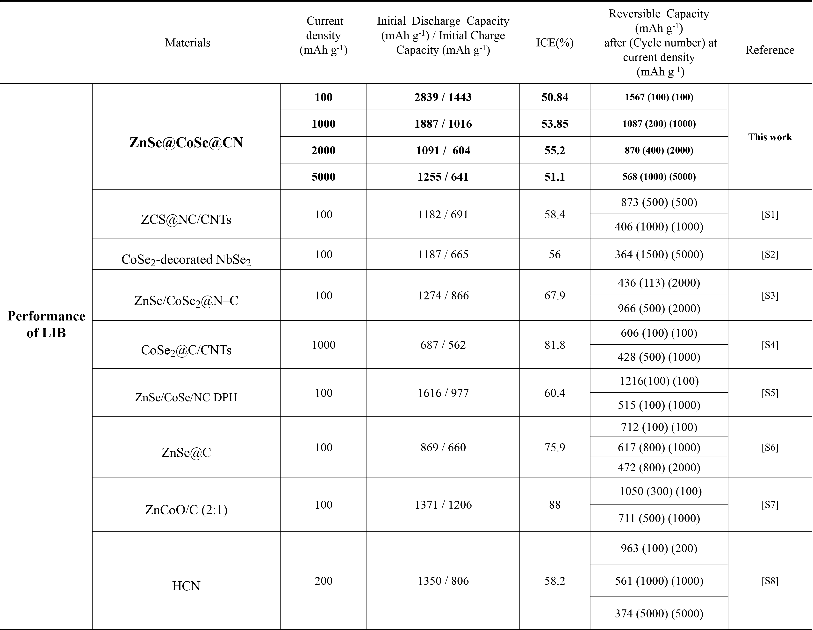

Table S4 Electrochemical performances of the anode materials for sodium-ion storage.
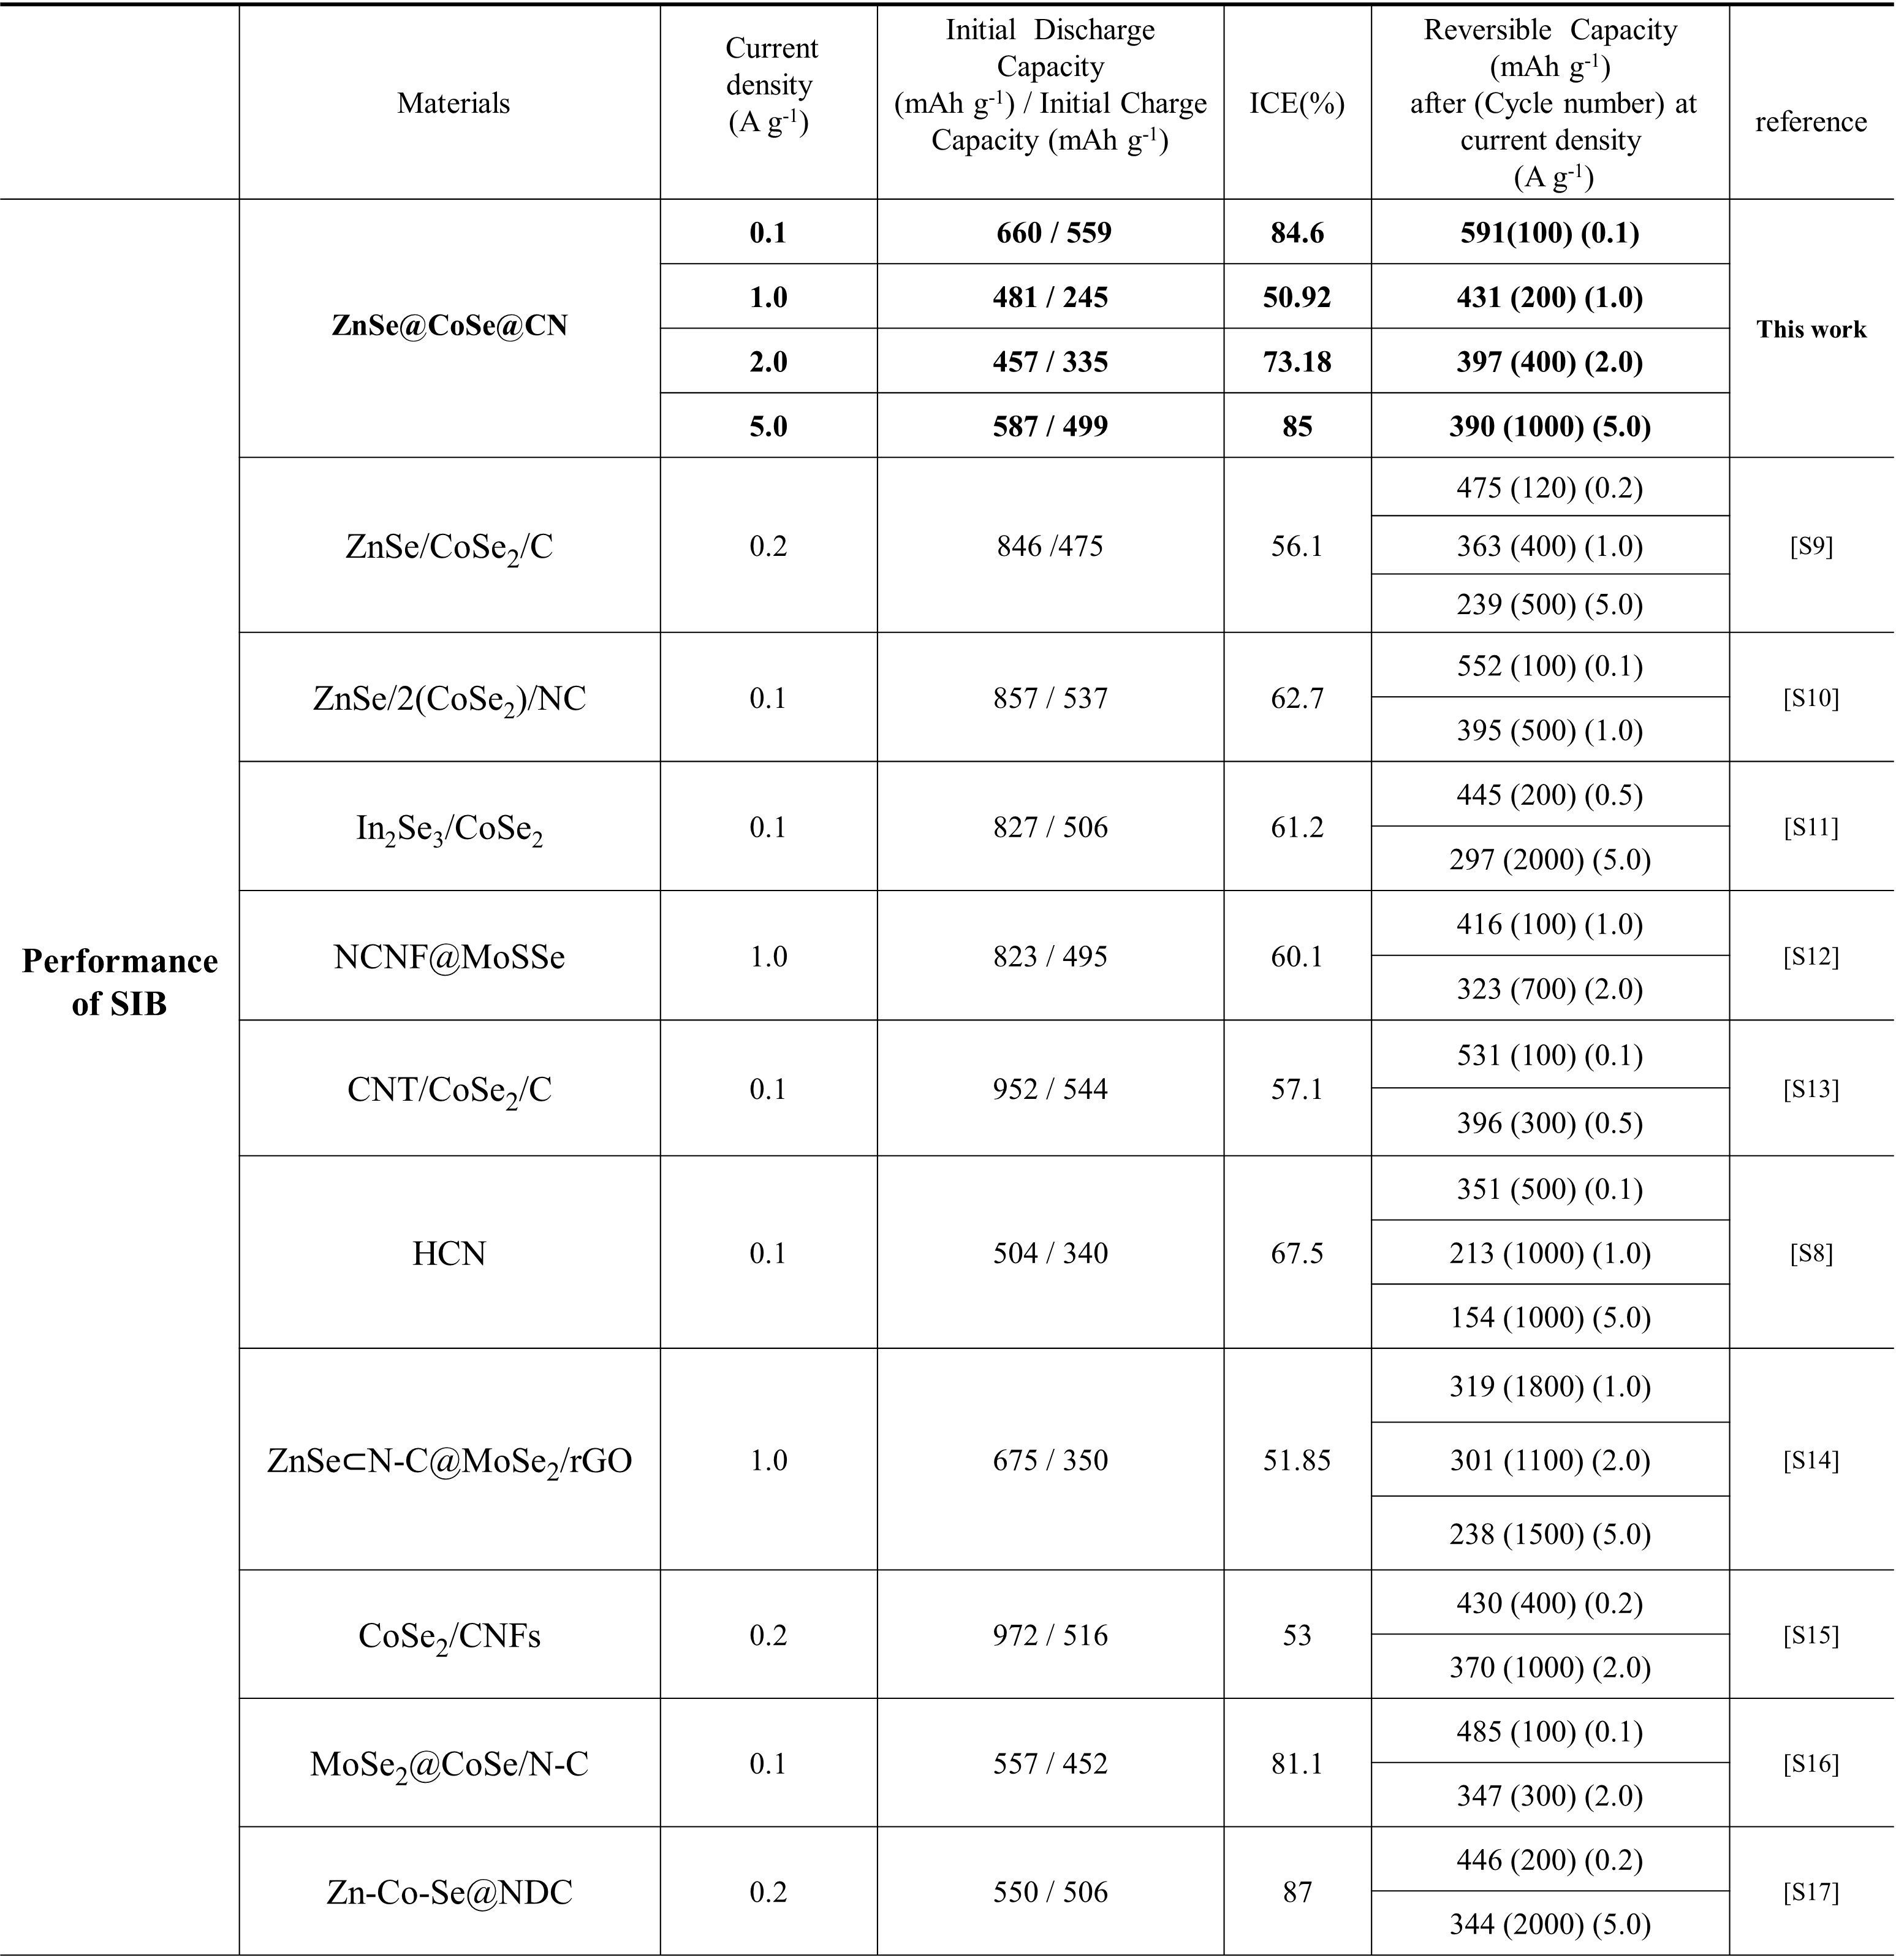
References
[S1] Jin J, Zheng Y, Kong LB, Srikanth N, Yan QY, Zhou KA (2018) A reflection on lithium-ion battery cathode chemistry. J Mater Chem A 6:15710-15717.
[S2] Zhang JL, Du CF, Zhao J, Ren H, Liang QH, Zheng Y, Madhavi S, Wang X, Zhu W, Yan QY (2018) CoSe₂-Decorated NbSe₂ Nanosheets Fabricated via Cation Exchange for Li Storage. ACS Appl Mater Interfaces 10:37773-37778.
[S3] Liu Q, Hou JG, Hao Q, Huang P, Xu CX, Zhou QX, Zhou J, Liu H (2020) Nitrogen-doped carbon encapsulated hollow ZnSe/CoSe₂ nanospheres as high performance anodes for lithium-ion batteries. Nanoscale 12:22778-22786.
[S4] Yang J, Gao HC, Men S, Shi ZQ, Lin Z, Kang XW, Chen SW (2018) CoSe₂ Nanoparticles Encapsulated by N-Doped Carbon Framework Intertwined with Carbon Nanotubes: High-Performance Dual-Role Anode Materials for Both Li- and Na-Ion Batteries. Adv Sci 5:1800763.
[S5] Liu HD, Lin Y, Li MN, Zhang L, Lu Y, Xiao W (2021) ZnSe/CoSe/NCDPH composites as anode materials for lithium ion batteries with high capacity and long cycle. Int J Hydrog Energy 46:30818-30827.
[S6] Ma DJ, Zhu QL, Li XT, Gao HC, Wang XF, Kang XW, Tian Y (2019) Unraveling the Impact of Ether and Carbonate Electrolytes on the Solid-Electrolyte Interface and the Electrochemical Performances of ZnSe@C Core-Shell Composites as Anodes of Lithium-Ion Batteries. ACS Appl Mater Interfaces 11:8009-8017.
[S7] Joshi B, Samuel E, Kim YI, Periyasami G, Rahaman M, Yoon SS (2021) Bimetallic zeolitic imidazolate framework-derived substrate-free anode with superior cyclability for high-capacity lithium-ion batteries. J Mater Sci Technol 67:116-126.
[S8] Zhang Z, Huang Y, Li X, Zhang S, Jia QX, Li TH (2021) Hollow carbon nanocages toward long cycle lifespan lithium/sodium-ion half/full batteries. Chem Eng J 421:129827.
[S9] Jeong SY, Cho JS (2019) Porous Hybrid Nanofibers Comprising ZnSe/CoSe₂/Carbon with Uniformly Distributed Pores as Anodes for High-Performance Sodium-Ion Batteries. Nanomaterials Basel 9:1362.
[S10] Liu P, Han J, Zhu K, Dong Z, Jiao L (2020) Heterostructure SnSe₂/ZnSe@PDA Nanobox for Stable and Highly Efficient Sodium-Ion Storage. Adv Energy Mater 10:2000741.
[S11] Xiao SH, Li XY, Zhang WS, Xiang Y, Li TS, Niu XB, Chen JS, Yan QY (2021) Bilateral Interfaces in In₂Se₃-CoIn₂-CoSe₂ Heterostructures for High-Rate Reversible Sodium Storage. ACS Nano 15:13307-13318.
[S12] Shi JW, Li H, Liu YW, Lu QY, Gao F (2022) Molybdenum Sulfide Selenide Nanosheets Synergized with Nitrogen-Rich Carbon Frameworks toward High Performance and Stable Sodium Storage. Adv Mater Interfaces 9:2102408.
[S14] Shi NX, Chu YT, Xi BJ, Huang M, Chen WH, Duan B, Zhang CH, Feng JK, Xiong SL (2020) Sandwich Structures Constructed by ZnSe subset of N-C@MoSe₍₂₎ Located in Graphene for Efficient Sodium Storage. Adv Energy Mater 10:2002298.
[S15] Yin, H.; Qu, H. Q.; Liu, Z. T.; Jiang, R. Z.; Li, C.; Zhu, M. Q (2019) Long cycle life and high rate capability of three dimensional CoSe₂ grain-attached carbon nanofibers for flexible sodium-ion batteries. Nano Energy 58:715-723.
[S16] Chen J, Pan AQ, Wang YP, Cao XX (2019) Hierarchical mesoporous MoSe₂@CoSe/N-doped carbon nanocomposite for sodium ion batteries and hydrogen evolution reaction applications. Energy Stor Mater 21:97-106.
[S17] Feng J, Luo SH, Yan SX, Zhan Y, Wang Q, Zhang YH, Liu X, Chang LJ (2021) Rational Design of Yolk-Shell Zn-Co-Se@N-Doped Dual Carbon Architectures as Long-Life and High-Rate Anodes for Half/Full Na-Ion Batteries. Small 17:2101887.

