Annex:
Supporting Information (SI)

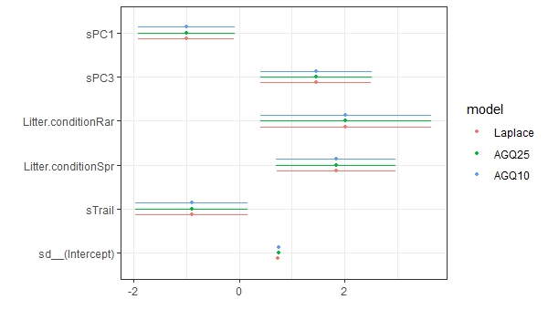
Fig. SI-A Model coefficient for Laplace, AGQ10 and AGQ25 where presence probability of invasive species is modeled as response variable. The variables are not scaled.
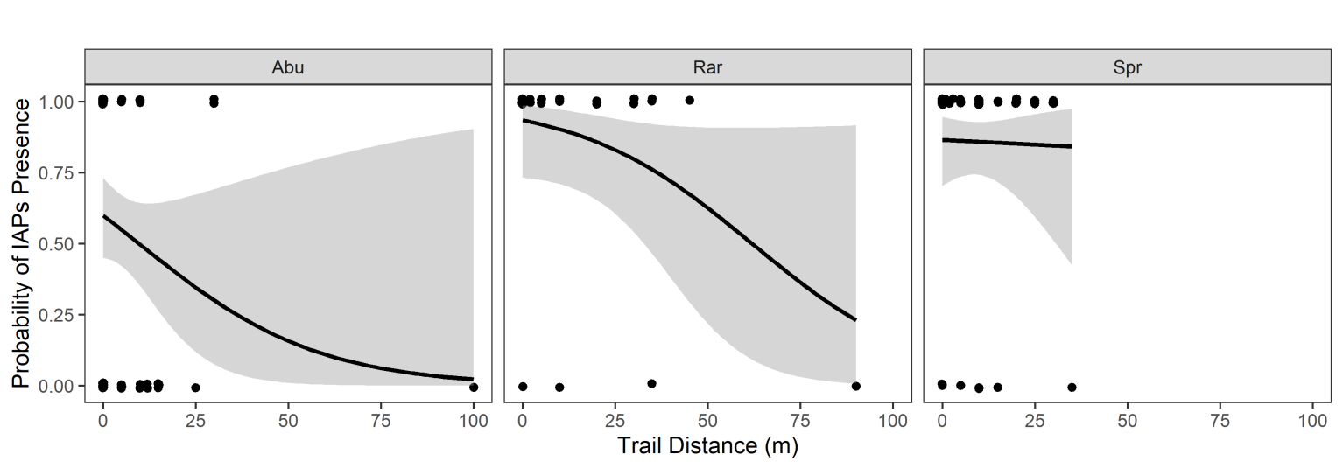
Fig. SI-B The probability of IAPs presence with trail distance shown for three-leaf litter conditions. Though non-significant, there is general pattern that the IAPs presence probability decreases with an increase in trail distance. The black dots are observed values, grey areas represent confidence interval and black lines represent predicted probabilities.
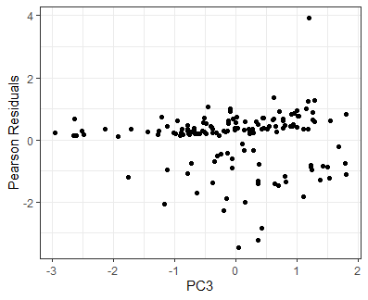
Fig. SI-C1 Pearson residuals vs PC3

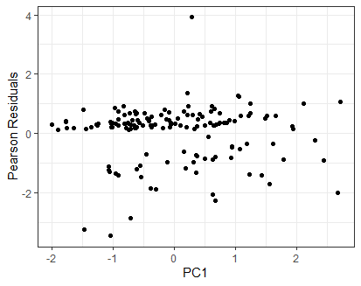
Fig. SI-C2 Pearson residuals vs PC1

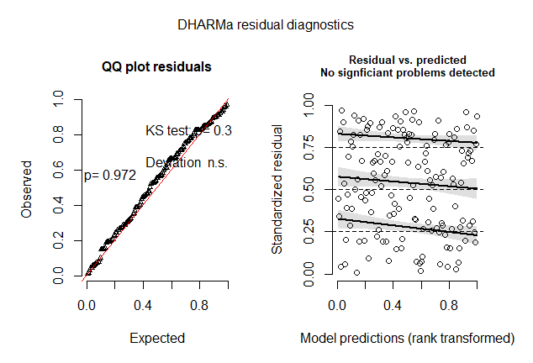
Fig. SI-D Residual diagnostic plots for minimum adequate model using package. The diagnostics plots show no serious issue of residual behavior

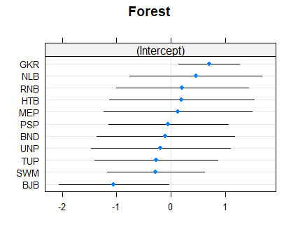
Fig. SI-E The random intercept plot for the model where individual forests are shown. The black lines show confidence intervals and blue points are average values

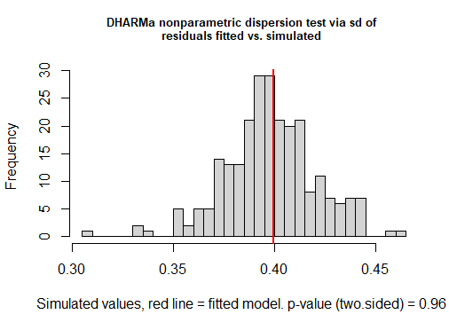
Fig. SI-F Histogram of residual distribution showing fitted and simulated values

