Supplementary Figures

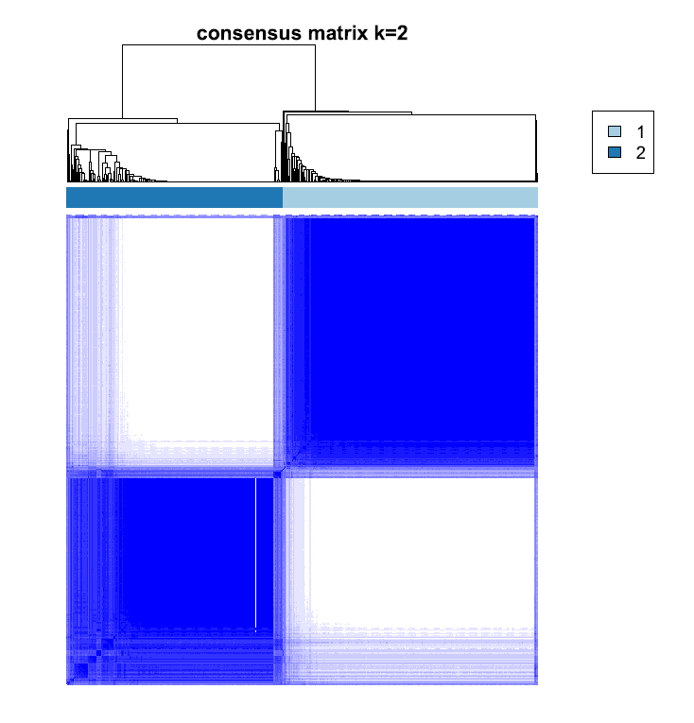
Figure S1 Identification of gene subtypes based on 82 DEGs among two angiogenesis subgroups in KIRC cohort.

A B
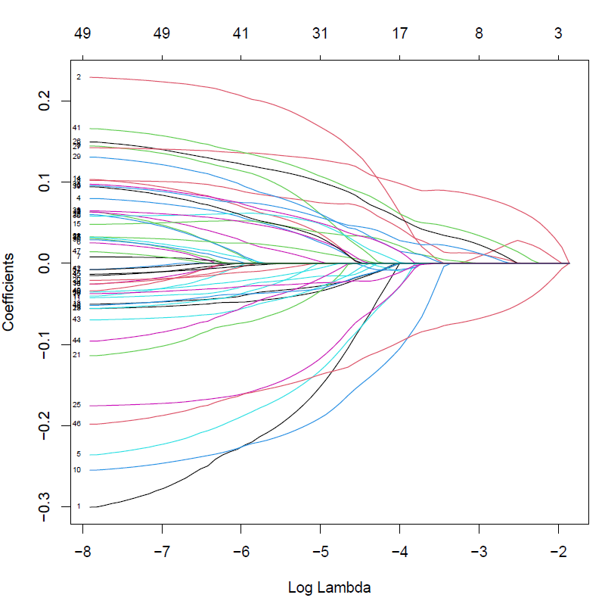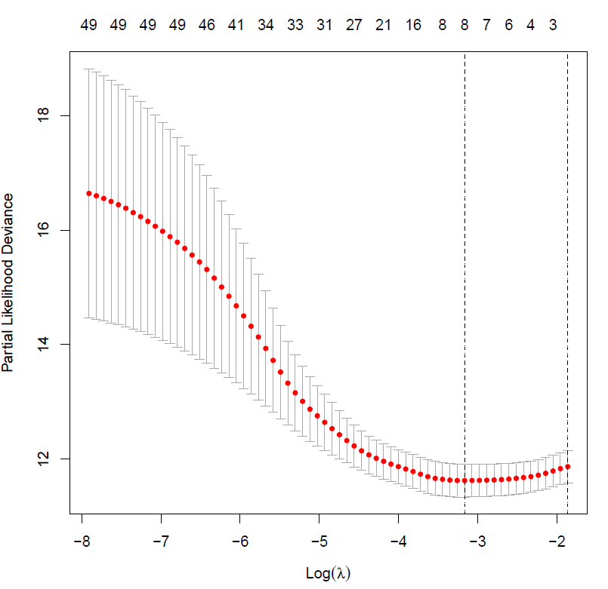
C
id | coef
COL22A1 | 0.0885670350319218
SLC38A5 | 0.137980139096561
G6PC | -0.116879957162185
Figure S2 Identifying representative candidate prognostic genes. (A-B) The LASSO regression analysis and partial likelihood deviance on the prognostic genes. (C) The results of multivariate cox regression analysis for prognostic genes.

A B C
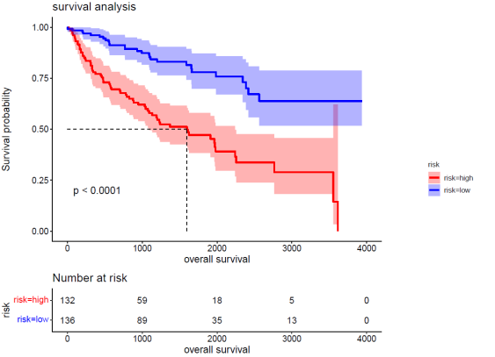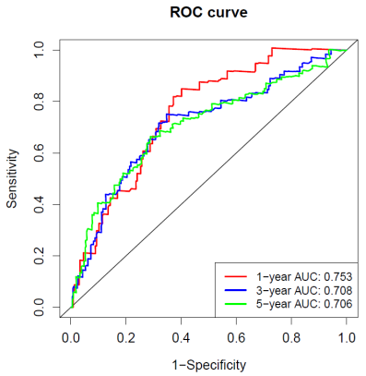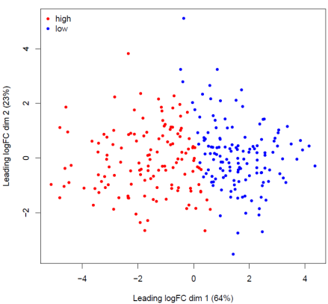
D E
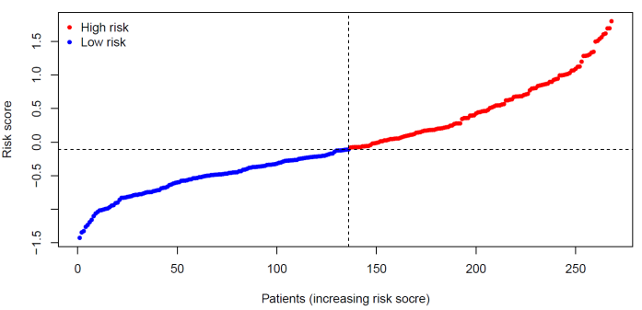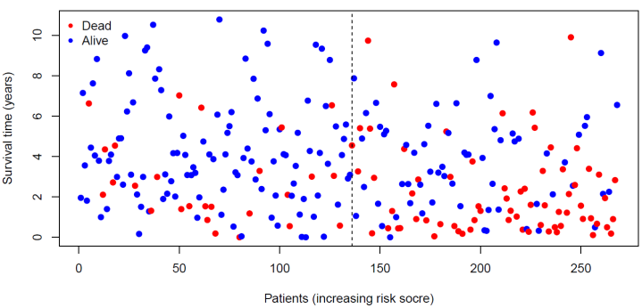
F
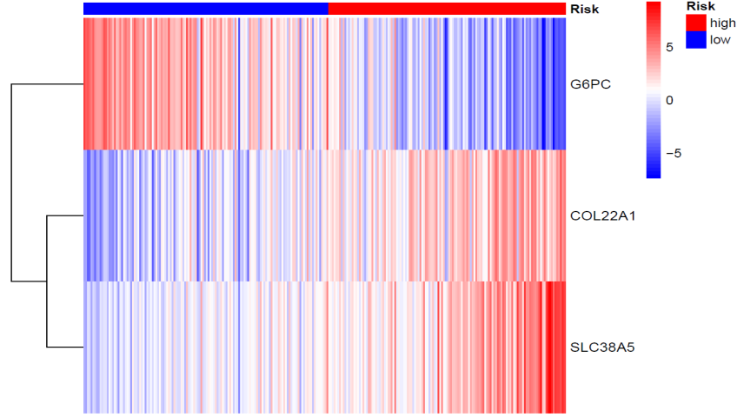
Figure S3 Validation of AAG_score in test cohort. (A) KM analysis of the OS between the two groups. (B) ROC curves to predict the sensitivity and specificity of 1-, 3-, and 5-year survival according to the AAG_score. (C) The PCA analysis demonstrated that the patients in the different risk groups were distributed in two directions. (D-E) The ranked dot plot indicates the AAG_score distribution and scatter plot presenting the patients’ survival status. (F) Expression patterns of 3 selected prognostic genes in high- and low-risk groups.
A B C
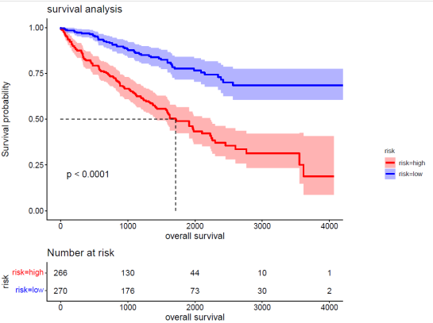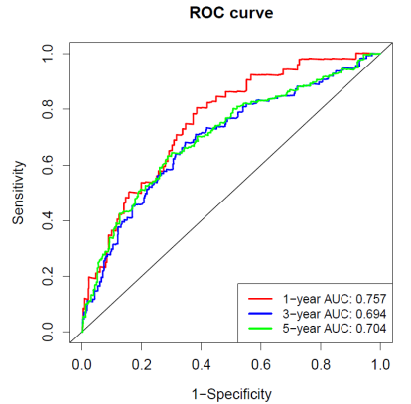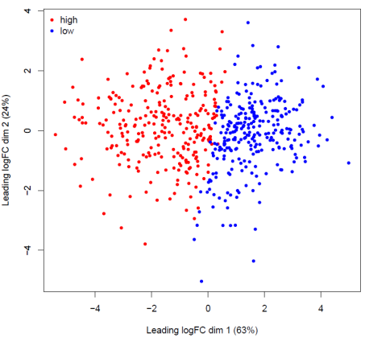
D E
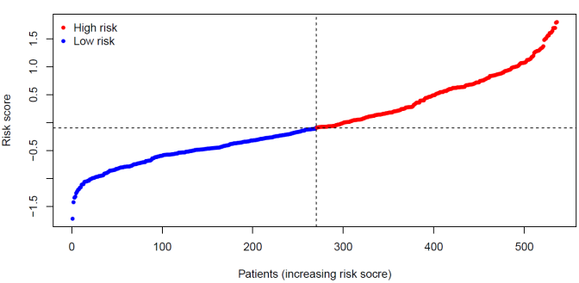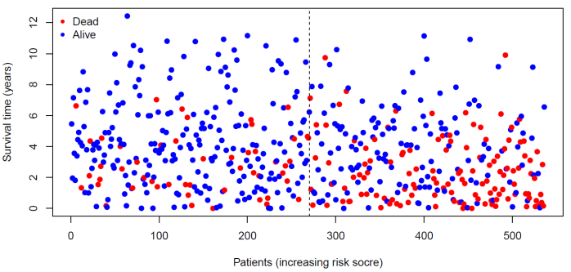
F
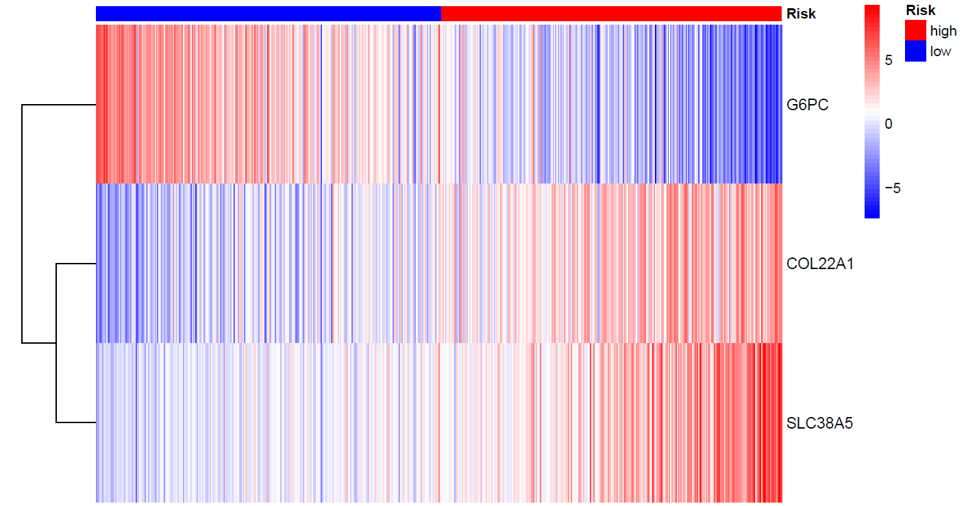
Figure S4 Validation of AAG_score in entire cohort. (A) KM analysis of the OS between the two groups. (B) ROC curves to predict the sensitivity and specificity of 1-, 3-, and 5-year survival according to the AAG_score. (C) The PCA analysis demonstrated that the patients in the different risk groups were distributed in two directions. (D-E) The ranked dot plot indicates the AAG_score distribution and scatter plot presenting the patients’ survival status. (F) Expression patterns of 3 selected prognostic genes in high- and low-risk groups.
A B C D
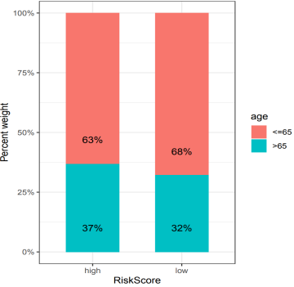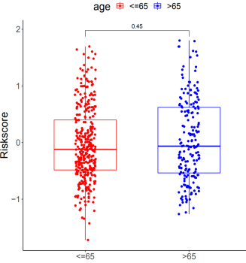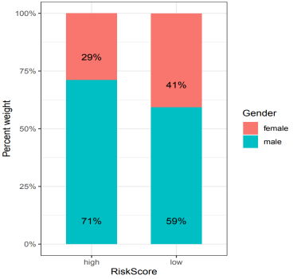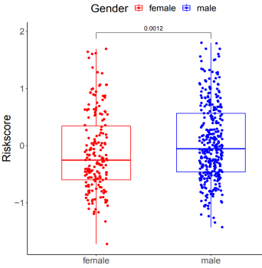
E F G H
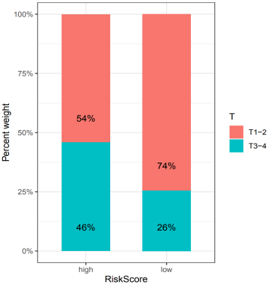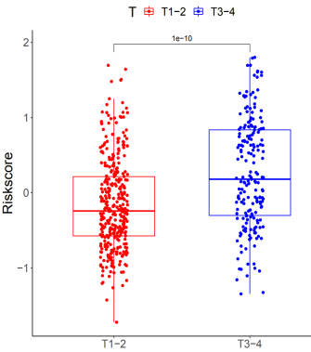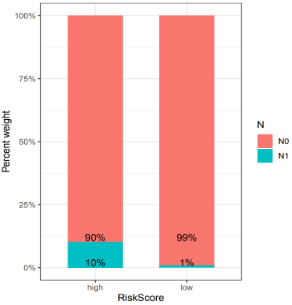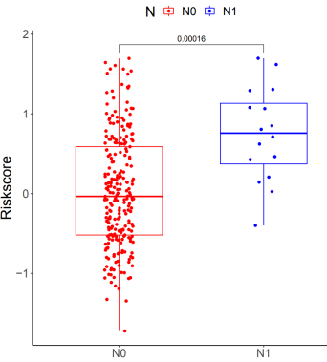
Figure S5 The correlation analysis of AAG_score and clinicopathological variables in KIRC. The (A) Age, (C) Gender, (E) T-stage, and (G) N-stage distribution of with patients in different risk groups. The correlation between the AAG_score and (B) Age, (D) Gender, (F) T-stage, and (H) N-stage.

A B
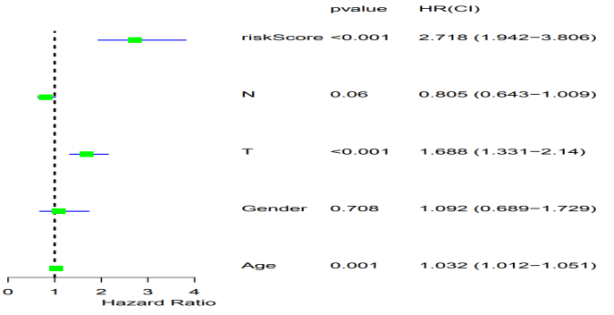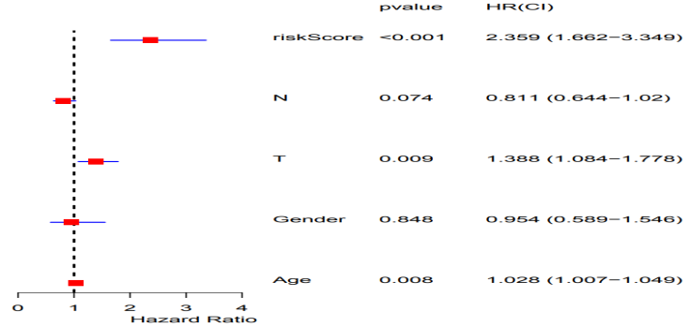
C D
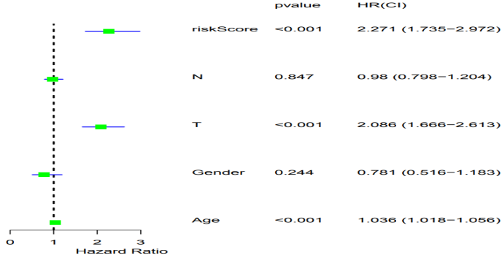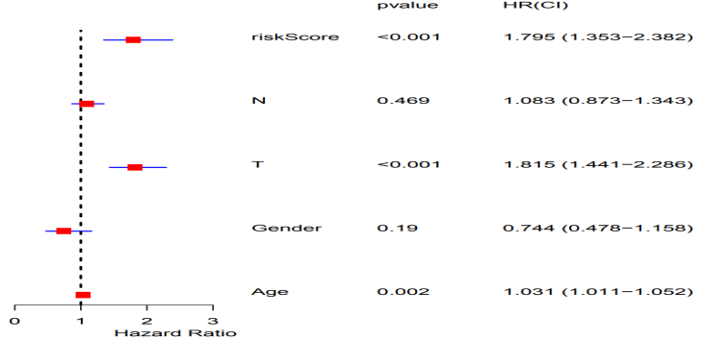
E F
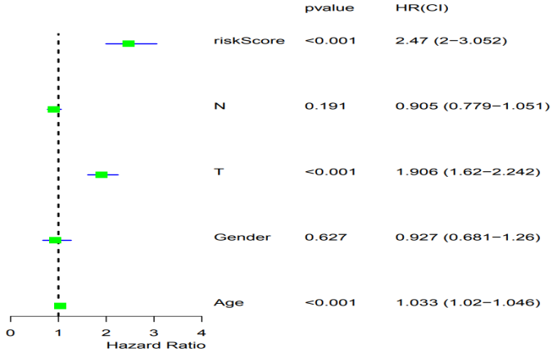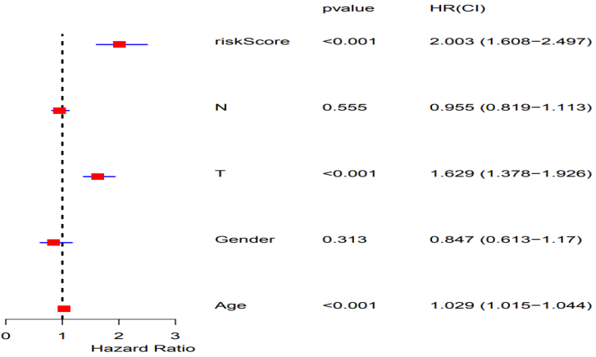
Figure S6 The independent prognosis analysis of AAG_score and clinicopathological variables in KIRC. (A-B) Univariate and multivariate analyses showed the prognostic value of the AAG_score in the training cohort. (C-D) Univariate and multivariate analyses showed the prognostic value of the AAG_score in the test cohort. (E-F) Univariate and multivariate analyses showed the prognostic value of the AAG_score in the entire cohort.
A B C D
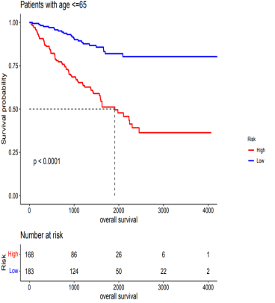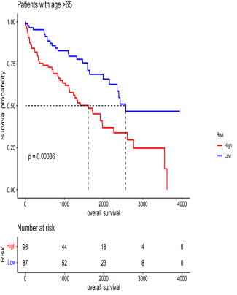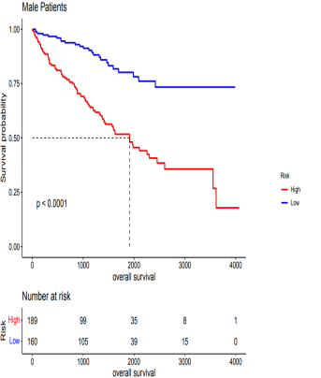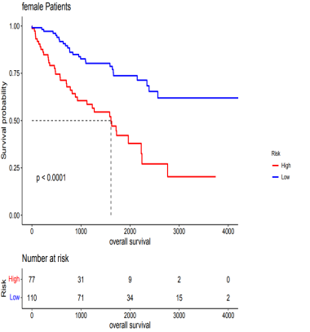
E F G H
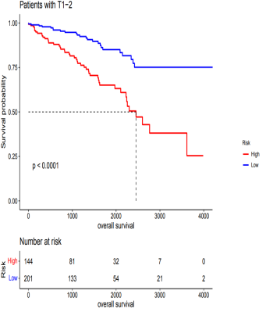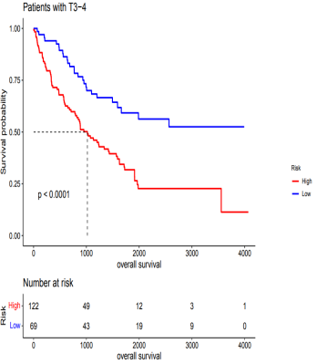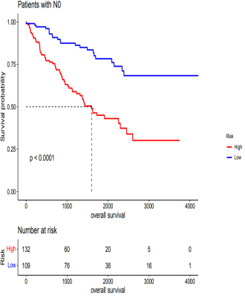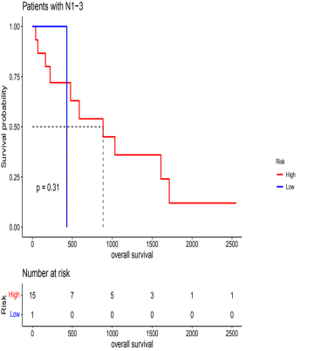
Figure S7 Stratification analysis of the AAG_score in KIRC. (A-B) Age (age ≤ 65 and age > 60 years old). (C-D) Gender (male and female). (E-F) T-stage (T1-2 and T3-4). (G-H) N-stage (N0 and N1-3).

