Supp Table 1 RT-qPCR Primers of P9 strains
Gene ID | Gene name (Annotation) | Length (bp) | Forward primer  (5’- 3’) | Reverse prime  (5’ -3’)
 | 16S rRNA | 136 | GCGATTACTAGCGACTCCGACTTC | AGGGCTTCACACATGCTACAATGG
ASU32_20935 | aceA  (isocitrate lyase) | 133 | GAGCTCGCCAAGAAGTTCGC | GCTCGTTCTGGAACTTCGCG
ASU32_15355 | alkM  (alkane 1-monooxygenase) | 148 | TGACCTACATCTTCCTGCCCTTCC | AGACTGAGAGTAAGACCGATCTGACTG
ASU32_07260 | gcl  (glyoxylate carboligase) | 80 | GGCTGCTTCCAGATGACCAATCAG | TTGTTGATGACGGCCACCTTGATC
ASU32_21730 | echA  (enoyl-CoA hydratase) | 139 | GAAGAAGCCGTTGATCGCCG | CATCGGGAACAGGCTCCACT
ASU32_12965 | argH  (argininosuccinate lyase) | 91 | CGCTGGTCCGAGGATGTGAT | GCATGATCGAACTGCCCGTG
ASU32_12970 | argG  (argininosuccinate synthase) | 128 | GAACCGGATCATCGAGGCCA | CGTTGTGGTACGTGGCGATG
ASU32_01795 | ABC  (ABC transporter) | 103 | TCGACGACCTGAGCTTCACC | GTGATCCGACCTGCGAGGAT
ASU32_01370 | smvA  (MFS transporter) | 137 | GTGCTGATCATCGGGATCTTCCTG | TGATCCTTGGCGAACCGTTTGATG
ASU32_09820 | ahpC  (lipoyl-dependent peroxiredoxin subunit C) | 101 | CCCTCTTGACGATCGGCGAT | GAAGTAGTCGTCCGGCTGCT
ASU32_21425 | fepD  (iron-siderophore transport system permease protein) | 149 | ATCCAGTACGTCTGGTTCGCCTTC | GAGGTCATCGAGCTGAGGAACATC
ASU32_21090 | fepB  (ferric enterobactin transport system substrate-binding protein) | 143 | GCGTCGTGCTGCTGAACTAC | GGCCTTGGTGAAGTCGTCCT
ASU32_09340 | fagD  (iron-siderophore transport system substrate-binding protein) | 120 | CGAGAAGCTGTACGCCCAGT | ATCTCGTCGGTCCGGTTCAC
ASU32_17345 | yqjH  (siderophore-interacting protein) | 98 | TCTACACCGTCCGCACCTTC | CTCCTCGATCCAGCGCATCA
ASU32_12785 | nfeF  (NADPH-dependent ferric siderophore reductase) | 134 | ACCTACACCGTCCGCTCCTT | GGGCCCATGATCGTGATCGT
The annealing temperature of ASU32_21425、ASU32_21090、ASU32_09340、ASU32_17345、ASU32_12785 is 59.5℃; the annealing temperature of ASU32_12965、ASU32_12970、ASU32_20935、ASU32_15355、ASU32_07260、ASU32_21730、ASU32_01795、ASU32_01370、ASU32_09820 is 60.1℃.

Supp 2 Table 1 Main Ingredients of Root Exudates of Peanut
Components | Main Materials | Relative Content（%）
Organic acids | 2-Deoxytetronic acid, 3-Hydroxypropionic acid, Lactic acid, Phenaceturic acid, Glycolic acid, Palmitic acid, Succinic acid, Citric acid, Malic acid, Pyruvic acid, Oxalic acid etc. | 66.80
Amino acids | 5-Aminovaleric acid, N-Acetyl-beta-alanine, Alanine, Valine, Tyrosine, Tryptophan, Isoleucine, Phenylalanine, Proline, Glycine etc. | 13.17
Alcohols | 4-Hydroxyphenylethanol, myo-Inositol, Diglycerol, Phytol, cis-Phytol, Glycerol etc. | 7.68
Sugars | Xylose, allose, Lyxose, Ribose, 1,5-Anhydroglucitol, Glucoheptonic acid etc. | 3.67
Amides | Indole-3-acetamide, Nicotinamide, Malonamide, Lactamide, 5-Aminovaleric acid lactam | 2.24
Growth factors | Biuret, Urea, N-(3-Aminopropyl)-morpholine, Vanillin, Loganin, Glutathione - H₂O, Salicin, 4-Aminobenzoic acid, (+/-)-Taxifolin, 3-Methyloxindole etc. | 1.00
Esters | 2-Methylfumarate, 4-Hydroxybutyrate, 2-Ketoadipate, Maleamate, Guanosine-5'-monophosphate, Methyl jasmonate, D-Erythronolactone, beta-Mannosylglycerate etc. | 0.64
Aldehydes | Succinate semialdehyde, Butyraldehyde, Phenylacetaldehyde, Glutaraldehyde,  trans-3,5-Dimethoxy-4-hydroxycinnamaldehyde etc. | 0.49
Pyridines | 2-Hydroxypyridine, 3,4-Dihydroxypyridine, 3-Hydroxypyridine, 4-Hydroxypyridine | 0.49
Amines | 1,3-Diaminopropane, N,N-Dimethyl-p-phenylenediamine, Aniline, Putrescine, Maleimide, Bis(2-hydroxypropyl)amine | 0.49
Ketones | 9-Fluorenone, 4-Hydroxy-6-methyl-2-pyrone, 1,4-Cyclohexanedione, Dihydroxyacetone etc. | 0.45
Nucleotides | Xanthine, Xanthosine, Adenine, Uracil, Thymidine, Guanine | 0.19
Phenols | o-Cresol, Thymol, 1,2,4-Benzenetriol, Resorcinol, 4-Aminophenol, cis-Phytol | 0.20
Others | IS | 2.49

Supp Table 3 Quality statistics of RNA-seq data of Tsukamurella tyrosinosolvens P9
Samples | Raw reads | Clean reads | Clean bases | Q30  (%) | GC content(%) | Total mapped | Mapped  Ratio(%)
P9_RE1 | 18058798 | 17793208 | 2.7G | 94.63 | 68.78 | 16205019 | 91.07%
P9_RE2 | 15964598 | 15868548 | 2.4G | 94.86 | 68.64 | 14742708 | 92.91%
P9_RE3 | 15964598 | 15868548 | 2.4G | 95.02 | 68.22 | 12214332 | 81.36%
P9_N1 | 15624044 | 15434410 | 2.3G | 95.32 | 67.99 | 13969310 | 90.51%
P9_N2 | 15574582 | 15468686 | 2.3G | 94.80 | 69.81 | 14266561 | 92.23%
P9_N3 | 15849826 | 15717066 | 2.4G | 95.05 | 68.18 | 14711996 | 93.61%

Supp Table 4 KEGG enrichment pathway of differentially expressed genes of Tsukamurella tyrosinosolvens P9 affected by peanut root exudates
Pathways | Sample  number | Background  number | Pvalue
Arginine biosynthesis | 5 | 22 | 6.83E-05
Butanoate metabolism | 5 | 34 | 0.000603999
Fatty acid degradation | 5 | 37 | 0.000904992
Tryptophan metabolism | 4 | 23 | 0.001208826
Biosynthesis of secondary metabolites | 14 | 304 | 0.001499759
Caprolactam degradation | 3 | 12 | 0.001809546
Lysine degradation | 4 | 27 | 0.002257534
Benzoate degradation | 4 | 28 | 0.002594928
Fatty acid metabolism | 5 | 47 | 0.002744802
Propanoate metabolism | 4 | 34 | 0.005375929
Valine, leucine and isoleucine degradation | 4 | 38 | 0.008062547
Glyoxylate and dicarboxylate metabolism | 4 | 38 | 0.008062547
Aminobenzoate degradation | 2 | 11 | 0.022608605
Microbial metabolism in diverse environments | 9 | 208 | 0.025792621
Biosynthesis of amino acids | 6 | 110 | 0.027141411
Limonene and pinene degradation | 2 | 13 | 0.031213868
beta-Alanine metabolism | 2 | 16 | 0.046131417

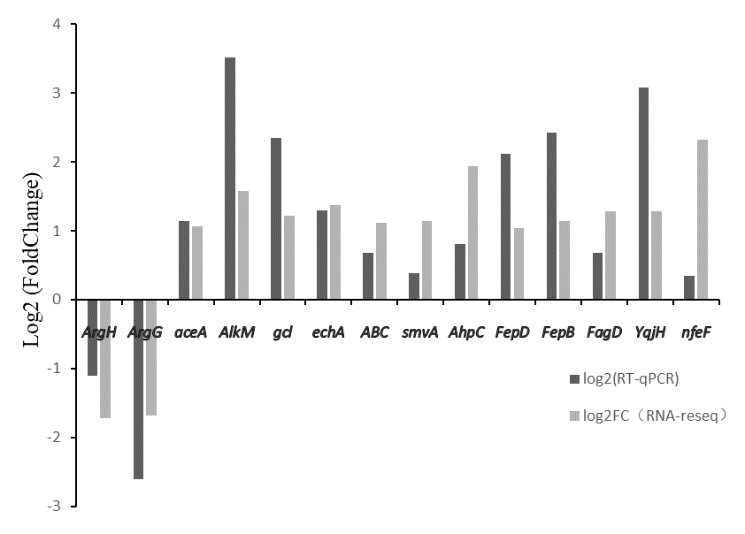
Supp Fig.5 The expression fold change of 14 candidate genes of P9

