Table S1 Genomic features of the wild-type strain XH26 and the mutant strain G₈-52
Features | Wild-type strain XH26 | Mutant strain G₈-52
Molecule shape | Circular | Circular
Genome size (bp) | 4,112,053 | 4,098,386
GC content (%) | 52.62% | 52.53%
Coding sequences (CDS)  Total RNA genes | 104,708  97 | 65,625  98
tRNAs  5S rRNAs  16S rRNAs  23S rRNAs | 63  6  6  6 | 64  6  6  6
rRNA (5S/6S/23S)  Other RNA genes  Coverage (%) | 1/1/1  16  100% | 1/1/1  16  100%
Predicted coding genes  Total length of predicted coding genes (bp) | 3,927  3,687,732 | 3,945  3,670,458

Table S2 Genomic comparison of wild-type strain XH26 and mutant strain G₈-52 regions
No. | ORF Number | Locus | Block | Reference | Change | Type
1 | orf00034 | 37964 | exonic | - | G | Insertion
2 | orf00215 | 222002 | exonic | A | - | Deletion
3 | orf00258 | 257737 | upstream | - | C | Insertion
4 | orf00263 | 261715 | upstream | - | T | Insertion
5 | orf00263 | 261744 | upstream | - | AG | Insertion
6 | orf00443 | 436707 | downstream | A | - | Deletion
7 | orf00721 | 727519 | upstream | T | - | Deletion
8 | orf00723 | 729148 | upstream | C | - | Deletion
9 | orf00726 | 732078 | exonic | - | GT | Insertion
10 | orf02141 | 2212367 | exonic | - | C | Insertion
11 | orf02186 | 2262995 | downstream | - | G | Insertion
12 | orf02266 | 2342959 | exonic | T | - | Deletion
13 | orf02522 | 2628488 | exonic | - | C | Insertion
14 | orf03151 | 3296311 | exonic | C | - | Deletion
15 | orf03335 | 3483088 | upstream | G | - | Deletion
16 | orf03412 | 3568183 | exonic | - | T | Insertion
17 | orf03417 | 3574134 | exonic | C | - | Deletion
18 | orf03539 | 3712840 | exonic | C | - | Deletion
19 | orf03568 | 3745920 | exonic | A | - | Deletion
20 | orf03677 | 3867248 | downstream | - | G | Insertion
21 | orf00424 | 419787 | exonic | C | T | Nonsynonymous SNV
22 | orf02403 | 2482248 | exonic | C | T | Synonymous SNV
23 | orf02552 | 2679511 | upstream | A | T | Synonymous SNV
24 | orf03427 | 3584077 | upstream | A | T | Synonymous SNV

Table S3 Representative Halomonas strains and ectoine production in shake-flask cultures
Representative strains | Type | Ectoine yield (g/L or CDWª) | Culture medium | Ref.
H. campaniensis strain XH26 | Wild | 0.51±0.01 g/L | CMEA | This study
H. campaniensis strain G₈-52 | Mutated | 1.51±0.01 g/L (0.65 g/g of CDW) | CMEA | This study
H. campaniensis strain G₈-44 | Mutated | 1.47±0.02 g/L (0.64 g/g of CDW) | CMEA | This study
H. salina | Wild | 0.52±0.02 g/L | CMEA | Our study
H. elongata strain KS3 | Wild | 0.12 g/g of CDW (2.56 M NaCl) | M63S-3 | Ono et al. 1998
H. ventosae strain DL7 | Wild | 0.46± 0.01 g/L | Nutrient | Zhu et al. 2007  Zhu et al. 2007  Zhu et al. 2007
H. ventosae DSM 15911^{T} | Wild | 0.43± 0.01 g/L | Nutrient | Zhu et al. 2007  Zhu et al. 2007  Zhu et al. 2007
H. halodenitrificans DSM 735^{T} | Wild | 0.33± 0.01 g/L | Nutrient | Zhu et al. 2007  Zhu et al. 2007  Zhu et al. 2007
H. boliviensis strain LC1^{T} | Wild | 0.74 g/L  1.25 g/L | HM  Seed | Guzmán et al. 2007 Van-Thuoc et al. 2010
H. salina DSM 5928^{T} | Wild | 0.29 g/L  0.82 g/L  1.08 ± 0.02 g/L | Nutrient  MM63  MG | Zhu et al. 2007  Zhang et al. 2009  Zhang et al. 2009
H. elongata DSM 2581^{T} | Wild | 0.81± 0.02 g/L | MM63 | Zhang et al. 2009
H. elongata OUT 30018 | Engineered | 0.54 g/g of CDW | MM63 ^{b} | Tanimura et al. 2013
Halomonas sp. strain H02 | Wild | 1.84 g/L | ZMG | Li et al. 2017
H. hydrothermalis strain Y2 | Wild | 0.10 g/g CDW | MG | Zhao et al. 2018
ªCDW: cell dry weight (g/g, ectoine per cell dry weight).
^{b}The engineered H. elongata strain produced 377 mmol/kg CDW of ectoine from a glucose/xylose mixture.

Figure legends

Fig. S1 Functional annotations of the wild-type strain XH26. A) KEGG annotations, B) GO annotations, C) COG annotations, D) CAZyme annotations, and E) Circular chromosome map.

Fig. S2 Functional annotations of the mutated strain G₈-52. A) KEGG annotations, B) GO annotations, C) COG annotations, D) CAZyme annotations, and E) Circular chromosome map.

Fig. S3 The ectoine synthesis pathway and intermediates involved in the tricarboxylic acid cycle of wild strain XH26. TCA is a tricarboxylic acid cycle. Gene davT and gabD were found to be involved in the tricarboxylic acid cycle, which leads to the increase of ectoine production.

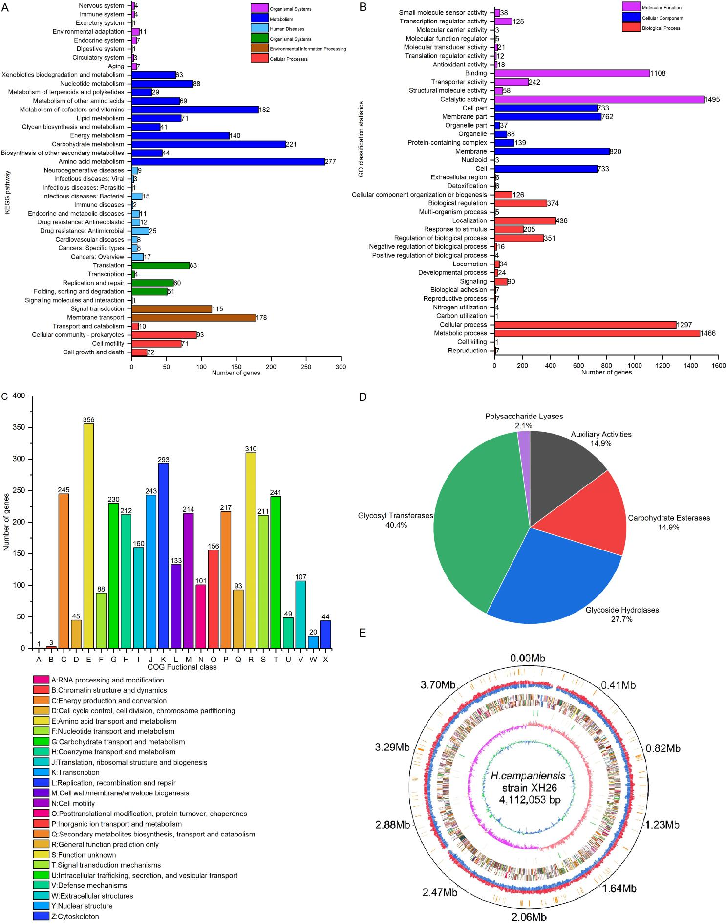
Fig. S1
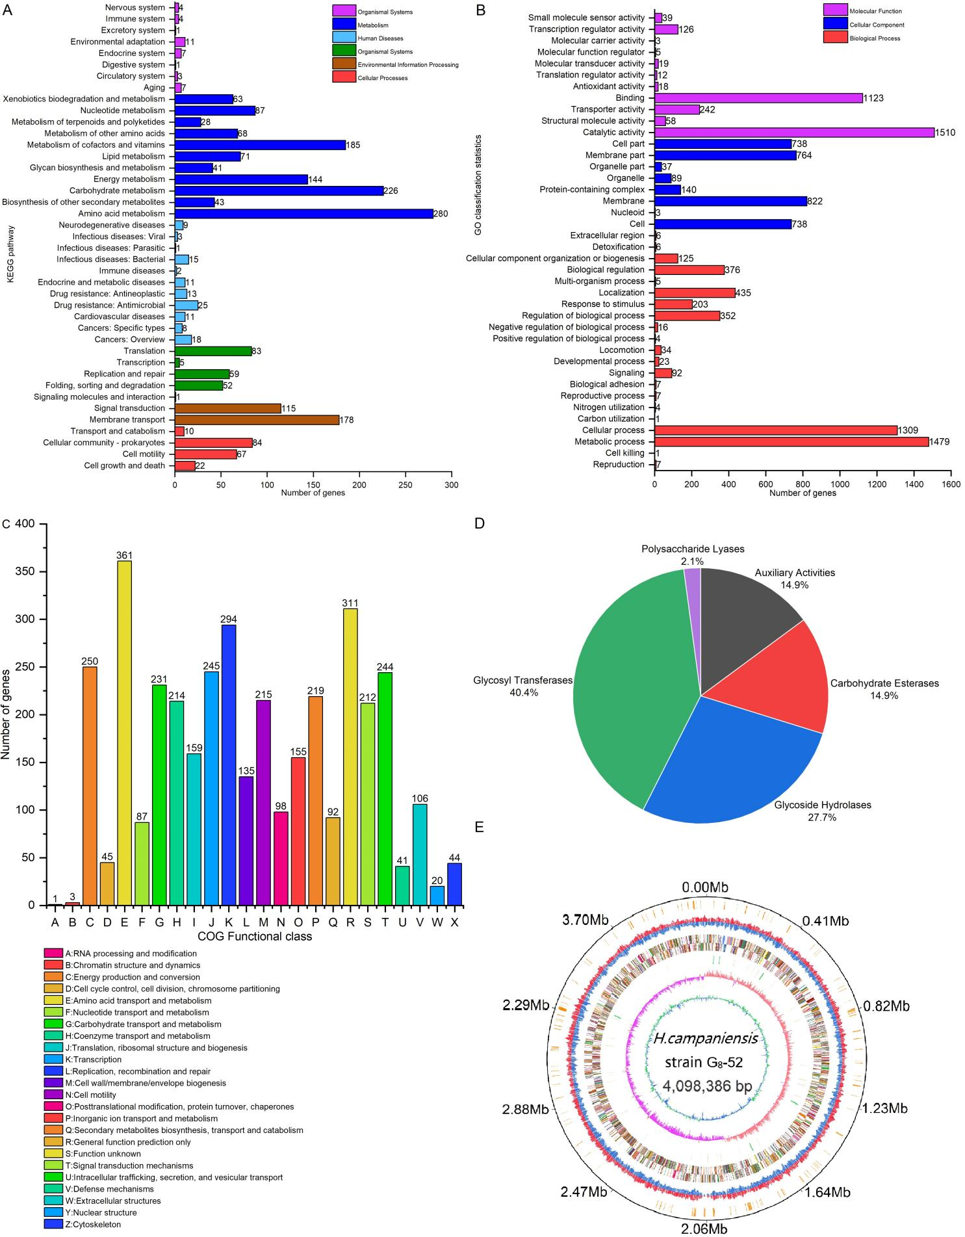
Fig. S2

Fig. S3

