Supplemental Results 1
Demographic, clinical and MRI features
A total of 1407 participants including 395 healthy controls (HC), 335 patients with Alzheimer's disease (AD), 295 patients with Parkinson's disease (PD), 161 patients with cerebral small vessel disease (SVD) and 221 multiple sclerosis (MS) were retrospectively included during December 2018 and September 2021 in Beijing Tiantan hospital, Capital Medical University, Beijing, China. According to the exclusion criteria, 19 HCs, 45 AD, 33 PD, 7 SVD and 9 MS were excluded due to other CNS disease history, incomplete diffusion acquisition or insufficient image quality. Further, we included a public MRI dataset of normal aging (N = 642) for reference and sensitivity analysis. In this dataset, 3 participants were excluded due to insufficient image quality. Finally, 1936 participants including 1018 HCs, 290 AD, 262 PD, 154 SVD, 212 MS were included for the following analyses. AD patients were older than PD, SVD and MS. MS patients were the youngest among all the disease groups. Female predominate were observed in AD and MS. Youth HCs and patients (e.g., MS) have high level education levels than elderly HCs and older patients (e.g., AD, PD and SVD). PD and MS have longer disease duration than AD and SVD. The elderly HCs and AD, PD and SVD patients showed significant cognitive impairments while MS showed no obvious cognitive decline. Middle-aged and elderly HCs showed significant brain atrophy (e.g., loss of gray and/or white matter volume) than Youth HCs, and all disease groups showed significant brain atrophies. Abnormal diffusion metrics including both neurite density index (NDI) and orientation dispersion index (ODI) within normal appearing white matter (NAWM) and white matter hyperintensity (WMH) were observed in disease groups compared to HC groups.
Supplemental Results 2
Sensitivity of periventricular diffusion gradient of NAWM in normal aging population and multiple neurological diseases
We conducted a series of sensitivity analyses to offer a detailed interpretation of the periventricular diffusion gradient and potential effects of ethnicity, reference group, sex and scanner-specific protocol.

We first conducted a subset analysis on normal aging population using only the public HC dataset in which the participants are predominantly non-Asian. Periventricular normalized NDI gradients were observed in Middle-aged (gradient = 0.012, p_{(n=573)} < 0.0001) and Elderly (gradient = 0.034; p_{(n=573)} < 0.0001). Periventricular normalized ODI gradients were observed in Elderly (gradient = 0.013; p_{(n=586)} < 0.0001).

Second, we conducted the analysis on the normalized diffusion metrics in neurological diseases using age-matched HC as case-control. Periventricular normalized NDI gradients were observed in AD (gradient = 0.017; p_{(n=891)} = 0.0002), PD (gradient = 0.017; p_{(n=852)} < 0.0001), SVD (gradient = 0.032; p_{(n=1038)} < 0.0001) and MS (gradient = 0.026; p_{(n=964)} < 0.0001). Periventricular normalized ODI gradients were observed in AD (gradient = 0.035; p_{(n=797)} < 0.0001), PD (gradient = 0.034; p_{(n=852)} < 0.0001), SVD (gradient = 0.026; p_{(n=88)} < 0.0001) and MS (gradient = 0.024; p_{(n=964)} < 0.0001).

Third, we conducted the subgroups analysis on female and male participants in normal aging and disease states. For female participants, periventricular normalized NDI gradients were observed in Middle-aged (gradient = 0.0092; p_{(n=964)} < 0.0001), Elderly (gradient = 0.019; p_{(n=964)} < 0.0001), AD (gradient = 0.030; p_{(n=964)} < 0.0001), PD (gradient = 0.023; p_{(n=964)} < 0.0001), SVD (gradient = 0.041; p_{(n=964)} < 0.0001) and MS (gradient = 0.036; p_{(n=964)} < 0.0001). Periventricular normalized ODI gradients were observed in AD (gradient = 0.031; p_{(n=900)} < 0.0001), PD (gradient = 0.028; p_{(n=900)} < 0.0001), SVD (gradient = 0.024; p_{(n=900)} < 0.0001) and MS (gradient = 0.018; p_{(n=900)} < 0.0001). For male participants, periventricular normalized NDI gradients were observed in Middle-aged (gradient = 0.012; p_{(n=806)} < 0.0001), Elderly (gradient = 0.022; p_{(n=806)} < 0.0001), AD (gradient = 0.044; p_{(n=806)} < 0.0001), PD (gradient = 0.040; p_{(n=806)} < 0.0001), SVD (gradient = 0.053; p_{(n=806)} < 0.0001) and MS (gradient = 0.040; p_{(n=806)} < 0.0001). Periventricular normalized ODI gradients were observed in Middle-aged (gradient = 0.0086; p_{(n=738)} = 0.001), Elderly (gradient = 0.0093; p_{(n=738)} < 0.0001), AD (gradient = 0.045; p_{(n=738)} < 0.0001), PD (gradient = 0.052; p_{(n=738)} < 0.0001), SVD (gradient = 0.034; p_{(n=738)} < 0.0001) and MS (gradient = 0.041; p_{(n=738)} < 0.0001).

Last, we conducted a subset analysis using GE-specific diffusion spectrum imaging acquisition. Periventricular normalized NDI gradients were observed in Middle-aged (gradient = 0.0058; p_{(n=375)} = 0.037), Elderly (gradient = 0.0095; p_{(n=375)} = 0.001), AD (gradient = 0.021; p_{(n=375)} < 0.0001), SVD (gradient = 0.019; p_{(n=375)} < 0.0001) and MS (gradient = 0.014; p_{(n=375)} = 0.001). Periventricular normalized ODI gradients were observed in Middle-aged (gradient = 0.0059; p_{(n=352)} = 0.032), Elderly (gradient = 0.0064; p_{(n=352)} = 0.028), AD (gradient = 0.025; p_{(n=352)} < 0.0001), PD (gradient = 0.018; p_{(n=352)} = 0.007), SVD (gradient = 0.016; p_{(n=352)} < 0.0001) and MS (gradient = 0.010; p_{(n=352)} = 0.021).

Supplemental Results 3
Findings on periventricular normalized ODI associated genes in HC and neurological diseases
The normalized ODI associated genes were identified according to contribution of gene expression to the PLS first component (PLS1), which explained 91.32%, 83.87%, 77.51%, 88.94%, 77.42% variance (p_{(permutation=5000)} = 0.0014, 0.0126, 0.0444, 0.0.001, 0.0396) of the normalized ODI within rings in HC, AD, PD, SVD and MS, respectively. ODI-PLS1- and ODI-PLS1+ genes were further defined according to the normalized PLS1 weightings (Z < -5 and Z > 5, pFDR_{(bootstrap=100000)} < 0.0001). Finally, 298 NDI-PLS1- and 132 NDI-PLS1+ genes for HC, 293 NDI-PLS1- and 158 NDI-PLS1+ genes for AD, 116 NDI-PLS1- and 43 NDI-PLS1+ genes for PD, 376 NDI-PLS1- and 239 NDI-PLS1+ genes for SVD and 72 NDI-PLS1- and 36 NDI-PLS1+ genes for MS were identified.

We assessed the relationship between identified ODI-PLS1 genes and disease-associated genome-wide association study (GWAS) genes in AD (3465 genes), PD (2230 genes), SVD (981 genes) and MS (1839 genes) from the DiseGeNET in Metascape (https://www.disgenet.org/downloads) using enrichment analysis to see whether these genes were disease-specific. Both ODI-PLS1- and ODI-PLS1+ genes were enriched in AD and PD (Figure S6).

Enrichment analysis in Gene Ontology biological process, Kyoto Encyclopedia of Genes and Genomes and Hallmark gene sets
Both ODI-PLS1- and ODI-PLS1+ genes shared GO, KEGG pathways and Hallmark Gene Sets (pFDR < 0.05 using hypergeometric test) among HC and neurological diseases, similar to those of ODI-PLS1 genes. ODI-PLS1- genes involved common GO biological progress including “cytoplasmic translation”, “quinone metabolic process”, “serine family amino acid metabolic process”, “regulation of DNA-binding transcription factor activity”, “organelle assembly”, “lipid biosynthetic process”,” small molecule biosynthetic process”,” establishment of endothelial intestinal barrier”,” response to steroid hormone”, ”Biosynthesis of cofactors” etc., and hallmark genes including “HALLMARK ADIPOGENESIS” and “HALLMARK INTERFERON GAMMA RESPONSE” (Figure S6). ODI-PLS1+ genes involved common GO biological progress including “regulation of ion transport”, “neuron projection development”, ”vesicle organization”, ”cell-cell adhesion”, ”intracellular protein transport”, “vesicle-mediated transport in synapse”, ” dendrite development”, ” protein localization to membrane”, “developmental growth involved in morphogenesis”, “regulation of autophagy” etc., and KEGG pathway of “Cell adhesion molecules” (Figure S6). Both ODI-PLS1- and ODI-PLS1+ genes are enriched in the up- or down- regulations of macrophage, T-cell and B-cell (Figure S7).

Enrichment analysis in CNS cell-types
We clustered the ODI-PLS1 gene into distinct CNS cell types. We observed that a majority of ODI-PLS1- genes in HC, AD and SVD were enriched in astrocyte endothelial cells (pFDR < 0.05 using hypergeometric test), while ODI-PLS1+ genes in HC, AD and SVD were enriched in neurons (including both excitatory neurons and inhibitory neurons, pFDR < 0.05 using hypergeometric test) (Figure S6).

Supplemental Results 4
Periventricular gradient of WMH volume and diffusion metrics in normal aging population and multiple neurological diseases
We conducted additional analysis on WMH volume and diffusion metrics of normal aging and multiple neurological diseases. Trends of periventricular WMH-volume gradients were observed in HC and disease groups but showed no statistical significance (Figure S9). Periventricular WMH-NDI gradient was observed in PD (gradient = 0.0041; p_{(n=980)} < 0.014). Periventricular WMH-ODI gradient was observed in PD (gradient = 0.0062; p_{(n=980)} = 0.001).
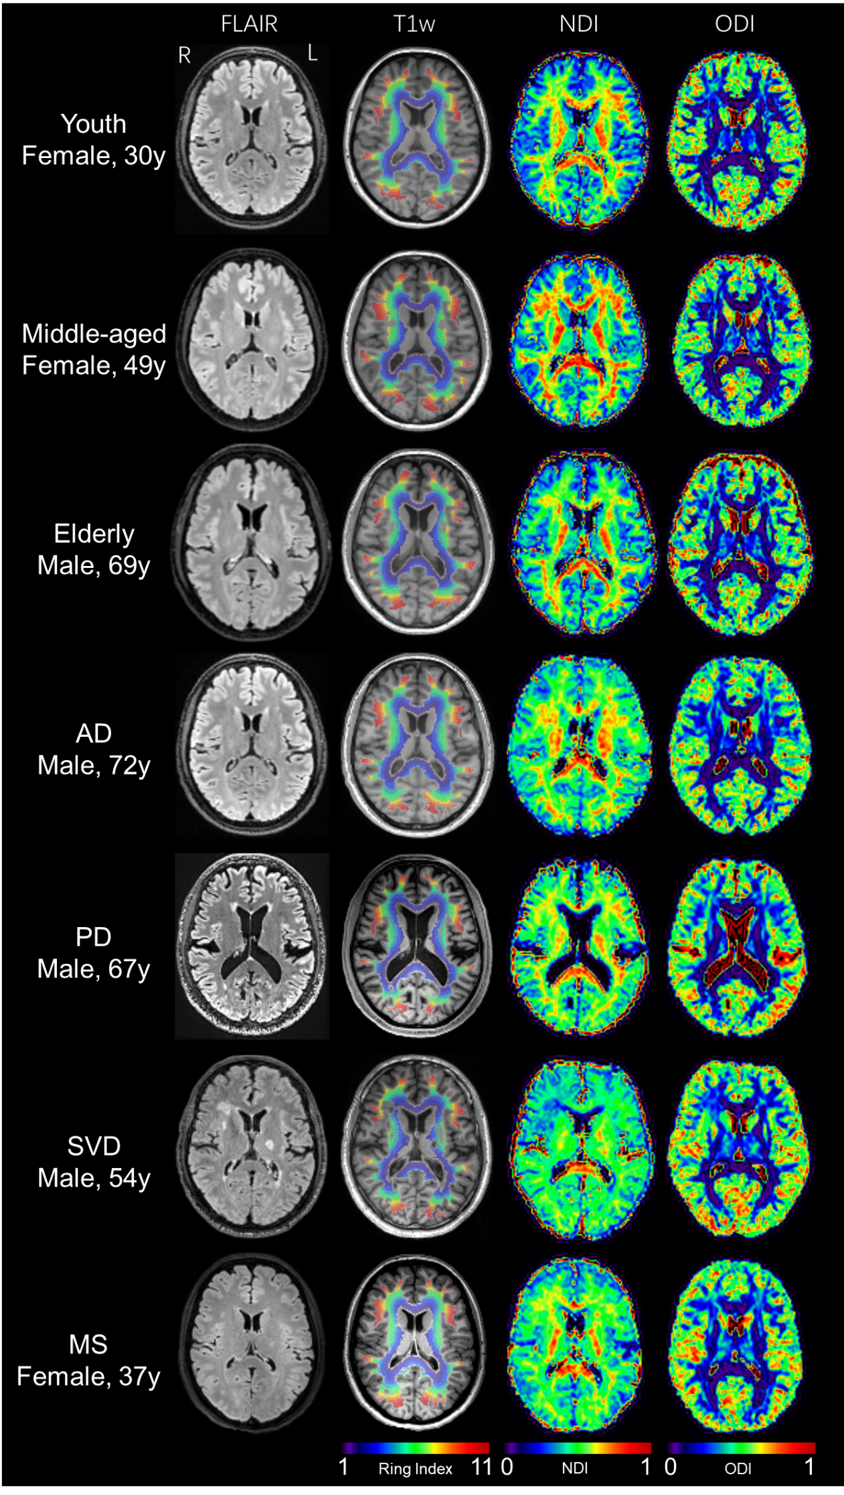
Figure S1. Representative cases of HC and neurological diseases.
AD, Alzheimer's disease; PD, Parkinson's disease; SVD, small vessel disease; MS, multiple sclerosis; NDI, neurite density index; ODI, orientation dispersion index; y, years; R, right; L, left.

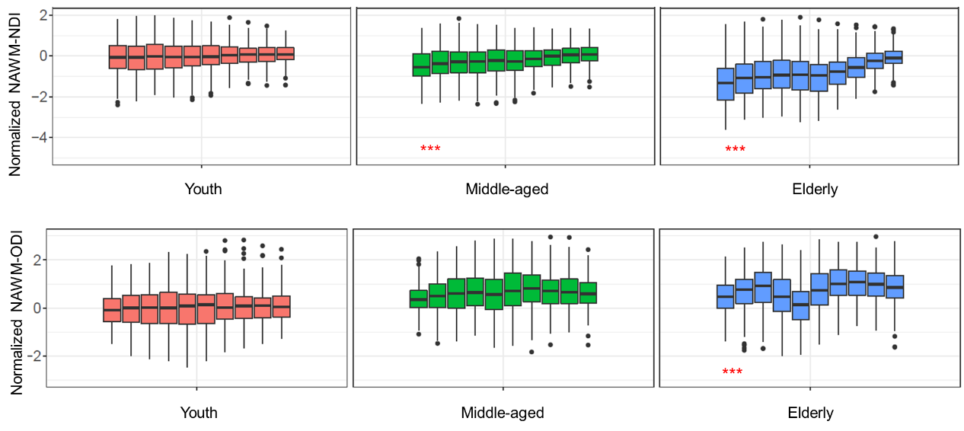
Figure S2. Sensitivity analysis of periventricular diffusion gradient of normal aging using only the public HC dataset, in which the participants are predominantly non-Asian. NDI, neurite density index; ODI, orientation dispersion index; NAWM, normal-appearing white matter. * indicates significant periventricular gradient with p < 0.05; ** indicates significant periventricular gradient with p < 0.005; *** indicates significant periventricular gradient with p < 0.0001.

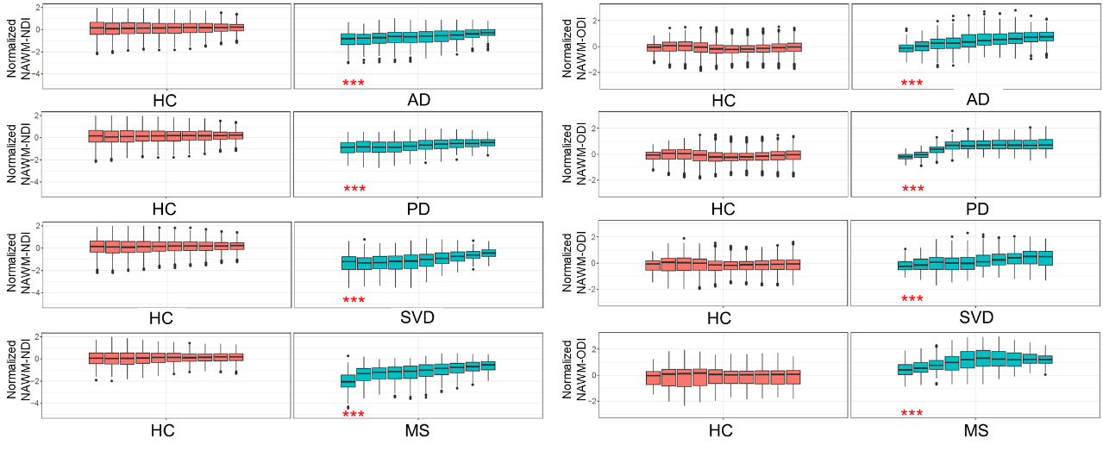
Figure S3. Sensitivity analysis of periventricular diffusion gradient in neurological diseases using age-matched HC as case-control. HC, healthy controls; AD, Alzheimer's disease; PD, Parkinson's disease; SVD, small vessel disease; MS, multiple sclerosis; NDI, neurite density index; ODI, orientation dispersion index; NAWM, normal-appearing white matter. * indicates significant periventricular gradient with p < 0.05; ** indicates significant periventricular gradient with p < 0.005; *** indicates significant periventricular gradient with p < 0.0001.

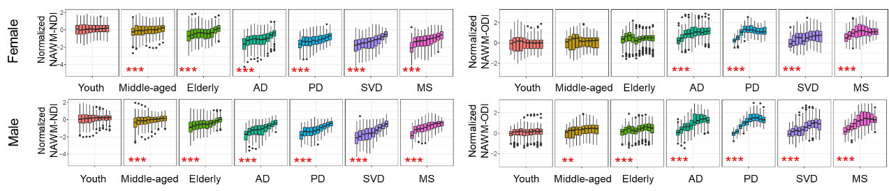
Figure S4. Sensitivity analysis of periventricular diffusion gradient of female and male participants in normal aging and disease states. HC, healthy controls; AD, Alzheimer's disease; PD, Parkinson's disease; SVD, small vessel disease; MS, multiple sclerosis; NDI, neurite density index; ODI, orientation dispersion index; NAWM, normal-appearing white matter. * indicates significant periventricular gradient with p < 0.05; ** indicates significant periventricular gradient with p < 0.005; *** indicates significant periventricular gradient with p < 0.0001.

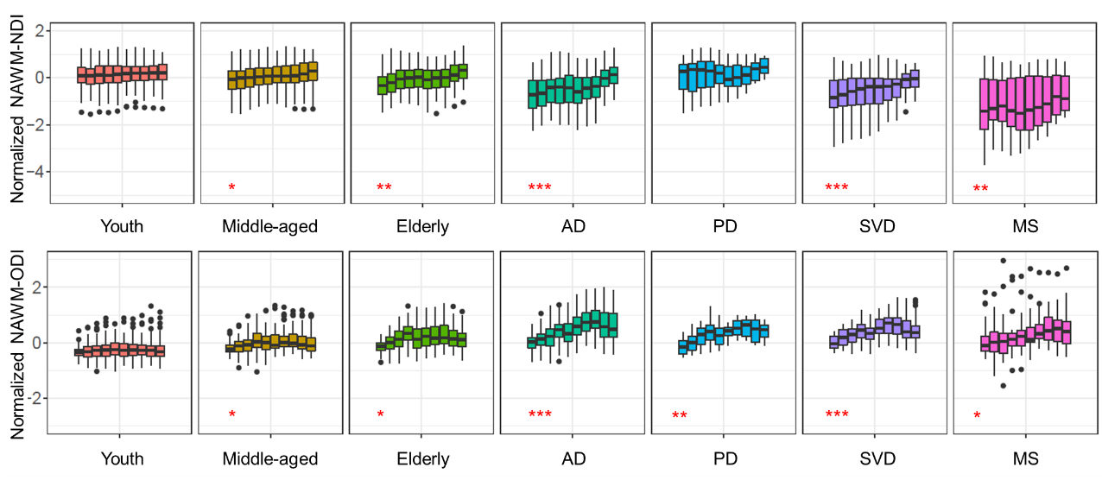
Figure S5. Sensitivity analysis on periventricular diffusion gradient using a subset of participants with GE-specific diffusion spectrum imaging acquisition. HC, healthy controls; AD, Alzheimer's disease; PD, Parkinson's disease; SVD, small vessel disease; MS, multiple sclerosis; NDI, neurite density index; ODI, orientation dispersion index; NAWM, normal-appearing white matter. * indicates significant periventricular gradient with p < 0.05; ** indicates significant periventricular gradient with p < 0.005; *** indicates significant periventricular gradient with p < 0.0001.
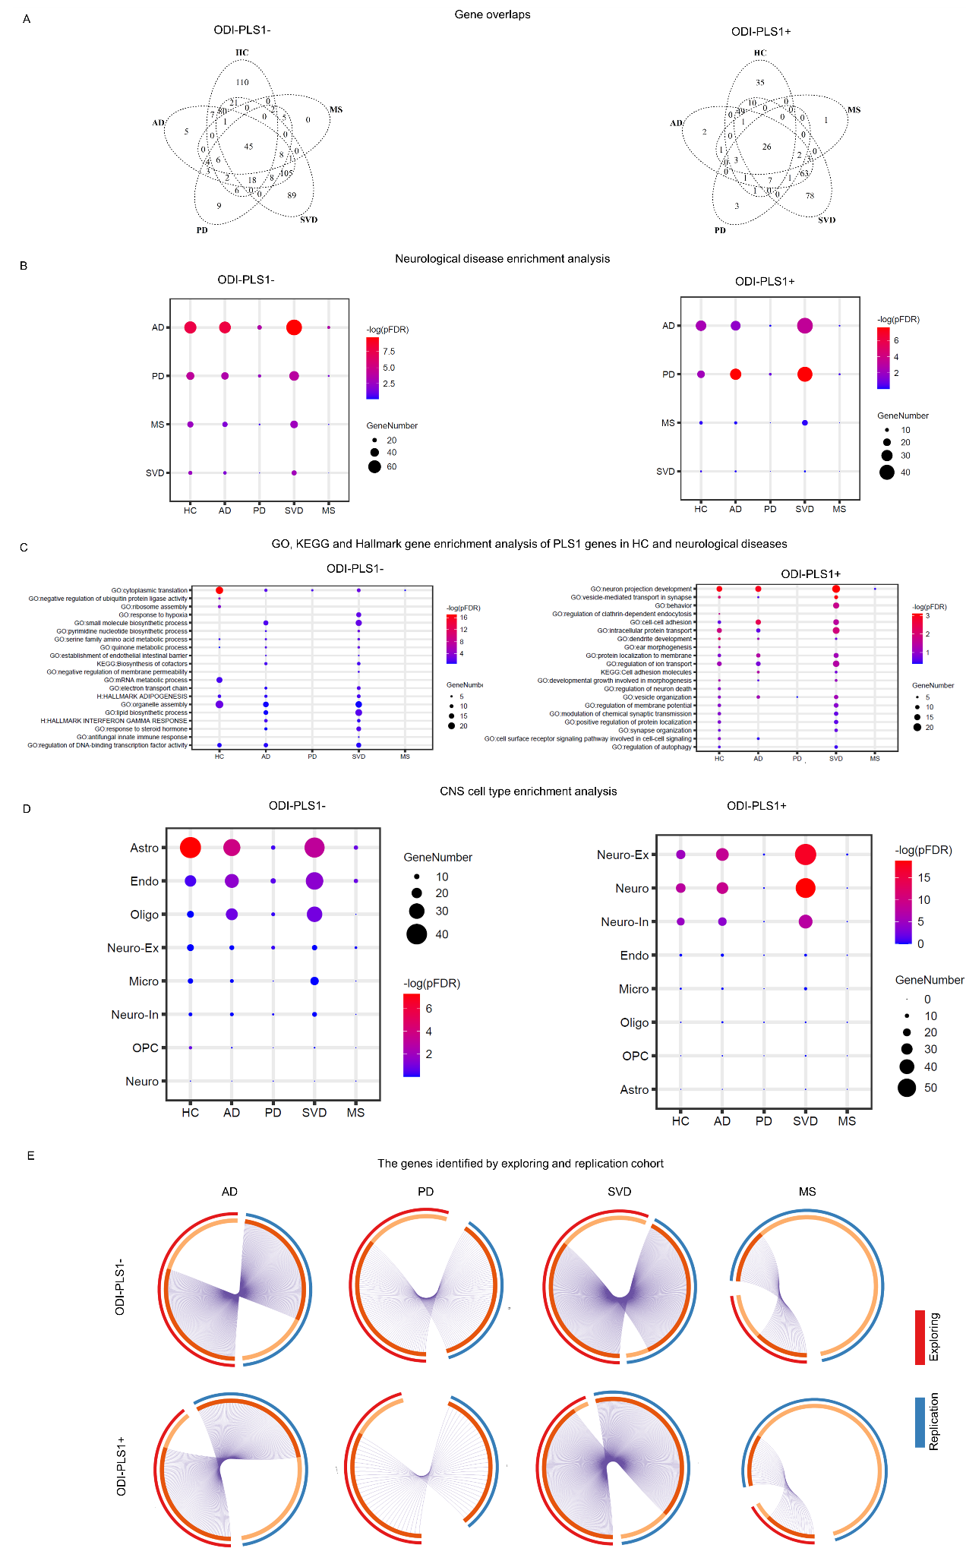
Figure S6. Neurological disease and GO/KEGG/hallmark gene sets enrichment analysis of ODI-PLS1 genes in HC, AD, PD, SVD and MS.
A.Overlaps of diffusion gradient associated ODI-PLS1 genes (ODI-PLS1- and ODI-PLS1+) in normal aging and neurological diseases. B. Overlapped genes of identified ODI-PLS1 gens with the disease GWAS gene database. C. Enrichment analysis of GO biological processes/KEGG/hallmark gene sets of ODI-PLS1 genes in HC and neurological diseases. D. ODI-PLS1 gene enrichment analysis in CNS cell types. E. The identified normalized ODI gradient associated genes using replication cohort are largely overlapped with those using exploring cohort. Note: HC, healthy controls; AD, Alzheimer's disease; PD, Parkinson's disease; SVD, small vessel disease; MS, multiple sclerosis; GO, Gene Ontology; KEGG, Kyoto Encyclopedia of Genes and Genomes; PLS, partial least-squares; FDR, false discovery rate; ODI, orientation dispersion index; PLS, partial least-squares.

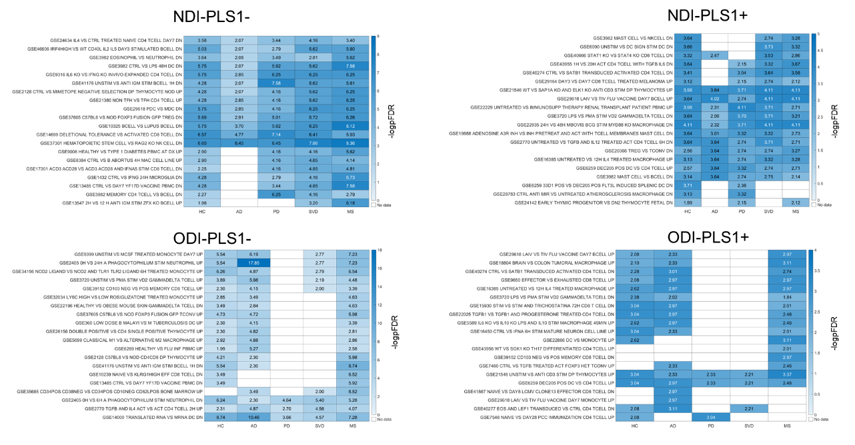
Figure S7. Enrichment analysis of both NODDI-PLS1- and NODDI -PLS1+ genes in immune activity pathways. Both NODDI -PLS1- and NODDI -PLS1+ genes enriched in the up- or down- regulations of macrophage, T-cell and B-cell. HC, healthy controls; AD, Alzheimer's disease; PD, Parkinson's disease; SVD, small vessel disease; MS, multiple sclerosis; NDI, neurite density index; ODI, orientation dispersion index; PLS, partial least-squares.

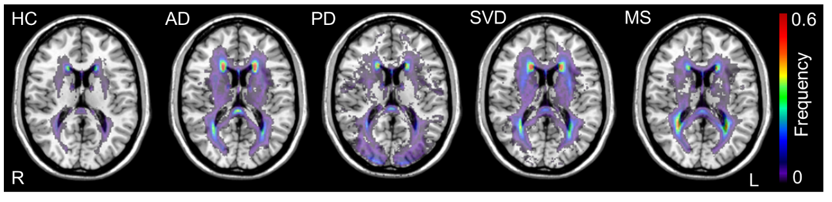
Figure S8. WMH frequency maps in HCs and multiple neurological diseases. HC, healthy controls; AD, Alzheimer's disease; PD, Parkinson's disease; SVD, small vessel disease; MS, multiple sclerosis.

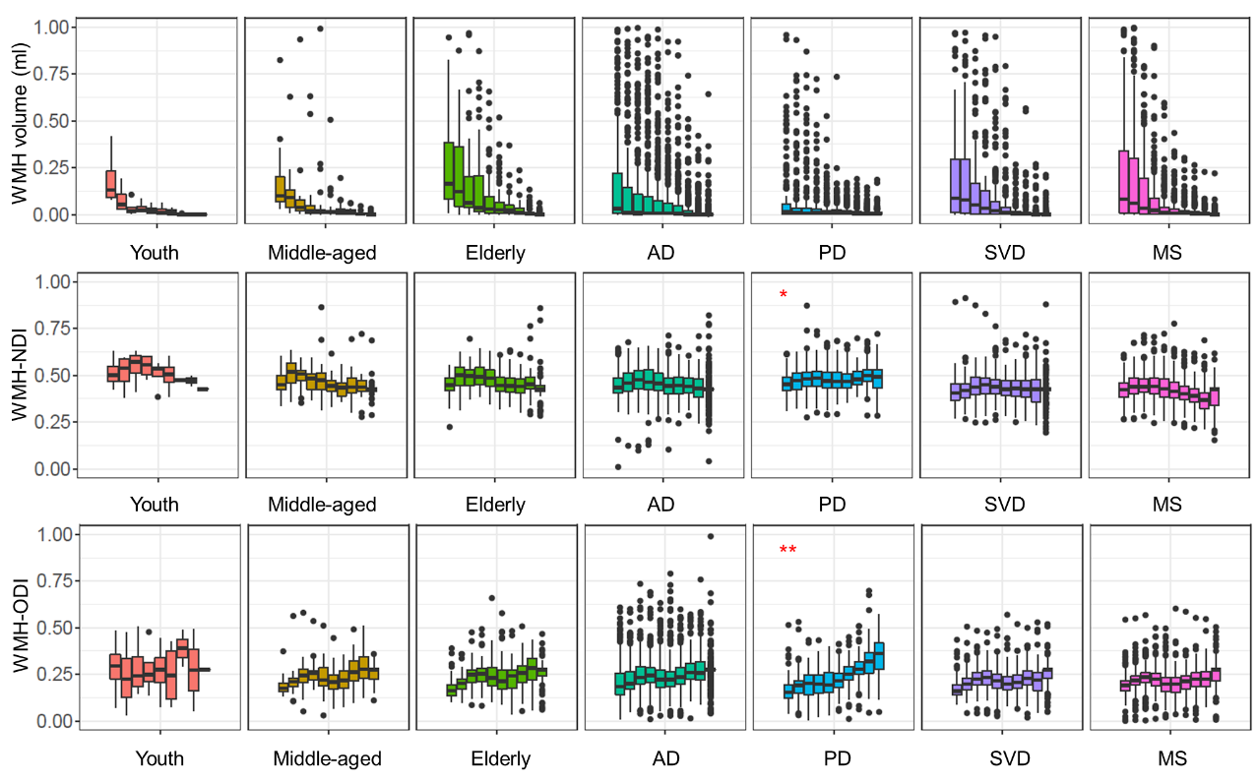
Figure S9. Periventricular gradients of volume and raw diffusion metrics of WMH area (based on undilated WMH mask). AD, Alzheimer's disease; PD, Parkinson's disease; SVD, small vessel disease; MS, multiple sclerosis; NDI, neurite density index; ODI, orientation dispersion index; WMH, white matter hyperintensity. * indicates significant periventricular gradient with p < 0.05; ** indicates significant periventricular gradient with p < 0.005; *** indicates significant periventricular gradient with p < 0.0001.

Table S1. Details of MR scanners and protocols
Scanner-Protocol | Sequence | TR (ms) | TE (ms) | IR (ms) | FA (degree) | In-plane resolution(mm²) | Slice thickness (mm) | Slice number | B values (s/mm²) and direction number
Siemens TIM Trio (Cam-CAN) | FLAIR | NA | NA | NA | NA | NA | NA | NA
 | 3D T1 | 2250 | 2.99 | 900 | 9 | 1 × 1 | 1 | 192
 | HARDI | 9100 | 104 |  | 90 | 2 × 2 | 2 | 66 | 0,1000(30),2000(30)
Siemens Prisma (Protocol-2) | FLAIR | 5000 | 388 | 1800 | 120 | 1 × 1 | 1 | 192
 | 3D T1 | 2300 | 2.26 | 900 | 8 | 1 × 1 | 1 | 192
 | HARDI | 4300 | 74 |  | 90 | 2 × 2 | 3.5 | 72 | 0, 1000(64),2000(64)
Siemens Prisma (Protocol-1) | FLAIR | 5000 | 580 | 1600 | 120 | 1 × 1 | 1 | 192
 | 3D T1 | 1560 | 1.69 | 778 | 8 | 1 × 1 | 1 | 176
 | HARDI | 2900 | 64 |  | 90 | 2.5 × 2.5 | 2.5 | 60 | 0,1000(64),2000(64)
GE Premier (Protocol-1) | FLAIR | 5002 | 107 | 1524 | 90 | 1 × 1 | 1 | 170
 | 3D T1 | 7.3 | 2.96 | 450 | 12 | 1 × 1 | 1 | 176
 | HARDI | 5000 | 72 |  | 90 | 1.7 × 1.7 |  | 81 | 0,1000(90),2000(90),3000(90)
GE Premier (Protocol-2) | FLAIR | 5002 | 107 | 1524 | 90 | 1 × 1 | 1 | 170
 | 3D T1 | 7.3 | 2.96 | 450 | 12 | 1 × 1 | 1 | 176
 | HARDI | 5000 | 65 |  | 90 | 2 × 2 | 2 | 62 | 0,1000(50),2000(50)
Philips Ingenia CX | FLAIR | 4800 | 228 | 1650 | 90 | 1 × 1 | 1 | 196
 | 3D T1 | 6.6 | 3 | 880 | 8 | 1 × 1 | 1 | 196
 | HARDI | 4000 | 88 |  | 90 | 2.5 × 2.5 | 2.5 | 60 | 0,1000(48),2000(48)
Note: FLAIR, Fluid Attenuated Inversion Recovery; HARDI, High Angular Resolution Diffusion Imaging; TR, Repetition Time; TE, Echo Time; IR, Inversion Recovery; FA, Flip Angle.

