Supplementary materials
Supplementary Figures
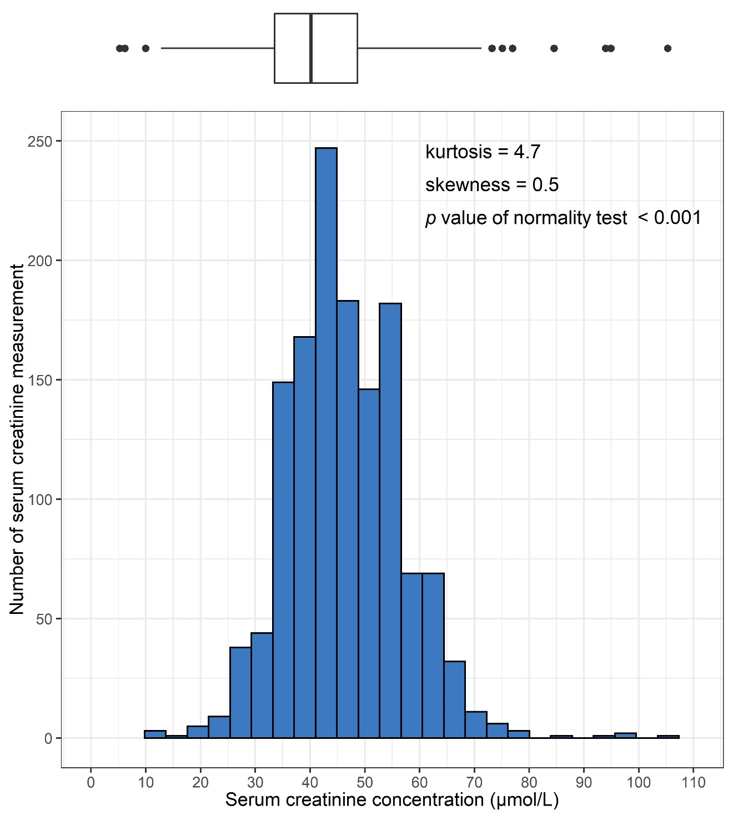
Supplementary Fig. 1. Distribution of SCr measurements regardless of GW. The distribution of SCr measurements regardless of GW was the pin-pointed and slightly right-skewed pattern without normality. The square of top boxplot is IQR, the middle line in the square is median, length of whiskers left and right by the square is 1.5*IQR, and dots are outliers. GW gestational week, IQR interquartile range, SCr serum creatinine.
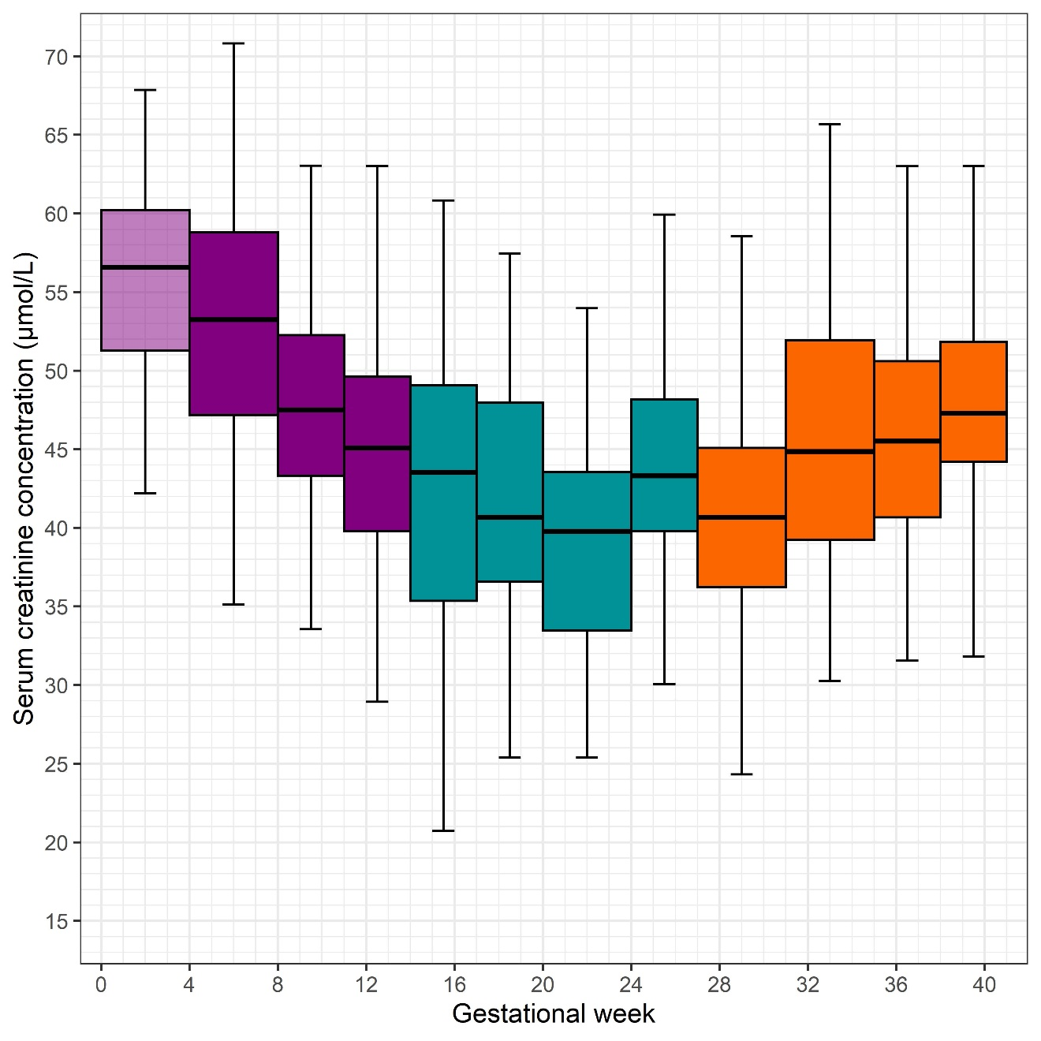
Supplementary Fig. 2. Distributions of serum creatinine concentration according to GPs. To consider the hormonal effect of pregnancy, the first GP had to be excluded because 0–3 gestational weeks are considered before the implantation. This exclusion was described as fainted color in the plot. The thick horizontal line in the central rectangle is the median. The central rectangle is in the interquartile range (25th–75th percentile). The whiskers above and below the rectangle show the 2.5th and 97.5th percentiles, respectively. Colors indicate three trimesters. GP gestational period.
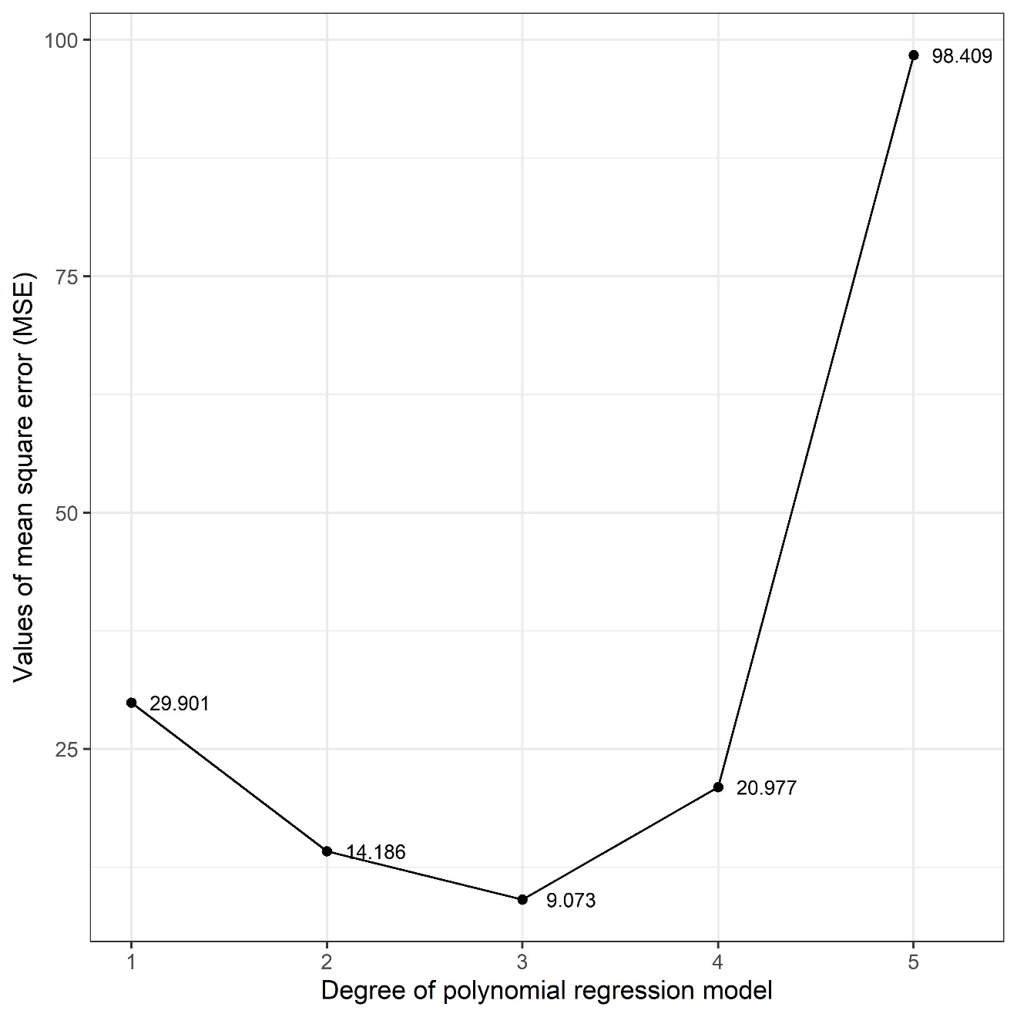
Supplementary Fig. 3. Determination of the best degree of polynomial regression model for upper limit of GP-specific SCr RI through comparing values of MSE. As the degree with the smallest MSE is determined the best, 3 is selected the best degree among 1 to 5. GP gestational period, MSE mean square error, RI reference interval, SCr serum creatinine.
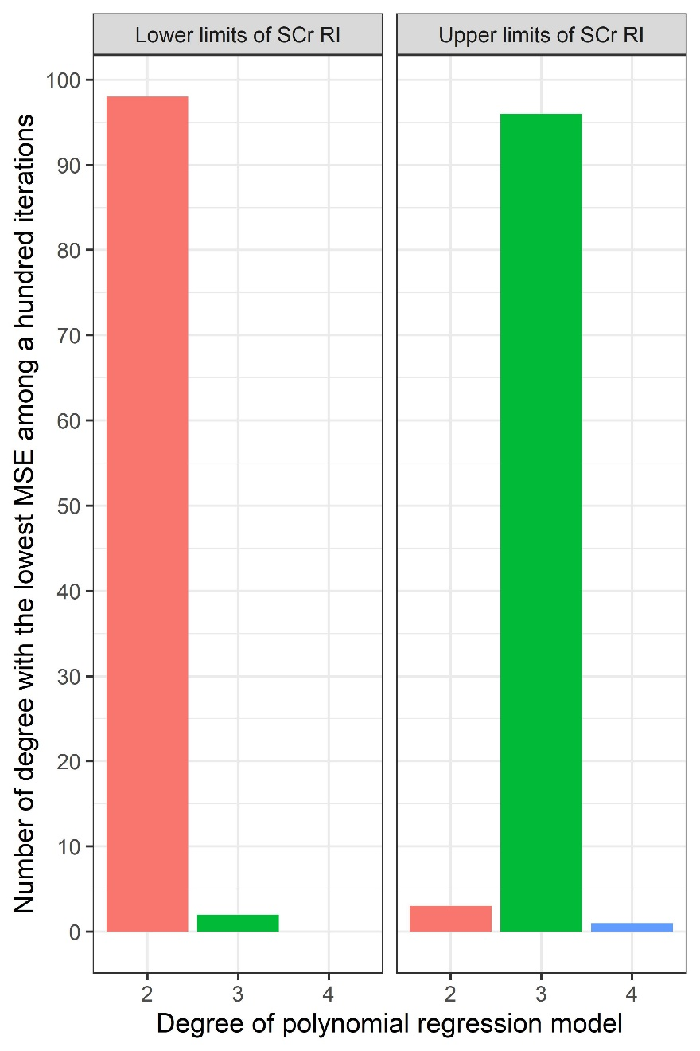
Supplementary Fig. 4. Best degrees of polynomial regression model for upper and lower limit of GP-specific SCr RI through a hundred iterations about calculating MSEs. While there are minority results of best degrees in both limits, the most frequently best degrees are obvious. GP gestational period, MSE mean square error, RI reference interval, SCr serum creatinine.
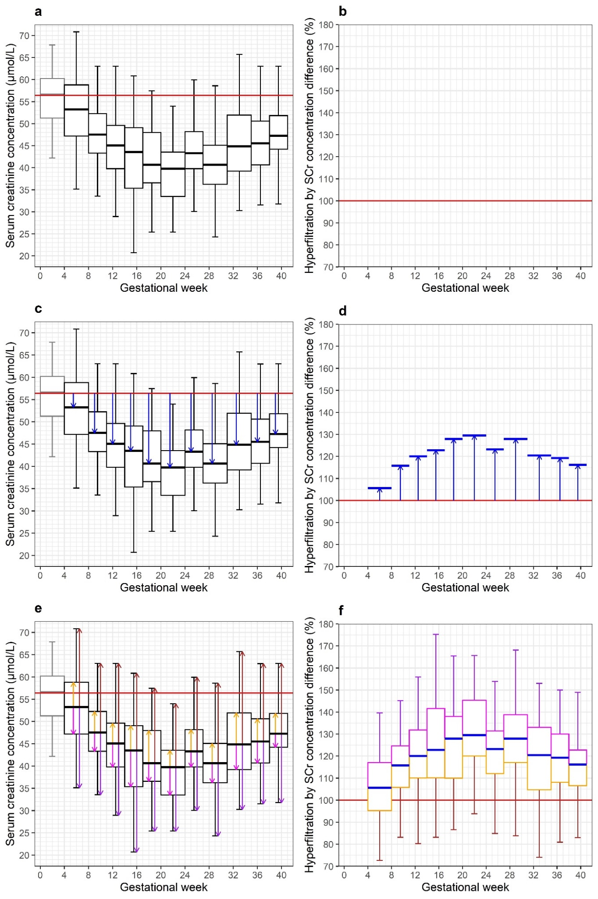
Supplementary Fig. 5. Schematic plots about deriving GP-specific hyperfiltration by SCr concentration difference. a For calculating values of hyper filtrated SCr concentration, BSC was set in 56.4 μmol/L (median of 4 GW SCr RI at Table 3). b The value of hyperfiltration of BSC was defined as 100%. c Gaps between BSC and a median of each 2-12 GPs were calculated. d While the proportion of each gap against BSC were calculated, these rates were set in hyperfiltrations. e Gaps between a median and 2.5 percentile (purple arrows), 25 percentile (magenta arrows), 75 percentile (orange arrows), and 97.5 percentile (brown arrows) were calculated, respectively. f As proportions of these gaps against each median were calculated, IQRs were drawn as boxes with magenta and orange outline. The whiskers above and below the rectangle show the 2.5th (purple lines) and 97.5th percentiles (brown lines), respectively. The first GP was excluded away from this process because of before implantation. BSC baseline serum creatinine concentration, GP gestational period, IQR interquartile range, RI reference interval, SCr serum creatinine.
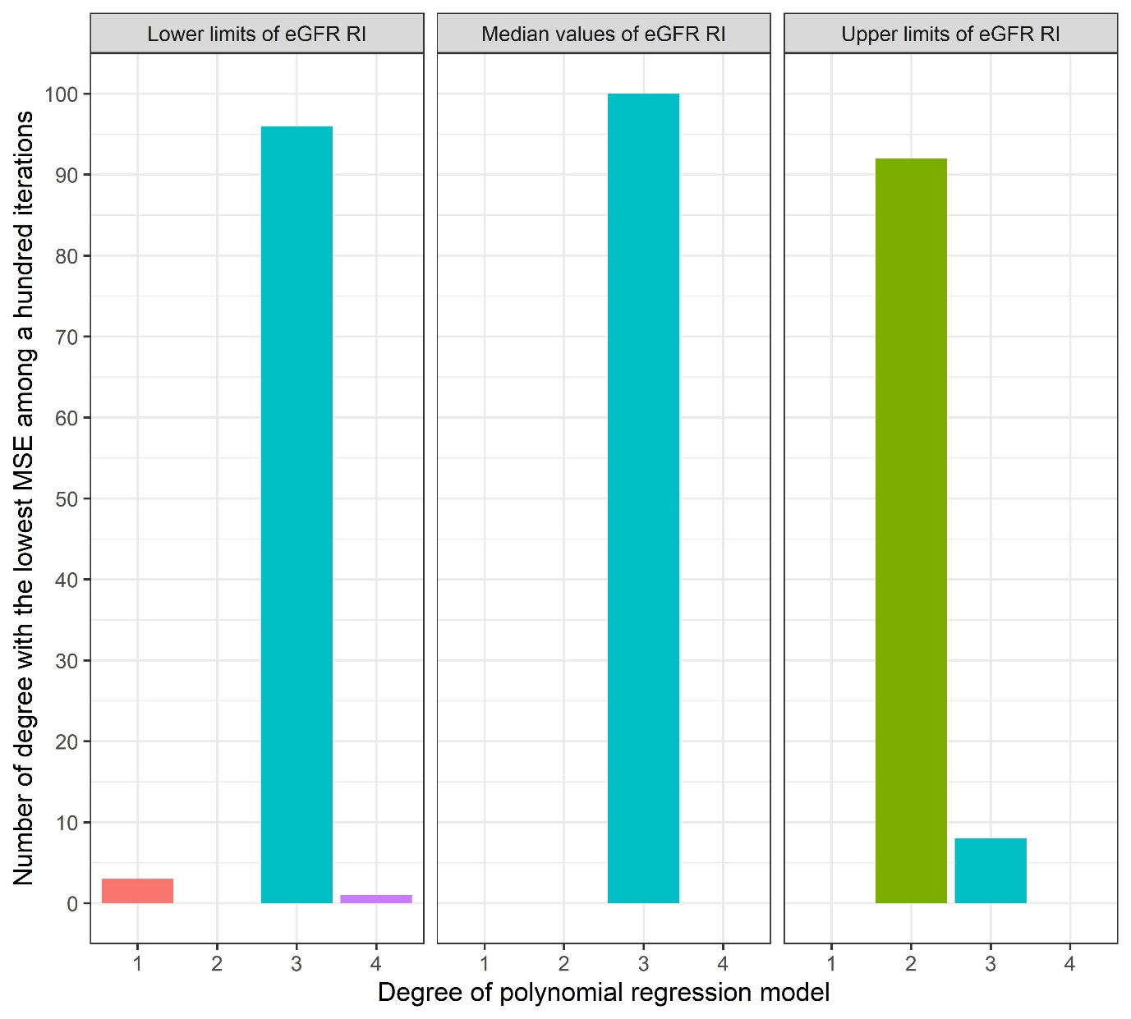
Supplementary Fig. 6. Best degrees of polynomial regression model for lower limit, median and upper limit of GP-specific eGFR RI through a hundred iterations about calculating MSEs. While the best degree of polynomial regression model for upper limit is 2, others are 3. eGFR estimated glomerular filtration rate, GP gestational period, MSE mean square error, RI reference interval.
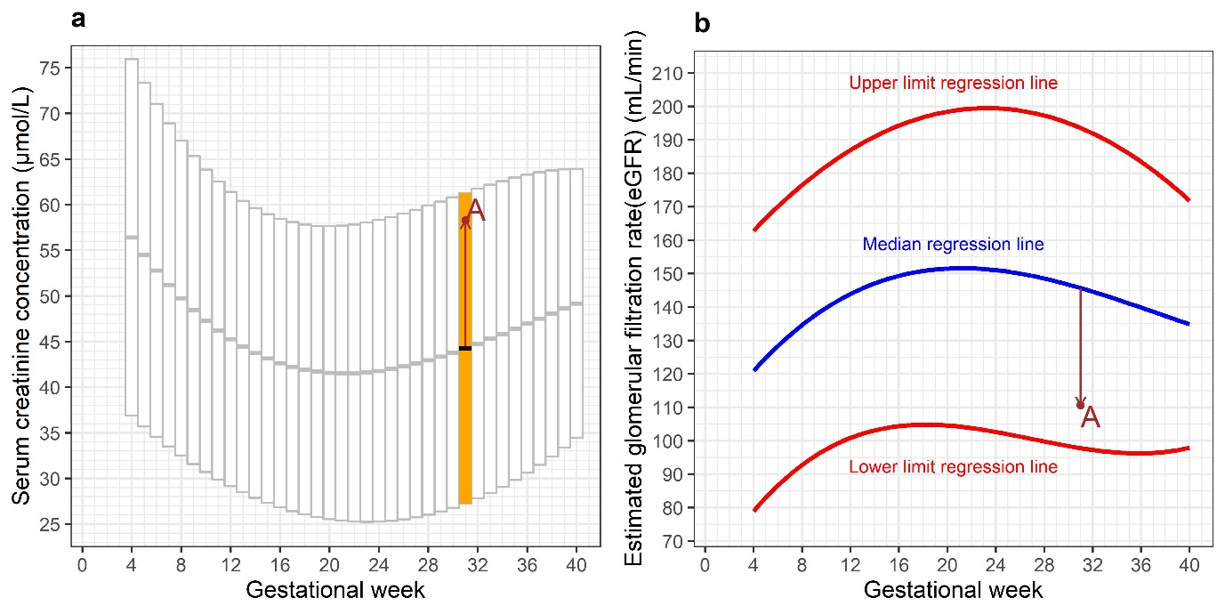
Supplementary Fig. 7. Schematic plots about establishing GEF through a real clinical case. a As the SCr concentration in the case is 58.3 μmol/L from 32 years old woman in 31 gestational weeks (brown colored point A), the hyperfiltration rate against mean of GW (thick black line in a orange box) is calculated (brown arrow). b This rate is applied on median regression line of eGFR RI at 31 GW (brown arrow and point). GEF gestational estimated glomerular filtration rate (eGFR) equation, GW gestational week ¸SCr serum creatinine.
Supplementary tables
Supplementary Table 1. General characteristics of 940 normal pregnant women
Subject |  |  |  | Mean | SD | 25th percentile | 75th percentile
Total (n = 940)
 | Age, years |  |  | 33.53 | 4.53 | 31.00 | 36.00
 | No. of SCr measurements during gestation (no. of pregnant women)
 |  | 1 (658) |  | 33.67 | 4.58 | 31.00 | 37.00
 |  | 2 (211) |  | 33.09 | 4.55 | 30.00 | 36.00
 |  | 3 (40) |  | 33.43 | 3.82 | 31.00 | 35.25
 |  | 4 (15) |  | 33.80 | 4.25 | 31.00 | 35.50
 |  | 5 (4) |  | 31.75 | 3.30 | 30.25 | 33.00
 |  | 6 (6) |  | 32.33 | 3.67 | 31.00 | 32.75
 |  | 7 (2) |  | 38.00 | 2.83 | 37.00 | 39.00
 |  | 8 (2) |  | 32.50 | 0.71 | 32.25 | 32.75
 |  | 9 (1) |  | 36.00 | - | - | -
 |  | 15 (1) |  | 39.00 | - | - | -
SCr serum creatinine, SD standard deviation
Supplementary Table 2. Trimester and gestational period according to the total gestational weeks (0–40)
Trimester | Gestational period | Gestational week
1 | 1ª | 0–3
 | 2 | 4–7
 | 3 | 8–10
 | 4 | 11–13
2 | 5 | 14–16
 | 6 | 17–19
 | 7 | 20–23
 | 8 | 24–26
3 | 9 | 27–30
 | 10 | 31–34
 | 11 | 35–37
 | 12 | 38–40
ª Because the implantation was not completed before 4 gestational weeks (GWs), gestational period 1 was excluded from constructing the GW-specific RIs for serum creatinine concentration and estimated glomerular filtration rate.

