Supporting Information
Bioinspired photothermal polyaniline composite polyurethane sponge: interlayer engineering for high-concentration seawater desalination
Xueting Zhao¹, Jiajing Dong¹, Xiaohong Yu¹, Lingling Liu, Jialin Liu, Jiefeng Pan
College of Chemical Engineering, Zhejiang University of Technology, Hangzhou 310014, P. R. China

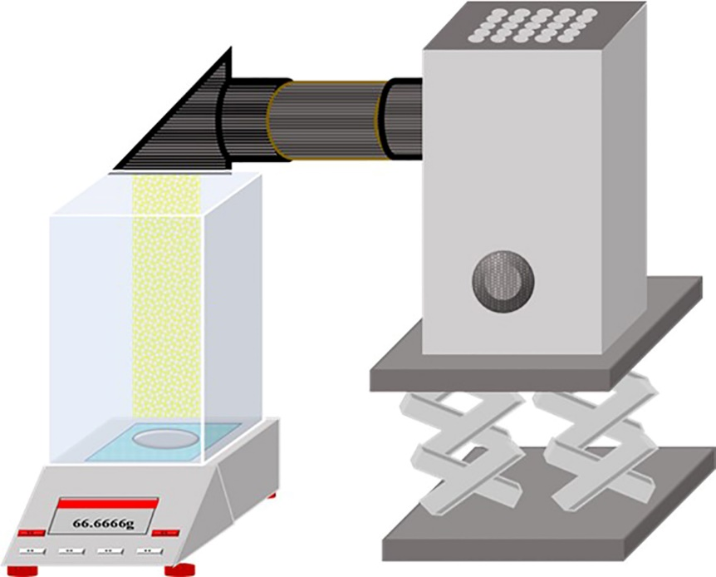
Fig. S1. The device was used to record the mass change of the solar interface evaporation system.

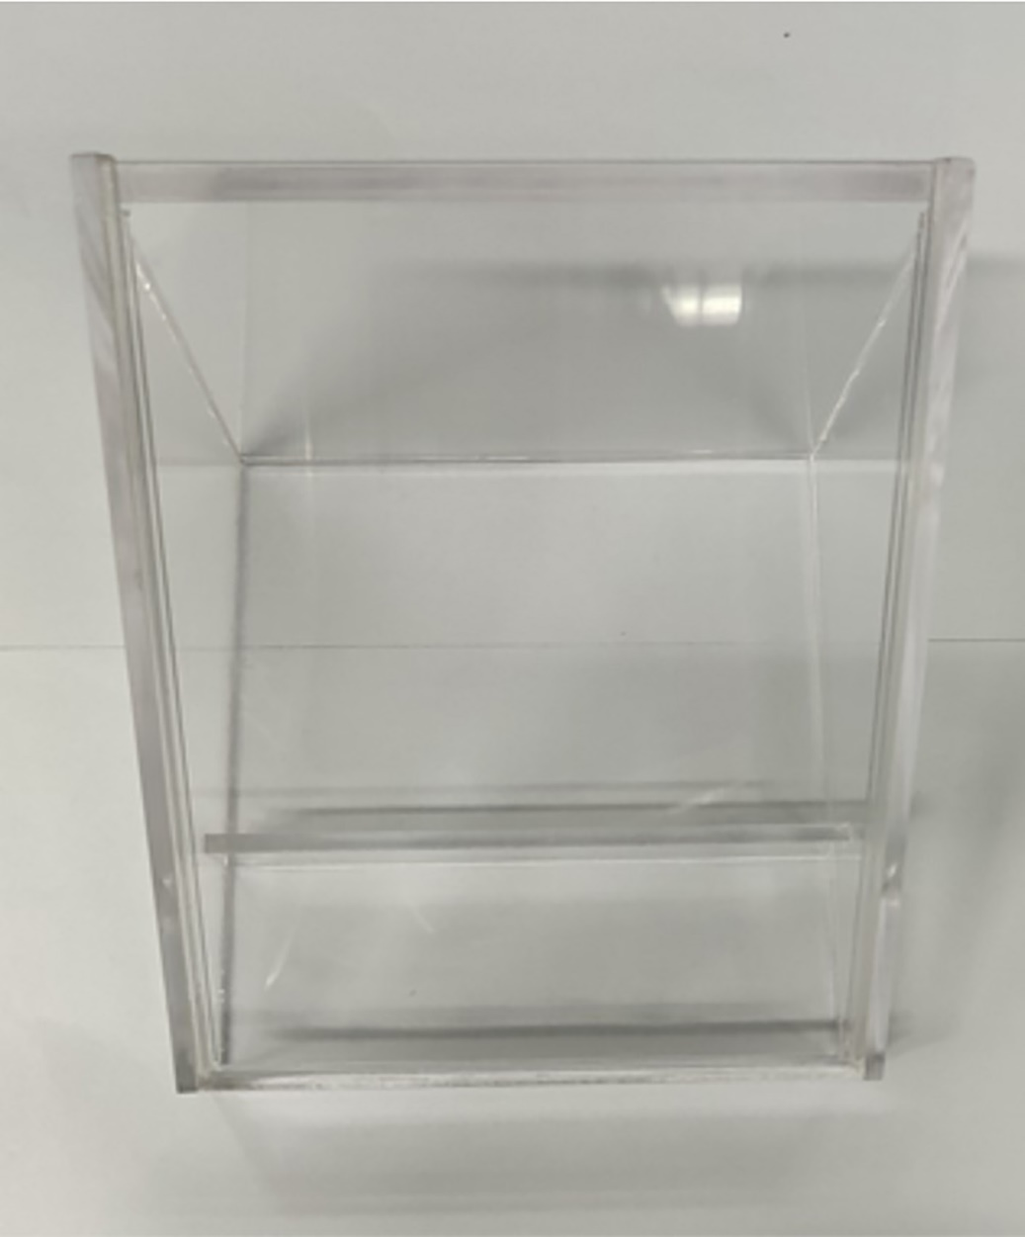
Fig. S2. The device was used to collect desalinated water.

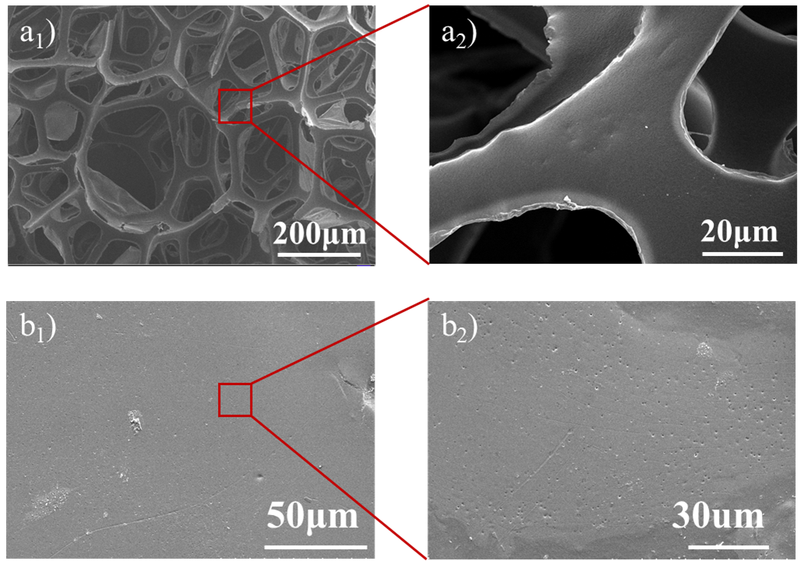
Fig. S3. SEM images of the top surface of PU and SPPSU@PU.

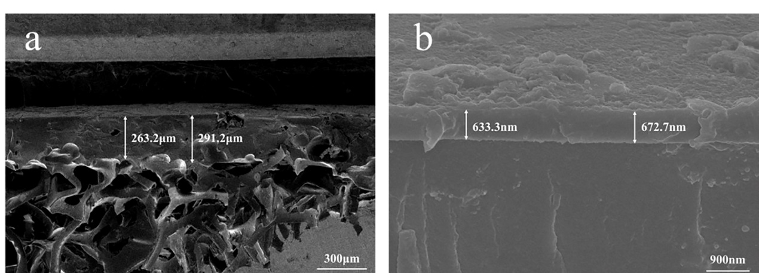
Fig. S4. SEM images of the cross-section of SPPSU@PU and the layer of PANI.

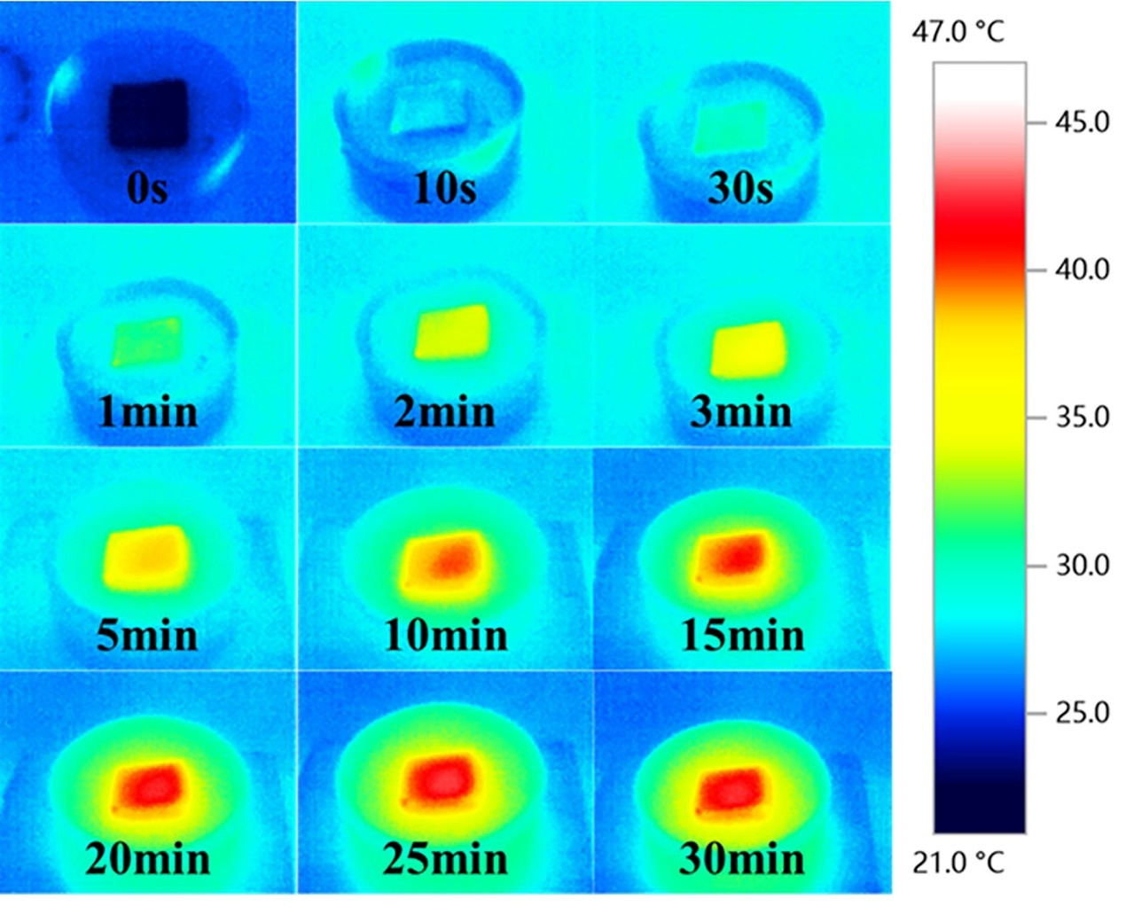
Fig. S5. Surface IR images of PANI-SPPSU@PU under 1 sun.

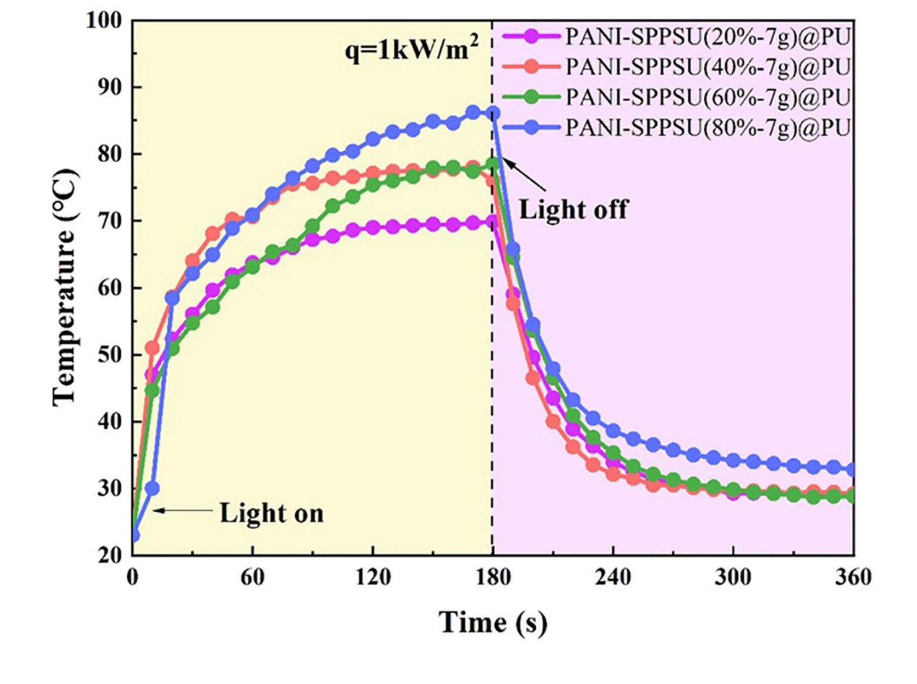
Fig. S6. The surface temperature change curves of PANI-SPPSU@PU with different degrees of sulfonation under 1 sun irradiation (dry).

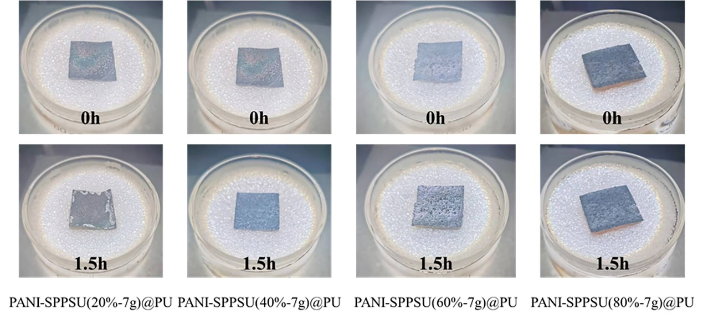
Fig. S7. The photos of the evaporation surface of PANI-SPPSU@PU with different sulfonation degrees after 1.5 hours of illumination (10 wt.% NaCl, 1 sun).

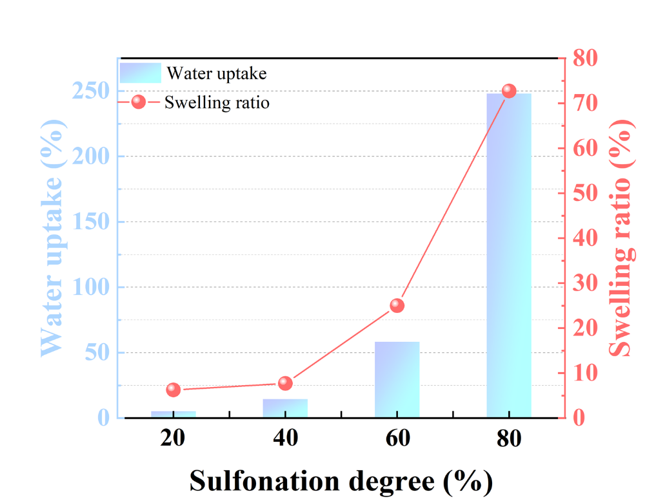
Fig. S8. The water uptake and swelling ratio of PANI-SPPSU@PU with different sulfonation degrees.

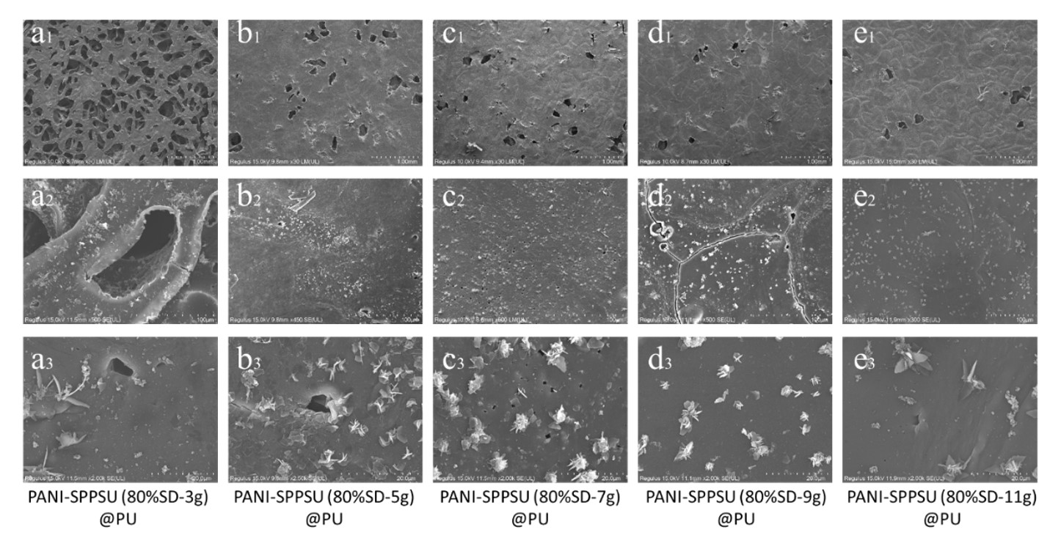
Fig. S9a-e. SEM images of (a₁-a₃) PANI-SPPSU(80%SD-3)@PU, (b₁-b₃) PANI-SPPSU(80%SD-5)@PU, (c₁-c₃) PANI-SPPSU(80%SD-7)@PU, (d₁-d₃) PANI-SPPSU(80%SD-9)@PU and (e₁-e₃) PANI-SPPSU(80%SD-11)@PU.

Evaporation enthalpy test
In the dark, the PANI-SPPSU@PU solar interface evaporation device and the pure water device without an interface evaporator were placed in a water bath, and the surface temperature was heated to 45 °C. After the surface temperature of each evaporation device was stabilized, the mass change was recorded for 2 hours. The Evaporation enthalpy was calculated by equations[1]:
$U_{in}=E_{0}∙m_{0}=E_{equ}∙m_{g}$ (1)
where $E_{0}$ and $m_{0}$ are the evaporation enthalpy and mass change of pure water, and $m_{g}$ is the mass change of the PANI-SPPSU@PU solar interface evaporation device. $E_{equ}$ is the actual evaporation enthalpy of the PANI-SPPSU@PU solar interface evaporation device. The evaporation rate of water in PANI-SPPSU@PU is 1.51 times that of pure water, indicating that water in PANI-SPPSU@PU has an evaporation enthalpy of 1589.45 J/g, which thereby provides a real solar-to-vapor efficiency of 88.7% for PANI-SPPSU@PU.
Water uptake and Swelling ratio test
The SPPSU films with different sulfonation degrees were vacuum-dried at 80 °C for 48 hours, and the mass and length of the films were recorded. Then the films were immersed in deionized water (DI) at room temperature for 24 hours to achieve equilibrium. Remove moisture from the film surface and measure the mass and length of the wet film. The water uptake ( WU ) and swelling ratio ( SR ) were calculated by :
$WU=\frac{m_{wet}-m_{dry}}{m_{dry}}×100\%$ (2)
$SR=\frac{l_{wet}-l_{dry}}{l_{dry}}×100\%$ (3)
Where m_{wet} and m_{dry} are the mass of the wet and dry SPPSU films; l_{wet} and l_{dry} are the length of the wet and dry SPPSU films.

Sponge materials | Evaporation rate (kg/m² h) | Salinity (wt.%) | Solar Intensity (kW m⁻²) | Ref.
Chinese ink/TiO2 @melamine sponge | 1.37 | 3.5 | 1 | [2]
Carbonized sugar @PDMS sponge | 1.43 | 3.5 | 1 | [3]
Silicone/MW sponge | 1.72 | 3.5 | 1 | [4]
In-air calcinated melamine sponge | 1.91 | 3.5 | 1 | [5]
Co₃O₄ @sodium alginate 3D-printed | 1.91 | 3.5 | 1 | [6]
Polypyrrole/nickel foam @PU sponge | 1.46 | 3.5 | 1 | [7]
Carbon black PVA sponge | 2.12 | 10 | 1 | [8]
TiB₂-Ti (C, N)/MoS₂ sponge | 1.70 | 15 | 1 | [9]
PI-CB-MHGM @PU sponge | 1.39 | 15 | 1 | [10]
MoS2/PDMS sponge | 1.44 | 15 | 1 | [11]
Bamboo fibers/CPPs @chitosan sponge | 1.45 | 15 | 1 | [12]
CNTs@ melamine/silicone sponge | 1.44 | 20 | 1 | [13]
Janus pomelo peel @MXene sponge | 1.24 | 20 | 1 | [14]
Agarose/MW @chitosan sponge | 1.96 | 20 | 1 | [15]
Black gold nanoparticles-deposited sponge | 1.24 | 20 | 1 | [16]
Loofah-based sponge | 1.25 | 20 | 1 | [17]
SA/Balsa wood sponge | 1.78 | 20 | 1 | [18]
TPC @carbon black sponge | 1.32 | 25 | 1 | [19]
Our work | 1.88 | 25 | 1

[1] Pan J, Yu X, Dong J, Zhao L, Liu L, Liu J, Zhao X, Liu L (2021) Diatom-Inspired TiO2-PANi-Decorated Bilayer Photothermal Foam for Solar-Driven Clean Water Generation. ACS Appl Mater Interfaces 13:58124–58133. https://doi.org/10.1021/acsami.1c16603
[2] Linjiang Z, Xuechun W, Xiaohui X, Jun Y, Junfeng X, Bo B, Qizhao W (2022) A Janus solar evaporator with photocatalysis and salt resistance for water purification. Sep Purif Technol 298:121643. https://doi.org/10.1016/j.seppur.2022.121643
[3] Hyeong Woo L, Sang Joon L (2022) Double-insulated porous PDMS sponge for heat-localized solar evaporative seawater desalination. Desalination 526:115540. https://doi.org/10.1016/j.desal.2021.115540
[4] Tao H, Lingxiao L, Yanfei Y, Junping Z (2020) A yolk@shell superhydrophobic/superhydrophilic solar evaporator for efficient and stable desalination. J Mater Chem A 8:14736-14745. https://doi.org/10.1039/d0ta04917d
[5] Gong F, Li H, Wang W, Huang J, Xia D, Liao J, Wu M, Papavassiliou D V (2019) Scalable, eco-friendly and ultrafast solar steam generators based on one-step melamine-derived carbon sponges toward water purification. Nano Energy 58:322-330. https://doi.org/10.1016/j.nanoen.2019.01.044
[6] Tianyang C, Wei C, Fukai C, Zhaoxin L, Yapeng Z, Zhou G, Yuan H (2022) Enhanced light trapping effect of hierarchical structure assembled from flower-like cobalt tetroxide and 3D-printed structure for efficient solar evaporation. Chem Eng J 451:139102. https://doi.org/10.1016/j.cej.2022.139102
[7] Shuo W, Yukang F, Fei W, Yanning S, Xu Z, Zhaoqi Z, Hanxue S, Weidong L, An L (2021) Potentially scalable fabrication of salt-rejection evaporator based on electrogenerated polypyrrole-coated nickel foam for efficient solar steam generation. Desalination 505:114982. https://doi.org/10.1016/j.desal.2021.114982
[8] Zhang T, Zhao J, Liang L, Guo C (2021) Constructing a Solar Evaporator with Salt-Collecting Paper by Stacking Hydrophilic Sponges for Freshwater Production and Salt Collection. ACS Appl Mater Interfaces 14:668–676. https://doi.org/10.1021/acsami.1c17534
[9] Xu R, Cui H, Sun K, Song X, Yang K, Wei N, Hou C, Zhao M (2022) Controllable 3D interconnected featured pore structure of transition metal borides-carbonitride/MoS2 for efficiently solar evaporation and wastewater purification. Chem Eng J 446:137275. https://doi.org/10.1016/j.cej.2022.137275
[10] Shuo W, Ye N, Lijuan Y, Wenjun C, Zhaoqi Z, Hanxue S, Jiyan L, Weidong L, An L (2022) Polyimide-based superhydrophilic porous membrane with enhanced thermal insulation for efficient interfacial solar evaporation. Compos Sci Technol 228:109683. https://doi.org/10.1016/j.compscitech.2022.109683
[11] Jing J, Huiling J, Ying X, Lunhong A (2022) 1T/2H MoS2 nanoflowers embedded in porous PDMS sponge with high salt-resistance for efficient and durable solar desalination. Desalination 539:115943. https://doi.org/10.1016/j.desal.2022.115943
[12] Sun X, Jia X, Yang J, Wang S, Li Y, Shao D, Song H (2021) Bamboo fiber-reinforced chitosan sponge as a robust photothermal evaporator for efficient solar vapor generation. J Mater Chem A 9:23891-23901. https://doi.org/10.1039/d1ta07459h
[13] Li L, Li Q, Feng Y, Chen K, Zhang J (2021) Melamine/Silicone Hybrid Sponges with Controllable Microstructure and Wettability for Efficient Solar-Driven Interfacial Desalination. ACS Appl Mater Interfaces 14:2360–2368. https://doi.org/10.1021/acsami.1c20734
[14] Heng-Shu G, Ting-Ting F, Hao-Yan B, Ying S, Zhong L, Xin N, Miao Y, Seeram R, Yun-Ze L (2021) A waste biomass-derived photothermic material with high salt-resistance for efficient solar evaporation. Carbon 188:265-275. https://doi.org/10.1016/j.carbon.2021.12.029
[15] Anukunwithaya P, Koh J J, Yeo J, Liu S, Hou X, Liu N, He C (2022) A self-regenerating 3D sponge evaporator with a tunable porous structure for efficient solar desalination. J Mater Chem A 10:15743-15751. https://doi.org/10.1039/d2ta03452b
[16] Liu Y, Liu Z, Huang Q, Liang X, Zhou X, Fu H, Wu Q, Zhang J, Xie W (2018) A high-absorption and self-driven salt-resistant black gold nanoparticle-deposited sponge for highly efficient, salt-free, and long-term durable solar desalination†. J Mater Chem A 7:2581-2588. https://doi.org/10.1039/c8ta10227a
[17] Liu C, Hong K, Sun X, Natan A, Luan P, Yang Y, Zhu H (2020) An ‘antifouling’ porous loofah sponge with internal microchannels as solar absorbers and water pumpers for thermal desalination. J Mater Chem A 8:12323-12333. https://doi.org/10.1039/d0ta03872e
[18] Lin L, Nan H, Sen Y, Qian Z, Haotian Z, Bingsen W, Tongyu D, Haonan W, Bo J, Dawei T (2022) Strong tough hydrogel solar evaporator with wood skeleton construction enabling ultra-durable brine desalination. EcoMat e12282. https://doi.org/10.1002/eom2.12282
[19] Li S, Qiu F, Xia Y, Chen D, Jiao X (2022) Integrating a Self-Floating Janus TPC@CB Sponge for Efficient Solar-Driven Interfacial Water Evaporation. ACS Appl Mater Interfaces 14:19409–19418. https://doi.org/10.1021/acsami.2c01359

Corresponding author. E-mail address: panjiefeng@zjut.edu.cn. ¹ X.T. Zhao, J.J. Dong, and Xiaohong Yu contributed equally to this work.
Table 1. Salt-resistant performance of reported sponge materials and our work. PDMS: polydimethylsiloxane PI-CB-MHGM: polyimide-carbon black-modified hollow glass microspheres CPPs: carbonized pomelo peel MW: multiwalled carbon nanotubes TPC: thermoplastic polyurethane-carbon nanotube

