Online Data Supplement

Limitation of life-sustaining therapies in critically-ill patients with COVID-19: a descriptive epidemiological investigation from the COVID-ICU study
Mikhael Giabicani, MD^{1,2*}, Christophe Le Terrier, MD^{3*}, Antoine Poncet, MSc^{4,5}, Bertrand Guidet, MD, PhD⁶, Jean-Philippe Rigaud, MD⁷, Jean-Pierre Quenot, MD, PhD⁸, Marie-France Mamzer, MD, PhD^{2,9}, Jérôme Pugin, MD³, Emmanuel Weiss, MD, PhD¹, Simon Bourcier, MD, PhD³on behalf of the COVID-ICU study investigators
* Contributed equally
¹ Department of Anaesthesiology and Critical Care, Beaujon Hospital, DMU Parabol, AP-HP Nord, Paris, France
² Centre de Recherche des Cordeliers, Sorbonne Université, Université Paris Cité, Inserm, Laboratoire ETREs, Paris, France.
³ Division of Intensive Care, Geneva University Hospitals and the University of Geneva Faculty of Medicine, Geneva, Switzerland
⁴ Clinical Research Centre, Faculty of Medicine, University of Geneva, Geneva, Switzerland
⁵ Division of Clinical Epidemiology, Department of Health and Community Medicine, University Hospitals of Geneva, Geneva, Switzerland
⁶ Service de Réanimation Médicale, Assistance Publique-Hôpitaux de Paris, Hôpital Saint-Antoine, Paris, France.
⁷ Réanimation polyvalente, Centre Hospitalier de Dieppe, Dieppe, France
⁸ Department of Intensive Care, François Mitterrand University Hospital, Dijon, France
⁹ Unité Fonctionnelle d’Ethique Médicale, Hôpital Necker-Enfants malades, APHP, Paris, France
List of additional files
Data collection
Epidemiological data used for ICU load calculation
Definitions of withholding and withdrawal of life-sustaining therapies (LST)
Statistical analysis: multivariable model and list of the variables included in the model
Table E1. Modalities of LST withholding and withdrawal in the study population
Table E2. Modalities of LST withholding according to a further (or not) LST withdrawal decision
Table E3. Centre characteristics at the patient level
Table E4. Adjunct measures during ICU stay according to LST limitation status
Figure E1. Distribution of ICU load at the patient level
Figure E2. ICU load (%) according to LST categories
Subgroup analysis by centre size, and in patients aged ≥75 years
Table E5. Expected prevalences estimated by the multivariate model according to the number of patients in the centre
Table E6. Prevalence of decisions of LST limitations in patients aged ≥ 75 years
Figure E3. Forest plot of prevalences of decisions of LST limitations in the 15 centres with ≥ 10 patients aged ≥75 years

Data collection

Day1 was defined as the first day when the patient was in the intensive care unit (ICU) at 10 am. Each day, the study investigators completed a standardized electronic case report form. Baseline information collected at ICU admission were: age; sex; body mass index; active smoker; simplified acute physiology score (SAPS II)¹; sequential organ failure assessment (SOFA) score ²; comorbidities; immunodeficiency (if present); clinical frailty scale score³; date of first symptom; and dates of hospital and ICU admissions.
The clinical frailty scale is an ordinal hierarchical scale with a 1 to 9 ranking: 1, very fit; 2, well; 3, managing well; 4, vulnerable; 5, mildly frail; 6, moderately frail; 7, severely frail; 8, very severely frail; and 9 terminally ill. Eventually, patients were categorised into three clinical frailty score groups: 1 to 3 (fit); 4 (vulnerable, but not frail); and 5 to 9 (frail) for our analyses. Immunodeficiency was defined as hematological malignancies, an active solid tumor or having received specific anti-tumor treatment within a year, solid organ transplant; human immunodeficiency virus or immunosuppressants; chronic respiratory disease included asthma, chronic obstructive pulmonary disease, restrictive pulmonary disease, or apnea. The mode of respiratory support was also collected: invasive/non-invasive mechanical ventilation; oxygen mask/high flow nasal oxygen; FiO₂, PaO₂/FiO₂ ratio; and use of neuromuscular blockades and corticosteroids (regardless of the indication and the dose). For patients who received standard oxygen therapy, day 1 PaO₂/FiO₂ was calculated by converting O₂ flow to the estimated FiO₂.⁴ We also collected data on complications and organ dysfunction during ICU stay, including acute renal failure requiring renal replacement therapy, thromboembolic complications (distal venous thrombosis or proven pulmonary embolism by either pulmonary CT angiography or cardiac echography), ventilator-associated pneumonia, and cardiac arrest. Ventilator-associated pneumonia was defined by either bronchoalveolar lavage cultures growing ≥10⁴cfu/mL, blind-protected, specimen brush distal sampling growing ≥10³cfu/mL, or endotracheal aspirates growing ≥10⁶cfu/mL.
If an LST limitation was decided upon during ICU stay, investigators were asked to record in detail the following items: cardiovascular support (vasopressors, do-not-resuscitate order); ventilatory support (invasive or non-invasive, intubation, tracheotomy, respiratory device settings, FiO₂); renal replacement therapy; blood transfusion; enteral or parenteral nutrition; surgical emergency treatment; antibiotics; and intracranial pressure monitoring.

Epidemiological data used for ICU load calculation

Daily regional ICU bed occupancy data was based on data publicly available from official epidemiological reports on governmental websites: France: Public Health France agency https://www.data.gouv.fr/fr/datasets/donnees-hospitalieres-relatives-a-lepidemie-de-covid-19/; Belgium: Health Public Institute Sciensano and Epistat platform (https://epistat.sciensano.be/Data/COVID19BE_HOSP.csv); Swiss Confederation: Covid-19 portal (https://www.covid19.admin.ch/fr/overview).

ICU bed occupancy was not available before March 19, 2020, for France and Belgium due to the delay in setting up the monitoring systems and to the absence of a COVID-19 related strain on ICU capacities at the early phase of the first wave. ICU load before this date was consequently considered as ≤100%.

Numbers of baseline regional ICU beds before the pandemic were obtained in France from the Ministry of Health website (https://drees.solidarites-sante.gouv.fr/article/nombre-de-lits-de-reanimation-de-soins-intensifs-et-de-soins-continus-en-france-fin-2013-et), and in Belgium from the Health Public Institute Sciensano (https://covid-19.sciensano.be/fr/covid-19-situation-epidemiologique). In Belgium, 60% of the total number of recognized ICU beds were reserved for COVID-19 patients as reported by Sciensano and Taccone et al⁵ and was therefore the baseline number of beds taken into account for ICU load calculation. In the canton of Geneva of the Swiss Confederation, data were provided by the authors of this article affiliated to the Division of Intensive Care of Geneva University Hospitals (CLT, JP, SB).

Definitions of withholding and withdrawal of life-sustaining therapies (LST)

LST withholding modalities included: a do-not-resuscitate-order; renal replacement therapy; vasopressors; no emergency surgical treatment; blood transfusion; FiO₂; intubation; antibiotherapy; intracranial pressure monitoring; tracheotomy; limitation of ventilator settings (mode); feeding (enteral or parenteral); and non-invasive mechanical ventilation.
LST withdrawal modalities included: vasopressors; renal replacement therapy; invasive mechanical ventilation; extubation; and non-invasive mechanical ventilation.

Statistical analysis: multivariable model and list of the variables included in the model

The treatment limitation decision was dichotomized as LST withholding or withdrawal versus no limitation. Associations between variables and treatment limitation were estimated in a complete case analysis using a random intercept logistic regression model to account for the clustering of patients within centres.
The following baseline variables obtained during the first 24 h in the ICU were included in the multivariable model and defined a priori (no statistical variable selection method was planned): age; gender; nursing home resident; clinical frailty scale (non-frail [1–3], pre-frail [4], frail [≥5]); body mass index ≥30 kg/m²; diabetes; hypertension; chronic heart failure; ischemic cardiomyopathy; chronic respiratory disease; chronic kidney disease; immunodepression; past hematologic disease; time between first signs and ICU admission; ICU admission period; ICU load; SOFA cardiovascular component ≥3; SOFA renal component ≥3; and ARDS severity during the first 24 h in the ICU.

Table E1. Modalities of withholding and withdrawal of LST in the study population

LST withholding (N=656) | N
Do-not-resuscitate-order | 568
Renal replacement therapy | 412
Vasopressors | 395
No emergency surgical treatment | 299
Blood transfusion | 240
FiO₂ | 209
Intubation | 205
Antibiotherapy | 178
Intracranial pressure monitoring | 165
Tracheotomy | 140
Limitation of ventilator settings (mode) | 136
Feeding (enteral or parenteral) | 136
Non-invasive mechanical ventilation | 102
Missing | 24
LST withdrawal (N=297) | N
Vasopressors | 158
Renal replacement therapy | 122
Invasive mechanical ventilation | 94
Extubation | 74
Non-invasive mechanical ventilation | 44
Missing | 41

Table E2. Modalities of LST withholding according to a further (or not) LST withdrawal decision

 | Withholding followed by withdrawal
Modality of LST withholding | No (N=378) | Yes (N=278)
Do-not-resuscitate-order | 316 (88) | 252 (93)
Renal replacement therapy | 207 (57) | 205 (76)
Vasopressors | 194 (54) | 201 (74)
Intubation | 104 (29) | 101 (37)
No emergency surgical treatment | 102 (28) | 197 (73)
Blood transfusion | 63 (17) | 177 (65)
Fraction of inspired oxygen | 57 (16) | 152 (56)
Tracheotomy | 55 (15) | 85 (31)
Intracranial pressure monitoring | 52 (14) | 113 (42)
Limitation of ventilator settings (mode) | 49 (14) | 87 (32)
Antibiotherapy | 30 (8) | 148 (55)
Non-invasive mechanical ventilation | 28 (8) | 74 (27)
Feeding (enteral or parenteral) | 13 (4) | 123 (45)
Missing | 17 | 7

Table E3. Centre characteristics at the patient level

Variable | Missing | All  (n=4671) | No limitation  (n=3996) | Withholding  (n=378) | Withdrawal  (n=297)
Hospital type, n (%) | 57
University |  | 2704 (59) | 2303 (58) | 222 (59) | 179 (61)
Public regional |  | 1446 (31) | 1229 (31) | 123 (33) | 94 (32)
Semi-private |  | 175 (4) | 154 (4) | 10 (3) | 11 (4)
Private |  | 289 (6) | 259 (7) | 20 (5) | 10 (3)
Number of beds in the hospital,  median (IQR) | 888 | 730 (500, 1200) | 717 (500, 1200) | 740 (550, 1038) | 734 (558, 1295)
Number of ICU beds in the centre | 634 | 24 (16, 32) | 23 (16, 32] | 26 (19, 34] | 24 (17, 32]
In ICU: number of, median (IQR)
Attending physicians | 734 | 8 (6, 12) | 8 (6, 12) | 8 (6, 12) | 8 (7, 14)
Residents | 734 | 8 (5, 10) | 8 (5, 10) | 8 (6, 10) | 8 (7, 10)
Nurses | 854 | 44 (33, 63) | 42 (33, 63) | 50 (34, 70) | 49 (34, 74)
Nursing auxiliaries | 938 | 28 (20, 36) | 28 (19, 36) | 30 (20, 38) | 28 (20, 36)

Table E4. Adjunct measures during ICU stay according to LST limitation status

Variable | Missing* | All  (n= 3686) | No limitation  (n=3094) | Withholding  (n=319) | Withdrawal  (n=273)
Tracheotomy | 1 | 568 (28) | 496 (26) | 53 (56) | 19 (61)
Prone position | 77 | 2431 (67) | 1986 (66) | 244 (77) | 201 (74)
Continuous neuromuscular blockers | 90 | 3135 (87) | 2609 (87) | 279 (88) | 247 (91)
Inhaled nitric oxide | 94 | 643 (18) | 494 (16) | 80 (25) | 69 (26)
Corticosteroids | 23 | 1506 (41) | 1205 (39) | 159 (50) | 142 (52)
Extracorporeal membrane  oxygenation | 30 | 342 (9) | 294 (10) | 22 (7) | 26 (10)
*Missing data among patients under invasive mechanical ventilation.

Figure E1. Distribution of ICU load at the patient level

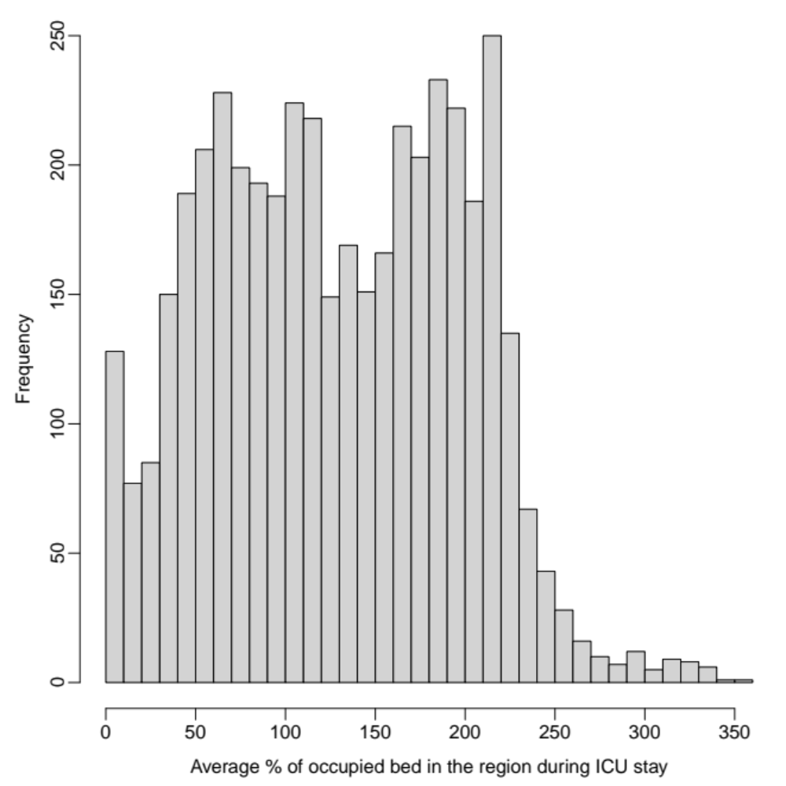
Average % of occupied beds in the regions during ICU stay

Figure E2. ICU load (%) according to LST categories

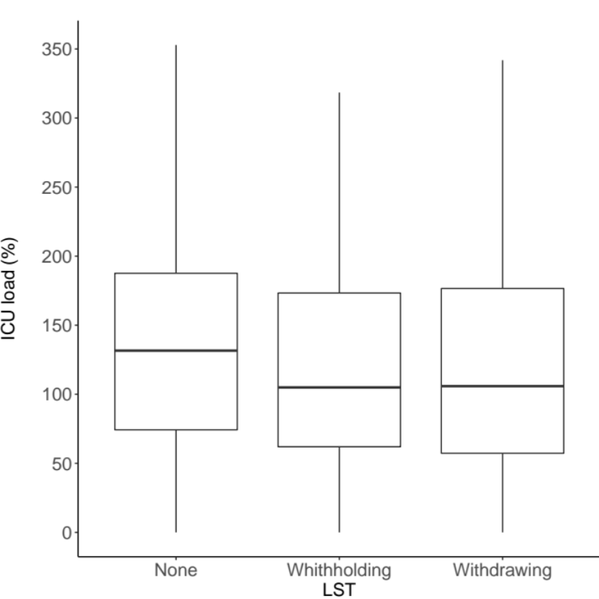
None Withholding Withdrawal
LST

Subgroup analysis by centre size, and in patients aged ≥75 years

Centre size
Similar results were observed in a subgroup analysis based on the number of patients per centre (10 to 29 patients included = “small” participating centre; 30 to 49 = “medium”; 50 or more = “large”).

Table E5. Expected prevalences estimated by the multivariate model according to the number of patients in the centre
Centre size (number of patients) | Expected prevalence, %  (95% CI)
10 – 29 | [3.8–31.9]
30 – 49 | [4.3–22.6]
≥ 50 | [6.6–29.5]

Age ≥ 75 years
Overall, 135 centres included at least one patient aged 75 years or over. Among these, only 15 centres included 10 patients aged 75 or over. The following results are based on 205 patients aged 75 years or over admitted to the 15 centres.
Table E6. Prevalence of decisions of LST limitations in patients aged ≥ 75 years
Model | Proportion (95% CI)
Fixed effect model | 0.4390 [0.3726-0.5077]
Random effects model | 0.4390 [0.3726-0.5077]

Quantifying heterogeneity: tau^2 = 0; tau = 0; I^2 = 0.0% [0.0%; 53.6%]; H = 1.00 [1.00; 1.47]
Testing heterogeneity, p-value for the likelihood ratio test was 0.487.
Figure E3. Forest plot of prevalences of decisions of LST limitations in the 15 centres with ≥ 10 patients aged ≥ 75 years

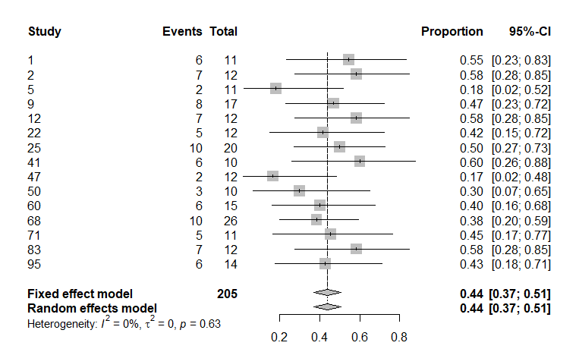

References
1. Le Gall JR, Lemeshow S, Saulnier F. A new Simplified Acute Physiology Score (SAPS II) based on a European/North American multicenter study. JAMA. 1993;270:2957–63.
2. Vincent JL, Moreno R, Takala J, et al. The SOFA (Sepsis-related Organ Failure Assessment) score to describe organ dysfunction/failure. On behalf of the Working Group on Sepsis-Related Problems of the European Society of Intensive Care Medicine. Intensive Care Med. 1996;22:707–10.
3. Juma S, Taabazuing M-M, Montero-Odasso M. Clinical frailty scale in an acute medicine unit: a simple tool that predicts length of stay. Can Geriatr J. 2016;19:34–9.
4. Vincent J-L, Rello J, Marshall J, et al. International study of the prevalence and outcomes of infection in intensive care units. JAMA. 2009;302:2323–9.
5. Taccone FS, Vangoethem N, Depauw R, et al. The role of organizational characteristics on the outcome of COVID-19 patients admitted to the ICU in Belgium. Lancet Regional Health - Europe. 2020;100019.

