Supplementary Figure 1
Western blot—FAP (95KD)
the cropping of the blot
100kd
75kd
Western blot—GAPDH (37KD)
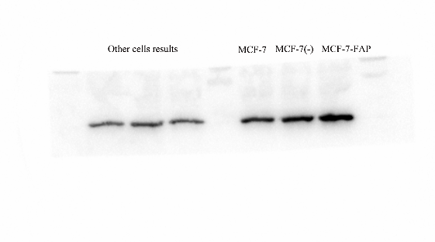
the cropping of the blot
48kd
35kd
Supplementary Figure 1：Full-length blots

