Supplementary Results

sTable 1: Characteristics of the whole UK Biobank population and of participants with COVID-19, stratified by genetic risk of coronary artery disease
Participant characteristics | All eligible UK Biobank participants² | Participants with COVID-19
Participant characteristics | All eligible UK Biobank participants² | All | Low genetic risk | Intermediate genetic risk | High genetic risk
Number | 408395 | 25335 | 5067 | 15201 | 5067
Mean age, year (SD) | 68.10 (8.10) | 65.99 (8.53) | 66.08 (8.49) | 66.05 (8.55) | 65.74 (8.54)

sex, No. (%)
Female | 225451 (55.2) | 13339 (52.7) | 2656 (52.4) | 8044 (52.9) | 2639 (52.1)
Male | 182944 (44.8) | 11996 (47.3) | 2411 (47.6) | 7157 (47.1) | 2428 (47.9)

Ethnicity, No. (%)
White | 382169 (93.6) | 3893 (15.4) | 820 (16.2) | 2244 (14.8) | 829 (16.4)
Other ethnic groups | 26226 ( 6.4) | 21442 (84.6) | 4247 (83.8) | 12957 (85.2) | 4238 (83.6)

Obesity, No. (%)
BMI < 30 | 311205 (76.2) | 17984 (71.0) | 3695 (72.9) | 10734 (70.6) | 3555 (70.2)
BMI ≥ 30 | 97190 (23.8) | 7351 (29.0) | 1372 (27.1) | 4467 (29.4) | 1512 (29.8)

Education categories³, No. (%)
Ⅰ | 73987 (18.1) | 4863 (19.2) | 880 (17.4) | 2932 (19.3) | 1051 (20.7)
Ⅱ | 110969 (27.2) | 7999 (31.6) | 1526 (30.1) | 4839 (31.8) | 1634 (32.2)
Ⅲ | 45409 (11.1) | 2613 (10.3) | 553 (10.9) | 1546 (10.2) | 514 (10.1)
Ⅳ | 20765 ( 5.1) | 1194 ( 4.7) | 260 ( 5.1) | 705 ( 4.6) | 229 ( 4.5)
Ⅴ | 157265 (38.5) | 8666 (34.2) | 1848 (36.5) | 5179 (34.1) | 1639 (32.3)
Index of multiple deprivation, mean (SD) | 17.51 (13.87) | 20.62 (14.85) | 20.61 (14.97) | 20.47 (14.69) | 21.07 (15.18)

Individual lifestyle factors, No. (%)

Smoking status
Never or past | 368471 (90.2) | 22590 (89.2) | 4543 (89.7) | 13565 (89.2) | 4482 (88.5)
Current | 39924 ( 9.8) | 2745 (10.8) | 524 (10.3) | 1636 (10.8) | 585 (11.5)

Alcohol intake
≤ 4 times week | 325341 (79.7) | 21062 (83.1) | 4143 (81.8) | 12671 (83.4) | 4248 (83.8)
Daily or almost daily | 83054 (20.3) | 4273 (16.9) | 924 (18.2) | 2530 (16.6) | 819 (16.2)

Physical activity
≥150 min per week of MIPA or ≥75 min per week of VIPA | 345208 (84.5) | 21194 (83.7) | 4243 (83.7) | 12751 (83.9) | 4200 (82.9)
<150 min per week of MIPA & <75 min per week of VIPA | 63187 (15.5) | 4141 (16.3) | 824 (16.3) | 2450 (16.1) | 867 (17.1)

Television viewing time
< 4 h/day | 293476 (71.9) | 17880 (70.6) | 3661 (72.3) | 10747 (70.7) | 3472 (68.5)
≥ 4 h/day | 114919 (28.1) | 7455 (29.4) | 1406 (27.7) | 4454 (29.3) | 1595 (31.5)

Sleep duration
≥7 & ≤9h/day | 301723 (73.9) | 18121 (71.5) | 3667 (72.4) | 10888 (71.6) | 3566 (70.4)
<7 or >9h/day | 106672 (26.1) | 7214 (28.5) | 1400 (27.6) | 4313 (28.4) | 1501 (29.6)

Fruit and vegetable intake
≥ 400 g/day | 327452 (80.2) | 19456 (76.8) | 3879 (76.6) | 11677 (76.8) | 3900 (77.0)
<400 g/ day | 80943 (19.8) | 5879 (23.2) | 1188 (23.4) | 3524 (23.2) | 1167 (23.0)

Oily fish intake
≥1 portion/week | 230406 (56.4) | 13047 (51.5) | 2638 (52.1) | 7775 (51.1) | 2634 (52.0)
<1 portion/week | 177989 (43.6) | 12288 (48.5) | 2429 (47.9) | 7426 (48.9) | 2433 (48.0)

Red meat intake
≤3 portion/week | 188229 (46.1) | 13118 (51.8) | 2545 (50.2) | 7883 (51.9) | 2690 (53.1)
>3 portion/week | 220166 (53.9) | 12217 (48.2) | 2522 (49.8) | 7318 (48.1) | 2377 (46.9)

Processed meat intake
≤1 portion/week | 282323 (69.1) | 16716 (66.0) | 3354 (66.2) | 9971 (65.6) | 3391 (66.9)
>1 portion/week | 126072 (30.9) | 8619 (34.0) | 1713 (33.8) | 5230 (34.4) | 1676 (33.1)

Combined lifestyle, No. (%)
Healthy (0-4 unhealthy factors) | 377279 (92.4) | 23151 (91.4) | 4627 (91.3) | 13889 (91.4) | 4635 (91.5)
Unhealthy (5-9 unhealthy factors) | 31116 ( 7.6) | 2184 ( 8.6) | 440 ( 8.7) | 1312 ( 8.6) | 432 ( 8.5)

sTable 2: Characteristics of the whole UK Biobank population and of participants with COVID-19, stratified by genetic risk of ischaemic stroke
Participant characteristics | All eligible UK Biobank participants² | Participants with COVID-19
Participant characteristics | All eligible UK Biobank participants² | All | Low genetic risk | Intermediate genetic risk | High genetic risk
Number | 408395 | 25335 | 5067 | 15201 | 5067
Mean age, year (SD) | 68.10 (8.10) | 65.99 (8.53) | 65.95 (8.53) | 66.06 (8.54) | 65.81 (8.53)

sex, No. (%)
Female | 225451 (55.2) | 13339 (52.7) | 2665 (52.6) | 8012 (52.7) | 2662 (52.5)
Male | 182944 (44.8) | 11996 (47.3) | 2402 (47.4) | 7189 (47.3) | 2405 (47.5)

Ethnicity, No. (%)
White | 382169 (93.6) | 3893 (15.4) | 886 (17.5) | 2250 (14.8) | 757 (14.9)
Other ethnic groups | 26226 ( 6.4) | 21442 (84.6) | 4181 (82.5) | 12951 (85.2) | 4310 (85.1)

Obesity, No. (%)
BMI < 30 | 311205 (76.2) | 17984 (71.0) | 3789 (74.8) | 10835 (71.3) | 3360 (66.3)
BMI ≥ 30 | 97190 (23.8) | 7351 (29.0) | 1278 (25.2) | 4366 (28.7) | 1707 (33.7)

Education categories³, No. (%)
Ⅰ | 73987 (18.1) | 4863 (19.2) | 866 (17.1) | 2909 (19.1) | 1088 (21.5)
Ⅱ | 110969 (27.2) | 7999 (31.6) | 1518 (30.0) | 4867 (32.0) | 1614 (31.9)
Ⅲ | 45409 (11.1) | 2613 (10.3) | 568 (11.2) | 1531 (10.1) | 514 (10.1)
Ⅳ | 20765 ( 5.1) | 1194 ( 4.7) | 241 ( 4.8) | 705 ( 4.6) | 248 ( 4.9)
Ⅴ | 157265 (38.5) | 8666 (34.2) | 1874 (37.0) | 5189 (34.1) | 1603 (31.6)
Index of multiple deprivation, mean (SD) | 17.51 (13.87) | 20.62 (14.85) | 20.41 (14.80) | 20.45 (14.73) | 21.32 (15.23)

Individual lifestyle factors, No. (%)

Smoking status
Never or past | 368471 (90.2) | 22590 (89.2) | 4571 (90.2) | 13548 (89.1) | 4471 (88.2)
Current | 39924 ( 9.8) | 2745 (10.8) | 496 ( 9.8) | 1653 (10.9) | 596 (11.8)

Alcohol intake
≤ 4 times week | 325341 (79.7) | 21062 (83.1) | 4188 (82.7) | 12618 (83.0) | 4256 (84.0)
Daily or almost daily | 83054 (20.3) | 4273 (16.9) | 879 (17.3) | 2583 (17.0) | 811 (16.0)

Physical activity
≥150 min per week of MIPA or ≥75 min per week of VIPA | 345208 (84.5) | 21194 (83.7) | 4284 (84.5) | 12766 (84.0) | 4144 (81.8)
<150 min per week of MIPA & <75 min per week of VIPA | 63187 (15.5) | 4141 (16.3) | 783 (15.5) | 2435 (16.0) | 923 (18.2)

Television viewing time
< 4 h/day | 293476 (71.9) | 17880 (70.6) | 3721 (73.4) | 10733 (70.6) | 3426 (67.6)
≥ 4 h/day | 114919 (28.1) | 7455 (29.4) | 1346 (26.6) | 4468 (29.4) | 1641 (32.4)

Sleep duration
≥7 & ≤9h/day | 301723 (73.9) | 18121 (71.5) | 3687 (72.8) | 10912 (71.8) | 3522 (69.5)
<7 or >9h/day | 106672 (26.1) | 7214 (28.5) | 1380 (27.2) | 4289 (28.2) | 1545 (30.5)

Fruit and vegetable intake
≥ 400 g/day | 327452 (80.2) | 19456 (76.8) | 3904 (77.0) | 11704 (77.0) | 3848 (75.9)
<400 g/ day | 80943 (19.8) | 5879 (23.2) | 1163 (23.0) | 3497 (23.0) | 1219 (24.1)

Oily fish intake
≥1 portion/week | 230406 (56.4) | 13047 (51.5) | 2594 (51.2) | 7880 (51.8) | 2573 (50.8)
<1 portion/week | 177989 (43.6) | 12288 (48.5) | 2473 (48.8) | 7321 (48.2) | 2494 (49.2)

Red meat intake
≤3 portion/week | 188229 (46.1) | 13118 (51.8) | 2473 (48.8) | 7915 (52.1) | 2730 (53.9)
>3 portion/week | 220166 (53.9) | 12217 (48.2) | 2594 (51.2) | 7286 (47.9) | 2337 (46.1)

Processed meat intake
≤1 portion/week | 282323 (69.1) | 16716 (66.0) | 3337 (65.9) | 10059 (66.2) | 3320 (65.5)
>1 portion/week | 126072 (30.9) | 8619 (34.0) | 1730 (34.1) | 5142 (33.8) | 1747 (34.5)

Combined lifestyle, No. (%)
Healthy (0-4 unhealthy factors) | 377279 (92.4) | 23151 (91.4) | 4641 (91.6) | 13924 (91.6) | 4586 (90.5)
Unhealthy (5-9 unhealthy factors) | 31116 ( 7.6) | 2184 ( 8.6) | 426 ( 8.4) | 1277 ( 8.4) | 481 ( 9.5)

sTable 3: Characteristics of the whole UK Biobank population and of participants with COVID-19, stratified by genetic risk of venous thromboembolism
Participant characteristics | All eligible UK Biobank participants² | Participants with COVID-19
Participant characteristics | All eligible UK Biobank participants² | All | Low genetic risk | Intermediate genetic risk | High genetic risk
Number | 408395 | 25335 | 5067 | 15201 | 5067
Mean age, year (SD) | 68.10 (8.10) | 65.99 (8.53) | 65.87 (8.57) | 66.05 (8.54) | 65.95 (8.47)

sex, No. (%)
Female | 225451 (55.2) | 13339 (52.7) | 2660 (52.5) | 7971 (52.4) | 2708 (53.4)
Male | 182944 (44.8) | 11996 (47.3) | 2407 (47.5) | 7230 (47.6) | 2359 (46.6)

Ethnicity, No. (%)
White | 382169 (93.6) | 3893 (15.4) | 789 (15.6) | 2296 (15.1) | 808 (15.9)
Other ethnic groups | 26226 ( 6.4) | 21442 (84.6) | 4278 (84.4) | 12905 (84.9) | 4259 (84.1)

Obesity, No. (%)
BMI < 30 | 311205 (76.2) | 17984 (71.0) | 3630 (71.6) | 10805 (71.1) | 3549 (70.0)
BMI ≥ 30 | 97190 (23.8) | 7351 (29.0) | 1437 (28.4) | 4396 (28.9) | 1518 (30.0)

Education categories³, No. (%)
Ⅰ | 73987 (18.1) | 4863 (19.2) | 904 (17.8) | 2949 (19.4) | 1010 (19.9)
Ⅱ | 110969 (27.2) | 7999 (31.6) | 1632 (32.2) | 4750 (31.2) | 1617 (31.9)
Ⅲ | 45409 (11.1) | 2613 (10.3) | 536 (10.6) | 1546 (10.2) | 531 (10.5)
Ⅳ | 20765 ( 5.1) | 1194 ( 4.7) | 252 ( 5.0) | 715 ( 4.7) | 227 ( 4.5)
Ⅴ | 157265 (38.5) | 8666 (34.2) | 1743 (34.4) | 5241 (34.5) | 1682 (33.2)
Index of multiple deprivation, mean (SD) | 17.51 (13.87) | 20.62 (14.85) | 20.31 (14.58) | 20.68 (14.96) | 20.72 (14.78)

Individual lifestyle factors, No. (%)

Smoking status
Never or past | 368471 (90.2) | 22590 (89.2) | 4540 (89.6) | 13510 (88.9) | 4540 (89.6)
Current | 39924 ( 9.8) | 2745 (10.8) | 527 (10.4) | 1691 (11.1) | 527 (10.4)

Alcohol intake
≤ 4 times week | 325341 (79.7) | 21062 (83.1) | 4224 (83.4) | 12591 (82.8) | 4247 (83.8)
Daily or almost daily | 83054 (20.3) | 4273 (16.9) | 843 (16.6) | 2610 (17.2) | 820 (16.2)

Physical activity
≥150 min per week of MIPA or ≥75 min per week of VIPA | 345208 (84.5) | 21194 (83.7) | 4253 (83.9) | 12750 (83.9) | 4191 (82.7)
<150 min per week of MIPA & <75 min per week of VIPA | 63187 (15.5) | 4141 (16.3) | 814 (16.1) | 2451 (16.1) | 876 (17.3)

Television viewing time
< 4 h/day | 293476 (71.9) | 17880 (70.6) | 3609 (71.2) | 10697 (70.4) | 3574 (70.5)
≥ 4 h/day | 114919 (28.1) | 7455 (29.4) | 1458 (28.8) | 4504 (29.6) | 1493 (29.5)

Sleep duration
≥7 & ≤9h/day | 301723 (73.9) | 18121 (71.5) | 3602 (71.1) | 10930 (71.9) | 3589 (70.8)
<7 or >9h/day | 106672 (26.1) | 7214 (28.5) | 1465 (28.9) | 4271 (28.1) | 1478 (29.2)

Fruit and vegetable intake
≥ 400 g/day | 327452 (80.2) | 19456 (76.8) | 3880 (76.6) | 11663 (76.7) | 3913 (77.2)
<400 g/ day | 80943 (19.8) | 5879 (23.2) | 1187 (23.4) | 3538 (23.3) | 1154 (22.8)

Oily fish intake
≥1 portion/week | 230406 (56.4) | 13047 (51.5) | 2582 (51.0) | 7893 (51.9) | 2572 (50.8)
<1 portion/week | 177989 (43.6) | 12288 (48.5) | 2485 (49.0) | 7308 (48.1) | 2495 (49.2)

Red meat intake
≤3 portion/week | 188229 (46.1) | 13118 (51.8) | 2623 (51.8) | 7879 (51.8) | 2616 (51.6)
>3 portion/week | 220166 (53.9) | 12217 (48.2) | 2444 (48.2) | 7322 (48.2) | 2451 (48.4)

Processed meat intake
≤1 portion/week | 282323 (69.1) | 16716 (66.0) | 3338 (65.9) | 10038 (66.0) | 3340 (65.9)
>1 portion/week | 126072 (30.9) | 8619 (34.0) | 1729 (34.1) | 5163 (34.0) | 1727 (34.1)

Combined lifestyle, No. (%)
Healthy (0-4 unhealthy factors) | 377279 (92.4) | 23151 (91.4) | 4646 (91.7) | 13880 (91.3) | 4625 (91.3)
Unhealthy (5-9 unhealthy factors) | 31116 ( 7.6) | 2184 ( 8.6) | 421 ( 8.3) | 1321 ( 8.7) | 442 ( 8.7)

sFigure 1: Dose-response associations between continuous polygenic risk scores (PRSs) and study outcomes.
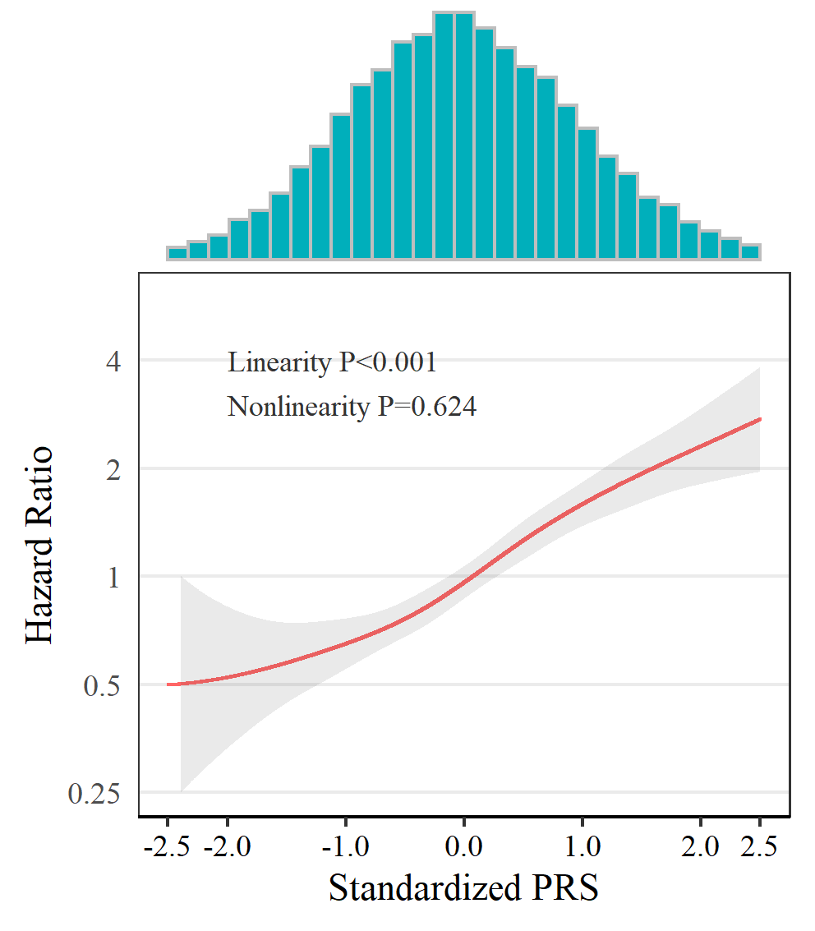 | 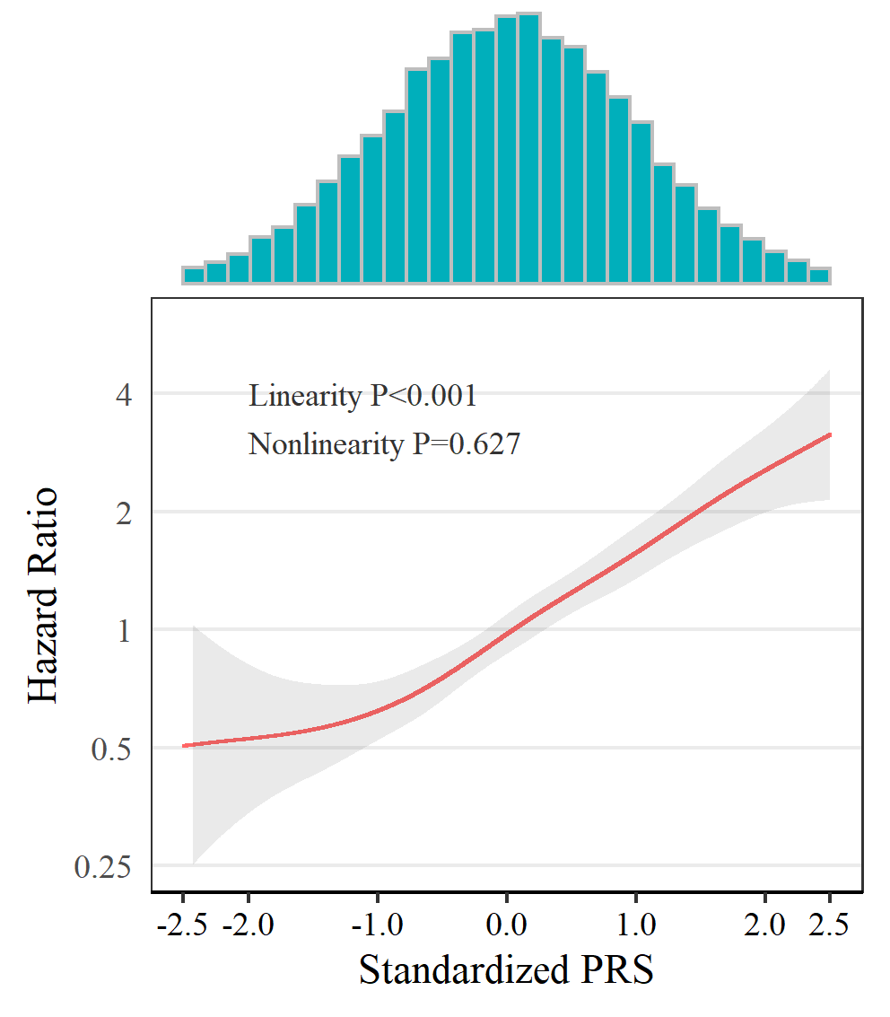 | 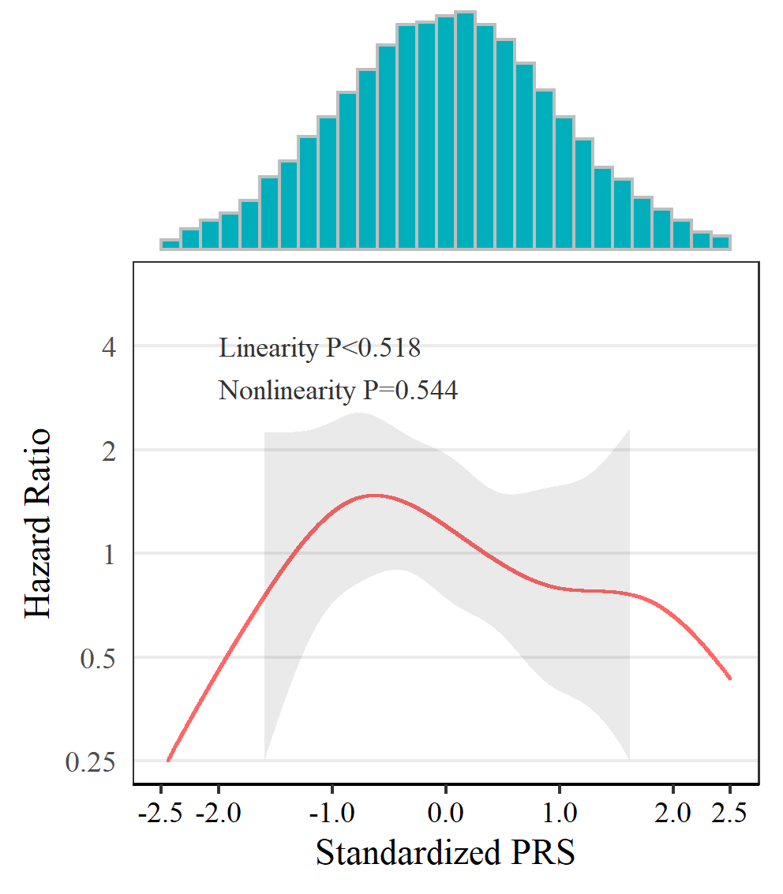 | 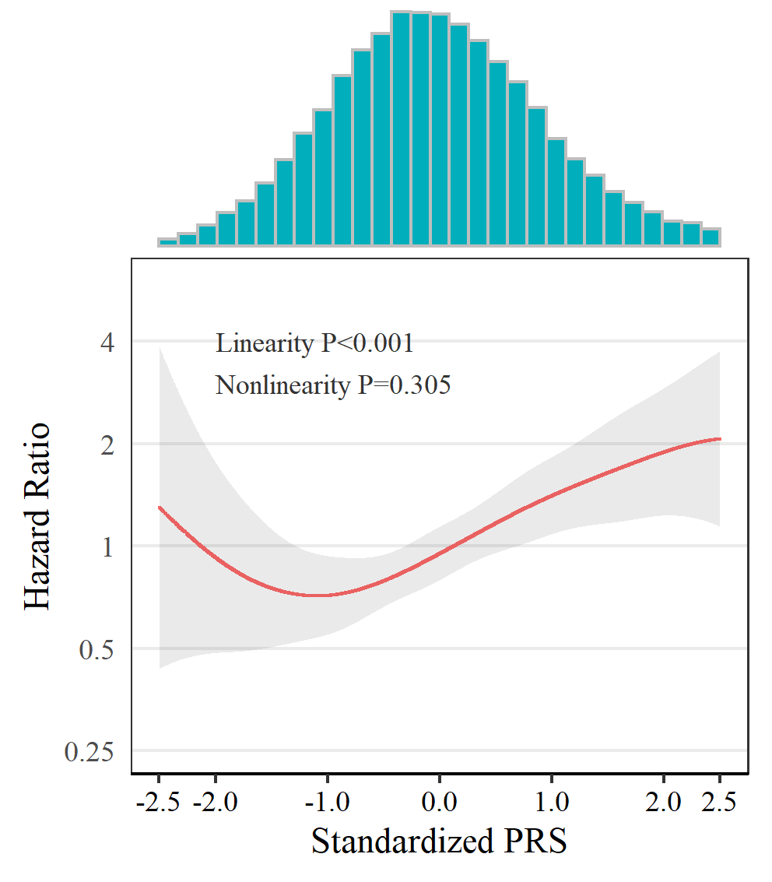
Atrial fibrillation | Coronary artery disease | Ischaemic stroke | Venous thromboembolism
If the confidence interval of the hazard ratio was larger than 4 or smaller than 0.25, it was removed.

sTable 4: Sensitivity analyses.
 | Atrial fibrillation | Coronary artery disease | Ischaemic stroke | Venous thromboembolism
Sensitivity results
Use of enhanced PRS | 1.67 (1.35 to 2.06) | 1.51 (1.17 to 1.95) | 0.81 (0.43 to 1.50) | 1.32 (0.98 to 1.78)
Incident cardiovascular and thromboembolic events | 1.33 (1.11 to 1.59) | 1.19 (0.87 to 1.63) | 0.84 (0.55 to 1.27) | 1.32 (1.11 to 1.55)
Hospital admission diagnosis | 1.31 (0.89 to 1.92) | 1.21 (0.71 to 2.08) | 0.87 (0.56 to 1.36) | 1.52 (1.14 to 2.02)
COVID-19-unrealted CVE (Positive control outcome) | 1.65 (1.58 to 1.72) | 1.56 (1.47 to 1.65) | 1.32 (1.13 to 1.53) | 1.41 (1.24 to 1.61)
Diabetes (Negative control outcome) | 0.82 (0.69 to 0.97) | 0.98 (0.83 to 1.15) | 1.13 (0.96 to 1.34) | 1.09 (0.93 to 1.29)

Supplementary Methods

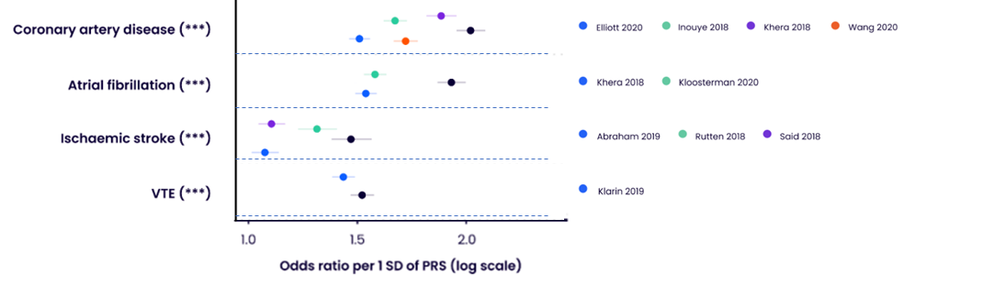
Predictive performance of the UK Biobank PRS Release (the black point) against published comparator PRSs (the colourful point).

(Citation: Deborah J. Thompson, Preprint medRxiv DOI: https://doi.org/10.1101/2022.06.16.22276246, 2022)

UK Biobank self-reported highest qualification mapped to the International Standard Classification of Education (ISCED).
UK Biobank self-reported highest qualification | Years of education | ISCED
Prefer not to answer | 7 | 1
None of the above | 7 | 1
CSEs or equivalent | 10 | 2
O levels/GCSEs or equivalent | 10 | 2
A levels/AS levels or equivalent | 13 | 3
Other professional qualifications eg: nursing, teaching | 15 | 4
NVQ or HND or HNC or equivalent | 19 | 5
College or University degree | 20 | 5

Variables in UK Biobank used to create the lifestyle score in this study.
Lifestyle factor | Questionnaire | Healthy (0) | Unhealthy (1)
1. Smoking status | "Do you smoke tobacco now?" and "In the past, how often have you smoked tobacco?" | past or never smoker | current
2. Alcohol intake | “About how often do you drink alcohol?” | ≤ 4 times week | Daily or almost daily
3. Physical activity | IPAQ short form2– total time walking or moderate and vigorous-intensity PA in previous week * | ≥150 min/week moderate or ≥ 75 min/week vigorous PA | < 75 min/week vigorous PA
4. TV viewing /sedentary time | “In a typical day, how many hours do you spend watching TV?” ǂ | < 4 h/day | ≥ 4 h/day
5. Sleep time | “About how many hours sleep do you get in every 24 hours?” | >7 or <9h/day | <7 or >9h/day
Dietary characteristics | Individual dietary components contributed directly to lifestyle score.ф
6. Fruit and vegetable intake | "About how many of …. would you eat per day?” Separate questions for pieces of fresh and dried fruit, tablespoons of salad or cooked/raw vegetables. Combined and converted to g/day (1 portion = 80 g) | ≥ 400 g/day | <400 g/ day
7. Oily fish intake | "How often do you eat oily fish? (e.g. sardines, salmon, mackerel, herring)" | ≥1 portion/week | <1  portion/week
8. Red meat intake | "How often do you eat…?” Separate questions for Beef / lamb or mutton / pork (excluding processed meats such as ham or bacon). Red meat included due to clear link between red meat and mortality.3 | ≤3 portion/week | >3  portion/week
9. Processed meat intake | "How often do you eat processed meats (such as bacon, ham, sausages, meat pies, kebabs, burgers, chicken nuggets)?" | ≤1 portion/week | >1  portion/week
Participants were classified as “not at risk/healthy” or “at risk/unhealthy” based on their responses to questions for each lifestyle factor. *UK Biobank physical activity (PA) data were analyzed in accordance with the International Physical Activity Questionnaire (IPAQ) scoring protocol, with total physical activity computed as the sum of walking, moderate, and vigorous activity, measured as metabolic equivalents (MET-hours/week). ǂ UK Biobank participants were asked about work-related sitting time and were not asked about discretionary/leisure time sedentary behavior. Therefore, TV viewing time, which is strongly associated with mortality, was used instead of sedentary time. UK Biobank participants were asked separately about time spent using a computer, excluding computer time at work. This information was used to check for implausible values for TV viewing time. Ф National dietary guidelines were used as the basis for the dietary components.

(Developed by Hamish M, Lancet Public Health 2018)

ICD-10 codes originally used to develop the polygenic risk score and define cardiovascular and thromboembolic events in this study.
Outcomes | ICD-10 codes
Atrial fibrillation | I48
Coronary artery disease | I21, I22, I23, I24.1, I25.2
Ischaemic stroke | I63, I64
Venous thromboembolic disease | I81, I82, I26, O22.3, O87.1, O08.2

