Additional file 2:

Lameness Locator data

Materials and Methods
The horses were assessed for lameness objectively on a concrete surface using a sensor-based movement analysis system (Lameness Locator® by Equinosis LLC) with sensors placed on the head, right front limb, and tubera sacrale. Outliers were automatically removed by the installed software using default settings.

Results
Lameness Locator Vector Sum did not differ between groups prior to OA induction (p = 0.2756) or prior to treatment on day 0 (p = 0.9497).

There was no significant difference in vector sum between groups at any time before or after MSC treatment. However, the untreated group developed right front limb (Control-leg) lameness (positive average vector sum days 24 – 38), obscuring comparison between groups (Supplementary Figure 1).

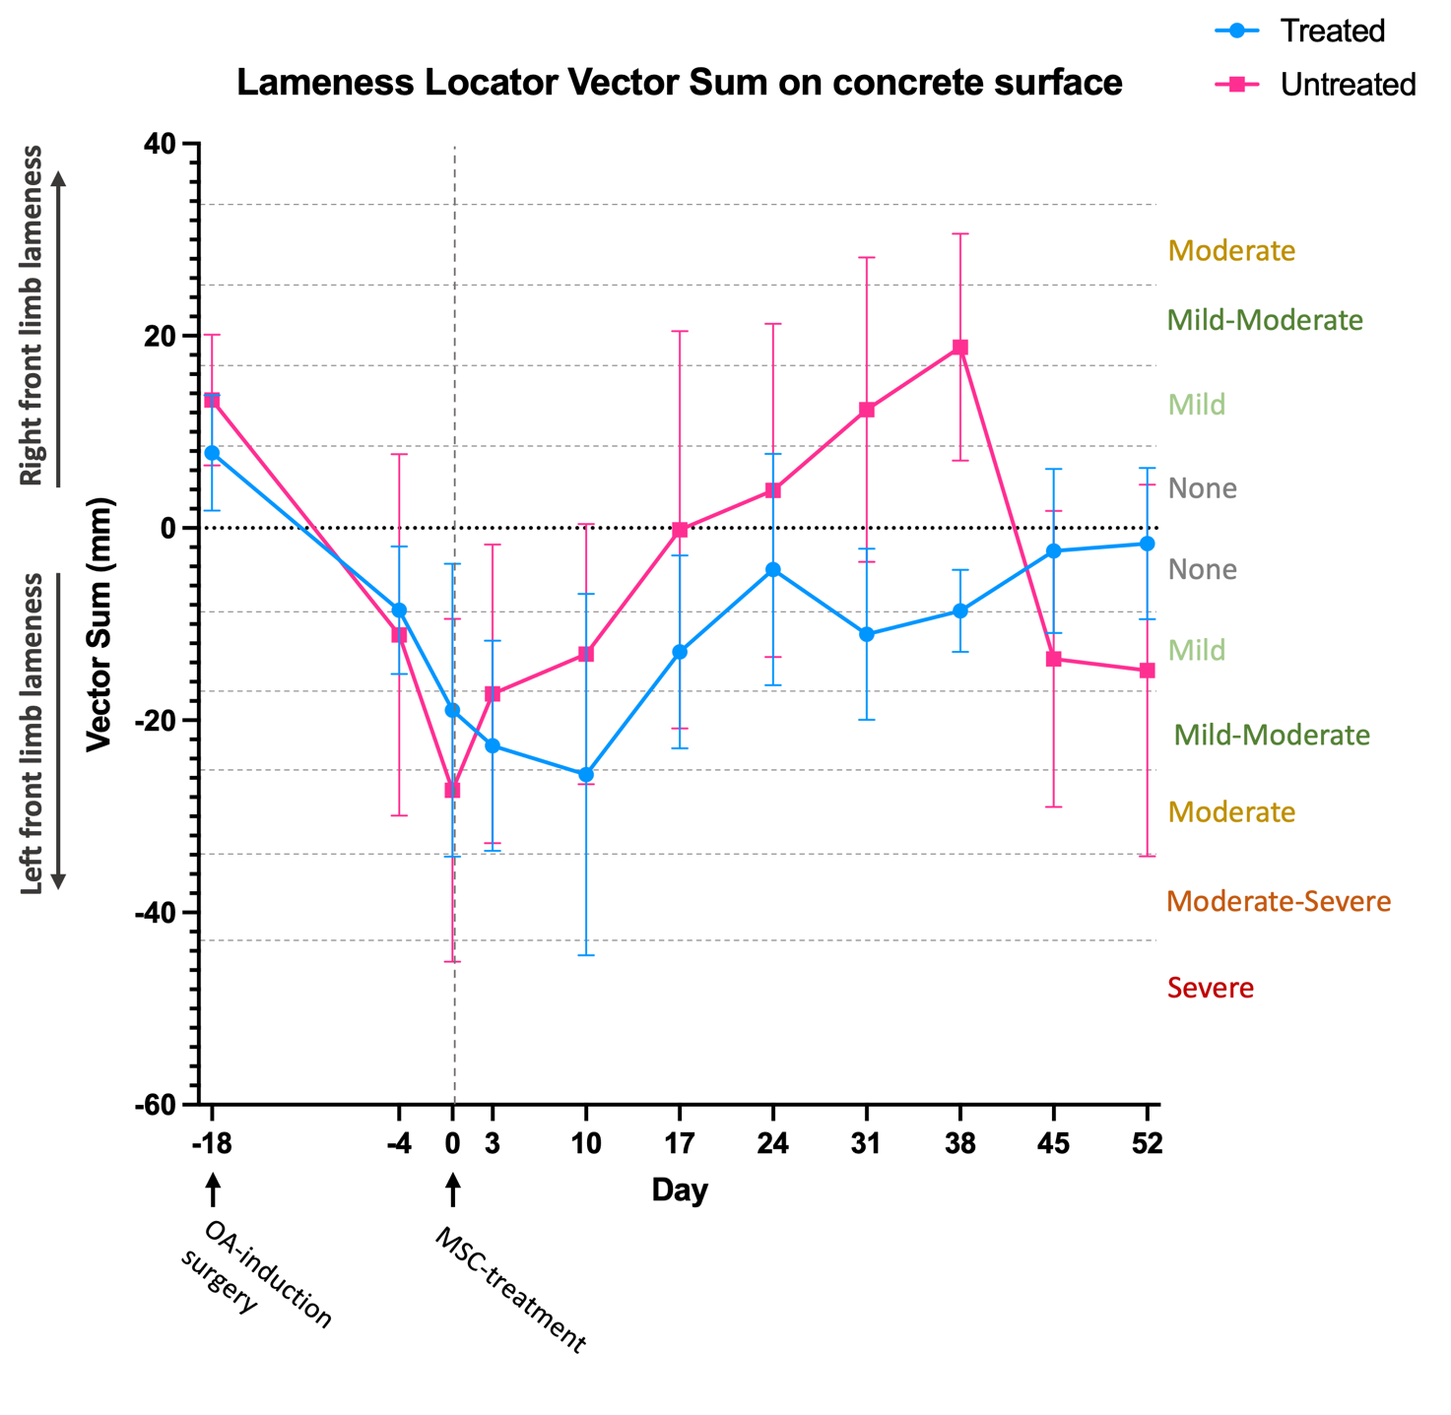
Supplementary Figure 1: Lameness Locator Vector Sum (VS) (objective lameness assessment) during the study period in the treated (blue) and untreated (pink) group. Both groups have no/mild front limb lameness at baseline (day -18). On day -4 both groups have a negative VS, indicating left front limb (OA-leg) lameness. The lameness of the treated group returns towards baseline during the study period. Some horses of the untreated group develop right front limb (Control-leg) lameness seen as a positive VS during the time of the study. The VS is a measure of the difference in lameness between front limbs. Category intervals were defined by Kallerud et al.¹.

Discussion
In our study, objectively measured Lameness Locator Vector Sum (VS) confirmed the trajectory of the lameness evaluated by the AAEP scale in the treated group, but not the untreated group. The reason for this is that the untreated horses developed contra-lateral front limb lameness from day 21 onwards. In the Lameness Locator software, the difference in head minimum/lowest positions between right and left portions of the stride is assigned HDmin and the maximum/highest head position is assigned HDmax, while the hind limb equivalent is assigned PDmin and PDmax. The Vector Sum is automatically calculated by the Lameness Locator Software using the ﻿Pythagorean Theorem as the ﻿hypotenuse of the difference in maximum and minimum head position during one stride cycle².That means that the Vector Sum of the Lameness Locator represents the difference in asymmetry between legs, while lameness on each leg can be subjectively assessed with the AAEP scale. Lameness shifting between the OA-limb and the control limb has been reported previously in a study using the equine carpal osteochondral fragment model³. The reason for development of contralateral front limb lameness was not determined in this study. Sometimes, multi-limb lameness is caused by an immediate compensatory movement pattern, with the purpose of relieving pain on the lame limb⁴. Over time, the horse may also develop secondary lameness as a result of long-term alterations in movement, which subsequently results in chronic overload and eventually pathology in the contralateral limb⁵. This could potentially be the explanation for control limb lameness in our untreated horses. These control joints had generally higher macroscopic pathology score (although not significant) along with significantly more histologic pathology in the synovial membrane compared to control joints in the treated horses.

When analyzing the Lameness Locator data, the recommendations for use of the system involves excluding measurements with “weak” evidence of asymmetry equivalent to a SD of more than 120% of HDmin and obvious hindlimb lameness that could interfere with front limb movement corresponding to a PDmin of > +/- 15mm^{1,2,6,7}. Standardbred trotters are known to have a somewhat asymmetric movement pattern^{1,8}. The same was seen in our study population. When measurements with a SD of more than 120% of HDmin and obvious hindlimb lameness of > +/- 15mm were excluded, very few datapoints were remained. Therefore, we put very little emphasis on these data.

Conclusion
The Equinosis Lameness Locator measurements confirmed the lameness results subjectively assessed by the AAEP scale in the treated group, while the measurements of the untreated group were obscured by the development of contralateral limb lameness. Therefore, we do not place much emphasis on these data.

References
1. Kallerud, A. S. et al. Objectively measured movement asymmetry in yearling Standardbred trotters. Equine Vet. J. 1–10 (2020). doi:10.1111/evj.13302
2. Equinosis User Manual Lameness Locator Touch 1.0 version 1.0. 6 (2019).
3. Donnell, J. R., Frisbie, D. D., King, M. R., Goodrich, L. R. & Haussler, K. K. Comparison of subjective lameness evaluation, force platforms and an inertial-sensor system to identify mild lameness in an equine osteoarthritis model. Vet. J. 206, 136–142 (2015).
4. Weishaupt, M. A., Wiestner, T., Hogg, H. P., Jordan, P. & Auer, J. A. Compensatory load redistribution of horses with induced weight-bearing forelimb lameness trotting on a treadmill. Vet. J. 171, 135–146 (2006).
5. Kelmer, G. et al. Computer-assisted kinematic evaluation of induced compensatory movements resembling lameness in horses trotting on a treadmill. Am. J. Vet. Res. 66, 646–655 (2005).
6. Keegan, K. G. et al. Assessment of repeatability of a wireless, inertial sensor–based lameness evaluation system for horses. Am. J. Vet. Res. 72, 1156–63 (2011).
7. Christensen, J. W., Bathellier, S., Rhodin, M., Palme, R. & Uldahl, M. Increased rider weight did not induce changes in behavior and physiological parameters in horses. Animals 10, (2020).
8. Petersson, E. Skillnader i rörelsesymmetri i olika tempo hos travhästar (Differences in movement symmetry in Standardbred trotters), Masters thesis, Sveriges lantbruksuniversitet, SLU. (2020).

