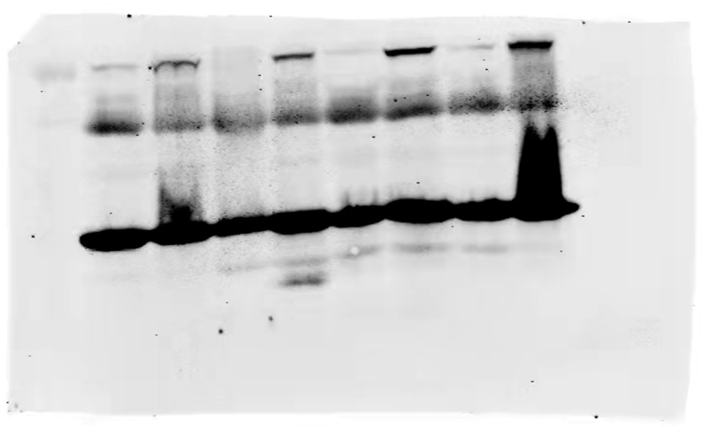
AIMP1 protein level in 4 pairs of LUAD tissues and their matched normal tissues were determined by western blotting.

GAPDH protein level in 4 pairs of LUAD tissues and their matched normal tissues were determined by western blotting.

