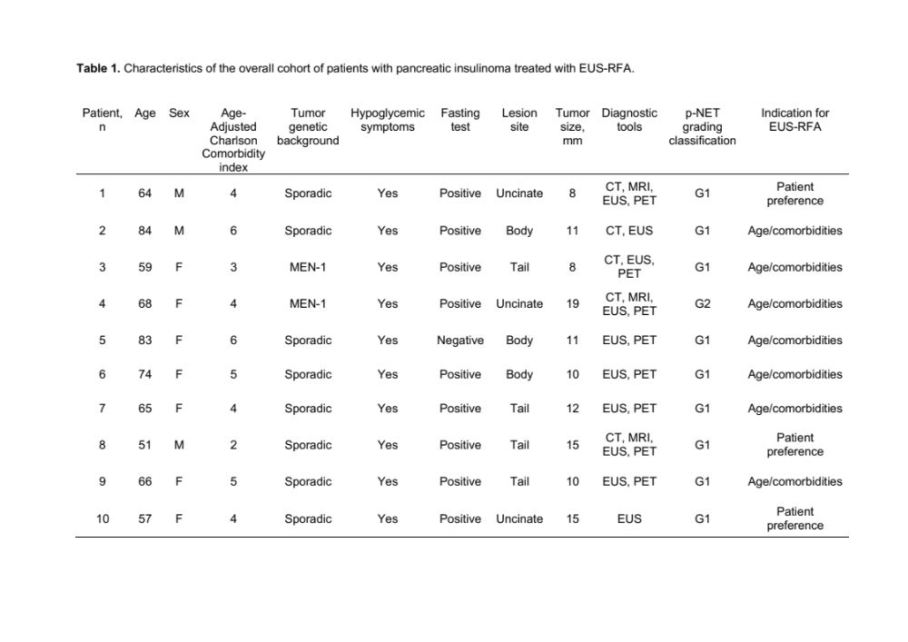

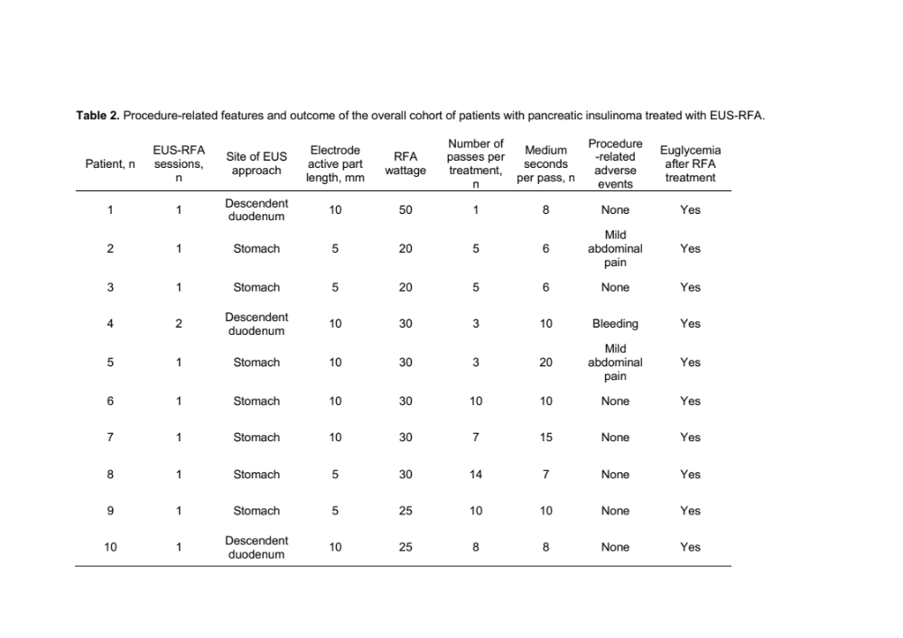
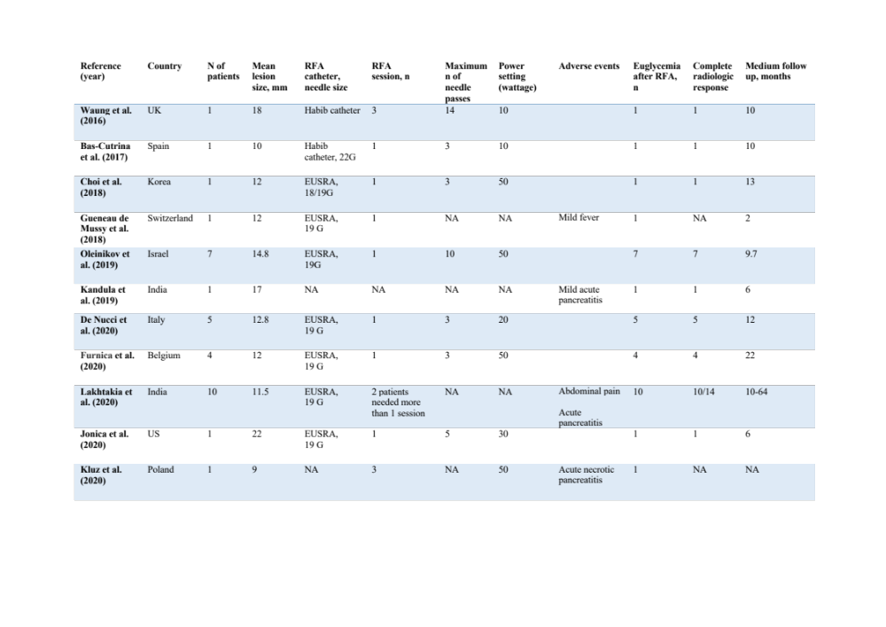
Table 3. Studies on pancreatic insulinomas treated with EUS-RFA.
v

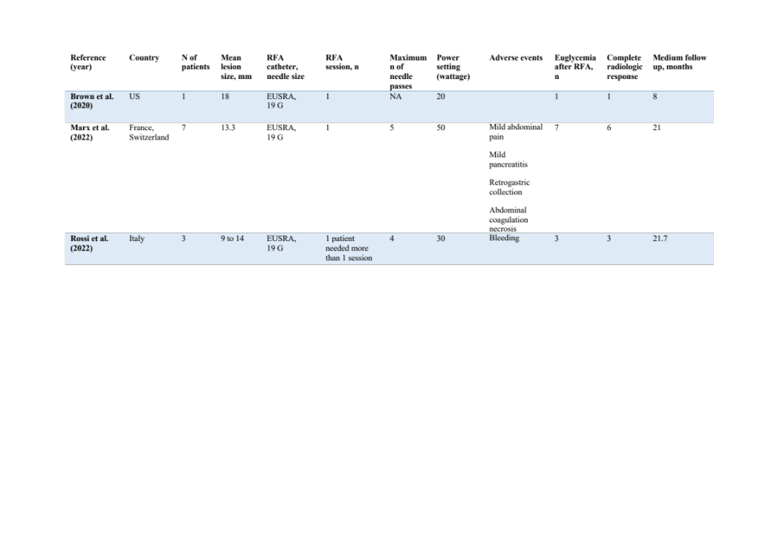
Table 3 (continued). Studies on pancreatic insulinomas treated with EUS-RFA.
3

