Supplementary Information
Additional file 1: Supplementary Figure 1. IRE1α silencing by siRNA rescues DHT-induced dysfunction of TCs.
Additional file 2: Supplementary Figure 2. Exercise reduces the level of ovarian fibrosis in PCOS rats.
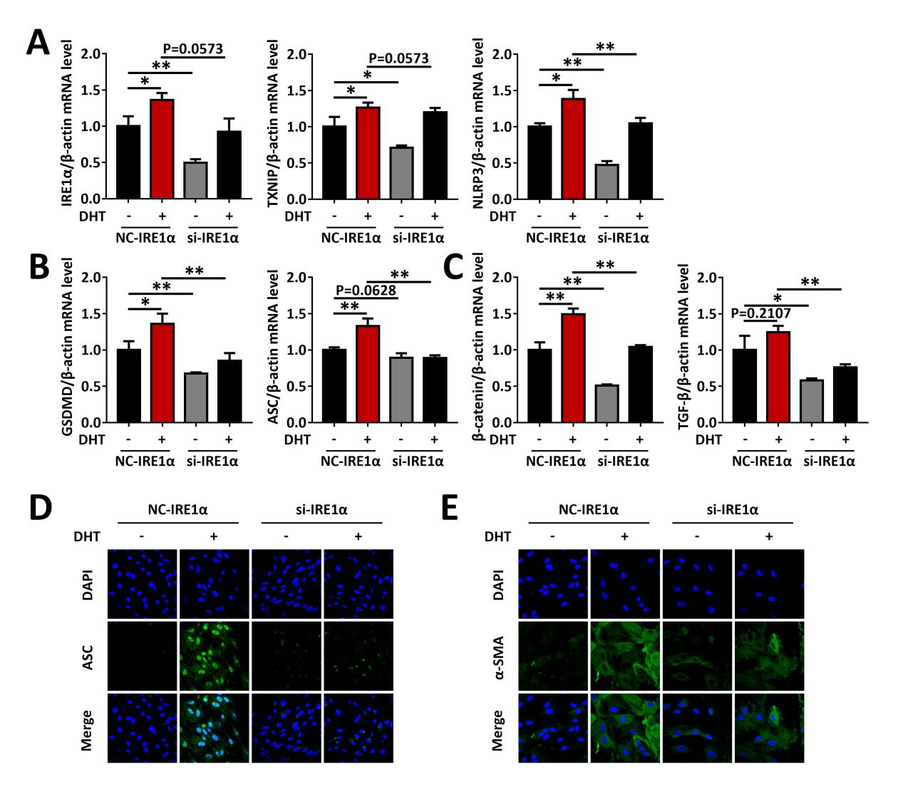
Supplementary Figure 1. IRE1α silencing by siRNA rescues DHT-induced dysfunction of TCs. TCs from naïve rats were treated with DHT, or were transfected with IRE1α siRNA followed by treatment with DHT. (A-C) The expression of IRE1α, TXNIP, NLRP3 (A), NLRP3 inflammasome activation factors (GSDMD, ASC) (B) and fibrosis factors (β-catenin, TGF-β) (C) in TCs was assessed by qRT-PCR. (D-E) The protein levels of ASC (D) and α-SMA (E) in TCs were analyzed by immunofluorescence staining (60×). Data are shown as the mean ± SD. *p ≤ 0.05, **p ≤ 0.01. NC, normal contrast; si, siRNA; DHT, dihydrotestosterone; IRE1α, inositol-requiring enzyme 1α; TXNIP, thioredoxin-interacting protein; NLRP3, NOD-like receptor family pyrin domain containing 3; GSDMD, gasdermin D; ASC, apoptosis-associated speck-like protein containing a CARD; TGF-β, transforming growth factor-beta; DAPI, 4’,6-diamidino-2-phenylindole; α-SMA, a-smooth muscle actin.
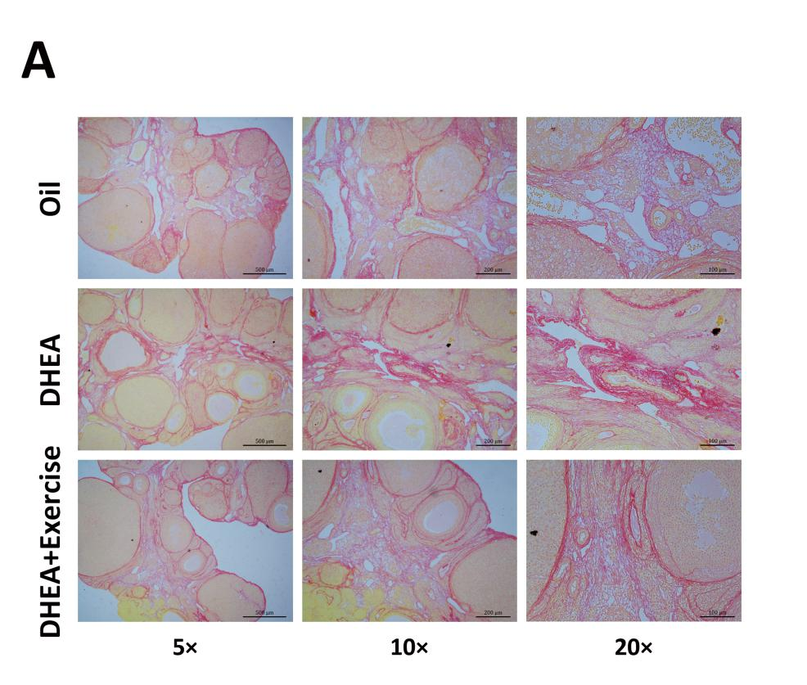
Supplementary Figure 2. Exercise reduces the level of ovarian fibrosis in PCOS rats. Rats received DHEA to induce polycystic ovary syndrome followed by exercise treatment. (A) Collagen in ovarian sections was revealed by Sirius Red staining. DHEA, dehydroepiandrosterone.

