- Files
All related Aspen Files and Excel Files and many PDF files, etc. will be put in these locations:
Shortened URL:
- https://bit.ly/Jasper-2022-DCE
Longer URL (just in case)
- https://aggiesncat-my.sharepoint.com/:f:/g/personal/mnjasper_aggies_ncat_edu/EpQ4azhHs9dEs2f3SL1vbsMB5Z2VoIldJ-8DEPfCZ3oP6Q?e=3jMn7F

- Gasification Reactions and Models

Pyrolysis Model
The pyrolysis model was used from Petersen 2005. It assumes that hydrogen is limiting. The X_{CH4} and X_{Tar} are used to adjust the percentage of methane and tar (C₆H₆) and consequently the C₂H₄ as well. X_{CO} is used to adjust the ratio of CO to CO₂ formed from the oxygen. For this work, X_{CO} = 0.3, X_{CH4} = 0.1673, and X_{Tar} = 0.05.

$$C_{c}H_{h}O_{o}N_{n}S_{s}Cl_{l}Ash_{a}H_{2}O_{w}→w H_{2}O+a Ash+\frac{l}{2}Cl_{2}+\frac{n}{2}N_{2}+s H_{2}S+\left(o X_{CO}\right) CO+\frac{o\left(1-X_{CO}\right)}{2}CO_{2}+\left(c X_{CH_{4}}\right) CH_{4}+\left(c X_{Tar}\right) C_{6}H_{6}+\left[\left(1-X_{CH_{4}}-6X_{Tar}\right)\frac{c}{2}-\left(X_{CO}+1\right)\frac{o}{4}\right]C_{2}H_{4}+ \left[\frac{h}{2}-s-\left(1+X_{CH_{4}}-3X_{Tar}\right)c+\left(X_{CO}+1\right)\frac{o}{2}\right]H_{2}$$

Fuel Air Equivalence Ratio

Stoichiometric Combustion of Solid Fuel
$$C_{c}H_{h}O_{o}N_{n}S_{s}Cl_{l}Ash_{a}H_{2}O_{w}+α\left(O_{2}+η N_{2}\right)→c CO_{2}+\left(\frac{h}{2}+w\right)H_{2}O+s SO_{2}+l Cl_{2}+α η N_{2}+a Ash$$
$$α = c+\frac{h}{4}+s-\frac{o}{2}, η = 3.76$$
$$NAFR_{st}=\frac{N_{Air,st}}{N_{Fuel, st}}=\frac{α(1+η)}{1}=α(1+η)$$
$$M_{Air}≈\frac{M_{O_{2}}+ηM_{N_{2}}}{1+η}≈\frac{31.9988+3.76∙28.0134}{1+3.76}=28.85$$
$$MAFR_{st}=\frac{{\dot{m}}_{Air}}{{\dot{m}}_{Fuel}}=\frac{N_{Air,st}M_{Air}}{N_{Fuel, st}M_{Fuel}}=α(1+η)M_{Air}≈α(M_{O_{2}}+ηM_{N_{2}})$$

$$λ=\frac{NAFR}{NAFR_{st}}=\frac{N_{Air}/N_{Fuel}}{N_{Air,st}/N_{Fuel,st}} =\frac{MAFR}{MAFR_{st}}=\frac{{\dot{m}}_{Air}/{\dot{m}}_{Fuel}}{{\dot{m}}_{Air,st}/{\dot{m}}_{Fuel,st}}→$$

$$λ=\frac{NAFR}{NAFR_{st}}=\frac{N_{Air}/N_{Fuel}}{N_{Air,st}/N_{Fuel,st}} =\frac{N_{Air}}{α\left(1+η\right)} (assuming N_{Fuel}=N_{Fuel,st}=1)$$
$$→ N_{Air}=λα\left(1+η\right)$$

Reactions
Table C.1- Reaction Kinetics Used in Simulation Model
No. | Reaction | Kinetic Expression  (kmol/m³/s) | k₀ | E_{a} / ΔG°  (kJ/kmol) | Source
R1-CPOX | C + 0.5 O₂ → CO | $$r_{1}=2.30 \left(\frac{6}{d_{p}}\right) T\exp\left(-\frac{92291}{RT}\right)C_{O_{2}}{\left(\frac{C_{C}}{C_{C,0}}\right)}^{2/3}$$ | 2.30  [m/s/K] | 92290.535 | Hobbs 1992
R2-CSG | C + H₂O → CO + H₂ | $$r_{2}=3.6e12\exp\left(-\frac{310000}{RT}\right)C_{C}C_{H_{2}O}$$ | 3.6e+12  [m³/kmol/s] | 310,000 | Jess 1995  Hobbs 1992
R3-CCG | C + CO₂ → 2 CO | $$r_{3}=3.6e12\exp\left(-\frac{310000}{RT}\right)C_{C}C_{CO_{2}}$$ | 3.6e+12  [m³/kmol/s] | 310,000 | Jess 1995  Hobbs 1992
R4-CM | C + 2 H₂ ^{C}→ CH₄ | $$r_{4}=1.11e-1 T\exp\left(-\frac{43211}{RT}\right)C_{H_{2}}^{2}C_{C}^{0.03}$$ | 1.11e-1  [m³/kmol/s] | 43210.88 | Calculated
MD K | CH₄ ↔ C + 2 H₂ | $$K_{P5}=403898\exp\left(-\frac{87748}{RT}\right) \\ T_{K_{P}=1}=544.401 ℃$$ | 403898 | 87748.323 | Gibbs
R5-MD | CH₄ ^{C}→ C + 2 H₂ | $$r_{5}=5.4e3\exp\left(-\frac{130959.2}{RT}\right)C_{CH_{4}}$$ | 5.4e+3  [1/s] | 130959.2 | Kobayashi 1992
R6-HOX | H₂ + 0.5 O₂ → H₂O | $$r_{6}=7.688e8 \exp\left(\frac{-156900}{RT}\right)C_{H_{2}}C_{O_{2}}^{0.25}$$ | 7.688e8 [m³/kmol/s] | 156900 | Wurzenberger 2002  Groppi 2000  Mitani 1980
R7-COX | CO + 0.5 O₂ → CO₂ | $$r_{7}=3.09e4\exp\left(-\frac{99760}{RT}\right)C_{CO}C_{O_{2}}^{0.25}$$ | 3.09e4 [m³/kmol/s] | 99760 | Aspen 2013 MBG Cen 1998  Liu DOE 2014
R8-WGS | H₂O + CO ^{C}→ H₂ + CO₂ | $$r_{8}=2777.78\exp\left(-\frac{12560}{RT}\right)C_{CO}C_{H_{2}O}$$ | 2777.78  [m³/kmol/s] | 12560 | Biba 1978  Gerber 2010
WGS K | H₂O + CO ↔ H₂ + CO₂ | $$K_{P6}=0.01702\exp\left(\frac{37238}{RT}\right) \\ T_{K_{P}=1}=826.385 ℃$$ | 0.01702 | -37238.044 | Gibbs
R8r-WGSR | H₂ + CO₂ ^{C}→ H₂O + CO | $$r_{8r}=163192\exp\left(-\frac{49798}{RT}\right)C_{CO_{2}}C_{H_{2}}$$ | 163192  [m³/kmol/s] | 49798.044 | Calculated
R9-MPOX | $${CH}_{4}+\frac{1}{2}O_{2}→CO+2 H_{2}$$ | $$r_{9}=4.4e11\exp\left(-\frac{125520}{RT}\right)C_{C_{n}H_{m}}C_{O_{2}}$$ | 4.4e11 [m³/kmol/s] | 125520 | Jones 1988
R10-MSR | $${CH}_{4}+H_{2}O→CO+3 H_{2}$$ | $$r_{10}=3.0e8\exp\left(-\frac{125520}{RT}\right)C_{CH_{4}}C_{H_{2}O}$$ | 3.0e8 [m³/kmol/s] | 125520 | Jones 1988
R11-MDR | $${CH}_{4}+CO_{2}→2 CO+2 H_{2}$$ | $$r_{11}=3.0e8\exp\left(-\frac{125520}{RT}\right)C_{CH_{4}}C_{CO_{2}}$$ | 3.0e8 [m³/kmol/s] | 125520 | Jones 1988
R12-EPOX | $$C_{2}H_{4}+O_{2}→2 CO+2 H_{2}$$ | $$r_{12}=4.2e11\exp\left(-\frac{125520}{RT}\right)C_{C_{n}H_{m}}C_{O_{2}}$$ | 4.2e11 [m³/kmol/s] | 125520 | Jones 1988
R13-ESR | $$C_{2}H_{4}+2 H_{2}O→2 CO+4 H_{2}$$ | $$r_{13}=3.0e8\exp\left(-\frac{125520}{RT}\right)C_{C_{2}H_{4}}C_{H_{2}O}$$ | 3.0e8 [m³/kmol/s] | 125520 | Jones 1988
R14-EDR | $$C_{2}H_{4}+2 CO_{2}→4 CO+2 H_{2}$$ | $$r_{14}=3.0e8\exp\left(-\frac{125520}{RT}\right)C_{C_{2}H_{4}}C_{CO_{2}}$$ | 3.0e8 [m³/kmol/s] | 125520 | Jones 1988
R15-TPOX | $$C_{6}H_{6}+3 O_{2}→6 CO+3 H_{2}$$ | $$r_{15}=3.4e11\exp\left(-\frac{125520}{RT}\right)C_{C_{6}H_{6}}C_{O_{2}}$$ | 3.4e11 [m³/kmol/s] | 125520 | Jones 1988
R16-TSR | $$C_{6}H_{6}+6 H_{2}O→6 CO+9 H_{2}$$ | $$r_{16}=3.0e8\exp\left(-\frac{125520}{RT}\right)C_{C_{6}H_{6}}C_{H_{2}O}$$ | 3.0e8 [m³/kmol/s] | 125520 | Jones 1988
R17-TDR | $$C_{6}H_{6}+6 CO_{2}→12 CO+3 H_{2}$$ | $$r_{17}=3.0e8\exp\left(-\frac{125520}{RT}\right)C_{C_{6}H_{6}}C_{CO_{2}}$$ | 3.0e8 [m³/kmol/s] | 125520 | Jones 1988
C_{n}H_{m} + O₂ | $$C_{n}H_{m}+\frac{n}{2}O_{2}→n CO+\frac{m}{2}H_{2}$$ | $$r_{POX}=\left(4.6e11-2e10∙n\right)\exp\left(-\frac{125520}{RT}\right)C_{C_{n}H_{m}}C_{O_{2}}$$ | 4.6e11 [m³/kmol/s] | 125520 | Jones 1988  (Modified)
C_{n}H_{m} + H₂O | $$C_{n}H_{m}+n H_{2}O→n CO+\left(\frac{m}{2}+n\right)H_{2}$$ | $$r_{SR}=3.0e8\exp\left(-\frac{125520}{RT}\right)C_{C_{n}H_{m}}C_{H_{2}O}$$ | 3.0e8 [m³/kmol/s] | 125520 | Jones 1988
C_{n}H_{m} + CO₂ | $$C_{n}H_{m}+n CO_{2}→2n CO+\frac{m}{2}H_{2}$$ | $$r_{DR}=3.0e8\exp\left(-\frac{125520}{RT}\right)C_{C_{n}H_{m}}C_{CO_{2}}$$ | 3.0e8 [m³/kmol/s] | 125520 | Jones 1988, Hobbs 1992  (Assumed)

Aspen Plus Model

The Aspen Plus model was set up to duplicate the input fuel stream into four separate reactors, the Gibbs, the PFR, the CSTR, and the FB reactors. Figure 3.1 shows the gasification setup in Aspen Plus to test the different reactor models. All reactors are set to 0.11781 m³ in volume at 750 °C and 1 atm (Porrazzo 2005). All streams have the same input from Petersen 2005. The fuel is fed at a feed rate of 0.004789 kg/s and the air flow is 0.009602 kg/s. This gives a velocity exiting the reactors at u_{top} = 5 m/s and an air-fuel equivalence ratio λ = 0.6. The biomass fuel composition is given in Table C.2. Note: this is not the Aspen model used in the paper, just an illustration of the gasification Aspen Model.

Table C.2 - Biomass Composition
Proximate analysis (wt. fraction)
Moisture, wt% (raw) | 7.3
Fixed Carbon (FC), wt% (dry) | 9.061057
Volital Matter (VM), wt% (dry) | 45.52362
Ash, wt% (dry) | 45.41532
Ultimate analysis
Ash, wt% (dry) | 45.41532
C, wt% (dry) | 27.61985
H, wt% (dry) | 3.602589
N, wt% (dry) | 3.875512
Cl, wt% (dry) | 0
S, wt% (dry) | 0.655016
O, wt% (dry) | 18.83172

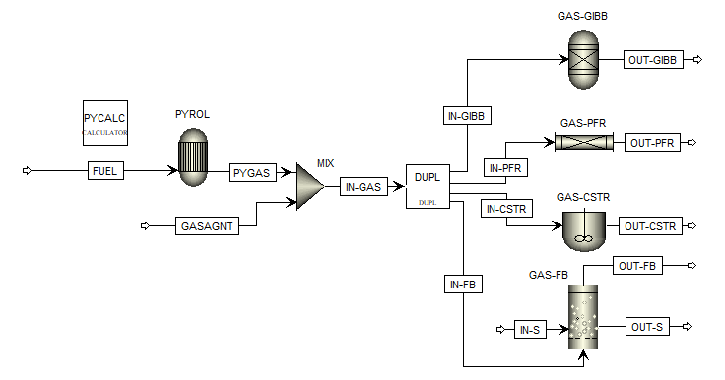
Figure C.1 - Aspen Plus setup to test different kinds of fluidized bed reactor models.

Results

Table A.2 shows the composition of the syngas exiting the gasifier in mole fraction for different model types in Aspen Plus. The built-in FB unit process most closely resembles the single PFR but is in between the CSTR and the PFR. This is because the FB unit process most likely contains a two or three phase model with many stages of parallel PFRs and CSTRs in series, but Aspen Plus does not disclose the details of the model. All of the reactors give similar results in this case. The CSTR is the most different because it does not allow the same amount of time for the reactions to progress. The Gibbs equilibrium model usually overestimates the reaction conversion. This is because it does not have a fixed reactor size and assumed that all reactions are taken to completion, with factors like hydraulic retention time, reaction rate, activation energy, or catalysts not being considered.

Table C.3 - Syngas Mole Fractions using different Aspen Plus Model types.
 | CSTR | PFR | FB | GIBBS
H2 | 11.73% | 10.22% | 10.22% | 10.16%
CO | 13.27% | 9.06% | 9.17% | 9.10%
H2O | 8.95% | 10.61% | 10.61% | 10.66%
CO2 | 9.86% | 12.67% | 12.59% | 12.62%
CH4 | 0.66% | 0.00% | 0.00% | 0.00%
C2H4 | 0.43% | 0.00% | 0.00% | 0.00%
C6H6 | 0.37% | 0.00% | 0.00% | 0.00%
N2 | 54.48% | 57.26% | 57.22% | 57.26%
O2 | 0.07% | 0.00% | 0.00% | 0.00%

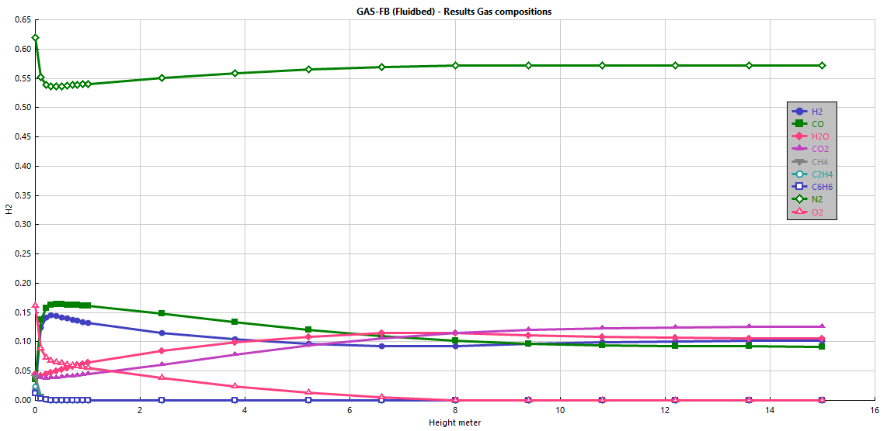
Figure C.2 - The gas composition inside of the FB reactor in mole fraction (vol%)

