Mussel-inspired Injectable Microbubbles Delivery System for Drug Ultrasound Contrast and Long-lasting Analgesic Effect in Peripheral Nerve Block
Hui-Jie Shang^{a1}, Hao-Tian Ye^{a1}, Cai-Bao Yue^{a,b}, Mu-Huo Ji^{c}, Han-Wen Guª, Wei-Tong Pan^{a,b}, Pan-Miao Liu^{a*}, Jian-Jun Yang^{a*}
ªDepartment of Anesthesiology, Pain and Perioperative Medicine, The First Affiliated Hospital of Zhengzhou University, Zhengzhou 450052, China
^{b}Neuroscience Research Institute, Zhengzhou University Academy of Medical Sciences, Zhengzhou 450052, China
^{c}Department of Anesthesiology, The Second Affiliated Hospital, Nanjing Medical University, Nanjing 210003, China
*Corresponding authors at: Department of Anesthesiology, Pain and Perioperative Medicine, The First Affiliated Hospital of Zhengzhou University, Zhengzhou 450052, China (J.J. Yang)
E-mail addresses: liupan3374@126.com (P.M. Liu), yjyangjj@126.com (J.J. Yang)
¹Authors contributed to the paper equally.

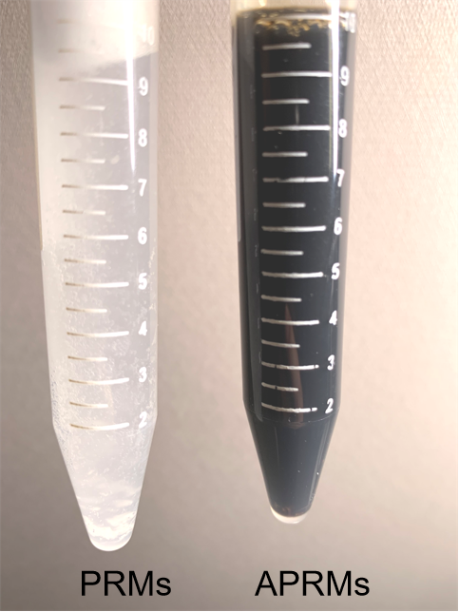
Fig. S1. Photograph of PRMs and APRMs in PBS solution.

Fig. S2. Relationship between ropivacaine concentration and UV-Vis absorption intensity at 263 nm (black line). Red line is the linear fitting line.

Fig. S3. SEM images of PRMs.

Fig. S4. Schematic diagram of rat plantar incision pain model (a) and rat spare nerve injury (SNI) (b).

Fig. S5. Mean plasma concentration of ropivacaine at different time points as indicated after perisciatic nerve injection of 0.25% free ropivacaine and 0.25% APRMs. **P<0.01 comparison between the APRMs group and the free ropivacaine group. n=3 rats/group.

Fig. S6. Photograph of the sciatic nerve after the perisciatic nerve injection of ropivacaine, Sudan blue Ⅱ labelled PRMs and APRMs. The yellow circle is the extent of the drug’s spread.

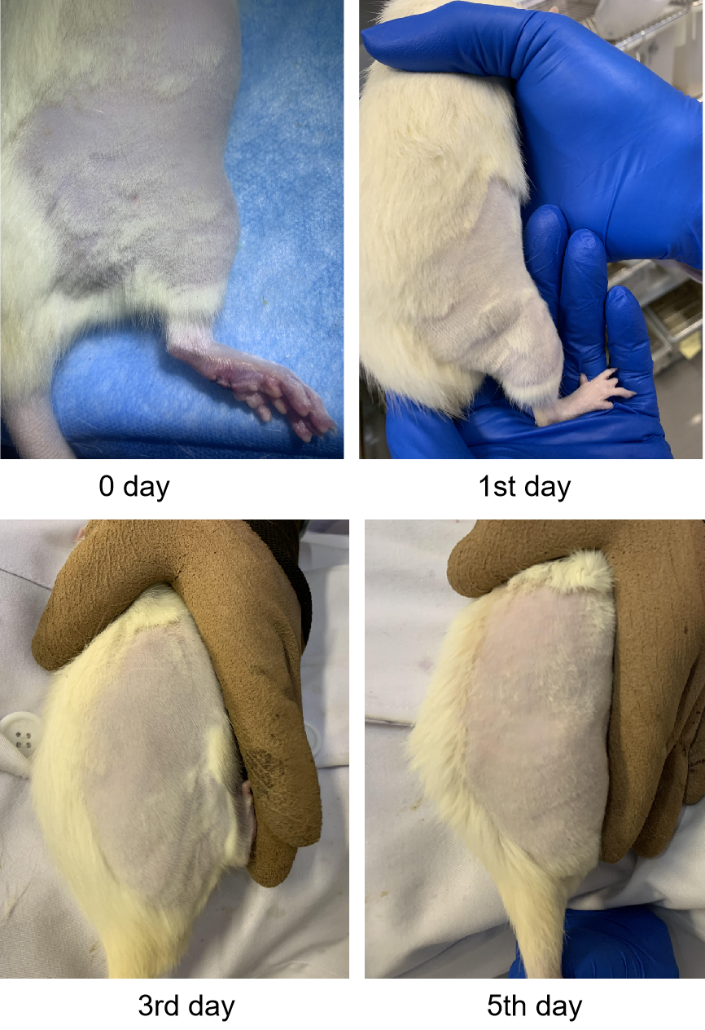
Fig. S7. Photograph of the injected site after the perisciatic nerve injection of APRMs.

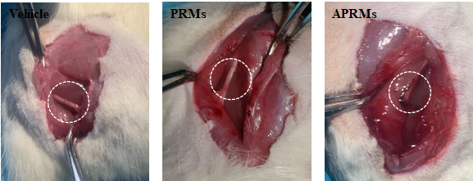
Fig. S8. Photograph of the sciatic nerve after the perisciatic nerve injection of vehicle, PRMs, and APRMs.

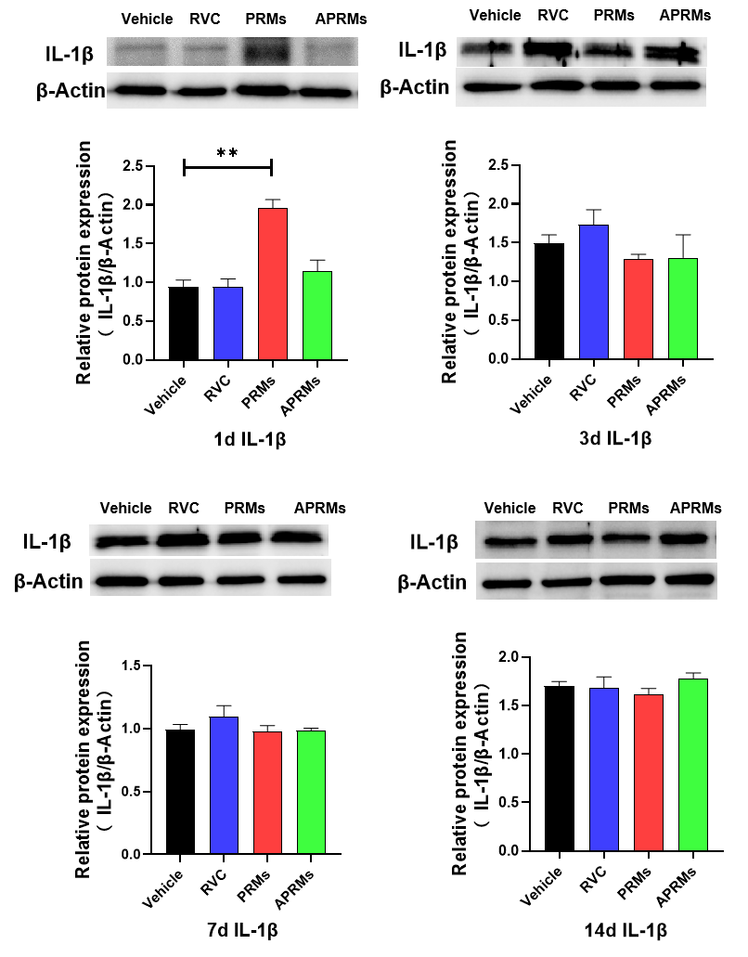
Fig. S9. Western blots and a summary of densitometric analysis of IL-1β on day 1, 3, 7, and 14 after the perisciatic nerve injection of vehicle, RVC, PRMs, and APRMs. n=4 rats/group.

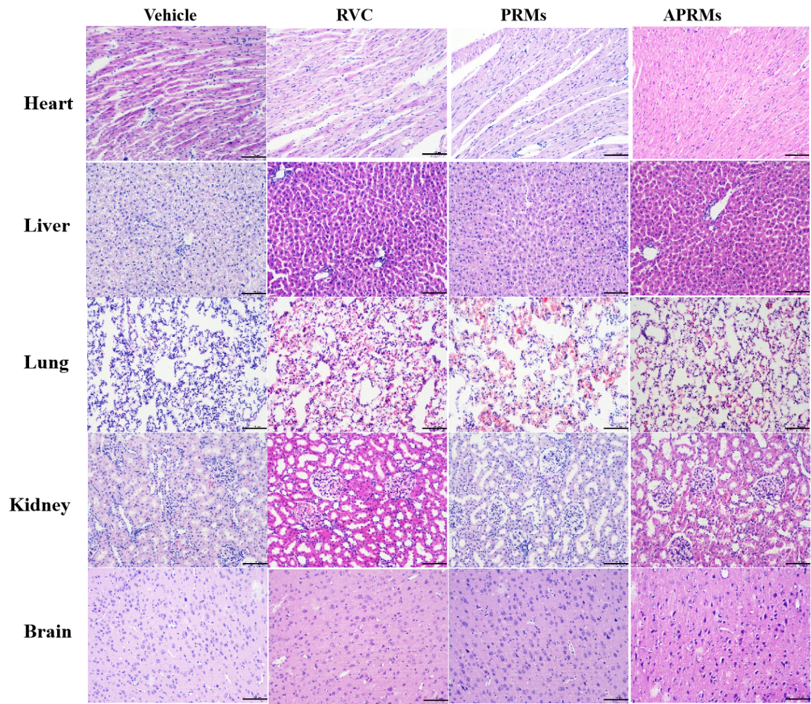
Fig. S10. Representational HE stained images of heart, brain, liver, kidney and lung on day 11 after the perisciatic nerve injection of vehicle, ropivacaine, PRMs, and APRMs. n = 3 rats/group. RVC: ropivacaine. Scale bar: 100 μm.

