Supplementary Material
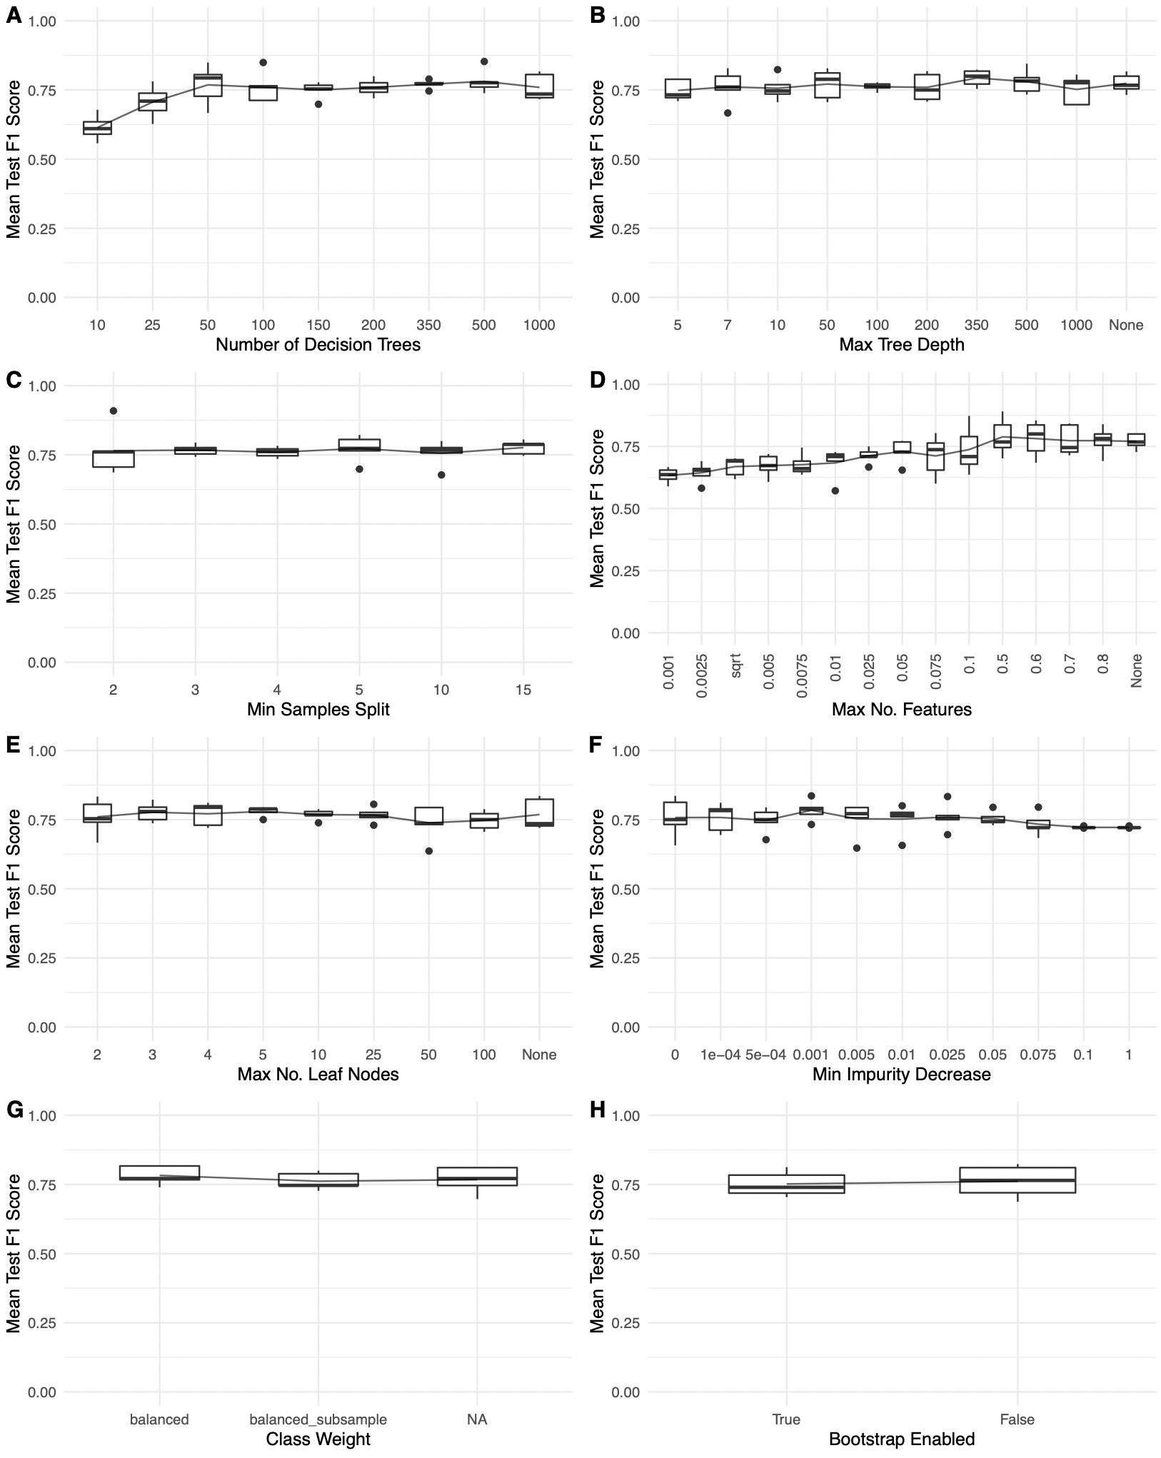
Supplementary Fig. 1 Mean test F1 scores over 8 hyperparameters set to a varying range of intervals, used in building the RF genes-only model for purposes of narrowing down the hyperparameters searched during GridSearchCV to speed up computing time.
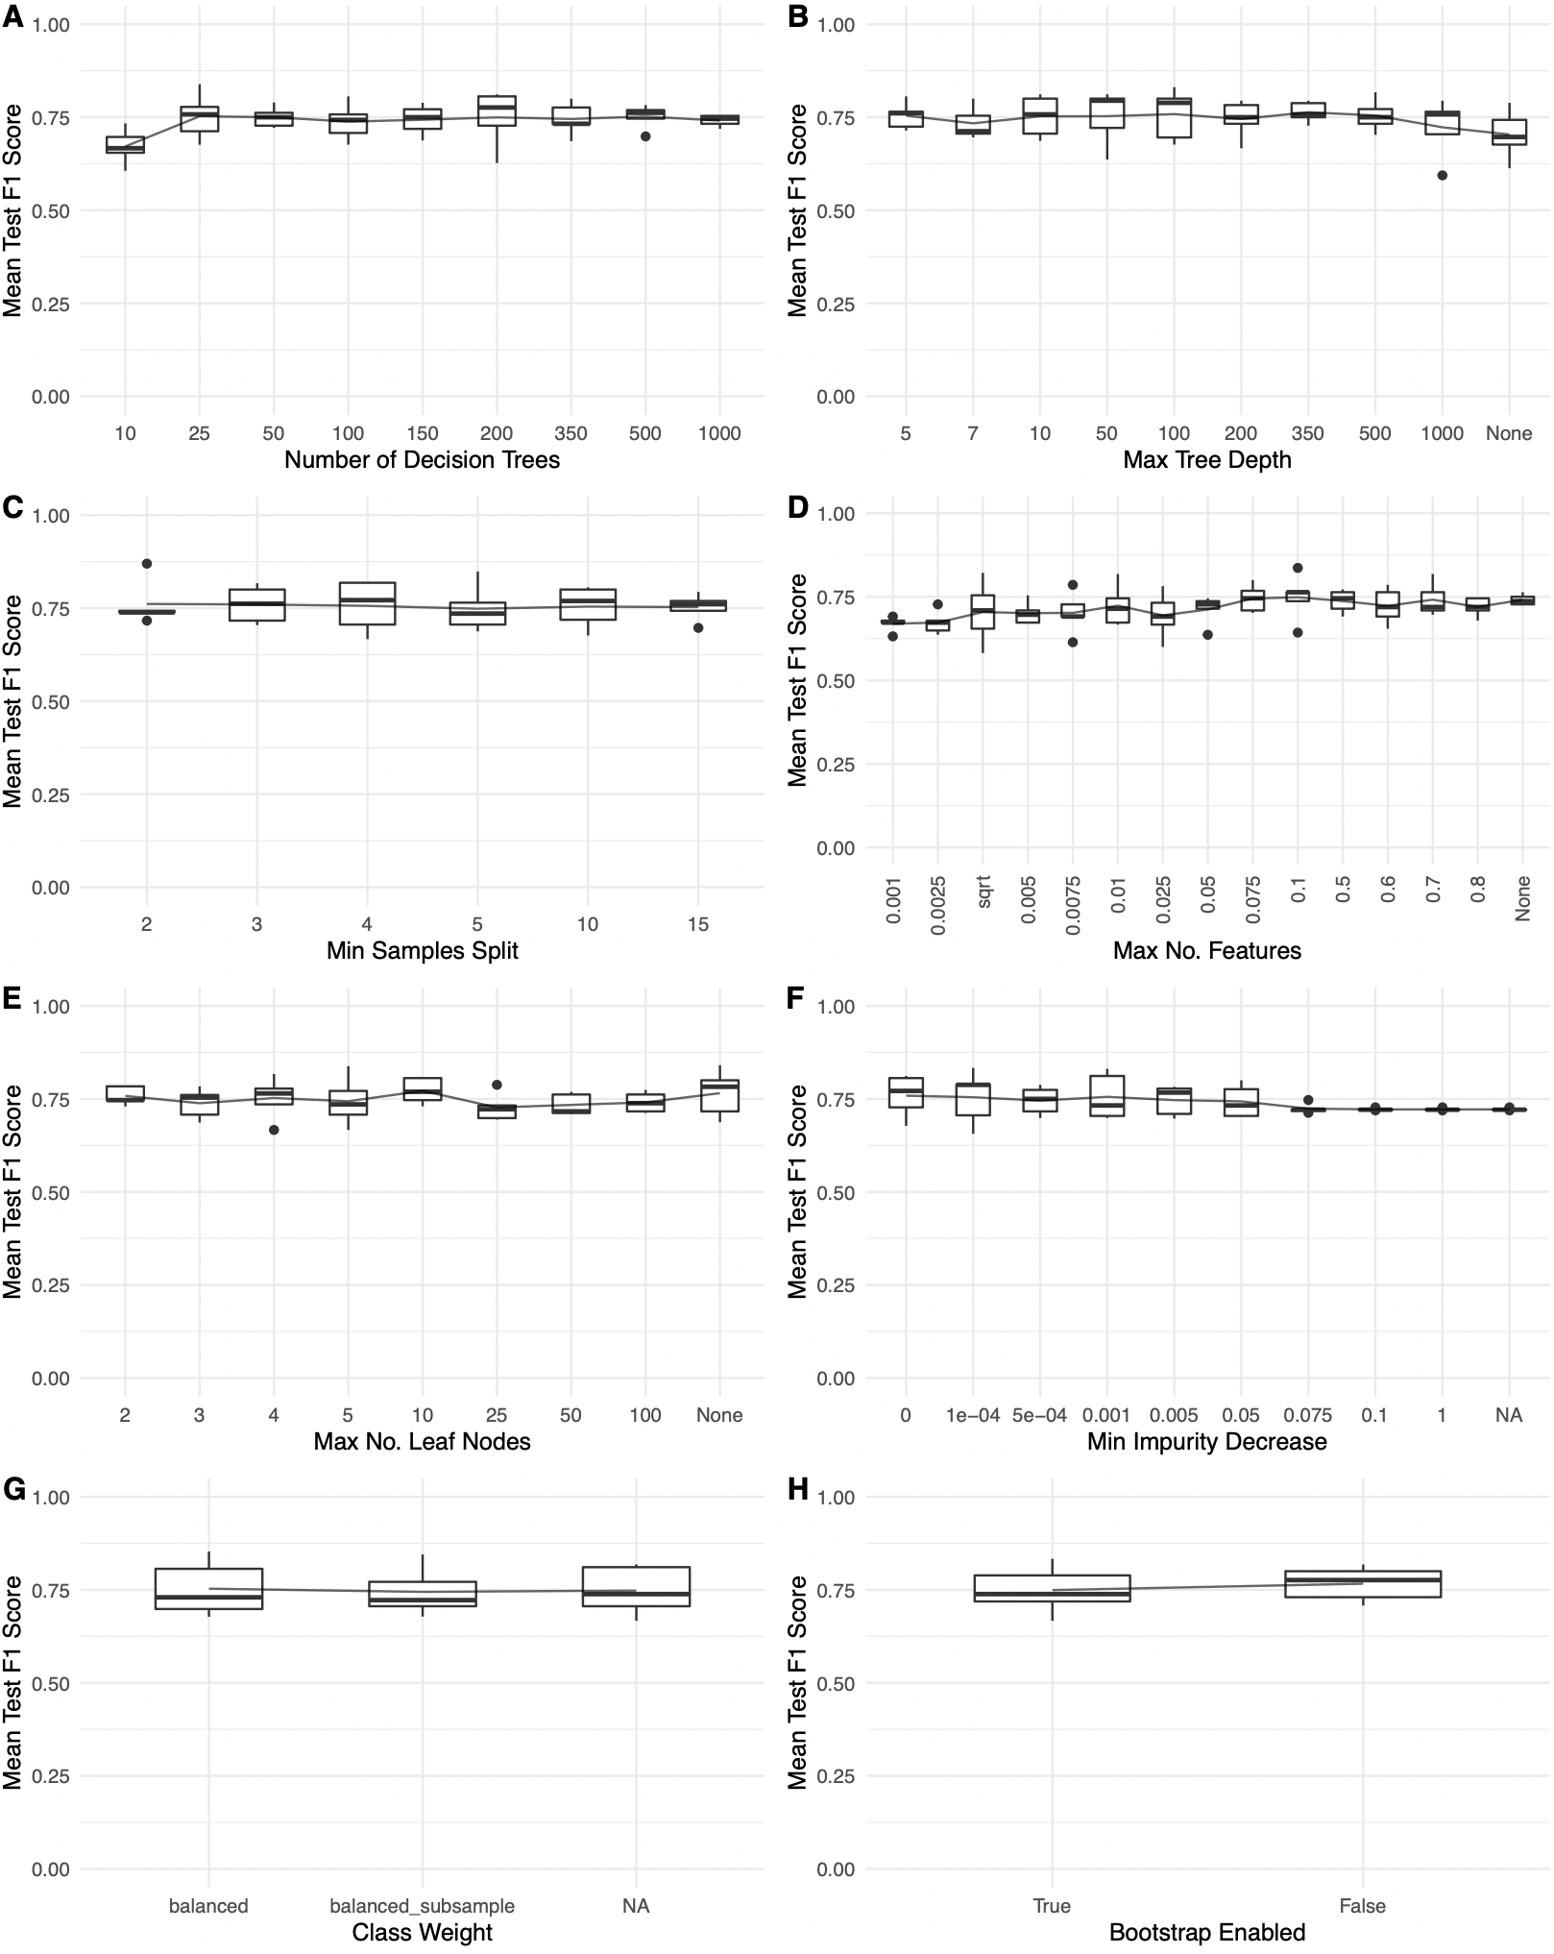
Supplementary Fig. 2 Mean test F1 scores over 8 hyperparameters set to a varying range of intervals, used in building the RF microbial-only model for purposes of narrowing down the hyperparameters searched during GridSearchCV to speed up computing time.
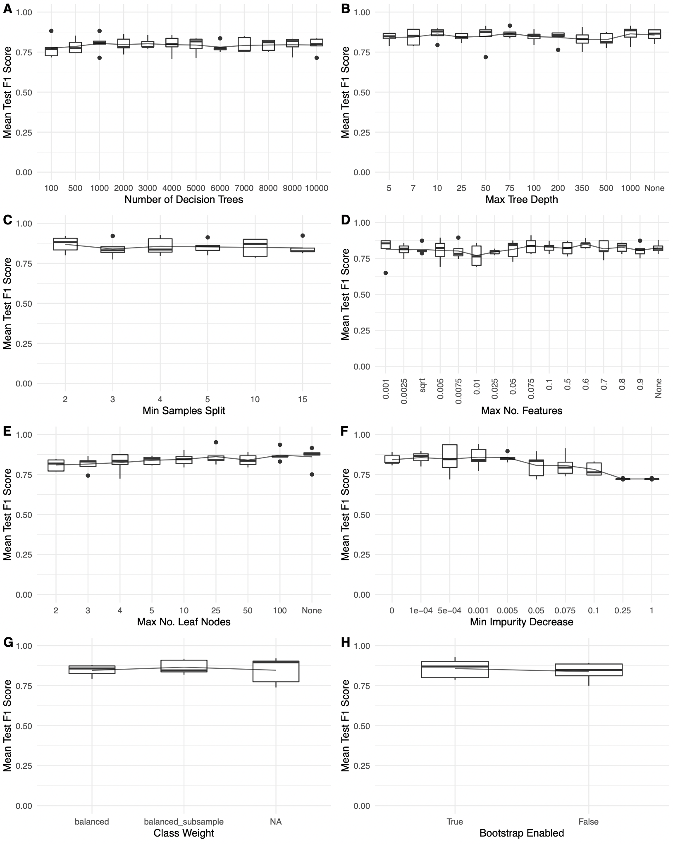
Supplementary Fig. 3 Mean test F1 scores over eight hyperparameters set to a varying range of intervals, used in building the RF genes-and-microbes model for purposes of narrowing down the hyperparameters searched during GridSearchCV to speed up computing time.

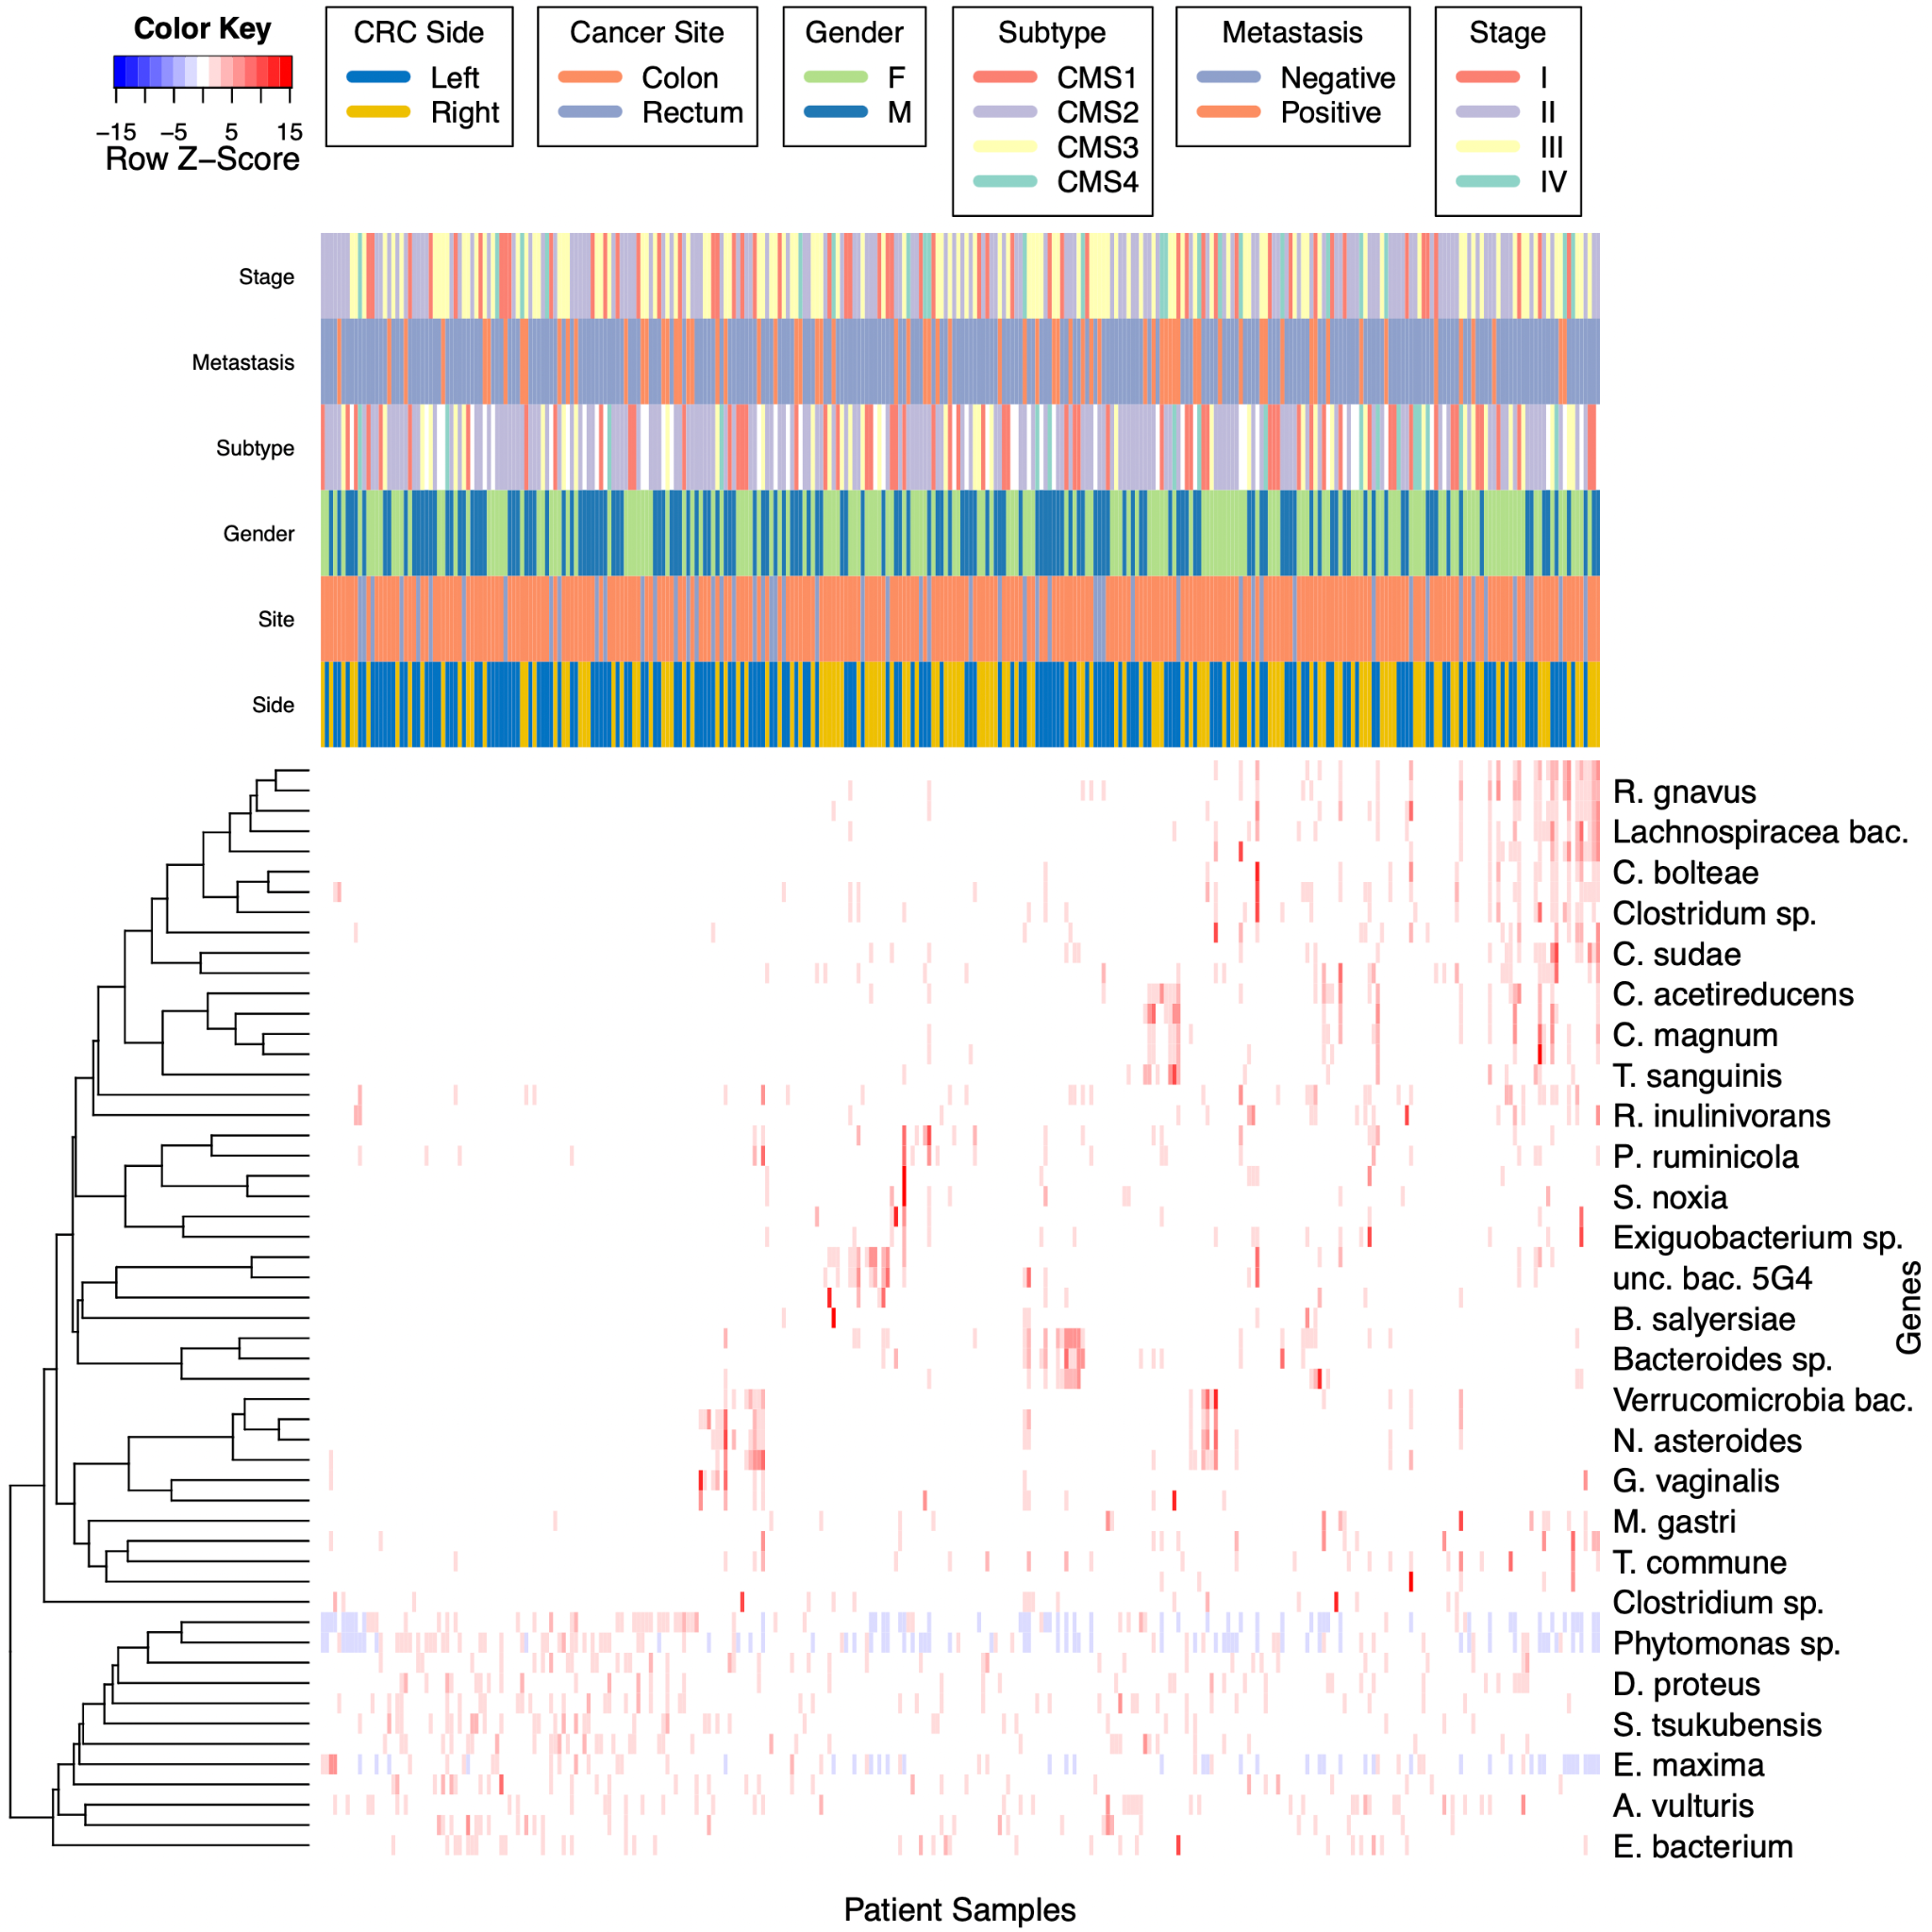

Supplementary Fig. 4 A heatmap of scaled gene expression values of the top-scoring microbial features discovered by the microbes-only RF model and clinical characteristics. Hierarchical clustering of both genes and patients is via Pearson correlation, based on average linkage distance. The colors indicate row-scaled z-scores of TPM RNA-seq gene expression ratios.

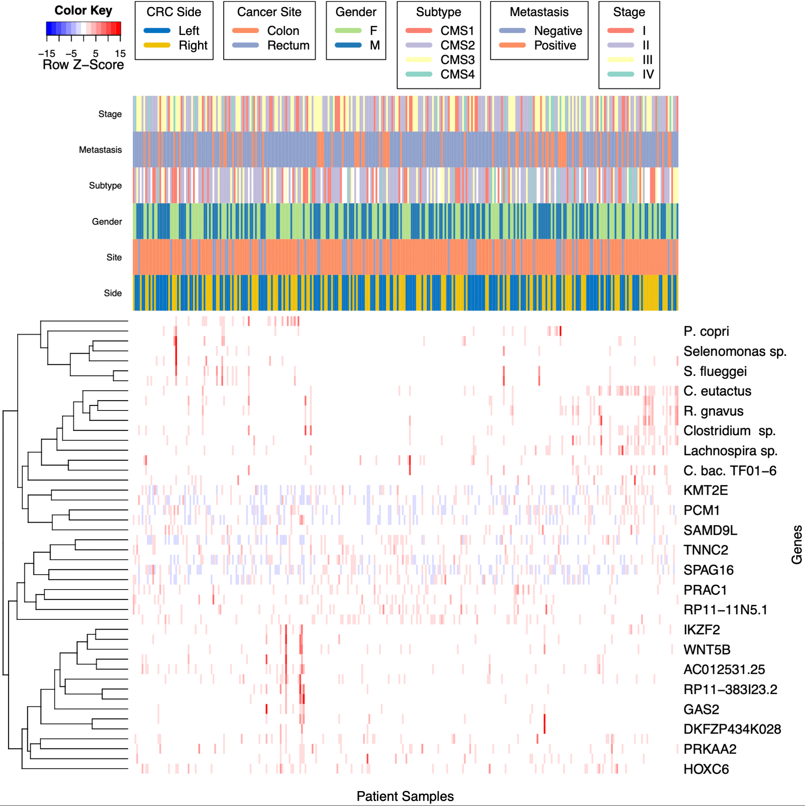Supplementary Fig. 5 A heatmap of scaled genomic and microbial expression values of the top-scoring features discovered by the genes-and-microbes RF model and clinical characteristics. Hierarchical clustering of both genes and patients is via Pearson correlation, based on average linkage distance. The colors indicate row-scaled z-scores of TPM RNA-seq gene expression ratios, as well as CPM normalized RNA-seq human unmapped microbial reads.

Supplementary Table 1. Full version of table 4. Top ranking features with p-values less than 0.05 and their importance scores discovered by our microbes-only model (Left). Side-paired differential expression (fold change) analysis results of CPM values for the same features (Right) Wilcoxon-rank sum test was used to calculate p-values and FDR (Benjamini & Hochberg).

Model Feature Importance Metrics |  |  |  |  | Differential Expression
Rank | Tax ID_Name | Importance Score | Log Importance Score | p-value | Log2 FC | p-value | FDR | Greater Expr. Side
1 | 33038_[Ruminococcus] gnavus | 0.025 | -3.69 | 0 | 2.07E+00 | 1.31E-15 | 3.54E-14 | Right
2 | 76489_Clostridium acetireducens | 0.020 | -3.91 | 0 | 1.88E+00 | 1.69E-13 | 1.52E-12 | Right
3 | 1701326_uncultured bacterium 5G4 | 0.018 | -4.04 | 0 | 1.73E+00 | 6.55E-11 | 2.52E-10 | Right
4 | 397291_Lachnospiraceae bacterium A4 | 0.014 | -4.27 | 0 | 2.30E+00 | 5.29E-16 | 2.85E-14 | Right
5 | 2293240_Ruminococcus sp. TF10-6 | 0.013 | -4.34 | 0 | 2.41E+00 | 2.86E-15 | 5.14E-14 | Right
6 | 239935_Akkermansia muciniphila | 0.011 | -4.51 | 0 | -5.30E-01 | 2.27E-05 | 3.96E-05 | Left
7 | 1531_[Clostridium] clostridioforme | 0.011 | -4.55 | 0 | 1.47E+00 | 1.73E-12 | 1.03E-11 | Right
8 | 936381_Selenomonas sp. CM52 | 0.010 | -4.61 | 0 | 4.03E+00 | 8.68E-11 | 3.13E-10 | Right
9 | 46228_Ruminococcus lactaris | 0.009 | -4.76 | 0 | 1.86E+00 | 2.96E-12 | 1.45E-11 | Right
10 | 43064_Trichococcus pasteurii | 0.007 | -4.97 | 0 | 2.18E+00 | 1.67E-08 | 4.10E-08 | Right
11 | 1262831_Clostridium sp. CAG:678 | 0.007 | -5.01 | 0 | 1.3 | 0.0322 | 0.0464 | Right
12 | 1824_Nocardia asteroides | 0.007 | -5.02 | 0 | -0.19 | 0.00112 | 0.00172 | Left
13 | 208479_[Clostridium] bolteae | 0.007 | -5.03 | 0 | 1.76E+00 | 2.18E-13 | 1.68E-12 | Right
14 | 2026799_Verrucomicrobia bacterium | 0.006 | -5.14 | 0.01 | -0.17 | 2.02E-06 | 3.76E-06 | Left
15 | 1262706_Azospirillum sp. CAG:260 | 0.006 | -5.14 | 0 | 1.15 | 1.86E-09 | 5.57E-09 | Right
16 | 360807_Roseburia inulinivorans | 0.006 | -5.15 | 0 | 1.9 | 1.49E-12 | 1.01E-11 | Right
17 | 83915_Distigma proteus | 0.006 | -5.17 | 0 | 0.29 | 0.109 | 0.137 | Right
18 | 1328_Streptococcus anginosus | 0.006 | -5.19 | 0 | -0.36 | 0.106 | 0.136 | Left
19 | 747377_Clostridium sp. DMHC 10 | 0.006 | -5.20 | 0 | 1.99 | 2.12E-09 | 6.04E-09 | Right
20 | 91626_Mucor ambiguus | 0.006 | -5.20 | 0 | 0.83 | 1.19E-09 | 3.78E-09 | Right
21 | 1741_Thermodesulfobacterium commune | 0.005 | -5.21 | 0 | -0.73 | 0.54 | 0.583 | Left
22 | 88431_Dorea longicatena | 0.005 | -5.23 | 0 | 2.01 | 2.12E-14 | 2.86E-13 | Right
23 | 2702_Gardnerella vaginalis | 0.005 | -5.25 | 0 | -0.49 | 0.624 | 0.661 | Left
24 | 33954_Clostridium magnum | 0.005 | -5.26 | 0 | 2.33 | 2.69E-08 | 6.32E-08 | Right
25 | 291644_Bacteroides salyersiae | 0.005 | -5.27 | 0 | 2.17 | 0.00102 | 0.00161 | Right
26 | 105841_Anaerostipes caccae | 0.005 | -5.27 | 0 | 1.67 | 1.90E-12 | 1.03E-11 | Right
27 | 839_Prevotella ruminicola | 0.005 | -5.27 | 0 | 0.95 | 0.172 | 0.197 | Right
28 | 134013_Phytomonas sp. isolate Hart1 | 0.005 | -5.28 | 0 | -0.29 | 0.0379 | 0.0525 | Left
29 | 1262910_Oscillibacter sp. CAG:155 | 0.005 | -5.29 | 0 | -0.26 | 0.833 | 0.849 | Left
30 | 83656_Streptomyces tsukubensis | 0.005 | -5.31 | 0 | -0.68 | 0.000729 | 0.00119 | Left
31 | 135083_Selenomonas noxia | 0.005 | -5.35 | 0 | 3.44 | 8.73E-06 | 1.57E-05 | Right
32 | 162156_uncultured Bacteroides sp. | 0.005 | -5.35 | 0 | 0.39 | 1.87E-07 | 3.60E-07 | Right
33 | 39486_Dorea formicigenerans | 0.005 | -5.35 | 0 | 1.23 | 4.61E-08 | 9.96E-08 | Right
34 | 872327_Lactobacillus pasteurii | 0.005 | -5.35 | 0 | 1.21 | 1.31E-08 | 3.54E-08 | Right
35 | 1736298_Exiguobacterium sp. Leaf196 | 0.005 | -5.38 | 0 | 2.89 | 3.47E-12 | 1.56E-11 | Right
36 | 310300_Bacteroides pyogenes | 0.004 | -5.41 | 0 | 1.76 | 3.29E-08 | 7.41E-08 | Right
37 | 260710_Olavius algarvensis spirochete endosymbiont | 0.004 | -5.42 | 0 | 1.8 | 1.66E-08 | 4.10E-08 | Right
38 | 1522369_Cyanophora sudae | 0.004 | -5.46 | 0 | 1.61 | 1.19E-13 | 1.28E-12 | Right
39 | 857335_Candidatus Dactylopiibacterium carminicum | 0.004 | -5.46 | 0 | 0.15 | 0.14 | 0.168 | Right
40 | 261299_Intestinibacter bartlettii | 0.004 | -5.48 | 0 | 2 | 2.23E-11 | 9.24E-11 | Right
41 | 564198_Mycolicibacterium bacteremicum | 0.004 | -5.50 | 0 | -0.82 | 0.0132 | 0.0198 | Left
42 | 411484_Clostridium sp. SS2/1 | 0.004 | -5.51 | 0 | 1.99 | 1.44E-10 | 4.87E-10 | Right
43 | 1777_Mycobacterium gastri | 0.004 | -5.57 | 0.01 | 0.17 | 0.418 | 0.471 | Right
44 | 1857645_Actinomyces vulturis | 0.004 | -5.58 | 0.01 | 0.47 | 0.161 | 0.189 | Right
45 | 11768_Feline leukemia virus | 0.004 | -5.58 | 0.01 | -0.49 | 6.37E-05 | 0.000107 | Left
46 | 1736483_Microbacterium sp. Root180 | 0.004 | -5.58 | 0.01 | -0.7 | 0.129 | 0.159 | Left
47 | 1768115_bacterium F082 | 0.004 | -5.58 | 0.01 | 1.44 | 9.65E-08 | 1.93E-07 | Right
48 | 877415_Erysipelotrichaceae bacterium NK3D112 | 0.004 | -5.60 | 0.01 | 0.64 | 0.0327 | 0.0464 | Right
49 | 1632858_Massilibacterium senegalense | 0.004 | -5.61 | 0.01 | -0.09 | 0.444 | 0.489 | Left
50 | 5804_Eimeria maxima | 0.004 | -5.61 | 0.01 | -0.19 | 0.0681 | 0.0919 | Left
51 | 154288_Turicibacter sanguinis | 0.004 | -5.62 | 0.01 | 1.9 | 5.00E-08 | 1.04E-07 | Right
52 | 490622_Trichoderma arundinaceum | 0.004 | -5.63 | 0.01 | -0.04 | 0.791 | 0.821 | Left
53 | 653385_Actinomyces sp. oral taxon 849 | 0.004 | -5.63 | 0.01 | -0.05 | 0.938 | 0.938 | Left
54 | 467085_Candidatus Symbiothrix dinenymphae | 0.004 | -5.65 | 0.01 | -1.95 | 0.0923 | 0.122 | Left

Supplementary Table 2. Full version of table 5. Top ranking features with p-values less than 0.05 and their importance scores discovered by our genes-and-microbes model (Left). Side-paired differential expression (fold change) analysis results of TPM and CPM values for the same features (Right) Wilcoxon-rank sum test was used to calculate p-values and FDR (Benjamini & Hochberg).

Model Feature Importance Metrics |  |  |  |  | Differential Expression
Rank | ENSG ID_Gene/Tax ID_Name | Importance Score | Log Importance Score | p-value | Log2 FC | p-value | FDR | Associated Side
1 | ENSG00000142661_MYOM3 | 0.037 | -3.29 | 0 | -0.62 | 1.36E-08 | 2.71E-08 | Left
2 | ENSG00000198353_HOXC4 | 0.033 | -3.40 | 0 | 1.88 | 2.11E-15 | 3.23E-14 | Right
3 | 33043_Coprococcus eutactus | 0.027 | -3.62 | 0 | 2.08 | 2.00E-14 | 1.54E-13 | Right
4 | ENSG00000159182_PRAC1 | 0.024 | -3.72 | 0 | -2.86 | 5.08E-21 | 2.34E-19 | Left
5 | ENSG00000260597_AC012531.25 | 0.020 | -3.90 | 0 | 1.19 | 4.26E-12 | 2.17E-11 | Right
6 | 33038_[Ruminococcus] gnavus | 0.016 | -4.13 | 0 | 2.07 | 1.31E-15 | 3.02E-14 | Right
7 | ENSG00000184719_RNLS | 0.011 | -4.50 | 0.01 | -0.89 | 2.85E-10 | 9.37E-10 | Left
8 | ENSG00000197757_HOXC6 | 0.011 | -4.54 | 0 | 1.28 | 5.02E-12 | 2.31E-11 | Right
9 | ENSG00000144451_SPAG16 | 0.010 | -4.61 | 0 | -0.64 | 9.00E-09 | 1.97E-08 | Left
10 | 851_Fusobacterium nucleatum | 0.010 | -4.62 | 0 | 1.67 | 2.73E-06 | 3.49E-06 | Right
11 | ENSG00000273374_RP11-383I23.2 | 0.010 | -4.62 | 0 | -1.02 | 2.86E-08 | 5.47E-08 | Left
12 | 446043_uncultured Lachnospira sp. | 0.010 | -4.63 | 0 | 1.46 | 5.97E-09 | 1.37E-08 | Right
13 | 165179_Prevotella copri | 0.009 | -4.66 | 0 | 1.6 | 1.50E-09 | 3.85E-09 | Right
14 | 154288_Turicibacter sanguinis | 0.009 | -4.67 | 0 | 1.9 | 5.00E-08 | 8.51E-08 | Right
15 | 59620_uncultured Clostridium sp. | 0.009 | -4.67 | 0 | 1.09 | 6.86E-12 | 2.87E-11 | Right
16 | ENSG00000101470_TNNC2 | 0.009 | -4.69 | 0 | -1.29 | 3.34E-10 | 1.02E-09 | Left
17 | 936381_Selenomonas sp. CM52 | 0.009 | -4.69 | 0 | 4.03 | 8.68E-11 | 3.07E-10 | Right
18 | ENSG00000162409_PRKAA2 | 0.009 | -4.69 | 0 | -1.2 | 3.90E-10 | 1.12E-09 | Left
19 | ENSG00000124915_DKFZP434K028 | 0.009 | -4.70 | 0 | 0.91 | 1.67E-05 | 1.97E-05 | Right
20 | 712991_Lachnospiraceae bacterium oral taxon 500 | 0.009 | -4.71 | 0 | 2.33 | 9.20E-07 | 1.28E-06 | Right
21 | ENSG00000101076_HNF4A | 0.009 | -4.72 | 0 | -0.48 | 4.73E-08 | 8.37E-08 | Left
22 | ENSG00000177409_SAMD9L | 0.009 | -4.72 | 0 | 1.01 | 7.55E-08 | 1.20E-07 | Right
23 | 2293240_Ruminococcus sp. TF10-6 | 0.009 | -4.72 | 0 | 2.41 | 2.86E-15 | 3.28E-14 | Right
24 | ENSG00000146386_ABRACL | 0.009 | -4.72 | 0 | -0.29 | 1.71E-04 | 0.000192 | Left
25 | 2305245_Clostridiaceae bacterium TF01-6 | 0.009 | -4.74 | 0 | 1.79 | 1.96E-14 | 1.54E-13 | Right
26 | ENSG00000111186_WNT5B | 0.009 | -4.75 | 0 | -0.53 | 2.65E-04 | 0.00029 | Left
27 | ENSG00000188610_FAM72B | 0.009 | -4.75 | 0 | 0.67 | 2.58E-06 | 3.39E-06 | Right
28 | ENSG00000250829_RP11-11N5.1 | 0.009 | -4.75 | 0 | -3.79 | 1.14E-08 | 2.39E-08 | Left
29 | ENSG00000126218_F10 | 0.009 | -4.75 | 0 | -0.55 | 4.46E-10 | 1.21E-09 | Left
30 | 28133_Prevotella nigrescens | 0.009 | -4.75 | 0 | 1.27 | 5.70E-08 | 9.37E-08 | Right
31 | ENSG00000103534_TMC5 | 0.009 | -4.76 | 0 | 0.29 | 7.29E-03 | 0.0078 | Right
32 | 113574_Hyphomicrobium sp. GJ21 | 0.009 | -4.77 | 0 | 2.24 | 2.10E-09 | 5.09E-09 | Right
33 | ENSG00000078674_PCM1 | 0.008 | -4.78 | 0 | 0.39 | 3.38E-08 | 6.22E-08 | Right
34 | 2026799_Verrucomicrobia bacterium | 0.008 | -4.79 | 0 | -0.17 | 2.02E-06 | 2.73E-06 | Left
35 | 105841_Anaerostipes caccae | 0.008 | -4.80 | 0 | 1.67 | 1.90E-12 | 1.09E-11 | Right
36 | 2320113_bacterium 1xD42-87 | 0.008 | -4.80 | 0 | 1.4 | 2.73E-07 | 4.05E-07 | Right
37 | ENSG00000005483_KMT2E | 0.008 | -4.81 | 0 | 0.15 | 2.08E-02 | 0.0213 | Right
38 | ENSG00000197217_ENTPD4 | 0.008 | -4.81 | 0 | 0.3 | 9.00E-07 | 1.28E-06 | Right
39 | ENSG00000030419_IKZF2 | 0.008 | -4.81 | 0 | 0.48 | 1.36E-05 | 1.64E-05 | Right
40 | 135080_Selenomonas flueggei | 0.008 | -4.81 | 0 | 3.21 | 9.96E-13 | 6.54E-12 | Right
41 | ENSG00000166173_LARP6 | 0.008 | -4.84 | 0 | -0.8 | 1.21E-05 | 1.51E-05 | Left
42 | ENSG00000267506_RP11-13K12.1 | 0.008 | -4.85 | 0 | -1.79 | 1.16E-11 | 4.43E-11 | Left
43 | ENSG00000148935_GAS2 | 0.008 | -4.87 | 0 | 0.05 | 2.34E-07 | 3.59E-07 | Right
44 | ENSG00000026559_KCNG1 | 0.008 | -4.87 | 0 | -0.22 | 5.56E-02 | 0.0556 | Left
45 | 1908690_Fimbriiglobus ruber | 0.007 | -4.90 | 0.04 | -0.46 | 2.04E-02 | 0.0213 | Left
46 | ENSG00000144891_AGTR1 | 0.007 | -4.91 | 0.03 | -1.83 | 4.72E-05 | 5.42E-05 | Left

