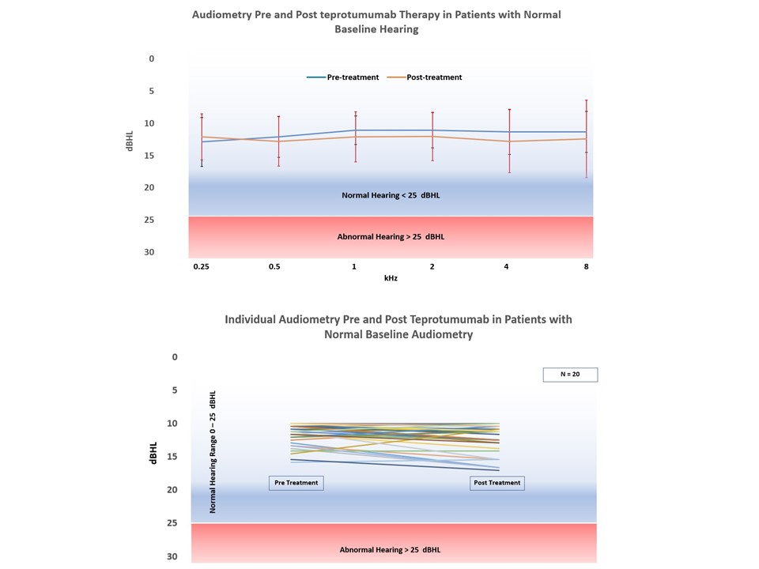

Supplemental File 1: Audiometry pre and post teprotumumab therapy in patients with normal baseline audiometry.

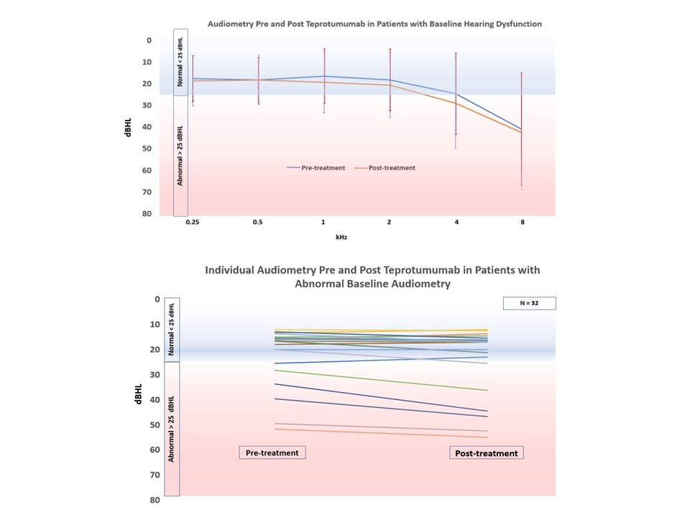
Supplemental File 2: Audiometry in patients pre and post teprotumumab therapy with abnormal baseline audiometry.

