Supplemental information
Table S1: Parameters of April food-access models for red and Arctic foxes between 2011 and 2021.
 |  | model | variable | coeff | SE | odds ratio | CI 2.5-97.5 | z value | p value
Arctic | Tundra | count | (Intercept) | 0.61 | 0.06 | 1.83 | 1.64-2.05 | 10.70 | <0.001
fox | food | count | perimeter of ponds | 0.33 | 0.06 | 1.39 | 1.24-1.57 | 5.45 | <0.001
food |  | count | Length stream | 0.50 | 0.06 | 1.65 | 1.47-1.87 | 8.16 | <0.001
models |  | count | Shrubland,Lichen,Moss | 0.20 | 0.05 | 1.23 | 1.11-1.35 | 4.14 | <0.001
 |  | zero | (Intercept) | 0.85 | 0.12 | 2.35 | 1.85-2.98 | 7.04 | <0.001
 |  | zero | Length stream | 0.52 | 0.16 | 1.69 | 1.23-2.31 | 3.23 | <0.001
 |  | zero | Shrubland,Lichen,Moss | 0.43 | 0.14 | 1.54 | 1.18-2.01 | 3.14 | <0.001
 |  | zero | Grassland,Lichen,Moss | -0.77 | 0.20 | 0.46 | 0.31-0.68 | -3.87 | <0.001
 |  | zero | Wetland | 0.29 | 0.14 | 1.34 | 1.01-1.78 | 2.03 | 0.04
 | Forest | count | (Intercept) | 0.45 | 0.09 | 1.57 | 1.31-1.88 | 4.94 | <0.001
 | food | count | Distance treeline | -0.15 | 0.05 | 0.86 | 0.78-0.96 | -2.77 | 0.01
 |  | count | Needleleaf forest | -1.12 | 0.23 | 0.33 | 0.21-0.51 | -4.96 | <0.001
 |  | zero | (Intercept) | 0.78 | 0.11 | 2.18 | 1.75-2.71 | 6.98 | <0.001
 | Coastal | count | (Intercept) | 0.67 | 0.06 | 1.96 | 1.75-2.19 | 11.98 | <0.001
 | food | count | Distance coast line | -0.21 | 0.06 | 0.81 | 0.72-0.91 | -3.53 | <0.001
 |  | count | Intertidal flats | -0.46 | 0.11 | 0.63 | 0.51-0.79 | -4.13 | <0.001
 |  | zero | (Intercept) | 0.88 | 0.12 | 2.40 | 1.89-3.04 | 7.23 | <0.001
 |  | zero | Distance coast line | 0.66 | 0.13 | 1.93 | 1.49-2.50 | 4.93 | <0.001
Red | Tundra | count | (Intercept) | -20.99 | 2.88 | 0.00 | 0.00-0.00 | -7.30 | <0.001
fox | food | count | Length stream | -37.01 | 4.90 | 0.00 | 0.00-0.00 | -7.56 | <0.001
food |  | count | perimeter of ponds | -1.03 | 0.14 | 0.36 | 0.27-0.47 | -7.32 | <0.001
models |  | count | Shrubland,Lichen,Moss | -2.04 | 0.26 | 0.13 | 0.08-0.21 | -7.98 | <0.001
 |  | count | Grassland,Lichen,Moss | 2.09 | 0.27 | 8.10 | 4.75-13.82 | 7.68 | <0.001
 |  | count | Wetland | 0.27 | 0.11 | 1.32 | 1.05-1.64 | 2.43 | 0.01
 |  | zero | (Intercept) | -1.98 | 0.49 | 0.14 | 0.05-0.36 | -4.04 | <0.001
 |  | zero | Length stream | -5.51 | 0.95 | 0.00 | 0.00-0.03 | -5.81 | <0.001
 |  | zero | Perimeter of ponds | -1.74 | 0.27 | 0.18 | 0.10-0.30 | -6.54 | <0.001
 |  | zero | Shrubland,Lichen,Moss | -1.93 | 0.26 | 0.15 | 0.09-0.24 | -7.39 | <0.001
 |  | zero | Grassland,Lichen,Moss | 1.26 | 0.37 | 3.51 | 1.70-7.24 | 3.40 | <0.001
 |  | zero | Wetland | -1.24 | 0.24 | 0.29 | 0.18-0.47 | -5.07 | <0.001
 | Coastal | count | (Intercept) | -0.04 | 0.15 | 0.96 | 0.72-1.27 | -0.30 | 0.77
 | food | count | Distance coast line | -1.11 | 0.12 | 0.33 | 0.26-0.42 | -9.03 | <0.001
 |  | zero | (Intercept) | -0.49 | 0.12 | 0.62 | 0.49-0.77 | -4.21 | <0,001
 |  | zero | Intertidal flats | 0.87 | 0.16 | 2.39 | 1.75-3.25 | 5.53 | <0.001
 | Forest | count | (Intercept) | 0.73 | 0.07 | 2.07 | 1.81-2.37 | 10.67 | <0.001
 | food | count | Distance treeline | 0.28 | 0.07 | 1.32 | 1.15-1.52 | 3.92 | <0.001
 |  | count | Needleleaf forest | 0.42 | 0.07 | 1.53 | 1.33-1.75 | 6.08 | <0.001
 |  | zero | (Intercept) | -0.49 | 0.11 | 0.61 | 0.50-0.75 | -4.62 | <0.001

Table S2: Parameters of August food-access models for red and Arctic foxes between 2011 and 2021.
 |  | model | variable | coeff | SE | odds ratio | CI 2.5-97.5 | Z value | p value
Arctic | Tundra | count | (Intercept) | 0.59 | 0.06 | 1.80 | 1.59-2.05 | 9.07 | <0.001
fox | food | count | Length stream | -0.29 | 0.10 | 0.75 | 0.62-0.91 | -2.99 | 0.00
food |  | count | Grassland, Lichen, Moss | -0.35 | 0.09 | 0.71 | 0.59-0.84 | -3.87 | <0.001
models |  | zero | (Intercept) | 1.14 | 0.24 | 3.12 | 1.96-4.96 | 4.82 | <0.001
 |  | zero | Perimeter of ponds | 1.44 | 0.24 | 4.21 | 2.63-6.76 | 5.96 | <0.001
 |  | zero | Length stream | -0.78 | 0.23 | 0.46 | 0.29-0.72 | -3.41 | <0.001
 |  | zero | Shrubland, Lichen, Moss | 3.88 | 0.40 | 48.27 | 21.86-106.58 | 9.59 | <0.001
 | Forest | count | (Intercept) | 0.40 | 0.09 | 1.49 | 1.26-1.76 | 4.69 | <0.001
 | food | count | Distance treeline | 0.44 | 0.08 | 1.56 | 1.33-1.83 | 5.41 | <0.001
 |  | zero | (Intercept) | 0.37 | 0.13 | 1.45 | 1.13-1.86 | 2.91 | 0.00
 |  | zero | Distance treeline | 1.61 | 0.15 | 4.98 | 3.74-6.64 | 10.95 | <0.001
 | Coastal | count | (Intercept) | 0.71 | 0.05 | 2.03 | 1.83-2.24 | 13.63 | <0.001
 | food | zero | (Intercept) | 0.17 | 0.11 | 1.18 | 0.96-1.46 | 1.57 | 0.11
 |  | zero | Distance coast line | -0.33 | 0.12 | 0.72 | 0.56-0.91 | -2.68 | 0.01
 |  | zero | Intertidal flats | -0.99 | 0.18 | 0.37 | 0.26-0.53 | -5.52 | <0.001
Red | Tundra | count | (Intercept) | 0.24 | 0.11 | 1.28 | 1.03-1.58 | 2.25 | 0.02
fox | food | count | Grassland, Lichen, Moss | 0.49 | 0.12 | 1.63 | 1.28-2.06 | 4.04 | <0.001
food |  | count | Perimeter of ponds | -0.51 | 0.11 | 0.60 | 0.48-0.74 | -4.65 | <0.001
models |  | count | Shrubland, Lichen, Moss | -0.99 | 0.12 | 0.37 | 0.29-0.47 | -8.33 | <0.001
 |  | zero | (Intercept) | -0.45 | 0.14 | 0.64 | 0.49-0.84 | -3.21 | <0.001
 |  | zero | Length stream | -1.76 | 0.21 | 0.17 | 0.11-0.26 | -8.29 | <0.001
 |  | zero | Perimeter of ponds | -0.88 | 0.14 | 0.42 | 0.32-0.55 | -6.32 | <0.001
 | Forest | count | (Intercept) | 0.38 | 0.07 | 1.46 | 1.26-1.68 | 5.17 | <0.001
 | food | count | Needleleaf forest | 0.21 | 0.04 | 1.24 | 1.15-1.32 | 6.06 | <0.001
 |  | zero | (Intercept) | -0.15 | 0.10 | 0.86 | 0.71-1.05 | -1.47 | 0.14
 |  | zero | Needleleaf forest | 0.56 | 0.13 | 1.74 | 1.36-2.24 | 4.37 | <0.001
 | Coastal | count | (Intercept) | 0.53 | 0.07 | 1.70 | 1.49-1.93 | 8.03 | <0.001
 | food | count | Distance coast line | -0.38 | 0.08 | 0.68 | 0.58-0.81 | -4.47 | <0.001
 |  | count | Intertidal flats | -0.21 | 0.09 | 0.81 | 0.67-0.97 | -2.24 | 0.03
 |  | zero | (Intercept) | -0.18 | 0.10 | 0.84 | 0.69-1.02 | -1.75 | 0.08
 |  | zero | Distance coast line | 0.62 | 0.13 | 1.87 | 1.46-2.39 | 4.94 | <0.001
 |  | zero | Intertidal flats | 0.48 | 0.12 | 1.62 | 1.27-2.06 | 3.89 | <0.001

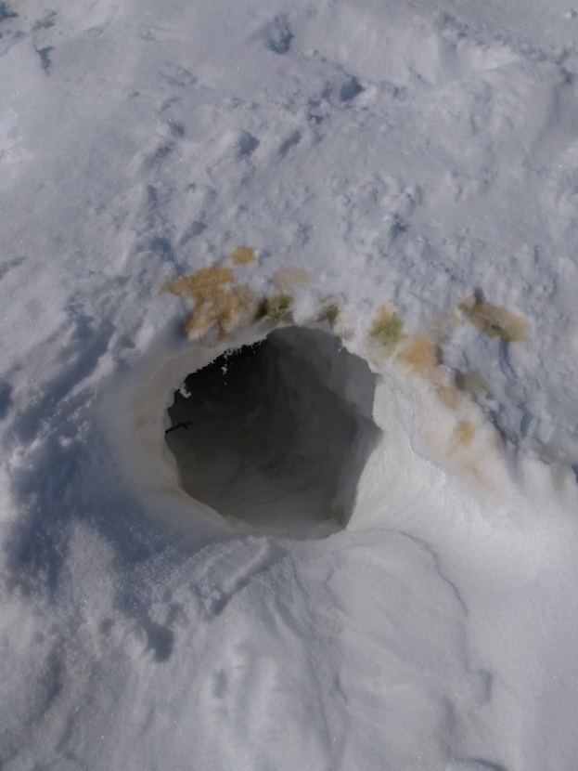
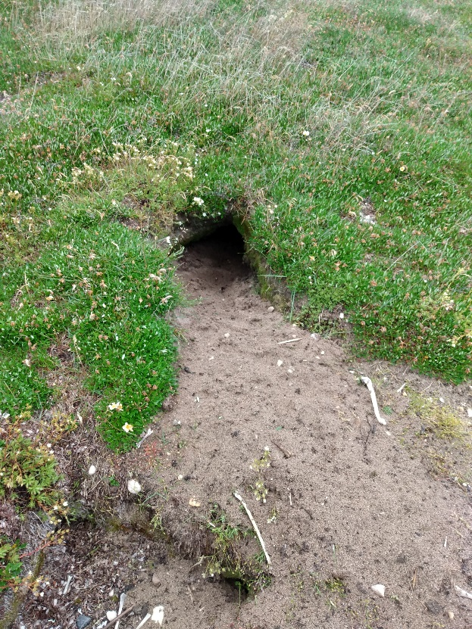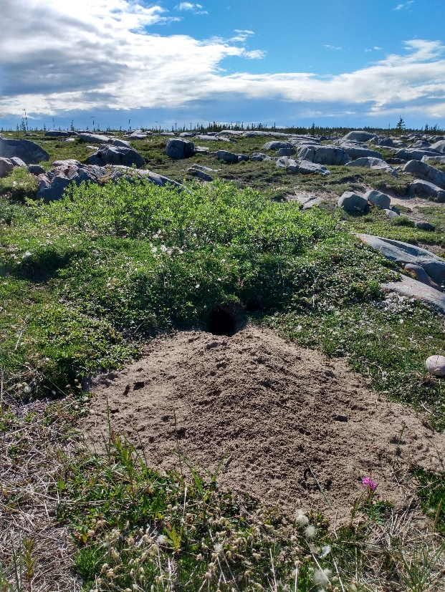
Figure S1. Dens with burrows dug out in winter (with urine on edge; top) and summer (bottom).

