Supplementary figure legends：
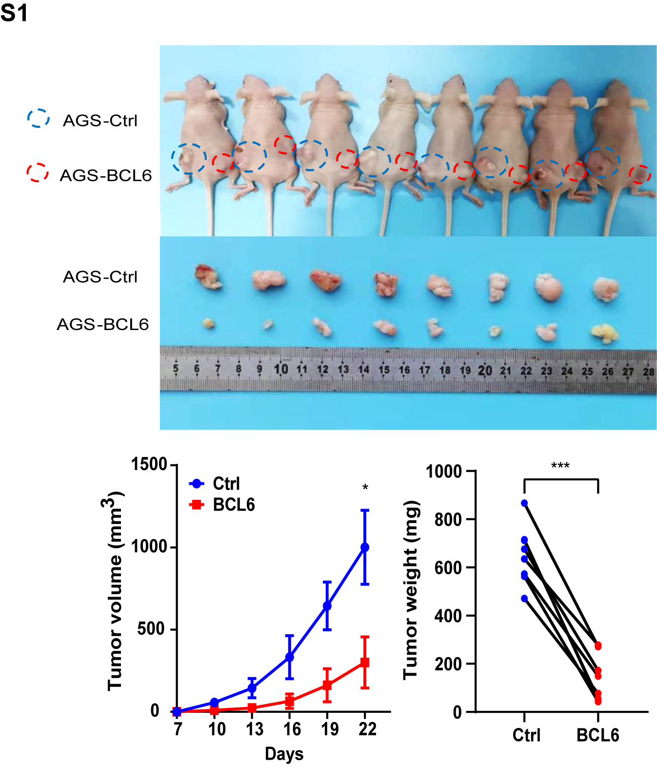
Supplementary Figure S1. BCL6 inhibited the growth of AGS cells in vivo. Tumor growth curves and tumor weight shows the inhibitory effect of BCL6 on tumor in vivo(N=8) (*p<0.05,***p<0.001).

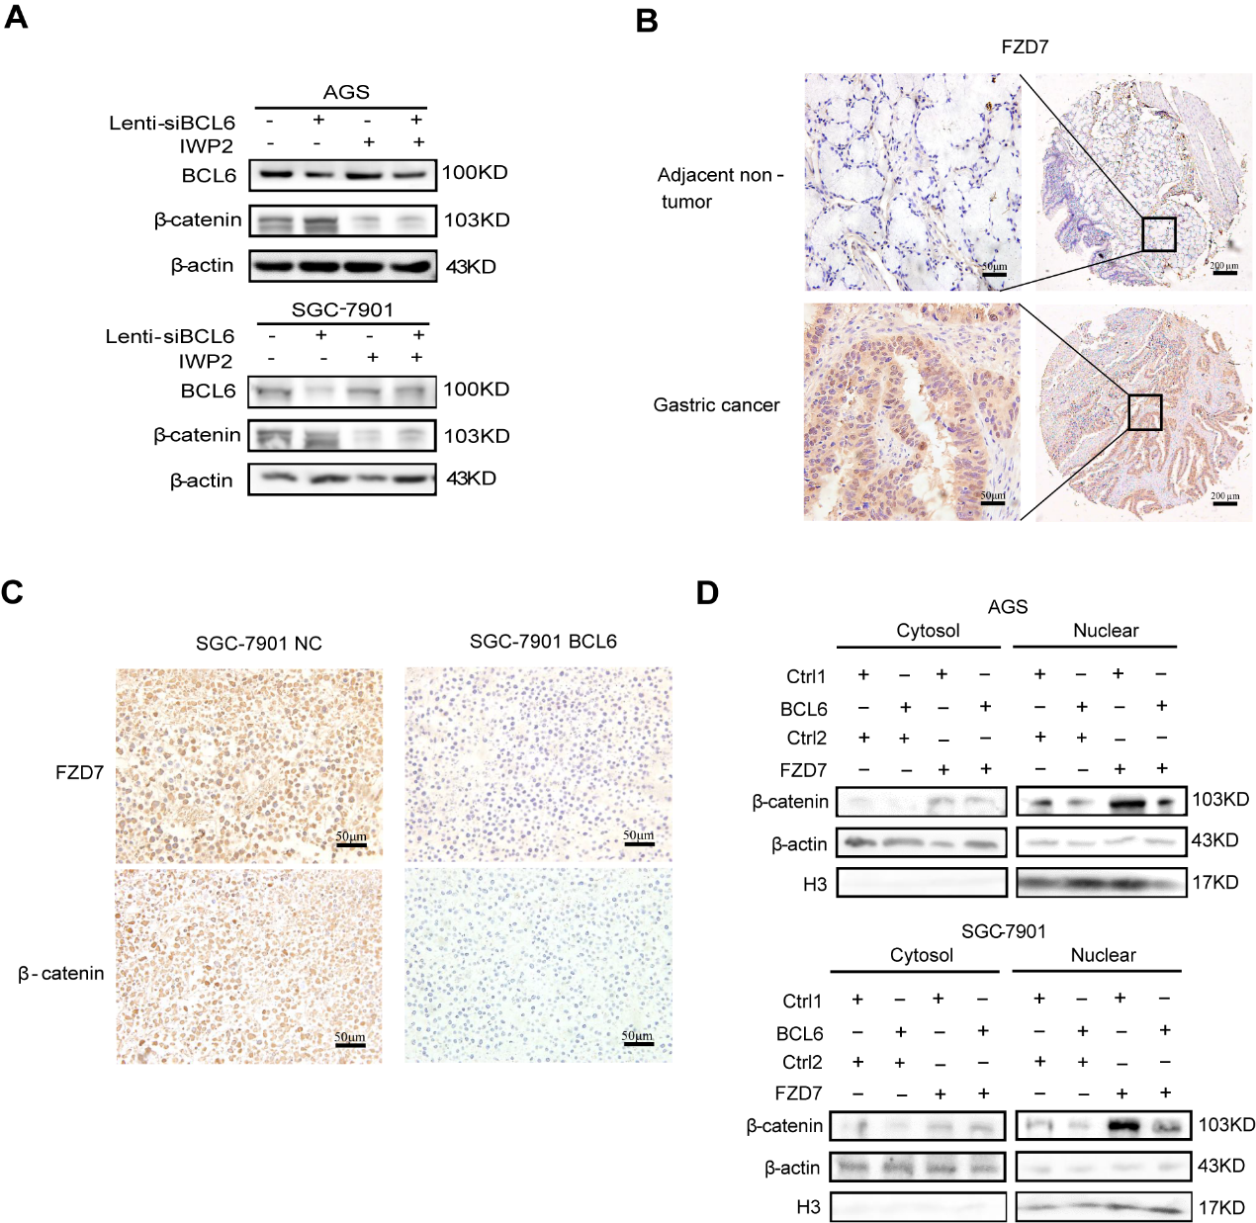
Supplementary Figure S2. BCL6 inhibited Wnt/β-catenin pathway by supressing FZD7. A β-catenin protein levels of GC cells after BCL6 knockdown combined with Wnt inhibitor IWP2 treatment(5 µM,12h). B Representative immunohistochemistry of FZD7 from GC tissue microarrays (Original magnification, ×100 and ×400). C Representative immunohistochemistry of FZD7 and β-catenin in tumor xenografts derived from SGC-7901-NC, SGC-7901-BCL6 cell lines (Original magnification, ×400). D Western blot for nuclear and cytoplasmic β-catenin in AGS and SGC-7901 cells transfected with control vector (Ctrl1+Ctrl2, Ctrl1+FZD7, BCL6+Ctrl2) or co-transfected BCL6 plasmid and FZD7 plasmid (BCL6+FZD7).
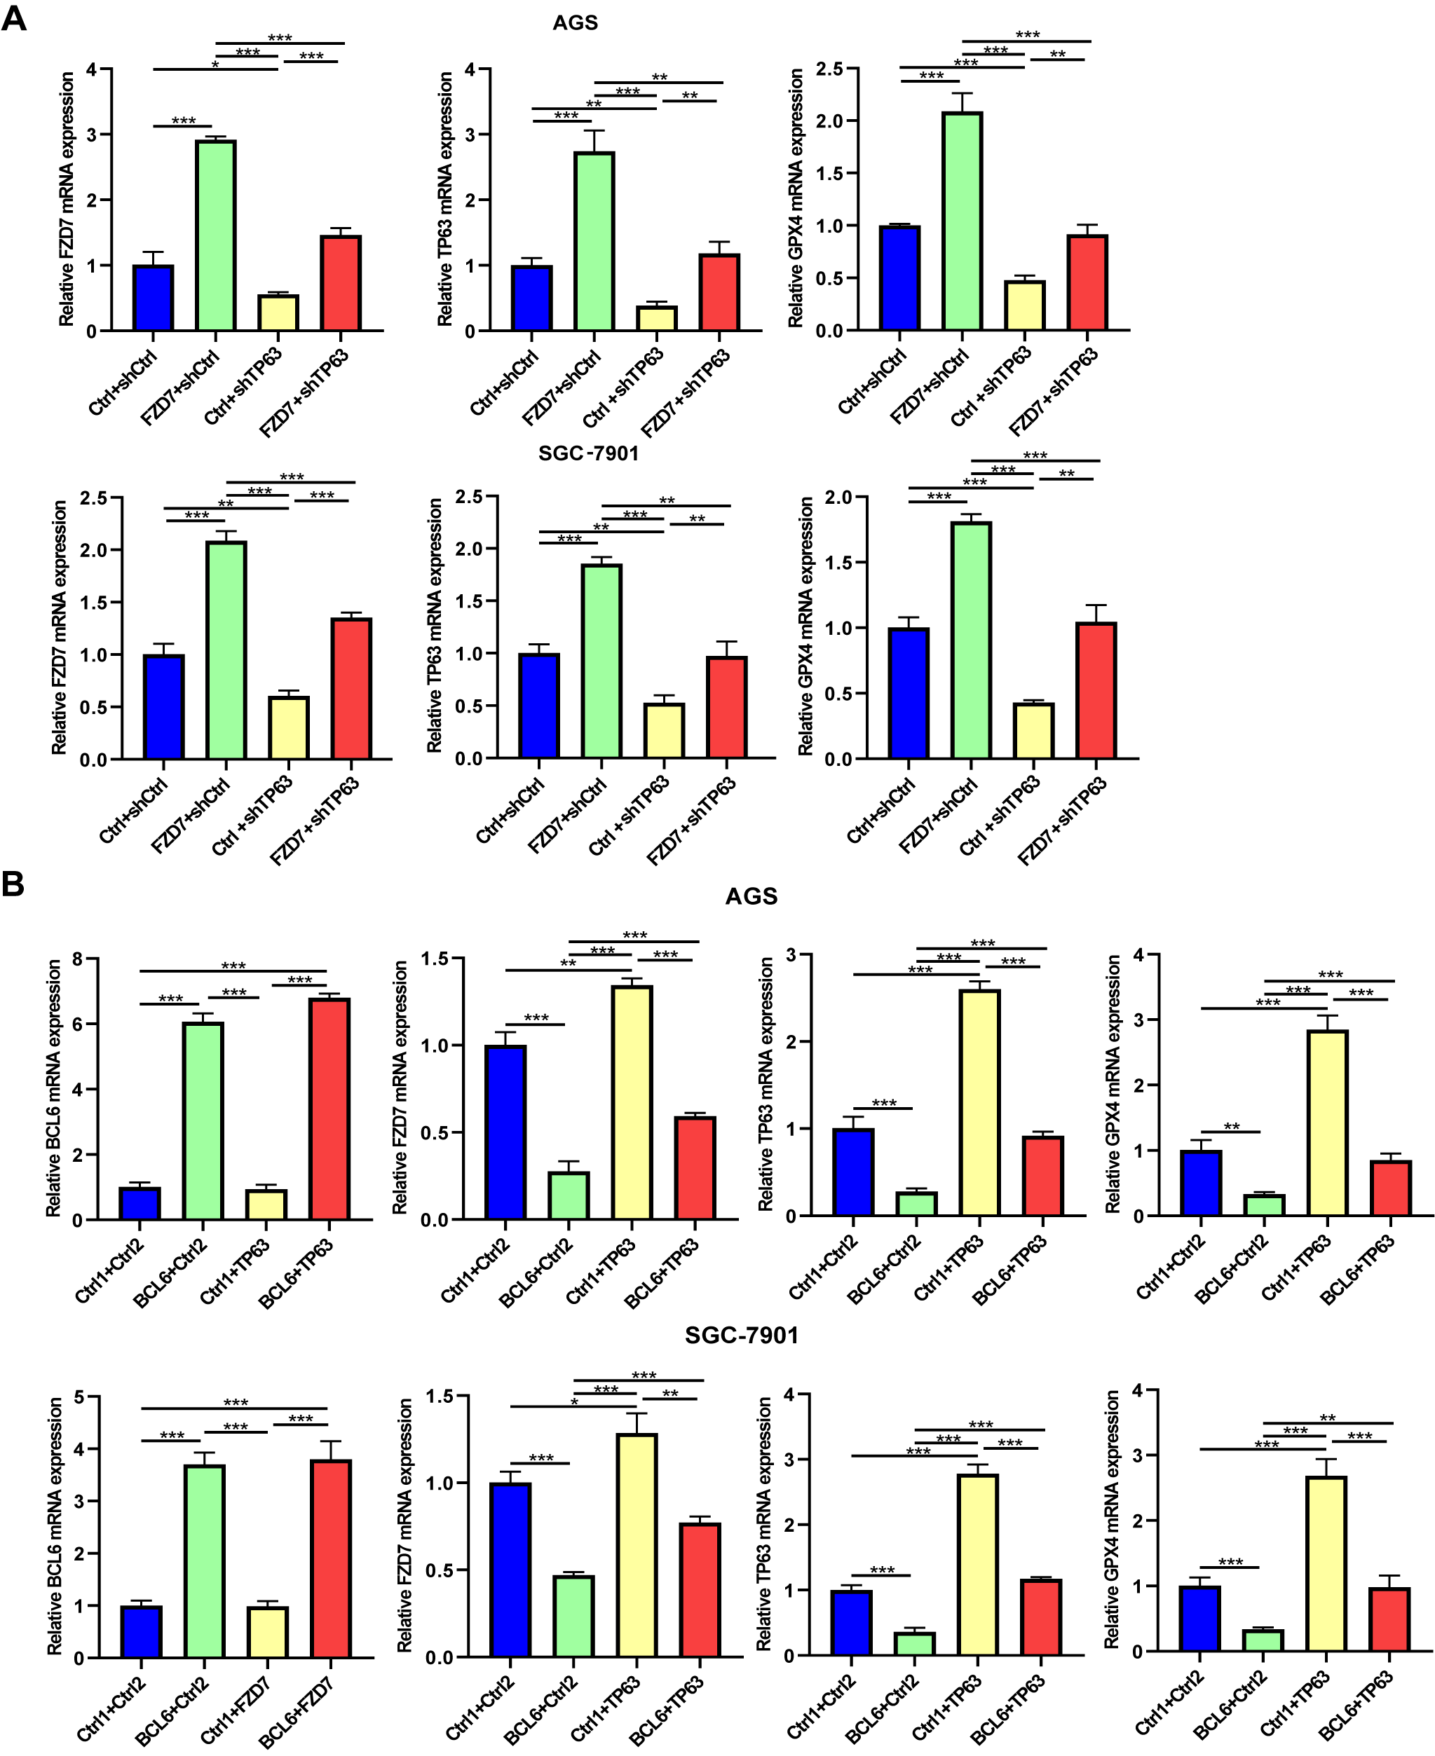
Supplementary Figure S3. TP63 mediated the regulation of GPX4 by the BCL6-FZD7 pathway. A FZD7, TP63 and GPX4 mRNA levels in AGS and SGC-7901 cells transfected with control vector (Ctrl+shCtrl, Ctrl+shTP63, FZD7+shCtrl) or co-transfected FZD7 plasmid and shRNA targeting TP63 (FZD7+shTP63) (*p<0.05, **p<0.01, ***p<0.001). B BCL6, FZD7, TP63 and GPX4 mRNA levels in AGS and SGC-7901 cells transfected with control vector (Ctrl1+Ctrl2, Ctrl1+TP63, BCL6+Ctrl2) or co-transfected BCL6 plasmid and TP63 plasmid (BCL6+TP63) (*p<0.05, **p<0.01, ***p<0.001).
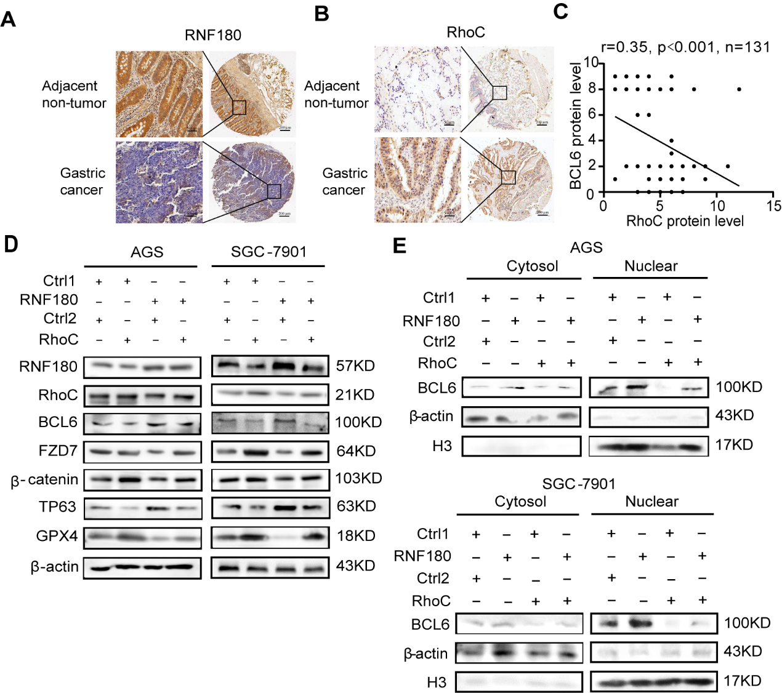
Supplementary Figure S4. RNF180 promoted the expression of BCL6 in nucleus through RhoC and strengthened its inhibitory effect on downstream genes.
A Representative immunohistochemistry of RNF180 from GC tissue microarrays (Original magnification, ×100 and ×400). B Representative immunohistochemistry of RhoC from GC tissue microarrays (Original magnification, ×100 and ×400). C Correlations between the the expression of BCL6 and RhoC according to the IHC of TMAs. BCL6 negtively correlates with RhoC in human GC tissues (N=131). D BCL6, FZD7, β-catenin, TP63, GPX4 protein expression in AGS and SGC-7901 cells transfected with control vector (Ctrl1+Ctrl2, Ctrl1+RhoC, RNF180+Ctrl2) or co-transfected RNF180 plasmid and RhoC plasmid (RNF180+RhoC). E Western blot for nuclear and cytoplasmic BCL6 in AGS and SGC-7901 cells transfected with control vector (Ctrl1+Ctrl2, Ctrl1+RhoC, RNF180+Ctrl2) or co-transfected RNF180 plasmid and RhoC plasmid RNF180+RhoC).
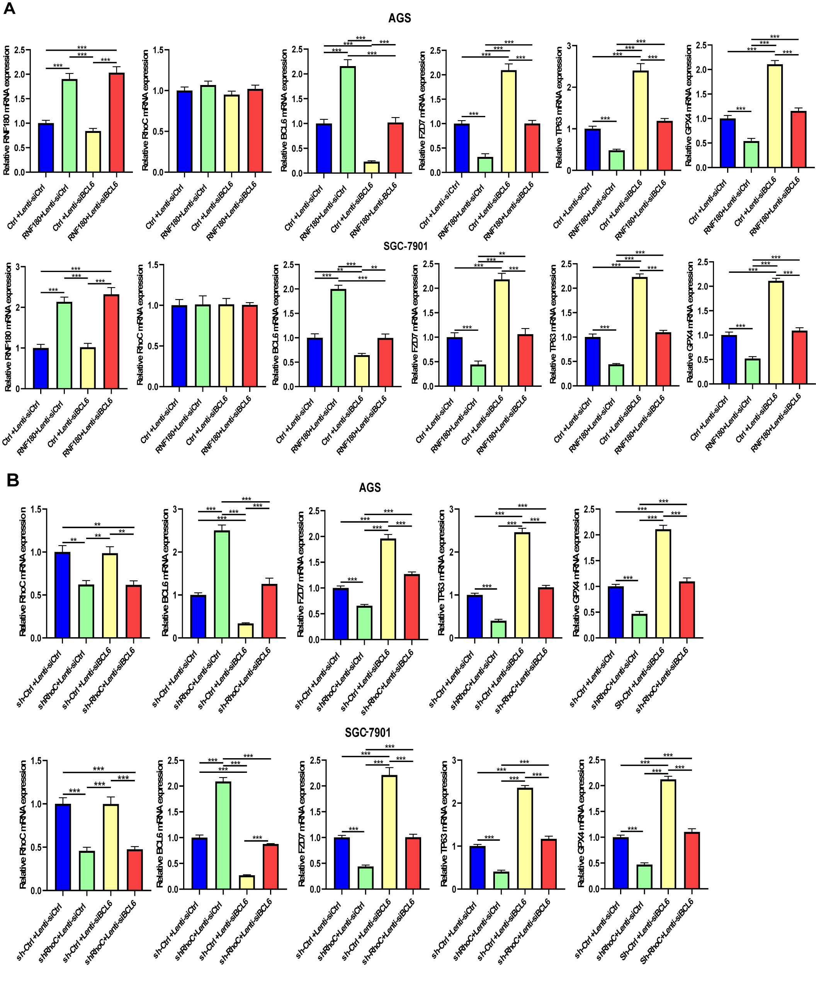

Supplementary Figure S5. Expression of BCL6 and its downstream genes was regulated by RNF180 and RhoC. A RNF180, RhoC, BCL6, FZD7, TP63, GPX4 mRNA expression in AGS and SGC-7901 cells transduced with control vector (Ctrl+Lenti-siCtrl, Ctrl+Lenti-siBCL6, RNF180+Lenti-siCtrl) or co-transduced RNF180 plasmid and Lenti-si BCL6 virus (RNF180+Lenti-siBCL6) (**p<0.01, ***p<0.001). B RhoC, BCL6, FZD7, TP63, GPX4 mRNA expression in AGS and SGC-7901 cells transduced with control vector (shCtrl+Lenti-siCtrl, shCtrl+Lenti-siBCL6, shRhoC+Lenti-siCtrl) or co-transduced shRhoC plasmid and Lenti-si BCL6 virus (shRhoC+ Lenti-siBCL6) (**p<0.01, ***p<0.001).
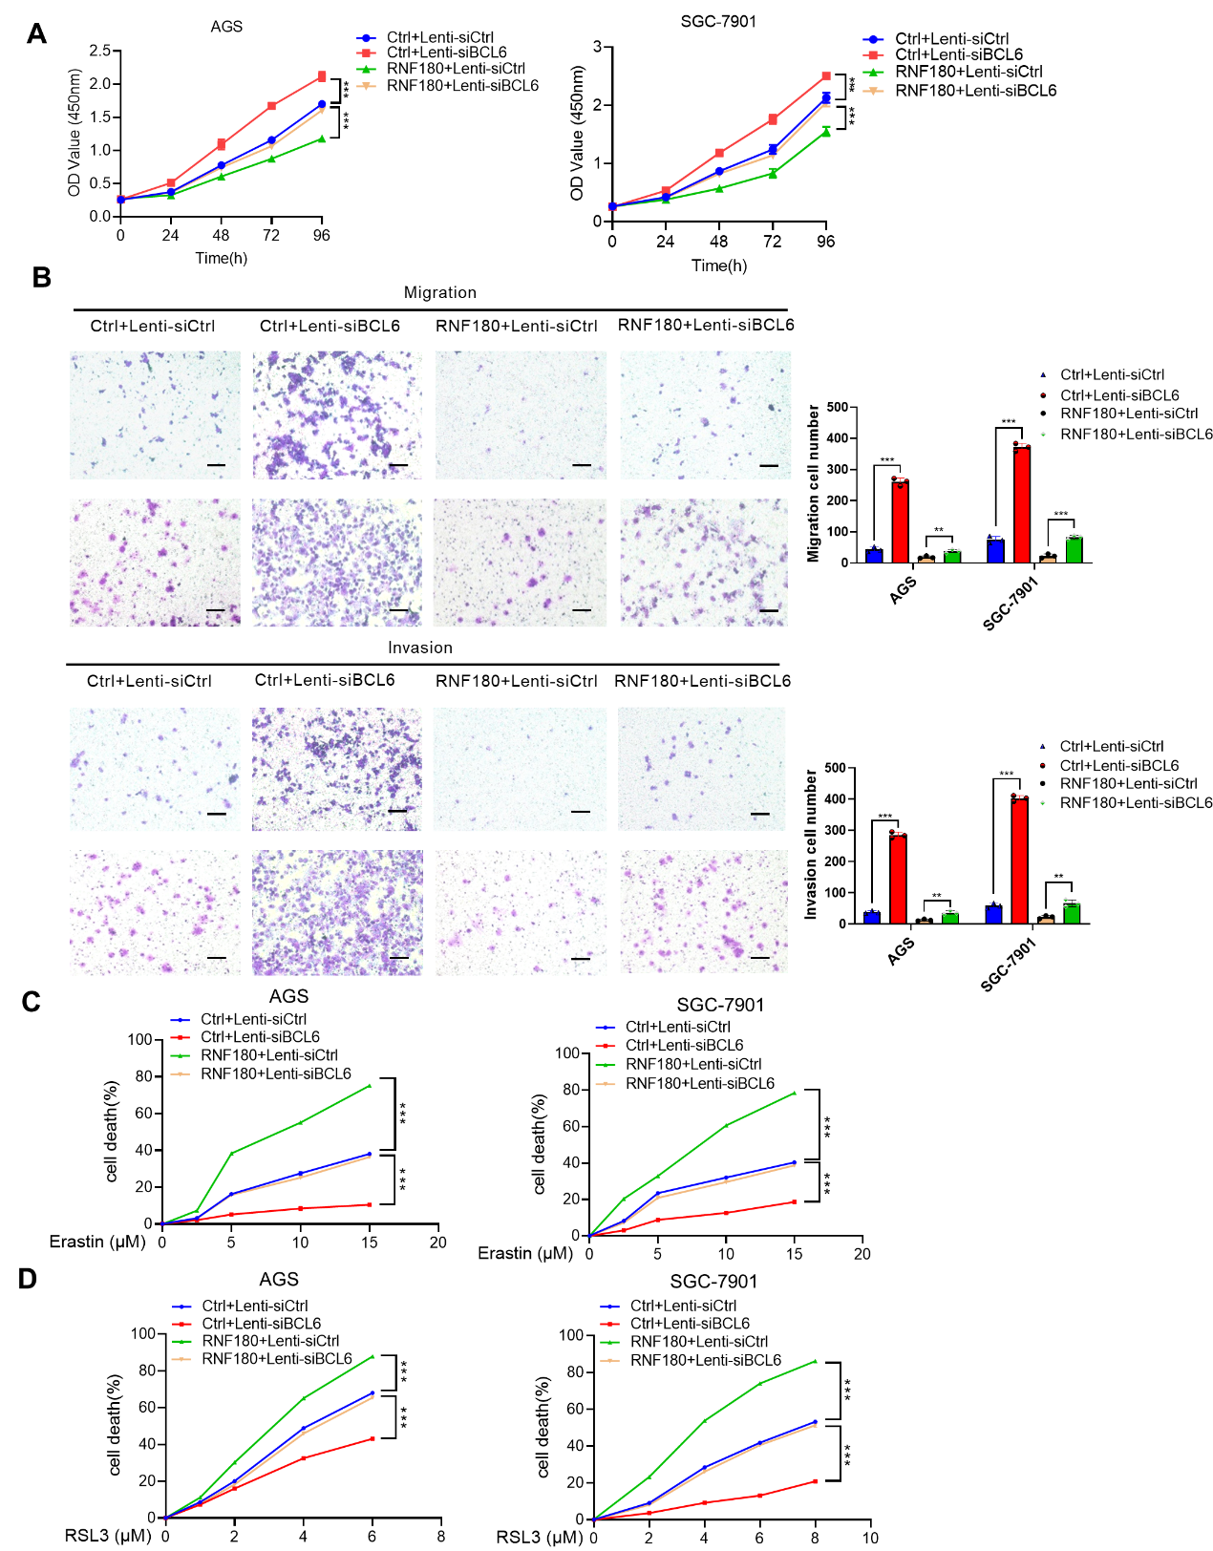
Supplementary Figure S6. Malignancy reppression and ferroptosis facilitation of BCL6 in GC cells were up-regulated by RNF180. A, B BCL6 depletion reversed the inhibition of cell proliferation, migration and invasion induced by RNF180 overexpression in AGS and SGC-7901 cells(Scale bar, 100μm) (**p<0.01,***p<0.001). C, D BCL6 depletion reversed cell death induced by erastin or RSL3 in RNF180-overexpressed AGS and SGC-7901 cells (***p<0.001).

Supplementary table legends:
Supplementary Table S1. Correlation of BCL6 expression to clinicopathological features in gastric cancer patients
Characteristics Total |  | BCL6 expression N (%） |  | χ2 | P-value
 |  | Low | High | χ2 | P-value
Gender |  |  |  | 3.795 | 0 . 078
Male | 103 | 62(60.2) | 41(39.8)
Female | 40 | 31(77.5) | 9(22.5)
Age(year) |  |  |  | 0 . 845 | 0 . 372
＜65 | 90 | 56(62.2) | 34(37.8)
≥65 | 53 | 37(69.8) | 16(30.2)
pT stage |  |  |  | 3.182 | 0 . 198ª
pT2 | 10 | 5(50.0) | 5(50.0)
pT3 | 9 | 4(44.4) | 5(55.6)
pT4 | 124 | 84(67.7) | 40(32.3)
pN stage |  |  |  | 10. 899 | 0 .012*
pN0 | 34 | 18(52.9) | 16(47.1)
pN1 | 15 | 7(46.7) | 8(53.3)
pN2 | 34 | 20(58.8) | 14(41.2)
pN3 | 60 | 48(80.0) | 12(20.0)
Tumor location |  |  |  | 5 .389 | 0 . 151
Upper third | 19 | 9(47.4) | 10(52. 6)
Middle third | 14 | 11(76.8) | 3(21.4)
Lower third | 63 | 38(60.3) | 25(39.7)
More than 2/3 stoma | 28 | 21(75.0) | 7(25.0)
Tumor size(cm) |  |  |  | 4 .7 | 0 .042*
<5 | 49 | 26(53.1) | 23(46.9)
≥5 | 94 | 67(71.3) | 27(28.7)
Lauren type |  |  |  | 1.332 | 0.644ª
Intestinal | 34 | 21(61.8) | 13(38.2)
Diffuse | 105 | 68(64.8) | 37(35.2)
Mixed | 3 | 3(100.0) | 23(0.0)
Bormann type |  |  |  | 1.466 | 0.754ª
Ⅰ | 3 | 2(66.7) | 1(33.3)
Ⅱ | 24 | 17(70.8) | 7(29.2)
Ⅲ | 67 | 42(62.7) | 25(37.3)
Ⅳ | 10 | 8(80.0) | 2(20.0)
a fisher exact test;
* P<0 . 05

Supplementary Table S2. The Primer Sequences Used in this Study
Gene | type | Sequence (5’ to 3’)
BCL6 | Forwrd primer | GTCGTGAGGTGGTGGAGAACAAC
BCL6 | Reverse primer | AGAGGCTGGCGGTGTGGAC
FZD7 | Forwrd primer | GTCAAGACCATCACTATCCTGG
FZD7 | Reverse primer | ATGAAGAGGTAGACGAACAGAG
TP63  TP63  GPX4  GPX4 | Forwrd primer  Reverse primer  Forwrd primer  Reverse primer | GCAACGCCCTCACTCCTACAAC  AGTCCATTCATGTCTCCAGCCATTG  CCCGATACGCTGAGTGTGGTTTG  TCTTCGTTACTCCCTGGCTCCTG
RNF180 | Forwrd primer | TGTTACCCTTGCCATCACATCTTCT
RNF180 | Reverse primer | CCATCCACGGCTATCATCCTCAAA
RhoC | Forwrd primer | AGGTCTACGTCCCTACTGTCTTTGA
RhoC | Reverse primer | GTCTTGCCTCAGGTCCTTCTTATTC
β-actin | Forwrd primer | CATGTACGTTGCTATCCAGGC
β-actin | Reverse primer | CTCCTTAATGTCACGCACGAT
BCL6/FZD7 binding site 1 | Forwrd primer | GGAGGGCGAAACTGATGCTTGG
BCL6/FZD7 binding site 1 | Reverse primer | GTTAATAGGTCGAAAGGGCGGAAGG
BCL6/FZD7 binding site 2 | Forwrd primer | AAACAGAGAAAGCCAAAGTC
BCL6/FZD7 binding site 2 | Reverse primer | GAGCCCTTCTGCCT
BCL6/FZD7 binding site 3 | Forwrd primer | ACGCTACCCGAGAACG
BCL6/FZD7 binding site 3 | Reverse primer | AGCAACCATTTGATCCTCCA
BCL6/FZD7 Vicinity region | Forwrd primer | AGTGCACCAGGAAGAGGAACAAATC
BCL6/FZD7 Vicinity region | Reverse primer | TGGGAGGGAAAAGTTCGGAAAAACT
FZD7 promoter –2000/+180 | Forwrd primer | GGGGTACCCAACCGAAGATCAAC
FZD7 promoter –2000/+180 | Reverse primer | CCCAAGCTTACAGTCAAGGCATTC
FZD7 promoter –1672/+180 | Forwrd primer | GGGGTACCGGAAAGAACGATTCC
FZD7 promoter –1672/+180 | Reverse primer | CCCAAGCTTACAGTCAAGGCATTC
FZD7 promoter –1296/+180 | Forwrd primer | GGGGTACCCAACATGTCACTTTC
FZD7 promoter –1296/+180 | Reverse primer | CCCAAGCTTACAGTCAAGGCATTC
FZD7 promoter –950/+180 | Forwrd primer | GGGGTACCAGGCACACGGGGCCA
FZD7 promoter –950/+180 | Reverse primer | CCCAAGCTTACAGTCAAGGCATTC
FZD7 promoter BS1 mutation | Forwrd primer | GGCGAAACTGACACACACACACACACAGGCGA
FZD7 promoter BS1 mutation | Reverse primer | GGGAGTCGCCTGTGTGTGTGTGTGTGTCAGTT
FZD7 promoter BS2 mutation | Forwrd primer | GAATGAGTTTTTTTCACACACACACACAGCACG
FZD7 promoter BS2 mutation | Reverse primer | TGCCTCCCGTGCTGTGTGTGTGTGTGAAAA
FZD7 promoter BS3 mutation | Forwrd primer | ACTCTTTAATTAGCCACACACACACACACACATTAA
FZD7 promoter BS3 mutation | Reverse primer | TAGGAATGTTTTAATGTGTGTGTGTGTGTGTGGCTA

