Supplementary Information

Tungsten Oxide Nanostructures Peculiarity and Photocatalytic Activity for the Efficient Elimination of the Organic Pollutant
Deepika Jamwalª, Vishal Mutreja^{b}, Rahul,^{c} Surinder Kumar Mehta,ª Akash Katoch,^{c†} Sang Sub Kim^{d*}
ªDepartment of Chemistry and Centre of Advanced Studies in Chemistry, Panjab University, Chandigarh 160014, India
^{b}Department of Chemistry, Chandigarh University, Mohali, 140413 India
^{c}Centre for Nanoscience and Nanotechnology, University Institute of Science, Panjab University, Chandigarh 160014, India
^{d}Department of Materials Science and Engineering, Inha University, Incheon 22212, Republic of Korea

E-mail- katochakash@gmail.com†, akatoch@pu.ac.in†, sangsub@inha.ac.kr*

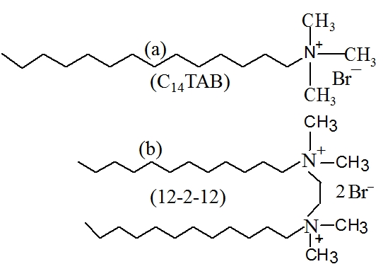

Scheme S1. (a) Molecular structure of C₁₄TAB and, (b) TTS, respectively.

Fig. S1. W–H analysis of WO₃ web of chains (a) UDM, (b) USDM, (c) UDEDM, and (d) SSP. Fit to the data, the strain is extracted from the slope and the crystalline size is extracted from the y-intercept of the fit.
Fig. S2. W–H analysis of WO₃ cube shaped nanoparticles (a) UDM, (b) USDM, (c) UDEDM, and (d) SSP. Fit to the data, the strain is extracted from the slope and the crystalline size is extracted from the y-intercept of the fit.

