Supplementary Tables and Figures
Supplementary Table 1: Primer sequences used in the study
 | RT adapter Primer | PCR Forward Primer | PCR Reverse Primer
hsa-miR-197a-5p | AGCATTCGTCTCGACACAGCCTCCCACTGC | TGACTCTGCCGGGTAGAGAGGGCA | TAGAGCATTCGTCTCGACACAG
GPX3 | RANDOM HEXAMERS | 5'- CAACCAATTTGGAAAACAGG -3’ | 5'- GTGGGAGGACAGGAGTTCTT-3'

Supplementary Table 2a: Combination of ST drugs used with Cisplatin in MDA-MB-231 cells (CP-Cisplatin)
MDA | Control | CP  2.5 µM | CP  3 µM | ST09  10nM | ST09  20nM
 | No drug | CP | CP | 09 | 09
CP  2.5 µM | - | + | - | CP+09 | CP+09
CP  3 µM | - | - | + | CP+09 | CP+09

Supplementary Table 2b: Combination of ST drugs used with Cisplatin in MCF7 cells (CP-Cisplatin)
MCF7 | Control | CP  1 µM | CP  2 µM | ST09  30nM | ST09  40nM
 | No drug | CP | CP | 09 | 09
CP  1 µM | - | + | - | CP+09 | CP+09
CP  2 µM | - | - | + | CP+09 | CP+09

Supplementary Table 3:Total reads and percentage mapping of all the in house sequenced samples
mRNA | Total Reads | % Alignment | miRNA | Total Reads | % Alignment
MDA-MB-231 | 47335455 | 78.91 | MDA-MB-231 | 576044256 | 82.25
MDA-MB-231 | 66478647 | 83.34 | MDA-MB-231 | 48990066 | 82.35
MDA-MB-09 1 | 28885006 | 80.81 | MDA-MB-09 1 | 41857694 | 82.15
MDA-MB 09 2 | 29149926 | 82.34 | MDA-MB 09 2 | 49960126 | 82.33
MCF7 | 55887233 | 84.01 | MCF7 | 68697278 | 89.44
MCF7 09 1 | 44921892 | 84.79 | MCF7 | 63580633 | 92.08
MCF7 09 2 | 31180272 | 84.16 | MCF7 09 1 | 40469653 | 86.78
T47D | 25870576 | 80.88 | MCF7 Cur | 55955641 | 86.09
T47D | 45580543 | 85.58 | T47D | 56379588 | 81.54
T47D 09 1 | 35051915 | 83.73 | T47D | 56819311 | 82.15
T47D 09 2 | 30565457 | 83.81 | T47D 09 1 | 64175416 | 83

Supplementary Table 4: Total significant mRNAs and miRNAs and % regulation in each treatment
Sample | Significant reads  (log 2 Fold Change >0.75, P-value< 0.05) | % of Significant Upregulated | % of Significant downregulated
mRNA
MCF7_ST09 | 1906 | 49 | 51
MDA_ST09 | 763 | 44 | 56
T47D_ST09 | 1879 | 28 | 72
miRNA
MCF7_ST09 | 2235 | 48 | 52
MDA_ST09 | 1155 | 55 | 45
T47D_ST09 | 1606 | 50 | 50

Supplementary Figure 1: Structure of Curcumin(A), ST03(B), ST08(C), ST09(D)
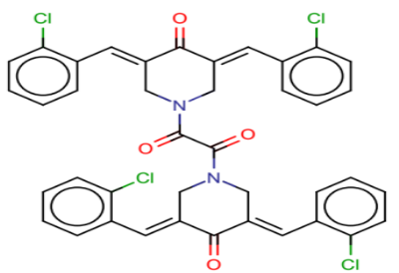
B
A
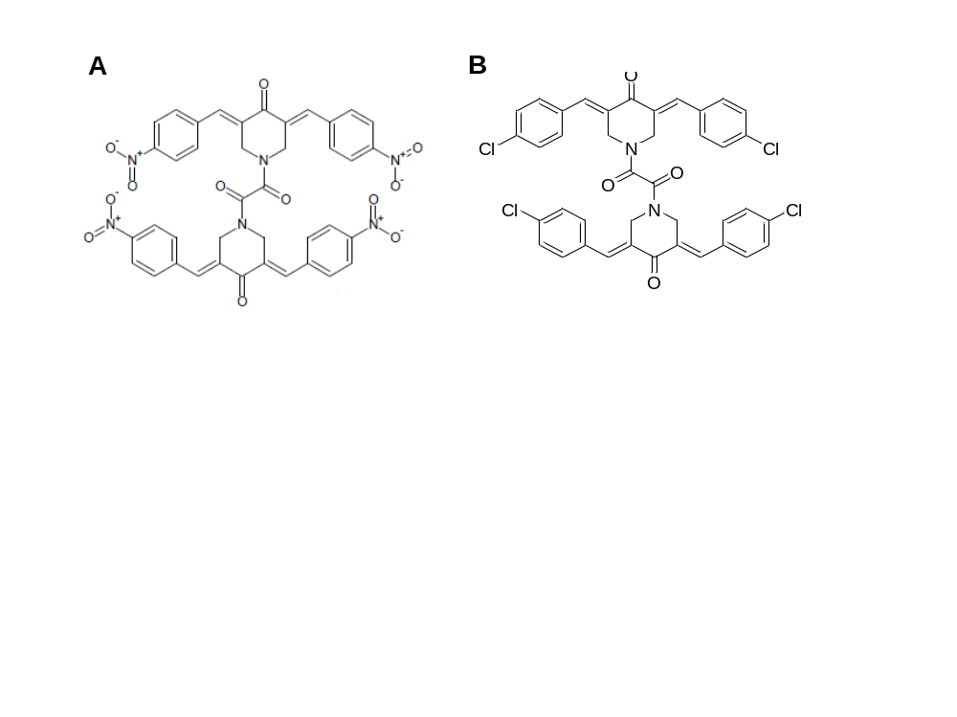
D
C
Supplementary Figure 2: miR-197-5p target(GPX3) validation by Targetscan(A) and miRDB(B)
A
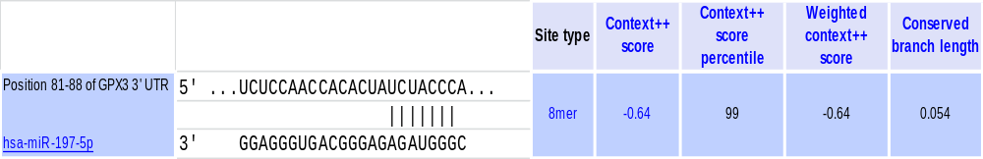
B
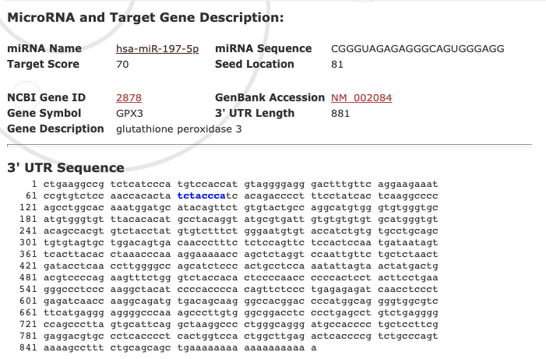
Supplementary Figure 3: PCA plots for ST09 treated and control miRNA-seq samples(A) and ST09 treated and control mRNA-seq samples(B).(Abbreviations- ST09:09)
A
B
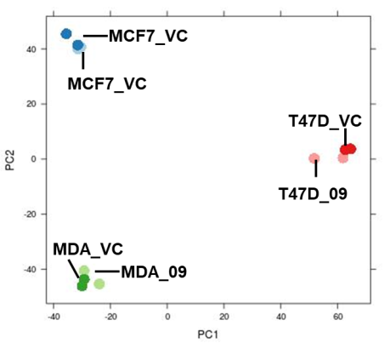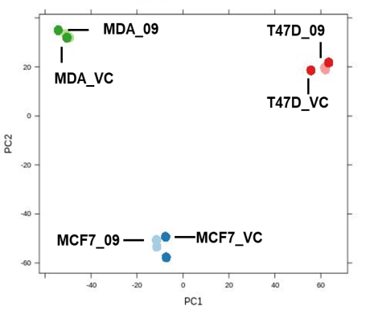
Supplementary Figure 4: Cell proliferation assay(MTT) on anti-miR+ST09 treated MDA-MB-231 cells.
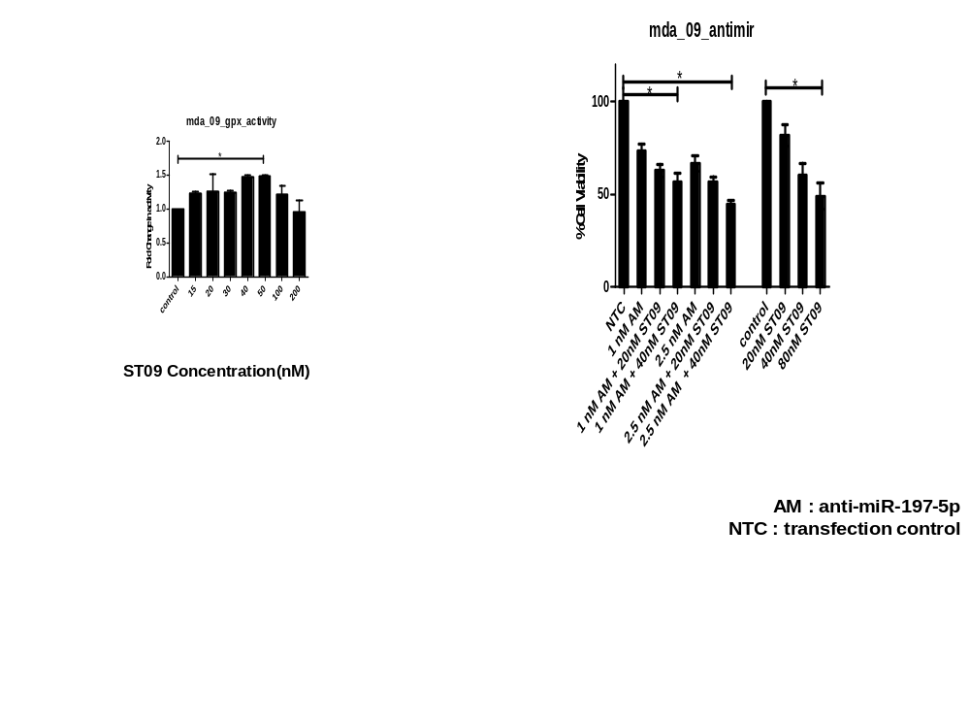

Supplementary Figure 5: Pathways regulated by ST09 in breast cancer cells of MCF7(A), MDA-MB-231(B), T47D(C).

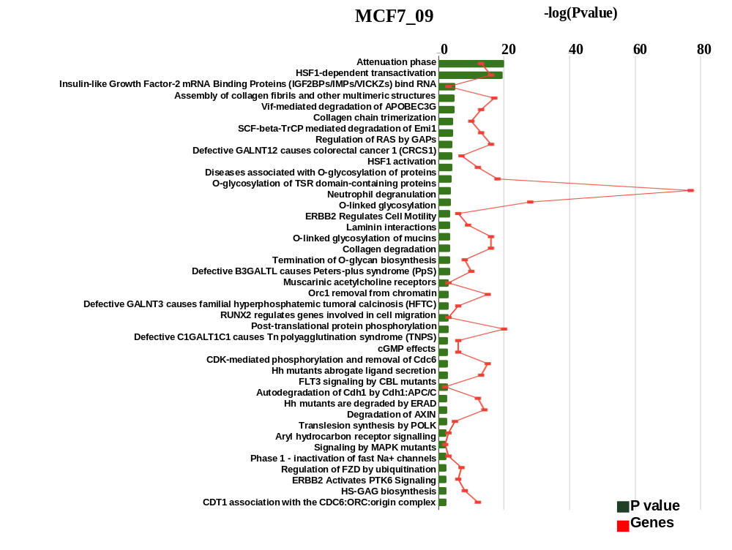
B
A
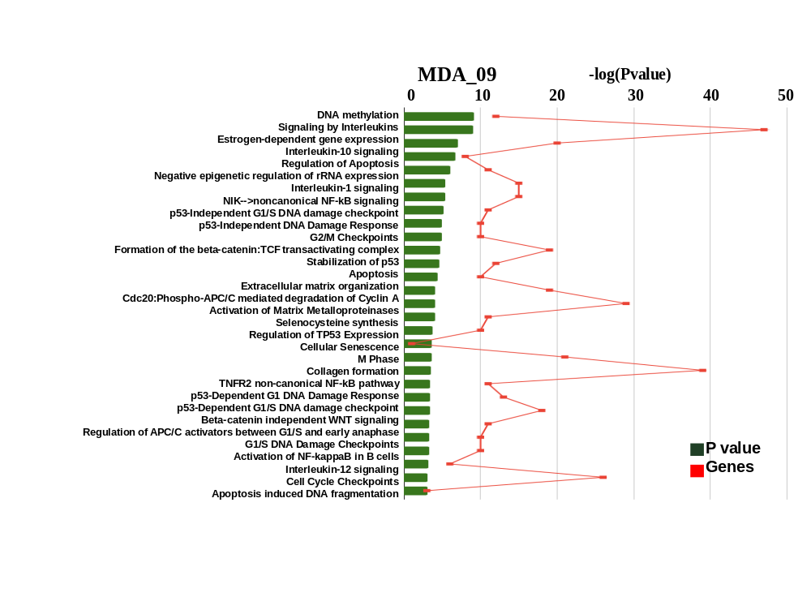
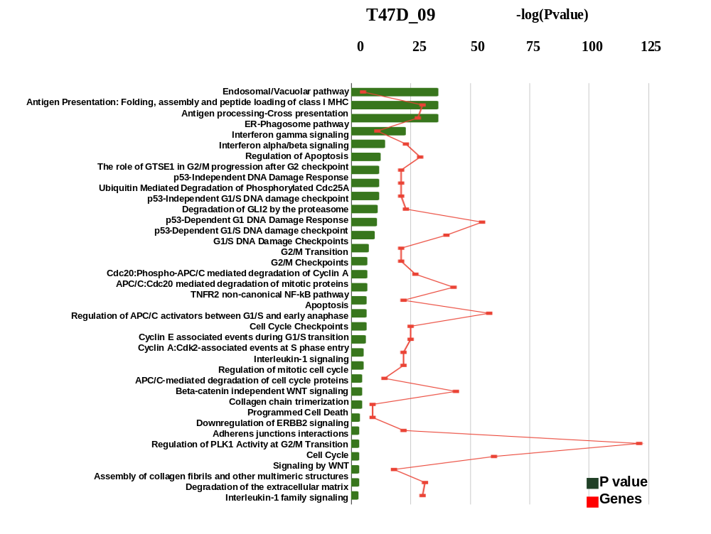
C

