Fig. S1 FHL3 was specifically overexpressed in skeletal muscles of transgenic mice
(A) Schematic diagram of FHL3 transgenic vector construction. The expression of FHL3 was induced by the MCK promoter. (B) PCR identification results of F0 FHL3 TG mice, Lane 27 female (♀), 46 male (♂), 51♀: FHL3 TG founder mice, Lane M: DL2000, Lane P: positive plasmid, Lane N: WT mice. (C) Schematic diagram of FHL3 TG mice hybridization. F0 mice were hybridized with WT mice to produce F1, and then crossed from F2 to produce offspring. (D-F) q-PCR results show the FHL3 copy number decreased with generation form F1 to F5 mice in 27♀ (D) ,46 ♂ (E), 51♀ (F) FHL3 TG offspring, respectively. (G) PCR identification results of F5 FHL3 TG mice, Lane M: DL2000, Lane P: positive plasmid, Lane N: WT mice, Lane 1-3: F5 FHL3 TG mice. (H) Western blotting results showed that there was no significant difference for FHL3 protein expression in heart, liver, kidney, and testis between WT and TG mice of 2-month-old (n=2). The relative protein levels were normalized to β-actin. The data were presented as mean ± SD of two independent experiments; N.S. indicates statistical non-significance.

Fig. S2 FHL3 overexpression significantly increasesin female mice muscle growth and the cross-sectional area of muscle fibers
(A) The growth curve showed that the body weight of female TG mice was higher than that of male WT mice at the same week of age (n=10 for each group). (B) The weight of Qu, GAS and TA muscles of female FHL3 TG mice was significantly higher than these of WT mice (n = 10 for each group). Data were normalized to the body weight (BW) (mg/g). (C) Representative images of H&E staining for Qu, Gas, and TA muscles from 2-month-old TG and WT mice. Quantification of ten independent experiments indicated that TG mice had higher mean cross-sectional areas of individual myofibers than WT mice. At least 150 myofibers were analyzed in an independent experiment. Scale bars, 50 μm. (D) Representative photographs of H&E staining showed that there was no significant morphological difference for heart between 2-month-old WT and FHL3 TG mice. Scale bars 50 μm. (E) Heart weight statistics showed there was no difference in heart weight between male and female WT mice and TG mice, respectively. The data were presented as mean ± SD of independent experiments; ***P < 0.001, N.S. indicates statistical non-significance.
Fig. S3 Pig FHL3 has the conserved function of promoting formation of fast-twitch muscle fibers
(A) Schematic diagram of FHL3 amino acid sequence alignment among pig, mouse, human, bovine, ovis and gallus. (B) Homology of FHL3 amino acid sequences among pig, mouse, human, bovine, ovis and gallus. (C) Western blotting results showed that si-pFHL3-3 RNA had the highest efficiency of knocking down FHL3 in pig skeletal muscle satellite cells (pSMSC) among the three siRNAs. (D) Representative images of MyHC2a, MyHC2b, and MyHC1/slow immunofluorescence staining for the siRNA-mediated pig FHL3 (si-pFHL3) knockdown in pig skeletal muscle satellite cells (pSMSC) differentiated for 2 days. Quantification of three independent experiments indicated that pFHL3 knockdown significantly decreased the proportion of MyHC2a-and MyHC2b-positive myotubes, but significantly increased the proportion of MyHC1/slow- positive myotubes. Nuclei were stained with DAPI. Scale bars 50 μm. (E)Western blotting results show that siRNA-mediated pig FHL3 knockdown significantly decreased the expression levels of MyHC2a and MyHC2b, and increased the expression level of MyHC1/slow in pSMSC differentiated for 2 days. (F) Representative images of H&E staining for the Gas of pigs and quantification of three independent experiments indicates that lentivirus-mediated pFHL3 overexpression in GAS muscles of pigs significantly increased the mean cross-sectional areas of individual myofibers. At least 150 myofibers were analyzed in an independent experiment. P values were determined by paired t‐test. Scale bar, 100μm. The relative protein levels were normalized to β-actin. The data were presented as mean ± SD of independent experiments; *P < 0.05, **P < 0.01, ***P < 0.001.
Fig. S4 Identification of Cas9/sgRNAs mediated FHL3 knockout cell lines and expression analysis of genes related to muscle fiber types
(A) Schematic diagram of two pairs of sgRNAs were designed by CHOPCHOP to knock out FHL3 (http://chopchop.cbu.uib.no/). PCR amplification and sequencing results of WT and FHL3 KO C2C12 cells showed that two pairs of Cas9/sgRNAs (sgRNA-1 and sgRNA-2) transfection resulted in frameshift mutation of FHL3 and termination of translation. PAM: protospacer adjacent motif. (B) Western blotting results showed that FHL3 was completely knocked out in cells transfected with sgRNA (sgRNA-1 and sgRNA-2), the relative protein levels were normalized to β-actin. (C) Representative images of MyHC2a, MyHC2b, and MyHC1/slow immunofluorescence staining and quantification of three independent experiments indicated that FHL3 knockout significantly decreased the proportion of MyHC2a- and MyHC2b-positive myotubes, but significantly increased the proportion of MyHC1/slow- positive myotubes. Nuclei were stained with DAPI. Scale bars 50 μm. (D) GO enrichment dot plot of the differentially downregulated genes in FHL3 KO RNA-seq. (E) Heatmap of genes related to muscle fiber type regulation in FHL3 KO RNA-seq. (F) The potential transcription factors at the MyHC1/slow, MyHC2a and MyHC2b 5' regulatory region were predicted by online software (PROMO). The data were presented as mean ± SD of three independent experiments; **P < 0.01.

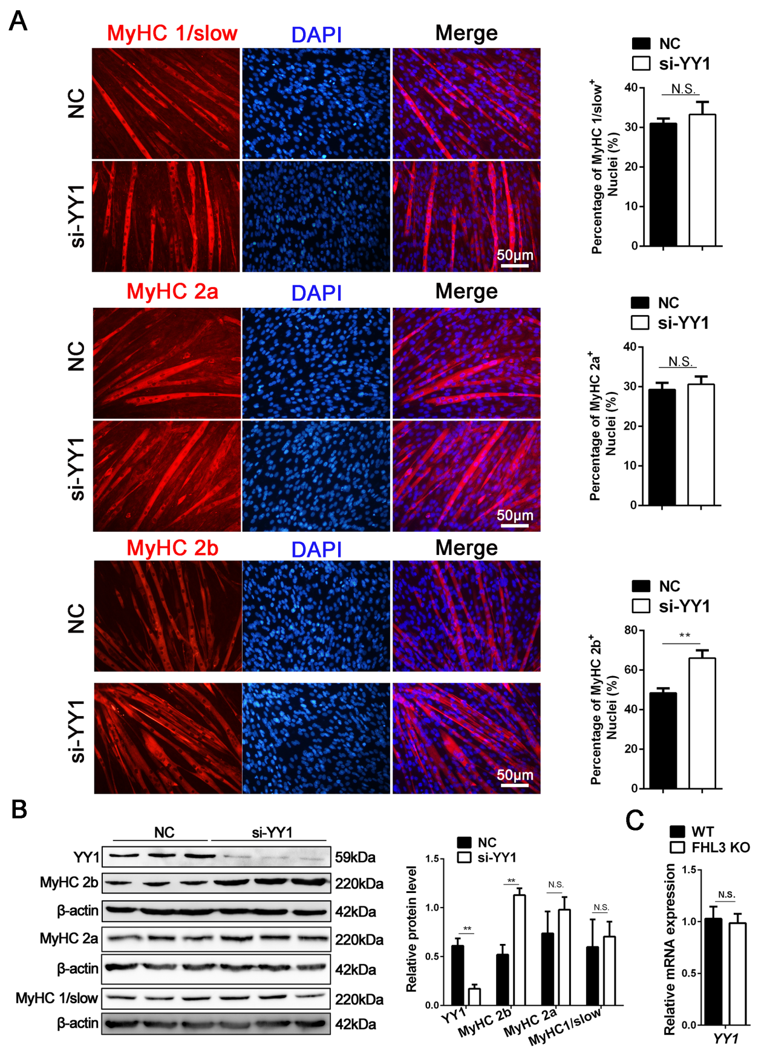 Fig. S5 YY1 knockdown promotes the expression of MyHC2b
(A) Representative images of MyHC2a, MyHC2b, and MyHC1/slow immunofluorescence staining and quantification of three independent experiments indicated that YY1 knockdown (si-YY1) significantly increased the proportion of MyHC2b- positive myotubes, but had no significant effects on the proportion of MyHC1/slow-and MyHC2a- positive myotubes in C2C12 cells differentiated for 4 days. The cells were stained with anti-MyHC1/slow antibodies (red), anti-MyHC2a antibodies (red), anti-MyHC2b antibodies (red) and DAPI (blue). Scale bars 50 μm. (B) Western blotting results showed that YY1 knockdown (si-YY1) significantly increased the expression level of MyHC2b, but did not affect the expression levels of MyHC1/slow and MyHC2a in C2C12 cells differentiated for 4 days. (C) qRT-PCR results showed that FHL3 knockout did not change the expression of YY1. The relative protein and mRNA levels were normalized to β-actin. The data were presented as mean ± SD of three independent experiments; **P < 0.01, ***P < 0.001, N.S. indicates statistical non-significance.

Fig. S6 His-EZH2(465-519) directly interacts with RD2 domain of YY1 and FHL3 knockdown can increase the enrichment of YY1 in MyHC2b gene 5' regulatory region
(A) GST-pulldown results indicated that GST-YY1-RD and GST-YY1 could interact with His-EZH2 (465-519). In vitro translated proteins of GST, GST-YY1-TD, GST-YY1-RD, GST-YY1-DD, GSY-YY1 and His-EZH2 (465-519) were used for GST pulldown assays. The interaction of GST-YY1 truncated proteins with His-EZH2 was detected by western blotting with anti-His (up). The GST-tagged proteins were detected by western blotting with anti-GST (down). (B) ChIP-qPCR results showed the YY1 enrichments at the MyHC2b regulatory regions were significantly increased after FHL3 knockdow (si-FHL3) in C2C12 myotubes differentiated for 2 days. IgG were performed as controls and precipitated DNA was amplified by PCR with primers for the MyHC2b 5' regulatory region; **P < 0.01. (C) GST-pulldown results indicated that GST-YY1-RD2 could interact with His-EZH2 (465-519). In vitro translated proteins of GST, GST-YY1-RD1, GST-YY1-RD2, GST-YY1-RD and His-EZH2 (465-519) were used for GST pulldown assays. The interaction of GST-YY1 truncated proteins with His-EZH2 were detected by western blotting with anti-His (up). The GST-tagged proteins were detected by western blotting with anti-His (down).

