On-Line Only Data Supplement

His-Purkinje System Pacing versus Biventricular Pacing in clinical efficacy: A Systematic Review and Meta-Analysis

Ya Wang¹, Fangchao Liu¹, Mengyao Liu¹, Zefeng Wang², Xiangfeng Lu¹, Jianfeng Huang¹, Dongfeng Gu^{1 3*}
1 Department of Epidemiology, Fuwai Hospital, State Key Laboratory of Cardiovascular Disease, National Center for Cardiovascular Diseases, Chinese Academy of Medical Sciences and Peking Union Medical College, Beijing, China
2 Department of Cardiology, Beijing Anzhen Hospital Affiliated to Capital Medical University, Beijing, China.
3 School of Medicine, Southern University of Science and Technology, Shenzhen, 518055, China.

Corresponding Author
Dongfeng Gu, MD, PhD
Email: gudongfeng@cashq.ac.cn
Address: No. 167 Beilishi Road, Beijing, 100037, China.
Tel: +861068331752, China
ORCID: 0000-0002-2781-7825

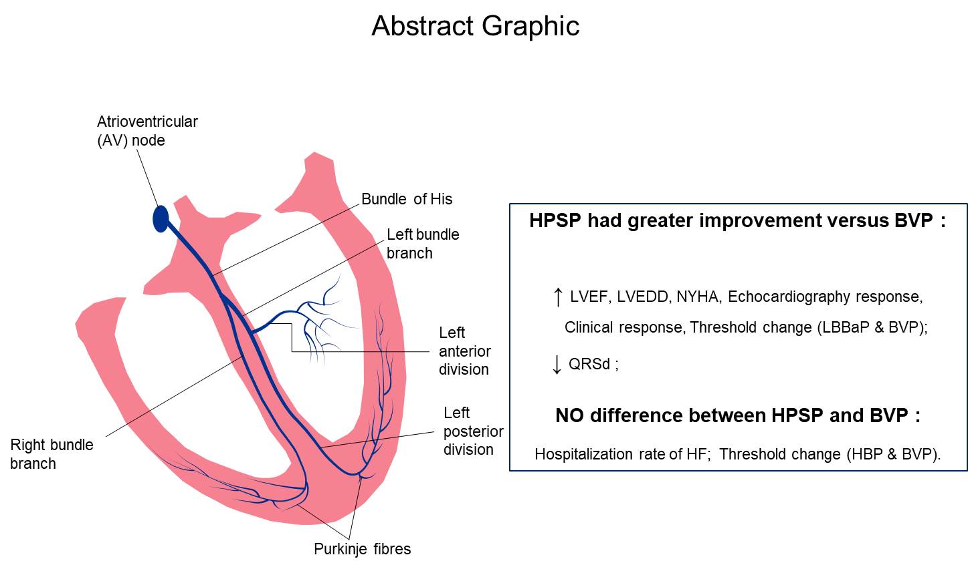

PubMed Search strategy
#1: (left bundle branch area pacing) AND (biventricular) OR (cardiac resynchronization therapy) OR (CRT);
#2: (His-bundle pacing) AND (biventricular)) OR (cardiac resynchronization therapy) OR (CRT);
#3: (#1 AND #2) Filters: Humans；
#4: (#1 AND #2) Filters: (Clinical Trial) OR (Randomized Controlled Trial)

EMBASE Search strategy
#1: 'left bundle branch area pacing':ti,ab,kw AND biventricular:ti,ab,kw OR 'cardiac resynchronization therapy':ti,ab,kw OR crt:ti,ab,kw；
#2: 'his-bundle pacing':ti,ab,kw AND biventricular:ti,ab,kw OR 'cardiac resynchronization therapy':ti,ab,kw OR crt:ti,ab,kw；
#3: (#1 AND #2) Filters: [humans]/lim AND [clinical study];
#4: (#1 AND #2) Filters: [controlled clinical trial]/lim OR [randomized controlled trial]/lim

Cochrane’s Library Search strategy
#1: “left bundle branch area pacing” [ti, ab, kw] and “biventricular” [ti, ab, kw] or “cardiac resynchronization therapy” [ti, ab, kw] or “CRT” [ti, ab, kw];
#2: “his-bundle pacing” [ti, ab, kw] and “biventricular” [ti, ab, kw] or “cardiac resynchronization therapy” [ti, ab, kw] or “CRT” [ti, ab, kw];
#3: (#1 AND #2) Filters: [trials]/lim(Word variations have been searched);

Web of Science Search strategy
#1: (((TS = (left bundle branch area pacing)) AND TS=(biventricular)) OR TS = (cardiac resynchronization therapy)) OR TS=(CRT);
#2: (((TS = (his-bundle pacing)) AND TS=(biventricular)) OR TS = (cardiac resynchronization therapy)) OR TS=(CRT);
#3: (#1 AND #2) Filters: [Clinical Trials]/Ref;
#4: (#1 AND #2) Filters: [Humans]/Ref;

A B
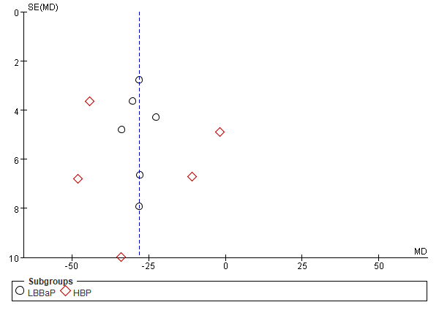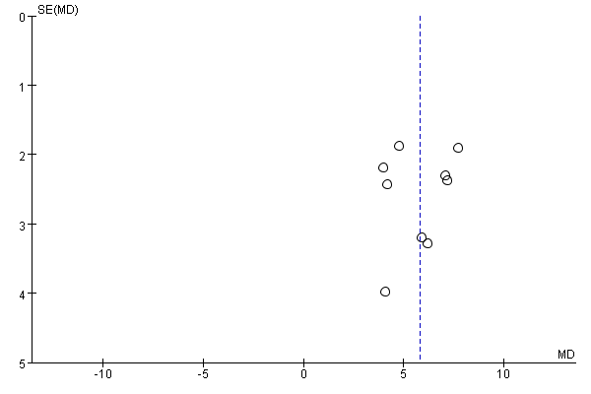
C D
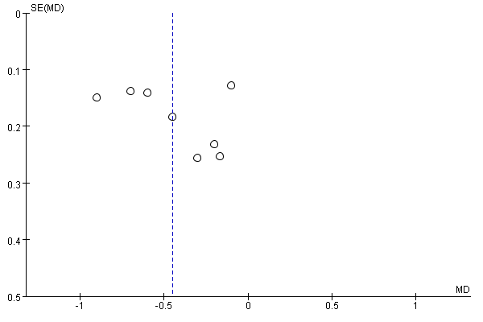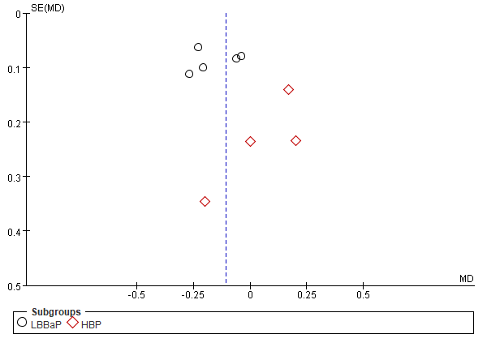
Figure S1. Funnel plots for the meta-analysis on the association of pacing implantation intervention with QRSd decreasing (A); LVEF improvement (B); NYHA improvement (C) and Threshold change (D); SE, standard error.

