The HPLC peak of the drug in 2, 5, 10, and 30 minutes after release. The peak in the 4.5-minute bill is related to the drug.
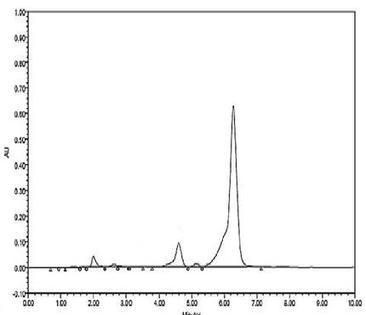
Time= 2min
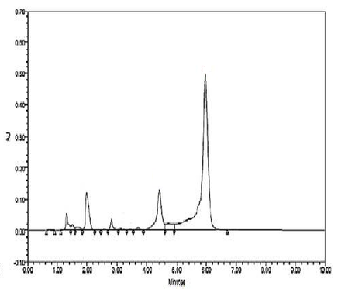
Time= 5 min

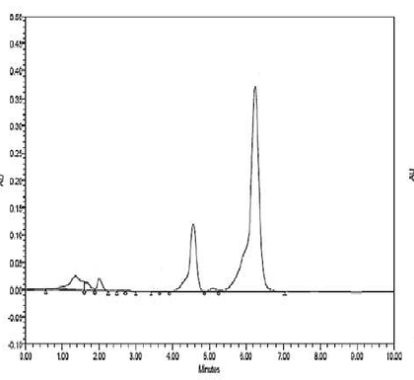
Time= 10 min
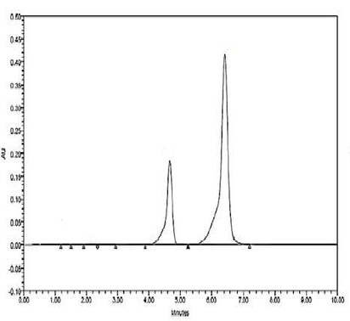
Time= 30 min

