Table S1. Missing number (%) for variables
Variables | Missing number (%)
Demographic features
Age | 0(0)
Sex, male | 0(0)
Weight | 174(2.1%)
Chronic disease history | 0(0)
Chronic pulmonary disease | 0(0)
Peptic ulcer disease | 0(0)
Peripheral vascular disease | 0(0)
Myocardial infarction | 0(0)
Cerebrovascular disease | 0(0)
Diabetes | 0(0)
Aids | 0(0)
Renal disease | 0(0)
Dementia | 0(0)
Rheumatic disease | 0(0)
Paraplegia | 0(0)
Liver disease | 0(0)
Cancer | 0(0)
Congestive heart failure | 0(0)
Vital signs
Heart rate | 1(0%)
MAP | 1(0%)
Respiratory rate | 3(0%)
Body temperature | 529(6.5%)
SpO₂ | 1(0%)
Laboratory results
Scr | 7(0%)
Serum glucose | 39(0%)
Serum chloride | 7(0%)
Serum calcium, | 613(7.5%)
Hematocrit | 7(0%)
Hemoglobin | 8(0%)
Platelets | 9(0%)
Anion gap | 21(0%)
WBC | 8(0%)
INR | 274(3.4%)
Bicarbonate | 8(0%)
Serum sodium | 10(0%)
BUN | 9(0%)
Serum potassium | 14(0%)
PT | 274(3.4%)
PTT | 294(3.6%)
Urine output | 146(1.8%)
Treatments
RRT | 0(0)
Vasopressors use | 0(0)
Mechanical ventilation | 0(0)
Severity scores of illness
SOFA | 0(0)
SAPS II | 0(0)
Abbreviations: Aids: acquired immune deficiency syndrome, MAP: mean arterial pressure, SpO₂: oxygen saturation, WBC: white blood cell, BUN: blood urea nitrogen, INR: international normalized ratio, PT: prothrombin time, PTT: partial thromboplastin time, RRT: renal replacement therapy, SOFA: sequential organ failure assessment, Scr: serum creatinine, SAPS II: Simplified Acute Physiology Score II.

Table S2. Comparison of baseline characteristics between the training and test sets
Variables | Total  (n =8129) | Training set  (n =6503) | Test set  (n =1626) | P value
Demographic features
Age (years) | 68.7 [57.2, 79.6] | 68.7 [57.3, 79.6] | 68.7 [57.1, 79.6] | 0.534
Sex, male, n (%) | 4708 (57.9) | 3760 (57.8) | 948 (58.3) | 0.745
Weight (kg) | 81.8 [68.7, 98.0] | 81.6 [68.5, 98.0] | 82.1 [69.3, 97.6] | 0.637
Chronic disease history, n (%)
Chronic pulmonary disease | 2358 (29.0) | 1877 (28.9) | 481 (29.6) | 0.589
Peptic ulcer disease | 261 (3.2) | 206 (3.2) | 55 (3.4) | 0.718
Peripheral vascular disease | 1143 (14.1) | 915 (14.1) | 228 (14.0) | 0.992
Myocardial infarction | 1643 (20.2) | 1312 (20.2) | 331 (20.4) | 0.898
Cerebrovascular disease | 1250 (15.4) | 999 (15.4) | 251 (15.4) | 0.971
Diabetes | 2566 (31.6) | 2061 (31.7) | 505 (31.1) | 0.643
Aids | 37 (0.5) | 29 (0.4) | 8 (0.5) | 0.967
Renal disease | 1938 (23.8) | 1544 (23.7) | 394 (24.2) | 0.703
Dementia | 321 (3.9) | 255 (3.9) | 66 (4.1) | 0.854
Rheumatic disease | 305 (3.8) | 242 (3.7) | 63 (3.9) | 0.828
Paraplegia | 376 (4.6) | 300 (4.6) | 76 (4.7) | 0.969
Liver disease | 1384 (17.0) | 1097 (16.9) | 287 (17.7) | 0.476
Cancer | 1108 (13.6) | 886 (13.6) | 222 (13.7) | 1
Congestive heart failure | 2831 (34.8) | 2239 (34.4) | 592 (36.4) | 0.142
Vital signs
Heart rate (beats/minute) | 86.1 [76.2, 98.5] | 86.2 [76.4, 98.6] | 85.4 [75.6, 98.1] | 0.424
MAP (mmHg) | 74.8 [69.6, 81.3] | 74.8 [69.5, 81.3] | 74.9 [69.7, 81.4] | 0.736
Respiratory rate (beats/minute) | 19.3 [16.9, 22.4] | 19.3 [17.0, 22.5] | 19.3 [16.8, 22.4] | 0.32
Body temperature (°C) | 36.9 [36.6, 37.3] | 36.9 [36.6, 37.2] | 36.9 [36.6, 37.3] | 0.873
SpO₂ (%) | 97.4 [95.9, 98.7] | 97.4 [95.9, 98.7] | 97.4 [95.9, 98.7] | 0.666
Laboratory results
Scr (mg/dL) | 1.3 [0.9, 2.1] | 1.3 [0.9, 2.1] | 1.2 [0.9, 2.1] | 0.423
Serum glucose (mg/dL) | 155 [124, 209] | 155 [124, 208] | 155 [124, 212] | 0.637
Serum chloride (mEq/l) | 107 [103, 111] | 107 [103, 111] | 107 [103, 111] | 0.212
Serum calcium (mg/dL) | 8.5 [8.0, 9.0] | 8.5 [8.0, 9.0] | 8.5 [8.0, 9.0] | 0.118
Hematocrit (%) | 34.8 [30.7, 39.7] | 34.8 [30.7, 39.7] | 35.1 [30.9, 39.7] | 0.401
Hemoglobin (g/dL) | 11.4 [10.0, 13.1] | 11.4 [10.0, 13.1] | 11.5 [10.1, 13.1] | 0.353
Platelets (K/uL) | 209 [151, 282] | 208 [151, 281] | 213 [151, 286] | 0.282
Anion gap (mEq/L) | 17.0 [14.0, 20.0] | 17.0 [14.0, 20.0] | 16.5 [14.0, 20.0] | 0.603
WBC (K/uL) | 14.6 [10.6, 19.8] | 14.6 [10.6, 19.7] | 14.7 [10.9, 20.2] | 0.081
INR | 1.4 [1.2, 1.7] | 1.40 [1.2, 1.7] | 1.4 [1.2, 1.7] | 0.171
Bicarbonate (mmol/L) | 24.0 [21.0, 27.0] | 24.0 [21.0, 27.0] | 24.0 [22.0, 26.0] | 0.782
Serum sodium (mEq/L) | 140 [137, 143] | 140 [137, 143] | 140 [138, 143] | 0.093
BUN (mg/dL) | 26.0 [17.0, 42.0] | 26.0 [17.0, 42.0] | 25.0 [17.0, 42.0] | 0.282
Serum potassium (mEq/L) | 4.6 [4.2, 5.1] | 4.60 [4.2, 5.1] | 4.60 [4.2, 5.1] | 0.965
PT (s) | 15.2 [13.2, 18.7] | 15.2 [13.3, 18.8] | 15.0 [13.2, 18.6] | 0.189
PTT (s) | 34.2 [29.0, 48.9] | 34.3 [29.0, 48.8] | 34.1 [28.9, 49.3] | 0.655
Urine output (mL) | 1295 [765, 2000] | 1280 [760, 1985] | 1350 [794, 2050] | 0.029
Treatments, n (%)
RRT | 592 (7.3) | 475 (7.3) | 117 (7.2) | 0.922
Vasopressors use | 785 (9.7) | 647 (9.9) | 138 (8.5) | 0.082
Mechanical ventilation | 7485 (92.1) | 5978 (91.9) | 1507 (92.7) | 0.339
Severity scores of illness
SOFA | 7 [5, 10] | 7 [5, 10] | 7 [5, 10] | 0.124
SAPS II | 42 [34, 52] | 42 [34, 52] | 42 [33, 51] | 0.128
Abbreviations: Aids: acquired immune deficiency syndrome, MAP: mean arterial pressure, SpO₂: oxygen saturation, WBC: white blood cell, BUN: blood urea nitrogen, INR: international normalized ratio, PT: prothrombin time, PTT: partial thromboplastin time, RRT: renal replacement therapy, SOFA: sequential organ failure assessment, Scr: serum creatinine, SAPS II: Simplified Acute Physiology Score II.

Table S3. Clinical features used for developing the models.
Variables
Demographic features
Age
Weight
Chronic disease history
Cerebrovascular disease
Diabetes
Rheumatic disease
Paraplegia
Liver disease
Cancer
Vital signs
Heart rate
Respiratory rate
Body temperature
Laboratory results
Scr
Serum chloride
Hemoglobin
Platelets
Anion gap
WBC
INR
Serum sodium
BUN
PTT
Urine output
Severity scores of illness
SOFA
SAPS II
Abbreviations: WBC: white blood cell, BUN: blood urea nitrogen, INR: international normalized ratio, PTT: partial thromboplastin time, Scr: serum creatinine, SOFA: sequential organ failure assessment, SAPS II: Simplified Acute Physiology Score II.

Figure S1. Feature selection using the LASSO regression model
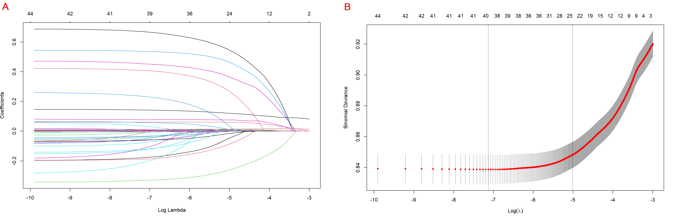
(A) LASSO coefficient profiles of the 44 baseline features.
(B) Tuning parameter (λ) selection in the LASSO model used 10-fold cross-validation via minimum criteria.
Abbreviations: LASSO: least absolute shrinkage and selection operator.

