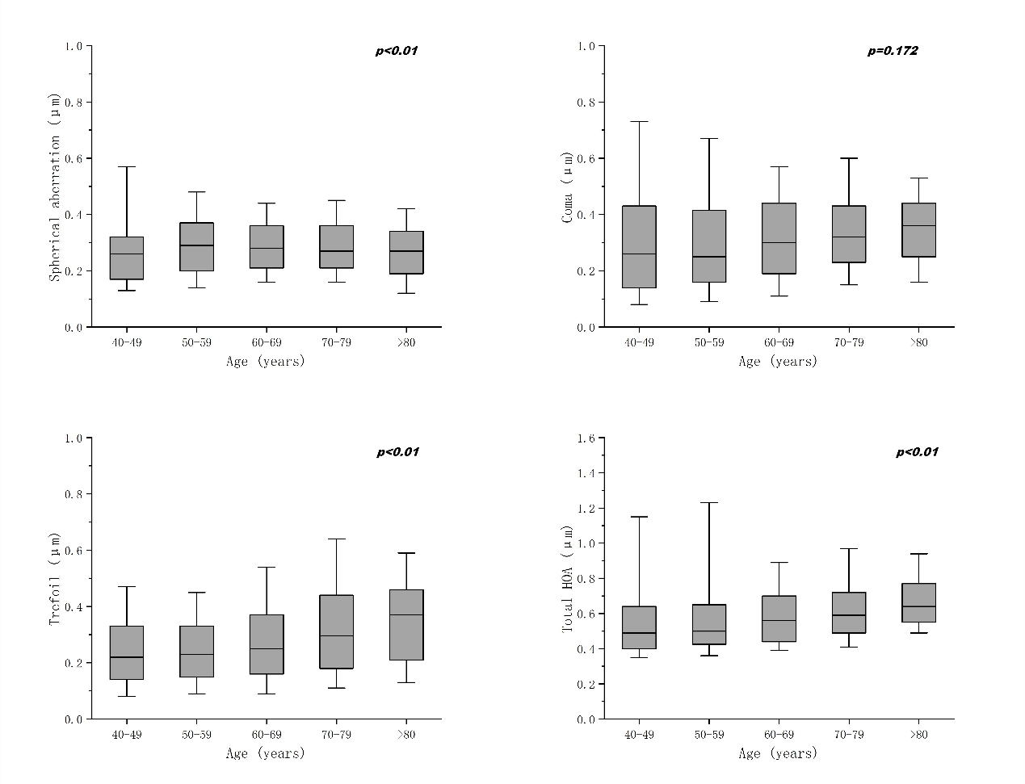
Supplemental Figure 1 Distribution of corneal higher-order aberrations (HOAs) at central 6mm optic zone stratified by age.

