Synthesis, structure, hirshfeld surface analysis, non-covalent interaction, and in silico studies of 4-hydroxy-1-[(4-nitrophenyl)sulphonyl]pyrrolidine-2-carboxyllic acid
David Izuchukwu Ugwu,¹ Florence Uchenna Eze¹, Chigozie Julius Ezeorah^{1,2} Lydia Rhyman ^{4,5}, Ponnadurai Ramasami ^{4,5}, Groutso Tania⁶, Cosmas Chinweike Eze^{1,7,8}, Chiamaka Peace Uzoewulu^{1,8}, Blessing Chinweotito Ogboo^{1,9} Obinna Chibueze Okpareke^{1*},
¹Department of Pure and Industrial Chemistry, University of Nigeria, Nsukka, 410001, Nigeria
²Department of Chemistry and Biochemistry, University of South Carolina, Columbia, SC 29208, United States of America,
³Computational Chemistry Group, Department of Chemistry, Faculty of Science, University of Mauritius, Réduit 808037, Mauritius
⁵Centre for Natural Product Research, Department of Chemical Sciences, University of
Johannesburg, Doornfontein, Johannesburg 2028, South Africa
⁶School of Chemical Sciences, University of Auckland, Private Bag 92019, Auckland, 1142, New Zealand
⁷Natural Science Unit, School of General Studies, University of Nigeria, Nsukka, 410001, Nigeria.
⁸ Department of Chemistry, North Carolina State University, Raleigh, North Carolina 27695-8204, USA.
⁹Department of Chemistry, State University of NewYork at Buffalo, NY, 14260

Corresponding author email: obinna.okpareke@unn.edu.ng

Supplementary information

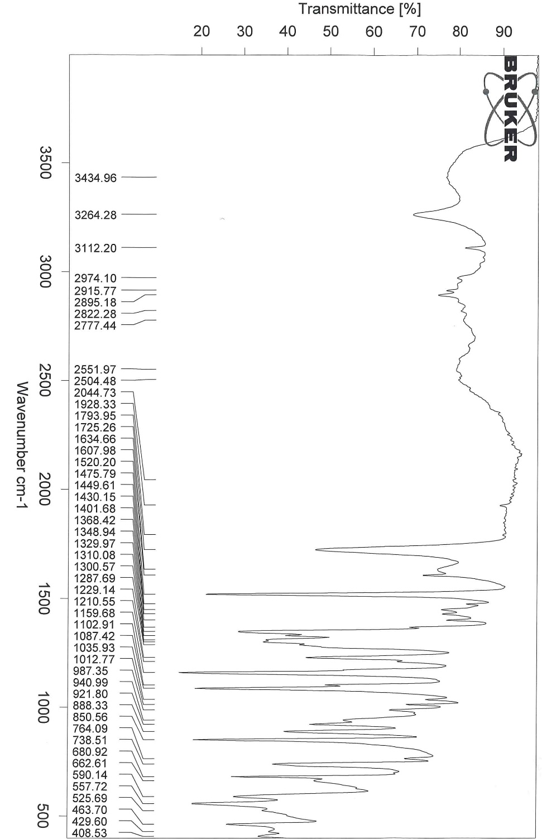
Figure S1: FTIR of HNCPA
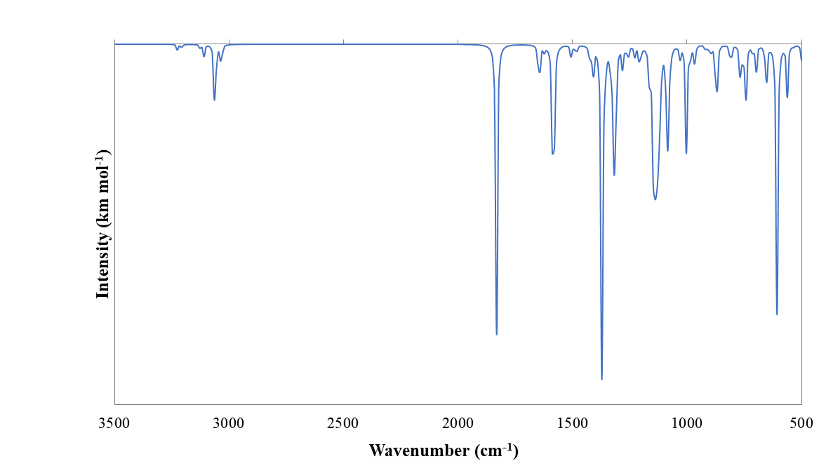
Figure S2: Simulated IR spectra of HNPCA in the gas phase.

Figure S3: Mass Spec of HNCPA

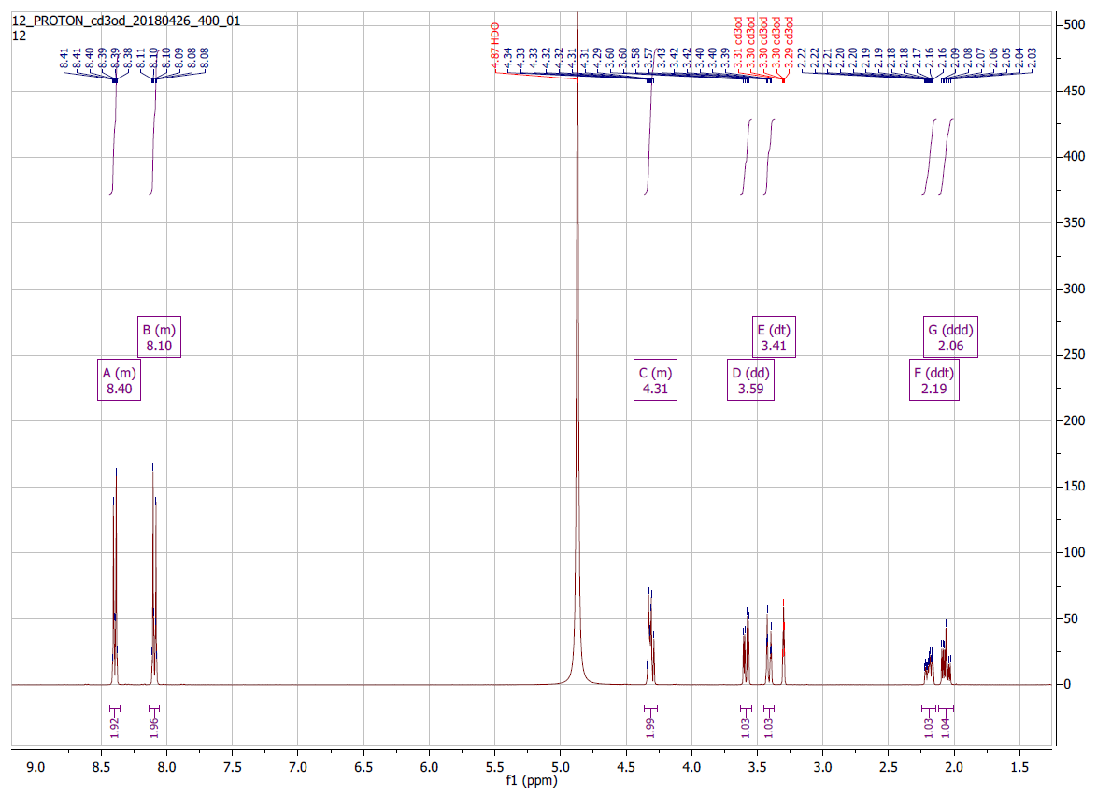
Figure S4: Proton NMR of HNCPA

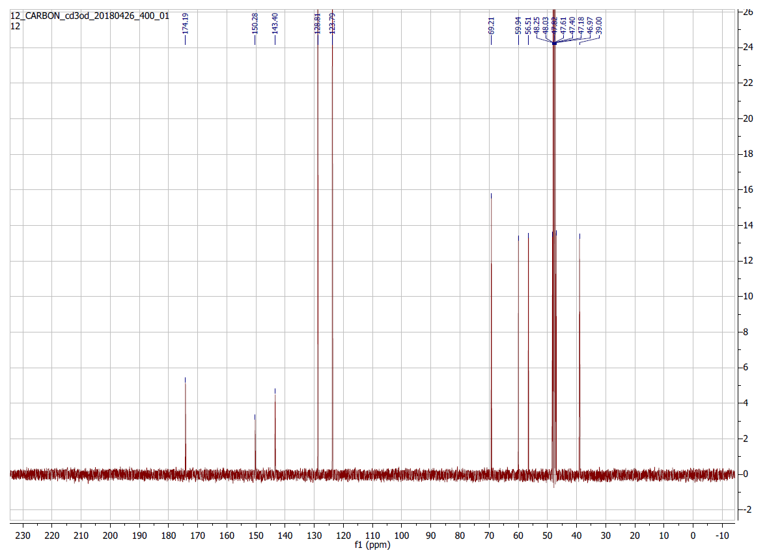
Figure S5: Carbon-13 NMR of HNCPA

Table S1: Computed chemical shifts of ¹H and ¹³C (ppm) along with the optimised geometry of HNPCA for atom labelling
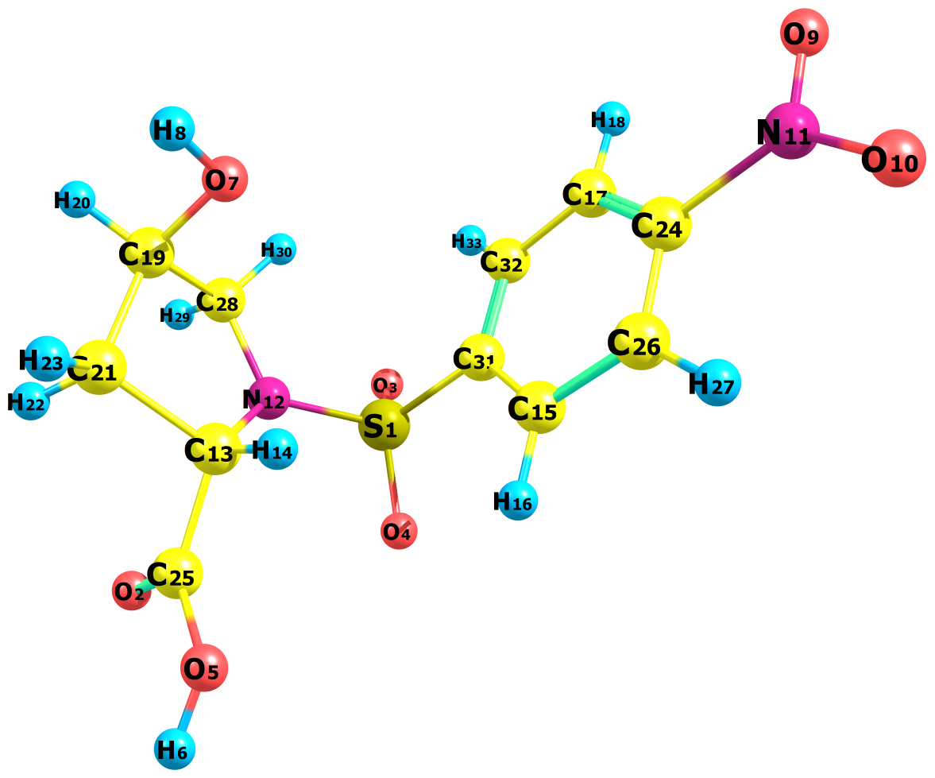
Atom  labeling | δ ¹H (ppm) | Atom labelling | δ ¹³C (ppm)
6 | 6.62 | 13 | 65.31
8 | 0.41 | 15 | 134.86
14 | 4.36 | 17 | 132.93
16 | 8.16 | 19 | 79.10
18 | 8.74 | 21 | 46.81
20 | 4.39 | 24 | 158.98
22 | 2.07 | 25 | 183.79
23 | 2.21 | 26 | 133.01
27 | 8.73 | 28 | 61.47
29 | 3.76 | 31 | 155.86
30 | 3.34 | 32 | 135.83
33 | 8.21

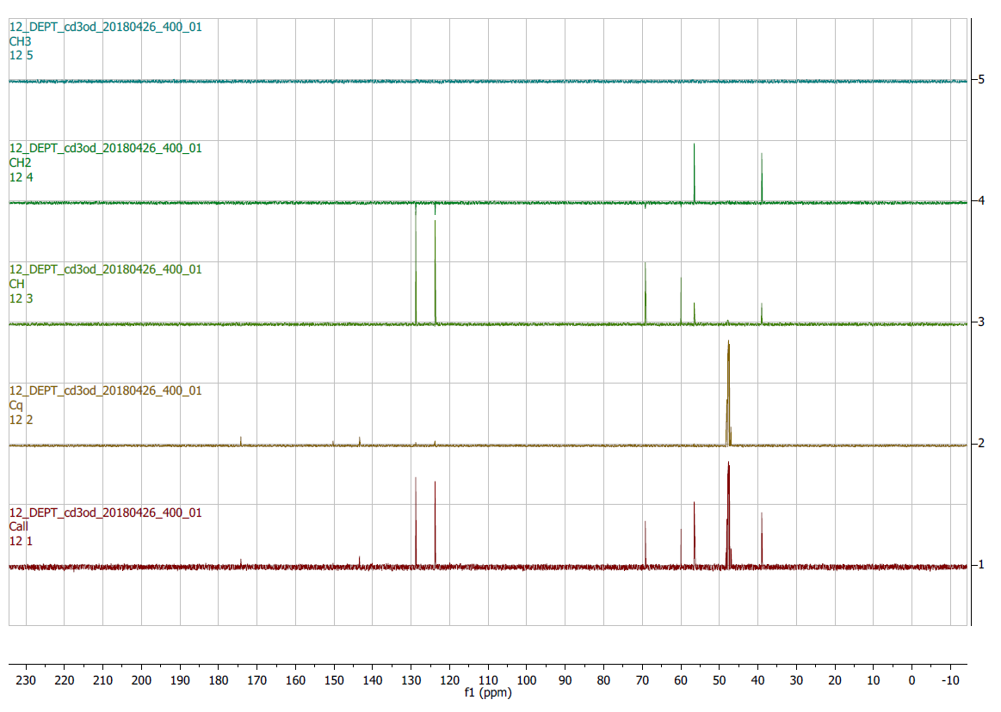
Figure S6: Depth of HNCPA

